**Webpack Tutorial**

**1. set up your project directory**

create a new directory for your project and navigate into it:

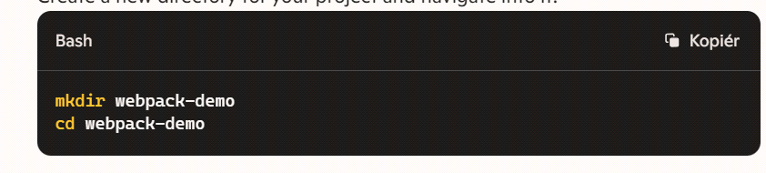

**2. Initialize npm:**

initialize npm in your project directory:

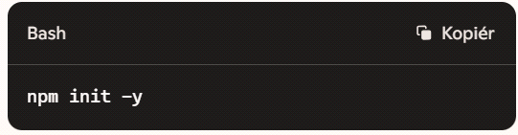

**3. Install webpack and webpack CLI:**

**Install webpack and webpack cli as development dependencies:**

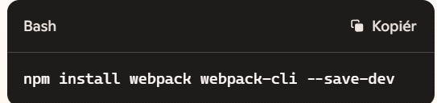

**4. Create a basic project structure:**

**create a src folder for your source code and an index.js file inside it:**

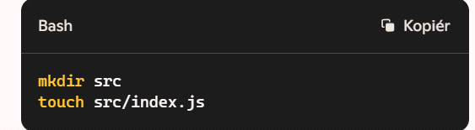

**5. Create an entry file:**

**add some basic javascript code to your index.js file:**

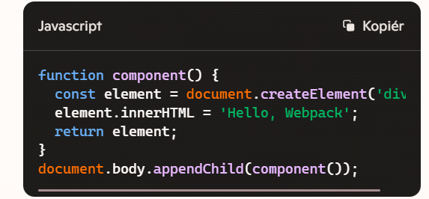

**6. Create an Html file:**

**create an index.html file in the root directory:**

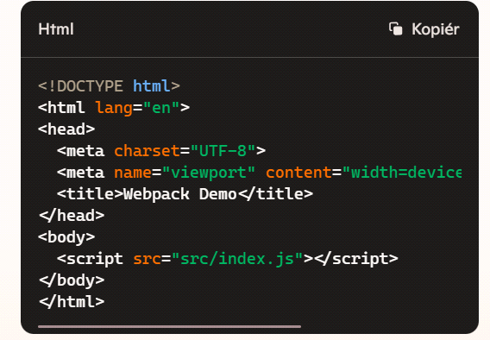

**7. Configure webpack:**

**create a webpack.config.js file in the root directory and add the following configuration:**

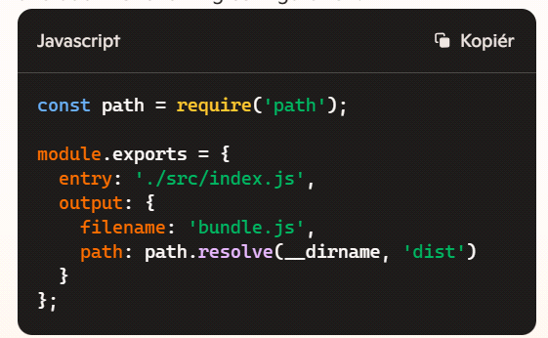

**8. Add script to package.json:**

**add script to your package.json to run webpack:**

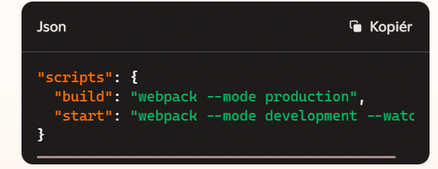

**9.Run webpack:**

**run webpack to bundle your javascript file:**

