SUBSTITUA ESTA FOLHA PELA CAPA GERADA A PARTIR DO MODELO LATEX.
Data Mining Approach to build a classification predictor for the nominee soccer players of Ballon d’Or award
Renato Toshiaki Shibata1, Hélio Pedrini2
1 Instituto de Computação, Universidade Estadual de Campinas (UNICAMP), Undergraduate Course, Computer Engineering. ra082674@dac.unicamp.br
2 Instituto de Computação Universidade Estadual de Campinas (UNICAMP),
13083-970 Campinas-SP, Brazil
helio@ic.unicamp.br

Abstract. This is a dissertation of Computer Engineering Bachelor Final Thesis, course whose initials are MC030, offered by Institute of Computing UNICAMP in the first semester of 2018. In this paper, a data set of professional football players’ historical in-game statistics from recent years were built through Feature Engineering methodology and then it was applied Machine Learning algorithms in order to characterize players who were nominated to the annually award called Ballon d’Or. That was approached as a classification problem, where the predictor should classify correctly whether the current player, according to his annual performance, will be nominated to the Ballon d’Or award at the end of the year or not. We applied some Machine Learning and Data Mining algorithms like: ZeroR, OneR, Iterative Dichotomiser 3 (ID3), Logistic Regression and Support Vector Machine (SVM). The obtained results by each method are discussed and compared between them in order to evaluate how accurate they are according to a football expert’s opinion.

Keywords: data mining; machine learning; classification; feature engineering; ballon d’or; football

Introduction
Football is a very popular game worldwide, it was invented in England in the XIX century and is now played regularly by more than 240 million people according to Fédération Internationale de Football Association (FIFA) [1].
Ballon d’Or is an award which is given by France Football to the player who is considered the best in the previous year. France Football is a French magazine which belongs to Amaury Group. At 5th July, 2010 the president of the Group Marie-Odile Amaury signed an agreement with former president of FIFA, Joseph Blatter, about unifying Ballon d’Or award and FIFA Best Player of the Year award into FIFA Ballon d’Or award. However, in September 2016, France Football announced that their partnership with FIFA Ballon d’Or award had come to an end and they would revive the Ballon d’Or Award [2].
Ballon d’Or award basically consists in 2 processes, but for this research only the first process matters for us. Firstly, it’s arbitrarily selected a number of candidates for the award.
That shortlist used to be made by FIFA’s Football Committee and a group of experts from France Football magazine until 2015, where they chose 23 candidates. From 2016 onwards, only France Football decides that shortlist, which was increased its size to 30 candidates [2].
The aim of this study is verifying possible objective criteria for the 30 nominees in that annual shortlist, where only one of those candidates will received the Ballon d’Or award and then be recognized as “Best Player of the World” of the most popular sport in the planet.
We assume that the nominee selections are made by reasonable and impartial criteria. In order to clarify all these underlying possibilities, we decided to investigate objective criteria to identify a pattern of the nominee player. Also, we assume that the choice for Ballon d’Or nominee players made by FIFA (from 2010 until 2015) and France Football magazine has sufficient positive relations to the player’s in-game statistics and we investigate those using convincing objective criteria. For this objective, we chose to use an approach which uses Machine Learning algorithms.
There are some previous studies on applying techniques related to Machine Learning and Data Mining at football. For example, Wang and Wang [3] used the Apriori algorithm [4] in data mining to determine association rules between different types of technical movements in football. Those technical movements were movements relating to shots converted in goals. Their objective is providing a scientific decision for coaches to train and guide the football players. Another example using similar approach is used by Chai [5] to mine patterns from data of soccer using serial data to determine what chains of possession between players happened often. The model he provides intends to guide coach to establish an effective mechanism in football match.
Finally, the research whose intentions are closer to ours is by Nunes and Sousa [6]. One of the reasons is because they applied data mining techniques in the hopes of finding interesting and unexpected association rules. Their data set was based on historical data of European tournaments. Besides that, they used classification methods using Weka Software [7] to test their hypothesis that they would be able to classify matches, according to their results based on the available historical data.
However, our objective is not focused on predicting the outcome of European football matches, as Nunes and Sousa intended to. Furthermore, we found that it is not very effective to predict future outcome of matches based on that because we assume that historical data of a club does not an influential impact in the outcome of game, in comparison to the current staff of players of the club, staff of coach and administrators of the club among other factors.

Methods

Reasons for the use of Machine Learning and Data Mining Algorithms

Data Mining is the process of extracting valid, previously unknown, comprehensible, and actionable information from large databases and using it to make crucial business decisions (Connolly, 2004). In other words we can say that data mining is mining the knowledge from data. In Data Mining and Machine Learning there are other types of methods, like Clustering and Neural Network. But for this research, we are all about finding interesting associations between features of the data set and build a classifier model. Classification maps data into predefined groups or classes (Dunham, 2002). So, classification is the process of finding a model that describes the data classes or concepts. Its purpose is being able to use this model to predict the class of objects whose class label is unknown.
Hence that mathematical approach fits a lot in the case of dealing with footballers’ statistics around all the world. As all we know, there is a huge amount of data about the players that need to be turned into useful information, so data mining would be perfect to deal with big data in order to extract from it only what we want to know, that is, a pattern of characteristics typical for a Ballon d’Or nominee.
Besides that, players’ statistics are sometimes unknown, so we need a proper mathematical approach to deal with imperfect knowledge of the players.
Moreover, we have previously unknown information about the characteristics of Ballon d’Or nominees and we are assuming France Football’s choice of the nominees are reasonable.
Tools for Data Mining are very powerful, but they require very skilled specialist who can prepare the data and understand the output. Data Mining brings out the patterns and relationships, but the significance and validity of those patterns must be made by the user. Besides that, some Data Mining and Machine Learning methods can bring better results than others depending on the nature of the data set. That’s why comparing the several obtained results through the user’s experience and knowledge of football is fundamental.
Then among all types of data mining methods, we have chosen only classification algorithms. As you can see in the definition above, it’s clearly obvious the reason to use this type of method. In this research, we have distinguished two groups of players: Ballon d’Or nominees and non-Ballon d’Or nominees. Those groups are already predefined since we already know who are they in the previous Ballon d’Or nominations.

Feature Engineering

There are so few websites providing detailed statistics of players, and even more rare through all the season. We tried to collect the most number of individual recorded statistics we could get at the Internet scattered through lots of websites¹. Lots of them didn’t provided all the 29 attributes, so we gathered all them together, taking data piece by piece, mainly for players like Neymar, who had a pivotal role at South America tournaments during 2012, which are not well considered by Europe journalists.
We made a training data containing 181 instances and 30 attributes, where one of them is the target attribute, which specifies whether a player is a Ballon d’Or nominee or not. The instances are represented by football players and their respective season. We could not have time to get a higher number of players given the work rate to gather all the statistical information about them within some months. Otherwise we would not have enough time to apply data mining methods and analyzing their results.
¹ http://espnfc.com/
http://www.ogol.com.br/
http://www.fifa.com/
http://br.soccerway.com/
http://www.whoscored.com/

Those 181 instances were composed of players’ statistics during the following period: 13 August 2012 to 25 December 2013 and 22 August 2011 to 25 December 2012. These two periods corresponds roughly to the season of year 2012 and to the season of the year 2013. Among those 181 selected players, 22 of them were nominee players for Ballon d’Or Award at 2013 and 20 of them were nominee players for Ballon d’Or Award. So in total, there are 42 nominee players’ statistics and 139 non-nominee players’ statistics. We didn’t chose the total 23 players in those years, because some of them were goalkeepers.
We haven’t included goalkeeper because the relevant statistics for a goalkeeper is very different from all other type of players. It would be necessary another data set only to deal with goalkeepers to get an accurate result.
In order to get a balanced data set in terms of player’s position, we got a similar proportion of players who act in the same position among those 42 nominee players and among those 139 nominee players. That’s very important in this research because we have a very limited number of instances to work with, plus most of nominee players are Center or Wide Forwards. So in that case, there would be a risk that the classification models obtained by data mining and Machine Learning methods could end up just describing a common feature of any average Forward if there were not enough proportion of Forwards among non-nominee players. There are 20 Forwards, 11 Attacking Midfielders, 7 Defensive Midfielders, 2 Fullbacks and 2 Center-backs among those 42 nominees. Forwards represent almost half of all nominees. That’s why we collected data from 51 Forwards, 38 Attacking Midfielders, 23 Defensive Midfielders, 13 Fullbacks and 14 Center-backs among those 139 non-nominees.
We managed to gather more attributes than those 29, which are:

- Number of times a player started a game playing in that season;
- Number of times a player was on the bench and came into the match in that season;
- Total number of goals a player scored in that season;
- Total number of passes a player made that lead directly to a goal for his teammate, that is, assists, in that season;
- Average number of goals a player scored per match in that season;
- Average number of assists a player did per match in that season;
- Total number of yellow cards a player received in that season;
- Total number of red cards a player received in that season;
- Average number of shots a player attempted to the goal either on or off target per game;
- Average number of winning a header in a direct contest with an opponent per game;
- Average number of time a player dispossess an opponent, whether the tackling player comes away with the ball or not, per game;
- Average number of opponent’s pass intercepted by a player per game;
- Average number of fouls committed by a player per game;
- Average number of times a player is the last man to step up to catch an opponent in offside position per game;
- Average number of fouls clearances a player made to remove attacking threat on his goal per game;
- Average number of times a player was dribbled by an opponent without winning a tackle per game;
- Average number of times a player blocked a shot by opponent per game;
- Total number of own goals by a player in that season;
- Average number of passes a player made to lead to a shot at goal from a team mate per game;
- Average number of times a player successfully dribbles past per game;
- Average number of time a player is fouled by opposite team per game;
- Average number of times a player is caught offside per game;
- Average number of times a player is tackled by an opponent without attempting to dribble past them per game;
- Average number of times a player loses possession due mistake or poor control per game;
- Average number of passes a player attempts (short passes, long balls, through balls, crosses) per game;
- Percentage of attempted passes by a player that successfully found a teammate per game;
- Average number of attempted and accurate pass from a wide position to a central attacking area by a player per game;
- Average number of attempted and accurate pass of 25 yards or more by a player per game;
- Average number of an attempted and accurate pass between opposition players in their defensive line to find an onrushing teammate per game;
Some other attributes like the number of victories and losses by the team he is playing for we ignored because we assume that Ballon d’Or is an award exclusively for individual skills.
From some type of tournaments we couldn’t gather the data relating to all the 29 attributes. But at least, from the big 5 European national leagues² plus the Brazilian national league we have gathered all the data. Fortunately most of the matches played by a regular player in a season come from national league.
Also, from UEFA Champions League, which is the most important tournament in Europe, we have gathered all the data too. We included data related to UEFA Europa League too, since it’s the 2nd more important tournament in Europe.
All other tournaments like African Cup of Nations, AFC Asian Cup, Copa America, Club World Cup, National Cups from the big 5 European football leagues, we couldn’t gathered data corresponding to all those 29 attributes.
In order to get the best data set possible to avoid possible overfitting, we thought in choosing the players’ statistics not only in terms his position but in terms of the league that he plays for. That’s because we believe that each league has specific characteristics of playstyle and an algorithm could have the risk of learning the underlying concept of a particular playstyle of a certain league in detriment of others. That’s why the data set has a similar proportion of players acting in each league. That was not done in a rigorous strict way like it was done to equalize the proportion of players by position, but we tried to not choose the players in a way that a certain league becomes much more predominant than the others in relation to the group of the Ballon D’Or nominees and the non-nominees.
All of that was said before in this section is related to the training data. But a very similar approach was made to make the testing data in order to have coherency with the training data. For example, there were no goalkeeper among the instances in the testing data. Again, we used only players’ statistics from the big 5 European football Leagues. In that, we included only data from National Leagues, from UEFA Champions League and from UEFA Europa League.
The differences between the training data relies on the number of instances. We chose to gather 52 instances, where 26 are Ballon d’Or nominees and the other 26 are non-nominees.
We handpicked each player by position and league that he plays, so that we had equally divided in both groups of the Ballon d’Or nominees and the non-nominees : 11 Forwards, 8 Attacking Midfielders, 3 Defensive Midfielders, 3 Center-backs and 1 Fullback. In this way, we kept the same proportion of positions among Ballon d’Or nominees and non-nominees in order to make the test more reliable.
Another important difference with the training set is that the testing set was made of players’ statistics from the season 2016/2017. That is a much more recent data then those from the training set, which were from 2011/2012/2013.

Data Preparation

We can divide the Data Preparation in 3 stages: data cleaning, data transformation and feature selection.
About data cleaning, that is, preparing the data in a way that reduce noise and handle missing values, we had no real trouble since we chose the attributes in relation to the data available at the Internet. Otherwise there would be many non-nominee players with missing values, since the statistical data for those type of players are hard to find at the Internet.
About the data transformation, for certain experiments, we decided to use normalization to the training set. Specifically, we used the Z-score normalization, whose transformation of the value of an attribute a of a n instance x_{i} can be described in the equation below:

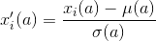
...(1)

where:
x’_{i}(a) is the new value for the instance i for attribute a,
x_{i}(a) is the initial raw value for the instance i for attribute a,
μ(a) is the mean of the set of values of attribute a,
σ(a) is the standard deviation of the set of values of attribute a

About feature selection, we experimented with 2 different functions to select the k attributes with the highest score, according to the definition of its function. k is an integer which can be arbitrarily chosen between 1 and the number of attributes in that data set. The functions we chose were: Chi-square statistics (χ2) between each attribute and the target vector and the ANOVA F-value between each feature and the target vector.

Algorithms

We have selected algorithms that range from the simplest one to those a bit more sophisticated, where all of them possess very different concept between each one of them. We will briefly explain how each of them works.

1. ZeroR
ZeroR, short for Zero rule, is the simplest classification algorithm, that is, if we can actually label it as an algorithm since it only relies on the values of the target attribute and ignore all other feature attributes. ZeroR simply predicts the majority class in a data set by building a model based on the most frequent value in the target attribute. In other words, the ZeroR predictor model would be:
‘target attribute’ = ‘most frequent value of the target attribute’

2. OneR
OneR, short for "One Rule", is a simple accurate classification algorithm that generates one rule for each attribute in the data, and then selects the rule with the smallest total error as its "one rule", which is associated to only 1 attribute.
²Bundesliga - German 1st division football league
Barclays Premier League - English 1st division football league
La Liga - Spanish 1st division football league
Serie A - Italian 1st division football league
Ligue 1 - French 1st division football league
OneR is regarded as one of the simplest classifiers existent. Nevertheless, it’s always good to try a simple version firstly. It has been shown that OneR produces rules only slightly less accurate than very sophisticated classification algorithms while producing rules that are simple for humans to interpret.
In short, this algorithm chooses only 1 of all attributes to make a rule. In other words, it bases on the value of just one, the best attribute to classify all future data. In the following we present the pseudo code of that algorithm.

For each attribute A:
For each value V of that attribute, create a rule:
Count how often each class appears
Find the most frequent class, c
Make a rule "if A=V then C=c"
Calculate the error rate of this rule
Pick the attribute whose rules produce the lowest error rate

3. Decision Tree
CART, short for Classification and Regression Trees, is very similar to C 4.5.
C 4.5 is used in classification problems and it is one of the most used algorithm for building Decision Trees (Quinlan, 1993). It improves and extends the ID3 algorithm [8] by dealing with both continuous and discrete attributes, missing values and pruning trees after construction. C 4.5 dynamically defines a discrete attribute (based on numerical variables) that partitions the continuous attribute value into a discrete set of intervals. C 4.5 converts the trained trees into sets of if-then rules. These accuracy of each rule is then evaluated to determine the order which they should be applied. Pruning is done by removing a rule’s precondition if the accuracy of the rule improves without it [9].
The difference between CART and C 4.5 is that CART supports numerical target variables and does not compute rule sets. CART constructs binary trees using the feature and threshold that yield the largest information gain at each node [9].

In the following we present the pseudo code of CART.

Check for base cases.
For each attribute a calculate:
Normalized information gain from splitting on attribute a.
Select the best attribute
Create a decision node that splits on best of attribute
Recurs on the sub lists obtained by splitting on best of attribute and add those nodes as children node.

The selection of best attribute in CART refers to selecting an attribute that produces the purest daughter nodes. The purest node possible is a leaf with only one class either “Yes” or “No”, so it will not have to be split further and it will favors for smaller tree. In other words, we select an attribute on which objects are partitioned most clearly after objects are partitioned. This brings on the concept of entropy and information gain.
...(2)

Entropy is a function defined by equation (2). Here p_{c} is the probability that a certain instance belongs to class c. In our case, probability can be defined just as frequency, that is, the proportion of instances which belong to class c in the data set T.
In the case of our research, where there are only 2 classes possible: “Yes Ballon d’Or” and “No Ballon d’Or”, we could reduce the sum in two parts only. The first term is related to the positive instances of T and the second one to the negative instances of T.
Entropy measures the impurity of a set of training instances T. That is, it represents the expected amount of information that would be needed to specify whether a new instance should be classified in a positive class “Yes Ballon d’Or” or a negative class “No Ballon d’Or”, in the case of our research.
Using this concept of entropy, it is used the concept of information gain, which is defined by the difference of entropy of parent node and average entropy of the children nodes. This is better described in the equation (3).

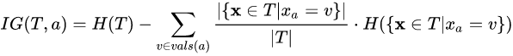
...(3)

Here T denotes a set of training examples, each of the form (x,y) = (x₁, x₂, x₃ ,.., x_{k} ,y) where x_{a} belongs to vals(a) is the value of the ath attribute of the instance x and y is the corresponding target value. The information gain of attribute a in terms of entropy H.
In that way it’s possible to check which of the attributes give us the highest information gain. So that attribute is selected as the best and taken as criteria for splitting. Then the nodes are expanded until all leaves are pure. The pruning is done while expanding the leaves, where the node will split if this split induces a decrease of the impurity greater than or equal to a threshold, arbitrarily chosen by us. In the figure 1 there is the function of entropy for the case of 2 classes.
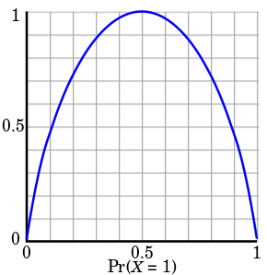

Figure 1: Graphical representation of the Entropy function,where the x axis is proportion of instances in the set belonging to the class X=1. Notice that this graph illustrates only the case where there are only 2 classes in the data set

Assuming there is 2 class, one class labeled as “0” and another one as “1”, it is possible to see that the Entropy of a set S is maximum when the probability of a class X Pr(X=1) is exactly 0.5. That value happens when the set S is equally divided in class “0” and class “1”.
When S is totally homogeneous, that is, when S represents the purest possible children nodes in a decision tree, then the Entropy equals to 0. That means that there is no need to split more nodes anymore since cannot have any information gain after that.

4. Logistic Regression
It is a modification of the Linear Regression method, but instead of outputting a continuous numerical value, it outputs only two possible values for the target value.
Unlike Linear Regression which simply uses the difference of the actual target value with its linear function to compute the cost, Logistic Regression calculates the cost in a different way.
Besides that, another crucial difference is that whereas Linear Regression model function is just a linear combination with the weights of the attributes, Logistic Regression model function is a function σ whose parameter is a linear combination with the weights of the attributes. That can be expressed in the equation (4), where

...(4)

Here h_{θ} is our hypothesis function, x is a vector of all the values of the attributes of a certain instance and θ^{T} is the transpose vector of the weights that we need to find out to build a classifier for the hypothesis function.
Logistic Regression uses a sigmoid function σ(t) , which takes any real input and outputs a value between zero and one, as the figure 2 shows below.

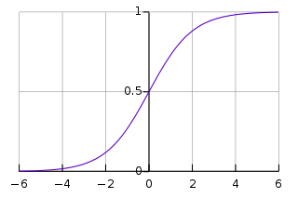

Figure 2: Graphical representation of the Sigmoid function. Notice that its y intercept is exactly 0.5 and that all the possible outputs are in the interval of [-1,1]
The equation of this function is defined by the equation (5).

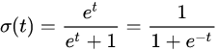
...(5)

Now it is defined in equation (6) the Cost Function, that measures how well the algorithm learns in each iteration.
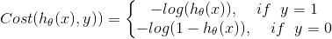
...(6)

So in this way, we penalize the learning algorithm by a very large cost as it commits mistakes, because that equation states that:
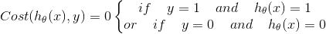
...(7)

and
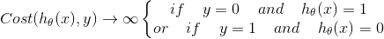
...(8)

Then, the algorithm tries to minimize the Cost J(θ) defined in the equation (9).
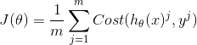
...(9)

After a defined number of iterations, the algorithm stops and deliver the hypothesis function h_{θ} with the weights θ that were calculated so far.

5. Support Vector Machines
Support Vector Machines (SVM) is a powerful algorithm for classification in Machine Learning whose goal is to design a hyperplane that classifies in the best way possible all training instances in two classes. That is done by maximizing the margin between two classes. The margin is the distance between the hyperplane and the closest instance of a class.
In the following we present the pseudo code of that algorithm:
Define an optimal hyperplane: maximize margin
Extend the above definition for non-linearly separable problems: have a penalty term for misclassification
Map data to high dimensional space where it is easier to classify with linear decision surfaces: reformulate problem so that data is mapped implicitly to this space
The hyperplane is designed in a way that is equidistant to its closest instance of both classes. The hyperplane can be defined in the equation (10):

...(10)

Here w is a vector of weights and b is a constant, like a bias. And it will deliver values equal or greater than 1 to all instances from class 1 and it will deliver values equal or lesser than -1 to all instances from class 2. The vectors who defines w are called support vectors.
In the end, it recurs to an optimization problem where we need to maximize the width of the margin w, with the constraints defined for the classification of class 1 and class 2, which was stated in the previous paragraph. All of that is better explained in the figure 3.
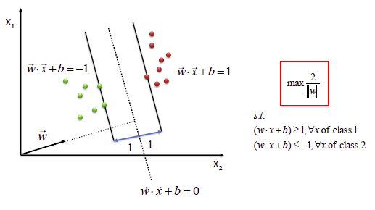

Figure 3: Visual representation of a 2-dimensional data set with 2 classes: one class is represented by red instances and the other one by green instances. The hyperplane is represented in dotted line and the distance between it and the closest red/green instance is 1/||w||, so objective function, which equals to the total margin, is 2/||w||.
Therefore, in order to maximize the separability between the 2 classes, it is needed to minimize the value of the vector w. An ideal SVM analysis should produce a hyperplane that completely separates the vectors(cases) into two non-overlapping classes. However, perfect separation may not be possible. In this situation SVM finds the hyperplane that maximizes the margin and minimizes the misclassification. In order to do that, it penalizes each instance which falls off the margin with a slack variable ξ_{i} . So the equation to be minimized can be defined in the figure 4.
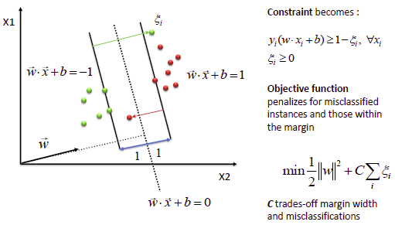

Figure 4: Visual representation of a 2-dimensional data set with 2 classes: one class is represented by red instances and the other one by green instances. There is one red instance which is misclassified by the hyperplane and one green instance which is misclassified by the hyperplane too

Here, the 2 constraints from figure 4 were reduced to only one expression. That’s because here we assume that the target value y_{i} has value equal to 1 for class 1 and -1 for class 2. The slack variable ξ_{i} for a certain instance is then add to the constraint equation for that instance.
The new objective has add a new term related to the penalization of all instances in the model. That is described with the product of a constant C and the sum of slack variables of all instances.

Proposed Solutions
In relation to Feature Engineering, it was used LibreOffice Calc to manually build the training and testing sets. After collecting data from several websites related to football, it was filtered which attributes, represented by columns, would be included in the data set. Everything was done by handpicking, since the choice of the player’s statistics to put in the data sets and formatting of the values in the table of data set before converting them to CSV files. Those data sets who were used in the research were:
(A) For the data without the attribute which counts the number of times a player started playing a match:
- CSV2012-2013_ALL_PLAYERS _No_app_no goalkeeper_ No MOM.csv as the training set;
- 2016-2017season.csv as the testing set;
(B) For the data with the attribute which counts the number of times a player started playing a match:
- CSV2012-2013_ALL_PLAYERS _YES_app_no goalkeeper_ No MOM.csv as the training set;
- 2016-2017season_YESapp.csv as the testing set;
In the end, after analyzing the results from both data sets, we decided to discuss in this report only the results from data set B. It was found out that the attribute which counts the number of times a player is much more important as we thought and initially we thought that the results were not coherent to our knowledge of football, but later on we reconsidered to have a different perspective about the game. So the data set B brought more relevant and complete results than data set A. We will discuss that later in the Results section.
In relation to the Algorithms which were used in this research, all the code was implemented by us using the programming language Python. The version of the Python used was 2.7. We used several libraries:
- pandas – to manipulate the data set,
- csv – to open the CSV files ,
- numpy – for several purposes like manipulating arrays and other data structures
- scikit-learn – the most important library in this research, from where we used methods that helped to implement the Machine Learning algorithms used in this research
The only algorithms which we did not use any implementation from scikit-learn to code them were ZeroR and OneR. Every other algorithm like Decision Trees, Logistic Regression and Support Vector Machine were implemented using sklearn.tree , sklearn.linear_model and sklearn.SVC, respectively. For all those 3 algorithms, we used the following classes respectively to run each one of those algorithms: DecisionTreeClassifier, LogisticRegression and SVC.
We set the default parameters to initialize each algorithm. There were exceptions like the DecisionTreeClassifier class where we used the parameter criterion=”entropy” since I intended to use that concept instead of using the Gini Index to become the concept for the split criteria of each node. Also, the parameter min_impurity_decrease (that is, the threshold for splitting at each node) was set in its default value, 0. That means that it would not prune any tree.
Another exception was the SVC() class, where we used parameter kernel=”linear” in order to retrieve the coefficients of each attribute. That was made in order to maintain it coherent with the method proposed in section II, where there were no transformation of the original space resulted of kernel transformation and thus the coefficients are directly related to the dimension of the data set.
Specifically, in the implementation of OneR, we did implemented the discretization of the data set for 5,6,7,8,…,19,20 categorical values for each attribute.
For OneR exclusively, we implemented a version where we used k-fold Cross Over validation. We applied k=10, that is dividing the training set into 10-folds, where 9 of them was used to build the classifier and 1 of them was used as the validation fold at each one of the 10 total iterations. One important thing to notice is that we used StratifiedKFold class from scikit-learn library, so the folds were made by preserving the percentage of samples for each class. When using the testing set, among the 10 generated OneR classifiers, it is chosen only one, the one who got the highest accuracy in the validation set.
For the other algorithms, except ZeroR because it doesn’t work with the non-target attributes, the data preparation was made with scikit-learn library. The standardization with Z-norm was made with sklearn.preprocessing while the Feature Selection was made with sklearn.feature_selection.
To normalize using Z-score normalization, we used the method StandardScaler(). To do the feature selection, the choice of the method depended of what type of experiments we did.
For experiments where we needed to work with discretized data, we used Chi-square as the function to be computed for the SelectKBest() method to select the K best attributes. To work with the data without discretizing it, we used f_classif , that is, the ANOVA F-value, as the function to be computed for the SelectKBest() method.
It is important to remind that Z-score normalization produces negative values in the data set. And because chi-square function does not accept negative values, we couldn’t use feature selection using chi2. We only used f_classif for feature selection after Z-score normalization.

Results
All the results were obtained through running Python programs. Some of the results were obtained by Weka Software, but the objective of doing that was just to compare them with their equivalent algorithm in a program coded by us.
We used the same training and testing sets that were defined in the section II for both Weka and Python programs.

I. ZeroR
ZeroR gave very modest results, but it was useful just to have a baseline for the performance of the others algorithms.
It doesn’t matter if we did Z-score normalization or used the SelectKBest()during the data preparation because this algorithm just uses the target attribute values. We tested the same algorithm at Weka software and we got exactly the same results. Prediction of class value: Ballon d’Or Nominee = “No”
Here are the results for the testing data:
* Correctly classified instances =50%
* Confusion matrix:
m=52 | Classified as “Yes” | Classified as “No”
Actual “Yes” | 0 | 26
Actual “No” | 0 | 26

It’s obvious that the prediction rule would be setting the target value Ballon d’Or Nominee to “No” value, since most of the instances in the training set are not nominees, only a few players are selected every year to be nominated.
Also, since the testing set was equally divided the instances into the 2 classes, so it was evident that the accuracy of ZeroR classifier would be 50%. As you can see in the confusion matrix, ZeroR classified all instances in the testing set as “No”, hence we had no true positives among the correctly classified instances. Because of that the other half of instances which were misclassified were all false positive.

II. OneR
For all resulted classifiers generated by OneR, we always had to discretize the numerical values in order to get categorical values for the algorithm to work. Some experiments were applied k-fold Cross over-validation, for others only Z-score normalization, for others only feature selection , for others both of them altogether and for others no type of preprocessing.
Firstly we will show OneR results with 10-fold cross over validation. After testing with several number of bins (b) for discretization as mentioned at section III, we have found out that the best accuracy for the testing, using the minimum possible value for b, happened when b=6. Its total average accuracy for all the 10-fold validations was 89.40 % and its accuracy in the testing data was 59.62 %.
For instance, for b=10 gave a total average accuracy for all the 10-fold validations equals to 89.90%% and an accuracy in the testing data equals to 55.77%. For b=5, it was 82.73% and 51.92%, respectively. For b=20, it was 88.72% and 55.77%, respectively.
Here below are the set of rules with the best validation accuracy among all iterations for b = 6:

IF Appearances = 0.0to10.0 THEN Ballond'OrNominee = No
IF Appearances = 10.0to20.0 THEN Ballond'OrNominee = No
IF Appearances = 20.0to30.0 THEN Ballond'OrNominee = No
IF Appearances = 30.0to40.0 THEN Ballond'OrNominee = No
IF Appearances = 40.0to50.0 THEN Ballond'OrNominee = Yes
IF Appearances = 50.0toInfinite THEN Ballond'OrNominee = Yes

Incredibly, the accuracy in the validation set of that specific iteration was 100%. The confusion matrix for b=6 using 10-fold cross over validation and not using it, was exactly the same. Applying SelectKBest with the parameter f_classif the results remained the same too.
* Correctly classified instances =59.62 %
m=52 | Classified as “Yes” | Classified as “No”
Actual “Yes” | 5 | 21
Actual “No” | 0 | 26

OneR could correctly predict all the 26 players who were not candidates for the Ballon d’Or. However, it found a hard time to classify correctly the nominee players.
Probably the main reason for that is that generating rules based on the values of a single one attribute is not enough to classify a Ballon d’Or nominee, that is, the characterization for the nominee is not that simple to be described.
However when using the parameter chi2, b=6 using 10-fold cross over validation, the total average accuracy for all iterations became a little lower 86.69% but the accuracy for the testing data drastically increased to 67.31%. Its confusion matrix is as following:
* Correctly classified instances =67.31 %
m=52 | Classified as “Yes” | Classified as “No”
Actual “Yes” | 9 | 16
Actual “No” | 0 | 26

There were no significant difference with the confusion matrix using f_classif or not using any feature selection at all, since it could guess correctly all the 26 non-nominee players, but it was not very effective to detect Ballon d’Or nominees, even though it improved.
No matter how we set the parameter b, the chosen attribute to generate the rules was always the number of times that a player start playing a match(‘Appearances’), attribute (0). Astoundingly, even without using the 10-fold cross over validation or even without using the feature selection method SelectKBest the chosen attribute was always ‘Appearances’, the attribute (0), no matter if you choose f_classif or chi2 as the function to calculate the score of each attribute.
Not only that but the accuracy metrics, the classifying rules and the confusion matrix were exactly the same. In that case, it doesn’t matter which value for k for SelectKBest you choose, the results remain the same. Every type of variation that you apply to the algorithm does not seem to have any change in the results, except when using Z-score normalization before the feature selection.
It was realized that the confusion matrix results were very different from the previous one. For instance, by using b=6, the total average accuracy for all the 10-fold validations was slightly lower 88.78% and its accuracy in the testing data was lower too, 50.00 %.

* Correctly classified instances =50 %
m=52 | Classified as “Yes” | Classified as “No”
Actual “Yes” | 26 | 0
Actual “No” | 26 | 0

By using Z-score normalization before applying SelectKBest with the parameter f_classif, even though the statistical metrics dropped, specially the accuracy testing, the results were promising. After all, this time it could guess correctly all the Ballon d’Or nominees. It could not detect any non-nominee though.
According to Weka software, we tried to replicate the same type of experiments however it has some limitations. One of them was that it could not use the set of rules generated in the cross over validation stage to test it in the testing data.
So instead we got only the accuracy of the selected set of rules of all iterations. For that, we chose to use a filter in Preprocessing section of Weka, which is called Discretize, in order to discretize the data. We set its parameters to discretize into 6 bins. The results were almost equal since its percentage of Correctly Classified Instances was 88.95% and the set of rules were exactly the same of the algorithm coded by us. In this case, we used stratified 10-fold cross over validation and number of bins for discretization equaling to 6.
In order to test a set of rules generated by Weka with the testing data built by us, we had to not discretize the training data. Unfortunately Weka has some incompatibilities to deal with categorical values (generated by discretizing the data into bins) and the numerical values of the testing data. Weka cannot interpret a categorical value from the transformed training data and associate it to a interval of numerical values, which would be used to the values of the training set. That’s because it cannot split the string name of the categorical value and figure out what numerical interval it does refer to. On the contrary, in our coded program we managed to deal with that.
So, we used raw numerical value in the training and supplied the testing data and we got the following results:
Apps:
< 39.5 -> No
>= 39.5 -> Yes

* Correctly Classified Instances = 59.62 %

m=52 | Classified as “Yes” | Classified as “No”
Actual “Yes” | 5 | 21
Actual “No” | 0 | 26

Here ‘Apps’ refers to attribute (0), the number of times a player starts playing a match. By working with numerical values, Weka find out the best numerical value to create only 2 predicting rules. We set the parameter minBucketSize to its defualt value, 6. That is the minimum number of instances for discretizing the numerical values.
As it is possible to see in the confusion matrix, the results were exactly the same of the algorithm coded by us, when we don’t use any normalization or when we use f_classif as the function for SelectKBest.
By using Weka preprocessing filter Standardize, that is, Z-score normalization before doing the training and testing, the results we got were exactly equal to the one we got with the algorithm coded by us. That is:

* Correctly classified instances =50 %
m=52 | Classified as “Yes” | Classified as “No”
Actual “Yes” | 26 | 0
Actual “No” | 26 | 0

In short, OneR brought results that go against the known knowledge about football that number of goals is the determining statistical metric for a player to be considered a Ballon d’Or nominee. On the contrary,it shows that the number of appearances of a player starting a match is the most important statistical metric to define whether a player will be nominated for Ballon d’Or.

III. Decision Tree
We did experiments in the program coded by us, where we used scikit-learn libraries. In order to compare Weka results with our program results, we had to adapt the Weka decision tree algorithm since it is based on C4.5 and not in CART.
Without using any type of preprocessing methods, we had the following results when we ran the program coded by us:
* Correctly Classified Instances = 71.15 %
m=52 | Classified as “Yes” | Classified as “No”
Actual “Yes” | 11 | 15
Actual “No” | 0 | 26

That was a great increase in the accuracy in relation to OneR experiments, even without Z-Score normalization and feature selection. However it is possible to see in the confusion matrix that the model remained with similar characteristics from those generated by OneR. Scikit-learn CART could perfectly predict all the true negatives, but it failed to deliver a good performance to predict the true positives. Only 11 of them were detected, that is, less than a half, in the same way the models generated by OneR behaved. Figure 5 shows the generated tree by scikit-learn CART.
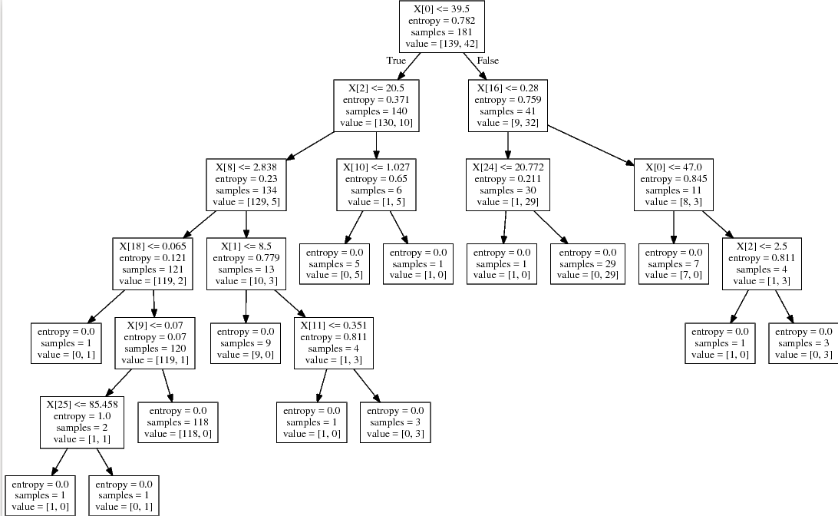
Figure 5: Visual representation of the decision tree generated by the program coded by us in Python, using scikit-learn libraries. Here, no feature selection or Z-score normalization was performed before the training.
As it is possible to see in the decision tree of Figure 5, that the first attribute to split is the attribute (0), the number of times a player starts playing a match, as it was stated earlier in the section II. Realize that CART does no pruning with our current configuration of the algorithm.
The other attributes which were chosen to split the nodes were from the top to the leaves:
- attribute (2), number of goals;
- attribute (16), average times he blocked a shot per game;
- attribute (8), average shots in the goal per game;
- attribute (10), average number of tackles per game;
- attribute (24), average number of passes per game;
- attribute (18), average number of keypasses per game;
- attribute (1), number of times the player came in from the bench;
- attribute (9), average aerial duels won per game;
- attribute (11), average number of pass interceptions per game;
- attribute (25), percentage of successful pass per game.
By using only SelectKBest as a preprocessing method, we decided to try different values of k, but specifically values around 11. That’s because in experiment without any preprocessing method, there were chosen only 11 attributes to split the nodes. So there’s no reason to set k as high as, 25 for example.
Firstly we will analyze the results coming from setting the parameter chi2(Chi-square) for the SelectKBest. For k=5,6,7,8 we had accuracy lower than the previous CART experiment,fluctuating around 65%. For k ≥ 15, we still had a decrease in the accuracy in comparison to the previous CART experiment, where it fluctuates around 68%. For k=9,10,11,12,13 and 14 the accuracy were equal or higher to 70%. But the best accuracy in the testing we got with k=13, where the results are below:
* Correctly Classified Instances = 80.77 %
m=52 | Classified as “Yes” | Classified as “No”
Actual “Yes” | 18 | 8
Actual “No” | 2 | 24
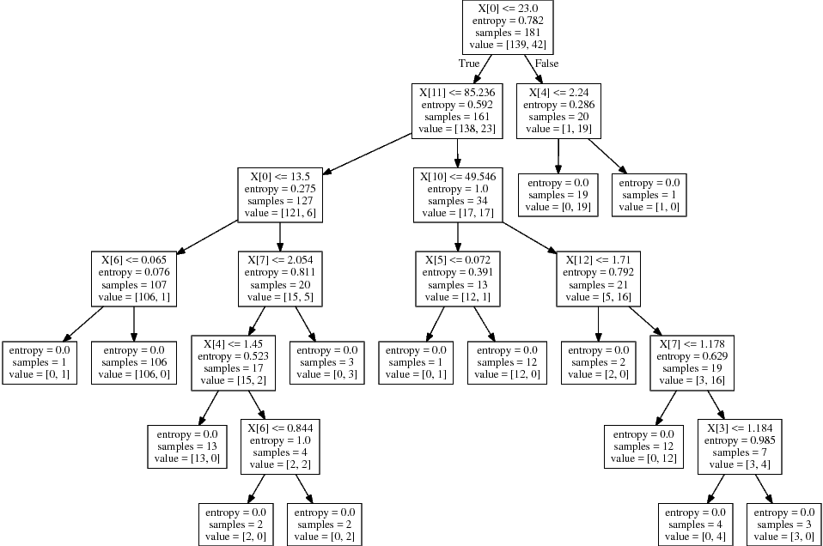
Figure 6: Visual representation of the decision tree generated by the program coded by us in Python, using scikit-learn libraries. Here, only feature selection using chi-squared function to calculate the score of each attribute was used. Here k=13 for the feature selection function SelectKBest.
When using f_classif as parameter for SelectKBest, we managed to get worser results than with chi2. Actually, even worser than the first CART experiment. The accuracy fluctuated around from 61% for any value of k. The best result we got was for k=13:

* Correctly Classified Instances = 67.31 %
m=52 | Classified as “Yes” | Classified as “No”
Actual “Yes” | 11 | 15
Actual “No” | 2 | 24
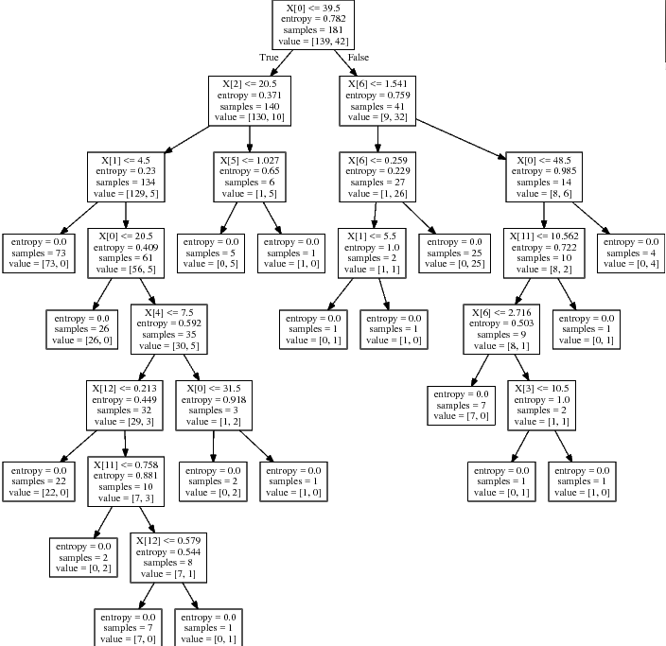

Figure 7: Visual representation of the decision tree generated by the program coded by us in Python, using scikit-learn libraries. Here, only feature selection using ANOVA F-value to calculate the score of each attribute was used. Here k=13 for the feature selection function SelectKBest.
Finally, we did the experiment where we applied Z-score normalization before SelectKBest. However the results were very disappointing, for most values of k the accuracy in the testing set were 50.0%. The best we got was for k=12:
* Correctly Classified Instances = 51.92 %
m=52 | Classified as “Yes” | Classified as “No”
Actual “Yes” | 26 | 0
Actual “No” | 25 | 1
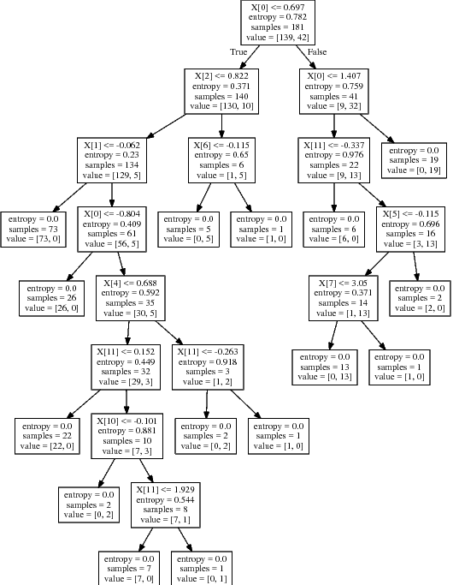

Figure 8: Visual representation of the decision tree generated by the program coded by us in Python, using scikit-learn libraries. Here, Z-score normalization was applied in the data set before applying feature selection, which used ANOVA F-value to calculate the score of each attribute was used. Here k=12 for the feature selection function SelectKBest.
Again, like in the previous OneR experiment with Z-score normalization, the generated model was good to predict true positives, all the 26 instances in this case, but failed badly to predict true negatives, only 1. For the other values of k, they could not get a single one true negative.
About Weka, we chose to use the J48 algorithm to produce decision trees, because it is based on C4.5 has some similarities to CART. In order to make it more similar to CART, we turned on the parameter Unpruned, since CART does not prune its tree too.
So without using any sort of preprocessing method of Weka, we set the default parameters of J48 and we got the following result:
* Correctly Classified Instances = 71.15 %
m=52 | Classified as “Yes” | Classified as “No”
Actual “Yes” | 11 | 15
Actual “No” | 0 | 26

Goals <= 22
| Apps <= 41
| | Assists <= 8
| | | Red <= 0: No
| | | Red > 0
| | | | Goals <= 11: No
| | | | Goals > 11
| | | | | Apps <= 30: Yes
| | | | | Apps > 30: No
| | Assists > 8
| | | SpG <= 2.9
| | | | TB <= 0.6: No
| | | | TB > 0.6: Yes
| | | SpG > 2.9: Yes
| Apps > 41
| | OffWon <= 0.641463
| | | BlkShots <= 2.04: Yes
| | | BlkShots > 2.04: No
| | OffWon > 0.641463: No
Goals > 22: Yes
Figure 9: Visual representation of the decision tree generated by Weka J48. Here, there was no feature selection nor normalization.
As it is possible to see from the confusion matrix above, J48 ,like the decision trees given by our program, is good to predict true negatives and struggles to classify correctly true positives.
By applying the filter Standardize before running J48, we got similar results of our program when we applied Z-score normalization in the training data:
* Correctly Classified Instances = 53.85 %
m=52 | Classified as “Yes” | Classified as “No”
Actual “Yes” | 26 | 0
Actual “No” | 24 | 2

Goals <= 0.935882
| Apps <= 0.812868
| | Assists <= 0.446482
| | | Red <= -0.503933: No
| | | Red > -0.503933
| | | | Trn <= -0.161462: No
| | | | Trn > -0.161462: Yes
| | Assists > 0.446482
| | | SpG <= -0.102306
| | | | TB <= 2.025302: No
| | | | TB > 2.025302: Yes
| | | SpG > -0.102306: Yes
| Apps > 0.812868
| | OffWon <= -0.086301
| | | BlkShots <= -0.066309: Yes
| | | BlkShots > -0.066309: No
| | OffWon > -0.086301: No
Goals > 0.935882: Yes
Figure 10: Visual representation of the decision tree generated by Weka J48. Here, only Z-score normalization was applied in the training data
One important thing to notice in both trees generated by Weka is that the attribute which was chosen to be the root of the decision trees were the number of goals, attribute (2).
The other attributes which were chosen to split the nodes were from the top to the bottom leaves are:
-Apps: attribute (0), number of times a player started playing a match;
-Assists: attribute (3), total number of assists;
-Red: attribute (7), number of red cards received;
-Trn: attribute (23), average number of times he lost the ball – turn overs;
-SpG: attribute (8), average number of shots in the goal per game;
-OffWon: attribute (13), average number of times he won an offside per game;
-BlkShots: attribute (16), average times a player blocked a shot per game;
That is, being able to classify the training data almost perfectly, but nothing else because instead of learning the underlying concept, the tree has learned the properties intrinsic and specific to the training data.

IV. Logistic Regression
Firstly we will present the classifiers generated by Logistic Regression with no type of preprocessing. In comparison to OneR classifier with no type of preprocessing, this performed slightly better:
* Correctly Classified Instances = 76.92 %
m=52 | Classified as “Yes” | Classified as “No”
Actual “Yes” | 15 | 11
Actual “No” | 1 | 25

Here below are the weights θ_{i} of each attribute i from the obtained hypothesis function:
Apps,attribute (0): -0.0896512579183
SubIn,attribute (1): -0.213789836045
Goals,attribute (2): 0.124552431694
Assists,attribute (3): 0.252873708623
AverageGoalspermatch,attribute (4):-0.044132979153
AverageAssistspermatch,attribute (5):-.0495894673716
Yellow,attribute (6): 0.0542204850821
Red,attribute (7): 0.0170118179154
SpG,attribute (8): -0.00115065975868
AW,attribute (9): -0.0222022168281
Tackle,attribute (10): -0.125403971544
Int,attribute (11): -0.233378868554
Fouls,attribute (12): -0.127731974841
OffWon,attribute (13): 0.0518291587652
Clr,attribute (14): -0.14279934855
WasDribbled,attribute (15): -0.177817918935
BlkShots,attribute (16): -0.0472284139999
OG,attribute (17): -0.0379192704386
KeyPasses,attribute (18): -0.246934474823
Dribbles,attribute (19): -0.0558734777214
Fouled,attribute (20): 0.0704385343643
Offs,attribute (21): -0.0190723253703
Disp,attribute (22): 0.00787598410165
Trn,attribute (23): -0.0112693476882
Avg.Passes,attribute (24): 0.0152446752573
PassSuc%,attribute (25): -5.0585247178e-05
Crosses,attribute (26): -0.203654178301
LB,attribute (27): 0.257716874307
TB,attribute (28): 0.0408887908759
That was the first experiment among all Machine Learning algorithms without using any type of preprocessing where it performed relatively well in predicting for both true positives and true negatives. It could correctly classify 25 out of 26 true negatives correctly and more than half of the true positives, 15.
In relation to the weights of the attributes, it is possible to see that the attribute with the largest value of weight θ_{i} was attribute (27) LB, the average number of accurate long passes. Then, that is closed followed by attribute (3) Assists and by attribute (2) Goals. At 4th place we have the attribute (20) Fouled, the average number of times a player is fouled per match. At 5th place we have the attribute (6) Yellow, the total number of yellow card a player received in a season.
Then we decided to use only the feature selection method SelectKBest to see if the performance would improve even more. Unfortunately the accuracy in the testing set for several values of k decreased to around 70% for the parameter f_classif.
For higher values of k like k≥12 the accuracy was better, around the same of the first Logistic Regression experiment, 76%. The best result we found was for k=13 using f_classif as parameter for SelectKBest:
* Correctly Classified Instances = 78.85 %
m=52 | Classified as “Yes” | Classified as “No”
Actual “Yes” | 15 | 11
Actual “No” | 0 | 26

Here we see that there was a slight improvement in the performance since now it could predict perfectly all the true negatives. The performance to detect true positive remained the same though, which at least classify more than half of the nominees correctly.
Here below are the selected attributes and their respective weights θ_{i} from the obtained hypothesis function:
Apps,attribute (0): 0.0111982316675
SubIn,attribute (1): -0.0929594156751
Goals,attribute (2): 0.0996933242685
Assists,attribute (3): 0.192223983619
AverageAssistspermatch,attribute(5):0.70660587160
Yellow,attribute (6): 0.0869674209114
SpG,attribute (8): -0.00039233514483
AW,attribute (9): -0.0014341502202
Fouls,attribute (12): -0.00149380563039
Offs,attribute (21): 0.0093501369622
Disp,attribute (22): 0.00105222885208
LB,attribute (27): 0.00114216070071
TB,attribute (28): 0.00984643565113
It is possible to see that the attribute with the largest value of weight θ_{i} was attribute (3) Assists. Then, it is followed by attribute (2) Goals . At 3rd place we have the attribute (0) Apps, the total number of times a player started playing a match. At 4th place we have the attribute (28) TB, the average number of accurate through ball passes.
By changing the parameter to chi2, the classifiers had a worser performance than with the parameter f_classif. Another detail that we realized was that for very small k like k=5,6,7,8 the accuracy dropped to around 55%.The values fluctuated around 70% to 75% for high values like k≥10 though.
By applying Z-score normalization before the feature selection, we have realized that the performance of Logistic Regression dropped even more. For most values of k, the accuracy remained 50% and stabilized around it. Here are the results for k=10:
* Correctly Classified Instances = 51.92 %
m=52 | Classified as “Yes” | Classified as “No”
Actual “Yes” | 26 | 0
Actual “No” | 25 | 1

It is possible to see that the performance to detect true positives for k=10 greatly increased, having a flawless performance. But the classifier could not detect true negatives anymore, only detecting 1 of them. For other smaller values of k, the classifier could not even detect a single true negative.
Here below are the selected attributes and their respective weights θ_{i} from the obtained hypothesis function:
Apps,attribute (0): 1.45382002462
Goals,attribute (2): 1.32574403033
Assists,attribute (3): 0.752794826885
Yellow,attribute (6): 0.51169220902
SpG,attribute (8): -0.0202936708261
AW,attribute (9): 0.160291411787
Fouls,attribute (12): 0.190964883888
Offs,attribute (21): 0.35479468468
LB,attribute (27): 0.497315968041
TB,attribute (28): -0.0813653864442
It is possible to see that the attribute with the largest value of weight θ_{i} was attribute (0) Apps. Then, it is followed by attribute (2) Goals . At 3rd place we have the attribute (3) Assists. At 4th place we have the attribute (27) LB, the average number of accurate long passes. At 5th and with a value very close to the 4th comes the attribute (21) Offs, the average times a player is caught offside. Using Z-score normalization it is clear to see that the weight of the selected attributes are just higher overall in comparison with the weights obtained in previous Logistic Regression Experiments.

Support Vector Machines
The most disappointing performance came from SVM since it was supposed to be a more powerful Machine Learning algorithm than the other ones. We were expecting a better accuracy than all the previous experiments with the other algorithms.
Here are the results when not applying any sort of preprocessing method:
* Correctly Classified Instances = 71.15 %
m=52 | Classified as “Yes” | Classified as “No”
Actual “Yes” | 11 | 15
Actual “No” | 0 | 26

Apps,attribute (0): 0.0691666460651
SubIn,attribute (1): 0.0372047861213
Goals,attribute (2): 0.0746694439984
Assists,attribute (3): 0.130409558566
AverageGoalspermatch,attribute(4):-0.0257449362893
AverageAssistspermatch,attribute(5):-0.150991421621
Yellow,attribute (6): -0.0016515270002
Red,attribute (7): -0.0389464619581
SpG,attribute (8): -0.000560025090302
AW,attribute (9): 0.0931713095751
Tackle,attribute (10): -0.261224217197
Int,attribute (11): -0.892310084742
Fouls,attribute (12): -0.0345770328897
OffWon,attribute (13): 0.0800112926712
Clr,attribute (14): 0.0401774928635
WasDribbled,attribute (15): -0.662987773041
BlkShots,attribute (16): 0.380578923743
OG,attribute (17): -0.285385088073
KeyPasses,attribute (18): -0.544282754791
Dribbles,attribute (19): -0.158342815635
Fouled,attribute (20): 0.340399629064
Offs,attribute (21): -0.816133377578
Disp,attribute (22): -0.0857702135888
Trn,attribute (23): -0.0747773595098
Avg.Passes,attribute (24): 0.0421985638021
PassSuc%,attribute (25): 1.57686866942e-06
Crosses,attribute (26): -0.319002176927
LB,attribute (27): 0.168812078952
TB,attribute (28): 0.52579820497
According to the values of the 5 largest coefficients, the most relevant attributes are in this order: attribute (28), attribute (16),attribute (20),attribute (27) and attribute (3).
The accuracy in the testing set was decent but was no better than Logistic Regression and was equal to Decision Trees algorithm. The classifier has similar characteristics than the previous ones like the Decision Trees: good in predicting true negatives but not good in predicting true positives.
By applying feature selection with f_classif we have realized that the performance improved slightly, but that happened only for certain values of k. The accuracy for k=1,2 was 55.77%,53.85%,respectively. For the rest of the values of k, the performance remained the same as the first SVM experiment. Here below are the results for k=2 using f_classif as parameter for the method SelectKBest:

* Correctly Classified Instances = 69.23 %
m=52 | Classified as “Yes” | Classified as “No”
Actual “Yes” | 10 | 16
Actual “No” | 0 | 26

By exchanging the parameter to chi2, the results remained the same of the first SVM experiment for most of values of k. But for some very small values of k like k=5,6 the accuracy dropped to less than half: 48,07%. Here below are the results for k=5:
* Correctly Classified Instances = 48.08 %
m=52 | Classified as “Yes” | Classified as “No”
Actual “Yes” | 0 | 26
Actual “No” | 1 | 25

It is astounding that it could misclassify only a single instance from the testing set as a “Ballon d’Or nominee” when it actually was not. That misclassification made the accuracy drop to less than 50.00% otherwise it would repeat the same performance of previous SVM experiments where it could correctly guess only the true negatives.
An interesting behavior happens to the generated SVM classifiers when it is applied Z-score normalization before the feature selection. For k≥8, the results remained the same as the first SVM experience. But for k=2,3,4,5,6,7, the classifier had a perfect performance to detect true positives as it shows the results below(for k=2):
* Correctly Classified Instances = 50.00 %
m=52 | Classified as “Yes” | Classified as “No”
Actual “Yes” | 26 | 0
Actual “No” | 26 | 0

For k=1, the results were equal to the SVM experiment with only feature selection using chi2 , that is, an accuracy of 48.07%.

Conclusion
This research obtained several classifiers by using 5 Machine Learning methods, that is, ZeroR, OneR,CART(decision tree),Logistic Regression and Support Vector Machines in order to get a new insight about the players who are nominated for Ballon d’Or award every year.
We obtained common-sense rules and surprisingly unexpected rules. That was interesting because it involved some discussion in preconceived concepts and ideas regarding the modern football like the prominence of a player in a team, being a regular starting XI in order to increase his chances to be nominated Ballon d’Or for example, according to OneR and Decision Trees results.
Unfortunately, the powerful algorithms like Support Vector Machine didn’t perform well probably because of the problem of having so few instances in the training set to build the model. That is a limitation that needs to be overcome for the next researches, plus a data cleaning to assure that no noise is in the data set, since the risk of occurring mistakes by copying and writing manually the numerical values from diverse sports websites.

References
- FIFA. FIFA Survey: approximately 250 million footballers worldwide, 2000. Available from: http://www.fifa.com/aboutfifa/organisation/news/newsid=88048/index.html [Retrieved 2018-30-06].
- 2016 Ballon D’Or. Available from: https://en.wikipedia.org/wiki/2016_Ballon_d%27Or [Retrieved 2018-30-06]
- B. Wang and L. Wang, Research of Association Rules in Analyzing Technique of Football Match, presented at Second International Conference on Power Electronics and Intelligent Transportation Systems, 178-180, 2009.

- R. Agrawal and R. Srikant, Fast Algorithms For Mining Association Rules, presented at 20th VLDB Conference,487-499, 1995.
- B. Chai, Time Series Data Mining Implemented on Football Match, Applied Mechanics and Materials, vol. 26-28, pp. 98-103, 2010.
- S. Nunes and M. Sousa, Applying Data Mining Techniques to Football Data from European Championships, presented at Conferência de Metodologias de Investigação Científica (CoMIC'06), 4-16, 2006.
- Weka 3 - Data Mining with Open Source Machine Learning Software in Java. Available from: http://www.cs.waikato.ac.nz/ml/weka/ [Retrieved 2014-11-08].
- J. R. Quinlan, "Induction of Decision Trees, pp 81-106”,1986.
- 1.10. Decision Trees. Available from: http://scikit-learn.org/stable/modules/tree.html#tree-algorithms-id3-c4-5-c5-0-and-cart [Retrieved 2018-30-06]

