*Recruitment Console API*

Overview

The Recruitment console APIs are organized around REST. Each API requires authentication and returns a JSON response.

REST APIs

A REST API is an application programming interface (API or web API) that conforms to the constraints of REST architectural style and allows for interaction with RESTful web services.

Pagination

All APIs that include listings have pagination. By default, it returns all items on the list. The response header indicates the total list count and its page size. Must have: URL for the "next" or "previous" page.

Context

|  |  |  |
| --- | --- | --- |
| ***S.NO*** | ***Description*** | ***Page No*** |
| 1 | Add New Users | 2 |
| 2 | Edit the User Profile | 3 |
| 3 | Delete the User Profile | 4 |
| 4 | List the User Profile | 5 |
| 5 | Upload New Resumes | 6 |
| 6 | Pagination | 7 |
| 7 | Search and filter | 8 |
| 8 | User Login |  |

**Add New Users:**

To create a new users/recruiters

**HTTP Request:**

<http://127.0.0.1:8000/api/recruiter>

**HTTP Response:**

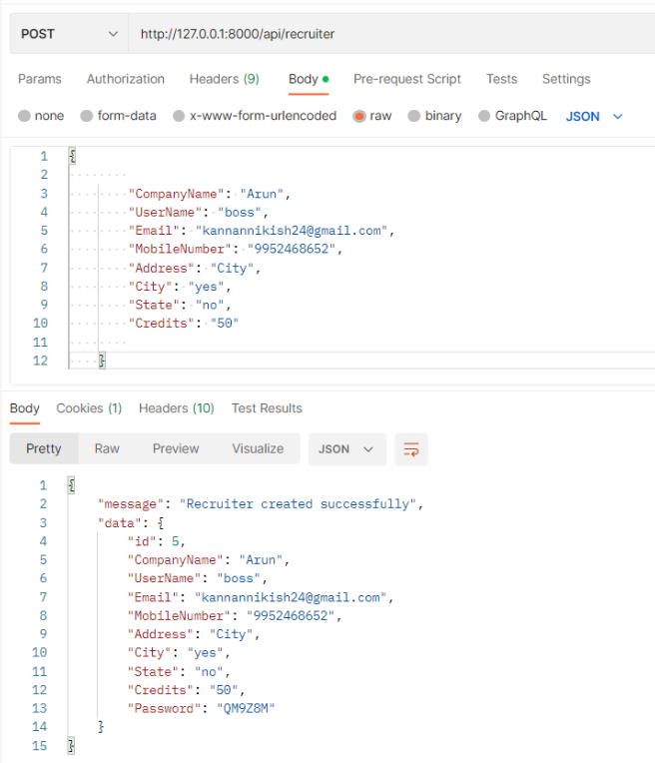

**Edit the User profile:**

To update the user/recruiter details

**HTTP Request:**

<http://127.0.0.1:8000/api/recruiter>/<user _id>

**HTTP Response:**

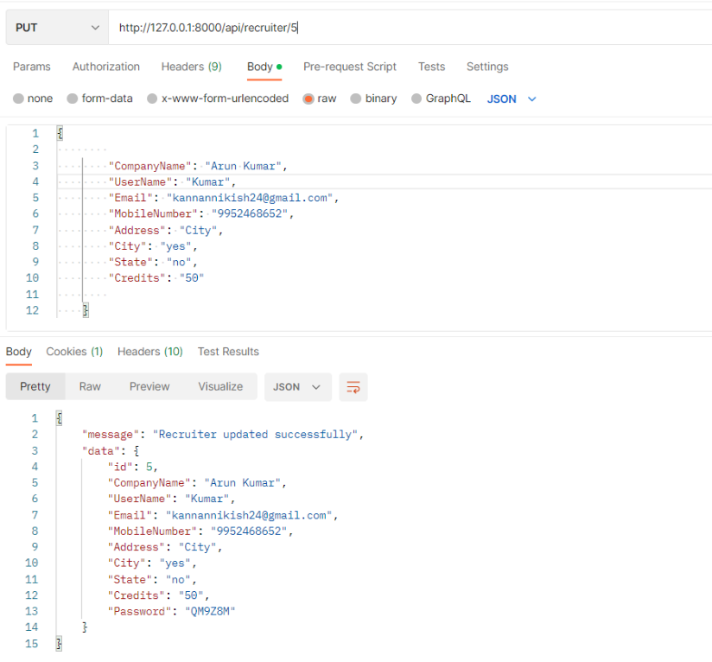

**Delete the user profile:**

To delete the user/recruiter profile

**HTTP Request:**

<http://127.0.0.1:8000/api/recruiter>/<user _id>

**HTTP Response:**

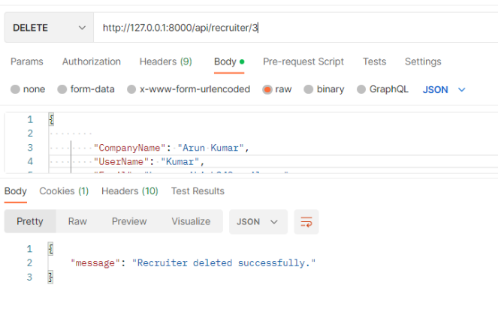

**List the user profile:**

To retrieve all users/recruiters profile

**HTTP Request:**

<http://127.0.0.1:8000/api/recruiter>

**HTTP Response:**

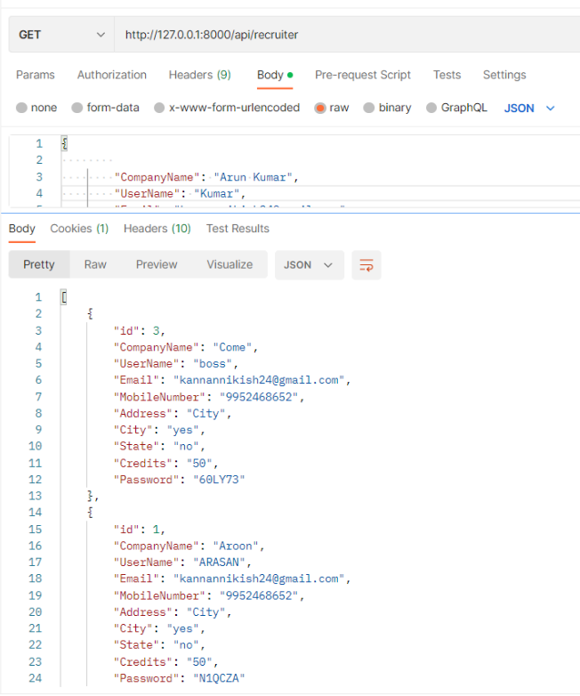

**Upload New Resumes:**

To upload the new resumes with the tags

**HTTP Request:**

<http://127.0.0.1:8000/api/file/upload>

**HTTP Response:**

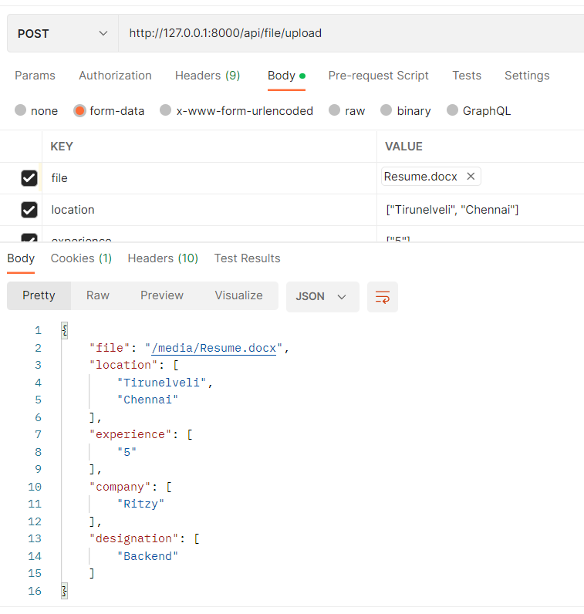

**Pagination:**

User search resumes by their requirement with the help of tags.

**HTTP Request:**

http://127.0.0.1:8000/api/admin?limit=1&offset=5

**HTTP Response:**

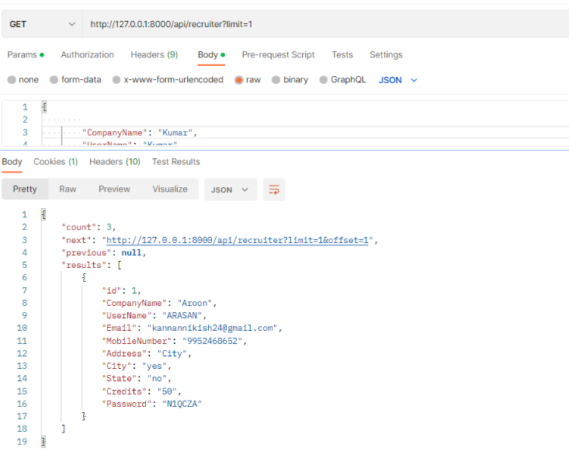

**Search and filter:**

**HTTP Request:**

<http://127.0.0.1:8000/api/recruiter?search=a>

**HTTP Response:**

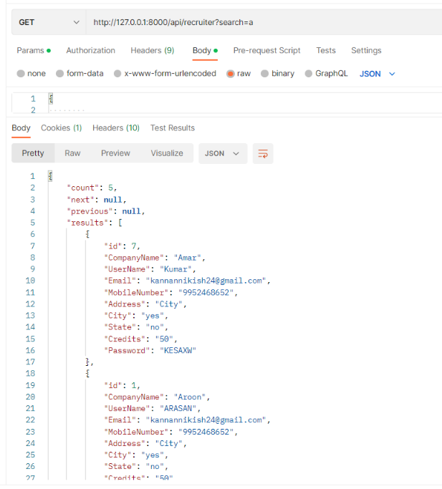

User Login :

Users Login with their Email ID and Password

**HTTP Request:**

<http://127.0.0.1:8000/api/login>

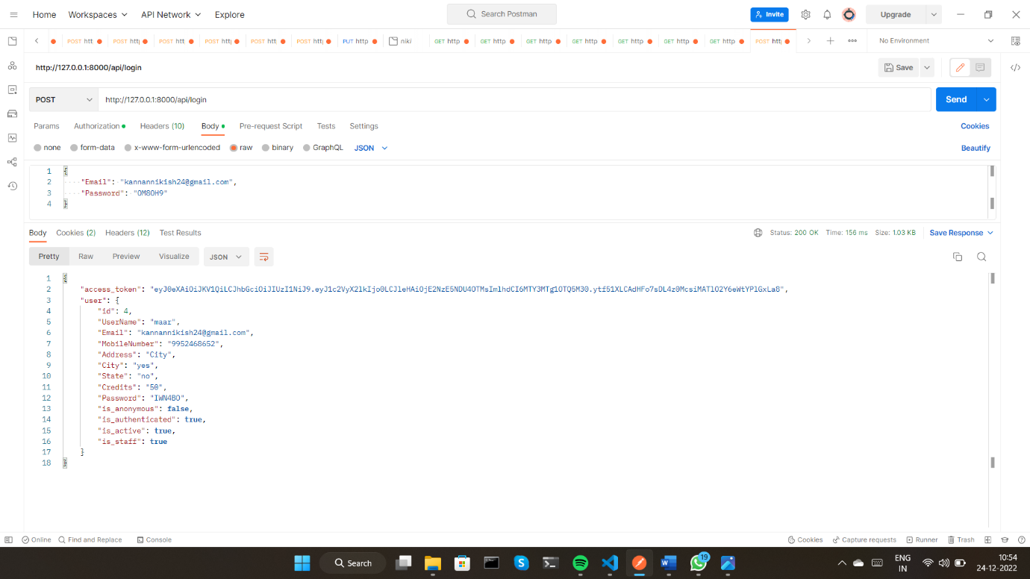

Recruiter Login :

Recruiters Login with their Email ID and password

**HTTP Request:**

<http://127.0.0.1:8000/api/userlogin>

**HTTP Response:**

