*Recruitment Console API*

Overview

The Recruitment console APIs are organized around REST. Each API requires authentication and returns a JSON response.

REST APIs

A REST API is an application programming interface (API or web API) that conforms to the constraints of REST architectural style and allows for interaction with RESTful web services.

Pagination

All APIs that include listings have pagination. By default, it returns all items on the list. The response header indicates the total list count and its page size. Must have: URL for the "next" or "previous" page.

Context

|  |  |  |
| --- | --- | --- |
| ***S.NO*** | ***Description*** | ***Page No*** |
| 1 | Add New Admin | 2 |
| 2 | Edit the User Profile | 3 |
| 3 | Delete the User Profile | 4 |
| 4 | List the User Profile | 5 |
| 5 | Upload New Resumes | 6 |
| 6 | Pagination | 7 |
| 7 | Search and filter | 8 |
| 8 | User Login | 10 |

Admin Login :

Admin Login with their Email ID and Password

**HTTP Request:**

<http://127.0.0.1:8000/api/login>

**HTTP Response:**

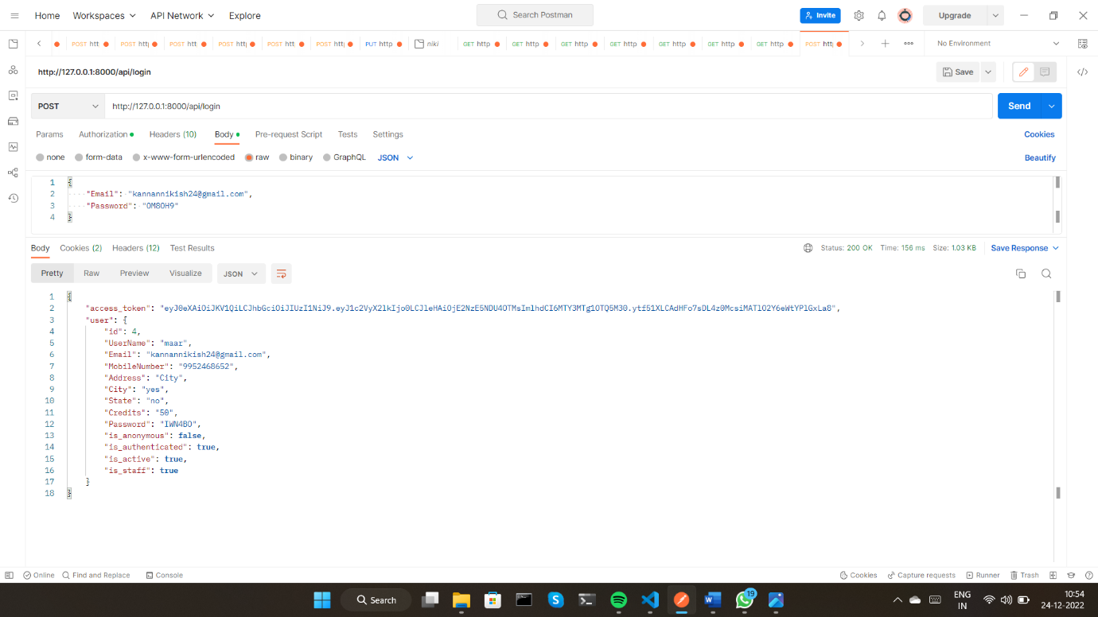

**Add New Admin:**

To create a new Admin

**HTTP Request:**

<http://127.0.0.1:8000/api/>admin

**HTTP Response:**

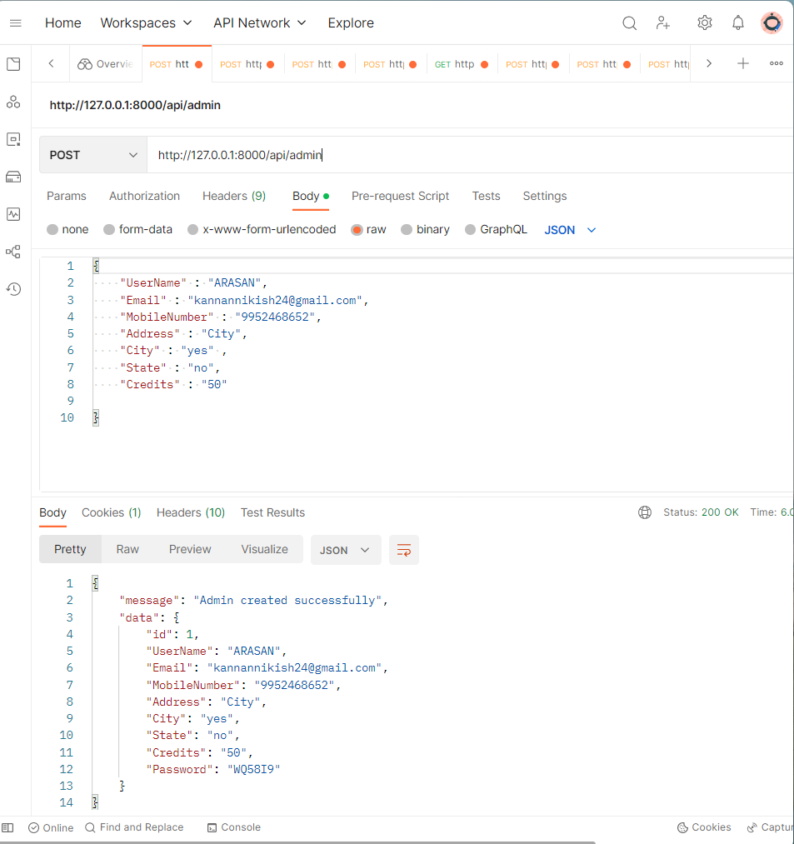

**List the Admin profile:**

To retrieve all admin profile

**HTTP Request:**

<http://127.0.0.1:8000/api/adimin>

**HTTP Response:**

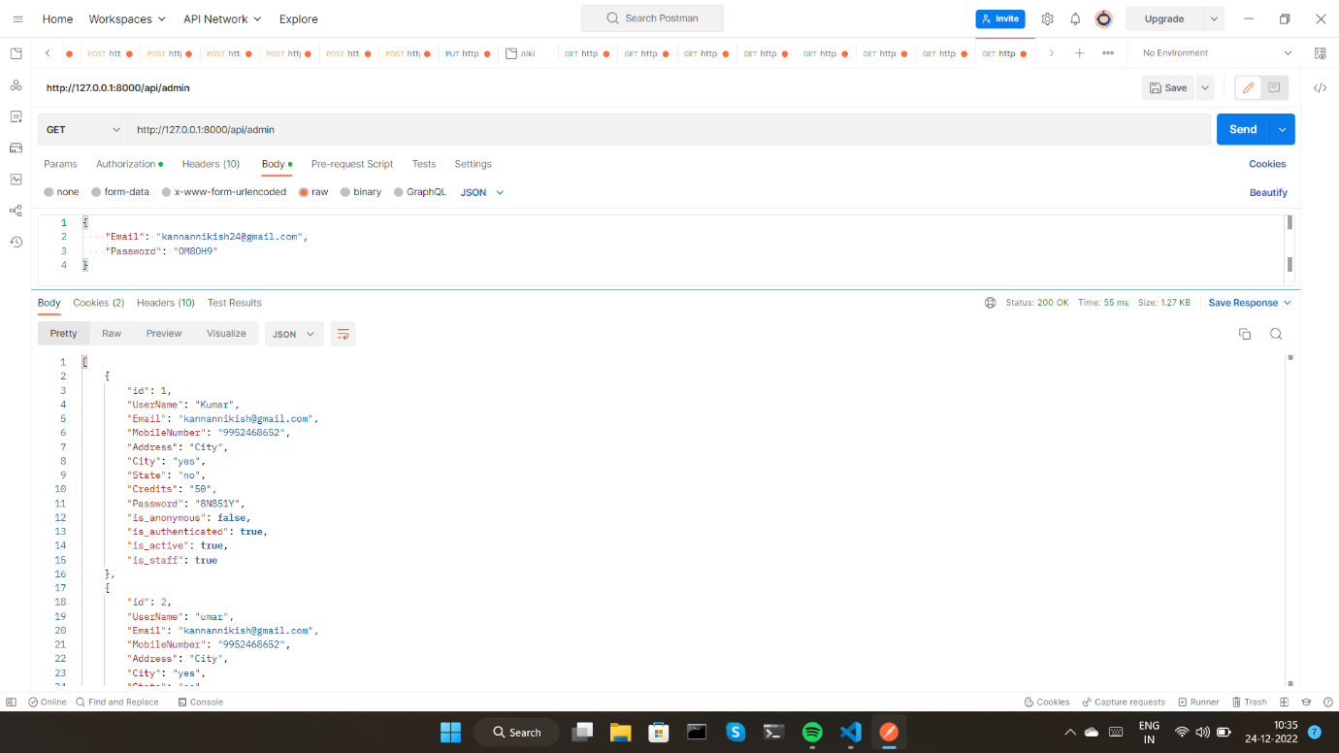

**Edit the admin profile:**

To update the admin details

**HTTP Request:**

[http://127.0.0.1:8000/api/](http://127.0.0.1:8000/api/recruiter)admin/<user _id>

**HTTP Response:**

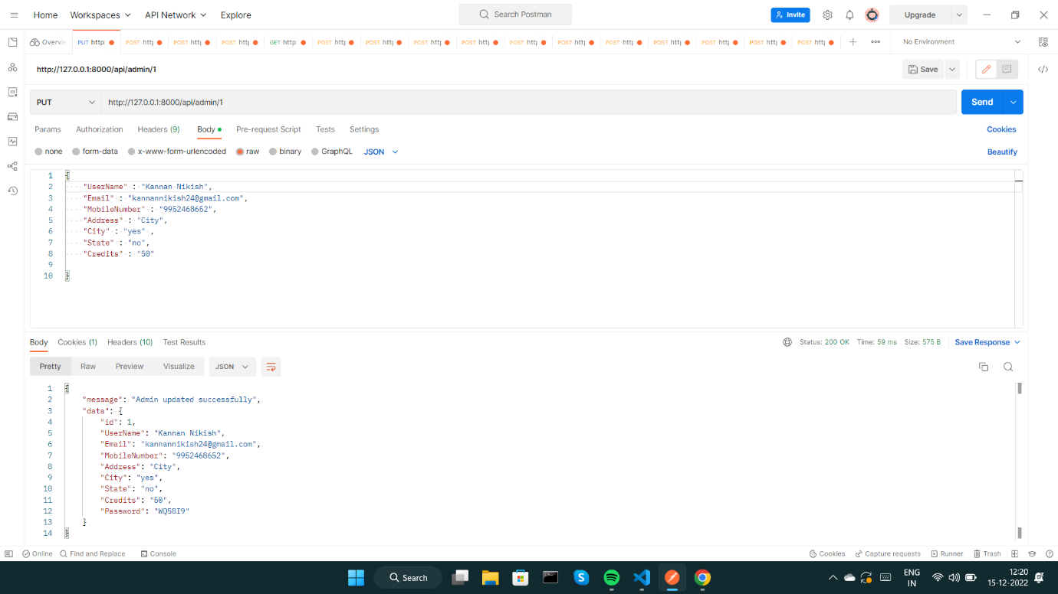

**Delete the admin profile:**

To delete the admin profile

**HTTP Request:**

<http://127.0.0.1:8000/api/admin>/<user _id>

**HTTP Response:**

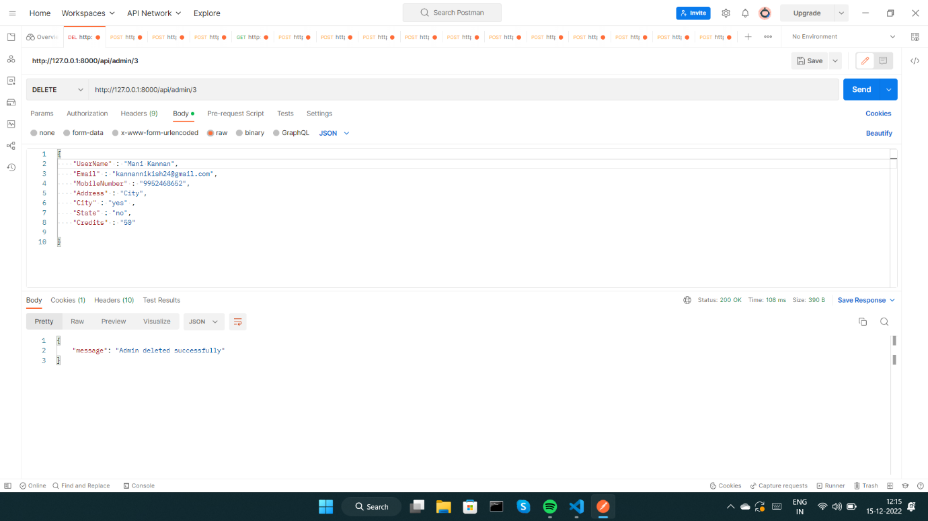

Recruiter Login :

Recruiter Login with their Email ID and Password

**HTTP Request:**

<http://127.0.0.1:8000/api/userlogin>

**HTTP Response:**

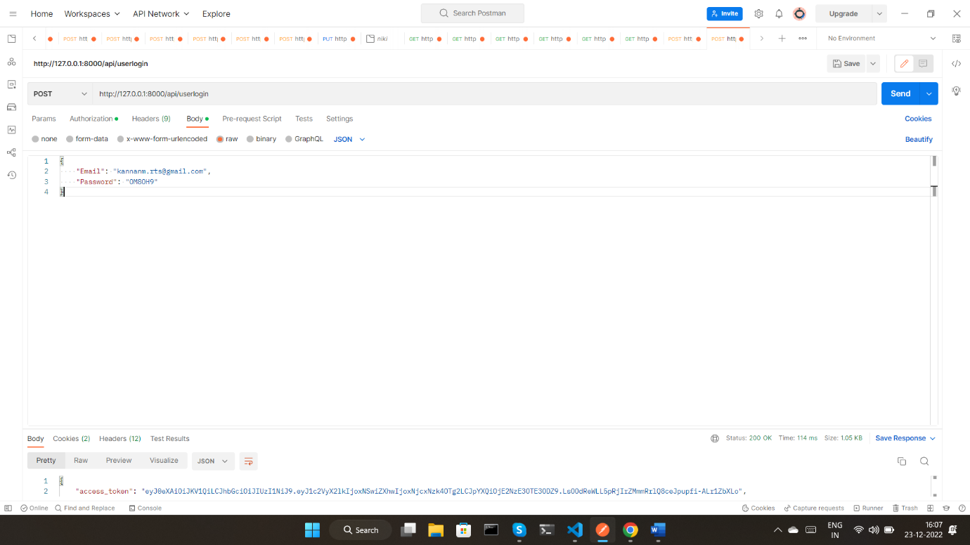

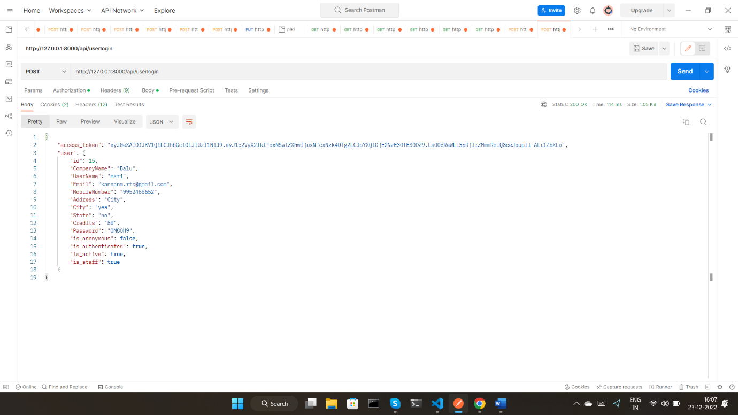

**Add New Recruiter:**

To create a new Recruiter

**HTTP Request:**

<http://127.0.0.1:8000/api/>recruiter

**HTTP Response:**

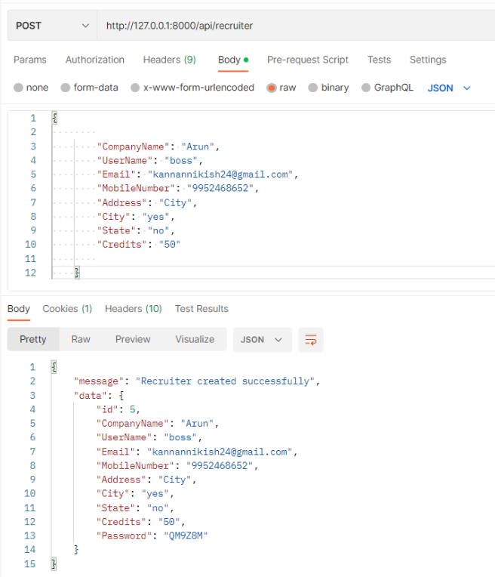

**List the user profile:**

To retrieve all users/recruiters profile

**HTTP Request:**

<http://127.0.0.1:8000/api/recruiter>

**HTTP Response:**

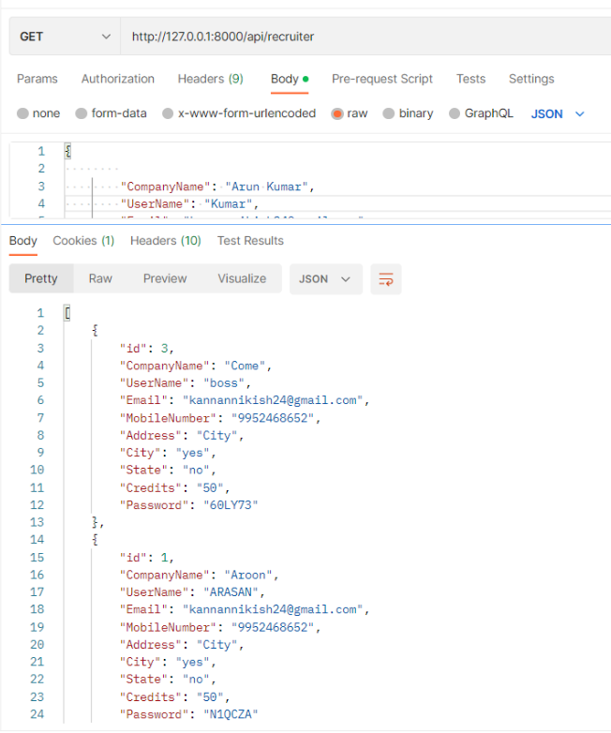

**Edit the User profile:**

To update the user/recruiter details

**HTTP Request:**

<http://127.0.0.1:8000/api/recruiter>/<user _id>

**HTTP Response:**

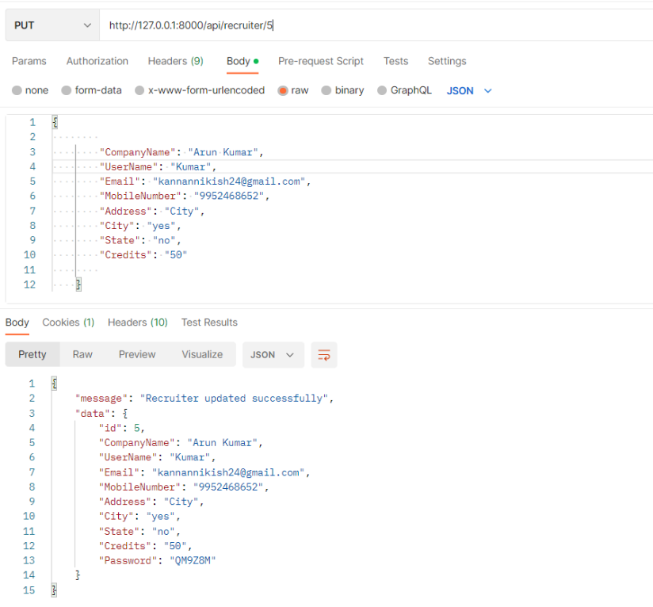

**Delete the user profile:**

To delete the user/recruiter profile

**HTTP Request:**

<http://127.0.0.1:8000/api/recruiter>/<user _id>

**HTTP Response:**

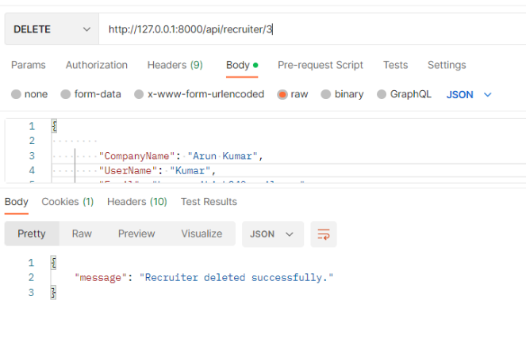

**Search and filter:**

User search resumes by their requirement with the help of tags.

**HTTP Request:**

<http://127.0.0.1:8000/api/recruiter?search=a>

**HTTP Response:**

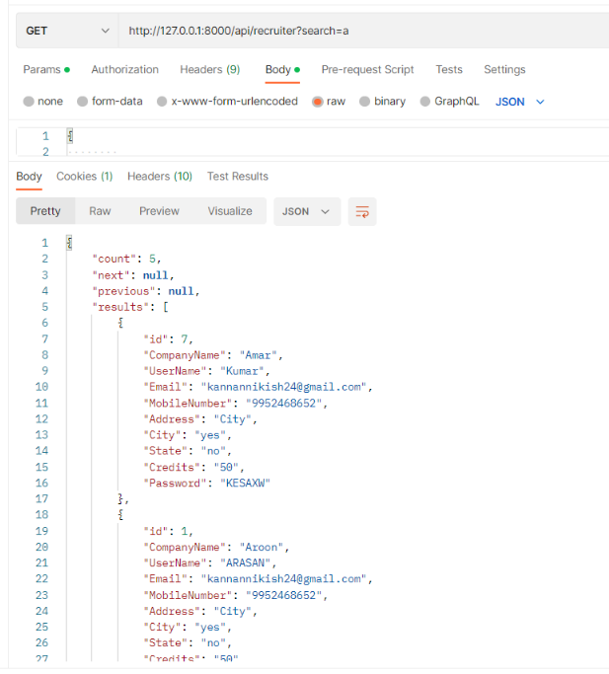

**Pagination:**

**HTTP Request:**

http://127.0.0.1:8000/api/admin?limit=1&offset=5

**HTTP Response:**

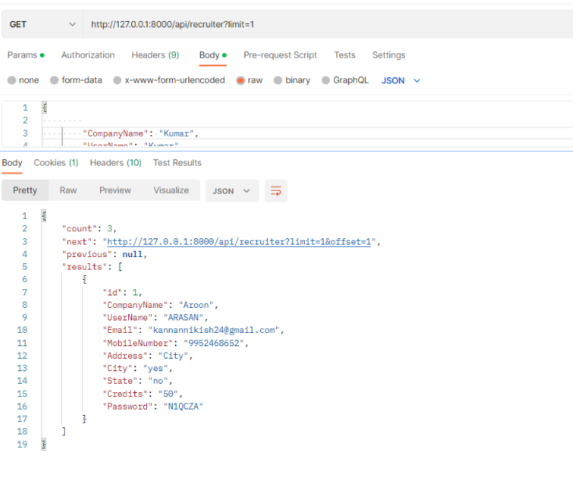

**Upload New Resumes:**

To upload the new resumes with the tags

**HTTP Request:**

<http://127.0.0.1:8000/api/file/upload>

**HTTP Response:**

