## **Ritzy Technewell Solution**

# **Employee Leave Form**

DATE: 15/12/2022

**Employee Name : Kannan.M**

**Reg No : -**

**Role of Designation : Developer**

**Leave Date: : 16/12/2022**

**Total Days : 1**

**Reason for leave : personel(going to hospital)**

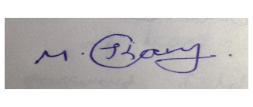

**Employee Signature**

Description:

After you submit all of the details here. You should mail this form to your HR And the CEO in the official Email id.

**CEO & Founder**: vanaraj@ritzyts.com

**HR Manager:** knagaraja.rts@gmail.com