## **Ritzy Technewell Solution**

# **Employee Permission Form**

DATE: 04.04.2023

**Employee Name :** Kannan.M

**Reg No :** -

**Role of Designation :** Frontend Developer

**TIME :** 2.30 P.M-6.30 P.M

**Reason :** personal (going to temple)

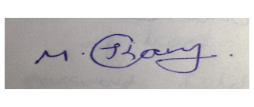

**Employee signature**

**Description**:

After you submit all of the details here. You should mail this form to your HR And the CEO in the official Email id.

This letter is not valid without **digital signature.**