Table of Contents
Hardware 1
Hardware Updates 2
Firmware Upgrade 3
Boot Sequence 8
ipq40xx: add support for the ASUS RT-AC58U / RT-ACRH13 10
LEDE- 13
How to flash LEDE firmware 14
Preface 14
LEDE flashing instructions 14
Method 1 (manual, 2 steps) 14
Method 2 (automatic) 14
Method 3 (with USB-UART cable) 14
Closing remarks. 14
Restoring stock (factory) firmware 15
ASUS Rescue Mode 15

Hardware
Here is an image of the ASUS-RT-AC58U board with the heatsink removed.
Image from http://www.tech-blog.pl/pliki/asus_rt-ac58u_1.jpg

Here is a close-up of the serial connector showing the signal names for the four connectors.

Hardware Updates
Here is an image of the ASUS RT-AC58U with the Adafruit serial cable connected.
Image by rtsmith134@gmail.com

ASUS Stock Firmware

The stock firmware and firmware source can be obtained from ASUS at https://www.asus.com/Networking/RT-AC58U/HelpDesk_Download/

Click the Drivers & Tools tab and then in Please select OS choose others.
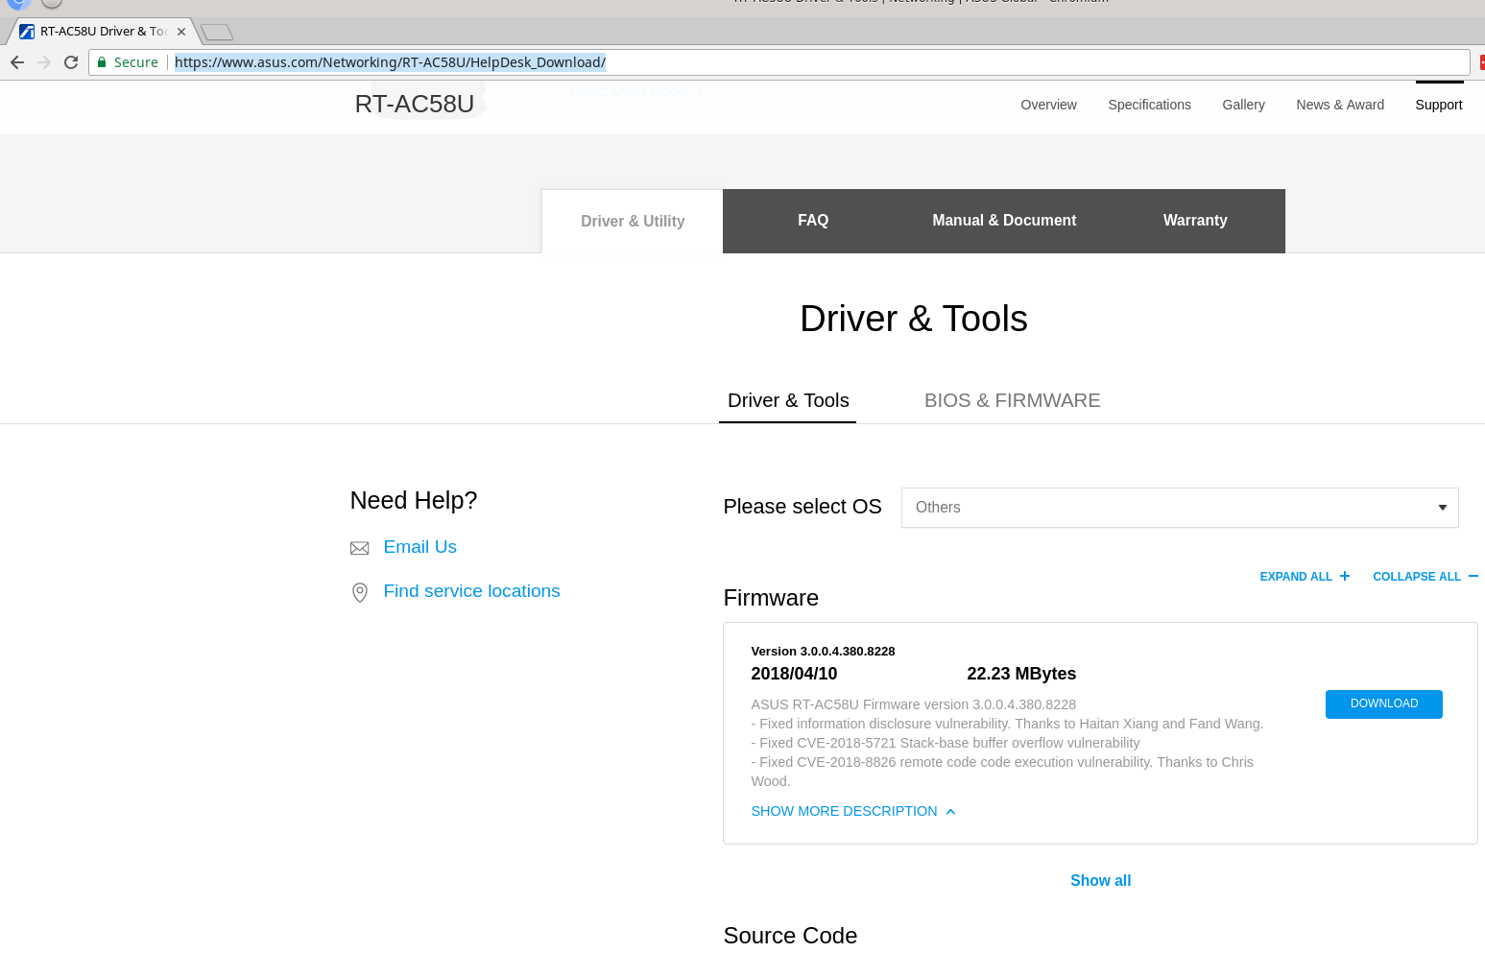

Firmware Upgrade
Here is a section of the Firmware Upgrade page on the ASUS RT-AC58U.
2017.09.27.asus_screen.jpg. Image by rtsmith134@gmail.com

This image shows where you can manually select a file and then you press the “Upload” button.
2017.09.27.Firmware_Upgrade_1.jpg. Image by rtsmith134@gmail.com

The code for the image above can be found in Advanced_FirmwareUpgrade_Contents.asp. “FW_item5” and “CTL_upload” come from English dictionary file “EN.dict”. Other languages have their own files.
<tr style="display:none;">
<th><#FW_item5#></th>
<td><input type="file" name="file" class="input" style="color:#FFCC00;*color:#000;width: 300px;"></td>
</tr>
<tr align="center" style="display:none;">
<td colspan="2"><input type="button" name="upload" class="button_gen" onclick="submitForm()" value="<#CTL_upload#>" /></td>
FW_item5=New Firmware File
CTL_upload=Upload

When the “Upload” button is pressed the subroutine submitForm is called. The routine checks if the file is a zip (etc) in which case it tells us “Please decompress the file first”. If it not a zip we proceed to onSubmitCtrlOnly
function submitForm(){
if(!check_zip(document.form.file))
return;
else
onSubmitCtrlOnly(document.form.upload, 'Upload1');
}

function check_zip(obj){
var reg = new RegExp("^.*.(zip|ZIP|rar|RAR|7z|7Z)$", "gi");
if(reg.test(obj.value)){
alert("<#FW_note_unzip#>");
obj.focus();
obj.select();
return false;
}
else
return true;
}
OnSubmitCtrlOnly is in www/general.js. The “Upload1” section is executed.
function onSubmitCtrlOnly(o, s){
if(s != 'Upload' && s != 'Upload1')
document.form.action_mode.value = s;
if(s == 'Upload1'){
if(document.form.file.value){
disableCheckChangedStatus(); // stopFlag = 1;
dr_advise();
document.form.submit();
}
else{
alert("<#JS_Shareblanktest#>"); // Ypu cannot leave this field blank
document.form.file.focus();
}
}
stopFlag = 1;
return true;
}

start_apply.htm
else if(action_script.indexOf("start_webs_upgrade") != -1) {
setTimeout("parent.startDownloading();", 1000);
}

Advanced_FirmwareUpgrade_Content.asp
function startDownloading(){
disableCheckChangedStatus();
dr_advise();
document.getElementById("drword").innerHTML = "&nbsp;&nbsp;&nbsp;<#fw_downloading#>...";
isDownloading();
}

function isDownloading(){
$.ajax({
url: '/detect_firmware.asp',
dataType: 'script',
timeout: 1500,
error: function(xhr)
{
rebooting++;
if(rebooting < 30){
setTimeout("isDownloading();", 1000);
}
else{
document.getElementById("drword").innerHTML = "<#connect_failed#>";
return false;
}
},
success: function(){
if(webs_state_upgrade == 0){
setTimeout("isDownloading();", 1000);
}
else{ // webs_upgrade.sh is done
if(webs_state_error == 1){
document.getElementById("drword").innerHTML = "<#connect_failed#>";
return false;
}
else if(webs_state_error == 2){
document.getElementById("drword").innerHTML = "Memory space is NOT enough to upgrade on internet. Please wait for rebooting.<br><#FW_desc1#>"; /* untranslated */ //Untranslated.fw_size_higher_mem
return false;
}
else if(webs_state_error == 3){
document.getElementById("drword").innerHTML = "<#FIRM_fail_desc#><br><#FW_desc1#>";
return false;
}
else{ // start upgrading
document.getElementById("hiddenMask").style.visibility = "hidden";
showLoadingBar(270);
setTimeout("detect_httpd();", 272000);
return false;
}
}
}
});
}
Services.c
mtd-write is in rc.c and it calls mtd_write_main which is in router/rc/mtd.c
The -d option indicate which partition to write to, in this case linux.
Here is the partition list
/ # cat /proc/mtd
dev: size erasesize name
mtd0: 00200000 00010000 "Bootloader"
mtd1: 08000000 00020000 "UBI_DEV"
mtd2: 0005d000 0001f000 "nvram"
mtd3: 0001f000 0001f000 "Factory"
mtd4: 0001f000 0001f000 "Factory2"
mtd5: 03013000 0001f000 "linux"
mtd6: 02e145c8 0001f000 "rootfs"
mtd7: 03013000 0001f000 "linux2"
mtd8: 02e145c8 0001f000 "rootfs2"

This image shows the progress window that is displayed while the firmware is upgraded
2017.09.27.Firmware_Upgrade_2.jpg. Image by rtsmith134@gmail.com

The code for the image above can be found in Advanced_FirmwareUpgrade_Contents.asp. “FIRM_ok_desc” is taken from the dictionary files. In English this corresponds to
<div id="LoadingBar" class="popup_bar_bg">
<table cellpadding="5" cellspacing="0" id="loadingBarBlock" class="loadingBarBlock" align="center">
<tr>
<td height="80">
<div id="loading_block1" class="Bar_container">
<span id="proceeding_img_text"></span>
<div id="proceeding_img"></div>
</div>
<div id="loading_block2" style="margin:5px auto; width:85%;">
<#FIRM_ok_desc#><br><#Main_alert_proceeding_desc5#>
</div>
<div id="loading_block3" style="margin:5px auto;width:85%; font-size:12pt;">
</div>
</td>
</tr>
</table>
<!--[if lte IE 6.5]><iframe class="hackiframe"></iframe><![endif]-->
</div>

FIRM_ok_desc=Firmware is upgrading. Please wait about 3 minutes.
Main_alert_proceeding_desc5=Do not power off ZVMODELVZ while upgrade in progress.

Boot Sequence
Here is the output I captured on the serial port following at re-boot.
ormat: Log Type - Time(microsec) - Message - Optional Info
Log Type: B - Since Boot(Power On Reset), D - Delta, S - Statistic
S - QC_IMAGE_VERSION_STRING=BOOT.BF.3.1.1-00110
S - IMAGE_VARIANT_STRING=DAABANAZA
S - OEM_IMAGE_VERSION_STRING=CRM
S - Boot Config, 0x00000021
S - Reset status Config, 0x00000010
S - Core 0 Frequency, 0 MHz
B - 261 - PBL, Start
B - 1338 - bootable_media_detect_entry, Start
B - 1678 - bootable_media_detect_success, Start
B - 1692 - elf_loader_entry, Start
B - 5068 - auth_hash_seg_entry, Start
B - 7210 - auth_hash_seg_exit, Start
B - 578514 - elf_segs_hash_verify_entry, Start
B - 694670 - PBL, End
B - 694694 - SBL1, Start
B - 784961 - pm_device_init, Start
D - 7 - pm_device_init, Delta
B - 786486 - boot_flash_init, Start
D - 54289 - boot_flash_init, Delta
B - 844920 - boot_config_data_table_init, Start
D - 3834 - boot_config_data_table_init, Delta - (419 Bytes)
B - 852123 - clock_init, Start
D - 7563 - clock_init, Delta
B - 864186 - CDT version:2,Platform ID:8,Major ID:1,Minor ID:1,Subtype:0
B - 867600 - sbl1_ddr_set_params, Start
B - 872697 - cpr_init, Start
D - 2 - cpr_init, Delta
B - 877080 - Pre_DDR_clock_init, Start
D - 5 - Pre_DDR_clock_init, Delta
D - 13177 - sbl1_ddr_set_params, Delta
B - 890813 - pm_driver_init, Start
D - 2 - pm_driver_init, Delta
B - 960762 - sbl1_wait_for_ddr_training, Start
D - 28 - sbl1_wait_for_ddr_training, Delta
B - 975859 - Image Load, Start
D - 138337 - QSEE Image Loaded, Delta - (268920 Bytes)
B - 1114623 - Image Load, Start
D - 1441 - SEC Image Loaded, Delta - (2048 Bytes)
B - 1125013 - Image Load, Start
D - 229160 - APPSBL Image Loaded, Delta - (468675 Bytes)
B - 1354571 - QSEE Execution, Start
D - 60 - QSEE Execution, Delta
B - 1360790 - SBL1, End
D - 668174 - SBL1, Delta
S - Flash Throughput, 2006 KB/s (740062 Bytes, 368747 us)
S - DDR Frequency, 537 MHz

U-Boot 2012.07-06802-ge44cc30 [local,local] (Apr 12 2017 - 17:24:25)
RT-AC58U bootloader version: 1.0.0.5

smem ram ptable found: ver: 1 len: 3
ASUS RT-AC58U gpio init : wps / reset pin
DRAM: 128 MiB
machid : 0x8010100
Maximum malloc length: 4096 KBytes
mem_malloc_start/brk/end: 0x86ee0000/86ee0000/872f0000
Relocation offset: 0
NAND: spi_nand: spi_nand_flash_probe SF NAND ID 0:ef:aa:21
SF: Detected W25N01GV with page size 2 KiB, total 128 MiB
SF: Detected MX25L1605D with page size 4 KiB, total 2 MiB
ipq_spi: page_size: 0x100, sector_size: 0x1000, size: 0x200000
130 MiB
*** Warning - bad CRC, using default environment

In: serial
Out: serial
Err: serial
name : offset size
0:SBL1 : 00000000 00040000
0:MIBIB : 00040000 00020000
0:QSEE : 00060000 00060000
0:CDT : 000c0000 00010000
0:DDRPARAMS : 000d0000 00010000
0:APPSBLENV : 000e0000 00010000
0:APPSBL : 000f0000 00080000
0:ART : 00170000 00010000
machid: 8010100
flash_type: 0
Creating 1 MTD partitions on "nand1":
0x00000000-0x08000000 : "mtd=0"
UBI: attaching mtd2 to ubi0
UBI: physical eraseblock size: 131072 bytes (128 KiB)
UBI: logical eraseblock size: 126976 bytes
UBI: smallest flash I/O unit: 2048
UBI: VID header offset: 2048 (aligned 2048)
UBI: data offset: 4096
UBI: max. sequence number: 222
UBI: attached mtd2 to ubi0
UBI: MTD device name: "mtd=0"
UBI: MTD device size: 128 MiB
UBI: number of good PEBs: 1024
UBI: number of bad PEBs: 0
UBI: number of corrupted PEBs: 0
UBI: max. allowed volumes: 128
UBI: wear-leveling threshold: 4096
UBI: number of internal volumes: 1
UBI: number of user volumes: 6
UBI: available PEBs: 30
UBI: total number of reserved PEBs: 994
UBI: number of PEBs reserved for bad PEB handling: 10
UBI: max/mean erase counter: 17/0
UBI: image sequence number: 1940622906
UBI: vol_id reserved_pebs alignment data_pad vol_type usable_leb_size used_ebs used_bytes last_eb_bytes corrupted upd_marker name_len name
UBI: 0 3 1 0 dynamic 1f000 3 5d000 1f000 0 0 5 nvram
UBI: 1 1 1 0 dynamic 1f000 1 1f000 1f000 0 0 7 Factory
UBI: 2 1 1 0 dynamic 1f000 1 1f000 1f000 0 0 8 Factory2
UBI: 3 18d 1 0 dynamic 1f000 18d 3013000 1f000 0 0 5 linux
UBI: 4 18d 1 0 dynamic 1f000 18d 3013000 1f000 0 0 6 linux2
UBI: 5 b5 1 0 dynamic 1f000 b5 15eb000 1f000 0 0 5 jffs2
UBI: 7fffefff 2 1 0 dynamic 1f000 2 3e000 2 0 0 d layout volume
Read 0x1f000 bytes from volume [Factory] offset 0x0 to 86ec0ce0
EEPROM set 0: OK (version 15)
Read 0x1f000 bytes from volume [Factory2] offset 0x0 to 86ec0ce0
EEPROM set 1: OK (version 15)
Read 0x1f000 bytes from volume [Factory] offset 0x0 to 86ee2f58
Select EEPROM set 0 at offset 0x0.

Please choose the operation:
1: Load System code to SDRAM 0
3: Boot System code via Flash (default).

RT-AC58U bootloader version: 1.0.0.5
MAC Address: 10:7B:44:5C:19:58
Read 0x40 bytes from volume [linux] offset 0x0 to 84000000
FIT/FDT format image found at 0x84000000, size 0x015fc974
Read 0x15fc9b4 bytes from volume [linux] offset 0x0 to 84000000
## Booting kernel from FIT Image at 84000000 ...
Using 'config@1' configuration
Trying 'kernel@1' kernel subimage
Description: ARM OpenWrt Linux-3.0
Type: Kernel Image
Compression: lzma compressed
Data Start: 0x840000e0
Data Size: 2091127 Bytes = 2 MiB
Architecture: ARM
OS: Linux
Load Address: 0x80208000
Entry Point: 0x80208000
Hash algo: crc32
Hash value: 85fd7d65
## Loading init Ramdisk from FIT Image at 84000000 ...
Using 'config@1' configuration
Trying 'rootfs@1' ramdisk subimage
Description: Root File System
Type: RAMDisk Image
Compression: lzma compressed
Data Start: 0x841fea38
Data Size: 20927914 Bytes = 20 MiB
Architecture: ARM
Hash algo: crc32
Hash value: 7a6cc620
## Flattened Device Tree from FIT Image at 84000000
Using 'config@1' configuration
Trying 'fdt@1' FDT blob subimage
Description: ARM OpenWrt qcom-ipq40xx-ap.dkxx device tree blob
Type: Flat Device Tree
Compression: uncompressed
Data Start: 0x855f40e0
Data Size: 34175 Bytes = 33.4 KiB
Architecture: ARM
Hash algo: crc32
Hash value: db893700
Hash algo: sha1
Hash value: 8a1d44bb71c536ad38d793af0a7851f0e2bd2fef
Booting using the fdt blob at 0x855f40e0
Read 0x28 bytes from volume [linux2] offset 0x0 to 86edfc38
Uncompressing Kernel Image ...

https://forum.lede-project.org/t/support-for-asus-wireless-ac1300-rt-acrh13/1133

The LEDE Forum is a place to talk about the LEDE Project - https://lede-project.org. LEDE is a Linux operating system for people who want to install high-performance, easily-configured, reliable and robust firmware on a home router or embed the Linux-based software in other equipment.
- This site - the LEDE Forum is a place that the community can talk about various features, problems, and enhancement requests for LEDE.
- The LEDE web site gives an overview of the the LEDE Project and has a large section for LEDE Documentation.

ipq40xx: add support for the ASUS RT-AC58U / RT-ACRH13
This patch adds support for ASUS RT-AC58U / RT-ACRH13.

hardware highlights:

SOC: IPQ4019 / QCA Dakota
CPU: Quad-Core ARMv7 Processor rev 5 (v7l) Cortex-A7
DRAM: 128 MiB DDR3L-1066 @ 537 MHz (1074?) NT5CC64M16GP-DI
NOR: 2 MiB Macronix MX25L1606E (for boot, QSEE)
NAND: 128 MiB Winbond W25NO1GVZE1G (cal + kernel + root, UBI)
ETH: Qualcomm Atheros QCA8075 Gigabit Switch (4 x LAN, 1 x WAN)
USB: 1 x 3.0 (via Synopsys DesignWare DWC3 controller in the SoC)
WLAN1: Qualcomm Atheros QCA4019 2.4GHz 802.11bgn 2:2x2
WLAN2: Qualcomm Atheros QCA4019 5GHz 802.11a/n/ac 2:2x2
INPUT: one Reset and one WPS button
LEDS: Status, WAN, WIFI1/2, USB and LAN (one blue LED for each)
Serial:
WARNING: The serial port needs a TTL/RS-232 v3.3 level converter!
The Serial setting is 115200-8-N-1. The board has a unpopulated
1x4 0.1" header. The pinout (VDD, RX, GND, TX) is printed on the
PCB right next to the connector.

U-Boot Note: The ethernet driver isn't always reliable and can sometime
time out... Don't worry, just retry.

To boot the initramfs image, you have to select option 1
(1: Load System code to SDRAM via TFTP.) during the boot sequence, (If your serial console is good, you can safely just mash "1" key, until you reach the next step). After that, the board asks you for it's IPv4 addres, the ipv4 address of your tftp server on the same network and the name of the initramfs image. After hitting enter on the last item, the bootloader will automatically load and run the image.

To install the image permanently, you have to do the following steps in the listed order.
Note: There's an temporary step involved to get from the temporary *-factory.trx image to a fully working image that keeps its settings and data after reboots.

Note2: Access via the serial console is not necessary for this, but it helps immensely!

1. Connect your router via one of the four LAN-ports (yellow) to a PC which can set the IP-Address and ssh and scp from.

If possible set your PC's IPv4 Address to 192.168.1.70 (As this is the IP-Address the Router's bootloader expects for the tftp server)

2. Install the factory.trx image. This can be done via the web-interface or via serial
console.
- For the web-console you just upload the .trx file.
1. login into your router
2. Select "Administration" under "Advanced Settings".
3. Select the "Firmware Upgrade" tab
4. Click on the "Choose File" button and select the
firmware file.
(If the web-interface doesn't accept the file, try
to rename it to:
FW_RT-AC58U_3.1.1.1_380_6516-g6772678.trx)

5. Hit "Upload" Button
- For the serial console you press the 2-key during the boot menu and
choose "2: Load System code then write to Flash via TFTP." and follow the instruction on the serial console.

After the image is written to the NAND, the router will reboot

3. Connect to the intermediate/temporary LEDE installation

Wait for your router's status LED to stop blinking rapidly and
get a solid blue. (The LAN LED should also be a solid blue)

The default IPv4-Address of your router will be 192.168.1.1.

1. Copy over the lede-sysupgrade.tar image to your router's
temporary directory
# scp lede-sysupgrade.tar root@192.168.1.1:/tmp

2. ssh from your PC into your router as root.

# ssh root@192.168.1.1

The default LEDE-Image won't ask for a password. Simply hit the Enter-Key.

Once connected...: run the following commands on your temporary installation

3. delete the "jffs2" ubi partition to make room for your new root partition

# ubirmvol /dev/ubi0 --name=jffs2

4. make a full LEDE installation

# sysupgrade -v /tmp/lede-sysupgrade.tar

It will automatically reboot.

Done.

works:
- Switch and Ethernet (99%)
- LEDs (Status, WAN, WLAN2G, WLAN5G, USB, LAN)
- Buttons (Reset, WPS)
- FLASH (1 x 2MiB NOR Chip for U-Boot, 1 x 128MiB NAND for ubi)
- WLAN2G and WLAN5G
- CPUFREQ scaling
- PRNG
- serial
- boot from ramdisk
- USB
- Crypto Accelerator
- sysupgrade
- install image via webinterface (flash-factory.trx)
- full LEDE Install
- many packages from other ARMv7 boards
(This does include the RaspberryPi Model 2!)

doesn't work yet:
- target specific packages from opkg (For now these
have to be compiled manually.) For non-rpi2 and
non-kernel specitifc packages, you can get away
with changing the packages in /etc/opkg/distfeeds.conf
manually to:
http://downloads.lede-project.org/snapshots/targets/brcm2708/bcm2709/packages

- ...

Not planned:
- WAN<->LAN short-cut
- LED Controller
- ad-hoc-bus configuration
- Qualcomm Secure Execution Environment
- ...

Signed-off-by: Christian Lamparter <chunkeey@gmail.com>

LEDE-
http://lede-ac58u.zyxmon.org/
The source code is here https://github.com/LEDE-RT-AC58U/LEDE_RT-AC58U it is based on chunkeey project - https://github.com/chunkeey/LEDE-IPQ40XX.
The latest binary firmwares are here http://lede-ac58u.zyxmon.org/firmware/
Core repo with kernel moudules is here http://lede-ac58u.zyxmon.org/packages/
Previous firmware versions are here - http://lede-ac58u.zyxmon.org/archive/
Flashing instructions - http://lede-ac58u.zyxmon.org/HowToFlashENG.html

How to flash LEDE firmware

Preface
NAND flash has different partitions (ubi volumes) for stock and LEDE firmwares. This makes flashing more sophisticated for ASUS RT-AC58U compared with other routers.

LEDE flashing instructions
More information and more details can be found on 4pda forum (Russian).

Method 1 (manual, 2 steps)
- Download two firmware files from http://lede-ac58u.zyxmon.org/firmware/ : lede-rt-...-factory.trx (step 1 firmware) and lede-rt-...-sysupgrade.tar (step 2 firmware).
- Flash lede-rt-ac58u-rxxx-xxxxxxx-ipq806x-RT-AC58U-squashfs-flash-factory.trx via web browser in a standard way.
- Login to router using SSH (ip 192.168.1.1, user root, no password) and delete ubi volume named jffs2. First check if jffs2 is not mounted, because it will prevent volume deletion. Run mount command, if the output has /dev/ubi0_5 on /mnt/ubi0_5... substring unmount
umount /mnt/ubi0_5
ubirmvol /dev/ubi0 -N jffs2
partition with umount /mnt/ubi0_5. Delete volume jffs2 with ubirmvol /dev/ubi0 -N jffs2.
(2) Use your web browser to flash second step firmware. Router ip is 192.168.1.1, user root, no password. Update firmware - install lede-rt-...-sysupgrade.tar as a new firmware. After router reboots you will have the latest lede firmware on it. Check firmware URL and upgrade firmware on a regular basis.

Method 2 (automatic)
Download stock2lede.trx (first "automatic" firmware was build by dullish 4pda.ru forum). This firmware has sysupgrade.tar file inside it and runs operations from Method 1 automatically. Please note that stock2lede does not install the latest lede firmware. Total time to flash sock2lede is about 6-10 minutes. Use your web browser to flash the latest firmware after flashing stock2lede.

Method 3 (with USB-UART cable)
This method requires router disassembly and some skills. You will need (usb-uart) for it and *.itb firmware. More details (Russian) are here - 4pda.

Closing remarks.
(1) The latest firmware has additional repository (installed automatically) with kernel kmod packages. If you need kmod packages use the latest firmware from this site.
(2) usb-uart method allows to restore router from nearly all firmware flashing errors.

Restoring stock (factory) firmware
To go back to factory firmware you need to remove ubi volumes that are different in lede and stock. After router reboots U-Boot bootloader will automatically restore stock partitions and enter recovery mode. To delete ubi volumes we will use sysupgrade script with -F (force) flag and junk firmware. In this case sysupgrade will remove three volumes linux, rootfs and rootfs_data. Since we use junk file as a firmware sysupgrade will not be able to calculate new volumes sizes and will reboot router. To avoid bootloop we will remove linux2 volume which is a copy of linux volume. Login to you router using SSH and run (1) ubirmvol /dev/ubi0 -N linux2 (we delete linux2 volume) and (2) sysupgrade -F /bin/busybox (we use busybox as a junk firmware). After the router reboots use ASUS Rescue utility (Windows) or tftp client binary to send RT-AC58U.trx stock firmware.

ASUS Rescue Mode
https://www.asus.com/support/FAQ/1000814/
Last Update : 2017/09/04 15:27
Please launch browser and go to the page of Driver& Tools in [RT-AC66U] Asus support site.
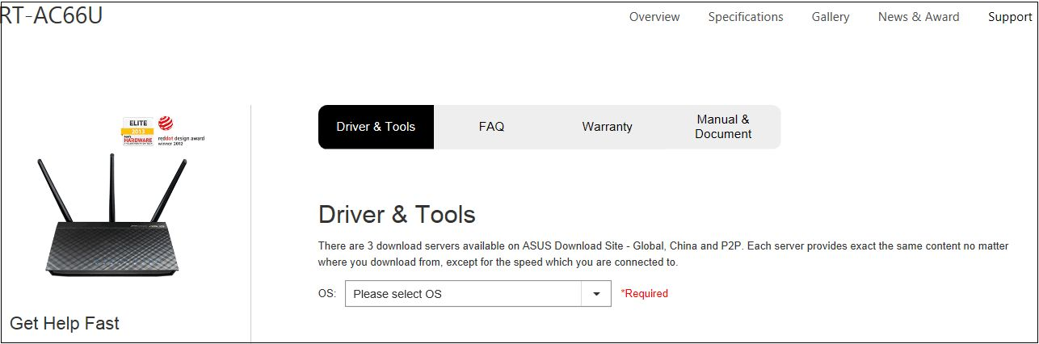
Select the correct OS and download the latest version of Firmware Restoration.
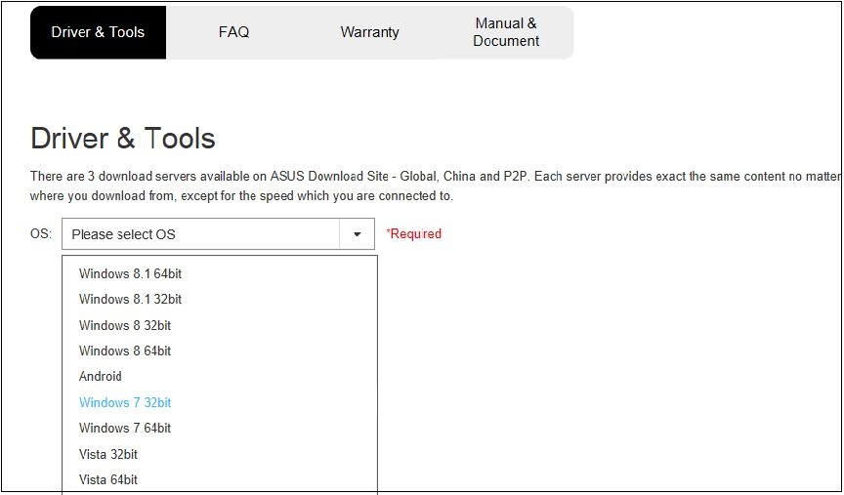
Select the latest firmware and utilities, and download them.
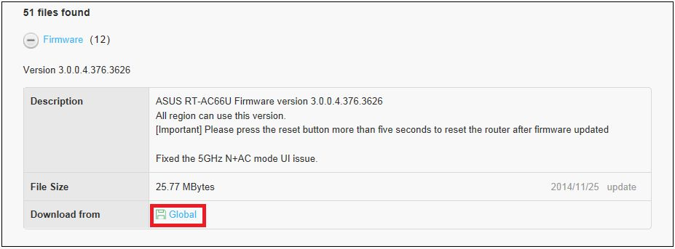
After saving utility and firmware, please decompress them and setup utility.
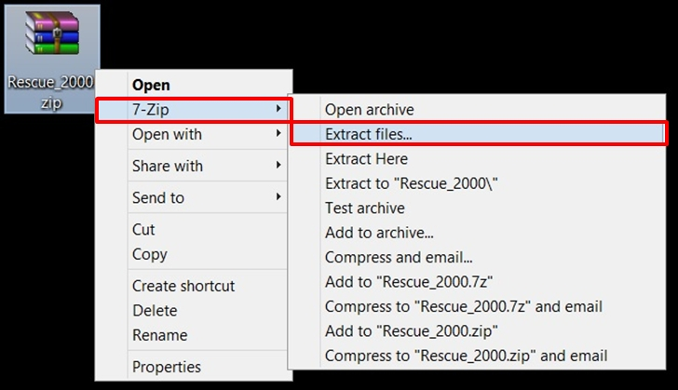

Router
Press the power button to turn off the router.
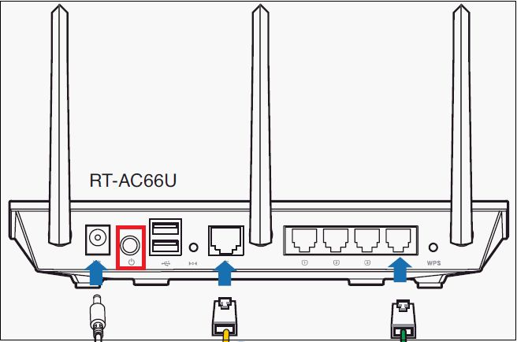

Keep long-pressing the button [RESTORE] about 5 seconds.
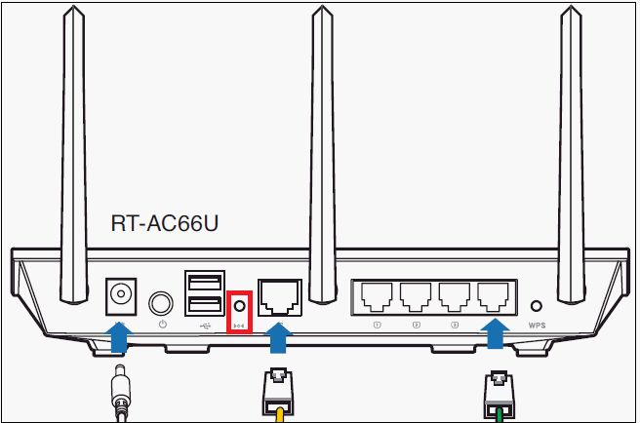
Please don't release the button [RESTORE]. And press the power button to turn on the Wireless Router

If the power is flashing-slow, the wireless router is on rescue mode.
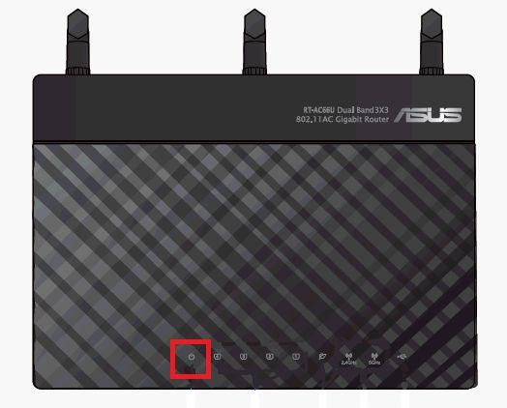
Computer:
Click [Start]→[Control panel]→ [network and Internet]→[Network and Sharing Center]→[Change adapter settings] → [LAN]→ Click [properties]
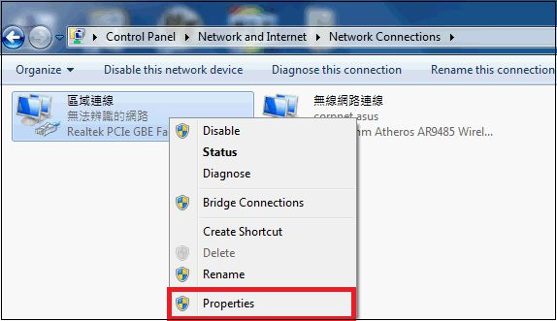

Click[Internet protocol version 4 (TCP/IPv4)]→Click [properties]
Modify the content of[Internet Protocol Version 4 (TCP/IPv4) Properties] as bellow: the following IP address，IP address：192.168.1.10， subnet mask：255.255.255.0 → click [OK]
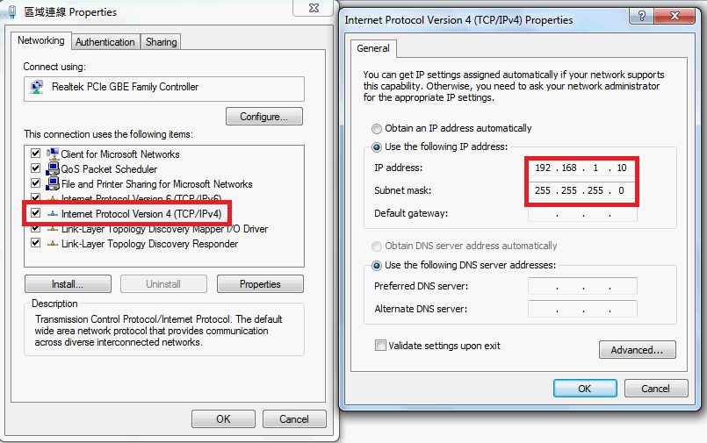

Click[Start]→[All programs]→[ASUS utility]→[Wireless Router]→[Firmware Restoration]
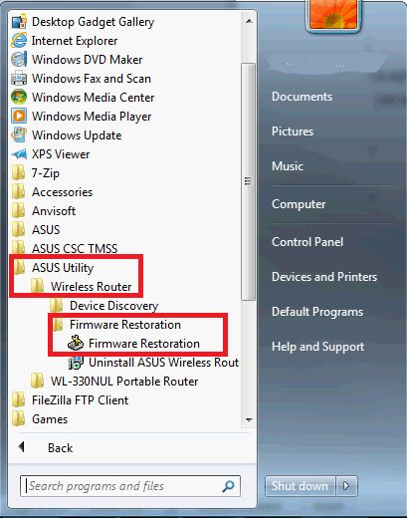
At the windows -[Firmware Restoration], click [browser] and choose the latest firmware which you had downloaded.
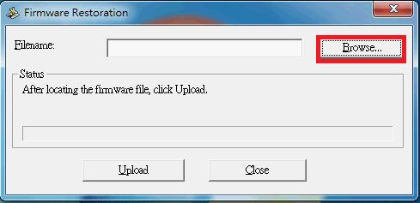
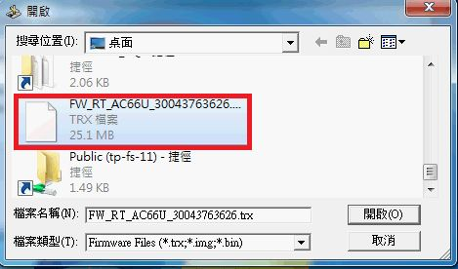

Click [Upload]
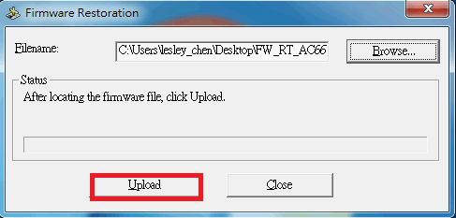

Please wait for 60 seconds
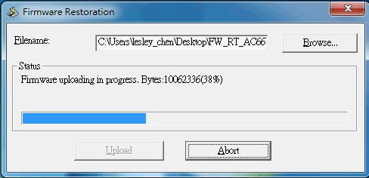

Click [Close] when the message shows [system recovery succeeds! Please wait for system reboot].
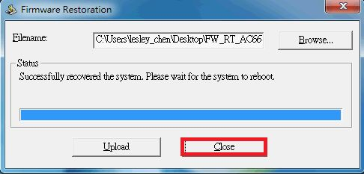

Router:
Steady power light indicates the setting procedure of rescue mode has been completed successfully.

※ NOTE: Please choose [obtain an IP address automatically] after the procedure is completed.

- Category Windows Setting/ Operation
- Type Product Knowledge

Recovering ASUS router firmware without Windows
https://chrishardie.com/2013/02/asus-router-firmware-windows-mac-linux/
If you own an ASUS router and you brick it while trying to upgrade the firmware or some other action, you'll probably find documentation saying you need to run a Windows-only firmware restoration program to undo this damage.
While this is apparently the only officially supported method for restoring firmware (the alternative being to ship the router to ASUS for repair, a 10+ day process), I found with some exploring that the Windows program is likely just a glorified tftp client, and that you can restore firmware using some more standard, non-Windows tools.
I'm listing below the steps I had to use today after trying to upgrade my RT-AC66U device from firmware version 3.0.0.4.266 to 3.0.0.4.270. (The release notes for the latter indicate a fix for a "live update related bug" which is what I suspect I encountered when I first tried to do the upgrade via the web GUI.)
I'm a Mac user, but these steps should work for other non-Windows operating systems such as Linux. It hopefully goes without saying that you should follow these steps at your own risk, and I make no claims or warranty about the outcome; you could end up worse off than you are now. You could set your router on fire. You could end up killing another version of yourself living in an alternate universe. Be careful.
1. Make sure your router is indeed in need of an emergency recovery firmware restore. On the ASUS unit I have, this is indicated by a slowly flashing power light and a clear lack of Internet connectivity. Make sure the other usual methods - power off, hold down the reset button, hold down the reset button as you power on, etc. - don't fix things.
2. Find a way to get a known good ASUS firmware image file onto your system. This is probably a file that ends in ".trx" such as "RT-AC66U_3.0.0.4_270.trx".
3. Unplug all other network devices from the unit, and connect your Mac or other system to the ASUS unit with an Ethernet cable plugged in to port #1 on the router.
4. Setup your network configuration so that you have a static IP address on the 192.168.1.0/24 network block. I used 192.168.1.10 with a netmask of 255.255.255.0 and a gateway of 192.168.1.0.
5. Open a Terminal window and make sure you can ping 192.168.1.1., the probably IP address of the ASUS router. If you can't ping the router, the rest of these steps probably won't work.
6. CD into the directory where the firmware image ending in .trx exists (see step #2 above).
7. Run these commands from the terminal prompt, using the correct firmware image filename in the "put" command:
1  2  3  4  5  6  7 | $ tftp  tftp> connect  (to) 192.168.1.1  tftp> binary  tftp> put RT-AC66U_3.0.0.4_266.trx  Sent 22765568 bytes in 76.5 seconds  tftp> quit
8. Give the router about 5 minutes to process the firmware image you've just sent it. I had to then manually turn the unit off and back on to get it to reboot into a working state. Once it came back up, I could again ping it and I could again access the admin GUI via the web.
If that doesn't work, it wouldn't hurt to repeat the steps again and give it another try. If that still doesn't work, you'll probably want to call ASUS for an RMA case (that's 812-282-2787 in the US and Canada).
I would have hoped that a company manufacturing devices for the modern age would not hobble their customers` ability to self-troubleshoot by limiting the recovery process to only users running Windows. Even if the above method is unsupported, they could at least publish it in some form so that they don't use up their time and their customers` time with unnecessary interactions with Windows users, or worse, mailing units in for repair that could instead be repaired where they sit.
I hope these steps are helpful to someone else. Let me know if you find other techniques that might help in similar situations. (If this post really got you out of a jam and you're feeling super thankful, consider donating Bitcoins.)

If you were connected via UART Usb, you would see something like
RT-AC58U bootloader version: 1.0.0.3
MAC Address: 2C: 4D: 54: XX: XX: 90
reset buootn pressed!

## Enter Rescue Mode ##
Preferred nic: eth0
eth0 PHY0 Down Speed: 10 Half duplex
eth0 PHY1 Down Speed: 10 Half duplex
eth0 PHY2 Down Speed: 10 Half duplex
eth0 PHY3 up Speed: 1000 Full duplex
eth0 PHY4 Down Speed: 10 Half duplex
switch prereq: 0
tftpd start

Our IP address is: (192.168.1.1)
Wait for TFTP request ...
tftpd open
D DDDDDDDD GOT ​​ARP REQUEST, return our IP
D DDDDDDDDD
Get read request from: (192.168.1.70)
Firmware Restoration assigns IP address: Here the left address is
New netmask: 0.0.0.128
Got ARP REPLY, set eth addr (fc: 45: 96: 7a: 1f: 31)
Got ARP REQUEST, return our IP
D #
First block received
################## ##############################################
#### .. ###########
The key point is reset buootn pressed!
## Enter Rescue Mode ##
At the time the uboot boot loader was started (it takes a few seconds), the reset button was pressed. Uboot enters recovery mode and waits for firmware. If you delete the partition using my instructions, the recovery mode is automatically selected
ERROR: can not get kernel image!

Hello !! Enter Recuse Mode: (Check error)

preferred nic: eth0
eth0 PHY0 Down Speed: 10 Half duplex
eth0 PHY1 Down Speed: 10 Half duplex
eth0 PHY2 Down Speed: 10 Half duplex
eth0 PHY3 up Speed: 1000 Full duplex
eth0 PHY4 Down Speed: 10 Half duplex
switch prereq: 0
tftpd start

Our IP address is: (192.168.1.1)
Wait for TFTP request ...
tftpd open
D DDDDDDDDDDDDDD Got ARP REPLY, set eth addr (fc: 45: 96: 7a: 1f: 31)
#
First block received
############################################### #################

Patchwork [PATCHv3,1/2] ath10k: add per peer htt tx stats support for 10.4login
register
mail settings
Project: linux-wireless : patches : project info : other projects about
Submitter akolli@qti.qualcomm.com
Date Nov. 15, 2016, 4:37 p.m.
Message ID <1479227849-10042-1-git-send-email-akolli@qti.qualcomm.com>
Download mbox | patch
Permalink /patch/9430195/
State Not Applicable
Delegated to: Kalle Valo
Headers show
Comments

akolli@qti.qualcomm.com - Nov. 15, 2016, 4:37 p.m.
From: Anilkumar Kolli <akolli@qti.qualcomm.com>

Per peer tx stats are part of 'HTT_10_4_T2H_MSG_TYPE_PEER_STATS'
event, Firmware sends one HTT event for every four PPDUs.
HTT payload has success pkts/bytes, failed pkts/bytes, retry
pkts/bytes and rate info per ppdu.
Peer stats are enabled through 'WMI_SERVICE_PEER_STATS',
which are nowadays enabled by default.

Parse peer stats and update the tx rate information per STA.

tx rate, Peer stats are tested on QCA4019 with Firmware version
10.4-3.2.1-00028.

Signed-off-by: Anilkumar Kolli <akolli@qti.qualcomm.com>
---
v2:
* address Kalle's comments
* fix compilation warnings
v3:
* fix compilation warnings (kvalo)

drivers/net/wireless/ath/ath10k/core.h | 17 ++++
drivers/net/wireless/ath/ath10k/htt.c | 2 +
drivers/net/wireless/ath/ath10k/htt.h | 25 ++++++
drivers/net/wireless/ath/ath10k/htt_rx.c | 125 ++++++++++++++++++++++++++++++
drivers/net/wireless/ath/ath10k/wmi.h | 10 ++-
5 files changed, 178 insertions(+), 1 deletion(-)
Kalle Valo - Nov. 23, 2016, 7:40 p.m.
akolli@qti.qualcomm.com wrote:
> From: Anilkumar Kolli <akolli@qti.qualcomm.com>
>
> Per peer tx stats are part of 'HTT_10_4_T2H_MSG_TYPE_PEER_STATS'
> event, Firmware sends one HTT event for every four PPDUs.
> HTT payload has success pkts/bytes, failed pkts/bytes, retry
> pkts/bytes and rate info per ppdu.
> Peer stats are enabled through 'WMI_SERVICE_PEER_STATS',
> which are nowadays enabled by default.
>
> Parse peer stats and update the tx rate information per STA.
>
> tx rate, Peer stats are tested on QCA4019 with Firmware version
> 10.4-3.2.1-00028.
>
> Signed-off-by: Anilkumar Kolli <akolli@qti.qualcomm.com>

2 patches applied to ath-next branch of ath.git, thanks.

cec17c382140 ath10k: add per peer htt tx stats support for 10.4
5608eaf7b086 ath10k: add support for per sta tx bitrate
Sven Eckelmann - May 11, 2017, 8:40 a.m.
On Dienstag, 15. November 2016 22:07:29 CEST akolli@qti.qualcomm.com wrote:
> From: Anilkumar Kolli <akolli@qti.qualcomm.com>
>
> Per peer tx stats are part of 'HTT_10_4_T2H_MSG_TYPE_PEER_STATS'
> event, Firmware sends one HTT event for every four PPDUs.
> HTT payload has success pkts/bytes, failed pkts/bytes, retry
> pkts/bytes and rate info per ppdu.
> Peer stats are enabled through 'WMI_SERVICE_PEER_STATS',
> which are nowadays enabled by default.
>
> Parse peer stats and update the tx rate information per STA.
>
> tx rate, Peer stats are tested on QCA4019 with Firmware version
> 10.4-3.2.1-00028.
>
> Signed-off-by: Anilkumar Kolli <akolli@qti.qualcomm.com>
> ---

Just played a little bit around with it and an 802.11n client (2x2x). The
thing I've observed was that MCS 0-7 was reported as MCS rate but the client
received mostly MCS 8-15.

Guessing from this section

> if (((txrate.flags == WMI_RATE_PREAMBLE_HT) ||
> (txrate.flags == WMI_RATE_PREAMBLE_VHT)) && txrate.mcs > 9) {
> ath10k_warn(ar, "Invalid mcs %hhd peer stats", txrate.mcs);
> return;
> }

it looks like HT rates are reported as 0-9 with an NSS setting (yes, as odd as
this is). I've printed the values to check it:

[ 68.529197] XXXXX txrate.flags 2, txrate.bw 1, txrate.nss 2, txrate.mcs 5
[ 68.529500] XXXXX txrate.flags 2, txrate.bw 1, txrate.nss 2, txrate.mcs 4
[ 68.535225] XXXXX txrate.flags 2, txrate.bw 1, txrate.nss 2, txrate.mcs 4
[ 68.542290] XXXXX txrate.flags 2, txrate.bw 1, txrate.nss 2, txrate.mcs 4
[ 68.549507] XXXXX txrate.flags 2, txrate.bw 1, txrate.nss 2, txrate.mcs 4
[ 68.555627] XXXXX txrate.flags 2, txrate.bw 1, txrate.nss 2, txrate.mcs 4
[ 68.562652] XXXXX txrate.flags 2, txrate.bw 1, txrate.nss 2, txrate.mcs 4

I don't know this for sure but my next guess is now that following change is
missing:

@@ -2231,8 +2231,10 @@ ath10k_update_per_peer_tx_stats(struct ath10k *ar,
sgi = ATH10K_HW_GI(peer_stats->flags);

if (((txrate.flags == WMI_RATE_PREAMBLE_HT) ||
- (txrate.flags == WMI_RATE_PREAMBLE_VHT)) && txrate.mcs > 9) {
- ath10k_warn(ar, "Invalid mcs %hhd peer stats", txrate.mcs);
+ (txrate.flags == WMI_RATE_PREAMBLE_VHT)) &&
+ (txrate.mcs > 9 || txrate.nss < 1)) {
+ ath10k_warn(ar, "Invalid mcs %hhd nss %hhd peer stats",
+ txrate.mcs, txrate.nss);
return;
}

@@ -2255,7 +2257,7 @@ ath10k_update_per_peer_tx_stats(struct ath10k *ar,
arsta->txrate.legacy = rate;
} else if (txrate.flags == WMI_RATE_PREAMBLE_HT) {
arsta->txrate.flags = RATE_INFO_FLAGS_MCS;
- arsta->txrate.mcs = txrate.mcs;
+ arsta->txrate.mcs = txrate.mcs + 8 * (txrate.nss - 1);
} else {
arsta->txrate.flags = RATE_INFO_FLAGS_VHT_MCS;
arsta->txrate.mcs = txrate.mcs;

Funny enough, I was spamming following with my 802.11n!!!! 2x2 client:

[ 115.694987] XXXXX txrate.flags 3, txrate.bw 1, txrate.nss 4, txrate.mcs 15
[ 115.701851] ath10k_ahb a800000.wifi: Invalid mcs 15 peer stats

Firmware was 10.4-3.2.1-00050 on an Dakota (IPQ401X) board.

Kind regards,
Sven
Patch

diff --git a/drivers/net/wireless/ath/ath10k/core.h b/drivers/net/wireless/ath/ath10k/core.h
index e8decfaba5b6..2f324a115b18 100644
--- a/drivers/net/wireless/ath/ath10k/core.h
+++ b/drivers/net/wireless/ath/ath10k/core.h
@@ -337,6 +337,7 @@ struct ath10k_sta {
u32 nss;
u32 smps;
u16 peer_id;
+ struct rate_info txrate;

struct work_struct update_wk;

@@ -693,6 +694,21 @@ struct ath10k_fw_components {
struct ath10k_fw_file fw_file;
};

+struct ath10k_per_peer_tx_stats {
+ u32 succ_bytes;
+ u32 retry_bytes;
+ u32 failed_bytes;
+ u8 ratecode;
+ u8 flags;
+ u16 peer_id;
+ u16 succ_pkts;
+ u16 retry_pkts;
+ u16 failed_pkts;
+ u16 duration;
+ u32 reserved1;
+ u32 reserved2;
+};
+
struct ath10k {
struct ath_common ath_common;
struct ieee80211_hw *hw;
@@ -906,6 +922,7 @@ struct ath10k {

struct ath10k_thermal thermal;
struct ath10k_wow wow;
+ struct ath10k_per_peer_tx_stats peer_tx_stats;

/* NAPI */
struct net_device napi_dev;
diff --git a/drivers/net/wireless/ath/ath10k/htt.c b/drivers/net/wireless/ath/ath10k/htt.c
index 130cd9502021..cd160b16db1e 100644
--- a/drivers/net/wireless/ath/ath10k/htt.c
+++ b/drivers/net/wireless/ath/ath10k/htt.c
@@ -137,6 +137,8 @@
HTT_T2H_MSG_TYPE_STATS_NOUPLOAD,
[HTT_10_4_T2H_MSG_TYPE_TX_MODE_SWITCH_IND] =
HTT_T2H_MSG_TYPE_TX_MODE_SWITCH_IND,
+ [HTT_10_4_T2H_MSG_TYPE_PEER_STATS] =
+ HTT_T2H_MSG_TYPE_PEER_STATS,
};

int ath10k_htt_connect(struct ath10k_htt *htt)
diff --git a/drivers/net/wireless/ath/ath10k/htt.h b/drivers/net/wireless/ath/ath10k/htt.h
index 0d2ed09f202b..164eb3a10566 100644
--- a/drivers/net/wireless/ath/ath10k/htt.h
+++ b/drivers/net/wireless/ath/ath10k/htt.h
@@ -419,6 +419,7 @@ enum htt_10_4_t2h_msg_type {
HTT_10_4_T2H_MSG_TYPE_STATS_NOUPLOAD = 0x18,
/* 0x19 to 0x2f are reserved */
HTT_10_4_T2H_MSG_TYPE_TX_MODE_SWITCH_IND = 0x30,
+ HTT_10_4_T2H_MSG_TYPE_PEER_STATS = 0x31,
/* keep this last */
HTT_10_4_T2H_NUM_MSGS
};
@@ -453,6 +454,7 @@ enum htt_t2h_msg_type {
HTT_T2H_MSG_TYPE_TX_FETCH_IND,
HTT_T2H_MSG_TYPE_TX_FETCH_CONFIRM,
HTT_T2H_MSG_TYPE_TX_MODE_SWITCH_IND,
+ HTT_T2H_MSG_TYPE_PEER_STATS,
/* keep this last */
HTT_T2H_NUM_MSGS
};
@@ -1470,6 +1472,28 @@ struct htt_channel_change {
__le32 phymode;
} __packed;

+struct htt_per_peer_tx_stats_ind {
+ __le32 succ_bytes;
+ __le32 retry_bytes;
+ __le32 failed_bytes;
+ u8 ratecode;
+ u8 flags;
+ __le16 peer_id;
+ __le16 succ_pkts;
+ __le16 retry_pkts;
+ __le16 failed_pkts;
+ __le16 tx_duration;
+ __le32 reserved1;
+ __le32 reserved2;
+} __packed;
+
+struct htt_peer_tx_stats {
+ u8 num_ppdu;
+ u8 ppdu_len;
+ u8 version;
+ u8 payload[0];
+} __packed;
+
union htt_rx_pn_t {
/* WEP: 24-bit PN */
u32 pn24;
@@ -1521,6 +1545,7 @@ struct htt_resp {
struct htt_tx_fetch_confirm tx_fetch_confirm;
struct htt_tx_mode_switch_ind tx_mode_switch_ind;
struct htt_channel_change chan_change;
+ struct htt_peer_tx_stats peer_tx_stats;
};
} __packed;

diff --git a/drivers/net/wireless/ath/ath10k/htt_rx.c b/drivers/net/wireless/ath/ath10k/htt_rx.c
index 285b235268d7..86d082cf4eef 100644
--- a/drivers/net/wireless/ath/ath10k/htt_rx.c
+++ b/drivers/net/wireless/ath/ath10k/htt_rx.c
@@ -2194,6 +2194,128 @@ void ath10k_htt_htc_t2h_msg_handler(struct ath10k *ar, struct sk_buff *skb)
dev_kfree_skb_any(skb);
}

+static inline bool is_valid_legacy_rate(u8 rate)
+{
+ static const u8 legacy_rates[] = {1, 2, 5, 11, 6, 9, 12,
+ 18, 24, 36, 48, 54};
+ int i;
+
+ for (i = 0; i < ARRAY_SIZE(legacy_rates); i++) {
+ if (rate == legacy_rates[i])
+ return true;
+ }
+
+ return false;
+}
+
+static void
+ath10k_update_per_peer_tx_stats(struct ath10k *ar,
+ struct ieee80211_sta *sta,
+ struct ath10k_per_peer_tx_stats *peer_stats)
+{
+ struct ath10k_sta *arsta = (struct ath10k_sta *)sta->drv_priv;
+ u8 rate = 0, sgi;
+ struct rate_info txrate;
+
+ lockdep_assert_held(&ar->data_lock);
+
+ txrate.flags = ATH10K_HW_PREAMBLE(peer_stats->ratecode);
+ txrate.bw = ATH10K_HW_BW(peer_stats->flags);
+ txrate.nss = ATH10K_HW_NSS(peer_stats->ratecode);
+ txrate.mcs = ATH10K_HW_MCS_RATE(peer_stats->ratecode);
+ sgi = ATH10K_HW_GI(peer_stats->flags);
+
+ if (((txrate.flags == WMI_RATE_PREAMBLE_HT) ||
+ (txrate.flags == WMI_RATE_PREAMBLE_VHT)) && txrate.mcs > 9) {
+ ath10k_warn(ar, "Invalid mcs %hhd peer stats", txrate.mcs);
+ return;
+ }
+
+ if (txrate.flags == WMI_RATE_PREAMBLE_CCK ||
+ txrate.flags == WMI_RATE_PREAMBLE_OFDM) {
+ rate = ATH10K_HW_LEGACY_RATE(peer_stats->ratecode);
+
+ if (!is_valid_legacy_rate(rate)) {
+ ath10k_warn(ar, "Invalid legacy rate %hhd peer stats",
+ rate);
+ return;
+ }
+
+ /* This is hacky, FW sends CCK rate 5.5Mbps as 6 */
+ rate *= 10;
+ if (rate == 60 && txrate.flags == WMI_RATE_PREAMBLE_CCK)
+ rate = rate - 5;
+ arsta->txrate.legacy = rate * 10;
+ } else if (txrate.flags == WMI_RATE_PREAMBLE_HT) {
+ arsta->txrate.flags = RATE_INFO_FLAGS_MCS;
+ arsta->txrate.mcs = txrate.mcs;
+ } else {
+ arsta->txrate.flags = RATE_INFO_FLAGS_VHT_MCS;
+ arsta->txrate.mcs = txrate.mcs;
+ }
+
+ if (sgi)
+ arsta->txrate.flags |= RATE_INFO_FLAGS_SHORT_GI;
+
+ arsta->txrate.nss = txrate.nss;
+ arsta->txrate.bw = txrate.bw + RATE_INFO_BW_20;
+}
+
+static void ath10k_htt_fetch_peer_stats(struct ath10k *ar,
+ struct sk_buff *skb)
+{
+ struct htt_resp *resp = (struct htt_resp *)skb->data;
+ struct ath10k_per_peer_tx_stats *p_tx_stats = &ar->peer_tx_stats;
+ struct htt_per_peer_tx_stats_ind *tx_stats;
+ struct ieee80211_sta *sta;
+ struct ath10k_peer *peer;
+ int peer_id, i;
+ u8 ppdu_len, num_ppdu;
+
+ num_ppdu = resp->peer_tx_stats.num_ppdu;
+ ppdu_len = resp->peer_tx_stats.ppdu_len * sizeof(__le32);
+
+ if (skb->len < sizeof(struct htt_resp_hdr) + num_ppdu * ppdu_len) {
+ ath10k_warn(ar, "Invalid peer stats buf length %d\n", skb->len);
+ return;
+ }
+
+ tx_stats = (struct htt_per_peer_tx_stats_ind *)
+ (resp->peer_tx_stats.payload);
+ peer_id = __le16_to_cpu(tx_stats->peer_id);
+
+ rcu_read_lock();
+ spin_lock_bh(&ar->data_lock);
+ peer = ath10k_peer_find_by_id(ar, peer_id);
+ if (!peer) {
+ ath10k_warn(ar, "Invalid peer id %d peer stats buffer\n",
+ peer_id);
+ goto out;
+ }
+
+ sta = peer->sta;
+ for (i = 0; i < num_ppdu; i++) {
+ tx_stats = (struct htt_per_peer_tx_stats_ind *)
+ (resp->peer_tx_stats.payload + i * ppdu_len);
+
+ p_tx_stats->succ_bytes = __le32_to_cpu(tx_stats->succ_bytes);
+ p_tx_stats->retry_bytes = __le32_to_cpu(tx_stats->retry_bytes);
+ p_tx_stats->failed_bytes =
+ __le32_to_cpu(tx_stats->failed_bytes);
+ p_tx_stats->ratecode = tx_stats->ratecode;
+ p_tx_stats->flags = tx_stats->flags;
+ p_tx_stats->succ_pkts = __le16_to_cpu(tx_stats->succ_pkts);
+ p_tx_stats->retry_pkts = __le16_to_cpu(tx_stats->retry_pkts);
+ p_tx_stats->failed_pkts = __le16_to_cpu(tx_stats->failed_pkts);
+
+ ath10k_update_per_peer_tx_stats(ar, sta, p_tx_stats);
+ }
+
+out:
+ spin_unlock_bh(&ar->data_lock);
+ rcu_read_unlock();
+}
+
bool ath10k_htt_t2h_msg_handler(struct ath10k *ar, struct sk_buff *skb)
{
struct ath10k_htt *htt = &ar->htt;
@@ -2354,6 +2476,9 @@ bool ath10k_htt_t2h_msg_handler(struct ath10k *ar, struct sk_buff *skb)
case HTT_T2H_MSG_TYPE_TX_MODE_SWITCH_IND:
ath10k_htt_rx_tx_mode_switch_ind(ar, skb);
break;
+ case HTT_T2H_MSG_TYPE_PEER_STATS:
+ ath10k_htt_fetch_peer_stats(ar, skb);
+ break;
case HTT_T2H_MSG_TYPE_EN_STATS:
default:
ath10k_warn(ar, "htt event (%d) not handled\n",
diff --git a/drivers/net/wireless/ath/ath10k/wmi.h b/drivers/net/wireless/ath/ath10k/wmi.h
index 1b243c899bef..e108d49998c3 100644
--- a/drivers/net/wireless/ath/ath10k/wmi.h
+++ b/drivers/net/wireless/ath/ath10k/wmi.h
@@ -4603,9 +4603,17 @@ enum wmi_rate_preamble {

#define ATH10K_HW_NSS(rate) (1 + (((rate) >> 4) & 0x3))
#define ATH10K_HW_PREAMBLE(rate) (((rate) >> 6) & 0x3)
-#define ATH10K_HW_RATECODE(rate, nss, preamble) \
+#define ATH10K_HW_MCS_RATE(rate) ((rate) & 0xf)
+#define ATH10K_HW_LEGACY_RATE(rate) ((rate) & 0x3f)
+#define ATH10K_HW_BW(flags) (((flags) >> 3) & 0x3)
+#define ATH10K_HW_GI(flags) (((flags) >> 5) & 0x1)
+#define ATH10K_HW_RATECODE(rate, nss, preamble) \
(((preamble) << 6) | ((nss) << 4) | (rate))

+#define VHT_MCS_NUM 10
+#define VHT_BW_NUM 4
+#define VHT_NSS_NUM 4
+
/* Value to disable fixed rate setting */
#define WMI_FIXED_RATE_NONE (0xff)

