Sun Devil Robotics Club- Autonomous Underwater Vehicle Team: Design and Manufacturing of Triton

John Rangel, Sami Mian, Marcos Garciaacosta, Ruy Garciaacosta, Dillon Dayea, Quenan Aaron Ruiz, Dustin Eads, Meghan Hebel, Andrew Warren, Chuck Dries

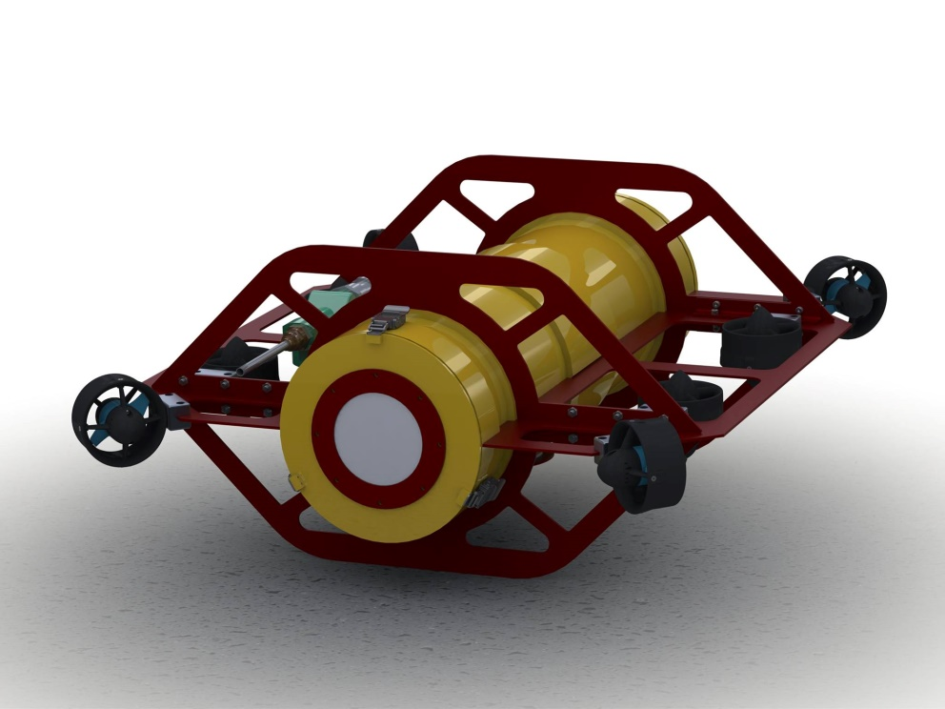

**Abstract**

**Triton is the Sun Devil Robotics Club's first ever autonomous underwater vehicle designed to compete in the Robosub competition. The vehicle is the product of a yearlong process of extensive requirements analysis, prototyping, CAD design, careful machining and manufacturing, and numerous code iterations. Triton was built by the Sun Devil Robotics Club's first ever autonomous underwater vehicle team division comprised of 10 dedicated and talented ASU students. Triton is comprised of a waterjet and machined aluminum frame and hull using new Blue Robotic Thrusters. Inside the hull, a 3D printed skeleton called the lattice structure holds all electronic components and sensors needed for Triton to operate the mission. Some of these components include a 3 axis IMU, 2 HD webcams, an Ethernet to VGA/USB transmitter, a pressure sensor for depth, and more. This fully autonomous vehicle was built with durability and maneuverability in mind along with plenty of room and space for expansion. By using cameras and highly complex algorithms and software, Triton will be storming Robosub in full force.**

**I. Introduction**

*A. Who Are We?*

Sun Devil Robotics (SDR) is a research and competition oriented robotics student organization at Arizona State University. The group is composed of students primarily from the Ira A. Fulton Schools of Engineering, and membership covers almost all disciplines of engineering. SDR has three main focus areas: Outreach, Professional Development, and Competitions. Members help organize and run regional and state STEM competitions, such as FIRST and VEX programs throughout Arizona. Several times each semester, workshops are hosted to teach members different skills, like SolidWorks 3D modeling software and C programming. SDR has several competition teams that participate in numerous national and international robotics and embedded systems focused competitions.

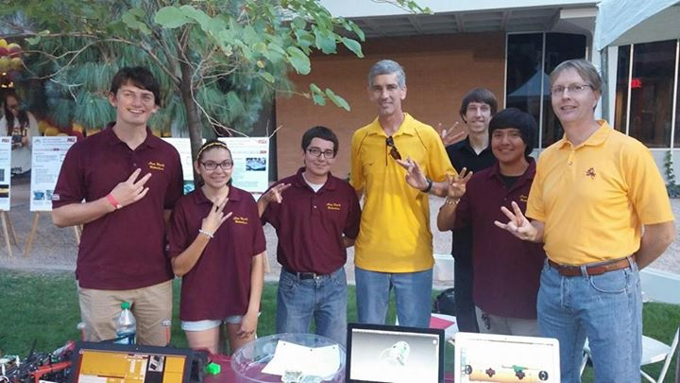

The Sun Devil Robotics Club Autonomous Underwater Vehicle group (SDRCAUV) is the competition team competing in the AUVSI Robosub competition this summer. The group is composed of entirely undergraduate students, many of whom are competing in this competition for the first time. However, a few members on the team have competed before through the Carl Hayden High School Falcon Robotics team. Starting this new team was very difficult to get off the ground. With the help of sponsors and the support of ASU and the engineering school, the team will be ready to compete for its first year. This team consists of our club's very best students and is intended to change the culture of ASU. Hopefully, this is the first step towards turning ASU into a robotic and technological powerhouse. A “varsity sport of the mind” robotics team.

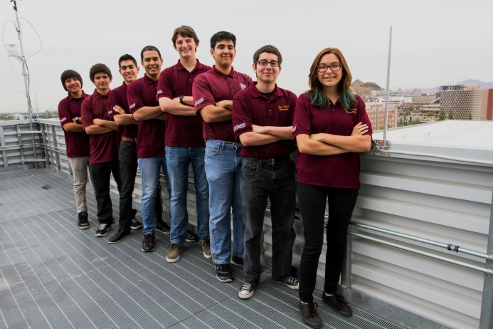

*B. Mission Strategy*

The team’s strategy for our first year competing was to build a sleek, robust vehicle with the capabilities to eventually do most tasks in the competition. We knew that we had to set reasonable goals for what we would accomplish in this year’s mission and decided to complete all tasks up to and including the obstacle course. We knew that if we were able to get to this point, we would have all the basics down to comfortably take our vehicle farther for next year. Doing the two buoys will make sure that we get color identification down along with low level tracking and going through the obstacle course with style would make sure that we have total control on all movement of the vehicle. Everything the vehicle needs to do this year has to be spot on. Our estimates show that we need at least 2500 points to have a chance to make it into the finals based on last year’s cutoff so we are shooting for 2600. We aren’t going to be doing too much in the water this year, but we are going to make sure everything we do, we do right.

**II. Mechanical System**

*A. The Hull*

For Triton, we opted for the rigidity of a full aluminum hull. The rationale is twofold. First, we’ve designed our robot to be watertight, and two, we use the natural heat dissipating properties of the metal as a heat sink to dissipate ambient heat generated by the electronics into the surrounding water. The front and end caps of our robot are fixed with locking latches compressed via an O-ring that is fitted in a milled slot. This same method of compression is also done with the acrylic portholes used for vision tracking, which are screwed onto the hull but also has a slot meant for an O-ring.

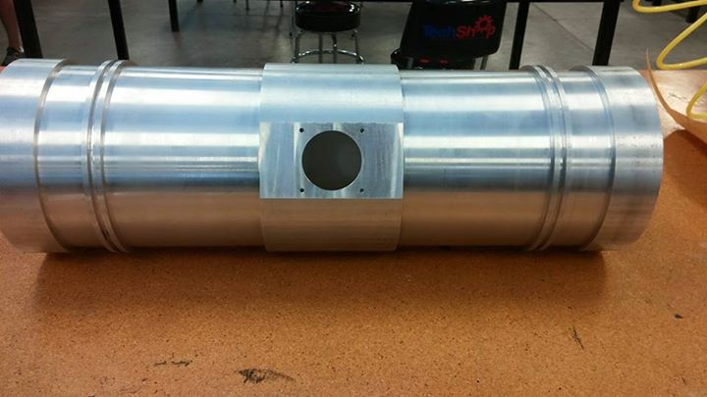

*B. The Wings/A-Frame*

The outside wings and a-frames were designed with two objectives in mind, protection of the hull and the cost of machining.  The robot frame was designed such that both the center of mass and center of buoyancy are located at the geometric center of the structure. All frame components are symmetric when reflected about the principle planes of the vehicle. These design features create a vehicle that is inherently unstable and symmetric about all axes. This enables our control system to stabilize the vehicle in any orientation and maneuver at any attitude.

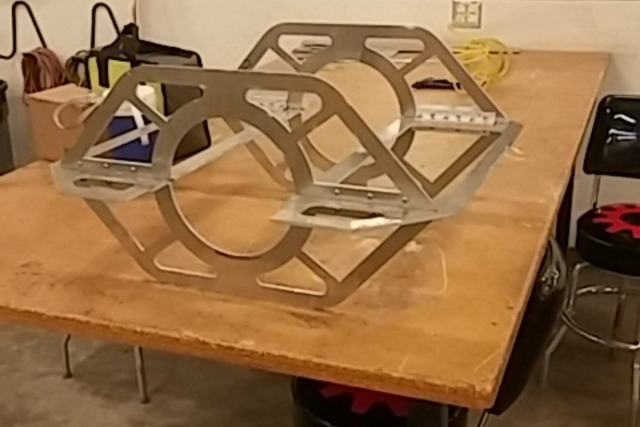

*C. Motors*

We are using the T100 thruster from Blue robotics, a new product that provides a powerful and efficient motor at an affordable cost. Each thruster is able to apply a maximum of 5 lbf of thrust. Most AUV’s use a minimal number of thrusters and rely on the geometric layout of their center of mass and center of buoyanct to provide stability. Because these thrusters are more affordable than most commercially available options, the team was able to create a novel propulsion system that uses 8 thrusters. This system is able to dynamically stabilize the vehicle and maneuver in any direction while at any attitude. This means that the robot is able to ascend, dive, strafe, or rotate about any axis while rotated at any combination of angles about the principle axes.

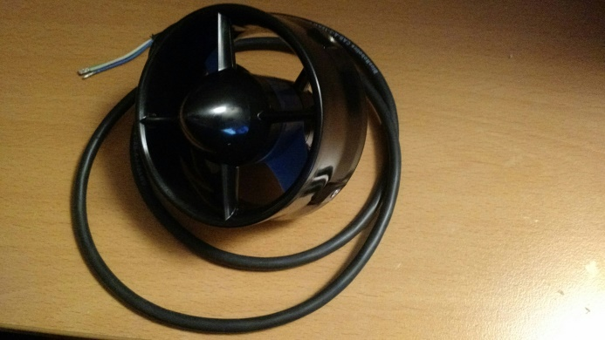

*D. Lattice Structure*

The lattice structure serves as a modular system for mounting electronic components. The lattice structure is the product of several months of development. By utilizing rapid prototyping technologies, the team was able to rapidly iterate through design changes to improve access to components and increase modularity.

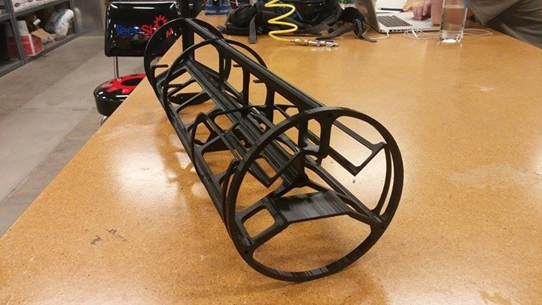

The final design of the lattice places power dissipating electrical components on the perimeter of the structure, close the hull. This allows heat to be effectively dissipated through convection. The lattice structure was printed from ABS plastic on a Stratasys Dimension FDM printer. Because this printer is capable of detailed support material structures we were able to produce a structure that would not be possible to manufacture with traditional methods. This enabled tight integration of components.

The Lattice structure is fastened to the rear end cap of the vehicle’s hull. The lattice structure can easily be removed for maintenance and repairs buy unlatching the rear endcap and extracting the entire system. This assembly can be removed smoothly because all through-hull interconnects are routed through the rear end cap.

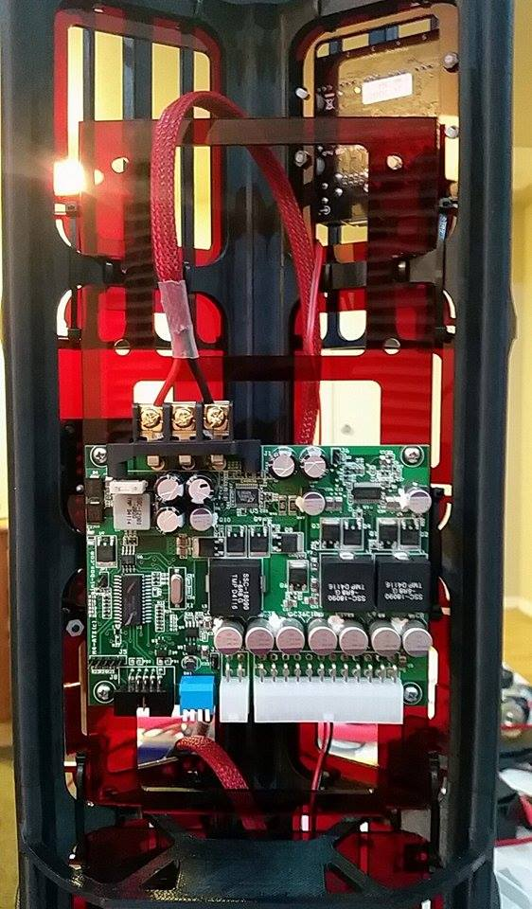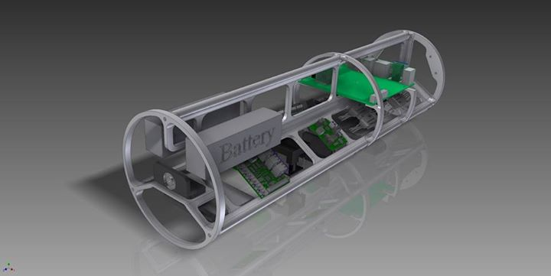

**III. Electrical System**

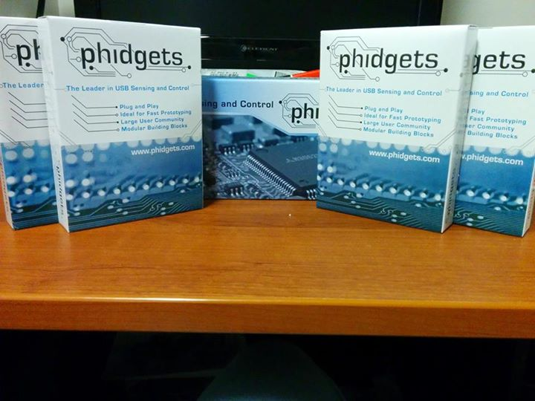

*A. Electrical Subsystem*

The electrical subsystem consists of the power supply and distribution system, computing system, sensing system, and actuator control system. Together, these systems support the functions of guidance, navigation and control as defined by our programming. The lattice structure houses all subsystems of the electrical systems within our hull. The electrical system was designed to be constructed with exclusively off the shelf components to ensure reliability and enable easy replacement upon failure. By eliminating the complexity of design, assembly, and testing of non-COTS electronic components the team was able to devote resources to other engineering challenges.

*B. Power Supply and Distribution*

The AV is powered by two parallel 4000mAh 14.8V Lithium Polymer batteries. A relay system is used as a primary power switch for both day-to-day power on control and emergency power cutoff. All power is routed through a 120amp power distribution board with voltage and current sensing. This enables accurate power consumption estimation to ensure safe battery usage. An M4-ATX power supply is used to provide voltage regulated power for our computing systems. This power supply provides a standard ATX power connector for the motherboard as well as regulated 5V and 12V supply rails. Propulsion systems are powered with unregulated power from the power distribution board.

*C. Computing Systems*

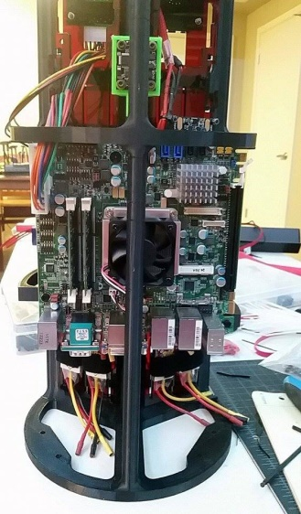 A mini-ITX form factor PC is responsible for the main data processing tasks. The PC runs on the Windows 8.1 Operating System. Phidgets USB devices are used for interfacing with the PC. USB architecture was chosen to enable reliable, high speed communications between the PC and peripherals. A Phidgets interface kit is used for GPIO and Analog to Digital Conversion. A CAT5 KVM extension system is used to enable tethered programming and control operations on the PC.

*D. Sensing System*

The Sensing System consists of two USB cameras and a Phidget Spatial Precision Inertial Measurement Unit. Together, these systems enable position and attitude state estimation. Due to the USB architecture, these devices can connect to the PC directly.

*E. Actuator Control System*

The actuator control system is responsible for controlling the thrusters, marker droppers, and torpedo systems. Each thruster is controlled by a 20 Amp brushless electronic speed controller (ESC). 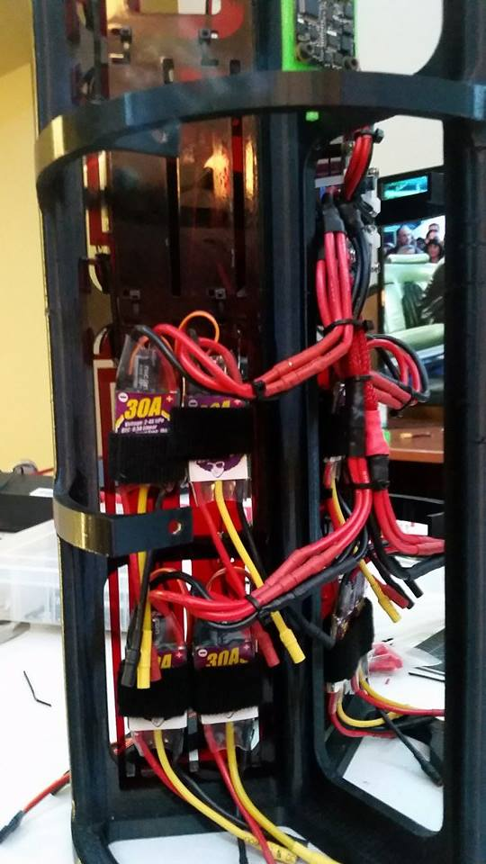These ESC’s are modified with special firmware that enables bidirectional control of thrust. The ESCs receive PWM control signals from a Phidgets Advanced Servo module which is connected to the PC via USB. The remaining actuation systems are controlled by a Phidgets 4 Channel relay module.

*F. Interconnects*

MacArtney Subconn Circular series connectors are used for all through hull interconnects. These industry standard connectors were chosen due to their proven reliability. The four port and four starboard thrusters are each connected via a pair of 12 pin connectors. The KVM is connected via a specially designed 8 pin Ethernet connector.

**IV. Software System**

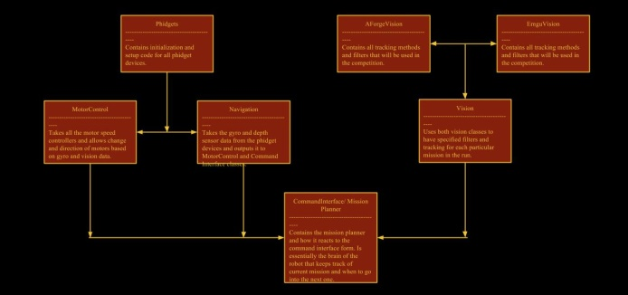

*A. Processing Framework*

The team is utilizing an Intel i7 motherboard and an Intel Edison board for all computer processing. The motherboard is going to run the mission planner system, which delegates which mission module, the vision tracking system, and the command interface which gives us ease of access control of the sub for debugging and testing. All code running on the motherboard is developed and run in Visual Studio C#. The Edison board’s primary function is to run all the diagnostics and monitor our entire electronic system. This includes temperature, voltage, and feedback from our devices. If there are any problems, the Edison board will notify the motherboard and indicate what the problem is. For any emergency critical problems, the Edison will flash LED lights that will be visible from the water.

*B. Vision System*

The Vision System for our vehicle is unlike what most teams use. Instead of just using one vision library such as OpenCV, the team is running two side by side in order to have maximum consistency when running mission code. The two vision libraries being used are EmguCV, an OpenCV wrapper for C#, and AForge.NET. EmguCV will be handling a lot of the more intricate vision tracking while AForge.NET will be handling most of the filters and the lower level tracking such as blob detection. We’ve found that sometimes searching for the perfect object is unreliable due to changing lighting conditions and water clarity. For tasks like the buoys, simple blob detection is plenty sufficient for tracking and is in a lot of cases, more reliable than searching for the shape of a buoy. AForge.NET also has many well developed filters we will be using such as their Flood Fill which takes parts of the background and filters all pixels similar to the background. By integrating EmguCV, we have the effective tracking and filters of AForge.NET, while still allowing us to use OpenCV methods to do more complex tracking such as the obstacle course or marker dropper task.

*C. Command Interface*

The Command Interface is a GUI built in Visual Studio to aid with development, testing, and deployment of the vehicle's software. It features real time monitoring of all vision and sensor data, on the fly configuration of vision filters and PID values, and contains the interface for our mission planner.

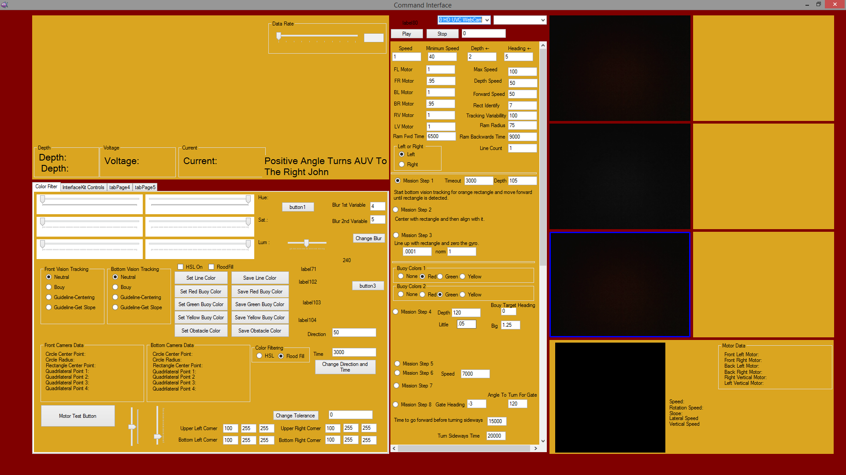

The mission planner is unique in that it is built in modules with the ability to select which missions to run and in what order. The Command Interface also allows on the fly changes to particular missions ranging from motor control multipliers to disabling parts of the mission altogether.

*D. Mission Logger and Playback*

The real time logging system along with its playback counterpart is essential to the development and testing of Triton and will be of vast importance for collecting as much data as we possibly can considering it's still our first year in the competition. Development for next year will be much faster and more reliable if we can collect data and video of the competition mission props in the actual facility. Even for those missions we are not attempting this year, data is of high importance for next year when we do start development for those tasks.

Our playback system is integrated in the Command Interface and simply allows playback of previous video and sensor data. From there, we can pause and adjust different vision algorithms and filters and test just about anything we want using the data. It is integral that we are able to collect as much data as possible during the practice days of Robosub so that we can be ready for the semifinal runs that really count.

**V. Vehicle Status**

The manufacturing of the mechanical portions of Triton is currently being wrapped up and dry testing of our entire electronic control system has passed systems check and is ready for underwater testing. The vast majority of the vehicle is now complete. Once the final endcap machining is complete, our Subconn connectors will be installed and Triton will be heading towards its first test underwater. We are expecting to just be calibrating PID values the first day or two of testing but once we have that solid, it's on to full mission runs.

**VI. Acknowledgements**

Sun Devil Robotics would like to thank all of our sponsors and supporters for helping to make this entire project a success. We have learned a tremendous amount of engineering and problem solving having taken on such a tremendously difficult task. We have had our ups and downs but we marched forward and you guys have always stuck with us. We would like to give a special mention now to all of our sponsors for helping us dive into the deep end. Thank you to:

* Arizona State University
* Ira A. Fulton Schools of Engineering
* Intel Corporation
* Phoenix Analysis and Design Technologies
* Phidgets Inc.
* Techshop Chandler
* State Technology and Manufacturing
* Frank Hernandez, City of Scottsdale Parks and Recreation