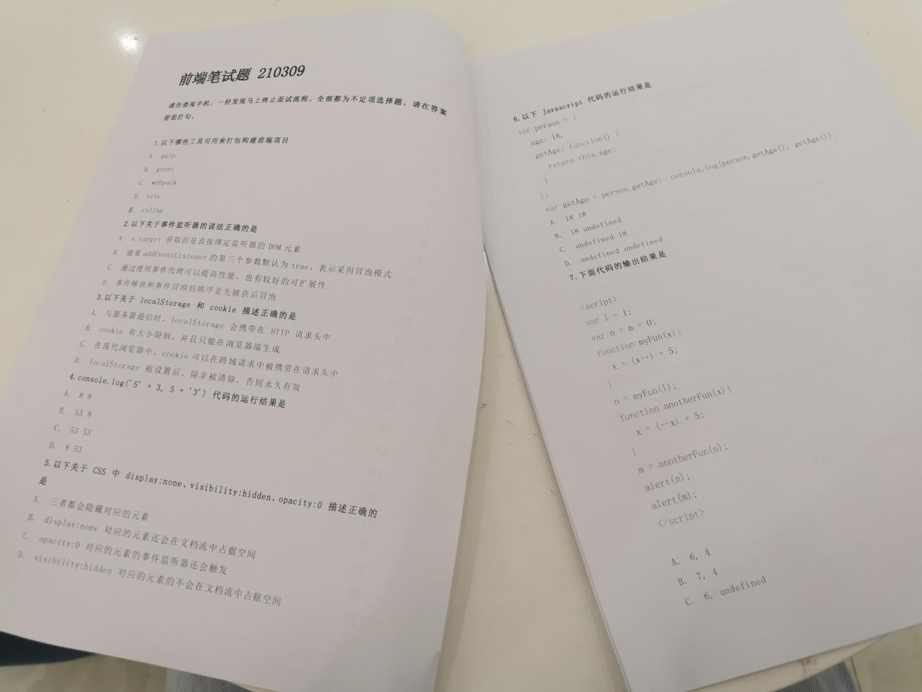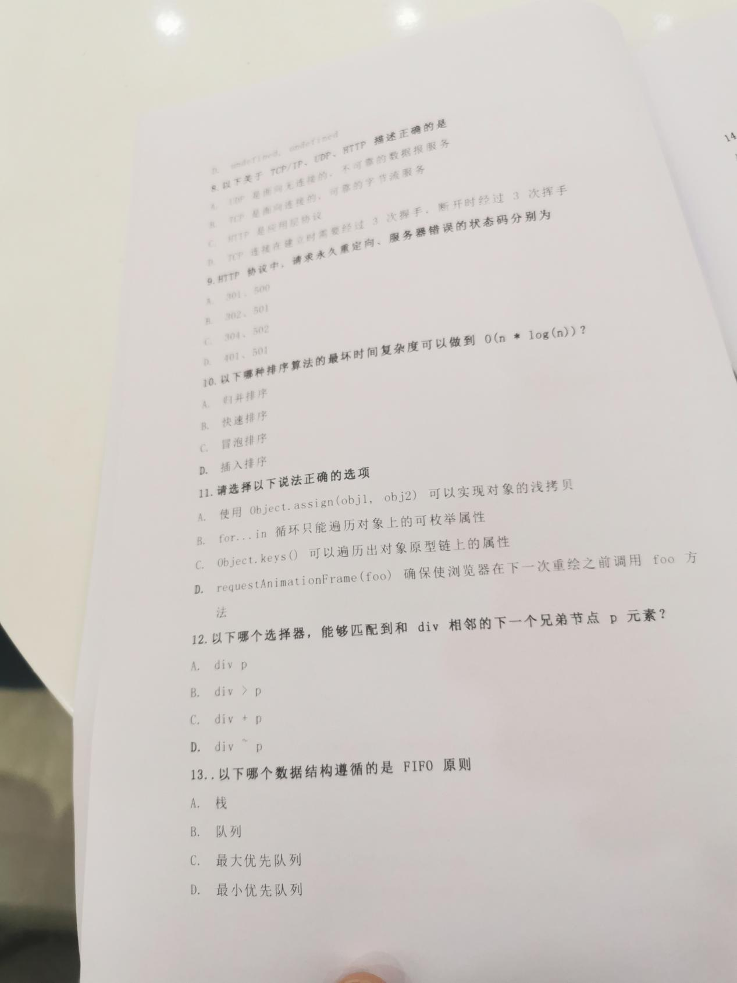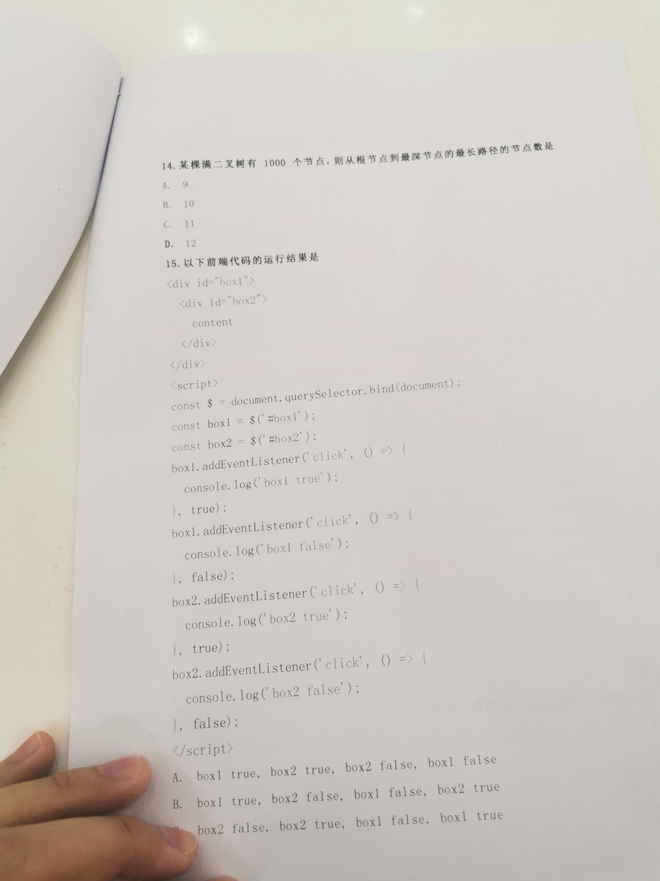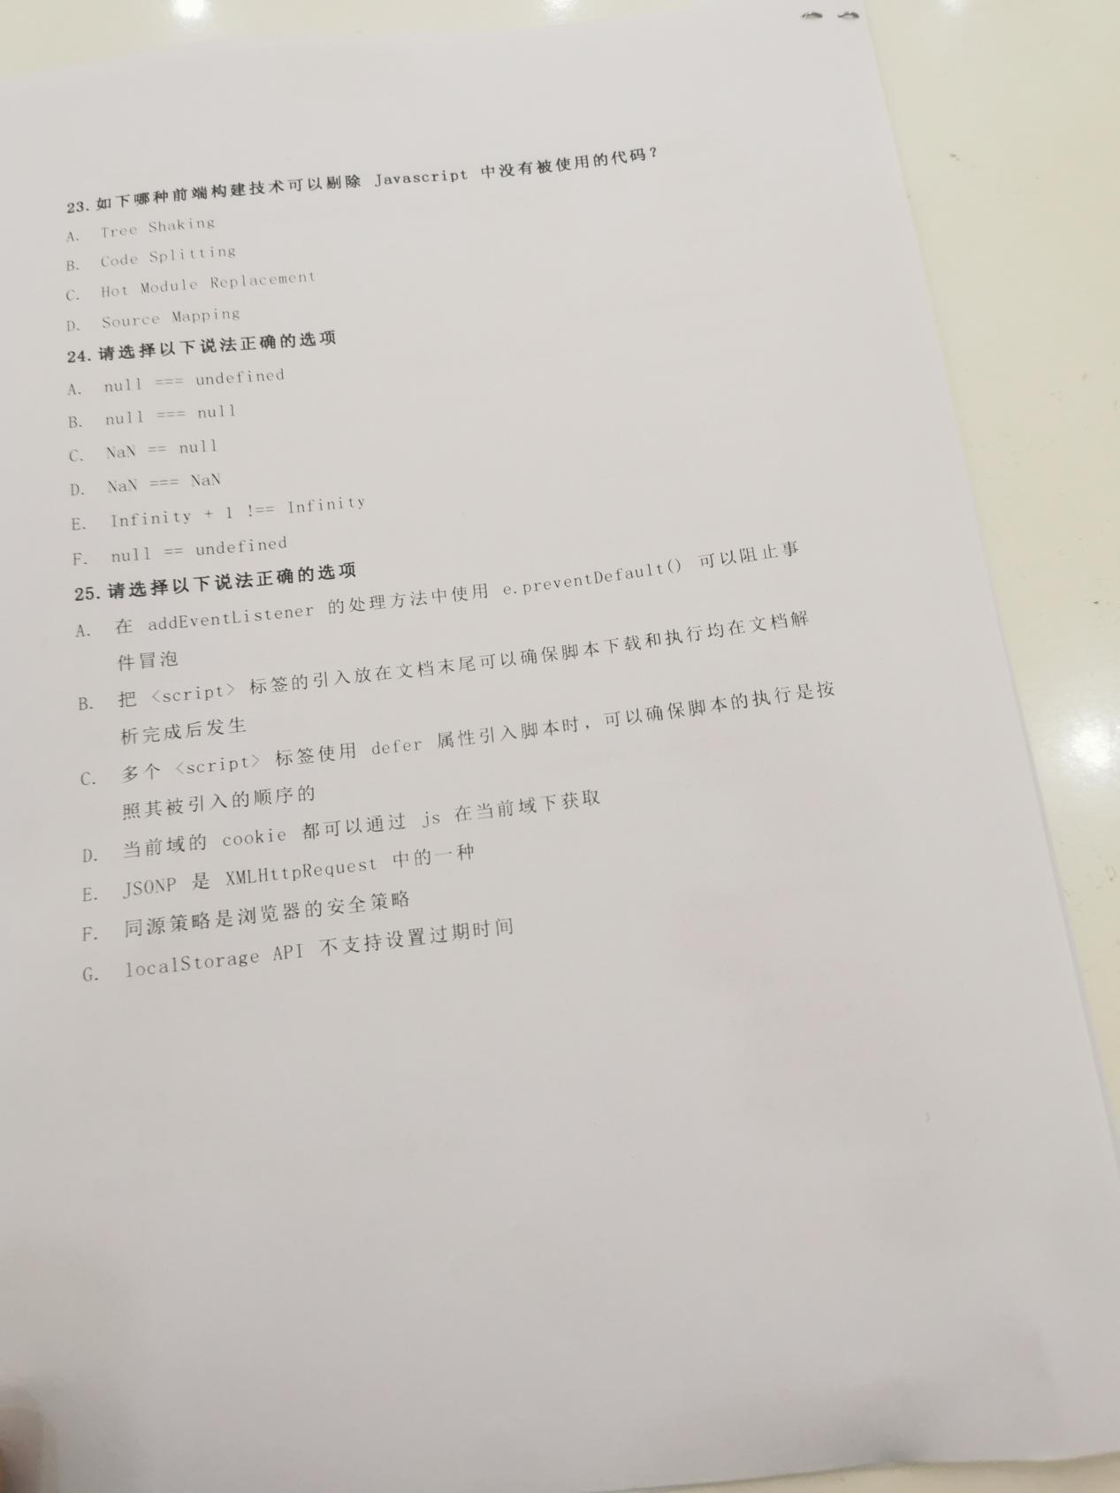

1. ABCD
2. CD
3. CD
4. C

console.log('5' + 3, 5 + '3')

1. AC
2. B

var person = {age: 18, getAge: function(){ return this.age }}; var getAge=person.getAge; console.log(person.getAge(), getAge())

1. D

var L = 1;var n=m=0;function myFun(x){x=(x++) + 5} n=myFun(L);function anotherFun(x) { x = (--x) + 5} m=anotherFun(n);alert(n);alert(m);

1. A

tcp是不可靠的

1. A
2. A
3. ACD
4. C

div+p ：将所有离<div>相邻的<p>标签选中

div~p ：将<div>后面所有的<p>标签选中

1. B
2. B
3. A
4. A
5. B
6. B
7. B
8. C
9. ABC
10. D

setTimeout(() => {console.log('1')},0); const promise = new Promise((resolve) => {console.log('3');resolve('4')}); (async () => {console.log('5');const str = await promise;console.log(str)})();promise.then(() => {console.log('6')});console.log('7')

1. A
2. BD
3. BCF