**TASK 1**

CREATE DATABASE academic_management_system;

USE academic_management_system;

CREATE TABLE StudentInfo (

STU_ID INT AUTO_INCREMENT PRIMARY KEY,

STU_NAME VARCHAR(100),

DOB DATE,

PHONE_NO VARCHAR(15),

EMAIL_ID VARCHAR(100),

ADDRESS TEXT

);

CREATE TABLE CoursesInfo (

COURSE_ID INT AUTO_INCREMENT PRIMARY KEY,

COURSE_NAME VARCHAR(100),

COURSE_INSTRUCTOR_NAME VARCHAR(100)

);

CREATE TABLE EnrollmentInfo (

ENROLLMENT_ID INT AUTO_INCREMENT PRIMARY KEY,

STU_ID INT,

COURSE_ID INT,

ENROLL_STATUS ENUM('Enrolled', 'Not Enrolled'),

FOREIGN KEY (STU_ID) REFERENCES StudentInfo(STU_ID),

FOREIGN KEY (COURSE_ID) REFERENCES CoursesInfo(COURSE_ID)

);

INSERT INTO StudentInfo (STU_NAME, DOB, PHONE_NO, EMAIL_ID, ADDRESS)

VALUES

('Atul Singh', '1990-01-15', '1234567890', 'atul@email.com', '123 Main St, City'),

('Bharat Chauhan', '1991-05-20', '9876543210', 'bharat@email.com', '456 Elm St, Town'),

('Deepak Tomar', '1992-07-12', '5555555555', 'deepak@email.com', '789 Oak St, Village'),

('Hitesh Pundir', '1993-03-03', '6666666666', 'hitesh@email.com', '101 Pine St, Hamlet'),

('Nitesh Sharma', '1994-09-09', '4444444444', 'nitesh@email.com', '222 Birch St, Town'),

('Akshay Dravid', '1995-02-18', '7777777777', 'akshay@email.com', '345 Cedar St, City'),

('Prabhat Tendulkar', '1996-04-30', '8888888888', 'prabhat@email.com', '789 Redwood St, Town'),

('Rahul Chauhan', '1997-08-27', '9999999999', 'rahul@email.com', '456 Sequoia St, Village'),

('Rohan Singh', '1998-12-10', '1111111111', 'rohan@email.com', '567 Maple St, City'),

('Puneet Tomar', '1999-06-06', '2222222222', 'puneet@email.com', '654 Fir St, Town');

INSERT INTO CoursesInfo (COURSE_NAME, COURSE_INSTRUCTOR_NAME)

VALUES

('Math 101', 'Professor Math'),

('Physics 101', 'Professor Physics'),

('Chemistry 101', 'Professor Chemistry'),

('Biology 101', 'Professor Biology'),

('Computer Science 101', 'Professor CS'),

('History 101', 'Professor History'),

('Geography 101', 'Professor Geography'),

('Literature 101', 'Professor Literature'),

('Economics 101', 'Professor Economics'),

('Psychology 101', 'Professor Psychology');

INSERT INTO EnrollmentInfo (STU_ID, COURSE_ID, ENROLL_STATUS)

VALUES

(1, 1, 'Enrolled'),

(1, 2, 'Enrolled'),

(2, 1, 'Enrolled'),

(2, 3, 'Enrolled'),

(3, 1, 'Enrolled'),

(4, 2, 'Enrolled'),

(5, 2, 'Enrolled'),

(6, 3, 'Enrolled'),

(7, 3, 'Enrolled'),

(8, 1, 'Enrolled'),

(8, 4, 'Enrolled'),

(9, 4, 'Enrolled'),

(9, 5, 'Enrolled'),

(10, 5, 'Enrolled'),

(10, 6, 'Enrolled');

SELECT SI.STU_NAME, SI.PHONE_NO, SI.EMAIL_ID, EI.ENROLL_STATUS

FROM StudentInfo SI

JOIN EnrollmentInfo EI ON SI.STU_ID = EI.STU_ID;

SELECT CI.COURSE_NAME

FROM CoursesInfo CI

JOIN EnrollmentInfo EI ON CI.COURSE_ID = EI.COURSE_ID

WHERE EI.STU_ID = 1;

SELECT COURSE_NAME, COURSE_INSTRUCTOR_NAME

FROM CoursesInfo;

SELECT *

FROM CoursesInfo

WHERE COURSE_ID = 1;

SELECT COURSE_NAME, COURSE_INSTRUCTOR_NAME

FROM CoursesInfo

WHERE COURSE_ID IN (1, 2, 3);

SELECT CI.COURSE_NAME, COUNT(EI.STU_ID) AS NUM_ENROLLED

FROM CoursesInfo CI

LEFT JOIN EnrollmentInfo EI ON CI.COURSE_ID = EI.COURSE_ID

GROUP BY CI.COURSE_NAME;

SELECT SI.STU_NAME

FROM StudentInfo SI

JOIN EnrollmentInfo EI ON SI.STU_ID = EI.STU_ID

WHERE EI.COURSE_ID = 1;

SELECT CI.COURSE_INSTRUCTOR_NAME, COUNT(EI.STU_ID) AS NUM_ENROLLED

FROM CoursesInfo CI

LEFT JOIN EnrollmentInfo EI ON CI.COURSE_ID = EI.COURSE_ID

GROUP BY CI.COURSE_INSTRUCTOR_NAME;

SELECT SI.STU_NAME

FROM StudentInfo SI

JOIN EnrollmentInfo EI ON SI.STU_ID = EI.STU_ID

WHERE EI.ENROLL_STATUS = 'Enrolled'

GROUP BY SI.STU_NAME

HAVING COUNT(DISTINCT EI.COURSE_ID) > 1;

SELECT CI.COURSE_NAME, COUNT(EI.STU_ID) AS NUM_ENROLLED

FROM CoursesInfo CI

LEFT JOIN EnrollmentInfo EI ON CI.COURSE_ID = EI.COURSE_ID

GROUP BY CI.COURSE_NAME

ORDER BY NUM_ENROLLED DESC;

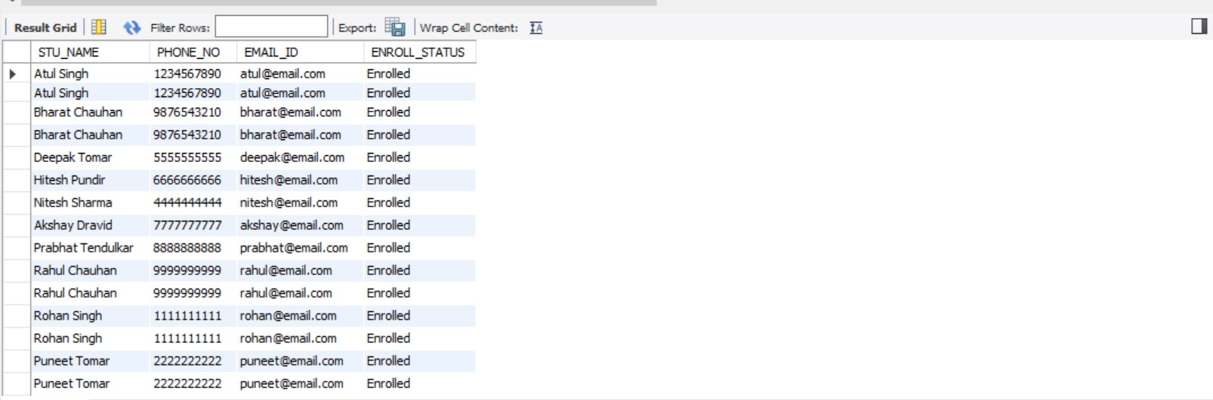

 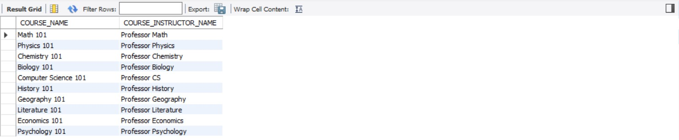

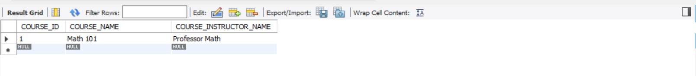



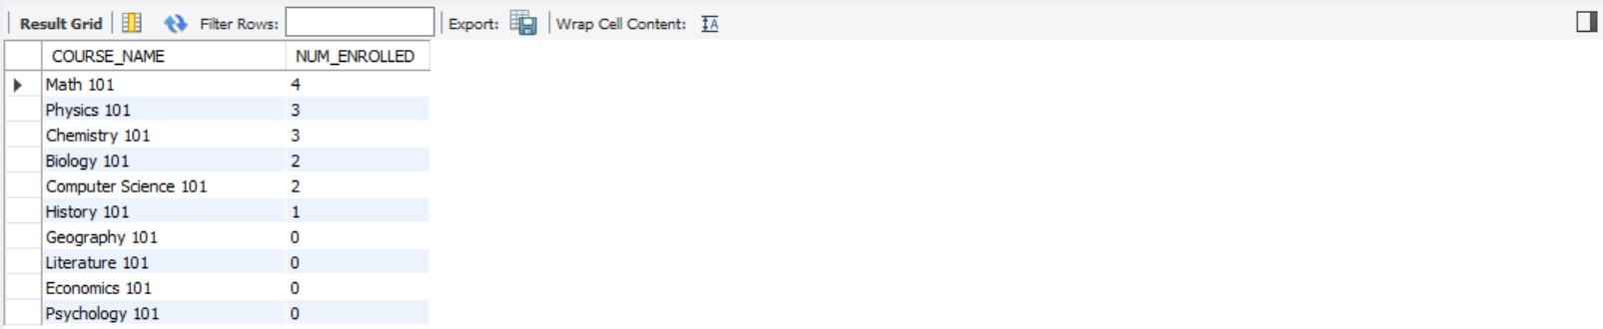

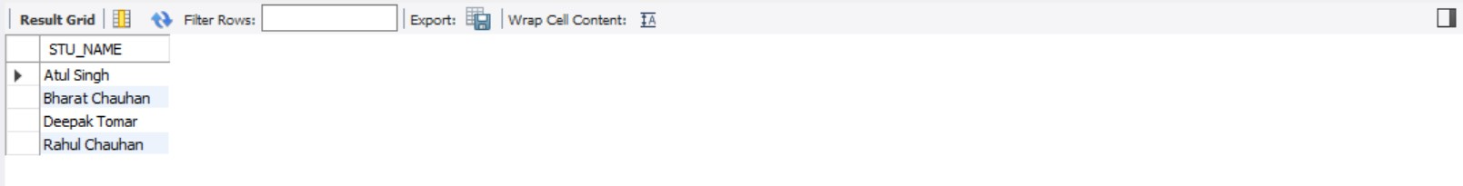

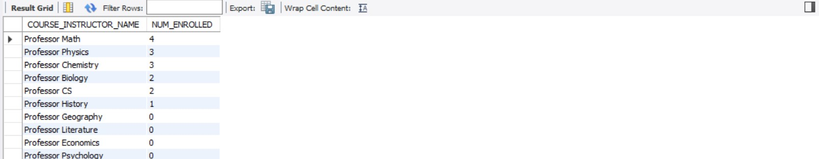

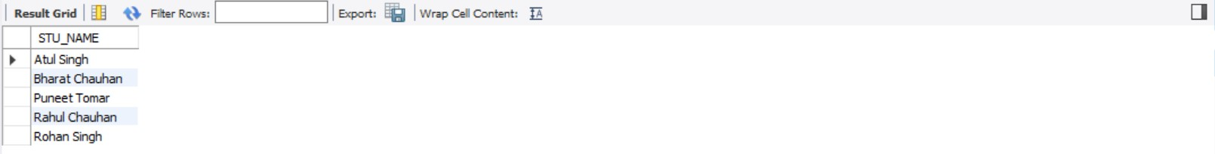

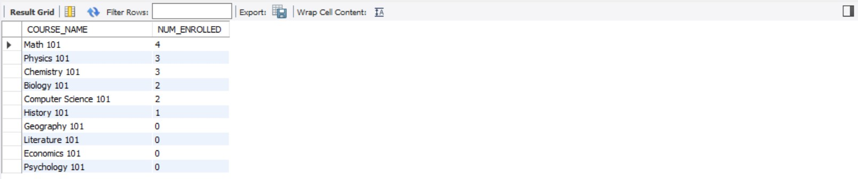

**TASK 2**  
  
CREATE DATABASE student_database;

CREATE TABLE student_info (

student_id SERIAL PRIMARY KEY,

stu_name TEXT,

department TEXT,

email_id TEXT,

phone_no NUMERIC,

address TEXT,

date_of_birth DATE,

gender TEXT,

major TEXT,

gpa NUMERIC,

grade TEXT

);

INSERT INTO student_info (stu_name, department, email_id, phone_no, address, date_of_birth, gender, major, gpa, grade)

VALUES

('Atul Singh', 'Computer Science', 'atul@yahoo.com', 1234567890, 'Mumbai', '1995-05-15', 'Male', 'Computer Engineering', 3.9, 'A'),

('Bharat Chauhan', 'Mathematics', 'bharat@yahoo.com', 9876543210, 'Delhi', '1996-03-20', 'Male', 'Applied Mathematics', 4.2, 'A'),

('Deepak Tomar', 'Electrical Engineering', 'deepak@yahoo.com', 5555555555, 'Chennai', '1997-07-12', 'Male', 'Power Systems', 3.7, 'B'),

('Hitesh Pundir', 'Physics', 'hitesh@yahoo.com', 6666666666, 'Kolkata', '1998-09-03', 'Male', 'Quantum Physics', 4.0, 'A'),

('Nitesh Sharma', 'Chemistry', 'nitesh@yahoo.com', 4444444444, 'Bangalore', '1999-01-09', 'Male', 'Inorganic Chemistry', 3.2, 'B'),

('Akshay Dravid', 'Economics', 'akshay@yahoo.com', 7777777777, 'Hyderabad', '1995-02-18', 'Male', 'Macroeconomics', 3.8, 'A'),

('Prabhat Tendulkar', 'Computer Science', 'prabhat@yahoo.com', 8888888888, 'Pune', '1996-04-30', 'Male', 'Machine Learning', 4.3, 'A'),

('Rahul Chauhan', 'Physics', 'rahul@yahoo.com', 9999999999, 'Jaipur', '1997-08-27', 'Male', 'Astrophysics', 3.5, 'B'),

('Rohan Singh', 'History', 'rohan@yahoo.com', 1111111111, 'Lucknow', '1998-12-10', 'Male', 'World History', 3.9, 'A'),

('Puneet Tomar', 'Mathematics', 'puneet@yahoo.com', 2222222222, 'Mumbai', '1999-06-06', 'Male', 'Number Theory', 3.6, 'B');

SELECT * FROM student_info ORDER BY grade DESC;

SELECT * FROM student_info WHERE gender = 'Male';

SELECT * FROM student_info WHERE gpa < 5.0;

UPDATE student_info

SET email_id = 'new_email@gmail.com', grade = 'D'

WHERE student_id = 3;

SELECT stu_name, date_part('year', age(current_date, date_of_birth)) AS age

FROM student_info

WHERE grade = 'B';

SELECT department, gender, AVG(gpa) AS avg_gpa

FROM student_info

GROUP BY department, gender;

ALTER TABLE student_info RENAME TO student_table;

SELECT stu_name

FROM student_table

ORDER BY gpa DESC

LIMIT 1;

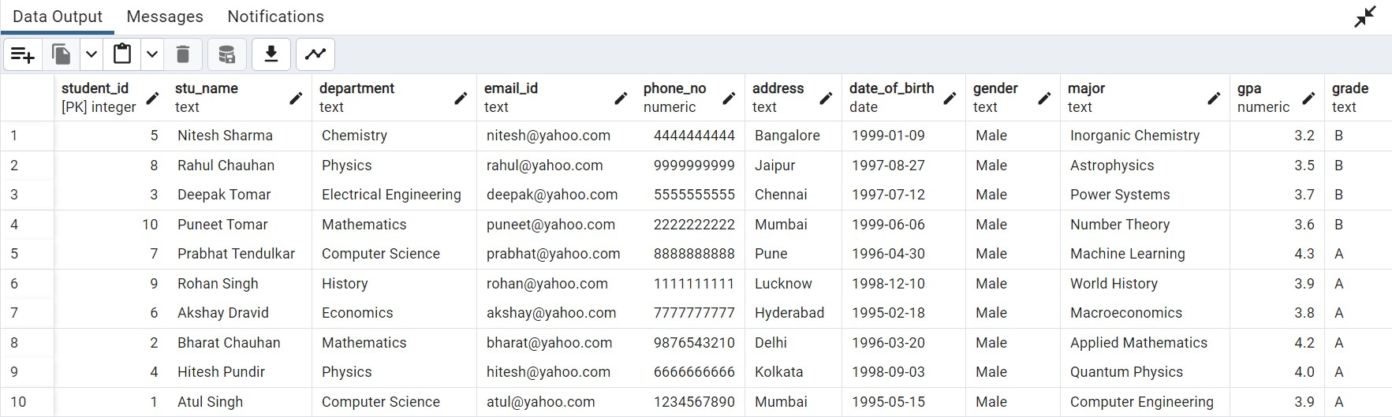

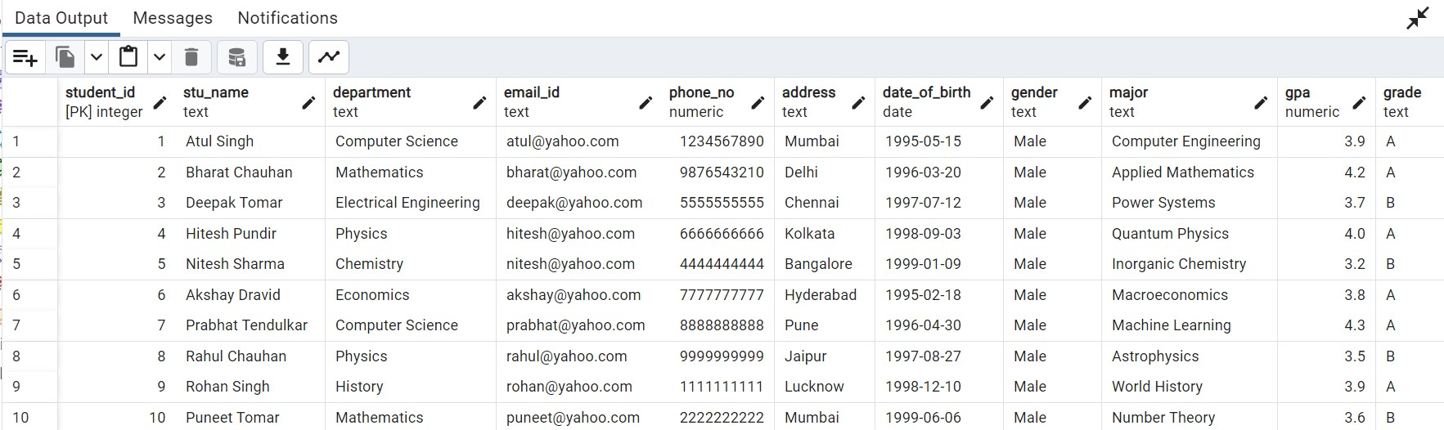

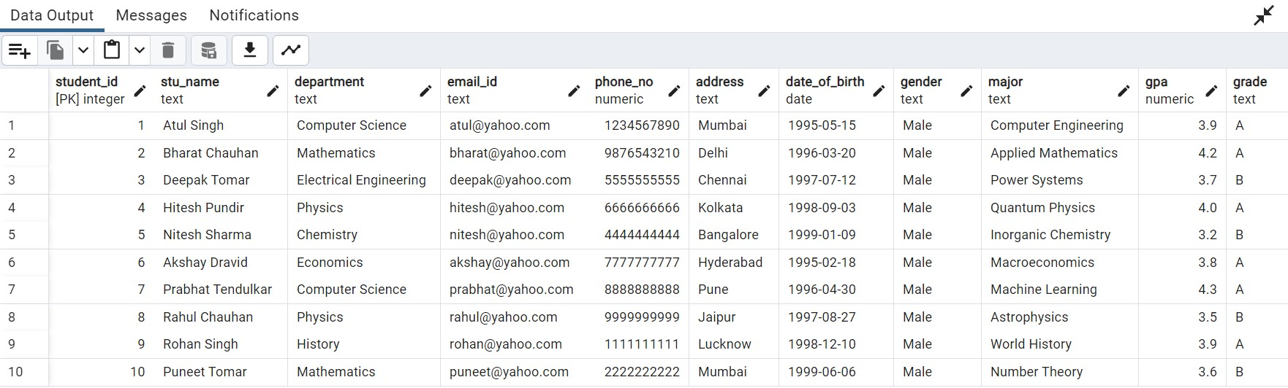

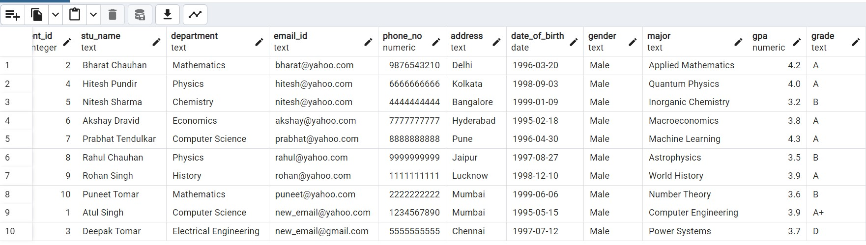

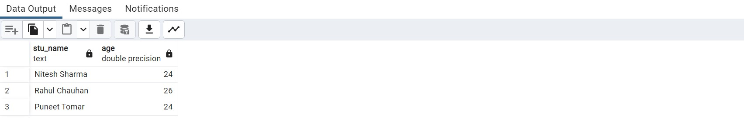

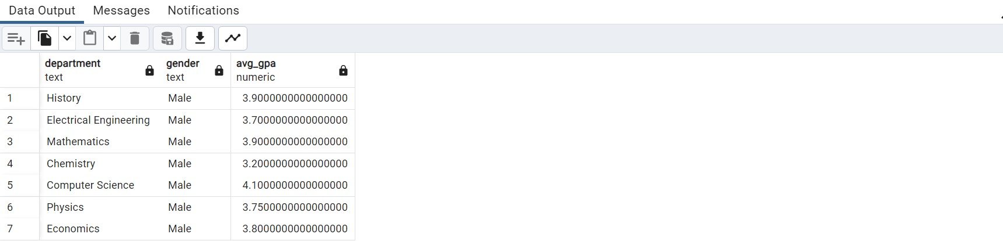

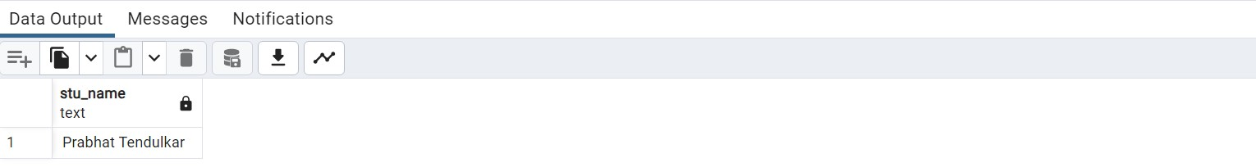

**TASK 3**  
  
  
CREATE DATABASE EventsManagement;

CREATE TABLE Events (

Event_Id SERIAL PRIMARY KEY,

Event_Name TEXT,

Event_Date DATE,

Event_Location TEXT,

Event_Description TEXT

);

CREATE TABLE Attendees (

Attendee_Id SERIAL PRIMARY KEY,

Attendee_Name TEXT,

Attendee_Phone NUMERIC,

Attendee_Email TEXT,

Attendee_City TEXT

);

CREATE TABLE Registrations (

Registration_Id SERIAL PRIMARY KEY,

Event_Id INT,

Attendee_Id INT,

Registration_Date DATE,

Registration_Amount NUMERIC,

FOREIGN KEY (Event_Id) REFERENCES Events(Event_Id),

FOREIGN KEY (Attendee_Id) REFERENCES Attendees(Attendee_Id)

);

INSERT INTO Events (Event_Name, Event_Date, Event_Location, Event_Description)

VALUES

('Tech Conference', '2023-05-15', 'Bangalore', 'Annual technology conference'),

('Music Festival', '2023-06-25', 'Mumbai', 'Weekend music festival'),

('Sports Tournament', '2023-07-10', 'Delhi', 'Inter-school sports competition'),

('Food Expo', '2023-08-20', 'Chennai', 'Culinary delights from around the world'),

('Art Exhibition', '2023-09-05', 'Kolkata', 'Display of contemporary art');

INSERT INTO Attendees (Attendee_Name, Attendee_Phone, Attendee_Email, Attendee_City)

VALUES

('Akshay Sharma', 9876543210, 'akshay@gmail.com', 'Bangalore'),

('Deepika Chauhan', 9988776655, 'deepika@gmail.com', 'Mumbai'),

('Rahul Tomar', 7777777777, 'rahul@gmail.com', 'Delhi'),

('Neha Singh', 8888888888, 'neha@gmail.com', 'Kolkata'),

('Anjali Reddy', 9999999999, 'anjali@gmail.com', 'Chennai');

INSERT INTO Registrations (Event_Id, Attendee_Id, Registration_Date, Registration_Amount)

VALUES

(1, 1, '2023-04-20', 500),

(1, 2, '2023-04-21', 500),

(2, 2, '2023-05-05', 750),

(3, 3, '2023-06-10', 300),

(3, 4, '2023-06-11', 300);

INSERT INTO Events (Event_Name, Event_Date, Event_Location, Event_Description)

VALUES ('Tech Workshop', '2023-10-15', 'Pune', 'Hands-on technology workshop');

UPDATE Events

SET Event_Description = 'Annual technology and innovation conference'

WHERE Event_Id = 1;

DELETE FROM Events WHERE Event_Id = 5;

INSERT INTO Attendees (Attendee_Name, Attendee_Phone, Attendee_Email, Attendee_City)

VALUES ('Sarika Verma', 7771112223, 'sarika@gmail.com', 'Hyderabad');

INSERT INTO Registrations (Event_Id, Attendee_Id, Registration_Date, Registration_Amount)

VALUES (2, 3, '2023-05-10', 750);

SELECT * FROM Events;

SELECT A.Attendee_Name, A.Attendee_Email

FROM Attendees A

JOIN Registrations R ON A.Attendee_Id = R.Attendee_Id

WHERE R.Event_Id = 2;

SELECT COUNT(*) AS total_attendees, AVG(Registration_Amount) AS avg_registration_amount

FROM Registrations

WHERE Event_Id = 1;

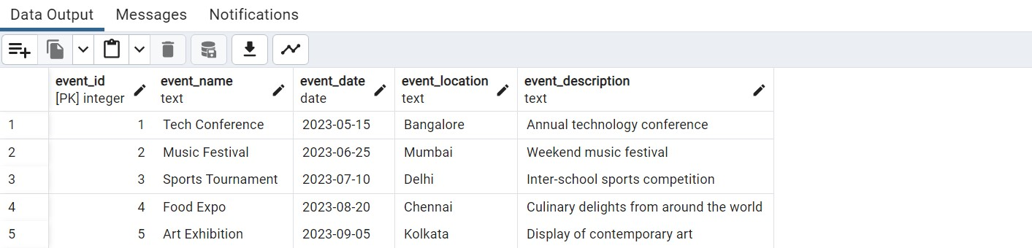

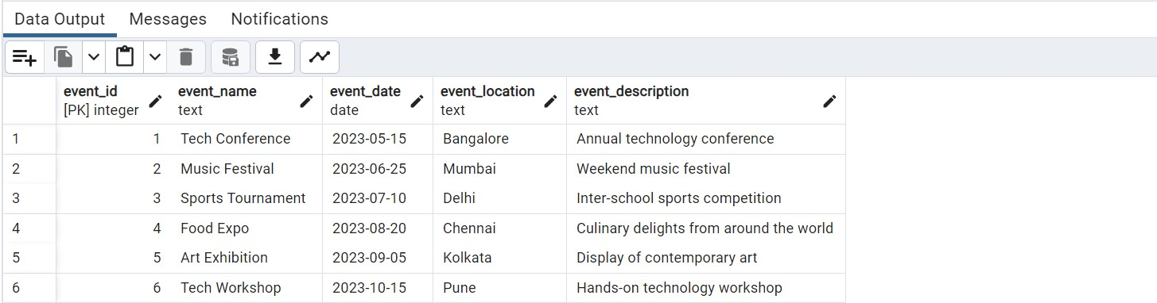

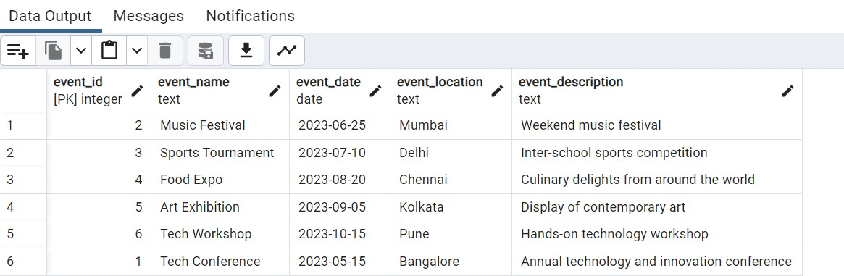

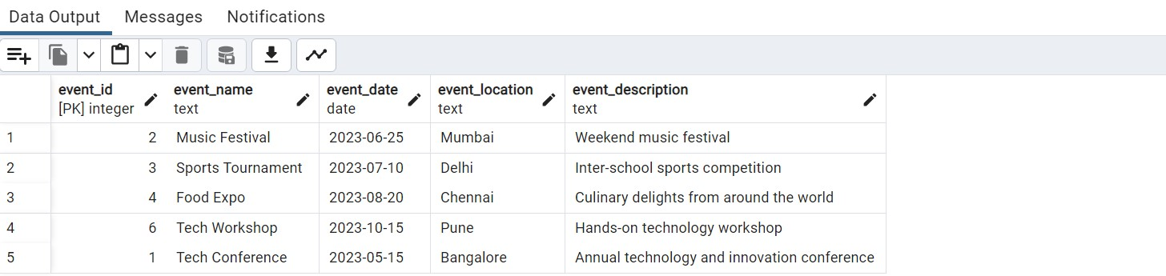

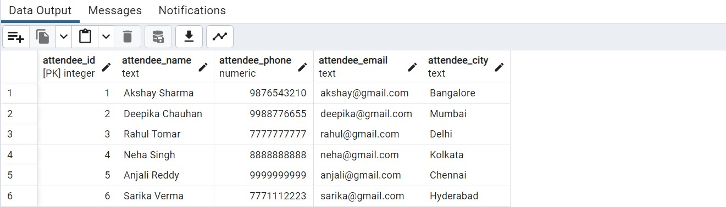

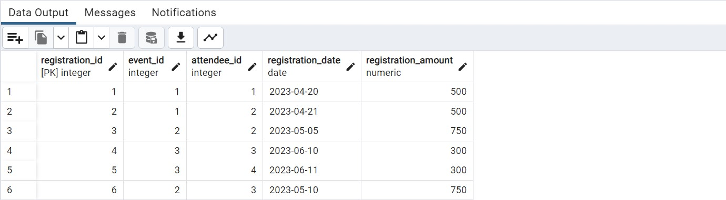

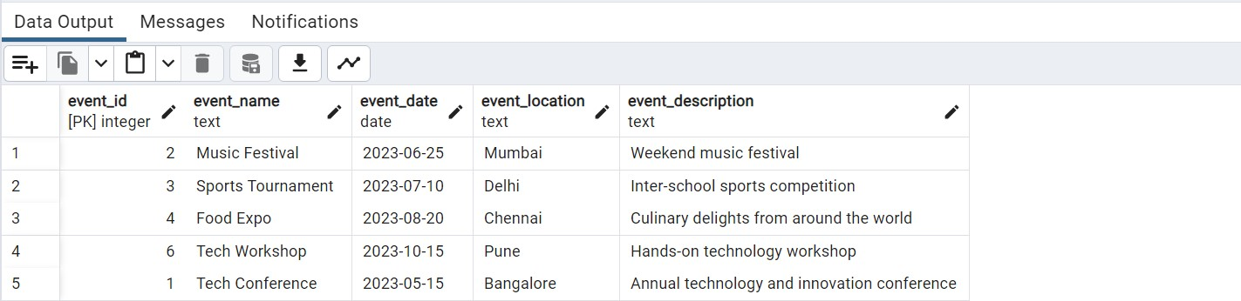

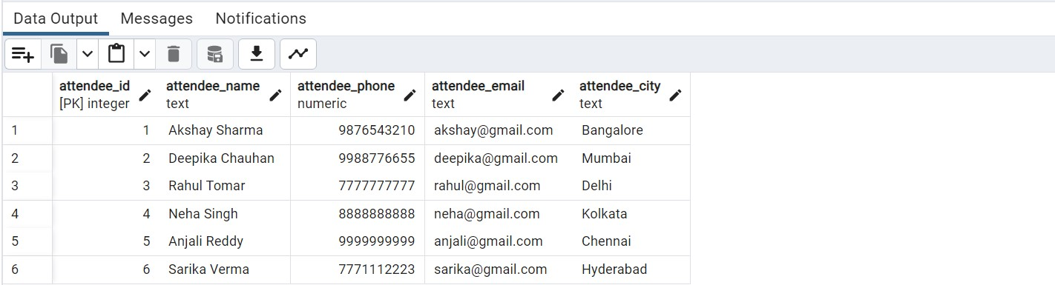

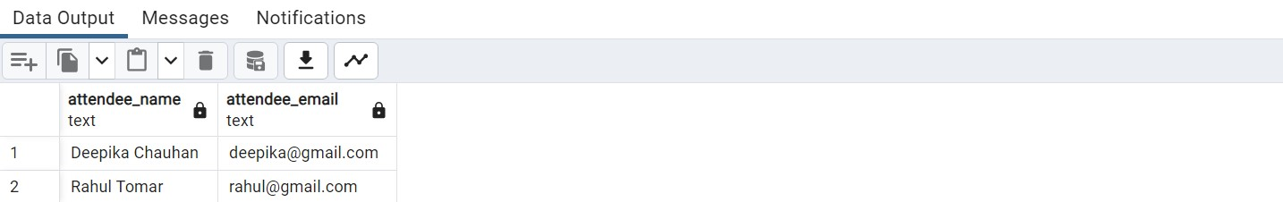

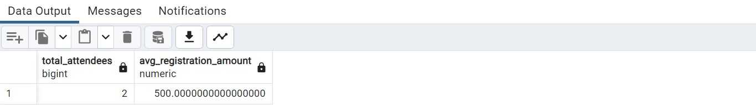

**TASK 4**  
  
CREATE DATABASE SalesData;

CREATE TABLE sales_sample (

Product_id SERIAL PRIMARY KEY,

Region VARCHAR(50),

Date DATE,

Sales_Amount NUMERIC

);

INSERT INTO sales_sample (Region, Date, Sales_Amount)

VALUES

('East', '2023-01-05', 1000.00),

('West', '2023-01-10', 750.00),

('North', '2023-02-15', 1200.00),

('South', '2023-03-20', 900.00),

('East', '2023-04-25', 1100.00),

('West', '2023-05-30', 850.00),

('North', '2023-06-05', 1300.00),

('South', '2023-07-10', 950.00),

('East', '2023-08-15', 1050.00),

('West', '2023-09-20', 800.00);

SELECT Region, Product_id, SUM(Sales_Amount) AS Total_Sales

FROM sales_sample

GROUP BY Region, Product_id

ORDER BY Region, Product_id;

SELECT Region, SUM(Sales_Amount) AS Total_Sales

FROM sales_sample

GROUP BY ROLLUP (Region, Product_id)

ORDER BY Region, Product_id;

SELECT Region, Product_id, Date, SUM(Sales_Amount) AS Total_Sales

FROM sales_sample

GROUP BY CUBE (Region, Product_id, Date)

ORDER BY Region, Product_id, Date;

SELECT Region, Date, SUM(Sales_Amount) AS Total_Sales

FROM sales_sample

WHERE Region = 'East' AND Date BETWEEN '2023-04-01' AND '2023-06-30'

GROUP BY Region, Date

ORDER BY Date;

SELECT Region, Product_id, Date, SUM(Sales_Amount) AS Total_Sales

FROM sales_sample

WHERE Region = 'West' AND Product_id = 2 AND Date BETWEEN '2023-01-01' AND '2023-03-31'

GROUP BY Region, Product_id, Date

ORDER BY Date;

