**Lab 02 Report**

**Problem 3 - Problem 5:**

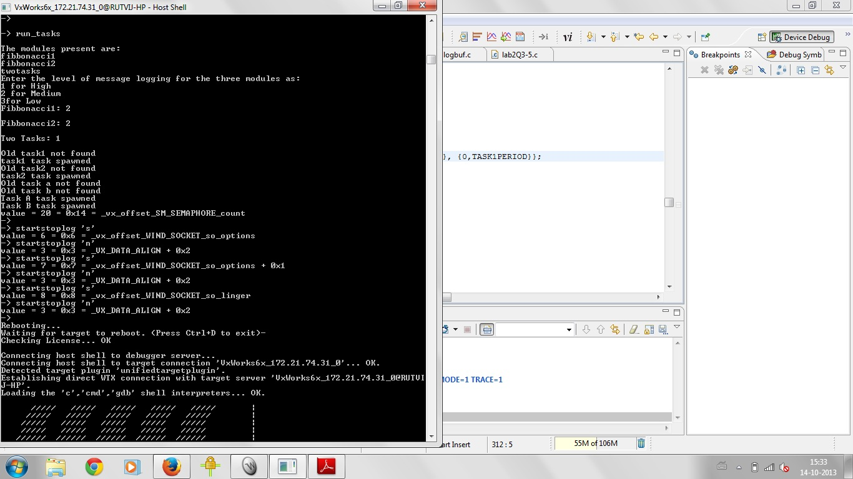

The program starts off by running a driver function 'run_tasks' as shown in the screenshot above. This prints the modules present in the logging system. The program then asks the set the logging level for each system. The logging levels are entered as follows:

* 1 = HIGH
* 2 = MEDUM
* 3 = LOW

To begin logging to a file the 'startstoplog' function is run using the parameter 's' as shown in the screenshot above.

After logging to the function is begun, the logs are stored in the workspace used.

**Problem 6:**

The profiling information of the tasks in the subsystems in printed on the target console. To increase the accuracy of the logging system, 'sysTimestampLock' is used along with the 'tickGet' function since the tickGet function just has an accuracy of 1 tick which in this system corresponds to 1ms.

**Problem 7:**

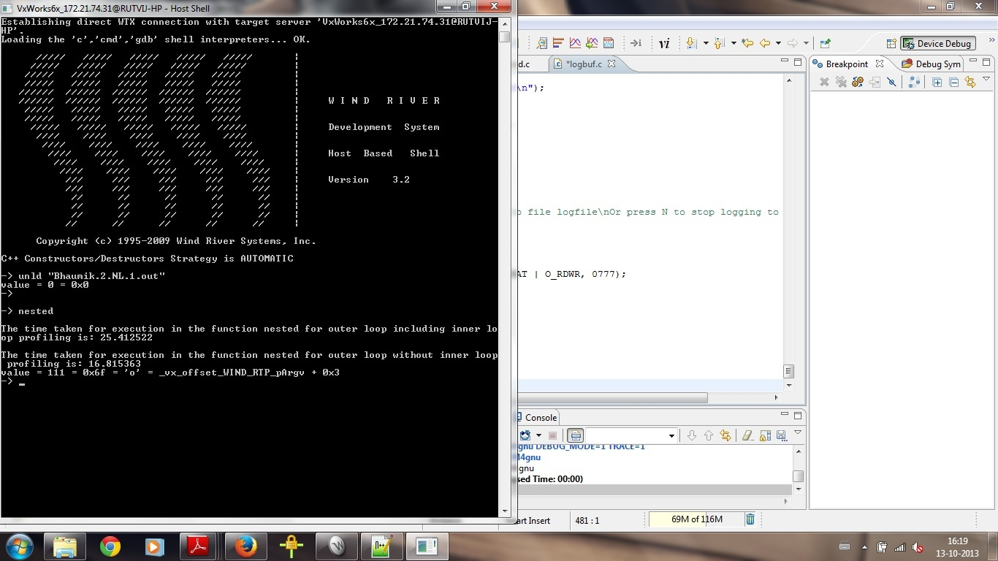

The net impact of profiling code was approximately 9microseconds.

**Problem 8:**

The algorithm was improved by running the loop for x/2 +1 times since the largest factor of a number can be number divided by 2. Also to perform quicksort on a sorted array is a wastage execution time so it is determined within the for loop whether the array is sorted and an improvement of approximately 51% as shown.

