ML-Driven PVT Variation Aware Leakage Estimation
Digital VLSI Design course project. Model file 16nm_HP, nominal VDD 0.9 V, test circuit 3-bit carry-lookahead adder.

Summary
Four transistor models (NMOS and PMOS, ON and OFF; residual neural networks on four 10,000-sample SPICE datasets of the 16nm_HP card) predict the four terminal currents of a transistor from its voltages, width, temperature and five process parameters. Their predictions, taken at the SPICE node voltages, are summed to the leakage of five gates (INV, NAND2, NOR2, AND2, OR2) at 200 PVT corners, and the gate leakages are summed to the leakage of a 3-bit carry-lookahead adder (40 gates, 128 input vectors). Every level is compared with a transistor-level ngspice simulation:
Table 0. Summary of the results (relative error against SPICE)
level | median error [%] | 95th percentile [%] | mean error [%]
Transistor currents (4 models, 1,500 test samples each) | 0.26 to 1.28 | 1.3 to 11.7 | 0.45 to 3.51
Gate leakage (5 gates, 18 input cases x 200 corners = 3,600 points) | 0.58 | 2.37 | 0.83
3-bit CLA leakage, hierarchical (128 vectors x 200 corners = 25,600 points) | 1.50 | 6.15 | 2.07
3-bit CLA with perfect gate models (the composition floor) | 1.37 | 5.25 | 1.85

The R2 of the signed-log currents is at least 0.9996 for every transistor model. The gate-level error is below 3 % for 95 % of the points. The circuit-level error is dominated by the composition method (ideal 0 / VDD gate inputs, no loading), which is prescribed by the project and costs a median of 1.37 % even with perfect gate models; it grows with temperature (sections 5.1 and 6.5). The most useful single step for the accuracy was to give the two OFF models extra training samples near the supply rails, where the gates operate (section 3.5).

1. Setup
Table 1. Assignment and tools
Item | Value
Model file | 16nm_HP: PTM high-performance 16 nm, metal gate / high-k, BSIM4 (level 54), TNOM 27 degC
Nominal VDD | 0.9 V (the file header says 0.7 V; the assigned 0.9 V is used, so VDD is sampled between 0.81 V and 0.99 V)
Geometry | L = 16 nm (= Lmin); W between 1 x Lmin and 8 x Lmin, i.e. 16 nm to 128 nm
Test circuit | 3-bit carry-lookahead adder with carry-in (7 inputs, 128 input vectors)
Simulator | ngspice-42, batch mode (ngspice -b), run through WSL on Windows 11; .options gmin=1e-18 abstol=1e-18 reltol=1e-6 vntol=1e-9 in every netlist; set numdgt = 15 so that currents are printed with 15 digits
Software | Python 3.12.8, numpy 1.26.4, pandas 2.2.3, scikit-learn 1.5.1, LightGBM 4.6.0, PyTorch 2.7.0 (CPU), matplotlib 3.9.2

The work is organised as seven self-contained Jupyter notebooks (notebooks/01 to 07), run in order by scripts/run_all.py; all random choices use fixed seeds. They produce the datasets (data/), the example netlists (netlists/), the four saved models (models/) and all tables and plots (results/).

2. Data generation

2.1 Sampling
For each of the four cases (NMOS ON, NMOS OFF, PMOS ON, PMOS OFF) 10,000 samples were drawn with the distributions of the project text. VDD is drawn first (uniform, 0.9 V +/- 10 %); then the drain and source voltages (uniform between 0 and the sampled VDD), the width (uniform 16 nm to 128 nm), the temperature (uniform -40 to 125 degC) and the five process parameters vth0, toxe, ndep, u0, xj (uniform, nominal value of the model card +/- 10 %, separately for the NMOS and the PMOS card). The gate and body voltages are fixed by the case: NMOS ON (VDD, 0), NMOS OFF (0, 0), PMOS ON (0, VDD), PMOS OFF (VDD, VDD). Every parameter of every sample is drawn independently; the seeds are 20261105 + case index.
Table 2. Nominal process parameters read from the model file
parameter | NMOS nominal | PMOS nominal
vth0 [V] | 0.47965 | -0.43121
toxe [m] | 9.5e-10 | 1.0e-9
ndep [1/cm3] | 7.0e18 | 5.5e18
u0 [m2/Vs] | 0.030 | 0.006
xj [m] | 5.0e-9 | 5.0e-9

2.2 Netlists and simulation
Each sample is simulated in a one-transistor netlist with its own voltage source on every terminal (Vd, Vg, Vs, Vb); the terminal currents flowing into the device are the negatives of the source currents. The junction areas are given explicitly, AD = AS = W x 32 nm (without them the OFF-state body current of the model is 12 to 23 times too large; the value of the diffusion length between 22 nm and 44 nm changes the currents by less than 0.004 %). The process parameters are set per sample with altermod (one altermod line per parameter, since only the first parameter on a line is applied), the temperature with set temp, the voltages, the width and the junction areas with alter, and an operating point (op) is run. 250 samples go into one ngspice script and the scripts run in parallel processes (17 to 26 s per dataset on the machine used). A sample whose operating point failed would be detected (the printed node voltages must equal the applied ones) and redrawn; none failed. A sample simulated alone gives exactly the same currents as inside its batch (checked on 5 random samples per case). Example netlists: netlists/single_<case>.cir.

2.3 Data check
Table 3. Kirchhoff check: the four terminal currents of every sample sum to zero
case | rows | max |sum of the 4 currents| [A] | median [A] | passes
NMOS ON | 10,000 | 1.55e-15 | 8.99e-17 | yes
NMOS OFF | 10,000 | 8.49e-19 | 4.80e-23 | yes
PMOS ON | 10,000 | 9.84e-16 | 3.24e-17 | yes
PMOS OFF | 10,000 | 1.30e-15 | 8.08e-17 | yes

The residual is at the level of the solver tolerance (at most 1.5e-15 A, against terminal currents of up to 3e-4 A). Three trend plots check the physics of the data (all Spearman correlations have the expected sign):
Table 4. Trend checks
case | relation | Spearman | expected sign | as expected
NMOS OFF | temperature | +0.235 | + | yes
NMOS OFF | |vth0| | -0.218 | - | yes
PMOS OFF | temperature | +0.297 | + | yes
PMOS OFF | |vth0| | -0.153 | - | yes
NMOS ON | toxe -> |ig| | -0.399 | - | yes
NMOS OFF | toxe -> |ig| | -0.597 | - | yes
PMOS ON | toxe -> |ig| | -0.184 | - | yes
PMOS OFF | toxe -> |ig| | -0.683 | - | yes

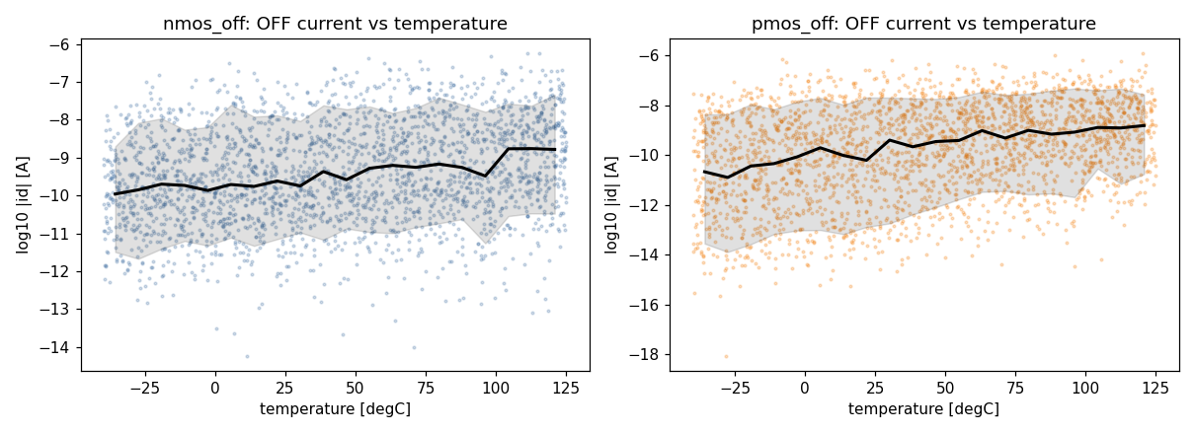
Figure 1. OFF-state leakage current against temperature (increases with temperature).
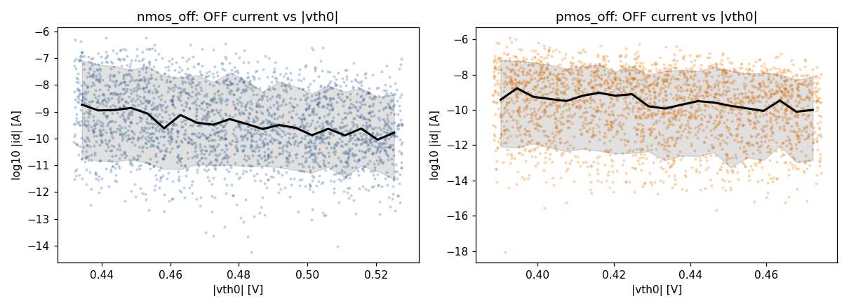
Figure 2. OFF-state leakage current against |vth0| (decreases with a higher threshold).
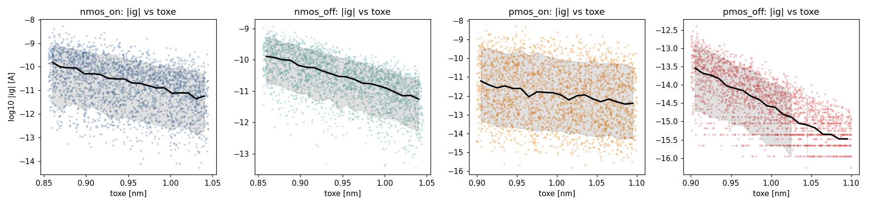
Figure 3. Gate current against oxide thickness (decreases with a thicker oxide).
One property of the data matters for the models: the simulator reports small currents only to a finite resolution. Many values are exact multiples of 2^-51 A = 4.4e-16 A (for example 44 % of the NMOS-ON gate currents and 43 % of the PMOS-OFF gate currents), so below about 1e-14 A a rounding of one quantum is more than 1 % of the current.

2.4 Split
Each dataset is split at random into 70 % training (7,000), 15 % validation (1,500) and 15 % test samples (1,500) with the fixed seed 20261105. The same split is used for every model type. All choices (options, number of trees or epochs, selection of the final model) are made on the training and validation samples; the test samples are used once, for the chosen models.

3. Transistor models

3.1 Preprocessing
- Source/drain canonicalisation. A transistor is symmetric in drain and source, so every sample is mapped to one orientation (Vds >= 0 for NMOS, Vsd >= 0 for PMOS; id and is swap with the terminals). This fixes the sign of id and is in the ON cases and removes the sign change at Vd = Vs from the learning problem. The saved models do this internally and swap the currents back.
- Target transform. The four currents span about 11 decades and some change sign, so the models predict arcsinh(I / I0) with I0 = 1e-14 A (a relative scale for large currents, linear near zero, sign kept). I0 was chosen on the validation samples (1e-16 to 1e-13 A tried); a smaller value makes the network chase the 4.4e-16 A resolution of the data (PMOS OFF: 11.3 % median error at 1e-16 A, 2.0 % at 1e-14 A, residual MLP).
- Vds-aware target (option). The BSIM sub-threshold current contains the factor 1 - exp(-Vds / V_T). For id and is the current is divided by this factor before the transform, which makes the ON-state current at |Vds| of microvolts to millivolts (where the transistors inside gates operate) a smooth function. It is chosen per case on the validation samples.
- Features. The 12 raw inputs plus 8 physics features: q/kT, Vgs, Vds, Vbs, Vgd, (Vgs - vth0)/V_T, Vds/V_T and ln W (source-referenced, sign mirrored for PMOS). Inputs and targets are standardised with training-set statistics only.

3.2 Model types and hyperparameters
One model per case, each predicting the four currents id, ig, is, ib. Four model types were compared:
Table 5. Model types
model type | main hyperparameters
Polynomial ridge regression | polynomial features of the standardised inputs (degrees 2 to 4 on the 12 raw inputs, 2 to 3 on the 20 physics features, at most about 1,800 terms); ridge penalty chosen per target by leave-one-out cross-validation on the training samples
Gradient boosting (LightGBM) | one regressor per current, 31 leaves, learning rate 0.05, up to 3,000 trees with early stopping on the validation samples, row/column subsampling 0.8/0.9, deterministic
MLP | 3 hidden layers of 256 units, SiLU activation; AdamW (weight decay 1e-5), batch 256, one-cycle learning rate (peak 3e-3), 600 epochs, seed 0; the epoch with the lowest validation MSE is kept
Residual MLP (ResNN) | input layer of 128 units, 4 residual blocks h <- SiLU(h + Linear(SiLU(Linear(h)))), linear output; same training as the MLP

For each model type and case the option sets (raw or physics features, Vds-aware target or not; for the networks MSE or Huber loss) were compared on the validation samples, and the best one is reported. Selection rule: the lowest mean over the four currents of the median relative error |pred - true| / |true| (rows with |I| >= 1e-15 A, where the solver floor is not dominant; the project text does not define "error", this definition is used throughout).

3.3 Model comparison on the validation set (deliverable 4)
Table 6. Validation set. Columns per model type (in order: polynomial ridge, LightGBM, MLP, residual MLP): R2 of the signed-log currents, median and 95th-percentile relative error (mean over the four currents)
case | R2 | med. % | p95 % | R2 | med. % | p95 % | R2 | med. % | p95 % | R2 | med. % | p95 %
NMOS ON | 0.9980 | 7.06 | 27.7 | 0.9983 | 5.90 | 27.8 | 1.0000 | 0.54 | 3.2 | 1.0000 | 0.39 | 2.2
NMOS OFF | 0.9736 | 33.43 | 268.9 | 0.9941 | 7.56 | 39.6 | 0.9987 | 0.86 | 8.6 | 0.9995 | 0.59 | 4.1
PMOS ON | 0.9983 | 8.26 | 31.1 | 0.9981 | 7.62 | 31.9 | 1.0000 | 0.36 | 1.9 | 1.0000 | 0.24 | 1.2
PMOS OFF | 0.9875 | 25.58 | 175.8 | 0.9975 | 8.87 | 38.5 | 0.9995 | 1.67 | 14.2 | 0.9996 | 1.24 | 9.9

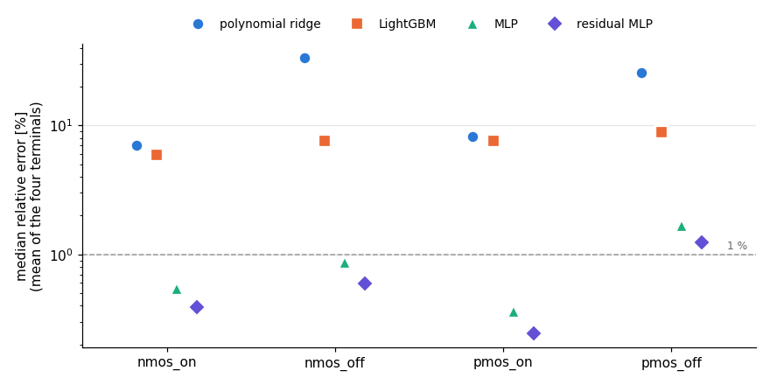
Figure 4. Median relative error of the four model types (validation set, log axis).
Reason for the final choice. The residual MLP has the lowest validation error in all four cases; its median error is 7 to 31 times lower than the best of the two classical models (polynomial ridge cannot follow currents that span many decades, LightGBM produces piece-wise constant predictions) and 1.35 to 1.5 times lower than the plain MLP. The final models are therefore the four residual MLPs: NMOS ON and PMOS ON with the Vds-aware target and Huber loss, NMOS OFF without the Vds-aware target (MSE loss), PMOS OFF with it (MSE loss), all with the physics features and 600 epochs.

3.4 Final models on the test set (deliverable 5)
Table 7. Final models, test set (1,500 samples per case; errors are means over the four currents; the models are scored from the saved files in `models/`)
case (residual MLP) | version | validation median [%] | test median [%] | test 95th pct [%] | test mean [%] | test R2 (log)
NMOS ON | as chosen | 0.39 | 0.37 | 2.19 | 0.73 | 1.0000
NMOS OFF | refined (section 3.5) | 0.74 | 0.69 | 4.64 | 1.62 | 0.9996
PMOS ON | as chosen | 0.24 | 0.26 | 1.31 | 0.45 | 1.0000
PMOS OFF | refined (section 3.5) | 1.29 | 1.28 | 11.68 | 3.51 | 0.9996

Table 8. Final models, test set, per current
case | current | median [%] | 95th pct [%] | mean [%] | median, |Vds| < 5 mV [%]
NMOS ON | id | 0.40 | 2.47 | 0.83 | 1.22
NMOS ON | ig | 0.36 | 1.97 | 0.65 | 0.72
NMOS ON | is | 0.37 | 2.20 | 0.76 | 0.93
NMOS ON | ib | 0.36 | 2.10 | 0.69 | 0.61
NMOS OFF | id | 0.47 | 2.63 | 0.94 | 0.52
NMOS OFF | ig | 0.36 | 1.95 | 0.61 | 0.33
NMOS OFF | is | 1.09 | 9.67 | 3.59 | 0.75
NMOS OFF | ib | 0.84 | 4.29 | 1.34 | 0.88
PMOS ON | id | 0.28 | 1.25 | 0.43 | 0.85
PMOS ON | ig | 0.23 | 1.28 | 0.51 | 0.55
PMOS ON | is | 0.28 | 1.16 | 0.42 | 0.56
PMOS ON | ib | 0.23 | 1.55 | 0.46 | 0.58
PMOS OFF | id | 1.31 | 10.12 | 3.46 | 26.52
PMOS OFF | ig | 1.35 | 16.07 | 4.09 | 1.14
PMOS OFF | is | 1.56 | 15.35 | 4.86 | 34.64
PMOS OFF | ib | 0.91 | 5.18 | 1.63 | 1.47

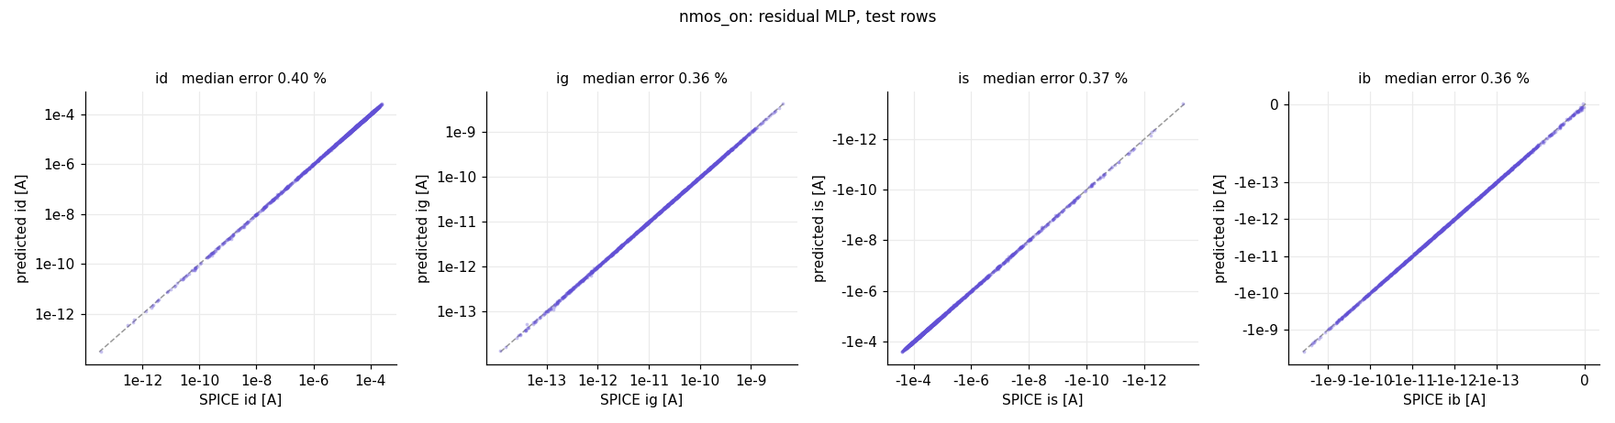
Figure: predicted against SPICE currents, NMOS ON (1,500 test samples, symmetric-log axes, dashed line = identity).
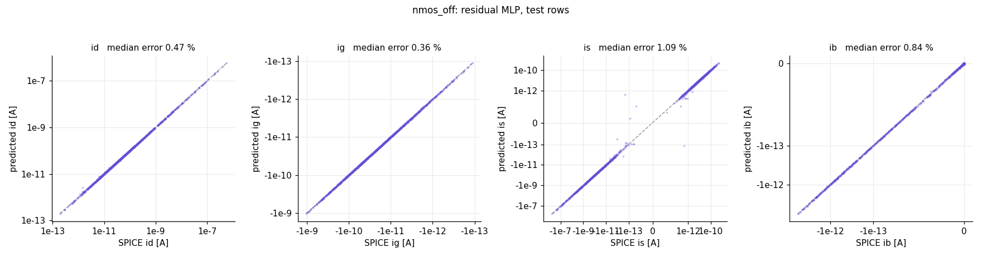
Figure: predicted against SPICE currents, NMOS OFF (1,500 test samples, symmetric-log axes, dashed line = identity).
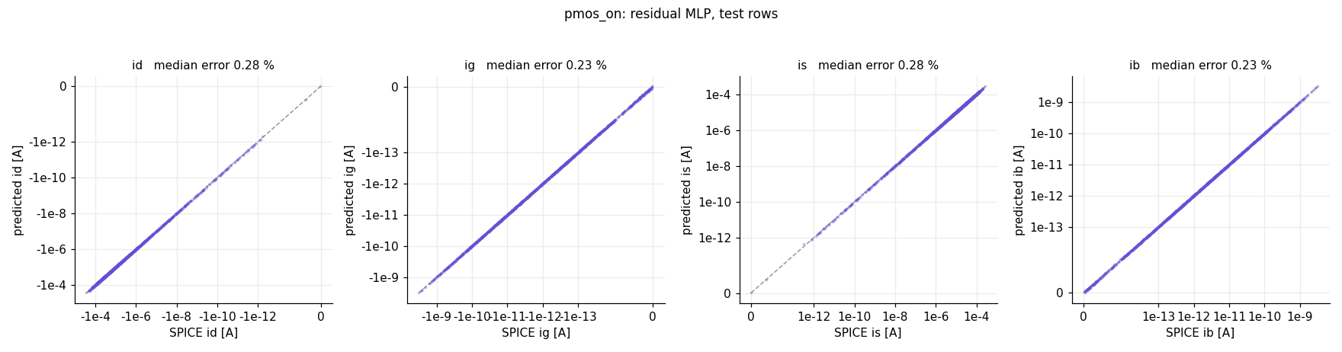
Figure: predicted against SPICE currents, PMOS ON (1,500 test samples, symmetric-log axes, dashed line = identity).
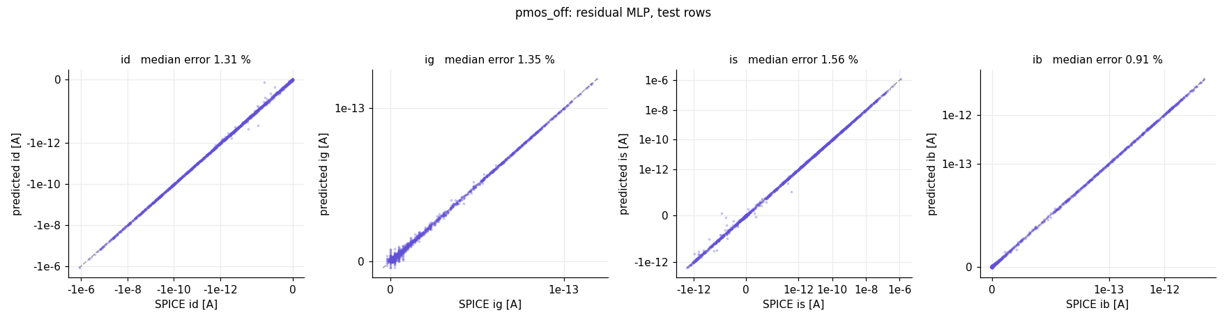
Figure: predicted against SPICE currents, PMOS OFF (1,500 test samples, symmetric-log axes, dashed line = identity).
The test errors agree with the validation errors (the test median differs from the validation median by at most 0.05 percentage points), so the choices made on the validation samples left little optimism. The median error is below 1 % for 3 of the four cases (NMOS ON, NMOS OFF, PMOS ON); PMOS OFF (1.28 %) is above it; the 95th percentile is 1.3 % to 11.7 % and the mean error 0.45 % to 3.51 % (a few samples with large relative errors, in currents close to the resolution of the data, raise the mean above the median). The R2 of the signed-log currents is at least 0.9996 in every case (the slide target R2 > 0.99). The hardest currents are is of PMOS OFF (median 1.56 %), ig of PMOS OFF (median 1.35 %), id of PMOS OFF (median 1.31 %): small currents that are sums of components of opposite sign. In the region of small |Vds| (< 5 mV), where the ON transistors of gates operate, the median error is 0.33 % to 1.47 % for all currents except the channel currents of PMOS OFF, for which it is 26.5 % (id) and 34.6 % (is) on only 18 and 17 test samples.

3.5 Refinement of the OFF models with extra samples near the rails
The transistors inside a gate operate at the corners of the (Vd, Vs) square: a terminal is at a supply rail or at an internal node close to one. The uniform datasets have only 6 % of their Vd values within 3 % of VDD of a rail, and the gate-level error analysis (section 6) showed that almost all gate-level error comes from the two OFF models there, because the OFF transistors carry almost all of the leakage. Notebook 01 (section 9) therefore draws 6,000 extra samples per OFF case with the same procedure and ranges as the datasets, except that each of Vd and Vs is drawn from a mixture (1/3 uniform, 1/3 within 3 % of VDD of 0 V, 1/3 within 3 % of VDD of VDD); about two thirds of the values then lie near a rail. They satisfy the same Kirchhoff check and are used only as additional training samples. Each OFF model is retrained with exactly the settings chosen in section 3.3 (residual MLP, same target options, loss, epochs, seed and scalers) on the 7,000 uniform training rows plus 5,000 of the extra samples; the other 1,000 extra samples form a separate rail validation set. The refined model replaces the chosen one if it lowers both the median and the 95th-percentile error on the rail validation set and raises the median error on the uniform validation rows by less than 0.5 percentage points (a rule evaluated on validation data only; the test rows play no part in the decision). The idea of the refinement comes from the gate-level analysis (which showed where the error is), but no gate-level data are used to train, select or tune any model.
Table 8b. Effect of the refinement (mean over the four currents; the test rows are shown for information only)
case | rows | as chosen: median [%] | refined: median [%] | as chosen: 95th pct [%] | refined: 95th pct [%]
NMOS OFF | uniform validation | 0.59 | 0.74 | 4.1 | 5.7
NMOS OFF | rail validation | 1.43 | 0.97 | 43.1 | 8.5
NMOS OFF | uniform test | 0.60 | 0.69 | 3.8 | 4.6
PMOS OFF | uniform validation | 1.24 | 1.29 | 9.9 | 11.2
PMOS OFF | rail validation | 2.02 | 1.30 | 26.6 | 12.8
PMOS OFF | uniform test | 1.21 | 1.28 | 9.3 | 11.7

The refined model was adopted for NMOS OFF and PMOS OFF; the ON models are unchanged (their leakage is a negligible part of the gate leakage). The effect on the gate-level and the circuit-level error is shown in sections 4.4 and 5.1.

4. Gate-level validation (Part B)

4.1 Gates, sizing and corners
The five gates are standard static CMOS (INV, NAND2, NOR2) with AND2 = NAND2 + INV and OR2 = NOR2 + INV, simulated as complete transistor-level netlists (one netlists/gate_<gate>.cir per gate). The sizes follow the convention of the course slides (inverter Wp = 2 Wn; devices in a series stack scaled by the stack height) with a drive-strength multiplier XX = 2: INV 32 nm / 64 nm (NMOS / PMOS), NAND2 64 nm / 64 nm, NOR2 32 nm / 128 nm, and the INV inside AND2 and OR2 as above; all widths are within the allowed 16 nm to 128 nm. (XX = 1 would put the NMOS of the INV and NOR2 at exactly the minimum width, the edge of the training range, where the models are least accurate; Table 11 shows the effect.) The ground rail is connected through a 0 V source so that its current can be read, which gives a Kirchhoff check for every gate. Every gate netlist contains the required .options line.
A corner is one random draw of VDD (0.9 V +/- 10 %), temperature (-40 to 125 degC) and the five process parameters (nominal +/- 10 %), drawn separately for the NMOS and the PMOS card, so that all NMOS of a gate share one draw and all PMOS another. 200 corners were drawn once (seed 20261105 + 100, data/corners.csv) and are used for all gates and for the test circuit. For each of the 18 gate and input cases (INV: A = 0, 1; the other gates: AB = 00, 01, 10, 11) every corner is simulated: 3,600 operating points. Per corner the process parameters are set on the shared model cards, per input pattern the input sources, and the supply current, the input currents and all internal and output node voltages are recorded. Checks on the reference: every output is within 30 mV of its logic rail, the four source currents sum to at most 2.0e-15 A, 12 points simulated alone reproduce the batch exactly, and the supply delivers current in every point.

4.2 How the gate leakage is defined and computed
SPICE reference. The leakage current of a gate is the power drawn from the supply and from the inputs held at VDD, divided by VDD (the definition of the instructor's inverter leakage netlist: supply power plus input-source power). An input at 0 V delivers no power. By Kirchhoff's laws this is the current that flows from the VDD level to the 0 V level through the gate, and it is additive when gates drive each other. The supply current alone, -I(VDD), differs from it (relative to the supply current) by less than 3.5 % except for NOR2 with inputs 11, where the supply current is the smallest of all states and the gate currents of the two inputs held at VDD are comparable to it (median difference 26 %); this is why the definition is stated explicitly.
ML estimate. The method of the course material: the leakage is the sum of the sub-threshold, gate and body (junction) components of all transistors. For every transistor of the gate the terminal voltages (drain, gate, source, bulk) are taken from the SPICE node voltages, the transistor is sent to the ON or OFF model of its type according to its gate voltage (NMOS ON if the gate is above VDD/2, PMOS ON if it is below), together with its width, the corner's temperature, VDD and process parameters, and the model returns id, ig, is, ib. The currents map onto the three components: the channel terminals (id, is) are the sub-threshold current (including GIDL), ig the gate current and ib the body / junction current. With voltages measured from the source terminal, the three components of a transistor, expressed as currents at the supply voltage, are
- channel: (Vd - Vs) Id + ... over the channel terminals divided by VDD,
- gate: (Vg - Vs) Ig / VDD,
- body: (Vb - Vs) Ib / VDD,
and the gate leakage is their sum over all transistors. Because the four currents of a transistor sum to zero, the sum of the three terms is exactly the power of the transistor, and the transistor powers add up to the power delivered by the sources (Tellegen's theorem), so with exact currents the sum equals the SPICE leakage. What this gives for the two states: an OFF transistor contributes all three components (its channel term is its sub-threshold current weighted by the share of the supply voltage across it, so a stack of two OFF transistors, which carry the same current and share the supply, is counted once in total); an ON transistor contributes its gate and body leakage, and its channel current (which is the leakage of the OFF transistor it is in series with) enters only with its own tiny Vds (microvolts to millivolts), i.e. practically not at all. The channel term of an ON transistor is nevertheless kept and not set to zero by hand, because an ON transistor can carry a real share of the supply (the upper NMOS of a NAND2 with inputs 10 has 0.25 V across it): dropping the term gives errors of 27 % to 28 % for NAND2 10 and NOR2 10 (section 4.3).

4.3 Oracle check of the composition
Table 9. Relative difference to the SPICE gate leakage when the transistor models are replaced by single-transistor SPICE runs (16,800 transistor instances)
composition (with exact SPICE transistor currents) | median | 95th pct | largest
component sum | 1.08e-09 | 1.93e-07 | 9.26e-06
KCL at VDD | 1.38e-08 | 1.81e-06 | 2.84e-04
component sum without the channel term of ON transistors | 3.43e-03 | 2.78e-01 | 2.99e-01

Before any ML number is trusted, the whole chain (voltage mapping, selection of the transistor, composition) is run with single-transistor SPICE simulations of all 16,800 transistor instances at the recorded voltages instead of the models. The component sum then reproduces the SPICE gate leakage with a largest relative difference of 9.26e-06, i.e. the voltage mapping and the composition are correct and all remaining error in Table 10 is model error. The table also shows the Kirchhoff composition (sum of the terminal currents at the nodes tied to the supply or to inputs at VDD), which is equally exact and is used as a cross-check, and the variant that drops the channel term of the ON transistors.

4.4 Gate results (deliverables 6 and 7)
Table 10. Gate results, 200 corners per case (bias = mean signed relative error (ML - SPICE) / SPICE)
gate | input | SPICE median [A] | ML median [A] | bias [%] | median error [%] | 95th pct error [%] | mean error [%]
INV | 0 | 6.50e-08 | 6.53e-08 | -0.38 | 0.47 | 1.97 | 0.69
INV | 1 | 3.00e-07 | 2.98e-07 | +0.36 | 0.60 | 2.58 | 0.87
NAND2 | 00 | 8.74e-10 | 8.74e-10 | +0.21 | 0.47 | 1.58 | 0.58
NAND2 | 01 | 1.56e-07 | 1.56e-07 | +0.27 | 0.35 | 1.54 | 0.49
NAND2 | 10 | 2.28e-08 | 2.29e-08 | +0.36 | 0.52 | 2.24 | 0.72
NAND2 | 11 | 5.86e-07 | 5.83e-07 | +0.35 | 0.60 | 2.50 | 0.85
NOR2 | 00 | 1.30e-07 | 1.30e-07 | -0.38 | 0.48 | 1.96 | 0.68
NOR2 | 01 | 5.98e-07 | 5.95e-07 | +0.45 | 0.79 | 2.85 | 1.04
NOR2 | 10 | 5.38e-08 | 5.37e-08 | -0.03 | 0.64 | 1.91 | 0.77
NOR2 | 11 | 9.40e-10 | 9.43e-10 | +0.10 | 0.69 | 2.17 | 0.83
AND2 | 00 | 3.01e-07 | 3.00e-07 | +0.35 | 0.59 | 2.58 | 0.86
AND2 | 01 | 5.12e-07 | 5.11e-07 | -0.93 | 0.90 | 3.63 | 1.29
AND2 | 10 | 3.26e-07 | 3.27e-07 | +0.01 | 0.58 | 2.52 | 0.82
AND2 | 11 | 6.63e-07 | 6.63e-07 | -0.28 | 0.66 | 2.62 | 0.86
OR2 | 00 | 4.85e-07 | 4.91e-07 | -0.93 | 0.89 | 3.81 | 1.27
OR2 | 01 | 6.66e-07 | 6.72e-07 | -0.24 | 0.71 | 2.83 | 1.01
OR2 | 10 | 1.34e-07 | 1.33e-07 | -0.47 | 0.47 | 1.83 | 0.67
OR2 | 11 | 6.58e-08 | 6.61e-08 | -0.38 | 0.49 | 1.94 | 0.67

Over all 3,600 operating points the median error is 0.58 %, the 95th percentile 2.37 % and the mean error 0.83 % (bias -0.09 %, largest single error 8.4 %); the mean accuracy, read as 100 % minus the mean error, is 99.17 %. Every one of the 18 cases has a median error below 1.0 % and a 95th percentile below 3.9 %. The most accurate case is NAND2 01 (median 0.35 %), the least accurate are AND2 01 (0.90 %, 95th percentile 3.63 %) and OR2 00 (0.89 %, 95th percentile 3.81 %). By gate type the median error lies between 0.46 % (NAND2) and 0.68 % (AND2); the two gate types with an internal inverter (AND2, OR2) have the largest 95th percentiles (2.90 % and 2.50 %; section 6). The Kirchhoff composition (current balance at the nodes tied to VDD) is a second, independent estimate from the same transistor currents: median 0.94 %, 95th percentile 3.05 %.
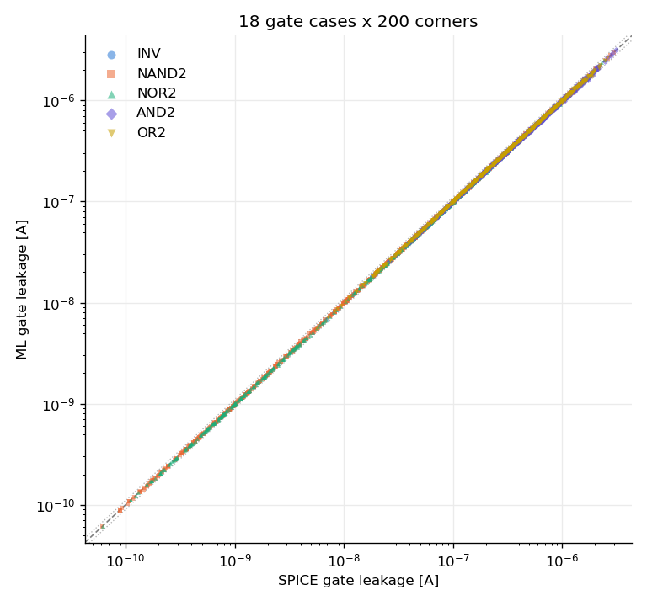
Figure 5. ML against SPICE gate leakage, 18 cases x 200 corners (log axes; identity dashed, +/- 10 % dotted).
Table 11. Gate-level error (3,600 operating points) for the sizing choice and for the refinement of the OFF models (`results/gate_summary_versions.csv`)
version | median [%] | 95th pct [%] | mean [%] | bias [%] | largest [%]
XX=1 sizing, first OFF models | 2.01 | 8.45 | 2.82 | -1.17 | 18.0
XX=2 sizing, first OFF models (before refinement) | 1.49 | 7.36 | 2.34 | -0.75 | 16.5
XX=2 sizing, refined OFF models (final) | 0.58 | 2.37 | 0.83 | -0.09 | 8.4

Table 11 shows the two decisions taken with the gate-level analysis. The drive-strength multiplier XX = 2 (instead of 1) keeps the NMOS widths of the gates inside the training range instead of exactly on its lower edge. The refinement of the two OFF models with rail samples (section 3.5) lowers the median error by a factor 2.6 and the 95th percentile by a factor 3.1, although the same models are slightly worse on the uniform test samples of section 3.4. The reason is the one given in 3.5: the operating region of a gate is a small part of the (Vd, Vs) square, and this is where the uniform datasets are sparse. The same models were used for the test circuit.

5. Test circuit: 3-bit carry-lookahead adder (Part C)
Circuit. A 3-bit carry-lookahead adder with carry-in, built only from the five gate types: generate g_i = a_i b_i, propagate p_i = a_i xor b_i, c1 = g0 + p0 c0, c2 = g1 + p1 g0 + p1 p0 c0, c3 = g2 + p2 g1 + p2 p1 g0 + p2 p1 p0 c0, s_i = p_i xor c_i. Every XOR is four NAND2 gates, the products are AND2 gates (shared sub-products are reused) and the sums are OR2 gates. The circuit has 40 gates (24 NAND2, 10 AND2, 6 OR2; 192 transistors), seven inputs (a0..a2, b0..b2, c0, hence 128 input vectors) and four outputs (s0..s2 and the carry-out c3). A Python logic simulator of the same netlist is checked against binary addition for all 128 vectors, and the SPICE outputs are checked against it at every operating point. Every gate is a subcircuit with exactly the transistors and sizes of Part B, the process parameters of a corner are set on the shared model cards (all NMOS of the circuit share one draw, all PMOS another). Example netlist: netlists/test_circuit_cla3.cir.
SPICE reference. The complete transistor-level netlist is simulated for every input vector at every one of the 200 corners of Part B: 25,600 operating points. The leakage is defined as for the gates (power drawn from the supply and from the inputs at VDD, divided by VDD). The simulation takes about 35 minutes with four parallel ngspice processes on the machine used.
ML prediction. For each input vector the logic value at the inputs of every gate is determined by the logic simulator; the pattern AB of each gate is read from the logic values of its two input nets, and the leakage of that gate type, pattern and corner is taken from Part B (the gate model driven by the node voltages of the isolated gate at the same corner). The 40 gate leakages are summed. This assumes that every gate input sits at exactly 0 or VDD and ignores loading between gates, as the project text prescribes. A second sum, built from the isolated-gate SPICE leakages, is the composition floor: what the hierarchical method would give with perfect gate models. The difference between the floor and the SPICE leakage of the full circuit is the error of the composition itself, which no better transistor model can remove.

5.1 Test-circuit results (deliverable 8)
Table 12. Test circuit, all 25,600 operating points (128 input vectors x 200 corners)
metric | hierarchical ML vs SPICE | composition floor (perfect gate models) | ML gate models vs isolated-gate SPICE sum
95th pct error [%] | 6.15 | 5.25 | 2.17
ML median [A] | 1.30e-05 | 1.30e-05
SPICE median [A] | 1.32e-05 | 1.32e-05
bias [%] | -1.88 | -1.85 | -0.03
mean error [%] | 2.07 | 1.85 | 0.70
median error [%] | 1.50 | 1.37 | 0.48

The hierarchical prediction has a median error of 1.50 %, a 95th percentile of 6.15 % and a mean error of 2.07 % (bias -1.88 %, largest 13.1 %); 35 % of the 25,600 points are within 1 %, 92 % within 5 % and 99.3 % within 10 %. Almost all of this is the composition itself: with perfect gate models the same method would give a median error of 1.37 % and a 95th percentile of 5.25 % (bias -1.85 %: the sum of the isolated gates underestimates the circuit). The ML gate models add little to it: against the sum of the isolated-gate SPICE leakages they have a median error of 0.48 % and a 95th percentile of 2.17 % (bias -0.03 %). The circuit error is therefore larger than the gate error (0.58 % median, 2.37 % 95th percentile) because of what the hierarchical method leaves out, not because of the transistor models.
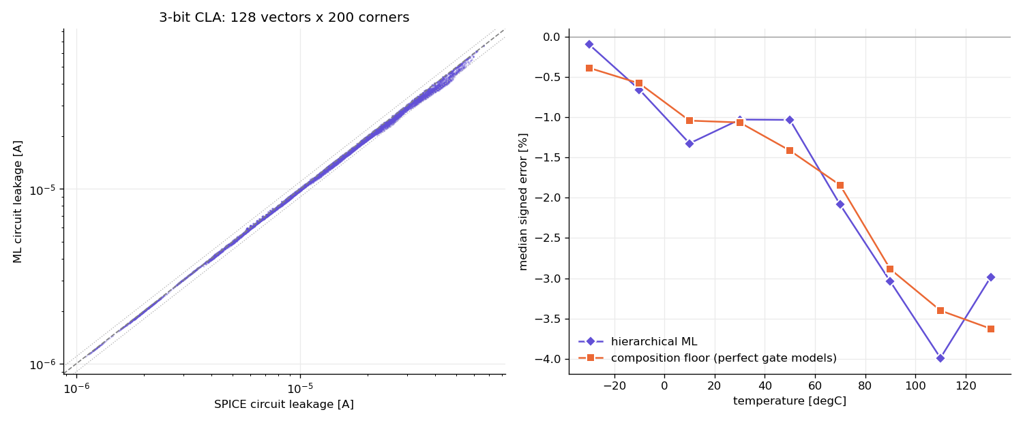
Figure 6. Left: ML against SPICE leakage of the complete circuit (log axes); right: median signed error against temperature.
The results for each of the 128 input vectors (median, 95th-percentile and mean error and bias over the 200 corners) are in Appendix A and in results/circuit_results_by_vector.csv. The vector changes the error very little (section 6.5): the median error per vector lies between 1.04 % and 2.10 %.

6. Error analysis
Notebook 07 analyses where the errors occur, at gate level and for the test circuit: by gate and input pattern, by corner condition (temperature, VDD, vth0, toxe of NMOS and PMOS), by transistor model and leakage component, by the voltage of the gate inputs, and by input vector. It reads the results of the earlier notebooks and needs no simulator.

6.1 Gate level: gate and input pattern
The ranking by input pattern is in Table 10 and Figure 5. AND2 01: median 0.90 %, 95th percentile 3.63 %, bias -0.93 %; OR2 00: median 0.89 %, 95th percentile 3.81 %, bias -0.93 %; NOR2 01: median 0.79 %, 95th percentile 2.85 %, bias +0.45 % are the three cases with the largest median error, and the least accurate case still has a median error of only 0.90 %. There is no systematic difference between the combinations in which the leakage is large and those in which it is small (the cases span 8.7e-10 A to 6.7e-07 A in median leakage); the two largest errors belong to the two gate types that contain an internal inverter driven by a node that is not exactly at a rail (section 6.4).

6.2 Gate level: corner conditions
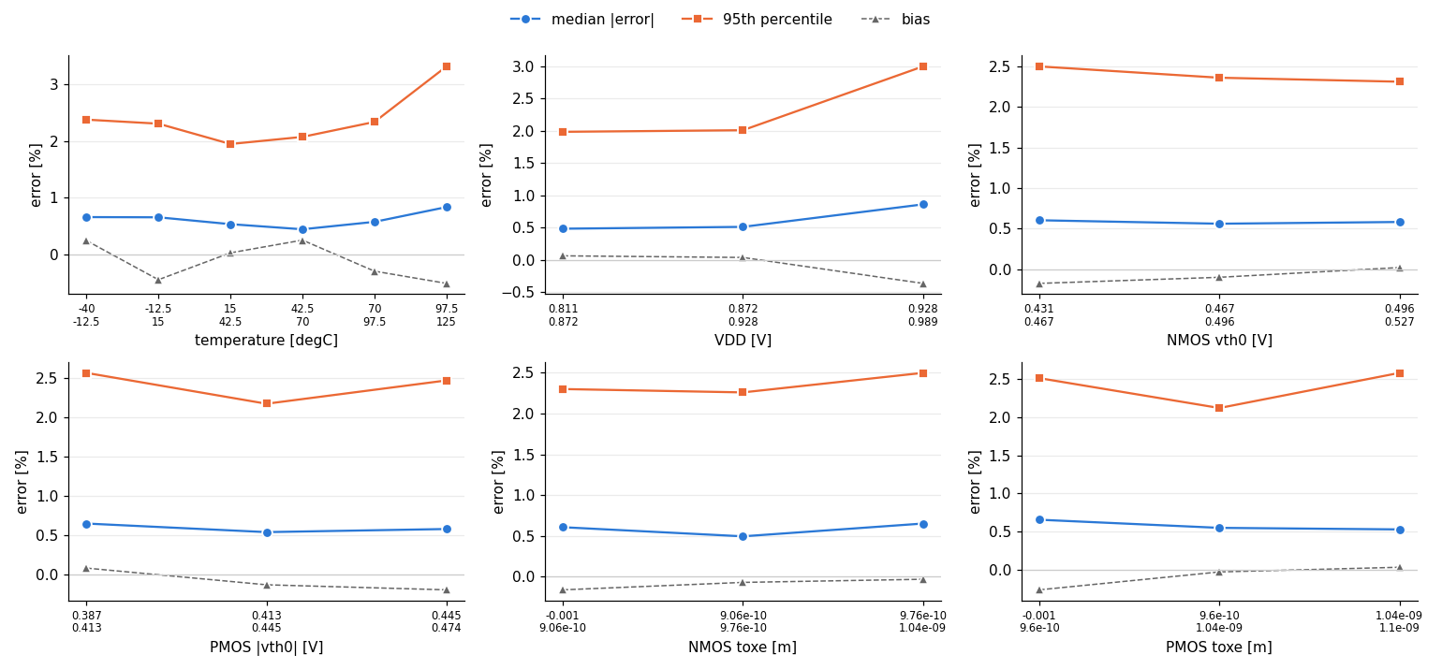
Figure 7. Gate-level error against corner conditions (median, 95th percentile and bias; terciles for VDD and the process parameters).
The error depends little on the corner. It is largest at the hot end: in the bin 97.5 .. 125 degC the median error is 0.84 % and the 95th percentile 3.31 %, against a median of 0.45 % to 0.66 % in the other temperature bins, and in the highest VDD tercile (0.928 .. 0.989 V: median 0.86 %, 95th percentile 2.99 %; the lower terciles 0.48 % and 0.51 %). The temperature dependence is explained in section 6.4 (the gate inputs of the inverter inside AND2 and OR2 move away from their rails as the temperature rises); no single cause was isolated for the VDD dependence. For vth0 and toxe of the NMOS and the PMOS there is no consistent trend (median error 0.50 % to 0.66 % over all terciles); a low threshold voltage, which raises the leakage, does not make the gate error larger. The bias stays between -0.51 % and +0.26 % in every bin.

6.3 Gate level: transistor model and leakage component
Table 13. Error budget of the gate leakage by transistor model (all 3,600 operating points; in % of the summed SPICE leakage)
transistor model | share of the leakage [%] | abs. error budget [%] | of which channel term [%] | of which gate + body terms [%] | bias [%]
NMOS ON | 1.0 | 0.02 | 0.02 | 0.000 | +0.01
NMOS OFF | 20.4 | 0.34 | 0.34 | 0.000 | -0.22
PMOS ON | 0.9 | 0.01 | 0.01 | 0.000 | +0.00
PMOS OFF | 77.8 | 1.06 | 1.06 | 0.000 | -0.07

With the same voltages, the ML and SPICE currents of every transistor give two values of each term of the leakage sum, so the error of the gate leakage can be traced back to a model (Table 13). The PMOS-OFF channel term alone is 75 % of the absolute error budget (1.06 of 1.43 percentage points) and the NMOS-OFF channel term 24 %; the OFF transistors carry 98 % of the leakage of the gates (PMOS OFF 78 %, NMOS OFF 20 %), the ON transistors about 2 %. The gate-current and body-current terms contribute less than 0.01 percentage points: the errors of the small currents ig and ib, which are among the hardest at transistor level (section 3.4), do not reach the gate leakage because these currents are tiny against the sub-threshold current. The summed bias of all terms (-0.27 %) is the bias of the gate leakage; it comes mainly from the NMOS-OFF channel term. This is why the refinement of the two OFF models (section 3.5) had such an effect at gate level, and why the ON models, although the most accurate at transistor level, hardly matter here.

6.4 Gate level: the worst points and gate inputs that are not at a rail
Table 14. The five worst gate operating points (the full list of ten is in `results/gate_worst_points.csv`)
gate | input | T [degC] | VDD [V] | SPICE [A] | ML [A] | error [%] | term with the largest error
AND2 | 01 | 122 | 0.965 | 1.94e-06 | 1.77e-06 | -8.4 | MP3 (pmos_off) channel
OR2 | 00 | 122 | 0.965 | 1.88e-06 | 1.72e-06 | -8.1 | MP3 (pmos_off) channel
AND2 | 01 | 105 | 0.984 | 1.73e-06 | 1.59e-06 | -7.6 | MP3 (pmos_off) channel
OR2 | 00 | 105 | 0.984 | 1.64e-06 | 1.53e-06 | -7.0 | MP3 (pmos_off) channel
AND2 | 01 | 110 | 0.927 | 1.06e-06 | 9.90e-07 | -6.5 | MP3 (pmos_off) channel

Table 15. AND2 and OR2: distance of the inverter input from its rail (SPICE) against the error of the gate leakage
gate | input | inverter input should be at | median distance [mV] | largest distance [mV] | Spearman (distance, error) | median signed error [%] | median |error| [%]
AND2 | 00 | VDD | 0.00 | 0.1 | +0.06 | +0.29 | 0.59
AND2 | 01 | VDD | 1.42 | 19.5 | -0.68 | -0.72 | 0.90
AND2 | 10 | VDD | 0.19 | 3.8 | -0.28 | +0.01 | 0.58
AND2 | 11 | 0 V | 3.99 | 29.2 | -0.19 | -0.23 | 0.66
OR2 | 00 | VDD | 1.09 | 17.6 | -0.61 | -0.68 | 0.89
OR2 | 01 | 0 V | 4.28 | 25.5 | -0.32 | -0.02 | 0.71
OR2 | 10 | 0 V | 0.43 | 2.8 | -0.28 | -0.35 | 0.47
OR2 | 11 | 0 V | 0.00 | 0.0 | +0.15 | -0.28 | 0.49

The ten worst points have errors between 5.3 % and 8.4 %, all of them underestimates; 7 of them are in corners with T > 100 degC. 6 of the ten (AND2 01 and OR2 00) have the PMOS-OFF channel term of the inverter as the term with the largest error and are explained below. The other 4 (OR2 01 at 122 degC, INV 0 at -4 degC, OR2 11 at -4 degC, NOR2 00 at -4 degC) are errors of the NMOS-OFF channel term of 5.3 % to 5.4 %; their cause was not investigated further. For the first group the explanation is a model assumption. The ON and OFF models were trained with the gate voltage at exactly 0 or VDD, and the gate voltage of every transistor is set to the nearest rail when the models are called (as in the instructor's AND2 equation). In AND2 and OR2 the inverter is driven by the NAND2 / NOR2 output, which in SPICE sits a few millivolts away from its rail because of the leakage through the ON network. A PMOS-OFF transistor whose gate is a few millivolts below the source leaks more, exponentially, than the model for gate = VDD says. Table 15 supports this: for AND2 01 and OR2 00 (inverter input at VDD, so that the PMOS of the inverter is the OFF transistor that carries the leakage) the distance of the input from the rail reaches 20 mV, it correlates strongly with the error (Spearman -0.68 and -0.61), and the model underestimates the leakage. The distance grows with temperature (Spearman 0.56 to 0.89 over the eight cases), because the leakage through the ON network grows, and so does the error of these two cases: the median error of AND2 01 is 0.68 % below 40 degC and 2.20 % above 90 degC. The remedy would be a gate-voltage margin in the training samples (the gate voltage within a few tens of millivolts of the rail), which the project text does not require.

6.5 Test circuit
Table 16. Test circuit: error of the hierarchical prediction (ML), of the composition floor and of the ML gate models by corner condition (200 corners, 128 vectors)
factor | bin | ML: median [%] | ML: 95th pct [%] | ML: bias [%] | floor: median [%] | floor: bias [%] | gate models: median [%]
temperature [degC] | -40 .. -12.5 | 0.60 | 2.74 | -0.19 | 0.40 | -0.55 | 0.45
temperature [degC] | -12.5 .. 15 | 1.26 | 3.81 | -1.35 | 0.78 | -0.96 | 0.68
temperature [degC] | 15 .. 42.5 | 1.35 | 2.90 | -1.22 | 1.21 | -1.38 | 0.41
temperature [degC] | 42.5 .. 70 | 1.10 | 3.58 | -1.27 | 1.31 | -1.65 | 0.34
temperature [degC] | 70 .. 97.5 | 2.46 | 7.25 | -3.05 | 2.31 | -2.76 | 0.46
temperature [degC] | 97.5 .. 125 | 3.87 | 9.88 | -4.52 | 3.42 | -3.91 | 0.86
VDD [V] | 0.811 .. 0.872 | 0.99 | 3.97 | -1.13 | 0.97 | -1.28 | 0.36
VDD [V] | 0.872 .. 0.928 | 1.57 | 4.51 | -1.80 | 1.54 | -1.82 | 0.38
VDD [V] | 0.928 .. 0.989 | 2.13 | 8.47 | -2.71 | 1.82 | -2.46 | 0.88
NMOS vth0 [V] | 0.431 .. 0.467 | 2.24 | 7.96 | -2.83 | 2.21 | -2.66 | 0.45
NMOS vth0 [V] | 0.467 .. 0.496 | 1.48 | 5.37 | -1.84 | 1.43 | -1.80 | 0.58
NMOS vth0 [V] | 0.496 .. 0.527 | 1.00 | 3.51 | -0.95 | 0.85 | -1.08 | 0.42
PMOS |vth0| [V] | 0.387 .. 0.413 | 1.36 | 5.37 | -1.63 | 1.54 | -1.92 | 0.46
PMOS |vth0| [V] | 0.413 .. 0.445 | 1.91 | 6.15 | -2.18 | 1.62 | -1.99 | 0.44
PMOS |vth0| [V] | 0.445 .. 0.474 | 1.27 | 7.14 | -1.82 | 1.10 | -1.63 | 0.54

The circuit-level error is a temperature effect of the composition. The median error of the hierarchical prediction rises from 0.60 % at the cold end (-40 .. -12.5 degC) to 3.87 % at the hot end (97.5 .. 125 degC; 95th percentile 9.9 %) and its bias from -0.19 % to -4.52 %. The composition floor follows it (0.40 % to 3.42 %, bias -0.55 % to -3.91 %), whereas the median error of the ML gate models stays between 0.34 % and 0.86 % in every temperature bin. By construction the floor contains only what is removed by isolating a gate: the real gate inputs are not exactly at 0 or VDD, and the real outputs are loaded by the inputs of the next gates (their gate-leakage currents). Both are expected to grow with the leakage current, which grows with temperature (for the inverter input of AND2 and OR2 this was measured in section 6.4). The error is also larger at high VDD (median 2.13 % in the top tercile against 0.99 % in the bottom one) and at a low NMOS threshold (2.24 % in the lowest tercile against 1.00 % in the highest), which are again the corners with the highest leakage. By input vector the error varies little: the median error per vector is between 1.04 % and 2.10 %, and the vector with the largest error is a = 0, b = 0, cin = 1 (2.10 %); no single input pattern is responsible for the error.

7. Limitations and improvements
- Hierarchical composition. The circuit prediction sums isolated-gate leakages with ideal 0 / VDD inputs and no loading, as prescribed. This limits the accuracy of any gate model: the composition floor is 1.37 % (median) and 5.25 % (95th percentile), and at the hot end (97.5 .. 125 degC) 3.42 % (median) with a bias of -3.91 %, so a 99 % accuracy at the circuit level is not reachable at hot corners with this composition, whatever the transistor models are. Propagating the real output voltages of each gate to the inputs of the next gates (an estimate of the node voltages, outside the prescribed method) would remove most of this error.
- Gate inputs that are not at a rail. The INV inside AND2 and OR2 is driven by an internal node that sits up to about 30 mV from its rail, while the models were trained at exact rails; the leakage of an OFF transistor depends exponentially on such a deviation (section 6.4). Training samples with the gate voltage within a few tens of millivolts of the rails, or the gate voltage as a free feature near the rails, would address it.
- Training distribution against operating region. The transistors of a gate operate at the corners of the (Vd, Vs) square at fixed gate and body voltages, whereas the datasets are uniform. The refinement of the two OFF models with 6,000 rail samples each (section 3.5) lowered the gate-level median error from 1.49 % to 0.58 % and the 95th percentile from 7.36 % to 2.37 %, at the price of a slightly worse score on the uniform test samples; a dataset designed from the operating region of the circuits, or an active-learning loop on the gate-level error, would go further. The refinement was motivated by the gate-level analysis (disclosed in section 3.5); it uses no gate-level data.
- Transistor accuracy. The PMOS-OFF model has a median test error of 1.28 % and a 95th percentile of 11.7 % (the project notes name an error below 1 % as a goal); its small currents ig and is are the hardest to learn, partly because the simulator resolves currents only to 4.4e-16 A, so that relative errors of currents below about 1e-14 A are limited by the data. At |Vds| < 5 mV the PMOS-OFF channel currents have a median error of 27 % to 35 % (on 17 to 18 test samples); this does not reach the gate level because the channel term of such a transistor is weighted by its own Vds.
- Definition of the leakage. The project text does not define the gate leakage; the supply-plus-input-power definition and the component sum are used and compared (section 4.2). The supply current alone differs by more than 5 % only in NOR2 with inputs 11.
- Statistics. One data split, one seed per model and 200 corners: the numbers carry sampling noise, and no confidence intervals are given. An ensemble of seeds would reduce the variance of the OFF models.
- Open points not answered by the course staff at the time of writing: whether the adder has a carry-in (7 inputs and 128 vectors are used; the 64 vectors without carry-in are a subset), whether notebooks are accepted as the code deliverable, and the exact definition of "mean accuracy" (median, 95th percentile and mean relative errors are all reported).

Appendix A. Test-circuit results per input vector
Table A1. Hierarchical prediction against the full-circuit SPICE simulation for each input vector (vector = a + 8 b + 64 cin; 200 corners per vector)
vector | a | b | cin | SPICE median [A] | ML median [A] | bias [%] | median error [%] | 95th pct [%] | mean error [%]
0 | 0 | 0 | 0 | 1.20e-05 | 1.17e-05 | -2.20 | 1.80 | 6.68 | 2.36
1 | 1 | 0 | 0 | 1.25e-05 | 1.21e-05 | -2.28 | 1.89 | 6.71 | 2.43
2 | 2 | 0 | 0 | 1.23e-05 | 1.19e-05 | -2.14 | 1.78 | 6.43 | 2.30
3 | 3 | 0 | 0 | 1.29e-05 | 1.25e-05 | -2.18 | 1.79 | 6.47 | 2.33
4 | 4 | 0 | 0 | 1.23e-05 | 1.20e-05 | -2.14 | 1.77 | 6.43 | 2.30
5 | 5 | 0 | 0 | 1.28e-05 | 1.26e-05 | -2.22 | 1.82 | 6.47 | 2.37
6 | 6 | 0 | 0 | 1.25e-05 | 1.23e-05 | -2.08 | 1.74 | 6.19 | 2.24
7 | 7 | 0 | 0 | 1.31e-05 | 1.29e-05 | -2.12 | 1.76 | 6.24 | 2.28
8 | 0 | 1 | 0 | 1.27e-05 | 1.24e-05 | -2.15 | 1.78 | 6.40 | 2.31
9 | 1 | 1 | 0 | 1.25e-05 | 1.22e-05 | -2.17 | 1.75 | 6.65 | 2.34
10 | 2 | 1 | 0 | 1.30e-05 | 1.28e-05 | -1.98 | 1.66 | 5.99 | 2.15
11 | 3 | 1 | 0 | 1.28e-05 | 1.26e-05 | -1.92 | 1.60 | 6.22 | 2.11
12 | 4 | 1 | 0 | 1.30e-05 | 1.29e-05 | -2.10 | 1.72 | 6.17 | 2.26
13 | 5 | 1 | 0 | 1.28e-05 | 1.25e-05 | -2.11 | 1.75 | 6.41 | 2.28
14 | 6 | 1 | 0 | 1.33e-05 | 1.32e-05 | -1.93 | 1.62 | 5.93 | 2.10
15 | 7 | 1 | 0 | 1.31e-05 | 1.30e-05 | -1.50 | 1.28 | 5.35 | 1.75
16 | 0 | 2 | 0 | 1.25e-05 | 1.21e-05 | -2.02 | 1.68 | 6.13 | 2.19
17 | 1 | 2 | 0 | 1.30e-05 | 1.28e-05 | -1.98 | 1.66 | 5.99 | 2.15
18 | 2 | 2 | 0 | 1.22e-05 | 1.19e-05 | -2.12 | 1.72 | 6.50 | 2.29
19 | 3 | 2 | 0 | 1.26e-05 | 1.23e-05 | -2.19 | 1.81 | 6.50 | 2.34
20 | 4 | 2 | 0 | 1.27e-05 | 1.26e-05 | -1.97 | 1.64 | 5.96 | 2.14
21 | 5 | 2 | 0 | 1.33e-05 | 1.32e-05 | -1.93 | 1.62 | 5.93 | 2.10
22 | 6 | 2 | 0 | 1.20e-05 | 1.19e-05 | -1.59 | 1.36 | 5.44 | 1.81
23 | 7 | 2 | 0 | 1.22e-05 | 1.21e-05 | -1.67 | 1.41 | 5.48 | 1.87
24 | 0 | 3 | 0 | 1.32e-05 | 1.31e-05 | -1.79 | 1.50 | 5.70 | 1.97
25 | 1 | 3 | 0 | 1.30e-05 | 1.28e-05 | -1.73 | 1.45 | 5.71 | 1.94
26 | 2 | 3 | 0 | 1.28e-05 | 1.25e-05 | -2.06 | 1.71 | 6.19 | 2.23
27 | 3 | 3 | 0 | 1.25e-05 | 1.23e-05 | -2.07 | 1.69 | 6.40 | 2.24
28 | 4 | 3 | 0 | 1.35e-05 | 1.34e-05 | -1.74 | 1.49 | 5.64 | 1.92
29 | 5 | 3 | 0 | 1.33e-05 | 1.32e-05 | -1.31 | 1.19 | 4.85 | 1.59
30 | 6 | 3 | 0 | 1.25e-05 | 1.23e-05 | -1.55 | 1.34 | 5.28 | 1.77
31 | 7 | 3 | 0 | 1.25e-05 | 1.23e-05 | -1.57 | 1.32 | 5.34 | 1.79
32 | 0 | 4 | 0 | 1.26e-05 | 1.22e-05 | -2.02 | 1.68 | 6.13 | 2.19
33 | 1 | 4 | 0 | 1.30e-05 | 1.29e-05 | -2.10 | 1.73 | 6.18 | 2.26
34 | 2 | 4 | 0 | 1.27e-05 | 1.26e-05 | -1.97 | 1.64 | 5.96 | 2.14
35 | 3 | 4 | 0 | 1.33e-05 | 1.32e-05 | -2.01 | 1.67 | 6.04 | 2.17
36 | 4 | 4 | 0 | 1.15e-05 | 1.13e-05 | -1.84 | 1.54 | 5.90 | 2.04
37 | 5 | 4 | 0 | 1.20e-05 | 1.17e-05 | -1.93 | 1.62 | 5.96 | 2.11
38 | 6 | 4 | 0 | 1.18e-05 | 1.15e-05 | -1.78 | 1.50 | 5.68 | 1.98
39 | 7 | 4 | 0 | 1.24e-05 | 1.21e-05 | -1.84 | 1.55 | 5.77 | 2.02
40 | 0 | 5 | 0 | 1.32e-05 | 1.31e-05 | -1.99 | 1.63 | 5.97 | 2.15
41 | 1 | 5 | 0 | 1.30e-05 | 1.27e-05 | -2.00 | 1.65 | 6.13 | 2.17
42 | 2 | 5 | 0 | 1.35e-05 | 1.34e-05 | -1.82 | 1.53 | 5.75 | 2.00
43 | 3 | 5 | 0 | 1.33e-05 | 1.32e-05 | -1.32 | 1.19 | 4.88 | 1.60
44 | 4 | 5 | 0 | 1.22e-05 | 1.19e-05 | -1.81 | 1.51 | 5.70 | 2.00
45 | 5 | 5 | 0 | 1.18e-05 | 1.17e-05 | -1.83 | 1.51 | 5.90 | 2.02
46 | 6 | 5 | 0 | 1.25e-05 | 1.23e-05 | -1.64 | 1.42 | 5.47 | 1.84
47 | 7 | 5 | 0 | 1.24e-05 | 1.22e-05 | -1.56 | 1.32 | 5.32 | 1.79
48 | 0 | 6 | 0 | 1.29e-05 | 1.29e-05 | -1.85 | 1.55 | 5.77 | 2.04
49 | 1 | 6 | 0 | 1.35e-05 | 1.34e-05 | -1.82 | 1.53 | 5.75 | 2.00
50 | 2 | 6 | 0 | 1.20e-05 | 1.20e-05 | -1.39 | 1.25 | 5.01 | 1.64
51 | 3 | 6 | 0 | 1.25e-05 | 1.23e-05 | -1.48 | 1.28 | 5.18 | 1.70
52 | 4 | 6 | 0 | 1.20e-05 | 1.17e-05 | -1.66 | 1.43 | 5.49 | 1.87
53 | 5 | 6 | 0 | 1.25e-05 | 1.23e-05 | -1.64 | 1.42 | 5.47 | 1.84
54 | 6 | 6 | 0 | 1.15e-05 | 1.14e-05 | -1.74 | 1.45 | 5.62 | 1.94
55 | 7 | 6 | 0 | 1.20e-05 | 1.17e-05 | -1.82 | 1.54 | 5.71 | 2.00
56 | 0 | 7 | 0 | 1.37e-05 | 1.36e-05 | -1.64 | 1.43 | 5.46 | 1.83
57 | 1 | 7 | 0 | 1.36e-05 | 1.34e-05 | -1.14 | 1.04 | 4.40 | 1.45
58 | 2 | 7 | 0 | 1.28e-05 | 1.25e-05 | -1.36 | 1.20 | 4.98 | 1.60
59 | 3 | 7 | 0 | 1.27e-05 | 1.25e-05 | -1.37 | 1.24 | 4.86 | 1.62
60 | 4 | 7 | 0 | 1.27e-05 | 1.25e-05 | -1.44 | 1.27 | 5.17 | 1.66
61 | 5 | 7 | 0 | 1.27e-05 | 1.25e-05 | -1.37 | 1.23 | 4.85 | 1.62
62 | 6 | 7 | 0 | 1.24e-05 | 1.20e-05 | -1.70 | 1.45 | 5.52 | 1.89
63 | 7 | 7 | 0 | 1.21e-05 | 1.19e-05 | -1.71 | 1.42 | 5.55 | 1.91
64 | 0 | 0 | 1 | 1.27e-05 | 1.23e-05 | -2.55 | 2.10 | 7.33 | 2.68
65 | 1 | 0 | 1 | 1.34e-05 | 1.31e-05 | -2.28 | 1.87 | 6.92 | 2.44
66 | 2 | 0 | 1 | 1.29e-05 | 1.27e-05 | -2.49 | 2.05 | 7.09 | 2.62
67 | 3 | 0 | 1 | 1.41e-05 | 1.40e-05 | -2.05 | 1.67 | 6.60 | 2.23
68 | 4 | 0 | 1 | 1.29e-05 | 1.27e-05 | -2.49 | 2.05 | 7.09 | 2.62
69 | 5 | 0 | 1 | 1.37e-05 | 1.34e-05 | -2.23 | 1.84 | 6.69 | 2.38
70 | 6 | 0 | 1 | 1.31e-05 | 1.30e-05 | -2.43 | 2.00 | 6.99 | 2.56
71 | 7 | 0 | 1 | 1.48e-05 | 1.45e-05 | -1.72 | 1.41 | 6.00 | 1.94
72 | 0 | 1 | 1 | 1.35e-05 | 1.32e-05 | -2.09 | 1.72 | 6.42 | 2.26
73 | 1 | 1 | 1 | 1.30e-05 | 1.27e-05 | -2.48 | 2.05 | 7.21 | 2.62
74 | 2 | 1 | 1 | 1.43e-05 | 1.41e-05 | -1.80 | 1.49 | 5.94 | 2.01
75 | 3 | 1 | 1 | 1.35e-05 | 1.31e-05 | -2.23 | 1.82 | 6.78 | 2.39
76 | 4 | 1 | 1 | 1.38e-05 | 1.35e-05 | -2.04 | 1.67 | 6.20 | 2.21
77 | 5 | 1 | 1 | 1.34e-05 | 1.30e-05 | -2.43 | 1.99 | 6.98 | 2.56
78 | 6 | 1 | 1 | 1.49e-05 | 1.48e-05 | -1.48 | 1.25 | 5.35 | 1.73
79 | 7 | 1 | 1 | 1.37e-05 | 1.35e-05 | -1.81 | 1.50 | 5.99 | 2.02
80 | 0 | 2 | 1 | 1.31e-05 | 1.30e-05 | -2.37 | 1.93 | 6.79 | 2.51
81 | 1 | 2 | 1 | 1.43e-05 | 1.41e-05 | -1.88 | 1.54 | 6.14 | 2.08
82 | 2 | 2 | 1 | 1.27e-05 | 1.24e-05 | -2.46 | 2.02 | 7.14 | 2.59
83 | 3 | 2 | 1 | 1.34e-05 | 1.31e-05 | -2.19 | 1.78 | 6.68 | 2.35
84 | 4 | 2 | 1 | 1.33e-05 | 1.32e-05 | -2.32 | 1.89 | 6.68 | 2.45
85 | 5 | 2 | 1 | 1.50e-05 | 1.48e-05 | -1.55 | 1.30 | 5.57 | 1.80
86 | 6 | 2 | 1 | 1.24e-05 | 1.22e-05 | -1.95 | 1.61 | 6.17 | 2.14
87 | 7 | 2 | 1 | 1.34e-05 | 1.31e-05 | -1.71 | 1.42 | 5.73 | 1.92
88 | 0 | 3 | 1 | 1.45e-05 | 1.43e-05 | -1.63 | 1.37 | 5.50 | 1.85
89 | 1 | 3 | 1 | 1.38e-05 | 1.34e-05 | -2.04 | 1.68 | 6.30 | 2.22
90 | 2 | 3 | 1 | 1.37e-05 | 1.33e-05 | -2.00 | 1.65 | 6.19 | 2.17
91 | 3 | 3 | 1 | 1.33e-05 | 1.29e-05 | -2.38 | 1.95 | 6.96 | 2.52
92 | 4 | 3 | 1 | 1.52e-05 | 1.50e-05 | -1.32 | 1.16 | 4.94 | 1.60
93 | 5 | 3 | 1 | 1.38e-05 | 1.37e-05 | -1.63 | 1.37 | 5.52 | 1.85
94 | 6 | 3 | 1 | 1.35e-05 | 1.33e-05 | -1.52 | 1.30 | 5.23 | 1.75
95 | 7 | 3 | 1 | 1.28e-05 | 1.28e-05 | -1.90 | 1.58 | 6.01 | 2.08
96 | 0 | 4 | 1 | 1.31e-05 | 1.30e-05 | -2.37 | 1.93 | 6.80 | 2.51
97 | 1 | 4 | 1 | 1.38e-05 | 1.35e-05 | -2.12 | 1.74 | 6.42 | 2.28
98 | 2 | 4 | 1 | 1.33e-05 | 1.32e-05 | -2.32 | 1.89 | 6.68 | 2.45
99 | 3 | 4 | 1 | 1.50e-05 | 1.48e-05 | -1.55 | 1.30 | 5.58 | 1.80
100 | 4 | 4 | 1 | 1.21e-05 | 1.18e-05 | -2.22 | 1.78 | 6.63 | 2.37
101 | 5 | 4 | 1 | 1.27e-05 | 1.25e-05 | -1.96 | 1.61 | 6.23 | 2.15
102 | 6 | 4 | 1 | 1.23e-05 | 1.21e-05 | -2.16 | 1.78 | 6.39 | 2.31
103 | 7 | 4 | 1 | 1.37e-05 | 1.35e-05 | -1.73 | 1.43 | 5.85 | 1.94
104 | 0 | 5 | 1 | 1.41e-05 | 1.37e-05 | -1.93 | 1.59 | 5.94 | 2.11
105 | 1 | 5 | 1 | 1.36e-05 | 1.33e-05 | -2.32 | 1.88 | 6.70 | 2.46
106 | 2 | 5 | 1 | 1.52e-05 | 1.50e-05 | -1.32 | 1.17 | 4.94 | 1.60
107 | 3 | 5 | 1 | 1.38e-05 | 1.37e-05 | -1.64 | 1.37 | 5.53 | 1.86
108 | 4 | 5 | 1 | 1.29e-05 | 1.27e-05 | -1.77 | 1.48 | 5.71 | 1.97
109 | 5 | 5 | 1 | 1.26e-05 | 1.22e-05 | -2.17 | 1.76 | 6.53 | 2.32
110 | 6 | 5 | 1 | 1.40e-05 | 1.37e-05 | -1.47 | 1.27 | 5.17 | 1.71
111 | 7 | 5 | 1 | 1.28e-05 | 1.27e-05 | -1.90 | 1.57 | 6.01 | 2.08
112 | 0 | 6 | 1 | 1.35e-05 | 1.34e-05 | -2.20 | 1.79 | 6.38 | 2.35
113 | 1 | 6 | 1 | 1.52e-05 | 1.50e-05 | -1.39 | 1.21 | 5.14 | 1.67
114 | 2 | 6 | 1 | 1.27e-05 | 1.24e-05 | -1.76 | 1.48 | 5.66 | 1.96
115 | 3 | 6 | 1 | 1.35e-05 | 1.33e-05 | -1.53 | 1.30 | 5.25 | 1.76
116 | 4 | 6 | 1 | 1.26e-05 | 1.22e-05 | -2.04 | 1.69 | 6.08 | 2.20
117 | 5 | 6 | 1 | 1.40e-05 | 1.37e-05 | -1.55 | 1.30 | 5.39 | 1.78
118 | 6 | 6 | 1 | 1.23e-05 | 1.19e-05 | -2.11 | 1.73 | 6.36 | 2.27
119 | 7 | 6 | 1 | 1.28e-05 | 1.27e-05 | -1.85 | 1.54 | 5.90 | 2.04
120 | 0 | 7 | 1 | 1.54e-05 | 1.53e-05 | -1.16 | 1.05 | 4.56 | 1.48
121 | 1 | 7 | 1 | 1.39e-05 | 1.38e-05 | -1.46 | 1.27 | 5.09 | 1.70
122 | 2 | 7 | 1 | 1.35e-05 | 1.35e-05 | -1.35 | 1.17 | 4.91 | 1.60
123 | 3 | 7 | 1 | 1.30e-05 | 1.29e-05 | -1.71 | 1.45 | 5.52 | 1.91
124 | 4 | 7 | 1 | 1.41e-05 | 1.40e-05 | -1.30 | 1.17 | 4.76 | 1.57
125 | 5 | 7 | 1 | 1.29e-05 | 1.28e-05 | -1.71 | 1.45 | 5.51 | 1.91
126 | 6 | 7 | 1 | 1.29e-05 | 1.28e-05 | -1.66 | 1.40 | 5.40 | 1.86
127 | 7 | 7 | 1 | 1.25e-05 | 1.23e-05 | -2.04 | 1.67 | 6.19 | 2.21

