IIPA Job Forum - AI Powered Recruitment Platform
Complete Storyboard, Workflow Architecture, Mind Map & Developer Blueprint

1. Executive Summary
IIPA Job Forum is a modern AI-powered recruitment ecosystem designed to simplify hiring, candidate discovery, career growth, and workforce intelligence. The platform combines advanced AI automation with enterprise-grade SaaS architecture while maintaining a simple, minimal, and highly scalable user experience.

2. Platform Overview
Component | Description
Employer Portal | AI-powered hiring, ATS, candidate management, analytics, and recruitment automation.
Job Seeker Portal | AI resume builder, smart job search, career assistant, and interview preparation.
Super Admin Portal | Hidden owner-only platform for full system management and monitoring.
AI Engine | Resume scoring, AI matching, recommendations, automation, and analytics.
Cloud Infrastructure | Scalable SaaS-ready cloud-native architecture.

3. Website Sitemap
- Home Page
- About Us
- Jobs
- Employers
- Candidates
- AI Resume Builder
- AI Career Assistant
- Pricing
- Blog
- Support Center
- Contact
- Login / Register
- Employer Dashboard
- Job Seeker Dashboard
- Hidden Super Admin Dashboard
- Privacy Policy
- Terms & Conditions

4. Employer Portal Storyboard

Employer Registration
Simple onboarding with email verification, company setup, and subscription selection.

AI Job Posting
Generate optimized job descriptions using AI with skill recommendations.

Candidate Matching
AI automatically ranks and filters best-fit candidates.

ATS Workflow
Track applicants from applied → shortlisted → interview → hired.

Analytics Dashboard
Hiring analytics, application trends, and performance insights.

Messaging System
Built-in employer-candidate communication center.

Interview Scheduling
Calendar integrations and automated scheduling workflows.

5. Job Seeker Portal Storyboard

AI Resume Builder
Create modern ATS-friendly resumes using AI assistance.

AI Resume Scoring
AI analyzes profile strength and improvement areas.

Smart Job Search
AI-powered search with personalized recommendations.

Application Tracking
Track application progress in real-time.

AI Career Assistant
AI chatbot for career guidance and interview preparation.

Skill Gap Analysis
AI recommends certifications and learning paths.

Video Resume
Upload or record video introductions for employers.

6. Super Admin Architecture
- Completely hidden owner-only portal
- Role-based access control
- Platform-wide analytics
- Revenue dashboard
- Fraud detection and AI moderation
- CMS and system management
- API management and monitoring
- Audit logs and activity tracking
- Database and infrastructure monitoring

7. AI Ecosystem
- AI Resume Builder
- AI Resume Scoring
- AI Candidate Matching
- AI Job Recommendations
- AI Skill Gap Analysis
- AI Hiring Assistant
- AI Smart Search
- AI Career Coach
- AI Fraud Detection

8. Recommended Technical Stack
Technology Area | Recommendation
Frontend | Next.js + React + Tailwind CSS
Backend | Node.js + NestJS
Database | PostgreSQL + Redis
AI Services | OpenAI APIs + Vector Database
Authentication | JWT + OAuth + MFA
Cloud Hosting | AWS / Azure
Search Engine | Elasticsearch
Payments | Stripe
Notifications | Firebase + Twilio + SendGrid

9. Core Workflow
- Employer registers and creates company profile
- Employer subscribes to a hiring plan
- Employer posts AI-generated job
- AI engine matches suitable candidates
- Candidates apply using one-click apply
- AI ranks and scores candidates
- Employer schedules interviews
- Hiring workflow completed
- Analytics and reports generated

10. Platform Mind Map
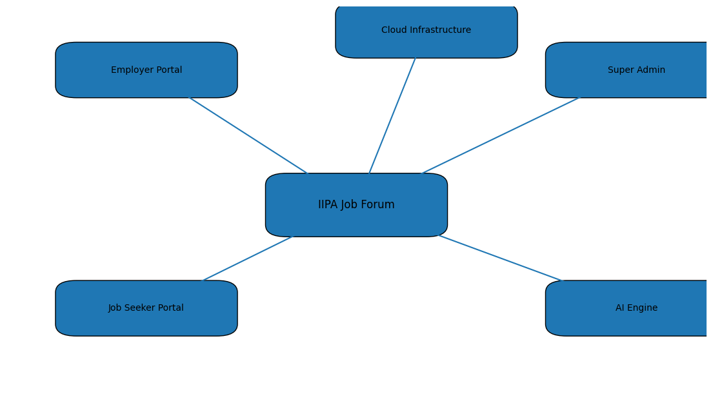

11. Future Roadmap
- Mobile Applications
- AI Video Interviews
- AI Recruiter Automation
- Global Hiring Marketplace
- HRMS Integration
- Learning Platform Integration
- Payroll Management
- Multi-language Support

