**地址：org\pbccrc\archive\collect\messagetools\validators\utils**

**Class名：GetFullNameValueHandlerRobot genHandler()**

pool.appendClassPath(**new** LoaderClassPath(Thread.*currentThread*().getContextClassLoader()));

CtClass ctInterface = pool.getCtClass("org.pbccrc.archive.collect.messagetools.validators.IGetValueHandler");

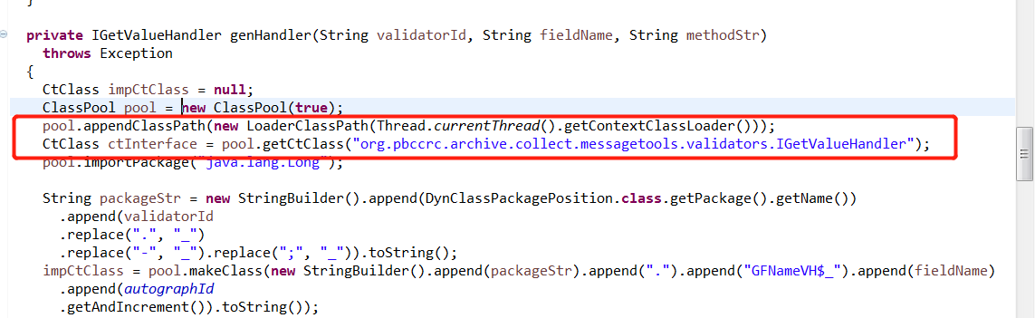

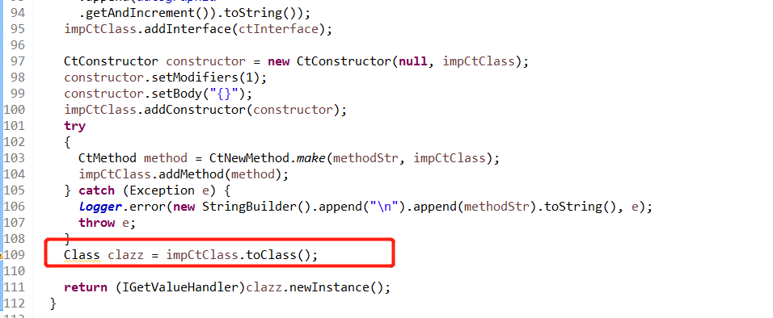

**GetSelfValueUtilRobot genSelfValueInstance()方法**

pool.appendClassPath(**new** LoaderClassPath(Thread.*currentThread*().getContextClassLoader()));

CtClass ctInterface = pool.getCtClass("org.pbccrc.archive.collect.messagetools.validators.IGetSelfValueHandler");

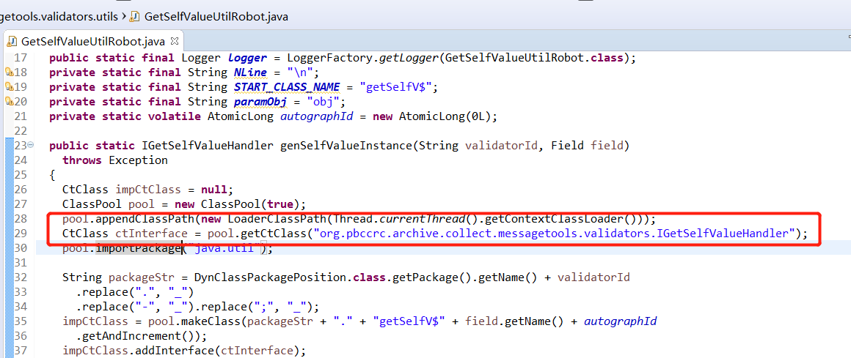

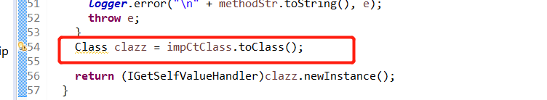

**DepExpExeHandlerClassRobot**

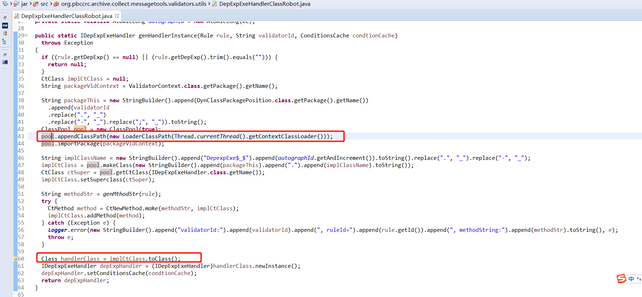

**RuleMethodUtilRobot**

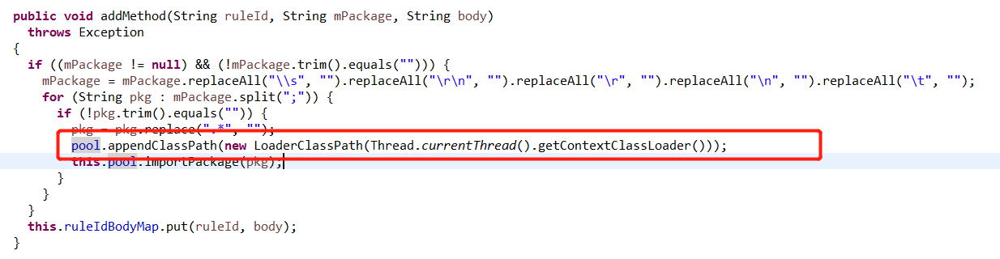

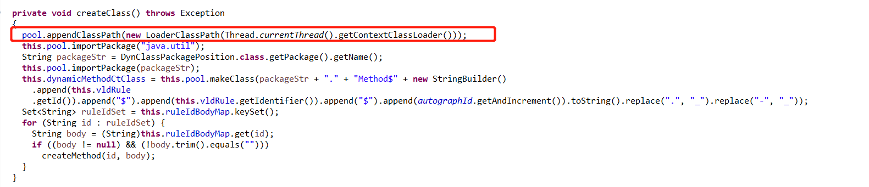

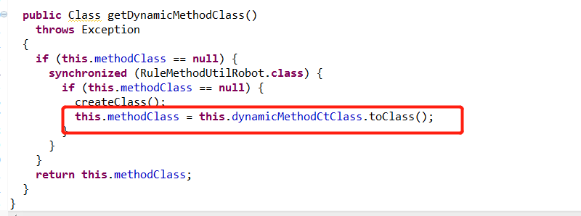

**org.pbccrc.collectclient.api DefaultReportFileProcess 去除加载缓存**

