**Problem #2: Submit Screenshots**

Setup a Node.js environment on your local computer.

* Download and install the Node.js from [https://nodejs.org/en /](https://nodejs.org/en%20/) (Links to an external site.)Links to an external site..

Tip: <https://www.tutorialspoint.com/nodejs/nodejs_environment_setup.htm> (Links to an external site.)Links to an external site.

Below is a screen shot of the Node.js console installed and running

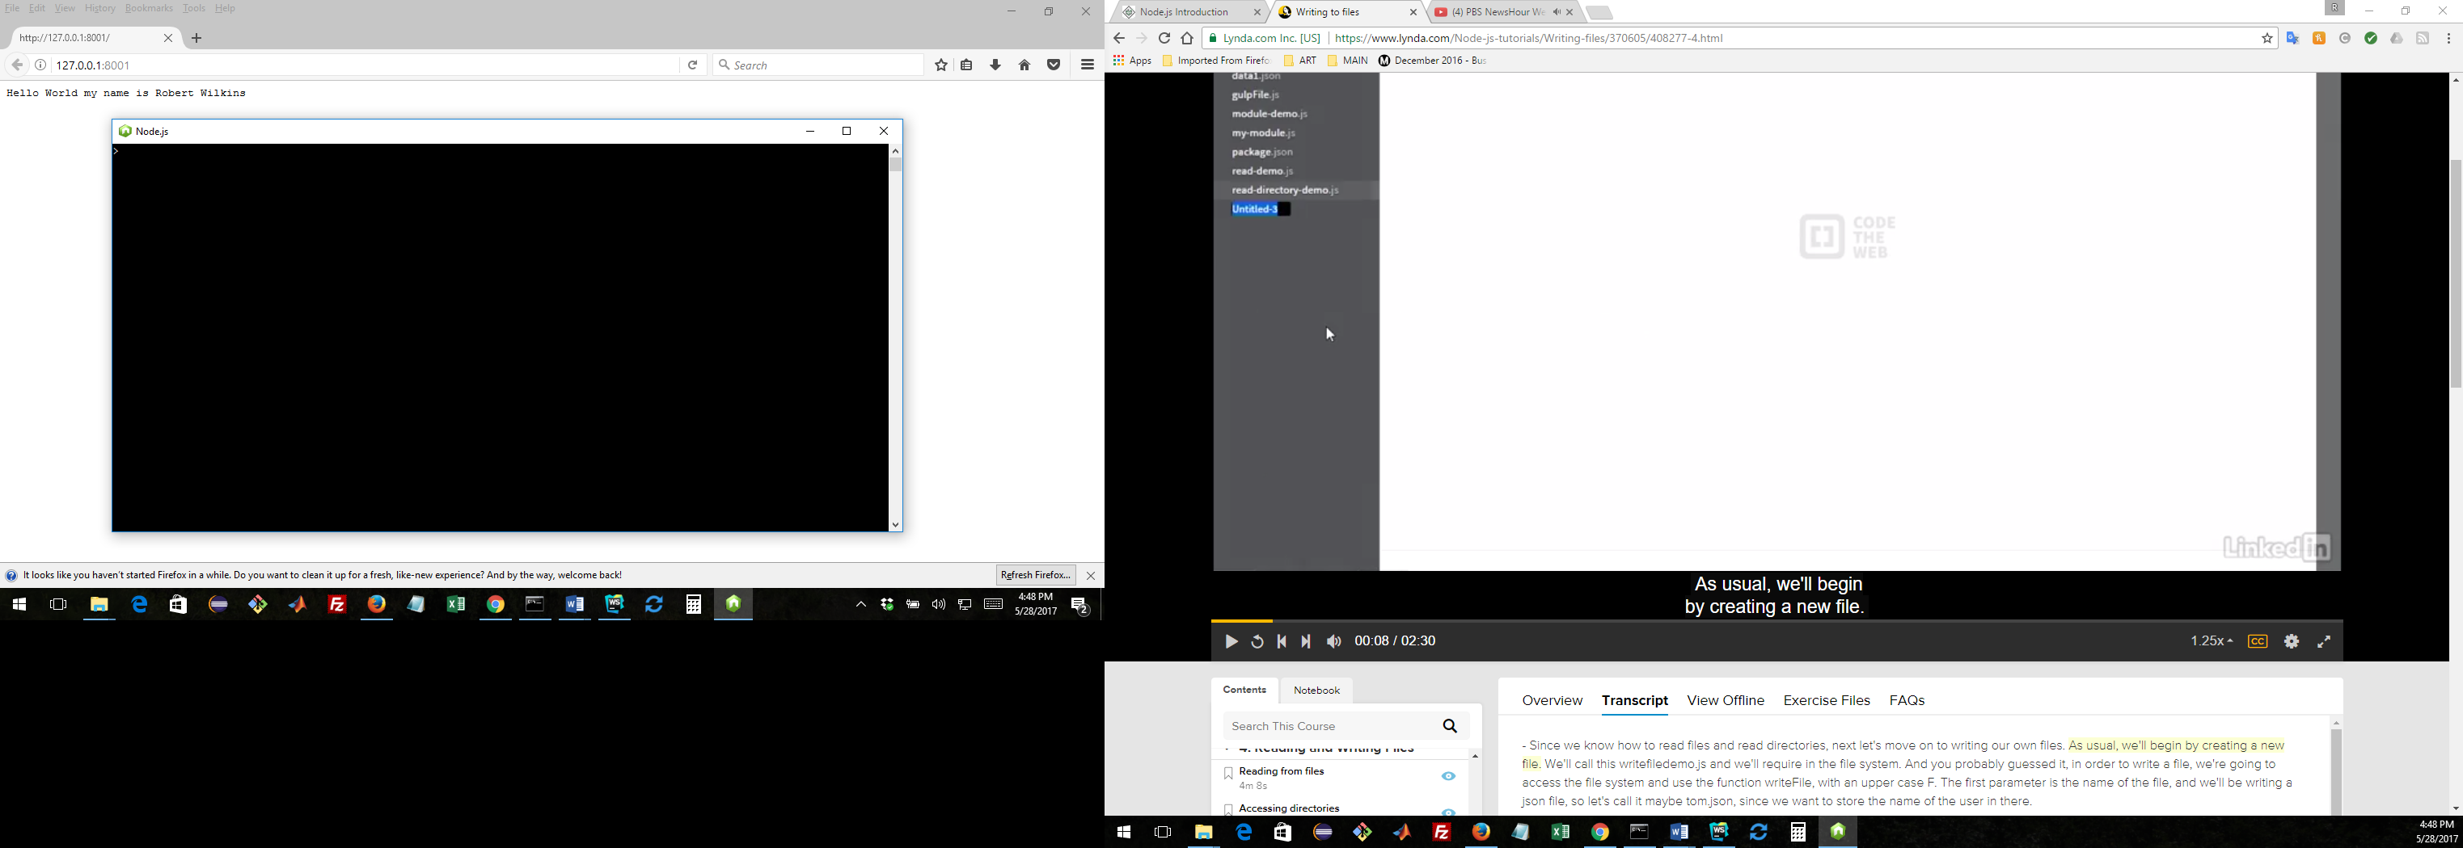

Below is a screen shot of **websvr.js** running in a Windows command window.

