Nomad eCommerce | MVC Prototype | Guide

Logon
- Provide the Logon, Passcode, the choose Logon
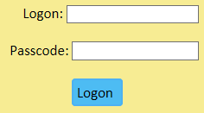
Search
This option queries the database for records where the search string is part of the name.

- Type the search string the choose Search
Filter
This option filters the current set of records where the filter string is part of the name

- Type the filter string. The filter is automatic.
Expand Component
Each component could contain sub components
- Choose the expand icon to the left of the component

Create Component or Sub Component
- Choose the new option
- or the create sub component option
- Provide the necessary attributes + image
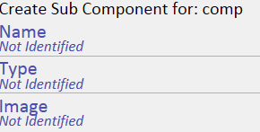
- Choose Store
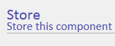
Delete Component
- Choose the Delete icon to the left of the component
Component Attributes
- Choose the component from the tree
- The attributes are shown
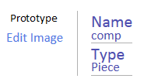

Revise Attributes
- From the Attributes view, choose the attribute
  - or
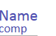
  - or
