*Terrain* and *cylinder*

generation

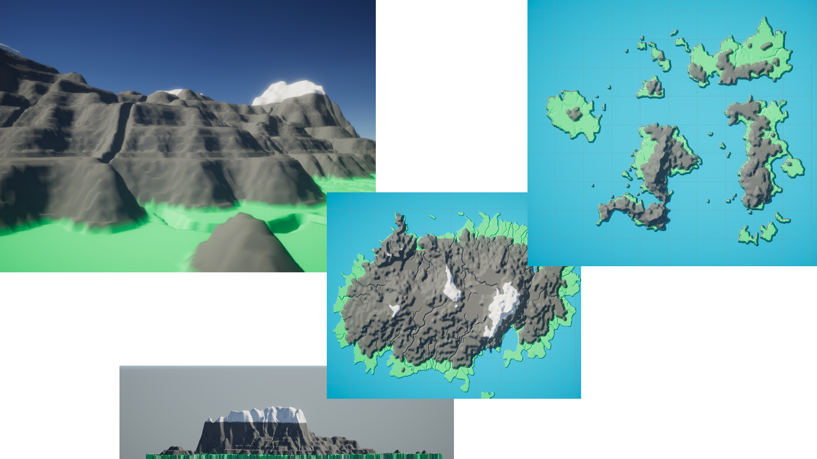

Date: 08.09.2021

Name: Luca Ruiters

Student nr: 500796991

GitHub: [ru1t3rl/GPE](https://github.com/ru1t3rl/GPE)

Table of Contents

Intro 3

Cylinder 3

Vertices 3

Triangles - Top and Bottom 3

Triangles - Side 4

Terrain Generator 5

Grid 5

Vertices 5

Triangles 5

Result 5

Heightmaps 5

Chunks 6

Results 7

References 7

# Intro

….

# Cylinder

## Vertices

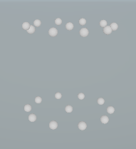



## Triangles - Top and Bottom

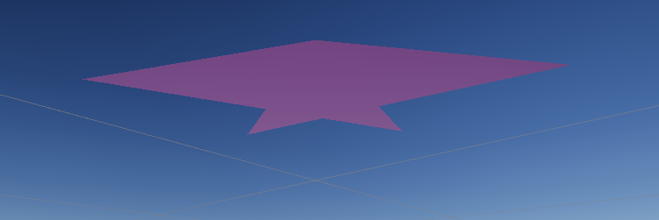

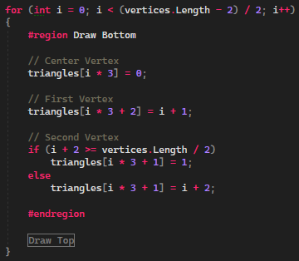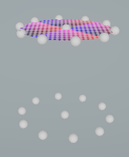

## Triangles - Side

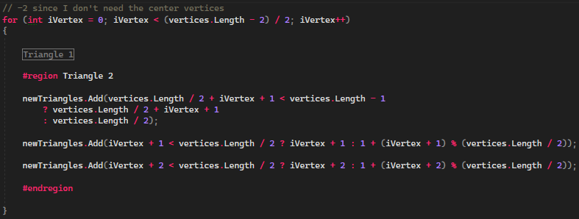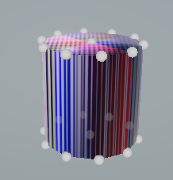

# Terrain Generator

## Grid

### Vertices

### Triangles

### Result

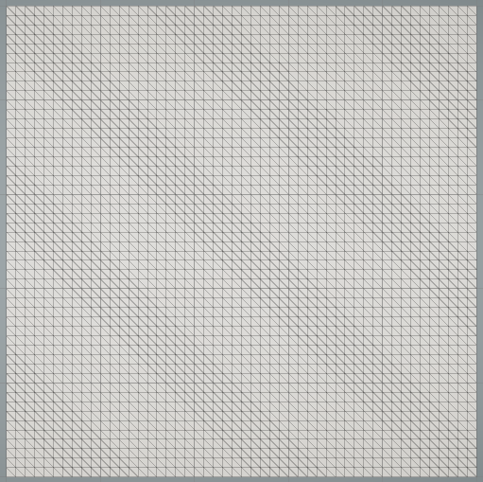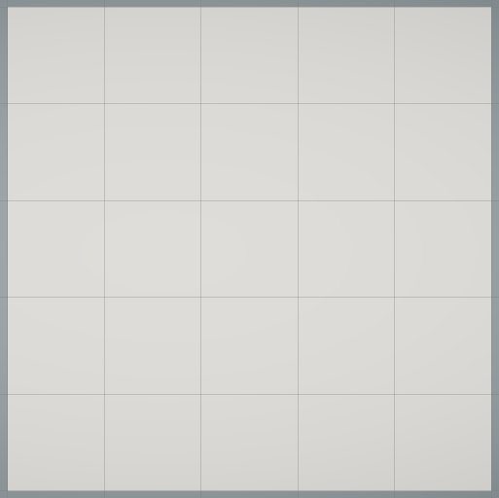

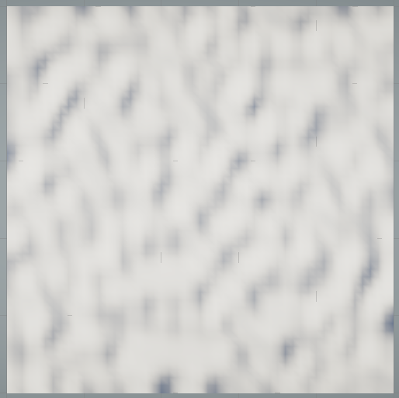

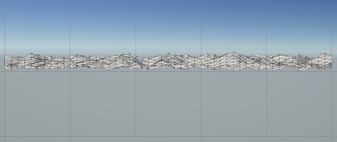

## Heightmaps

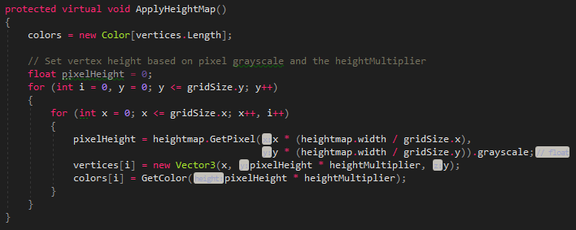

## Chunks

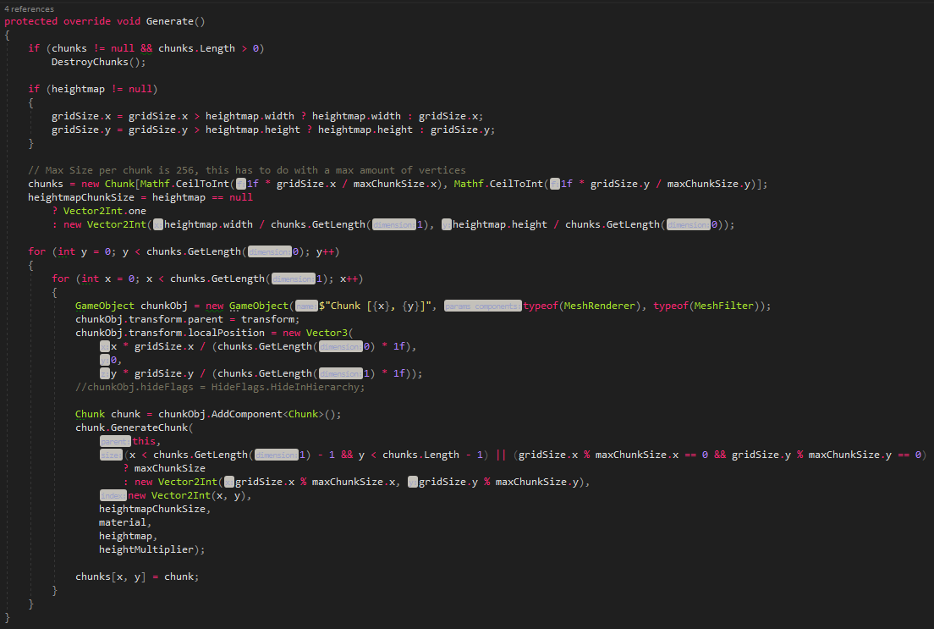





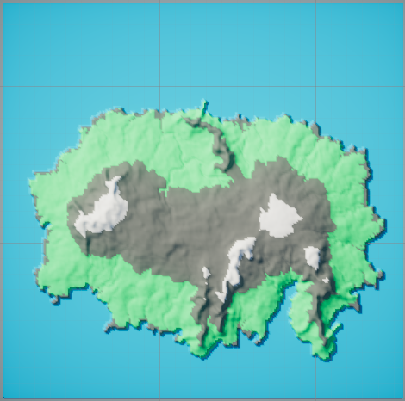

256x256 (What it should look like)

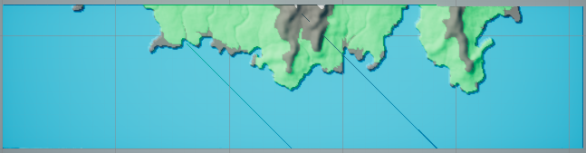

512x512 (The bug, only occurs on grid sizes above 256x256)

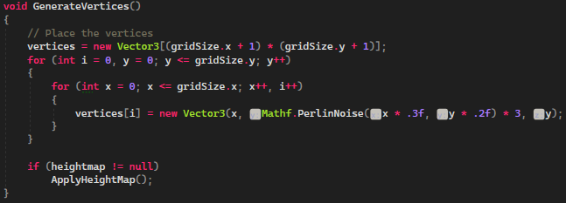

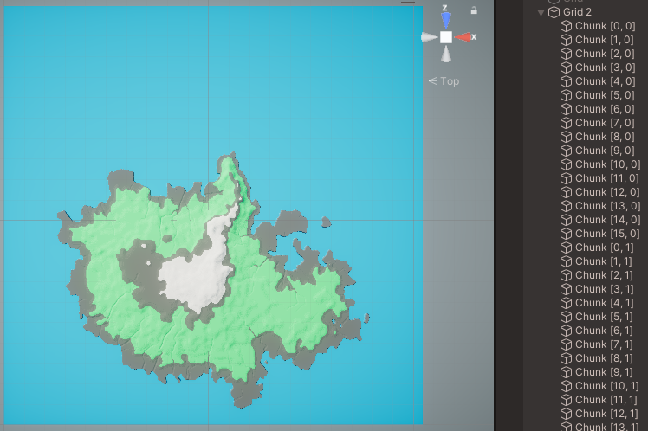Eventually, I discovered this bug had nothing to do with my code but a maximum number of vertices for each object. To fix this, I decided to use chunks, which resulted in *Figure 1*.

Figure 1 - 2048 x 2048

# Results

# References