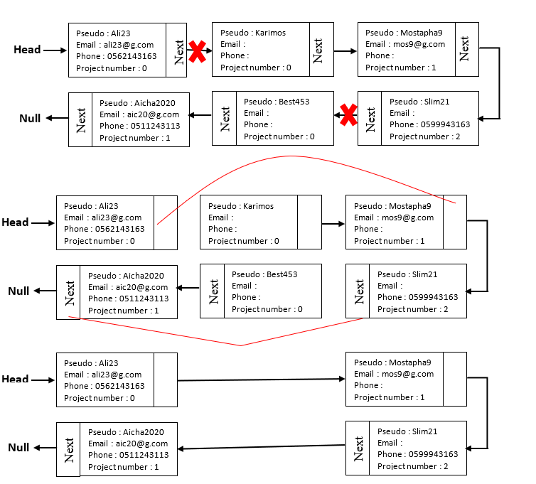

*Answer for Question 2:*

**Algorithm**: check if matching the freelancer's skills and the price matched with requirement or not and print the result if its matched.

data members: ‘Category(n), Price per Hour(n)’

algorithm:

for project(n),

if MinPrice(n) <=input.price and freelancer.skills == catagory;

print project details

else print not found

**Input**:

Linked list of freelancer's skills, price.

**Output**:

If the project has found with all the requirements matched with freelancer’s skills and the price per hour that is higher than the minimum price. Then print project details.

**Method**

Project helpPtr = head; //Set a pointer to loop through the list

//loop through the linked list

While(helpPtr!=null)

If (helpPtr.minprice <=input.price && helpPtr.catagory == freelancerSkills)

//if the Price is higher than the minimum price and equal to freelancer skills

Returen helpPtr;

//move the pointer after every check.

helpPtr = helpPtr.next;

//if does not matched

Return null;