
The Met Éireann Location Forecast API
The Met Éireann WDB API outputs a detailed point forecast in XML format for a coordinate point as defined by the user.
https://data.gov.ie/dataset/met-eireann-forecast-api

Accessing the API

Introduction
This document details how to request data from the Met Éireann WDB API.

License
Access to the api is granted subject to a custom Open Data license, similar to a modified Creative Commons CC-BY license.

License Summary
You are free to:
- Share — copy and redistribute the material in any medium or format
- Adapt — remix, transform, and build upon the material
for any purpose, even commercially.

Under the following terms:
- You must give appropriate credit to Met Éireann, provide a link to the licence, and indicate if changes were made.
- No additional restrictions — You may not apply legal terms or technological measures that legally restrict others from doing anything the licence permits.
- If you distribute or broadcast this data or use this data to create web content for the internet, you must also display our Weather Warnings. Please see here for details on how to access Weather Warnings: https://data.gov.ie/dataset/weather-warnings

This licence is almost identical to Creative Commons Attribution 4.0 International (CC BY 4.0), but with the additional requirement to concurrently display our Weather Warnings with web content you generate based on this data. To view a copy of the full licence, visit here.

Requesting data from the api
Data requests to the api are made by a http request to the URL:
http://openaccess.pf.api.met.ie/metno-wdb2ts/locationforecast?lat=<LATITUDE>;long=<LONGITUDE>
<LATITUDE> and <LONGITUDE> are substituted with the coordinates of the requested location. This will return an xml output containing the forecast from the current time until the end of available forecast.
http://openaccess.pf.api.met.ie/metno-wdb2ts/locationforecast?lat=<LATITUDE>;long=<LONGITUDE>;from=2018-11-10T02:00;to=2018-11-12T12:00
will return a forecast between 02:00 on 10th Nov 2018 to 12:00 on 12th Nov 2018. Leaving out the ’to’ keyword will return a forecast from 02:00 on 10th Nov 2018 until the end of available forecast.
Please note: https can be substituted for http in the above links.

Notes on the API XML file

Introduction
This document details the contents of the XML files that will be delivered by ICHEC on receipt of a call to the WDB API.
The API can be accessed at http://openaccess.pf.api.met.ie/metno-wdb2ts/locationforecast?lat=54.7210798611;long=-8.7237392806 . This is an example latitude and longitude but these can be changed for any valid lat and long over Ireland. Note that latitude and longitude follows the convention of positive values for North and East, negative values for South and West. Over Ireland latitude is always positive, longitude is always negative.
The API is based on a package originally developed by Met Norway, hence the occasional use of Norwegian language.

Changes
Please note, the API is subject to change from time to time. Changes may include addition of new parameters or alterations to the time frequency, etc. The change history is documented in https://www.met.ie/Open_Data/API-Changes.odt

Time Format
All time formats, in both the Header and the Meteorological Data, are in Coordinated Universal Time (UTC) format. UTC is not adjusted for daylight saving time. In Ireland, it is the same as local time during winter, but is one hour behind local time in summer time.

Header
There are 2 weather models producing data in the XML file:
- Harmonie data from 00h to 54h in one hour intervals: named as harmonie
- ECMWF data from 54h to 10 days in varying intervals:
  - ECMWF data from 54h to 90h in one hour intervals: named as ec_n1280_1hr
  - ECMWF data from 90h to 144h in three hour intervals: named as ec_n1280_3hr
  - ECMWF data from 144h to end of forecast in six hour intervals: named as ec_n1280_6hr
Please note: (i) Other models may appear from time to time.
(ii) Forecast intervals may change from time to time.
model name is a label for the model data used in the forecast. This label is used internally by the api.
model name="harmonie"

termin is the date and time of the model forecast run (note the trailing 'Z' in the time denoting UTC)
termin="2019-03-07T12:00:00Z”

runended and nextrun are the dates and times of the forecast processing run: runended relates to the current run,
nextrun is when the next forecast run is expected.
runended="2019-03-07T15:58:40Z" nextrun="2019-03-07T22:00:00Z"

from and to are the validity date and time of the model forecast run
from="2019-03-07T17:00:00Z" to="2019-03-09T18:00:00Z" />

NamespaceSchemaLocation contains a URL for the description of the xml schema used.
<weatherdata xmlns:xsi="http://www.w3.org/2001/XMLSchema-instance" xsi:noNamespaceSchemaLocation="http://api.met.no/weatherapi/locationforecast/1.9/schema" created="2019-03-07T16:40:25Z">

model name identifies an individual forecast model along with its validity date and time.
<meta>
<model name="harmonie" termin="2019-03-07T12:00:00Z" runended="2019-03-07T15:58:40Z" nextrun="2019-03-07T22:00:00Z" from="2019-03-07T17:00:00Z" to="2019-03-09T18:00:00Z" />
<model name="ec_n1280_1hr" termin="2019-03-07T00:00:00Z" runended="2019-03-07T15:58:40Z" nextrun="2019-03-07T18:00:00Z" from="2019-03-10T00:00:00Z" to="2019-03-17T00:00:00Z" />
<model name="ec_n1280_3hr" termin="2019-03-07T00:00:00Z" runended="2019-03-07T15:58:40Z" nextrun="2019-03-07T18:00:00Z" from="2019-03-10T00:00:00Z" to="2019-03-17T00:00:00Z" />
<model name="ec_n1280_6hr" termin="2019-03-07T00:00:00Z" runended="2019-03-07T15:58:40Z" nextrun="2019-03-07T18:00:00Z" from="2019-03-10T00:00:00Z" to="2019-03-17T00:00:00Z" />
</meta>

pointData identifies this as a forecast for a single location.
<product class="pointData">

Meteorological Data
For each timestep of the API there are two distinct forecast blocks:

Forecast Block A

Timing:
It displays the forecast time “from” and “to”; for Harmonie as data is outputted in 1 hour intervals the “from” and “to” times are the same.
<time datatype="forecast" from="2019-03-07T17:00:00Z" to="2019-03-07T17:00:00Z">

Location:
It displays the “altitude” (m), “latitude” and “longitude” values of the location.
<location altitude="9" latitude="54.7211" longitude="-8.7237">

Temperature:
The air temperature 2m above the ground is given in degrees Celsius.
<temperature id="TTT" unit="celsius" value="7.6"/>

Wind Direction and speed:
The direction of the wind is given in degrees from 0 to 360. The cardinal direction is also given i.e. southwest SW.
<windDirection id="dd" deg="353.1" name="N"/>
The wind speed is given in metres per second and in the Beaufort scale. The SI unit for wind speed is m/s. In order to convert to km/h the value must be multiplied by 3.6.

Humidity:
Relative humidity has a maximum value of 100 percent.
<humidity value="74.7" unit="percent"/>

Pressure:
Pressure is given in units of hPa.
<pressure id="pr" unit="hPa" value="1002.0"/>

Cloud:
There is a general level of cloudiness called NN, with a maximum of 100. Then there are three types of cloud cover, Low, Medium and High; again they will have a maximum of 100. See here for further details. https://cloudatlas.wmo.int/clouds-definitions.html
<cloudiness id="NN" percent="62.1"/>
<lowClouds id="LOW" percent="62.1"/>
<mediumClouds id="MEDIUM" percent="0.0"/>
<highClouds id="HIGH" percent="0.0"/>

Dewpoint temperature:
This is the temperature at which the air would become saturated. If it equals the actual temperature (TTT) we have 100% humidity so rain, mist, fog or low cloud.
<dewpointTemperature id="TD" unit="celsius" value="3.3"/>
</location>
</time>

Forecast Block B
The second block in the file is related to rainfall accumulations and weather symbol. It is important to note that precipitation and the appropriate weather symbol e.g. ’Cloudy’ are computed for a period of time.
Note that rainfall accumulations for different time periods are not directly comparable. For example, the rainfall accumulation for a 6-hour period should be divided by the number of hours before comparing it with a 1-hour accumulation. This can give rise to incorrect impressions when graphing output.

Timing:
It displays the forecast time “from” and “to”. Two distinct times are required to calculate the accumulated rainfall. For Harmonie, as data is outputted in 1 hour intervals the “from” and “to” times will differ by one hour as you can see in this example.
<time datatype="forecast" from="2019-03-07T16:00:00Z" to="2019-03-07T17:00:00Z">

Location:
It displays the “altitude”, “latitude” and “longitude” values of the location.
<location altitude="9" latitude="54.7211" longitude="-8.7237">

Precipitation unit:
Rain will be output in millimetres (mm).
The minvalue, value and maxvalue values are derived from statistical analysis of the forecast, and refer to the lower (20th percentile), middle (60th percentile) and higher (80th percentile) expected amount. If minvalue and maxvalue are not output, value is the basic forecast amount.
<precipitation unit="mm" value="0.0" minvalue="0.0" maxvalue="0.1"/>

Weather symbol:
The WDB computes the weather symbol for this period of time. In this case the main weather feature is cloud. This corresponds to number 4 in their list of weather symbols. A full list of symbols is shown in Table 1 below.
<symbol id="PartlyCloud" number="3"/>
The weather symbol is derived from a combination of temperature, humidity, cloud cover, precipitation.
</location>
</time>

The forecast blocks A and B will be repeated up to 54 times from the start of forecast until the Harmonie forecast is exhausted. At this point there will be a change over to the ECMWF model. The only difference will be that the data will be output in 1/3/6 hour intervals. This will continue up to 10 days from the start date of the forecast. As there is potential for the data intervals to vary both in number returned and, in future, in the size of the interval, your application should take account of the intervals returned in the xml.
Table 1: Weather symbol id and number
Daytime Symbol | Number | NightTime Symbol | Number
Error | 0
Sun | 1 | Dark_Sun | 101
LightCloud | 2 | Dark_LightCloud | 102
PartlyCloud | 3 | Dark_PartlyCloud | 103
Cloud | 4
LightRainSun | 5 | Dark_LightRainSun | 105
LightRainThunderSun | 6 | Dark_LightRainThunderSun | 106
SleetSun | 7 | Dark_SleetSun | 107
SnowSun | 8 | Dark_SnowSun | 108
LightRain | 9
Rain | 10
RainThunder | 11
Sleet | 12
Snow | 13
SnowThunder | 14
Fog | 15
SleetSunThunder | 20 | Dark_SleetSunThunder | 120
SnowSunThunder | 21 | Dark_SnowSunThunder | 121
LightRainThunder | 22
SleetThunder | 23
DrizzleThunderSun | 24 | Dark_DrizzleThunderSun | 124
RainThunderSun | 25 | Dark_RainThunderSun | 125
LightSleetThunderSun | 26 | Dark_LightSleetThunderSun | 126
HeavySleetThunderSun | 27 | Dark_HeavySleetThunderSun | 127
LightSnowThunderSun | 28 | Dark_LightSnowThunderSun | 128
HeavySnowThunderSun | 29 | Dark_HeavySnowThunderSun | 129
DrizzleThunder | 30
LightSleetThunder | 31
HeavySleetThunder | 32
LightSnowThunder | 33
HeavySnowThunder | 34
DrizzleSun | 40 | Dark_DrizzleSun | 140
RainSun | 41 | Dark_RainSun | 141
LightSleetSun | 42 | Dark_LightSleetSun | 142
HeavySleetSun | 43 | Dark_HeavySleetSun | 143
LightSnowSun | 44 | Dark_LightSnowSun | 144
HeavySnowSun | 45 | Dark_HeavySnowSun | 145
Drizzle | 46
LightSleet | 47
HeavySleet | 48
LightSnow | 49
HeavySnow | 50

A note on Geographic Coverage
Output will vary according to the coordinates chosen. Within the “Harmonie” area as shown in Table 2 below, there will be a full output of Harmonie followed by ECMWF data. Outside the “Harmonie” area but within the “ECMWF” grid, the api reverts to ECMWF data only. A map of the relevant areas is depicted in Figure 1.

Table 2: Geographic Coverage Coordinates
Model | NW | NE | SW | SE
Harmonie | 56.2N9.3W | 55N3.8W | 51.6N11.7W | 50.5N6.7W
ECMWF | 60N20.9W | 59.8N2.8E | 49.1N20.9W | 49.1N2.7E

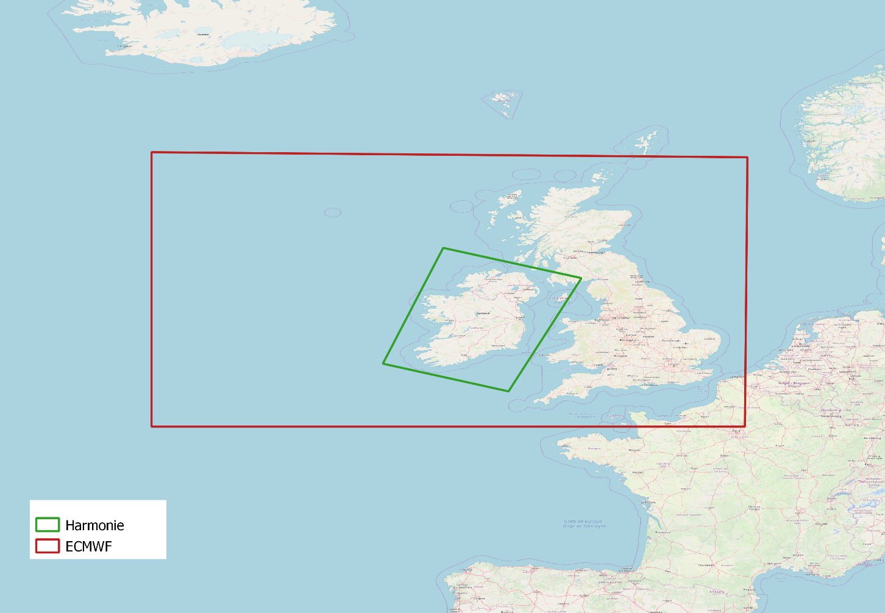
Figure 1: Forecast API Geographic Coverage

