右上初始位置

(1,-156.12,-372.86,47.04,82.18,-0.17,-54.94)

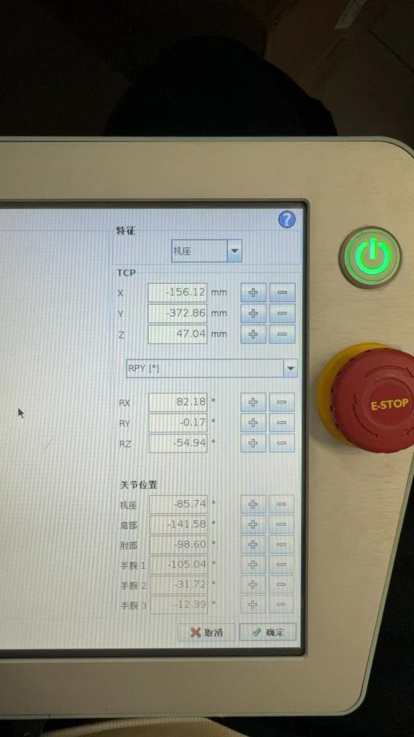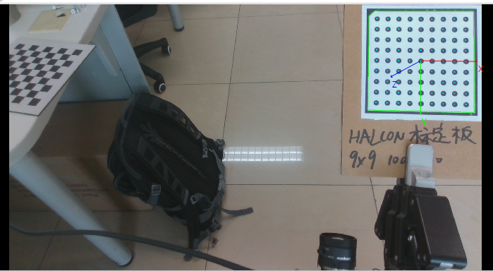

二排初始位置(1,-116.13,-367.99,32.01,82.18,-0.17,-54.94)

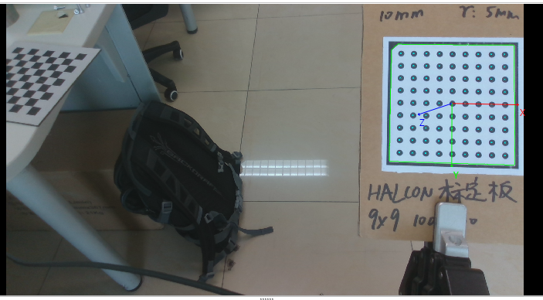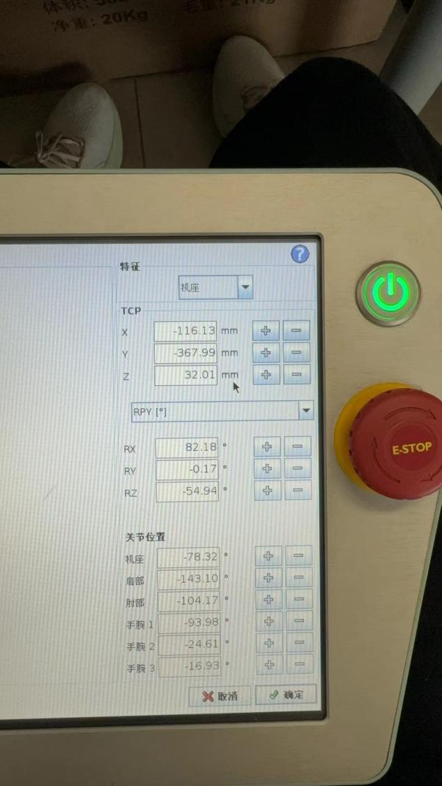

第三排初始位置(1,-250.94,-426.96,295.82,175.50,-2.16,-54.88)

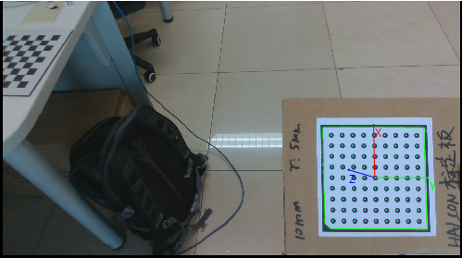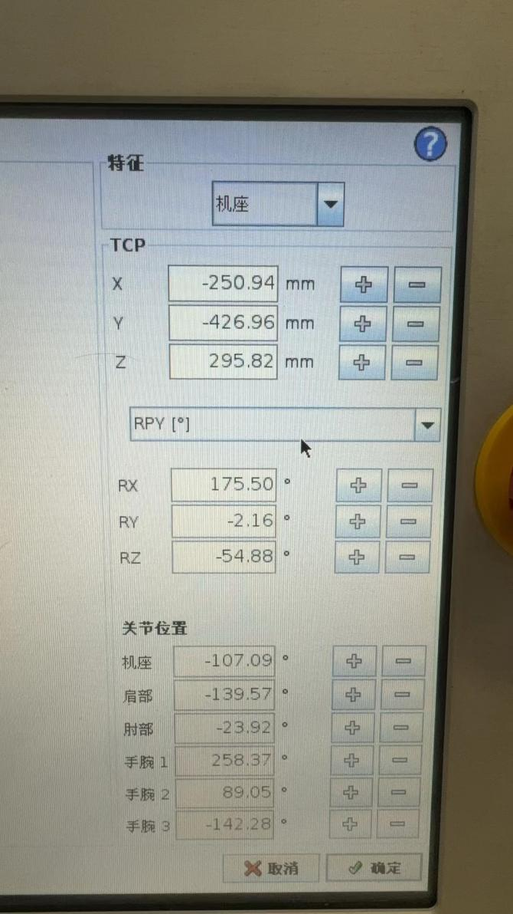

第三排终止位置(1,-250.95,-426.91,-5.62,175.52,-2.15,-54.88)

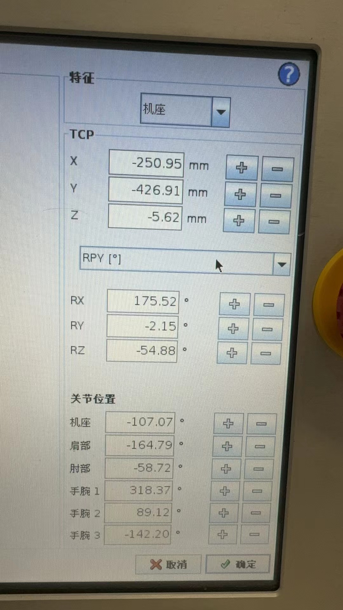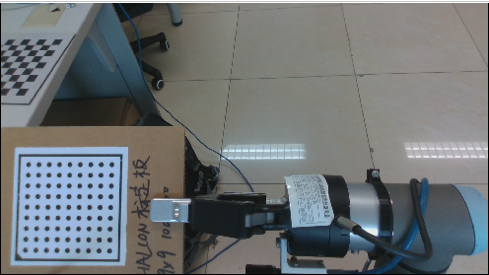

第一排

(3,3,3,3,3,3,3)

(1,-116.13,-367.99,328.01,82.18,-0.17,-54.94)

(1,-156.12,-372.86,47.04,82.18,-0.17,-54.94)

(1,-156.12,-372.86,-10.86,82.18,-0.17,-54.94)

(1,-156.12,-372.86,-68.76,82.18,-0.17,-54.94)

(1,-156.12,-372.86,-126.66,82.18,-0.17,-54.94)

(1,-156.12,-372.86,-184.56,82.18,-0.17,-54.94)

(1,-156.12,-372.86,-242.46,82.18,-0.17,-54.94)

第二排

(3,3,3,3,3,3,3)

(1,-116.13,-367.99,328.01,82.18,-0.17,-54.94)

(1,-116.13,-367.99,32.01,82.18,-0.17,-54.94)

(1,-116.13,-367.99,-28.01,82.18,-0.17,-54.94)

(1,-116.13,-367.99,-88.01,82.18,-0.17,-54.94)

(1,-116.13,-367.99,-148.01,82.18,-0.17,-54.94)

(1,-116.13,-367.99,-268.16,82.18,-0.17,-54.94)

第三排  
(1,-250.94,-426.96,295.82,175.50,-2.16,-54.88)  
(1,-250.94,-426.96,235.82,175.50,-2.16,-54.88)  
(1,-250.94,-426.96,175.82,175.50,-2.16,-54.88)  
(1,-250.94,-426.96,115.82,175.50,-2.16,-54.88)  
(1,-291.80,-435.30,46.82,175.50,-2.16,-54.88)