<https://devpost.com/software/recyclehub-tjub0w>

**Waste Management with Reward System**

**Login Form**

**Registration Form**

* Last name
* First name
* Middle name
* Gender
* Age
* Contact
* Email
* Address
* Profile
* Username
* Password

**Admin Account**

**Admin Dashboard**

* Number of Recycling Centers
* Number of Members
* Garbage Collected

**Junkshop and Recycling Center**

* Name
* Address
* Contact
* Email Address
* Google Map Location

**Garbage Type**

* Name
* Description
* Reward

**Member Information**

* Last name
* First name
* Middle name
* Gender
* Age
* Contact
* Email
* Address
* Profile
* Username
* Password
* Account Status

**Collection Records**

* Member name
* Garbage Type
* Quantity
* Unit
* Total Amount
* Date

**Statistics Report by Garbage Type**

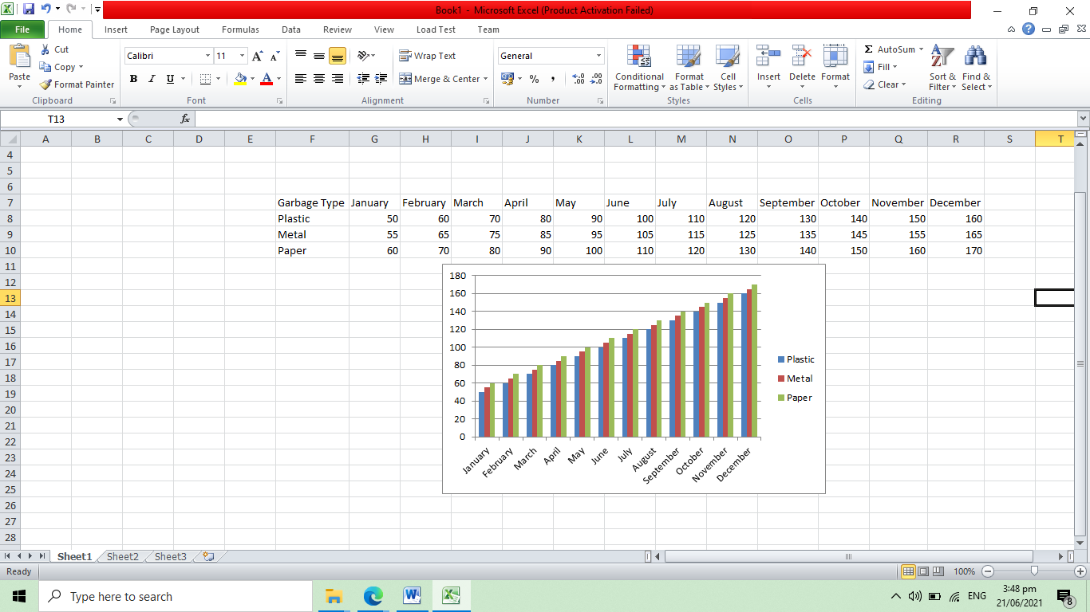

**Income Report by Center**

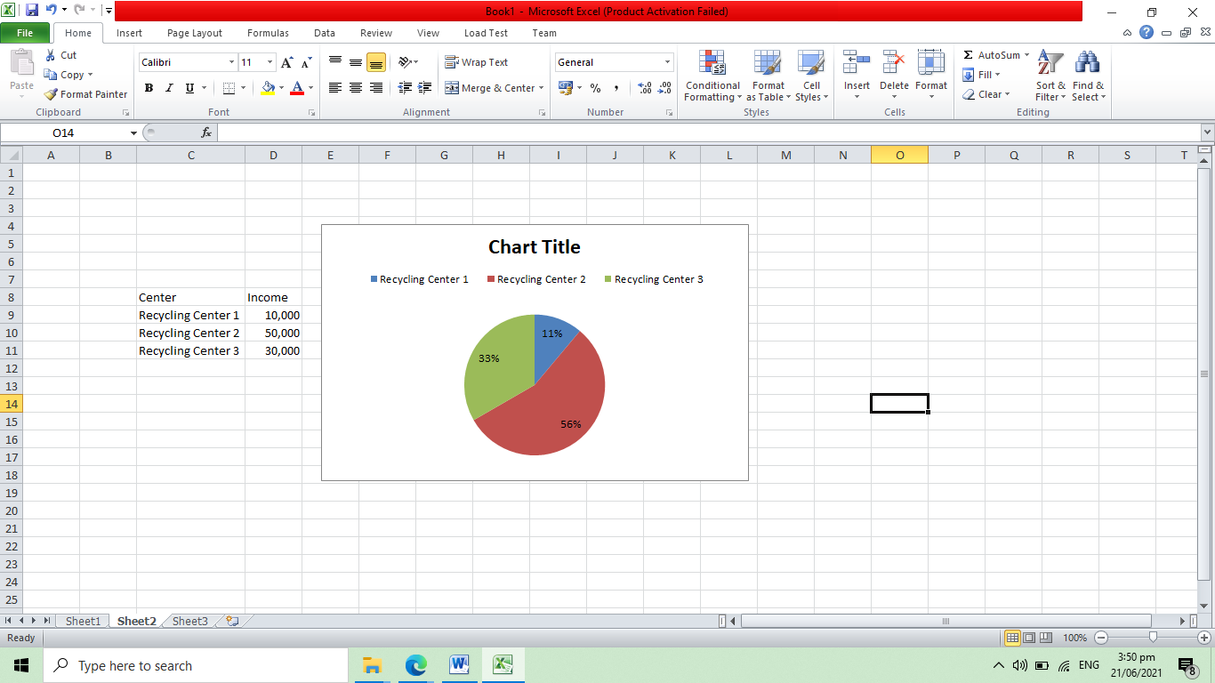

**Member Account**

**Dashboard**

|  |  |
| --- | --- |
| **Garbage Type** | **Income** |
| Plastic | 150.00 |
| Metal | 300.00 |
| Paper | 200.00 |
| **Total** | **650.00** |

**Garbage Collection Report**

* Garbage Type
* Quantity
* Total Amount
* Date
* Upload of Scan Garbage
* Status – accepted, rejected

**View Map of Junkshop and Recycling Center**

* Name
* Address
* Contact
* Email Address
* Google Map Location