Network:
A network is a group of two or more computers, devices, or systems connected together so they can communicate and share data or resources.

Types of Network
- PAN (Personal Area Network) — connects personal devices over a small area.
- LAN (Local Area Network) — connects devices within a home, office, school, etc.
- MAN (Metropolitan Area Network) — covers a city or large campus.
- WAN (Wide Area Network) — covers a large geographical area; the Internet is the largest example.

Port:
A port is a logical communication endpoint used to identify a specific service or application on a device.

Protocol — Definition
A protocol is a set of rules and standards that define how devices communicate, exchange, and understand data over a network.
Example:
HTTPS is a protocol used to securely transfer web data between a browser and a web server.

Examples:
Port | Protocol/Service | Common use | Default status
20 | FTP | Data transfer | Closed unless FTP is running
21 | FTP | File transfer/control | Closed unless FTP is running
22 | SSH | Secure remote access | Closed unless SSH is enabled
23 | Telnet | Remote access | Usually closed
25 | SMTP | Email transfer | Closed unless mail server is running
53 | DNS | Domain-name resolution | Closed unless DNS service is running
67 | DHCP | DHCP server | Closed unless DHCP server is running
68 | DHCP | DHCP client | Closed unless DHCP client is active
80 | HTTP | Web traffic | Closed unless web server is running
110 | POP3 | Email retrieval | Closed unless mail server is running
143 | IMAP | Email retrieval | Closed unless mail server is running
443 | HTTPS | Secure web traffic | Closed unless HTTPS server is running
445 | SMB | Windows file/printer sharing | Closed unless SMB is enabled
3306 | MySQL | Database | Closed unless MySQL is running
3389 | RDP | Windows Remote Desktop | Closed unless RDP is enabled
5432 | PostgreSQL | Database | Closed unless PostgreSQL is running
8080 | HTTP-alt | Web applications/proxies | Closed unless a service uses it

Important concept
Open port ≠ always dangerous.
For example, a web server normally needs 443 open to provide HTTPS.
Closed port = no service is accepting connections on that port.

TCP — Transmission Control Protocol
TCP is a connection-oriented protocol that provides reliable and ordered delivery of data between devices.
Key points:
- Reliable
- Connection-oriented
- Data arrives in order
- Uses acknowledgments and retransmission
- Generally slower than UDP
Examples: HTTPS, HTTP, SSH, FTP

UDP — User Datagram Protocol
UDP is a connectionless protocol that sends data without establishing a connection first.
Key points:
- Faster
- Connectionless
- No guarantee of delivery
- No guarantee of order
- Lower overhead than TCP
Examples: DNS, online gaming, live streaming, VoIP
TCP | UDP
Reliable | No delivery guarantee
Connection-oriented | Connectionless
Ordered data | No ordering guarantee
More overhead | Less overhead
Generally slower | Generally faster

SSL (Secure Sockets Layer)
SSL is an older security protocol used to encrypt communication between a client and a server.
Note: SSL is now obsolete and should not be used. Modern systems use TLS.
Example: just like an example

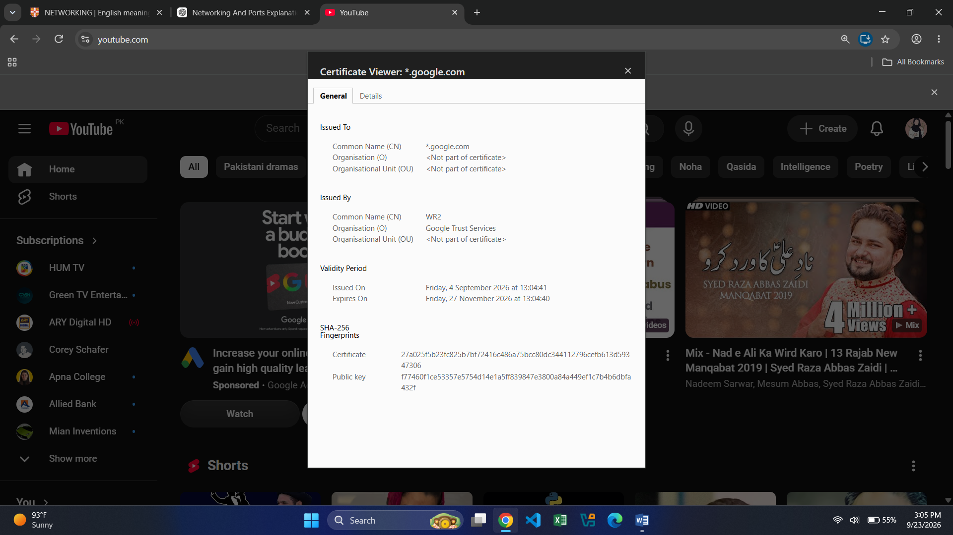

TLS (Transport Layer Security)
TLS is the modern protocol used to encrypt data and secure communication over a network.
Example:
When you visit an HTTPS website, TLS helps protect the communication between your browser and the website.

Digital Certificate
A digital certificate is used to prove the identity of a website/server and help establish a secure encrypted connection.
It commonly contains:
- Website/domain name
- Certificate issuer
- Public key
- Validity period
- Digital signature

Simple Difference
SSL → Old security protocol
TLS → Modern security protocol
Certificate → Helps verify the server's identity and establish trust
Example:
https://example.com → HTTPS + TLS + Digital Certificate 🔐

