

**FEDERAL URDU UNIVERSITY**  
**O F A R T S, S C I E N C E & T E C H N O L O G Y**



**ASSIGNMENT**

**Name:** Tabbassum Zaman

**Father name:** Ali Zaman

**Department:** Computer science

**Class:** BS **Semester:** 5th

**Section:** A. **Roll #** 56

**Subject:** Data Mining

**Submitted to:** Ma’am Uzma

Decision Tree (D.T) :

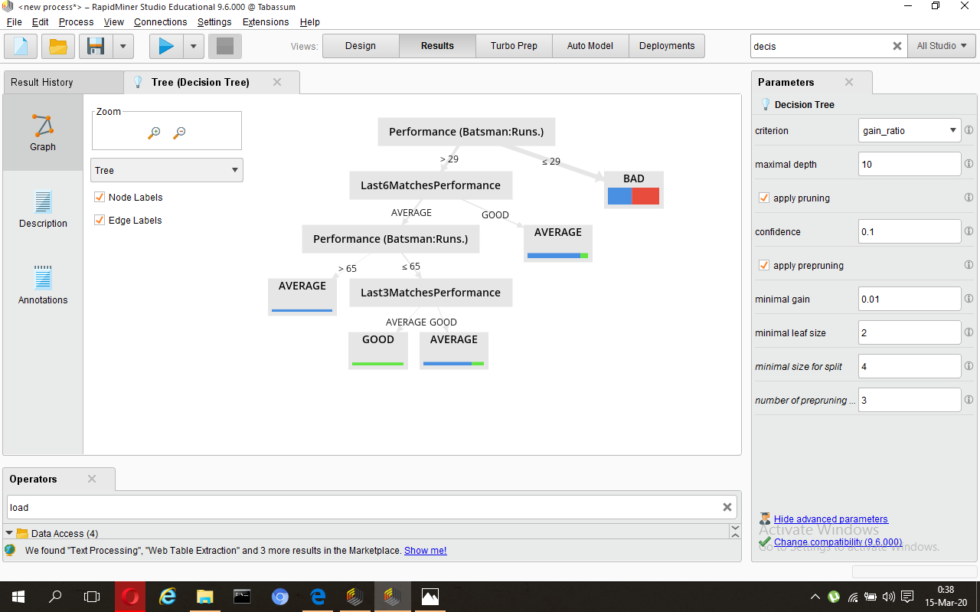

Explain D.T :

01 Decision tree builds classification or regression models in the form of a tree structure.

02 It breaks down a dataset into smaller and smaller subsets.

03 A decision node has two or more branches.

04 Leaf node (label) represents a classification or decision.

05 Decision trees can handle both categorical and numerical data.

06 In my case, The root is: **Last6MatchesPerformance** because it has heighest info gain.

Extract Good Rules :

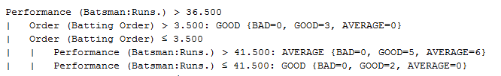

Accuracy :

