

**FEDERAL URDU UNIVERSITY**  
**O F A R T S, S C I E N C E & T E C H N O L O G Y**



**ASSIGNMENT**

**Name:** Tabbassum Zaman

**Father name:** Ali Zaman

**Department:** Computer science

**Class:** BS **Semester:** 5th

**Section:** A. **Roll #** 56

**Subject:** Data Mining

**Submitted to:** Ma’am Uzma

01. Random Forest Classifier and its Hyper Parameter :

Random forest is a classifier which is consist of many other decision trees. Which uses bagging and randomness when building a tree to try to make an uncorrelated forest of trees. Whose predictions by a committee is more accurate and informative than that of individual tree. There are number of Hyper parameters are available although we can get good results without any changes to these parameters. There are some parameter which can have good impact on the classifier.

02. Two Most Important Hyper Parameter of RF :

* **max_features** : max number of features considered for splitting a node
* **max_depth** : max number of levels in each decision tree

03. RF Classifier for my Dataset :

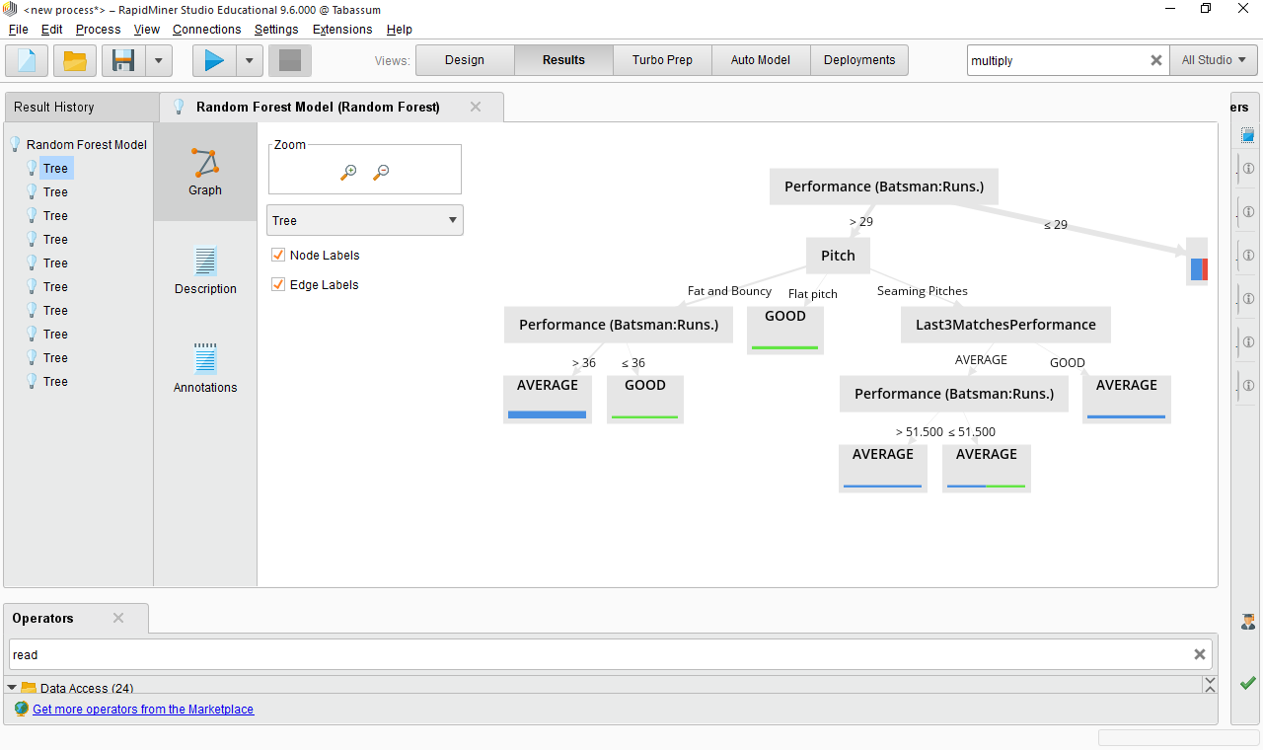

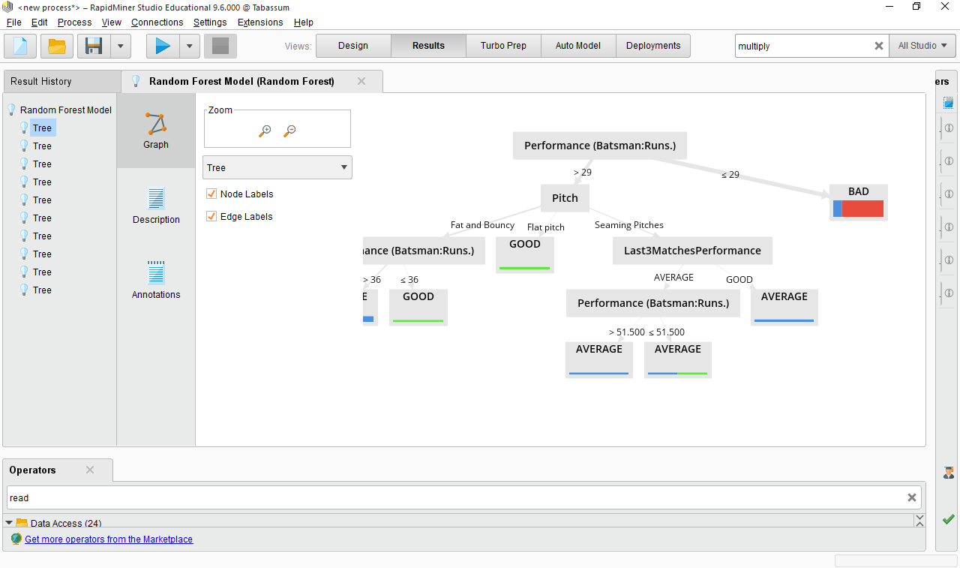

05. Extract Good Rules :

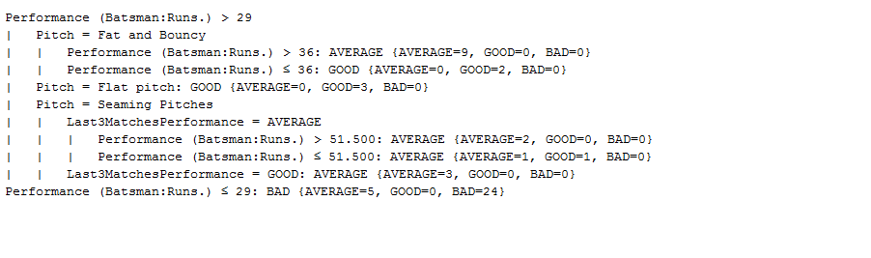

06. Prediction On 5 Random Rows :

