

**FEDERAL URDU UNIVERSITY**  
**O F A R T S, S C I E N C E & T E C H N O L O G Y**



**ASSIGNMENT**

**Name:** Tabbassum Zaman

**Father name:** Ali Zaman

**Department:** Computer science

**Class:** BS **Semester:** 5th

**Section:** A. **Roll #** 56

**Subject:** Data Mining

**Submitted to:** Ma’am Uzma

01.Laplace Correction Parameter Of NB :

A solution will be Laplace smoothing. Which is a techniques for smoothing categorical data. It calculates the m probability estimates and then multiples these estimates to get the class predictions.

02. NB Distribution Table Of Your Datasets :

In my Dataset my Label column is Performance of the player in last 6 matches or NB distribution table is according to dis label.

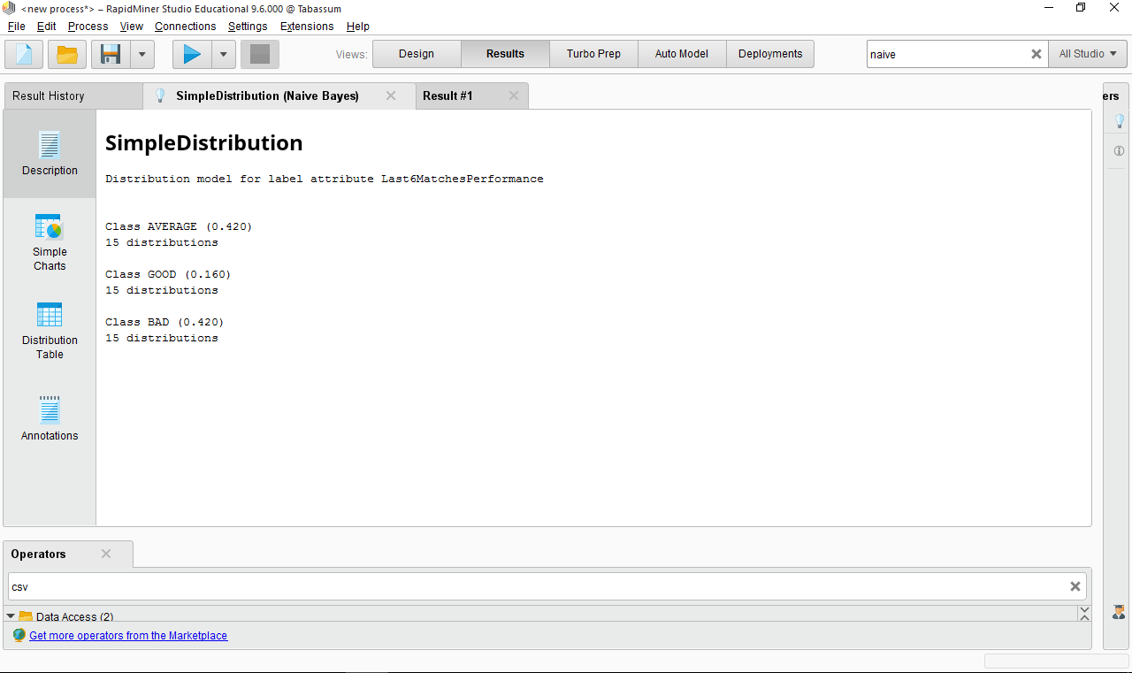

03. Prediction On 5 Random Rows :

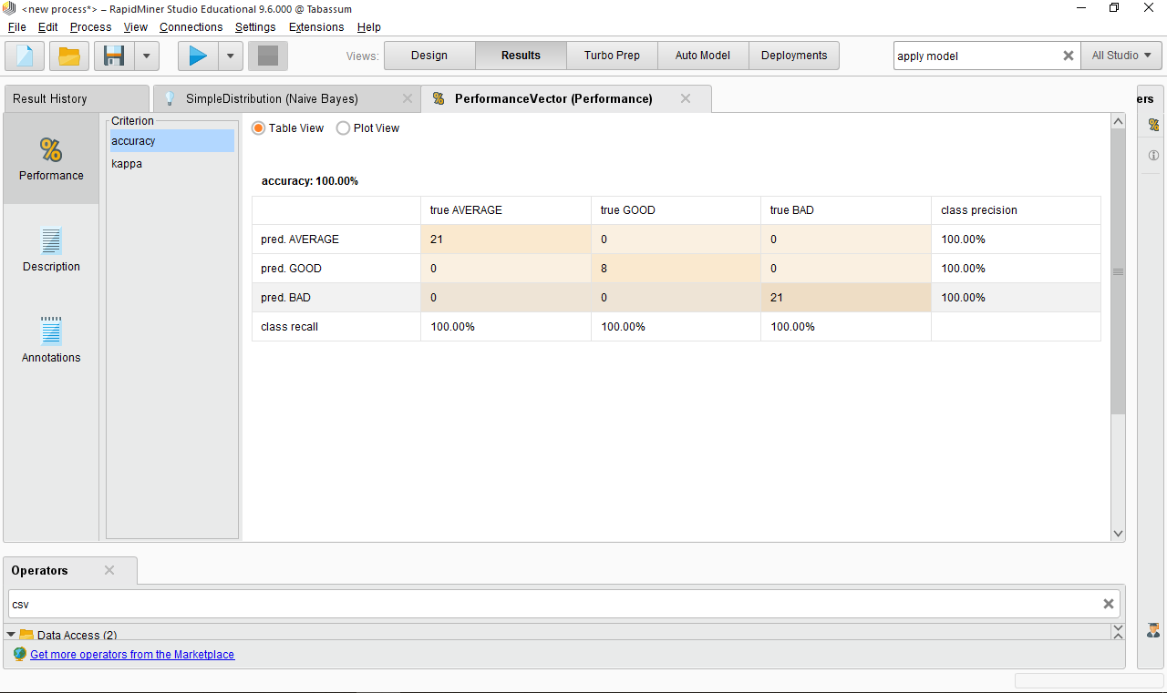

04. Calculate the prediction Accuracy :

Sorry Ma’am. Em unable to understand dis. ☺