**AI601 - Data Engineering for AI Systems**

24280006 – Hashim Shabbir

24280007 – Adil Mubashir Chaudhry

This lab is supposed to be completed individually. Please find below an ER of a hospital management system.

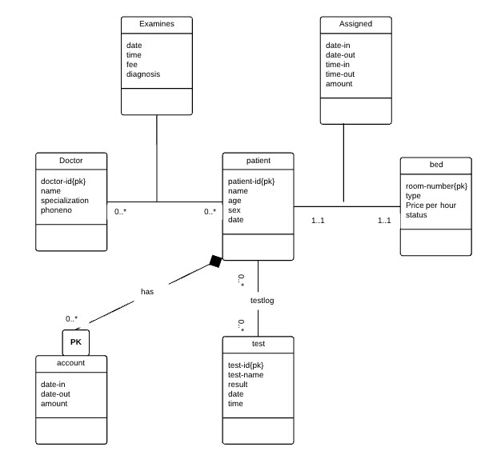

**Example Analytical Questions**

○ **Utilization**: “Which doctor has the highest patient throughput each month?”

○ **Length of Stay**: “What is the average length of stay per diagnosis, per month?”

○ **Cost Analysis**: “Which treatments drive the highest cost or revenue?”

○ **Staff Metrics**: “How many patients were seen by a particular doctor or specialty in a given time period?

**Design a star and snowflake schema for this data model. Use any document editor or drawing**

**AI601 - Data Engineering for AI Systems software e.g. Draw.io**

**Submission:**

Submit the PDF file by pushing to git and opening the PR.

**Create a new branch for Lab 2:**

1. git checkout -b lab2

**Stage and commit changes**:

1. git add hospital_schema.pdf
2. git commit -m "Completed Lab 1 - <student_id>"
3. git push origin lab2

**Go to GitHub → Open a Pull Request (PR)** from lab2-<studentid> to the main branch. The PR name should be "Lab 2: Student ID Part 1, 2, 3, 4" where part numbers represent the completed parts.

STAR SCHEMA

SNOWFLAKE SCHEMA

