**AMERICAN**  **INTERNATIONAL**

**UNIVERSITY-BANGLADESH**

408/1, Kuratoli, Khilkhet, Dhaka 1229, Bangladesh

Assignment Title: Implement a CNN architecture to classify the

MNIST handwritten dataset

|  |  |  |
| --- | --- | --- |
| Mid Report No:1 |  | Date of Submission:30/10/2021 |
| Course Title: | COMPUTER VISION AND PATTERN RECOGNITION |  |
| Course Code: |  | Section:B |
| Semester:20212022,Fall |  | Course Teacher:DEBAJYOTI  KARMAKER |

**Declaration and Statement of Authorship:**

1. I/we hold a copy of this Assignment/Case-Study, which can be produced if the original is lost/damaged.
2. This Assignment/Case-Study is my/our original work and no part of it has been copied from any other student’s work or from any other source except where due acknowledgement is made.
3. No part of this Assignment/Case-Study has been written for me/us by any other person except where such collaboration has been authorized by the concerned teacher and is clearly acknowledged in the assignment.
4. I/we have not previously submitted or currently submitting this work for any other course/unit.
5. This work may be reproduced, communicated, compared and archived for the purpose of detecting plagiarism.
6. I/we give permission for a copy of my/our marked work to be retained by the Faculty for review and comparison, including review by external examiners.
7. I/we understand that Plagiarism is the presentation of the work, idea or creation of another person as though it is your own. It is a formofcheatingandisaveryseriousacademicoffencethatmayleadtoexpulsionfromtheUniversity. Plagiarized material can be drawn from, and presented in, written, graphic and visual form, including electronic data, and oral presentations. Plagiarism occurs when the origin of them arterial used is not appropriately cited.
8. I/we also understand that enabling plagiarism is the act of assisting or allowing another person to plagiarize or to copy my/our work.

|  |  |  |  |  |
| --- | --- | --- | --- | --- |
| **No Name** | | **ID Program** | | **Signature** |
| 1 | Rubaia Akter Tonni | **18-37969-2** | **Bsc.Cse** |  |
|  |  |  |  |  |

**Title:** Implement a CNN architecture to classify the MNIST handwritten dataset.

**Abstract:**

The MNIST dataset is a large database of handwritten digits. MINIST dataset is widely used dataset in machine learning for handwritten recognition, image classification and many more. It commonly used for training various image processing systems. MNIST is short for Modified National Institute of Standards and Technology database. This dataset is used for training models to recognize handwritten digits

**Introduction:**

A convolutional neural network (CNN) is a specific type of artificial neural network that uses perceptions, a machine learning unit algorithm, for supervised learning, to analyze data. CNNs apply to image processing, natural language processing and other kinds of cognitive tasks. MINIST dataset is widely used dataset in machine learning for handwritten recognition, image classification and many more. It commonly used for training various image processing systems. It is a dataset of 60,000 small square 28×28 pixel grayscale images of handwritten single digits between 0 and 9. Which is quiet incredible to explore and analyze. It is a mostly used and profoundly understood dataset and, for the most part, is “solved.” Top-performing models are deep learning convolutional neural networks that achieve a classification accuracy of above 99%, with an error rate between 0.4 %and 0.2% on the hold out test dataset.

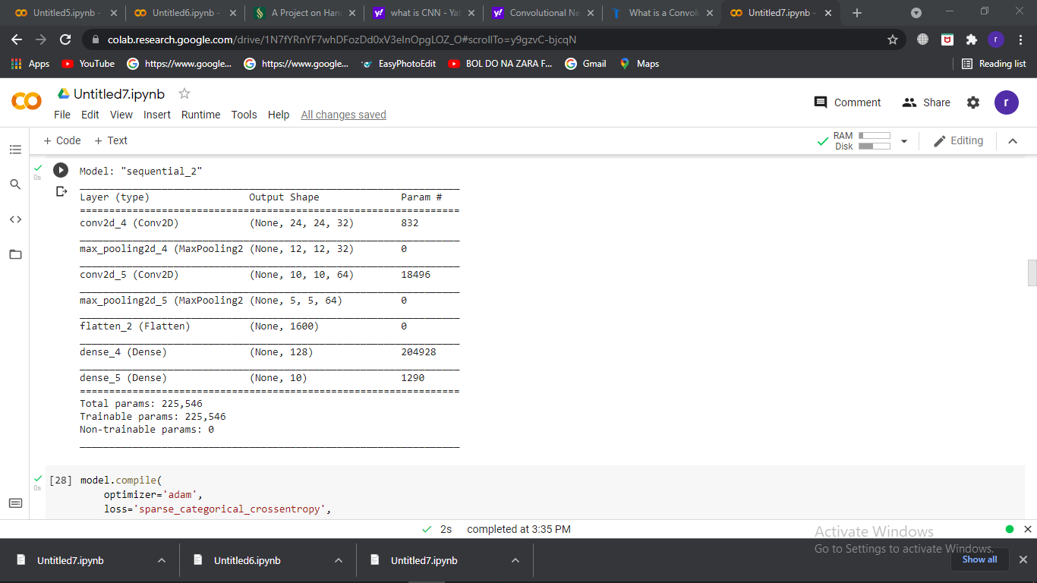

**Fig:1**

It is the hyper-parameter picture. It has an input layer, a two-dimensional convolutional neural network, a maximum pooling layer, a flattening layer, a dense layer, and the output layer.

**Results:**

Result of the different optimizer result are given below,

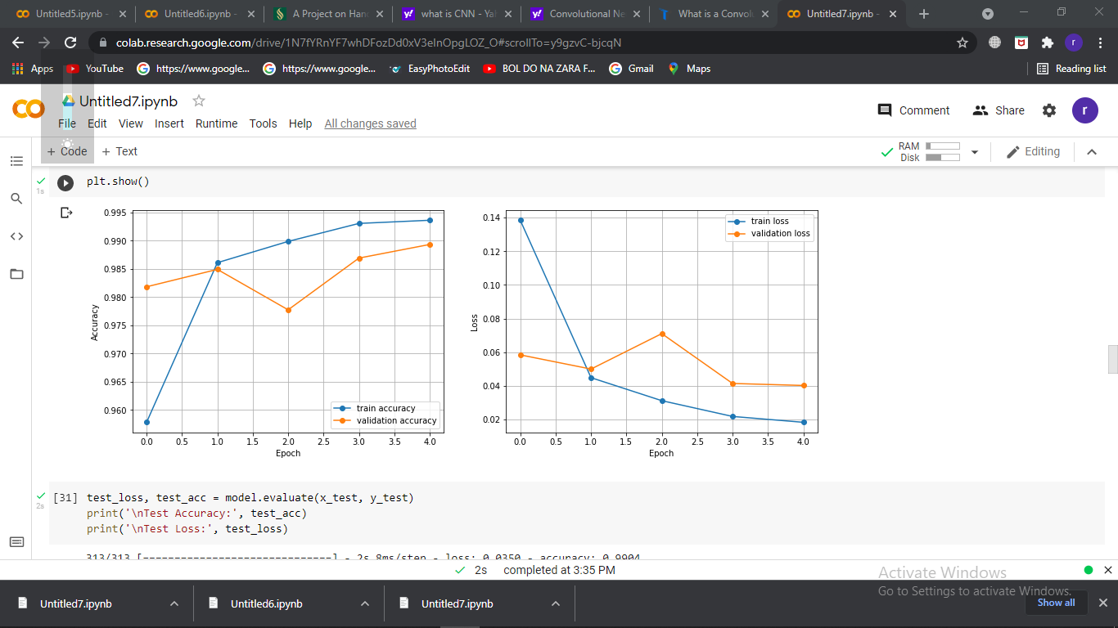

Fig2: Loss of Adam

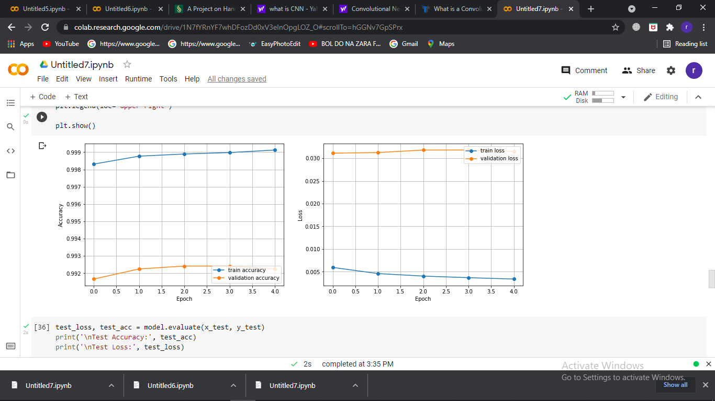

Fig3: Loss of

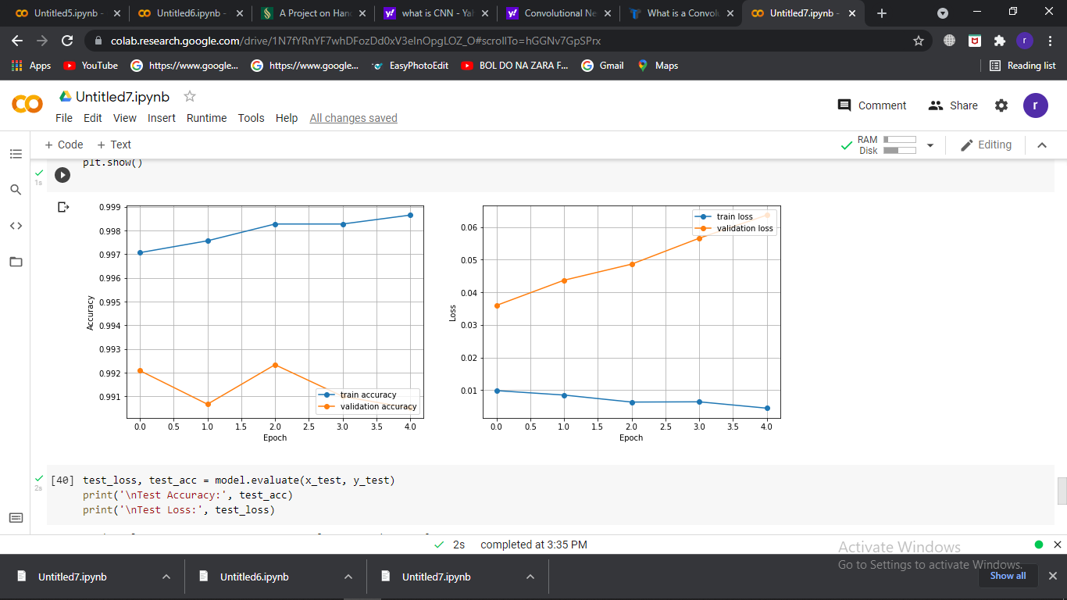

Fig4: Loss of RMSProp

|  |  |  |  |  |
| --- | --- | --- | --- | --- |
| Optimizer | Accuracy | Validation  Accuracy | Test Accuracy | Test Loss |
| Adam | 99.04% | 98.54% | 98.82% | 3.50% |
| SGD | 99.34% | 99.03% | 99.03% | 2.29% |
| RMSprop | 99.34% | 99.01% | 99.01% | 5.16% |

**Discussion:**

From the result we can see the difference between the accuracy result and test validation results.

We can see the method has the highest test accuracy percent on RMSprop optimizer and the lowest test accuracy percent on Adam optimizer. The graph analysis the difference in the rates of Train and Validation, indicating that the model will not perform consistently in real-world data. The RMSprop optimizer of the graph shows a somewhat comparable rate of Train and Validation accuracy, indicating that the model will perform better on real-life data.