TeleClinic
National Digital Health Platform
Technical Design Document
Software Architect, Digital Health: Remote Assignment (Tasks 1 to 4)
Prepared by: Bailly Rurangirwa
For: Irembo, People and Culture, Talent Acquisition
Version: 1.3 | Date: October 2026
What this document contains. The four deliverables requested in the brief: (1) architecture diagrams, including components, data flows and the AI inference pipeline; (2) a trade-off analysis explaining why each pattern was chosen; (3) API specifications in OpenAPI format for interoperability and AI triage; (4) an operational roadmap for monitoring and deployment on-premise. A traceability table in Section 3 shows where each task and each evaluation criterion is answered.
Contents
- 1 Executive summary
- 2 Scope, assumptions and design principles
- 3 How this document answers the brief (traceability and role alignment)
- 4 Deliverable 1: Architecture diagrams and design (Tasks 1 to 4)
- 5 Deliverable 2: Trade-off analysis
- 6 Deliverable 3: API specifications (OpenAPI)
- 7 Deliverable 4: Operational roadmap
- 8 Evaluation criteria: evidence and residual gaps
- Appendix A and B: OpenAPI specifications | Appendix C: Glossary | Appendix D: Companion reference implementation | Appendix E: Sources on the Rwandan context

1 Executive summary
TeleClinic must serve millions of citizens through web, mobile and USSD, while depending on four things that can fail independently: national identity (IremboAccount), payments (IremboPay), facility records (eBuzima in health centres, OpenMRS in hospitals), and an AI triage model. It must also keep all data on Irembo-controlled infrastructure. The design therefore follows one rule: every integration is assumed to be unreliable, and every clinical decision requires a human.

The eight decisions that shape the design
1. Modular monolith core, plus five deliberate separate services. One deployable holds consultation, payments, patient index, consent, audit and the FHIR facade. Separate services exist only where the failure, scaling or security profile differs: edge and gateway, USSD gateway, triage and anonymization, the sync gateway (OpenFn) and the data tier. This keeps on-premise operations small while leaving clean seams to extract more services later (Section 4.4). In the terms of the role, this is the TeleClinic microservices landscape: every service boundary is named and enforced on day one, and five of them run as separate deployables now.
2. Booking and payment as an orchestrated saga with a transactional outbox. No two-phase commit. Payment confirmation is double-checked server to server, deduplicated by event id, and every failure has a compensating action (Section 4.3).
3. FHIR R4 facade over a relational canonical model. The core keeps a relational model for speed and simplicity and maps to profile-validated FHIR resources at the boundary (Section 4.5).
4. Sync gateway without loops. Outbound writes go through the outbox and Kafka to OpenFn workflows. Every write carries an origin tag. A sync ledger stores ids, versions and content hashes, so echoes are dropped and real conflicts go to a review queue (Section 4.5).
5. Safe identity matching. Deterministic keys first, then probabilistic scoring. Records are linked with reversible FHIR links, never silently merged, and ambiguous pairs go to a human (Section 4.5).
6. Always-on infrastructure. PostgreSQL with Patroni and a three-member etcd quorum, synchronous replication, Kafka KRaft with replication factor 3, a third fault domain, and blue/green releases through HAProxy and Keepalived (Section 4.6).
7. Three-layer, tamper-evident audit. Gateway, application and database-level logs feed a hash-chained store with write-once archives. Every read and write of health data is attributable (Section 4.6).
8. AI that advises and never decides. Deterministic red-flag rules answer inside the USSD session. The model runs asynchronously behind an anonymization gateway in an isolated zone, can only raise urgency, and its output stays "proposed" until a clinician confirms or overrides it (Section 4.7).

Proposed service targets
Target | Value (proposed) | How it is achieved | Measured in the reference implementation
Core availability | 99.95% monthly for booking and consultation | Active-active core, Patroni failover, blue/green, graceful degradation | Release under load: 1,181 requests, 0 failed. A bad build was rolled back automatically at the 1% or 10% step
Data loss on node failure (RPO) | Zero for committed clinical writes | Synchronous replica commit (ANY 1), Kafka acks=all with min ISR 2 | Leader killed during writes: 0 acknowledged writes lost, in every run
Database failover time (RTO) | Under 60 seconds | Patroni leader election, HAProxy health checks | Writes resumed 16.8 to 21.3 s after the leader was killed
Site disaster recovery | RPO under 5 minutes, RTO under 4 hours | Asynchronous DR site, pgBackRest, tested quarterly | Not exercised (one machine)
USSD step response | p95 under 1.5 seconds | Stateless gateway, Valkey sessions, rules evaluated in-process | Slowest step 176 ms (booking, which runs the rules); PIN check 96 to 158 ms
Triage rules latency | p95 under 100 ms | In-memory deterministic rules, no network hop to the model | p95 under 1 ms
EMR sync lag | p95 under 5 seconds when the EMR is reachable | Event-driven outbound path, ordered per patient | Decision to encounter: eBuzima median 2.0 s, p95 3.8 s; OpenMRS median 1.8 s, p95 2.3 s

The values are design targets for agreement with Irembo. The last column shows what the companion reference implementation (Appendix D) measured on one 16 GB machine with synthetic data: it shows that the mechanisms work, not production capacity. Section 7 explains how each target is monitored and verified.

2 Scope, assumptions and design principles

2.1 Scope
In scope: the system blueprint and integration strategy (Task 1), interoperability and the data engine (Task 2), infrastructure, resilience and security (Task 3), and AI triage with clinical decision support (Task 4). Out of scope: user interface design, clinical content of the triage protocol (supplied by clinical leadership), pricing and tariff rules, and detailed procurement of hardware.

2.2 Assumptions to confirm
The brief does not specify several interfaces. The design states its assumptions explicitly so that each can be confirmed quickly with the Irembo platform teams.
ID | Assumption | If it is wrong | How to confirm
A1 | IremboAccount offers standard OpenID Connect: authorization code with PKCE, JWKS endpoint, refresh tokens, and a stable subject id. | Add an adapter in the identity module; the rest of the design is unaffected. | Integration guide from the IremboHub team
A2 | IremboPay offers REST payment creation with idempotency keys, signed webhooks, a status query endpoint, and a settlement report. | Add polling for status and file-based reconciliation. | IremboPay API documentation and sandbox
A3 | eBuzima, the Ministry of Health's national EMR, is one centrally managed web system built on ERPNext (Frappe) with the Healthcare app, in which each health centre is a tenant (an ERPNext Company) and patients are national records; TeleClinic can reach it through the Frappe REST API and document webhooks with an integration user. District, referral and teaching hospitals run their own OpenMRS, which exposes FHIR R4 through its FHIR module. | Bridge older versions, a non-FHIR API or HL7 v2 with an adaptor in the sync gateway; the core is unchanged. | Ministry of Health digital health team (eBuzima API access, tenant model, custom DocTypes, webhook policy, sandbox, data-sharing agreement); inventory of hospital OpenMRS sites
A4 | Telecom aggregators provide USSD session callbacks and mobile-money push. | Use a second aggregator behind the same gateway contract. | Aggregator technical contract
A5 | The data center has three independent fault domains (racks with separate power and network), or two sites plus a witness. | Reduce guarantees to single-site HA and document the residual risk. | Facility survey
A6 | National FHIR profiles will be agreed with the Ministry of Health. Until then the base R4 profiles and the International Patient Summary are used. | Re-map at the FHIR facade only; the core model is unchanged. | Interoperability framework owner
A7 | Clinical triage rules come from a national protocol approved by clinical leadership. The platform implements them; it does not invent them. | Triage launches in rules-only, advisory mode. | Ministry of Health clinical lead
A8 | Scale for design: 10 million registered citizens, 100,000 consultation journeys per day at national rollout (Section 7.5). | Capacity model is parametric and is re-run. | Rollout plan from Irembo
A9 | Data protection requirements (consent, residency, retention) follow national law and are confirmed by legal counsel. | Retention and consent rules are configuration, not code. | Legal review
A10 | TeleClinic is onboarded as an IremboHub consumer: it reuses IremboAccount and IremboPay through their published interfaces and follows IremboHub conventions for client registration, credentials and logging. | Keep the same ports; adjust client registration and gateway policies. | IremboHub platform team
A11 | The national health information exchange (OpenHIM interoperability layer, client registry issuing the UPI, shared health record) accepts TeleClinic as a registered client, and national ID checks against NIDA are available through it or through IremboAccount. | Keep TeleClinic's own patient index and integrate point to point; identifiers stay sliced by system, so joining the exchange later is a configuration change. | Ministry of Health and RBC health information exchange team
A12 | Health insurance coverage (CBHI/Mutuelle and RSSB schemes) can be checked through the national health insurance portal, as eBuzima already does at health centres. | Patients pay the full fee through IremboPay and claim afterwards. | RSSB

2.3 Design principles
Principle | What it means in practice
Assume every integration fails | Timeouts, circuit breakers, retries with backoff, idempotency keys, outbox queues and replay for every external call.
Humans decide, machines advise | AI output is a proposal. A practitioner finalises any clinical action. Rules provide a floor the model cannot lower.
Data stays home | All processing and storage on Irembo-controlled infrastructure. No internet egress from the AI zone.
Boring technology on a thin operations team | Mature open-source components with large communities. Fewer moving parts beats elegant diagrams.
Everything observable and auditable | Correlation id on every request, traces across components, and an audit entry for every access to health data.
Reversible decisions | Patient links can be undone, releases can be rolled back in seconds, and models can be switched off with one call.
Extract a service only when it is earned | Splitting requires evidence: independent scaling, isolation or team autonomy (Section 4.4).

3 How this document answers the brief

3.1 Tasks and deliverables
Brief requirement | Where it is answered | Evidence
Task 1: container-level diagram (C4) | 4.1, 4.2 | Figures 1 and 2
Task 1: flow from unauthenticated to paid consultation (IremboAccount OIDC, IremboPay) | 4.3 | Figures 3 to 7, OIDC and payment tables, failure handling
Task 1: decision log, microservices vs modular monolith, on-premise overhead | 4.4, 5.1 | ADR-001 with quantified operational overhead and extraction criteria
Task 2: FHIR strategy, mapping to R4 resources | 4.5.1 | Mapping table, profiles, terminology, validation
Task 2: sync gateway, write-back without loops | 4.5.2 | Figure 8, origin tag, ledger, conflict policy
Task 2: identity resolution and safe merge | 4.5.3 | Figure 9, scoring bands, link-not-merge, review queue
Task 3: HA for database and broker, split-brain in a 3-node cluster | 4.6.1, 4.6.2 | Figures 10 and 11, scenario table
Task 3: zero-downtime deployment without cloud load balancers | 4.6.3 | Figure 12, blue/green with HAProxy and Keepalived
Task 3: audit of every read and write | 4.6.4 | Figure 13, three-layer audit with hash chain
Task 4: sync vs async inference, USSD latency | 4.7.1 | Figure 14, latency budget table
Task 4: PII anonymization gateway | 4.7.2 | Layered masking design
Task 4: human-in-the-loop | 4.7.3 | Figure 15, state machine and rules
Deliverable 1: diagrams of components, data flows, AI pipeline | 4 | 16 figures (Figures 1 to 16)
Deliverable 2: trade-off analysis (for example Saga over 2PC, FHIR profiles) | 5 | Sixteen decision records and a profile table
Deliverable 3: OpenAPI for interoperability and AI triage | 6, Appendices A and B | Two validated OpenAPI 3.1 documents
Deliverable 4: operational roadmap (monitoring and deployment) | 7 | SLOs, monitoring, release strategy, game days, phased plan
Job description: key responsibilities | 3.3 | Mapping of each responsibility in the terms of reference to the design

3.2 Evaluation criteria
Criterion | Where the evidence is | Short answer
Architectural depth: edge cases such as network partitions or data inconsistency | 4.3 failure table, 4.5.2, 4.6.2, 7.4 | Partition behaviour designed and tested; inconsistency handled by outbox, idempotency, ledger and conflict queue
Domain expertise: HL7 FHIR and health-data security | 4.5, 4.6.4, 4.7.2, 5.3 | Resources, profiles, terminology, $match, conditional create, AuditEvent; consent, purpose of use, break-glass, pseudonymization
Pragmatism: on-premise, developing-market context | 2.3, 4.4, 7.5, 7.7 | Modular monolith, boring technology, USSD and low bandwidth, offline queues, phased rollout, small team runbooks
Safety: clinical safety and data privacy in AI triage | 4.7, 7.6 | Rules floor, escalate-only model, human confirmation, kill switch, shadow mode, no egress, anonymization gateway, hazard log

A fuller self-assessment, including known gaps, is in Section 8.

3.3 Alignment with the role
The terms of reference for the role list the responsibilities below. This table shows where the design answers each one.
Job description responsibility | Where it is answered | Short answer
Microservices landscape for web, mobile, USSD and voice | 4.2, 4.3, 4.4 | Every service boundary is a module with ports from day one; five deployables are separate now; USSD and voice share one core and saga
Integration with IremboAccount and IremboPay (payments and reimbursements) on IremboHub | 4.1, 4.2.1, 4.3 | OIDC with PKCE through a backend for frontend; payment saga with server-side confirmation; reimbursement ledger
Secure, highly available distributed system with containers on-premise | 4.6, 5.4 | Patroni, Kafka KRaft, HAProxy blue/green; containers everywhere, Kubernetes for the stateless tier (ADR-013)
Interoperability with EMRs such as OpenMRS and eBuzima | 4.5 | eBuzima first (one central connection reaches most health centres), OpenMRS sites through FHIR, national exchange through OpenHIM; safe identity matching with NIDA and UPI anchors
HL7 FHIR and ICD-10 for read and write access across facilities | 4.5.1, 5.6, 6.2 | Profiles, terminology bindings, transaction Bundles, conditional create, If-Match
On-premise AI inference and MLOps for triage and decision support | 4.7 | Hybrid inference, isolated AI zone, model registry, shadow and canary releases, drift monitoring, kill switch
National data protection and easy regulatory audits | 4.6.4, 4.7.2 | Consent and purpose of use on every read, three-layer tamper-evident audit, regulator and patient reports
Clinical safety standards | 4.7.3, 4.7.4 | Human gate enforced in the domain model, hazard log, named clinical safety lead

4 Deliverable 1: Architecture diagrams and design
This section contains the diagrams of components, data flows and the AI inference pipeline, with the design reasoning for Tasks 1 to 4. Diagram colour code: blue is TeleClinic components, orange is Irembo platform services, grey is external systems, green is data stores and healthy paths, red is security controls and failure paths, purple is the AI trust zone.
Figure | What it shows | Part of the brief it answers
1 System context | TeleClinic, its users and the national systems around it | Task 1: architecture diagram (C4 level 1)
2 Containers | All deployable components, data stores and external systems | Task 1: container-level diagram (C4 level 2); deliverable 1, components
3 to 6 Sequence diagrams | Login with IremboAccount, consent and triage, payment confirmation, USSD variant | Task 1: integration flow from unauthenticated to paid; data flows
7 Consultation saga | States and compensations of booking, payment and consultation | Task 1; trade-off Saga over 2PC
8 Sync gateway | Outbound and inbound data flow between TeleClinic and OpenMRS, with loop prevention | Task 2: sync gateway; data flows
9 Identity resolution | Matching, scoring bands, review queue, reversible links | Task 2: patient identity matching
10 High-availability topology | PostgreSQL, etcd and Kafka on three nodes, with a witness | Task 3: HA
11 Network partition behaviour | What each side of a 2 | 1 partition does | Task 3: split-brain
12 Blue/green release | Zero-downtime deployment with HAProxy and Keepalived | Task 3: zero-downtime deployment
13 Audit pipeline | Three audit layers feeding tamper-evident storage | Task 3: audit and compliance
14 AI triage pipeline | Synchronous rules, asynchronous model, anonymization, review | Task 4: inference pipeline, PII; deliverable 1, AI pipeline
15 Triage state machine | Human-in-the-loop states and gates | Task 4: human-in-the-loop
16 Observability architecture | Metrics, logs, traces and alerting | Operational roadmap

4.1 System context (C4 level 1)
TeleClinic sits between citizens, clinicians and a set of national systems. It does not replace any of them. It reuses IremboAccount for identity and IremboPay for money, exchanges clinical data with facility EMRs through FHIR, and reports to national systems. Figure 1 shows the context, and Figure 2 the containers. TeleClinic is built as a consumer of IremboHub: it reuses IremboAccount and IremboPay through their published interfaces and keeps no identity or payment logic of its own (assumption A10).

4.2 Containers (C4 level 2)
The container diagram (Figure 2, after the table) shows the deployable parts. The core is one modular monolith. Everything outside the core is either a deliberately separate service, a data store, or an external system. Section 4.4 explains why.
Container | Responsibility | Technology | Availability model
HAProxy pair + Keepalived | TLS termination, WAF, L7 routing, blue/green weights, connection draining | HAProxy, Keepalived (VRRP), Coraza WAF | Two hosts, active and standby, virtual IP moves in seconds
API gateway | OIDC and JWT validation, quotas (429), correlation id, request logging | Apache APISIX (Kong is an alternative) | Two or more instances behind HAProxy
Policy engine | Consent, role and purpose-of-use decisions as code | Open Policy Agent, embedded with the core | Runs inside each core instance
TeleClinic core | Identity link and consent, patient index, consultation, triage orchestration, payment saga, FHIR facade, audit interceptor, notifications | Java 21, Spring Boot 3, Spring Modulith | Two or more stateless active instances, blue/green
USSD gateway | Aggregator callbacks, menu state machine, token exchange, screen rendering | Small stateless service with Valkey sessions | Three instances, sessions survive instance loss
Patient web / PWA | Citizen booking, consent, payment redirect, visit history | React PWA, small bundles, offline shell | Served through the edge
Clinician workspace | Patient chart, orders, triage queue with AI-proposed labels | OpenMRS O3 UI plus a queue panel | Part of the facility EMR deployment
Video and voice | Consultation media, voice fallback | Jitsi, coturn (TURN) | Scaled by concurrent rooms
Triage service | Deterministic rules (synchronous) and model orchestration (asynchronous) | Rules in the core; model on ONNX Runtime or Triton; model registry (MLflow) | Two instances; core continues on rules if it is down
Anonymization gateway and pseudonym vault | Field allowlist, PII recognition and masking, tokenisation | Presidio with custom recognizers, vault in PostgreSQL with KMS-wrapped keys | Two instances in the AI trust zone, no internet egress
OpenFn Lightning | Sync gateway workflows between TeleClinic and OpenMRS and national systems | OpenFn Lightning (self-hosted, Docker) | Web plus workers, queue-backed, replay on failure
PostgreSQL | System of record, outbox, sync ledger, pseudonym vault | PostgreSQL 17, Patroni, three etcd members, PgBouncer | Three nodes, synchronous replica, automatic failover
Kafka | Events, outbox relay, audit stream, sync topics | Kafka in KRaft mode, three brokers and controllers | Replication factor 3, min ISR 2
Valkey | USSD sessions, rate-limit counters, short locks | Valkey (open-source, Redis-compatible) with Sentinel | Three nodes
MinIO | Write-once audit archive, backups, attachments | MinIO with object lock | Distributed erasure-coded
OpenSearch | Audit and log search | OpenSearch | Three nodes
Observability | Metrics, logs, traces, alerts | OpenTelemetry, Prometheus, Loki, Tempo, Grafana, Alertmanager | Redundant collectors, alert routing tested monthly
Secrets and keys | Secret storage, encryption keys, short-lived certificates | OpenBao (Vault-compatible), step-ca | Three nodes, auto-unseal with hardware module where available

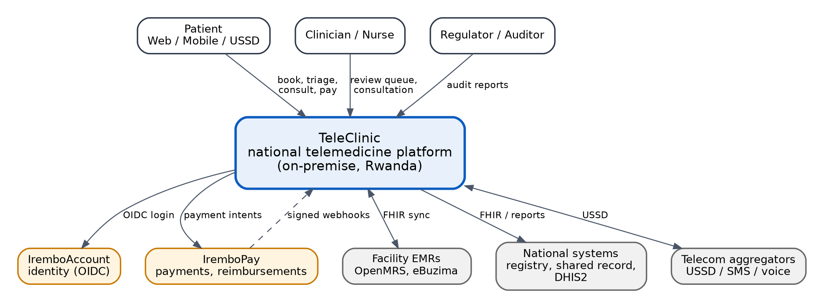
Figure 1. System context. TeleClinic and the systems and people around it.
How to read this diagram. Arrows show the main direction of requests. Orange boxes are existing Irembo platform services that TeleClinic reuses, so identity and payments are not rebuilt. Grey boxes are external systems.
Actor or system | Role in the design | Interface
Patient | Books, answers triage questions, consents, pays, joins the consultation | Web or mobile app (OIDC login) or USSD menu
Clinician or nurse | Reviews the triage queue, runs the consultation, confirms or overrides AI suggestions | Clinician workspace (OpenMRS O3 plus queue panel)
Regulator or auditor | Reads access reports and audit evidence | Audit report APIs and dashboards
IremboAccount | Identity provider for citizens and staff | OpenID Connect (authorization code with PKCE)
IremboPay | Payments and reimbursements | REST with idempotency keys, signed webhooks, settlement report
Telecom aggregators | USSD sessions, SMS, voice, mobile-money prompts | HTTP session callbacks
Facility EMRs (OpenMRS, eBuzima) | eBuzima: the national EMR in public health centres, one central web system. OpenMRS: facility installations in some hospitals and programmes | Through the sync gateway: FHIR R4 (OpenMRS) or the Frappe REST API and webhooks (eBuzima)
National systems | Client registry (UPI), shared health record, NIDA national ID, RSSB insurance, DHIS2 reporting | FHIR and reporting interfaces through the OpenHIM interoperability layer

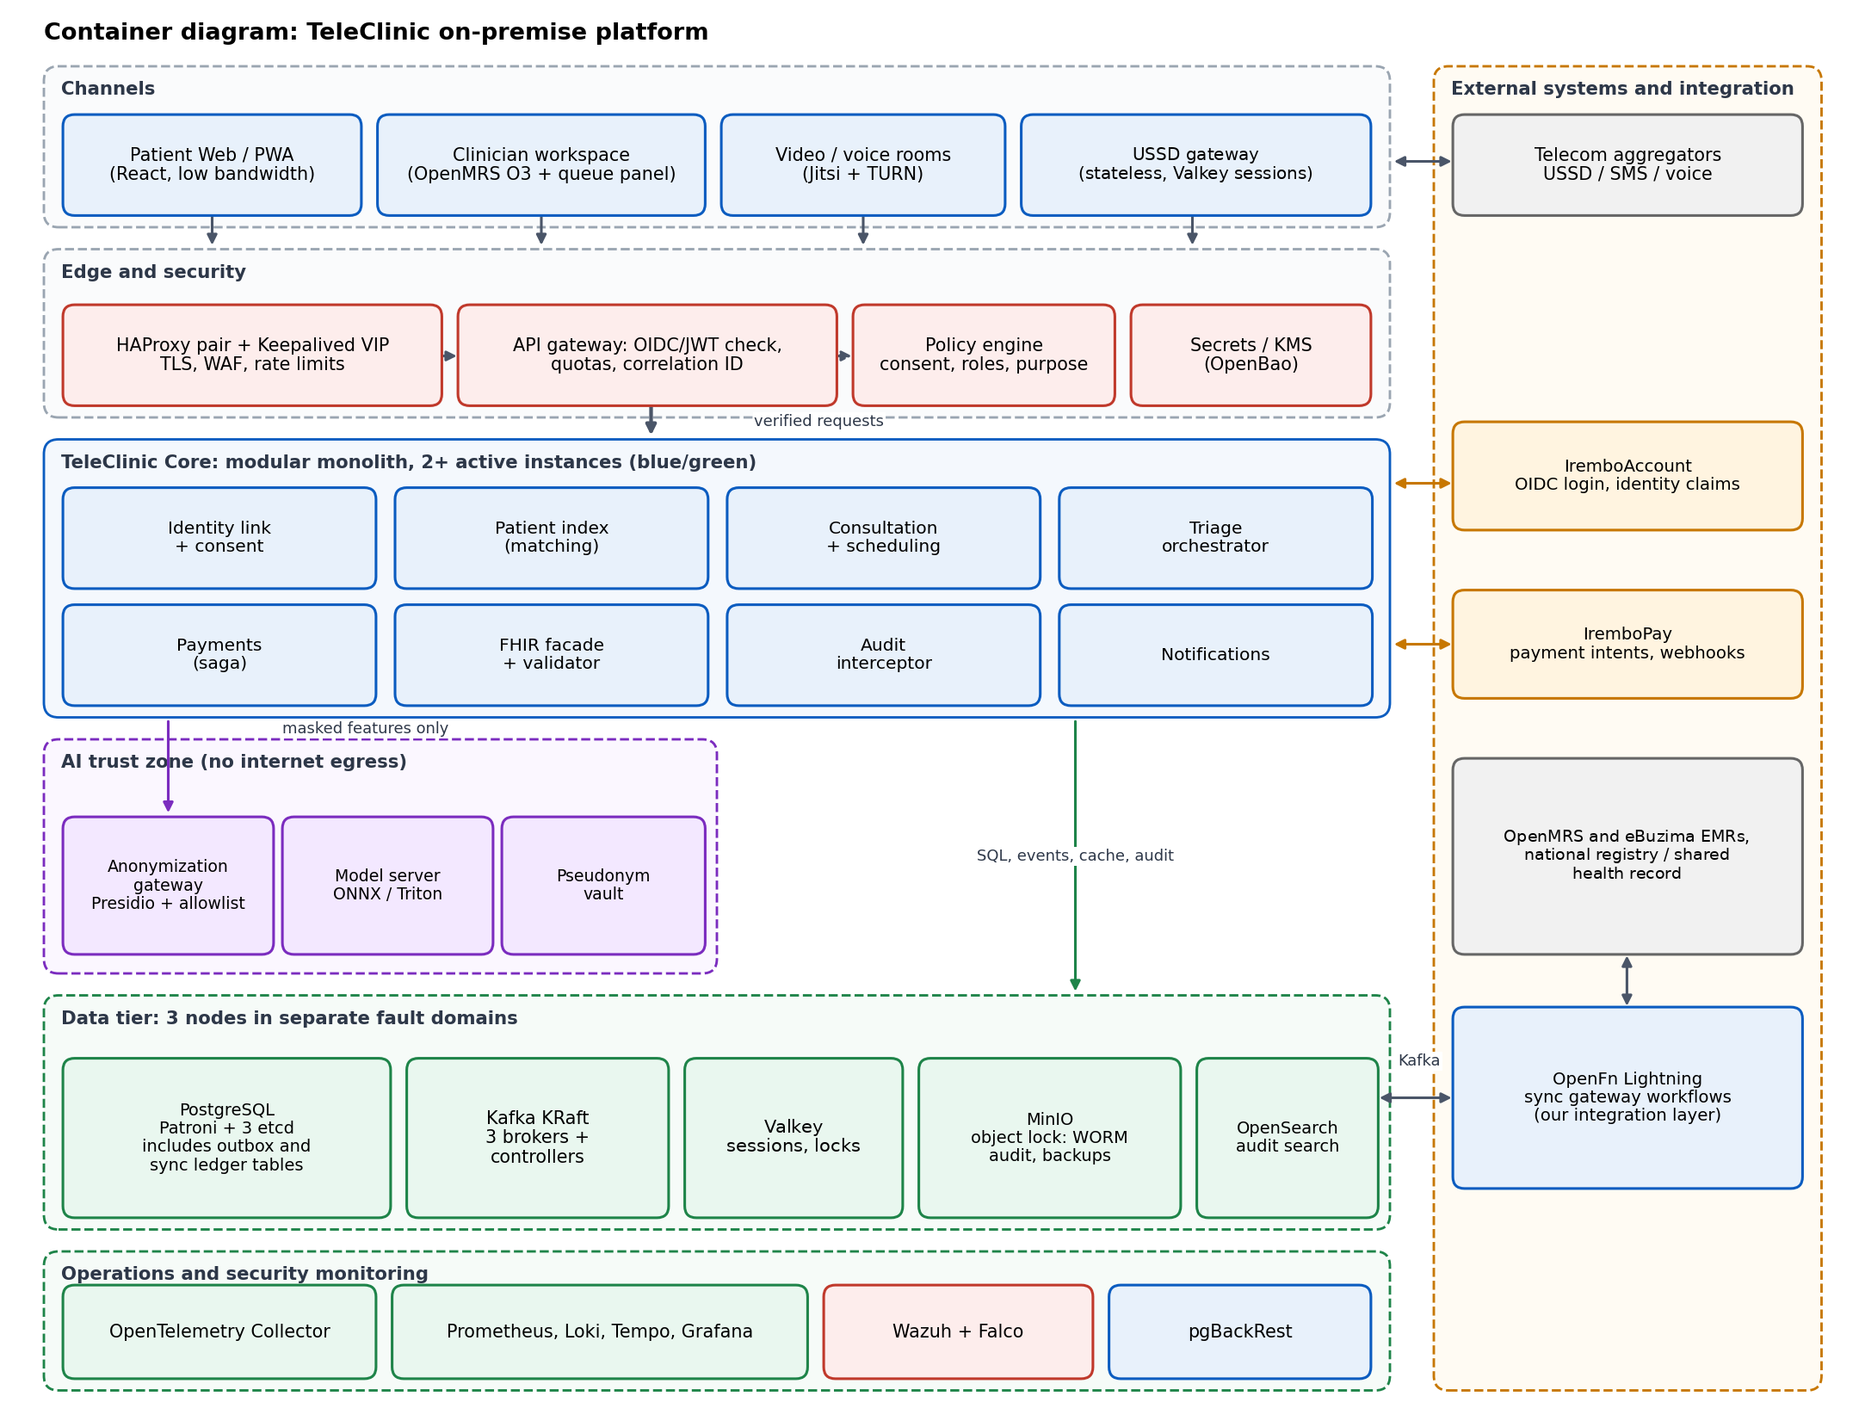
Figure 2. Container diagram. On-premise TeleClinic platform. A high-resolution PNG is supplied alongside this document.

4.2.1 API gateway management
The gateway is where TeleClinic meets every channel and partner system, so it is managed as a product, not a proxy.
- Routes per channel. Separate route groups for the patient web app, the mobile app, the USSD and voice gateway, the clinician workspace, partner EMRs and internal services, each with its own authentication, quotas and timeouts.
- Authentication at the edge. JWT validation against the IremboAccount JWKS for users; client credentials and mTLS for partner systems and the sync gateway. The core still re-checks scopes, consent and purpose of use.
- Quotas and protection. Rate limits per client, per user and per patient (429 with Retry-After), request size limits, and a circuit breaker per upstream so a slow EMR cannot exhaust gateway workers.
- Versioning and deprecation. Major version in the path. Old versions run side by side with a published sunset date and a Deprecation header.
- Partner onboarding. Each facility or partner system is a registered consumer with its own credentials, scopes and quota, created through a reviewed change and never by hand in production.
- Configuration as code. Routes, plugins and consumers are declarative files in version control (APISIX standalone mode, or Kong declarative configuration if Kong is chosen), applied by the pipeline.
- Observability. Every route emits latency, status and correlation id. The gateway access log is audit layer 1 (Section 4.6.4).

4.3 Task 1: Integration flow from unauthenticated user to paid consultation
The journey has three phases: prove who the user is, decide how urgent the case is, and take payment before the clinician is committed. The same core serves web, mobile and USSD. Only the edge differs.

Phase 1: identity through IremboAccount (OIDC)
Figure 3 shows the sequence. The core acts as a confidential client, so tokens stay on the server.
Topic | Design | Why
Flow | Authorization code with PKCE. The core acts as a confidential client (backend for frontend), so tokens never reach the browser. | Removes token theft from the browser and works for web and mobile apps.
Token validation | Verify signature against the provider JWKS (cached with rotation), then issuer, audience, expiry and nonce. The state parameter binds the callback to the session. | Standard checks that stop replay and mix-up attacks.
Session | Short-lived access token held server-side. Browser gets an HttpOnly, Secure, SameSite session cookie. Refresh tokens are stored encrypted server-side. | Limits the damage of a stolen cookie and allows revocation.
Step-up | Sensitive actions (view full record, download) require a fresh authentication level claim from IremboAccount. | Least privilege for high-risk data.
Subject mapping | The IremboAccount subject id is stored as an identifier on the Patient and never changes. National ID is an additional identifier, not the key. | Stable key even if a person changes name or phone.
Acting for a dependent | A guardian logs in with their own IremboAccount identity and books for a child or other dependent. The child is the Patient; the guardian is a RelatedPerson linked to the guardian's subject id, with the relationship verified once through a process agreed with the Ministry of Health. Consent is recorded with the guardian as performer. | Children are a large share of primary-care demand and rarely have their own account; the record must still belong to the child.
USSD identity | The phone number is linked to the IremboAccount identity once, with a one-time code. Each USSD session checks the number and a PIN, then exchanges them for a short-lived, limited-scope token (token exchange). | OIDC browser redirects are impossible on a feature phone; the core still gets a verifiable identity.
Logout and revocation | Back-channel logout from IremboAccount invalidates sessions. Admins can revoke by subject. | Lost phone or compromised account response.

Phase 2: consent, triage and payment request
Figure 4 shows the sequence. The patient gives consent, the synchronous rules engine returns an urgency and any red flags in under 100 ms, the core creates the consultation as PENDING_PAYMENT together with an outbox event in one transaction, and then asks IremboPay for a payment using an idempotency key.

Phase 3: payment confirmation and entry to the clinician queue
Figure 5 shows the sequence. The webhook is treated as a hint and confirmed server to server before the consultation becomes PAID.
Topic | Design | Why
Payment creation | POST with amount, internal reference and a unique Idempotency-Key. The reference is the consultation id. | A retry after a timeout cannot create a second charge.
Webhook security | Verify HMAC signature and timestamp window, then deduplicate on event id. | Stops forged and replayed events.
Server-side confirmation | On every webhook, call the status endpoint before moving to PAID. The webhook is a hint, not proof. | A forged or out-of-order webhook cannot unlock a paid consultation.
One transaction | The state change to PAID and the outbox event are written in the same database transaction. | No window where the money is taken but the event is lost.
Reconciliation | Daily match of the IremboPay settlement report against TeleClinic payments. Differences open a ticket and, for missing confirmations, trigger a status query. | Catches the cases no webhook can: lost webhooks and processor-side errors.
Reimbursement | Completed consultations create ledger entries for clinician payouts and insurer claims, posted by an OpenFn workflow. | Keeps finance records outside the clinical path.
Insurance coverage | Before asking for payment, check the patient's coverage (CBHI/Mutuelle or an RSSB scheme) through the national insurance portal, as eBuzima does. IremboPay collects only the patient's share; the insured share becomes a claim. | Patients are not charged for what their insurance covers (assumption A12).

USSD variant
USSD is session-based and screen-limited (roughly 160 characters per screen). The gateway keeps menu state in the session store, evaluates safety rules in the same step, and relies on the mobile-money prompt and an SMS for confirmation, because the USSD session may end before the webhook arrives. The saga does not depend on the session being alive. The first menu asks who the consultation is for, so a parent can book for a linked child.
Measured in the reference implementation. Every USSD step was answered within 176 ms (the booking step, which runs the safety rules and writes the consultation); other menu steps took under 5 ms. The longest screen is 130 of the 182 characters a page allows, and the smoke test fails if any screen is longer. Mobile-money approval and the confirmation SMS complete the booking after the session ends, as designed.

Voice (IVR) variant
Many citizens prefer a call to reading menus. The telecom aggregator sends voice session callbacks to a second adapter in the USSD gateway service, which runs the same menu state machine with recorded prompts in Kinyarwanda, English and French and keypad (DTMF) answers. Identity uses the same phone link and PIN, and the same rules endpoint answers during the call: a red flag plays the emergency advice and offers a transfer to a nurse line. Payment uses the same mobile-money push. The consultation itself can then be a phone call through the media service (Jitsi with its SIP gateway, or the aggregator's call bridging), so a feature-phone user gets the full journey. Speech recognition is not used in the first release: keypad answers are already coded, which keeps triage input structured and free text out of the model path. Voice adds no new deployable.

Sequence diagrams
The following four pages show the full sequences for Phases 1 to 3 and the USSD variant (Figures 3 to 6).

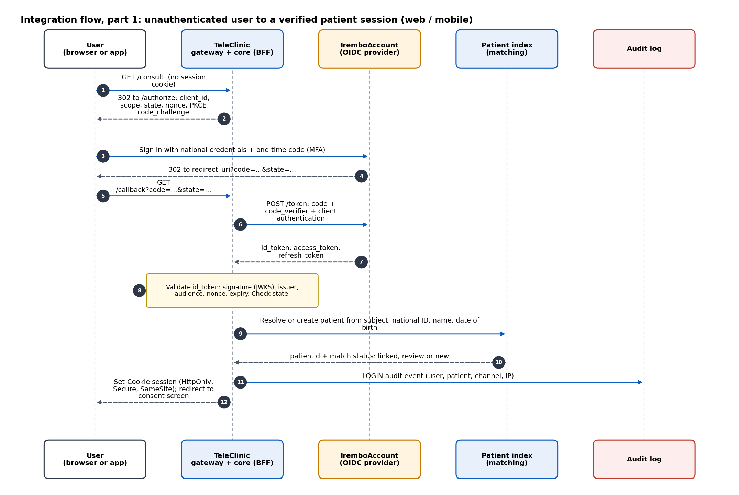
Figure 3. Phase 1. Authorization code flow with PKCE, token validation and patient resolution.

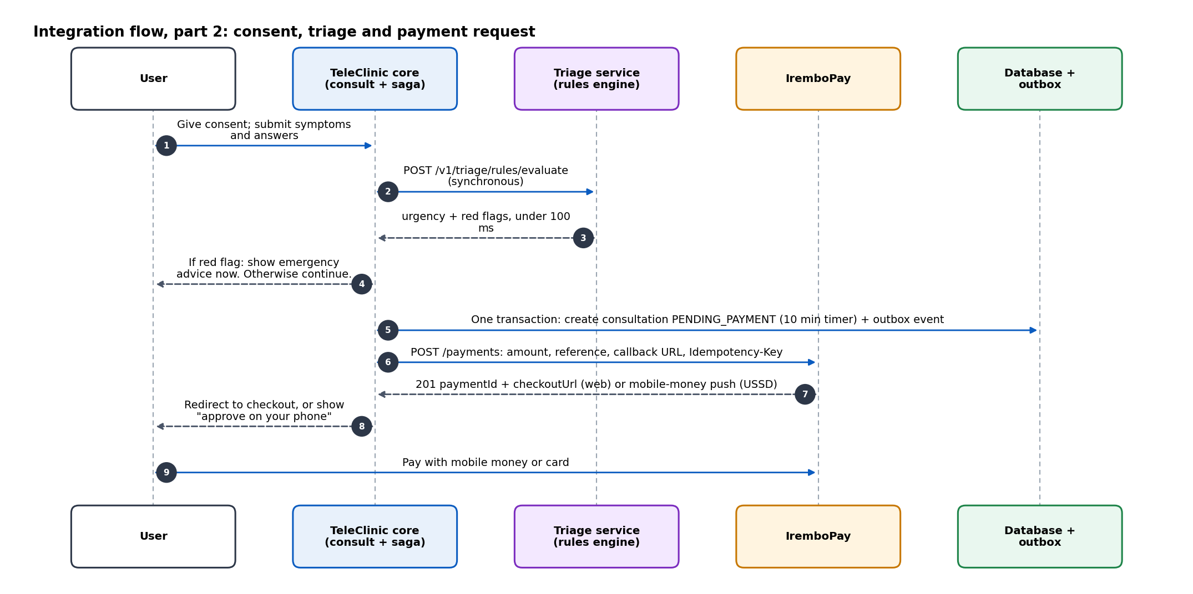
Figure 4. Phase 2. Consent, synchronous rules triage, and creation of the payment.

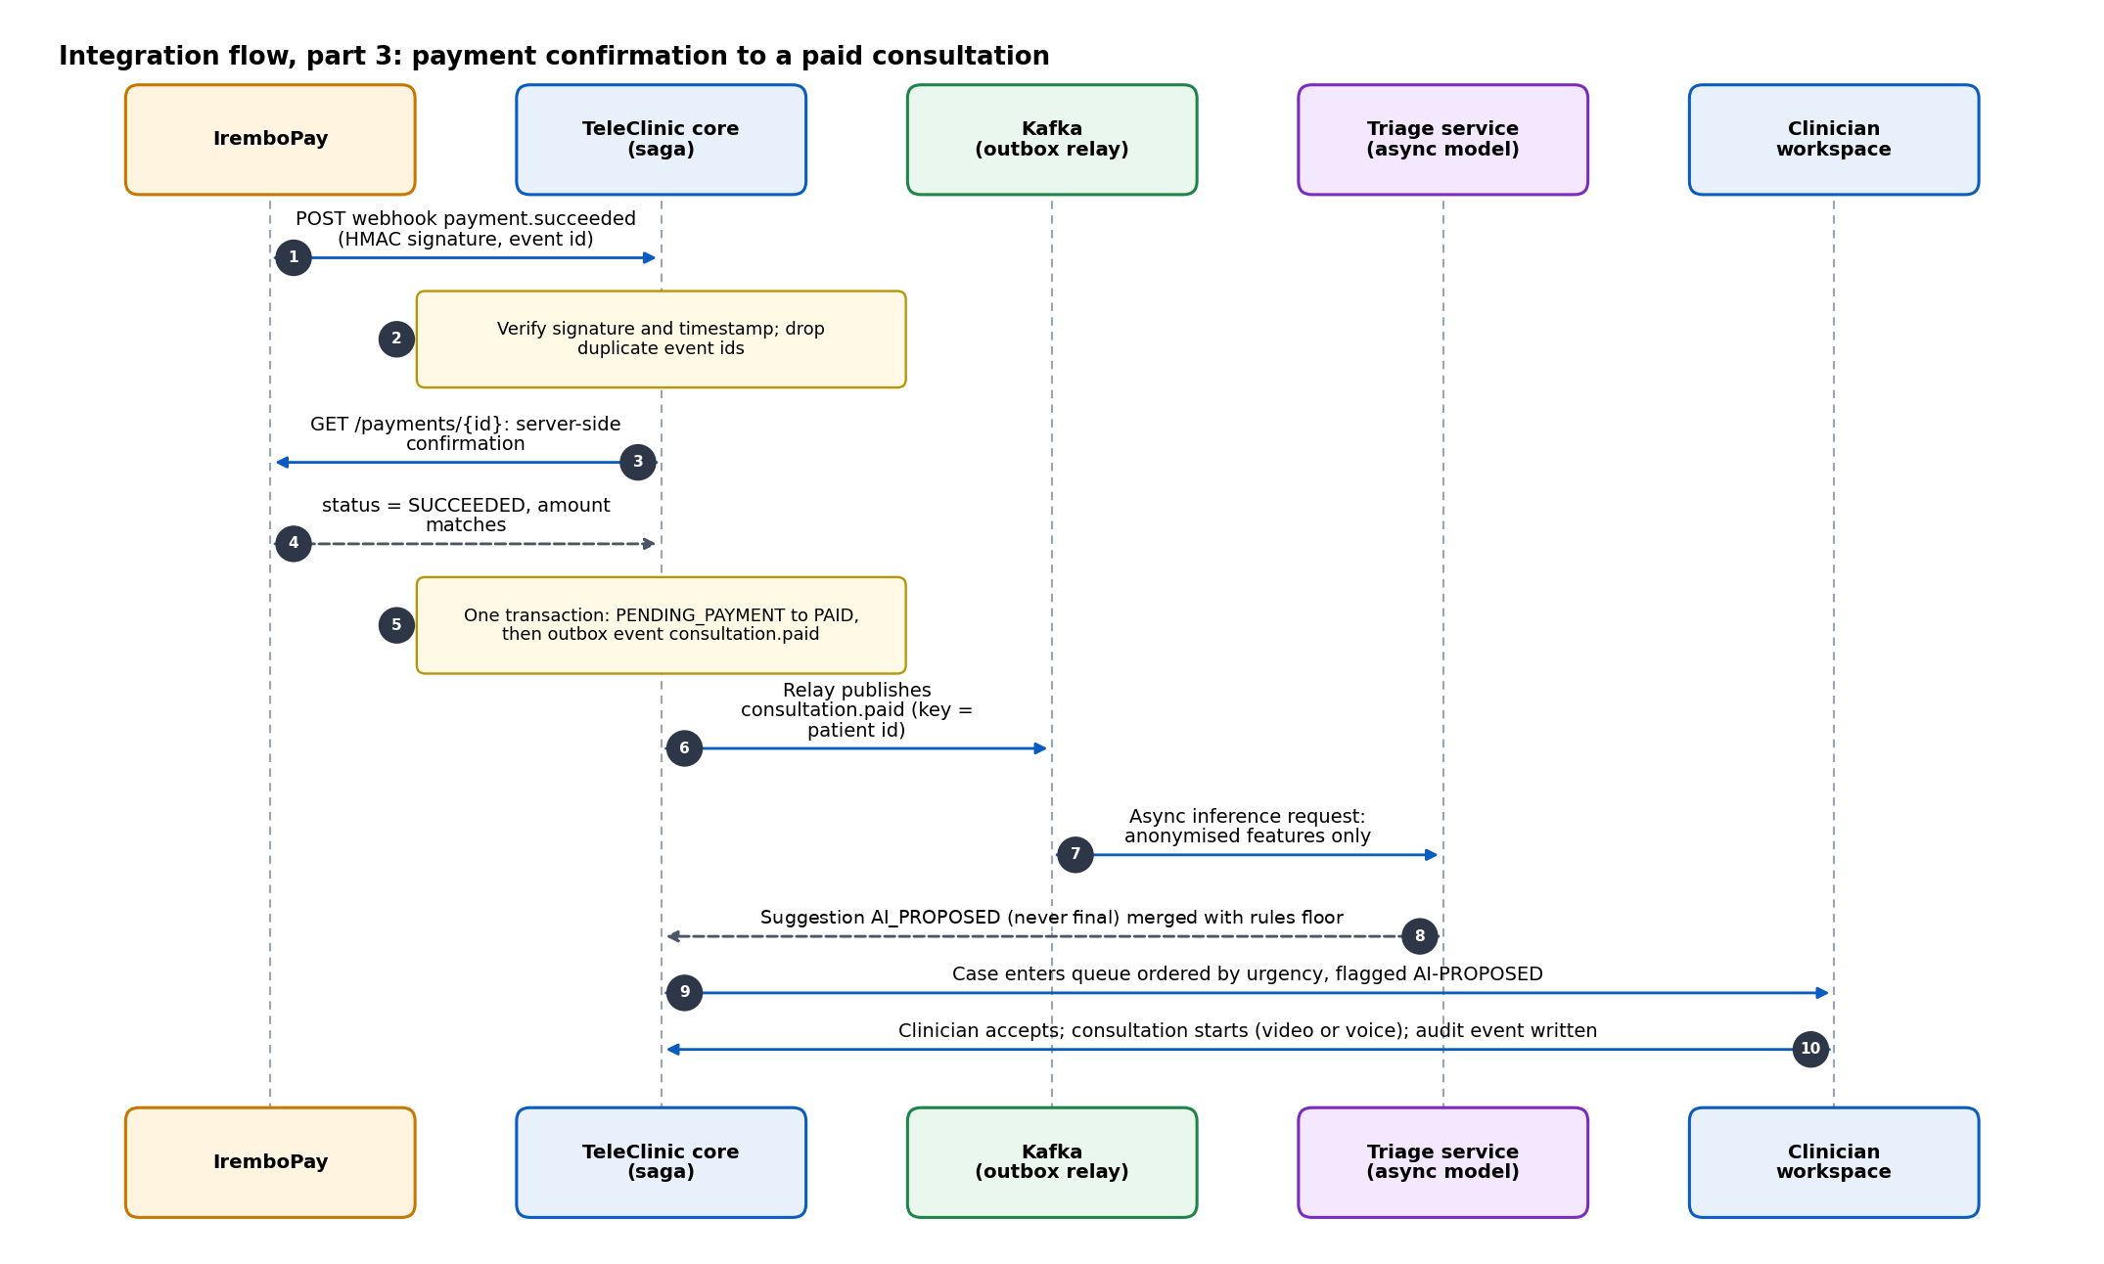
Figure 5. Phase 3. Webhook verification, saga transition to PAID, event publication and queueing.

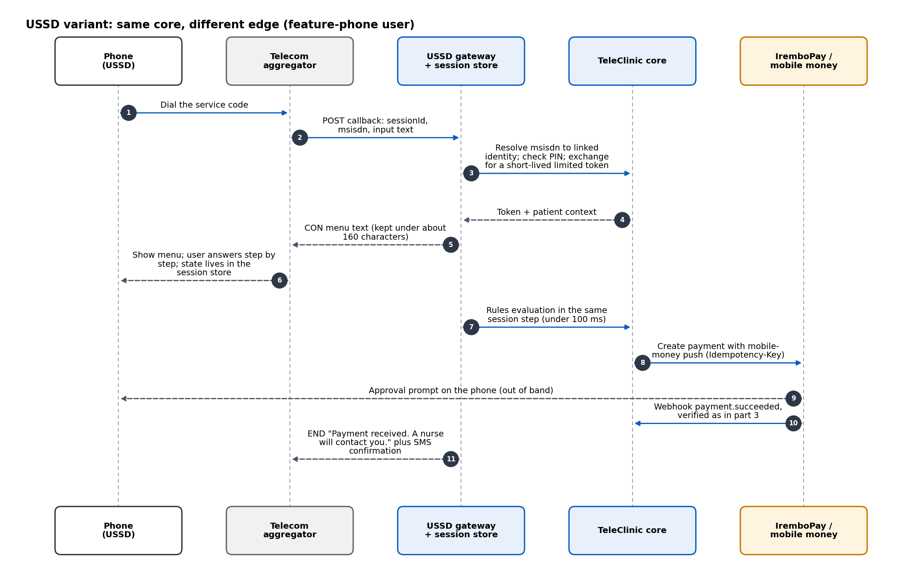
Figure 6. USSD variant. Same core and saga; only the edge and the payment prompt differ.

Booking and payment saga
Figure 7 shows the states of a consultation. Red paths are compensations or failures, and the table lists how each one is detected and handled.
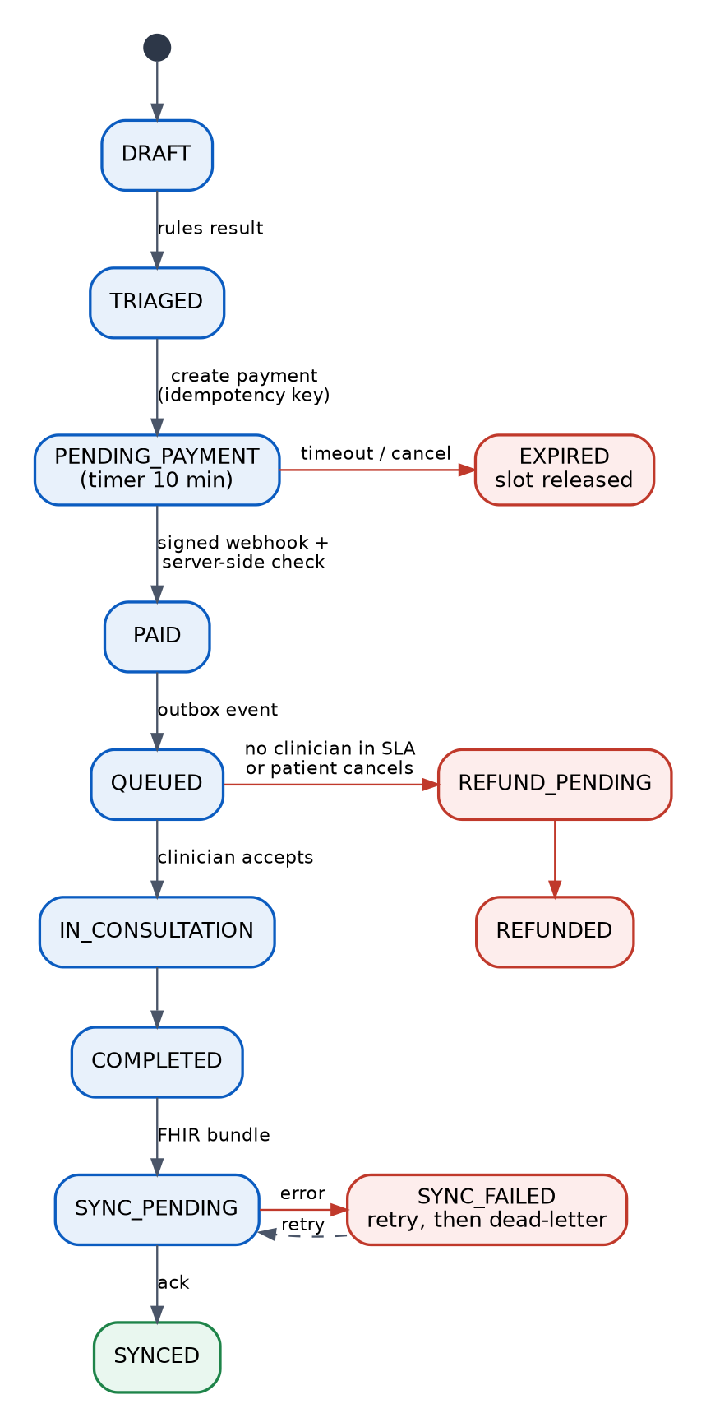
Figure 7. Consultation saga states. Red paths are compensations or failures.
Failure | Detection | Behaviour
Payment never completes | 10-minute timer on PENDING_PAYMENT | EXPIRED, slot released, patient notified, can restart
Webhook delivered twice | Event id already recorded | Second delivery acknowledged and ignored
Webhook lost | Reconciliation job and status query after the timer | State corrected to PAID or EXPIRED
Paid but no clinician in the SLA window | Queue SLA timer | REFUND_PENDING, refund request with idempotency key, patient told
IremboPay unavailable at creation | Circuit breaker opens | Show a clear retry message; no consultation is committed; rules advice is still shown
Core crashes between PAID and event publication | Outbox row exists without published mark | Relay publishes on restart; consumers are idempotent
Triage rules unavailable | Health check fails | Case enters the queue at a safe default urgency and is flagged for human triage

4.4 Task 1: Decision log. Microservices or modular monolith

ADR-001 Modular monolith core with five deliberate separate services
Context. TeleClinic runs on-premise. There is no managed Kubernetes, no managed database, no managed message service and no cloud load balancer. Every component adds a pipeline, dashboards, alerts, patching, backup and on-call burden that the operations team carries directly. At the same time the platform must scale to millions of citizens and integrate with many systems.
Criterion | A. Full microservices (about 12 services) | B. Single modular monolith | C. Chosen: modular monolith plus 5 separate services
Deployables to build, scan, release and patch | About 12 plus data tier | 1 plus data tier | About 6 plus data tier
Databases to run and back up | One per service (about 12) | One HA cluster, one schema per module | One HA cluster, one schema per module
Network hops per user request | 5 to 10 | 0 inside the core | 1 to 3 at the edges
Consistency across booking, payment and consult | Distributed sagas everywhere | Local transactions inside the core | Local transactions in the core; saga only for the external payment
Failure modes to design and test | Many (partial failures between every pair) | Few | Few, each at a clear boundary
Independent scaling | Excellent | Whole core scales together | Scale the parts that need it (USSD, triage, edge)
Team autonomy | Excellent but needs many teams | Limited above 15 developers | Good for a team of 8 to 25
Operations skills needed on-premise | High: service mesh, tracing, many pipelines | Low | Moderate
Time to first release | Slowest | Fastest | Fast
Cost of changing the decision later | Hard to merge services back | Extraction needs seams that may not exist | Low: seams are enforced from day one

The figures are indicative planning estimates, not measurements. They show the shape of the trade-off: on-premise, every extra deployable is a permanent operating cost, and a consistent booking-payment-consultation path is simpler inside one transaction boundary.
Decision. Build the domain as one modular monolith with enforced module boundaries (Spring Modulith). Run five things separately because their failure, scaling or security profile genuinely differs: (1) the edge and gateway, (2) the USSD gateway (very spiky, very simple, latency-critical), (3) the triage and anonymization services (isolated trust zone, different runtime), (4) the sync gateway (OpenFn, integration concerns and long-running retries), and (5) the data tier (stateful, operated differently).

Rules that keep the seams real
- Each module owns its tables. No cross-module joins or foreign keys; modules talk through interfaces and domain events.
- Events cross module boundaries through the outbox, exactly as they would cross a network later.
- Module dependencies are checked in the build. A violation fails the pipeline.
- Every external dependency sits behind a port (for example PaymentPort, IdentityPort, EmrPort), so a different payment or identity provider is a new adapter, not a rewrite.

When to extract a module into its own service
Extraction needs evidence of at least one of these conditions, measured over a quarter:
- Independent scaling: a module needs more than 3 times the resources of the rest and cannot share instances.
- Isolation or compliance: a module needs a separate security boundary, for example financial data or the AI trust zone.
- Deployment conflict: a module needs to release much more often than the rest and blocks others.
- Team boundary: a stable team owns the module and wants to run it end to end.

Likely first candidates are notifications (spiky, simple), payments (financial isolation), and the patient index (heavy matching load). The job description asks for the microservices landscape of TeleClinic. This design delivers that landscape as seams and ports from day one, and extracts services when evidence justifies the operating cost.

4.5 Task 2: Interoperability and the data engine

4.5.1 FHIR strategy: mapping internal entities to HL7 FHIR R4
Approach. The core keeps a relational canonical model, which is simple to query, index and audit. A FHIR facade module translates that model to profile-validated FHIR R4 (4.0.1) resources at the boundary. The facade is an anti-corruption layer: FHIR concerns do not leak into the domain, and a change in profiles or in FHIR version is contained in one module. A FHIR-native store was considered and rejected for the core (ADR-008).
Internal entity | FHIR R4 resource | Key mapping decisions | Terminology
Citizen / patient | Patient | Identifiers sliced by system: IremboAccount subject, national ID (NIDA), UPI from the national client registry, eBuzima and facility record numbers. Name with use, birthDate, administrative gender, telecom (+250 normalised), address as district and sector, communication language (rw, en, fr). link holds identity-matching results. | None required; identifier system URIs for NIDA and the UPI agreed with the registry owners
Guardian or caregiver | RelatedPerson | patient (the dependent), relationship (for example MTH, mother), identifier (the guardian's IremboAccount subject), period. Performer of the dependent's Consent and author of intake answers given on the child's behalf. | HL7 v3 RoleCode (personal relationship)
Consultation | Encounter (class VR, virtual) | status, type, subject, participant (Practitioner), period, reasonCode, serviceProvider. Extensions for channel (web, USSD, voice) and triage urgency. | ICD-10 where a reason is coded
Symptoms and intake answers | Observation (category survey) | One Observation per coded symptom answer, linked to the Encounter. Free text stored as a note, never sent to the model. | National symptom list, mapped to SNOMED CT where licensing allows
Vital signs | Observation (FHIR vital-signs profile) | valueQuantity with UCUM units, effectiveDateTime, device or self-reported flag. | LOINC, for example 8480-6 systolic BP, 8867-4 heart rate, 9279-1 respiratory rate, 8310-5 body temperature, 59408-5 SpO2
Diagnosis | Condition | clinicalStatus, verificationStatus, encounter, recordedDate, recorder. | ICD-10 (required binding)
Prescription | MedicationRequest | Medication from the national formulary with ATC as a secondary coding. dosageInstruction, requester, status, dispense request. | National formulary, ATC
Lab and imaging results | DiagnosticReport, Observation, DocumentReference | Structured results as Observation referenced by the report. Images and PDFs as DocumentReference attachments stored in object storage. | LOINC
Patient consent | Consent | scope, category, policy, provision by purpose and data class. Evaluated by the policy engine before any release. For a dependent, the performer is the guardian's RelatedPerson. | Consent policy codes
AI suggestion and review | RiskAssessment, Provenance | RiskAssessment prediction with qualitativeRisk. Provenance records the model version as a device agent and the clinician as the verifying agent. | Triage urgency value set
Audit trail | AuditEvent | Who, what, which patient, outcome, purpose of use, source system. Searchable per patient. | DICOM and FHIR audit event codes
Providers and facilities | Practitioner, PractitionerRole, Organization, Location | Master data from the national facility and workforce registries; local copy refreshed on a schedule. | National identifiers

Payments stay in the finance domain and are linked to the Encounter by id. They are not exposed as clinical data. Insurer claims, when needed, use Claim resources produced by a separate workflow.

Profiles, terminology and validation
- Layering. Base R4, then the International Patient Summary for summary exchange, then TeleClinic profiles that tighten rules for Rwanda (required identifiers, Encounter class, vital-signs usage, required ICD-10 binding for Condition, extensible LOINC binding for Observation).
- Authoring. Profiles are written as FSH, built with SUSHI into an implementation guide, and packaged as an NPM package.
- Validation. The HL7 validator runs in CI on every example. The FHIR facade validates every outbound and inbound resource at runtime. Invalid resources go to the review queue with the OperationOutcome attached.
- Terminology. ValueSets and ConceptMaps are managed in a small terminology service. Local codes are always mapped to a standard code, so exchange with other systems stays meaningful.
- Versioning. Profile canonical URLs carry versions. Changes are backward compatible within a major version, and a facade mapping layer lets an R5 move happen without touching the core.

4.5.2 The sync gateway: write-back without data loops
Problem. TeleClinic and the facility EMR both change clinical records. If each change is copied to the other side, the copy looks like a new change and bounces back forever. The design stops this with identity of origin, content comparison and ordering. Figure 8 (at the end of this section) shows the data flow.
Which EMRs, by facility level. Rwanda deploys EMRs by level of care, and TeleClinic follows it. Health centres use eBuzima, the Ministry of Health's national EMR: one central, web-based instance in which each health centre is a tenant (about 70% of roughly 500 health centres by mid-2026). There are too many health centres to run one installation each, so the Ministry runs one and adds a tenant per facility. District, referral and teaching hospitals run their own OpenMRS, one installation per hospital. TeleClinic therefore treats eBuzima as its first EMR integration: one connection reaches most health centres, and the tenant is a field on each write, not another connection. Each patient has a home facility in the patient index, and the facility registry gives that facility's level, EMR and tenant; teleconsultation notes, prescriptions and referrals go to that EMR, so the facility sees them at the patient's next visit. A referral to the district hospital adds the hospital's OpenMRS as a second target. National exchange (client registry, shared health record) goes through the OpenHIM interoperability layer. The mechanisms below apply to every EMR, and the queue, ledger and identity links are kept per EMR, so one EMR being down never holds up another.
Mechanism | How it works | What it prevents
Origin tag | Every resource written by the gateway carries meta.tag with origin teleclinic. A dedicated integration user is used in the EMR, so its audit shows the source. | The gateway re-importing its own writes
Content hash in the ledger | The sync ledger stores a hash of the last synchronised canonical form per record. An inbound change with the same hash is an echo and is dropped. | Loops caused by systems that rewrite metadata
Version check | Updates use If-Match with the resource version. A mismatch is a real conflict and goes to the conflict queue. | Lost updates from two writers
Conditional create | Creates use If-None-Exist on a business identifier. | Duplicates from retries
Idempotency key | Every workflow run carries a key derived from event id and target. | Double application after replay
Ordering per patient | Kafka key is the patient id, so one patient's events are processed in order. | Out-of-order updates
Authority rules | Each resource type has an authoritative system (table below). | Silent overwrites of clinical data

Data | Authority | Conflict policy
Legal identity fields (name, date of birth, national ID) | IremboAccount and the national registry | Registry wins; differences are logged and shown to the clerk
Contact details and facility-specific fields | The facility EMR | Latest write wins, with history kept
Encounters and prescriptions authored in TeleClinic | TeleClinic | EMR edits to these records are held for review, not applied
Encounters authored in the EMR | The EMR | TeleClinic stores a read-only copy
Observations and results | Source system | Append-only. A correction is a new Observation, the old one marked entered-in-error
Allergies, problem list, medication list | Shared clinical data | Never auto-overwritten; union with source labels, conflicts to a clinician

- Real time. Outbound p95 under 5 seconds when the EMR is reachable. Inbound is near real time by polling _lastUpdated per facility every 30 to 60 seconds, or by push where a facility's EMR supports it.
- EMR offline. Events wait in Kafka (retention 7 days). Workflows retry with exponential backoff and jitter, then dead-letter after a limit. A replay tool re-injects dead letters in order. Clinicians keep working in TeleClinic.
- Consent and minimisation. The policy engine checks consent before an outbound release, and only the resources the receiving system needs are sent.
- Observability. Sync lag, queue depth, dead-letter count and conflict rate are first-class dashboards and alerts (Section 7).
- eBuzima adaptor. The sync gateway is one pattern per EMR, not one integration per EMR. Each EMR gets its own workflow pair and adaptor behind the same EmrPort, with the same ledger, origin tags and authority rules. eBuzima is built on ERPNext (Frappe) with the Healthcare app, so it does not speak FHIR: its adaptor calls the Frappe REST API (/api/resource/<DocType>) and maps the healthcare DocTypes (for example Patient, Patient Encounter, Vital Signs, Lab Test) to FHIR R4 at the gateway, so the core receives FHIR from every EMR. Patients are national records shared by all tenants; an encounter is written in the tenant (the ERPNext Company) of the patient's health centre, which is how that health centre's staff, limited to their own tenant, see it. Inbound, eBuzima calls the gateway's webhook when a patient record is saved (a Frappe document webhook); the gateway then reads every record modified since its cursor, so a lost webhook delays a change but never loses it, and a scheduled run is the safety net. A dedicated integration user and an origin field mark TeleClinic's writes, and updates check the document's modified timestamp, which is Frappe's optimistic-concurrency field. The exact DocTypes, custom fields and partner API policy of eBuzima are to be confirmed (assumption A3).
Measured in the reference implementation. Two EMRs, as deployed by level: an eBuzima stand-in (ERPNext 15 with the Frappe Healthcare app, the public eBuzima stack, not the Ministry's instance) with Kimironko and Remera health centres as two tenants, and Kibagabaga District Hospital's OpenMRS O3, each with an OpenFn workflow pair. Encounters followed the patient's home facility: a clinician's decision reached eBuzima as one submitted encounter in Kimironko's tenant in 2.0 s median (p95 3.8 s, 10 consultations), and the hospital's OpenMRS in 1.8 s median (p95 2.3 s). TeleClinic's own write came back with the same content hash and was dropped. A contact phone saved by a Kimironko nurse, who sees only her tenant, reached TeleClinic 2.3 to 4.3 s later through eBuzima's document webhook, was applied once with eBuzima as the audited author, and was not sent back. With OpenMRS stopped, writes waited with backoff and arrived once each, in order, when it returned. One difference from Figure 8: outbound writes sit in a queue in the core that the workflow pulls (started at once by a webhook), because a Kafka trigger would turn an EMR outage into failed runs instead of waiting writes. Limit found: OpenMRS's _lastUpdated reports an edited phone but not one added where there was none, so production adds a periodic reconciliation sweep of linked records by hash.

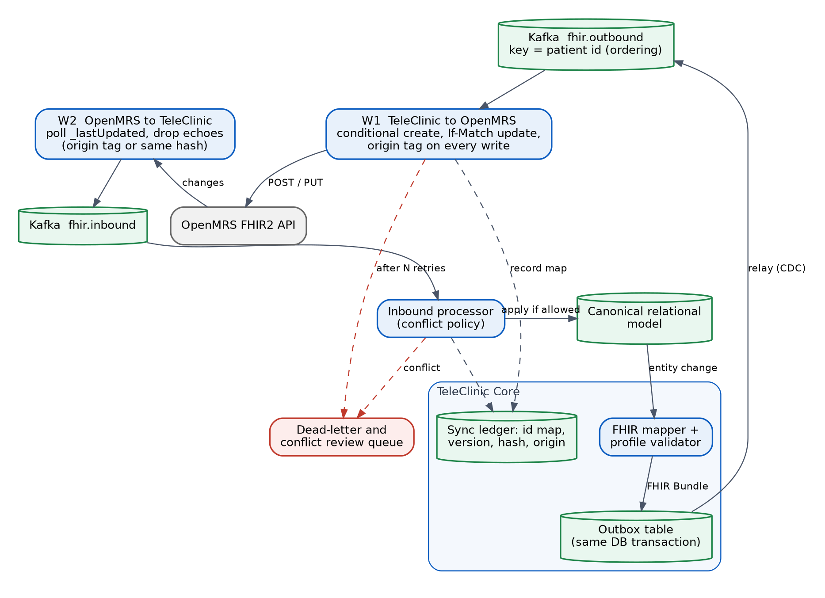
Figure 8. Sync gateway data flow. Outbound through the outbox and Kafka, inbound by reading recent changes (woken by a document webhook for eBuzima, polled for OpenMRS), with echo suppression and a conflict queue.

4.5.3 Patient identity matching and safe merge
Problem. The same person can exist in IremboAccount and in one or more EMRs with different spelling, swapped day and month, changed phone number or missing national ID. A wrong merge puts one person's medical history in another person's chart, which is a patient-safety event. A missed match only creates a duplicate, which is an inconvenience. The design is deliberately cautious.
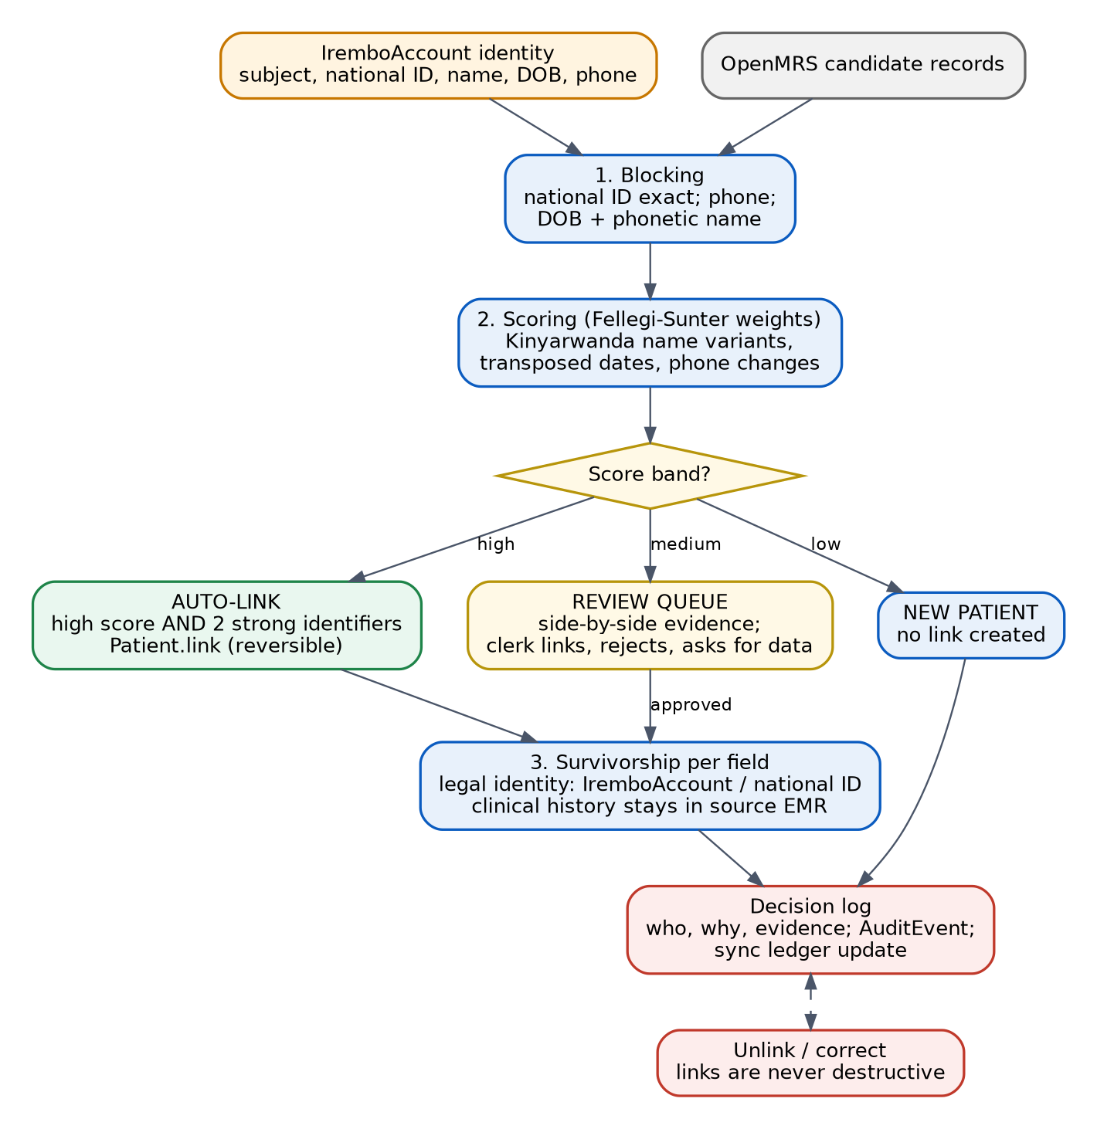
Figure 9. Identity resolution. Blocking, scoring, three outcome bands and reversible links.
Step | Design
Blocking | Candidates are found by exact national ID or UPI, by phone plus birth year, and by phonetic family name plus date of birth. This keeps comparison cheap at national scale.
National anchors | Before local scoring, the national ID is verified (through IremboAccount or NIDA) and the national client registry is queried with $match; an agreeing UPI counts as a strong identifier. A child without a national ID is identified by the UPI or the birth registration (CRVS) together with the guardian link (assumption A11).
Normalisation | Strip diacritics and honorifics, handle given and family name order, apply Kinyarwanda, French and English spelling variants, normalise phone numbers to +250 format, and accept day and month transpositions.
Scoring | Fellegi-Sunter weighted comparison per field, with weights estimated from a labelled sample. Jaro-Winkler for names, tolerant comparators for dates, weak weight for location.
Outcome bands | High score and at least two strong identifiers agree: auto-link. Middle band: human review. Low band: no link.
Hard blocks | Two different national IDs mean certainly-not-a-match, whatever the other fields say.
Twins and relatives | Same surname, same birth date and same address require an additional identifier before any link.
Link, never merge | The result is a Patient.link (type seealso or refer) between records. Source records are untouched and clinical history stays where it was written. Unlinking is a first-class, audited action.
Survivorship | Per-field rules: legal identity from the registry, contact details from the most recent verified source, clinical data not merged.
Review queue | A clerk sees both records side by side, agreeing and conflicting fields, and decides: link, reject, or request more data. Decisions record who, why and evidence.
Quality control | A 1% sample of auto-links is audited monthly. Targets: auto-link precision above 99.9%, review queue age under 3 working days, duplicate rate trending down.

Worked example. OpenMRS holds "Uwimana Marie", born 1990-03-04, no national ID. IremboAccount holds "Marie Uwimana", born 1990-04-03, with a national ID. The score is in the middle band: name match is strong after normalisation, the date shows a day-month swap, and no strong identifier agrees. The pair goes to review. After a clerk confirms, the link is created and the national ID is offered to the EMR as an update through the sync gateway, so the next encounter matches automatically.
Measured in the reference implementation. The facility's seeded records landed in the expected bands: the worked example (names in the other order, day and month swapped, no national ID) in the clerk's review queue with side-by-side evidence; a pair with different national IDs blocked and never offered; a pair sharing a UPI linked automatically, because two strong identifiers agreed (the UPI, and the exact name with the exact birth date). The clerk's link offered the national ID to the hospital's OpenMRS through the sync gateway; the unlink took it back and returned the pair to the queue. Both decisions are in the audit trail.

4.6 Task 3: Infrastructure, resiliency and security

4.6.1 High availability for the database and the message broker
Figure 10 (after the table) shows the three-node topology.
Component | Pattern | Failure tolerated | Recovery
PostgreSQL 17 | Patroni with etcd as the consensus store. One leader, one synchronous standby (quorum commit where supported), one asynchronous standby. PgBouncer for pooling. HAProxy routes writes to the node whose /primary check passes, reads to /replica. | One node or one disk lost with zero loss of committed data | Automatic promotion in under 60 seconds; the old leader rejoins with pg_rewind
etcd | Three members on fast disks. Raft quorum of 2. | One member lost | Replace member; leader keys are unaffected
Kafka | KRaft with three brokers and controllers. Replication factor 3, min.insync.replicas=2, producers acks=all and idempotent, unclean.leader.election.enable=false, rack awareness. | One broker lost without loss or unavailability | Leaders re-elected in seconds; the broker catches up on return
Valkey | Three nodes with Sentinel (quorum 2). | One node lost | Sessions may drop; USSD resumes or restarts the menu gracefully
MinIO | Distributed erasure coding, object lock on the audit bucket. | Drive or node loss within parity | Healing in the background
OpenSearch | Three nodes, one replica. Not a system of record: rebuilt from the audit stream. | One node lost | Shard reallocation
Backups and DR | pgBackRest: weekly full, daily incremental, continuous WAL to MinIO and to a second site. Monthly automated restore test. Asynchronous DR replica and Kafka mirroring at the DR site. | Loss of the primary site | Documented failover, RTO under 4 hours, RPO under 5 minutes

Synchronous commit trade-off. With one synchronous standby among two candidates, losing one replica does not block writes, and committed data exists on at least two nodes. If both replicas are lost, the design keeps the leader writable (availability) and pages the on-call team, accepting a short window of single-copy risk. A strict mode that blocks writes is available as a configuration switch if Irembo prefers zero data loss over availability.
Measured in the reference implementation. Killing the PostgreSQL leader while a client wrote every 200 ms: writes resumed after 16.8 to 21.3 s (three runs), and every acknowledged write was still there afterwards (0 of 17 to 18 lost). The old leader rejoined as a replica. With one of three Kafka brokers stopped, 50 of 50 messages were written with acks=all and no errors.

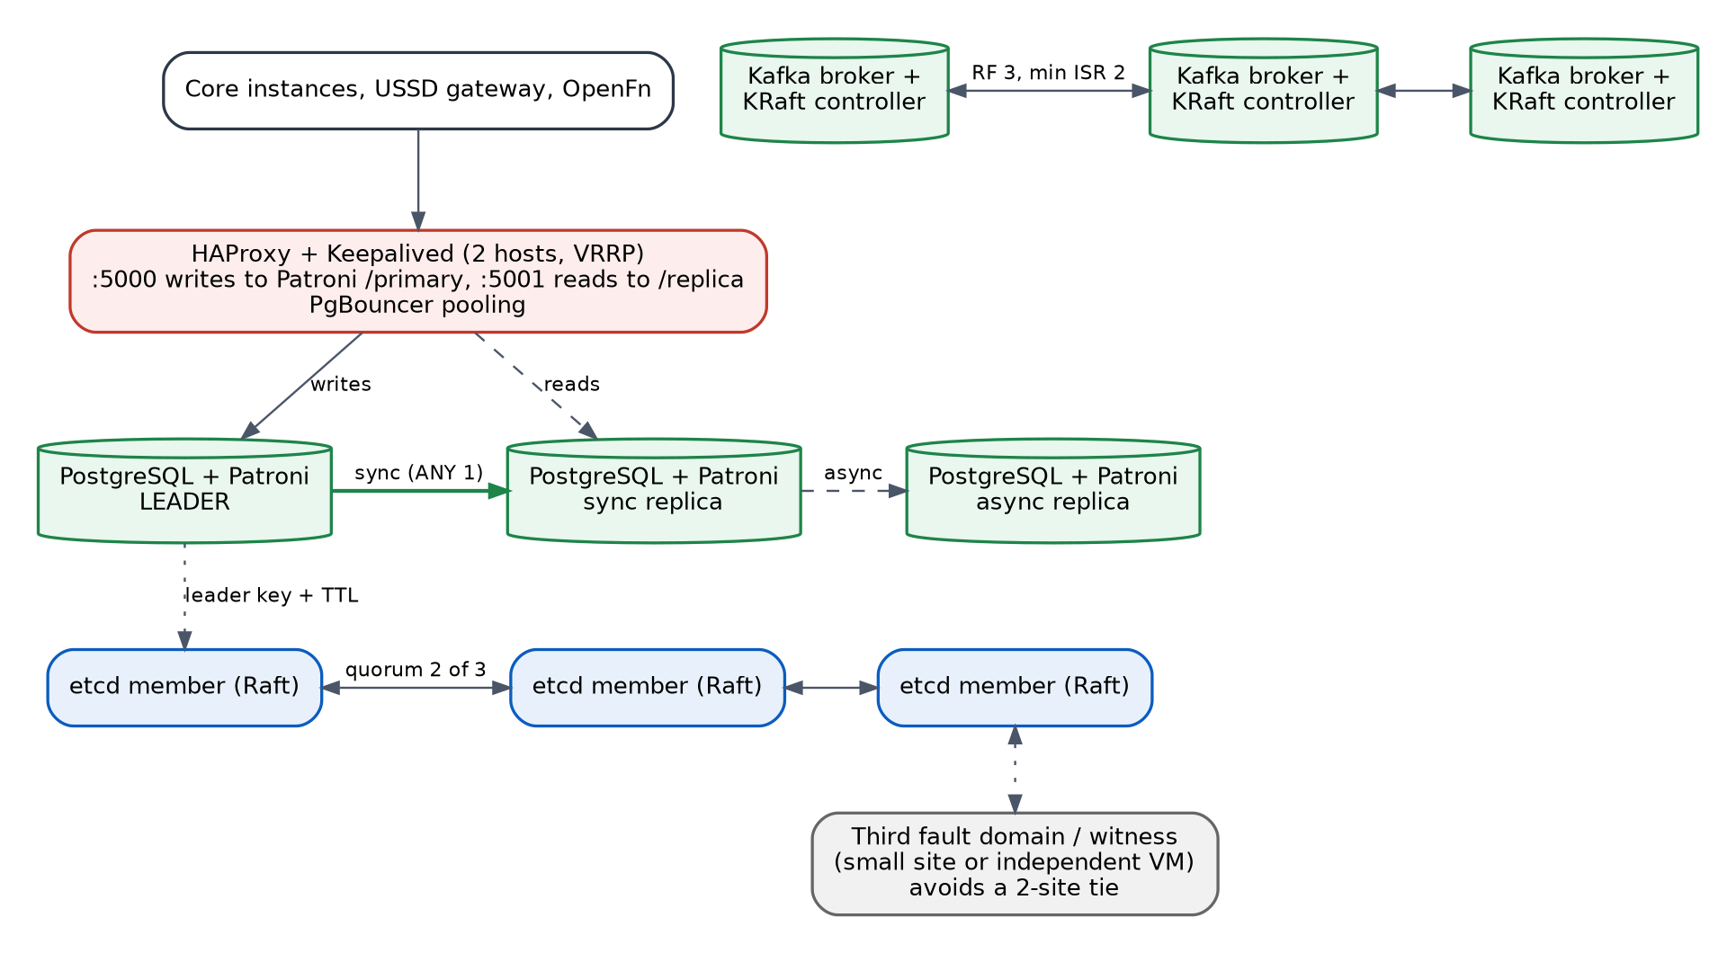
Figure 10. High-availability topology on three nodes in separate fault domains, with a witness for the third quorum vote.

4.6.2 Split-brain in a three-node cluster
Problem. After a network partition, two nodes might each believe they are the leader and both accept writes. When the network heals, the data has diverged and cannot be merged safely. The design makes this impossible by requiring a majority: only the side with two of three votes may have a leader.
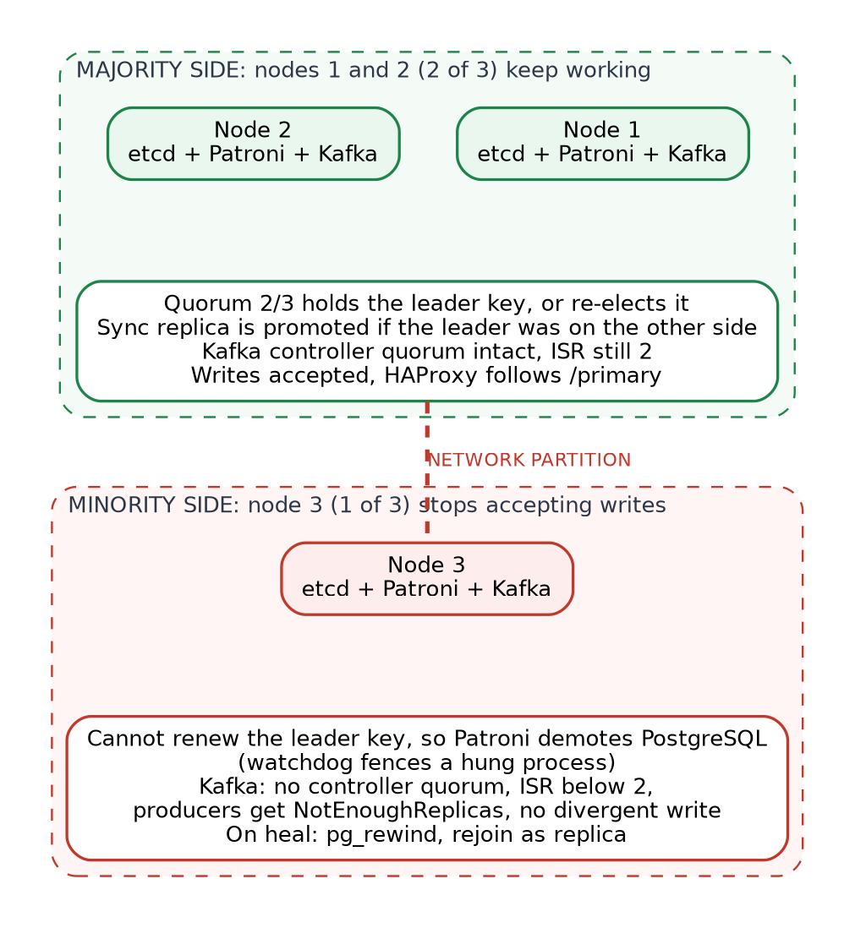
Figure 11. Behaviour during a 2 | 1 network partition.
Scenario | PostgreSQL | Kafka | Client effect
Leader node fails | etcd keeps quorum, Patroni promotes the synchronous standby, HAProxy follows /primary | Partition leaders move, ISR shrinks to 2 | Short burst of write errors; retries succeed with the same idempotency keys
Leader isolated alone (leader is in the minority) | Cannot renew its leader key, so it demotes itself; a watchdog resets the node if the process hangs. The majority elects a new leader. | Isolated broker cannot serve acks=all writes | No divergent writes; old leader is rewound on return
Replica isolated alone | Leader continues with the other standby; isolated node falls behind | Producers continue (ISR 2) | None
Two of three nodes down or partitioned apart | No quorum, no leader: platform becomes read-only or unavailable for clinical writes | No controller quorum | Edge returns a static emergency-advice message; on-call is paged; documented manual recovery
Two-site deployment without a witness | Not safe: a site-to-site cut leaves no majority | Same | Requirement: a third fault domain or witness
Slow disk or gray failure | Patroni TTL and watchdog, HAProxy health checks, alerts on fsync latency | Broker lag alerts | Failover happens on health, not only on crash

Initial Patroni timing (ttl, loop_wait, retry_timeout) is set to give failover in under a minute, then tuned from game-day measurements (Section 7.4).
Measured in the reference implementation. Cutting the leader's node off with docker network disconnect (etcd, PostgreSQL and Kafka of that node): the isolated leader stopped accepting writes after 4 to 7 s; the majority elected a new leader after 17 to 23 s; there was never a moment with two writable leaders; a write sent directly to the isolated node was refused as read-only; after healing, every node held the same rows (same count and checksum).

4.6.3 Zero-downtime deployment without cloud load balancers
Problem. On-premise there is no managed load balancer to shift traffic or drain connections. The edge layer must do it, and it must itself be redundant. Figure 12 (after the steps) shows the release topology.
1. Build and sign. The pipeline builds the image, produces an SBOM, scans it, signs it, and pushes to the internal registry.
2. Deploy green beside blue. New instances start with no traffic and must pass readiness checks.
3. Expand the database. Only backward-compatible migrations run first (add columns or tables, never drop or rename). Both versions work against the schema.
4. Smoke test green through the real edge with synthetic users (login, consent, sandbox payment).
5. Shift traffic by weight through the HAProxy runtime API: 1%, 10%, 50%, 100%. Each step waits for SLO gates on error rate, latency and saga failures.
6. Automatic rollback. A breached gate returns all weight to blue within seconds, with no restart.
7. Drain blue. Stop new connections, let in-flight requests and sagas finish, then stop. Keep blue for 24 hours as a fast rollback.
8. Contract the database (remove old columns) in a later release, once blue is gone.

- Edge redundancy. Two HAProxy hosts with identical configuration and a Keepalived virtual IP. Upgrading the edge is done one host at a time. If the network team supports it, BGP with ECMP through FRR is an alternative to VRRP; on Kubernetes, MetalLB provides the same role.
- Container platform. The same images run on Docker hosts today and on Kubernetes (RKE2) later. On Kubernetes, rolling updates with readiness gates replace the weight shift inside the cluster, MetalLB or BGP provides the virtual IP, and pod disruption budgets keep at least two core replicas during node maintenance. Release gates and expand-and-contract migrations stay the same (ADR-013).
- Messages. Event schemas are registered and must stay backward compatible, so old and new consumers can coexist.
- Stateful services. PostgreSQL minor upgrades use a controlled switchover; Kafka uses rolling restarts one broker at a time with ISR checks; OS patching is rolling by node.
- USSD sessions live in the shared session store, so any instance can continue a session during a release.
Measured in the reference implementation. A release through the HAProxy runtime API (1, 10, 50, 100 percent, each step gated on the new colour's error counters) under steady load through the public edge: 1,181 requests, 0 failed, p95 7 ms. In the rollback drill the new build passes its health checks but fails 30% of API calls; the gate caught it at the 1% or 10% step and moved all traffic back in 6 to 14 ms. Keepalived is not part of the reference implementation (virtual IPs do not work in Docker Compose).

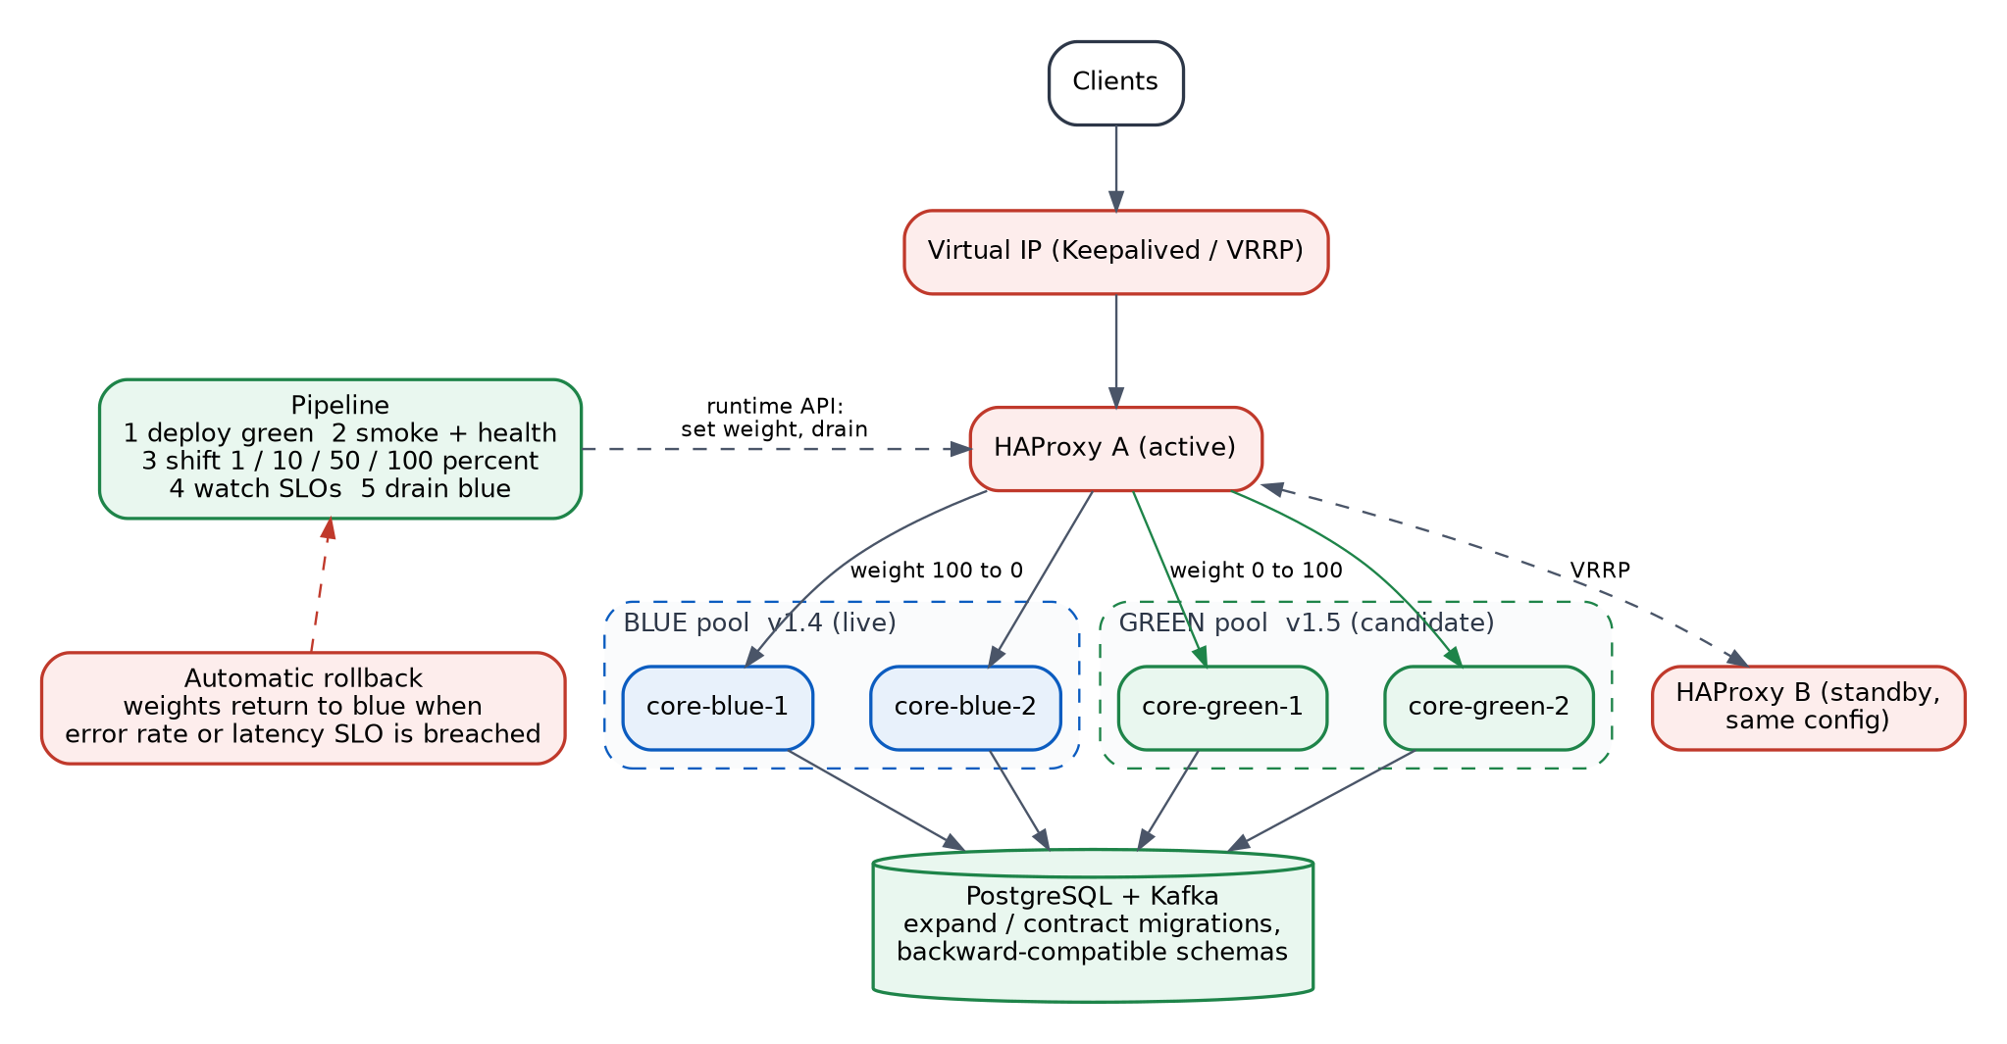
Figure 12. Blue/green release through HAProxy with Keepalived. Weights shift under automated SLO gates, with automatic rollback.

4.6.4 Audit and compliance: tracking every read and write
Requirement. Show, for any patient record, who read or changed it, when, why, and from where, and prove that the log was not altered. Doing this in one place is not enough, because each place has a blind spot. The design uses three overlapping layers, shown in Figure 13 after the tables.
Layer | What it captures | Blind spot it covers
Gateway access log | Every request: caller, scope, endpoint, status, correlation id | Calls that never reach the application
Application audit interceptor | Every API and FHIR read or write of health data: user, role, patient, resource type and id, purpose of use, consent basis, outcome | Business meaning: why the access happened
Database audit (pgAudit) | SELECT, INSERT, UPDATE, DELETE on sensitive tables, by every database role | Direct database access by administrators or tools
EMR and sync audit | eBuzima document version history (who changed which field, in which tenant) and OpenMRS audit, plus FHIR AuditEvent for sync operations | Cross-system movement of records
Break-glass | Emergency access with a mandatory reason, immediate alert, and supervisor review within 24 hours | Legitimate override that must not go unnoticed

- Tamper evidence. The audit writer assigns a sequence number and chains each entry to the hash of the previous one. A daily signed checkpoint is written to MinIO with object lock (write once). A monthly job re-verifies the chain, and a break in the chain pages the security team.
- Separation of duties. The audit store has its own administrators, separate from application and database administrators. The application account has no update or delete rights.
- Privileged access. Administrators reach production through a bastion with session recording. Their database activity is captured by pgAudit like any other role.
- Reporting. A regulator view (by user, patient, period), a patient-facing "who accessed my record" report, and alerts for bulk export, after-hours access and break-glass use.
- Performance. Audit events are written asynchronously to Kafka by the interceptor so reads are not slowed, and the stream is replicated before the response is released for sensitive writes. Sampling is not allowed for health data.
- Retention. Retention periods are configuration (assumption A9), with archive to cold storage.
Measured in the reference implementation. Clinical reads without X-Purpose-Of-Use, or for treatment without the patient's consent, are refused with 403 and an OperationOutcome, and the refusal is recorded. The patient sees every read of their record, with role, purpose and any break-glass reason. A database administrator's SELECT in psql reached the trail through pgAudit in about 1 s. When an administrator edited an audit row directly, the chain check named that entry, pgAudit showed the role and node that did it, and the audit-chain alert fired about 10 s later. The audit table refuses UPDATE and DELETE for every role; changing a row first needs DDL, which pgAudit records.

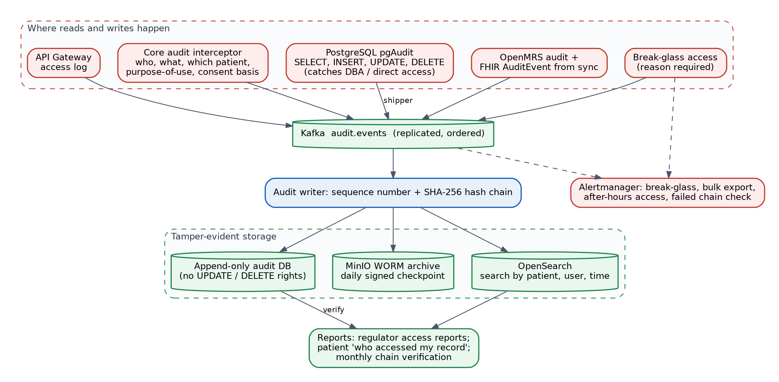
Figure 13. Three-layer audit pipeline feeding a hash-chained, write-once, searchable store.

Security architecture summary
Layer | Controls
Network | Zones: edge, application, data, AI trust zone, management. Default deny between zones. mTLS between services with short-lived certificates from an internal CA. The AI zone has no internet egress.
Identity and access | OIDC for users, MFA for clinicians and administrators, role and attribute based access with the policy engine, consent checked on release, least privilege for service accounts.
Data protection | TLS 1.2 or higher in transit. Full-disk encryption for data at rest, plus field-level encryption for the most sensitive fields with keys in OpenBao. Encrypted backups. Pseudonymization for analytics and AI.
Secrets and keys | No secrets in images or repositories. Dynamic or rotated credentials from OpenBao, with automated rotation and audited access.
Platform hardening | CIS-benchmark baselines applied by Ansible, minimal base images, runtime detection with Falco, host and log monitoring with Wazuh.
Software supply chain | Signed images, SBOM per build, vulnerability scanning with an agreed fix time by severity, dependency pinning, internal registry and mirror.
Application security | Input validation against schemas, parameterised queries, output encoding, rate limits, strict CORS, security tests in CI, annual independent penetration test.
Privacy | Data minimisation by design, purpose-of-use recorded, data subject access through the patient audit report, retention enforced by configuration.

4.7 Task 4: AI triage and clinical decision support

4.7.1 Inference pipeline: synchronous or asynchronous?
Decision: both, by purpose. A deterministic rules engine runs synchronously inside the user session and always provides a safe floor. The statistical model runs asynchronously and can only raise the urgency.
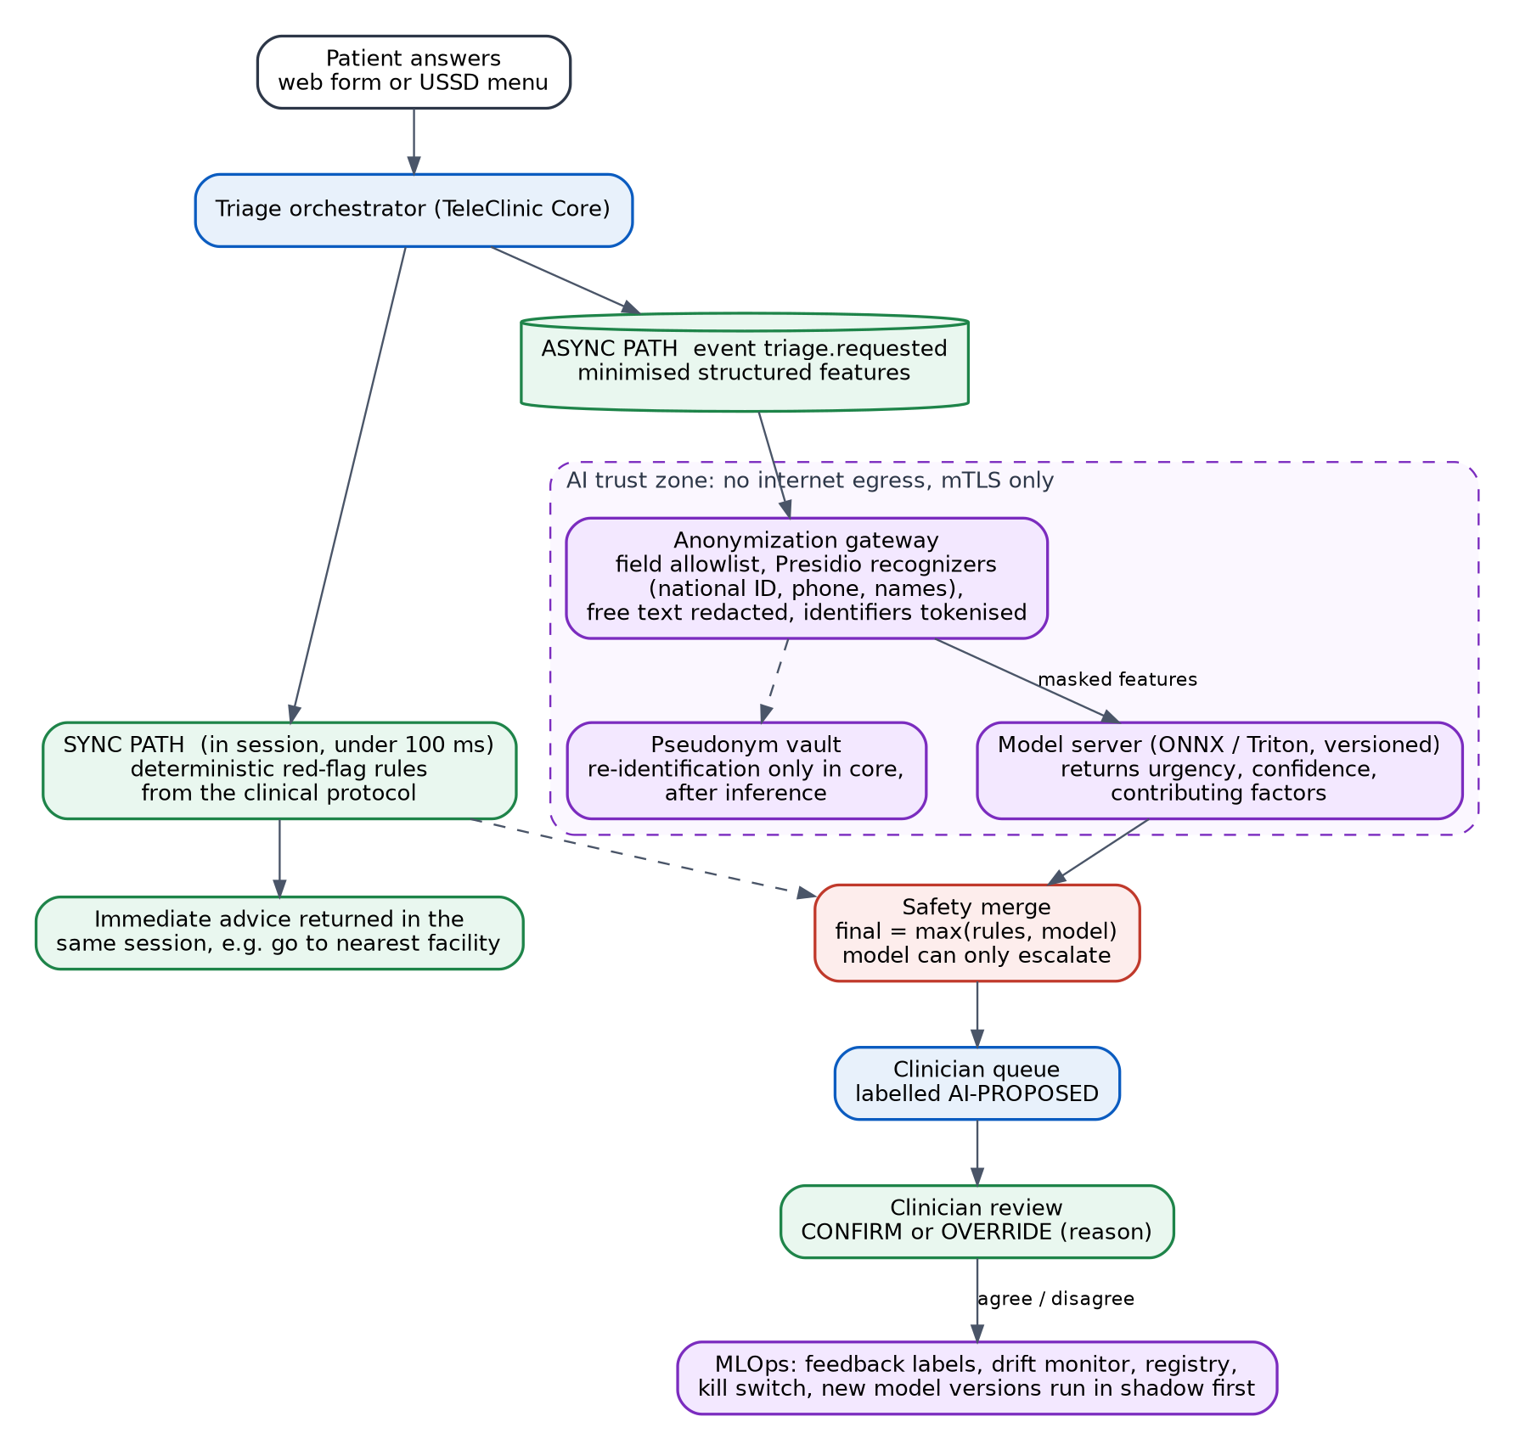
Figure 14. AI triage pipeline. Synchronous safety rules, asynchronous model in an isolated trust zone, escalate-only merge, and human review.
Option | USSD fit | Safety | Verdict
Model in the user session (synchronous) | Poor. USSD steps must answer in seconds, and model latency varies (queueing, cold start, CPU load). A model outage would break the channel. | Risky: the patient may act on an unreviewed AI answer | Rejected
Model after the session (asynchronous only) | Good, but red-flag emergencies would wait for the model | No immediate advice for emergencies | Rejected alone
Hybrid: rules synchronous, model asynchronous | Good. Rules answer in under 100 ms, so each USSD step stays inside its latency budget. | Strong: emergencies get instant advice; the model adds nuance for the clinician only | Chosen

USSD step latency budget (p95 target 1.5 s) | Allowance
Aggregator to gateway and back (network) | 200 to 400 ms
Gateway handling and session lookup | about 30 ms
Safety rules evaluation (in-process) | under 100 ms
Database write for the step | about 30 ms
Menu rendering | under 10 ms
Headroom for retries and GC pauses | remainder

The aggregator timeout is an assumption to confirm in the aggregator contract (A4). The budget leaves room for it either way. Model inference, typically hundreds of milliseconds on CPU plus anonymization time and queue wait, is kept out of this path on purpose. Results go to the clinician queue. The patient never receives an AI result directly; patient-facing advice comes only from the clinician-approved rules.

4.7.2 PII protection: the anonymization gateway
Problem. A model should never see who the patient is. Removing names alone is not enough, because phone numbers, national IDs, locations and free text can all identify a person. The gateway applies several independent layers, so one failure does not expose identity.
Layer | Mechanism
1 Data minimisation | A field allowlist sends only what the model needs: age band, sex, coded symptoms, vitals, duration, pregnancy flag. Dates of birth become age bands; addresses become district at most.
2 Structured masking | Identifiers (names, phone, national ID, IremboAccount subject) never enter the model payload. They are replaced by random tokens.
3 Free-text detection | Free text, if allowed at all on a channel, passes through Presidio with custom recognizers for the national ID format, +250 phone numbers, Kinyarwanda, French and English names and place names. Detected entities are removed or tokenised. USSD never accepts free text.
4 Tokenisation and vault | Tokens map to identities only inside the pseudonym vault, with keys wrapped by the KMS. Only the core can re-identify, and only after inference, to attach the suggestion to the right case.
5 Generalisation | Rare combinations (unusual age band in a small district) are generalised to reduce re-identification risk.
6 Output check | Model responses are scanned for identifiers and rejected if any appear.
7 Isolation | The AI zone has no internet egress, accepts mTLS traffic only from the gateway, and does not log payloads.
8 Verification | A synthetic PII test suite runs in CI with recall targets. Canary tokens planted in test data detect leaks. Any miss blocks release.

Training data follows the same rules: de-identified under a documented lawful basis, with a data protection impact assessment before use.

4.7.3 Human-in-the-loop pattern
Requirement. An AI suggestion must be flagged for practitioner validation before any clinical action is finalised. The pattern is enforced in the domain model, not just in the user interface, so no code path can skip it.
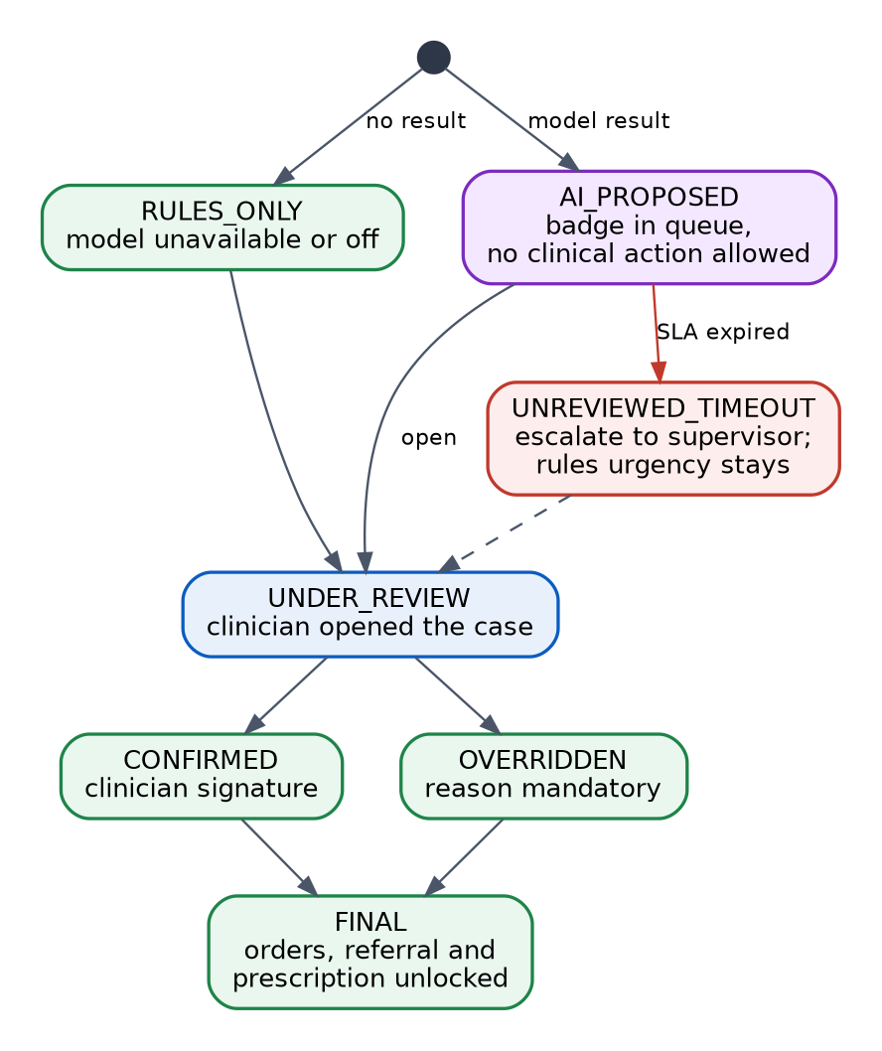
Figure 15. Triage state machine. An AI proposal cannot unlock clinical action until a clinician confirms or overrides it.
1. State machine in the core. A case has states RULES_ONLY, AI_PROPOSED, UNDER_REVIEW, CONFIRMED, OVERRIDDEN, UNREVIEWED_TIMEOUT and FINAL. Orders, referrals and prescriptions are only permitted in FINAL, enforced by the policy engine.
2. Escalate-only merge. Final urgency before review is the higher of the rules result and the model result. The model can never lower the safety floor.
3. Visible, labelled and explainable. The clinician queue shows an AI-PROPOSED badge, the rules result and the model result side by side, plus the contributing factors.
4. Signed decision. The clinician confirms or overrides with their identity. An override requires a reason. Both are recorded as FHIR Provenance and AuditEvent.
5. Timeouts. An unreviewed case past its SLA escalates to a supervisor. The rules urgency stays in force.
6. Fail safe. If the model is down, disabled by the kill switch, or returns an invalid result, the case continues as RULES_ONLY and human triage.
7. Feedback loop. Agreement and override rates, outcomes and reasons feed drift monitoring and model review.

4.7.4 Safety case, model governance and MLOps
Hazard | Cause | Controls
Under-triage (urgent case looks routine) | Model error, missing data, drift | Rules floor, escalate-only merge, clinician review, outcome monitoring, kill switch
Over-triage floods the queue | Conservative model or noisy inputs | Threshold tuning in shadow mode, queue capacity alerts, supervisor dashboards
Automation bias | Clinicians accept the label without thinking | Show rules and model side by side, require a reason on overrides, random audit, training
Wrong or outdated clinical rules | Protocol misreading | Clinical governance sign-off, versioned rule sets, test suite of clinician-approved cases
PII reaches the model | Gateway failure | Layered anonymization, no egress, output check, canary tests
Unequal performance across groups | Training data imbalance by language, age or region | Stratified evaluation before release and in production, release gates
Unauthorised model change | Process gap | Signed models, registry with approval, change control, audit trail

- Release path. Shadow mode (model runs, nobody sees it), then limited pilot, then active with human review. Each step has written exit criteria agreed with clinical leadership.
- Governance. Model card per version, a named clinical safety lead, a hazard log reviewed every quarter, and rollback or kill switch available to on-call.
- MLOps pipeline. Models are trained on de-identified data inside the AI zone, registered with their data window and metrics in a model registry (for example MLflow), packaged as signed ONNX artifacts, and released through the same pipeline as code: offline evaluation with stratified metrics, then shadow mode, then a canary share of cases, then active. Feature and prediction drift, clinician agreement and latency are monitored; a breach opens a ticket, and the kill switch is one call away. Rollback points the model router back to the previous registered version.
- Transparency. Patients are told when AI supports triage, and consent covers it.
Measured in the reference implementation. The demo model (logistic regression on ONNX Runtime, trained on synthetic data with illustrative labels, not clinically valid) passes its release gates: accuracy 0.958, under-triage rate 0.032 against a gate of 0.10, recall for urgent cases 0.97 to 0.99 in every age group and sex. The anonymization gateway removed 10 of 10 free-text identifiers in its test suite, which runs at build time, and the AI zone's logs held no identifier after a full run. A suggestion reaches the clinician queue 23 to 36 ms after the case event. Orders are refused until a clinician confirms or overrides, and the kill switch makes new cases rules-only at once.

5 Deliverable 2: Trade-off analysis
Each record states the decision, the alternatives that were seriously considered, why this choice fits an on-premise health platform in a developing-market context, what the choice costs, and what evidence would make us revisit it. ADR-001 is in Section 4.4.

5.1 Architecture and messaging
ID | Decision | Alternatives considered | Why this choice | What we accept | Revisit when
ADR-001 | Modular monolith core plus five separate services | Full microservices; single monolith | Lowest on-premise operating cost with real seams for later extraction (Section 4.4) | Core scales as one unit; module discipline must be enforced | A module meets an extraction criterion for a full quarter
ADR-002 | Saga with compensations for booking and payment, not two-phase commit | 2PC or XA across the core and IremboPay; distributed lock | IremboPay is external and cannot take part in a database transaction. 2PC blocks when the coordinator fails and does not scale. Local transactions plus compensations keep every step recoverable. | Temporary intermediate states (PENDING_PAYMENT, REFUND_PENDING) that must be designed, monitored and reconciled | Never for external payments; revisit only for purely internal multi-database steps
ADR-003 | Transactional outbox with an outbox relay, not dual writes | Write to database then publish in code; publish first | The state change and the event commit together or not at all. A crash cannot leave money taken with no event. Consumers must be idempotent, which is required anyway. | An outbox table to operate and monitor; consumers must tolerate duplicates | Never; change only the relay technology (polling to log-based CDC)
ADR-004 | Kafka (KRaft) as the event backbone | RabbitMQ quorum queues; database queue only | Replayable log suits audit, sync and multiple consumers. Replication and min ISR give explicit split-brain behaviour. KRaft removes ZooKeeper. | More operational skill than RabbitMQ; at least three brokers; disk planning | Message volume stays tiny and replay is never used: RabbitMQ becomes the simpler choice
ADR-005 | Orchestrated saga inside the core, not event choreography | Choreography across services | One component owns booking state, so support staff and auditors can see where every case is. Choreography makes the overall state hard to follow. | The orchestrator is a critical component, but it lives in the already redundant core | Many independent teams own steps of the flow

5.2 Data and high availability
ID | Decision | Alternatives considered | Why this choice | What we accept | Revisit when
ADR-006 | PostgreSQL with Patroni and etcd | repmgr; multi-master databases; distributed SQL; managed cloud database | Mature, widely understood, single-writer semantics make consistency simple. Patroni uses a consensus store so split-brain is prevented by design. Cloud databases are not allowed on-premise. | One writer; write scaling is vertical, then by region sharding | Writes exceed one node and regional sharding is not enough
ADR-007 | Synchronous standby with non-strict mode | Asynchronous only; strict synchronous | Committed clinical data exists on two nodes in normal operation. Non-strict keeps the service writable if one replica is lost. | A brief single-copy window during a double failure, with a page | Regulator requires zero loss even at the cost of availability: switch to strict
ADR-008 | Relational canonical model with a FHIR facade | FHIR-native store (for example HAPI JPA) as the core | Fast, simple queries and joins for operations; FHIR is the contract at the boundary; changes in profiles or FHIR version stay in one module. | Mapping code to maintain and test; two representations of a record | Most traffic becomes FHIR queries and mapping cost dominates

5.3 Interoperability and identity
ID | Decision | Alternatives considered | Why this choice | What we accept | Revisit when
ADR-009 | OpenFn workflows as the sync gateway | Custom integration service in Java; Mirth Connect; OpenHIM mediators only | Ready adaptors for OpenMRS, FHIR and others, visual workflows with run history and replay, and a small team can maintain it. It is kept out of the real-time USSD path. | Another platform to run; custom logic still needs tests | Latency or throughput needs exceed what workflows deliver
ADR-010 | Inbound changes by polling recent updates, push where available | Subscriptions only; database change capture on each EMR | Works with every OpenMRS version and needs no change to the EMR database. Polling every 30 to 60 seconds meets the near-real-time need for clinical continuity. | Up to a minute of inbound lag; more requests to EMRs | Facilities support reliable FHIR subscriptions
ADR-011 | Probabilistic matching with deterministic anchors, linking not merging | Exact ID only; machine-learning matcher; destructive merge | National ID is often missing in EMRs, so exact match alone leaves many duplicates. Links are reversible and keep clinical history in place, which makes wrong decisions recoverable. | A human review queue; tuning effort; some duplicates remain until reviewed | Review queue is overwhelmed: tune thresholds with labelled data

5.4 Edge, deployment and operations
ID | Decision | Alternatives considered | Why this choice | What we accept | Revisit when
ADR-012 | HAProxy and Keepalived with blue/green weights | Kubernetes ingress with MetalLB; service mesh; DNS switching | Proven, small, no dependency on a cloud load balancer, fast rollback through the runtime API. DNS switching is slow and uncontrolled. | Manual capacity planning at the edge; VRRP needs a layer-2 network | Network team prefers BGP, or workloads move to Kubernetes
ADR-013 | Containers everywhere from day one. Stateful tier (PostgreSQL, etcd, Kafka) on VMs managed by Ansible. Stateless tier on Docker hosts first, then on an on-premise Kubernetes distribution (RKE2) once readiness criteria are met | Kubernetes for everything from day one, including databases through operators; VMs without containers | Every service ships as a signed image with health probes and declarative configuration, so moving the stateless tier to Kubernetes is a deployment change, not a rewrite. Kubernetes pays off for the stateless tier (rolling updates, self-healing, bin packing). Running databases and Kafka on Kubernetes on-premise adds storage and operator failure modes a small team should not carry in the first year. | Two deployment styles for a period; the team learns Kubernetes on the stateless tier first | Readiness criteria met: two trained operators, a staging cluster run for a quarter, tested etcd backup and restore, a rehearsed cluster upgrade. Or more than about 15 stateless services

5.5 Security and AI
ID | Decision | Alternatives considered | Why this choice | What we accept | Revisit when
ADR-014 | Hybrid triage: synchronous rules, asynchronous model | Model in the user session; asynchronous only | USSD latency and availability; safety floor for emergencies (Section 4.7.1) | The model never influences the immediate patient advice | Model latency becomes consistently low and clinicians ask for it
ADR-015 | Tokenisation and minimisation before the model | Send raw data to an internal model; formal differential privacy | Simple, testable, reversible only inside the core. Differential privacy is a research-grade tool for aggregate statistics, not for per-patient triage. | Residual re-identification risk from quasi-identifiers, managed by generalisation | Training moves to shared or external environments
ADR-016 | Hash-chained audit with write-once archive | Distributed ledger; plain log files | Tamper evidence with tools the team already runs. A ledger adds complexity without a stronger guarantee here. | Trust anchor is the signed daily checkpoint and its custody | Regulator requires independent third-party anchoring
ADR-017 | EMR target chosen by the patient's home facility: eBuzima, one central multi-tenant instance, for health centres; each hospital's own OpenMRS. Every EMR is FHIR at the core boundary | One integration per facility; route by the last facility visited; the shared health record as the only target | Matches how Rwanda deploys EMRs by level. One connection reaches every health centre, and the tenant is a field on each write. The core keeps one inbound contract because the gateway maps each EMR to FHIR. | The home facility must be kept current; a patient seen at both levels has a record in each EMR, linked, not merged | The shared health record becomes the system of record for encounters, or eBuzima reaches the hospitals

5.6 Why these FHIR profiles
Choice | Why | Cost
HL7 FHIR R4 (4.0.1) | Broadest tool and EMR support, including the OpenMRS FHIR module. Stable normative parts. | Some newer features (topic-based subscriptions) are only back-ported
International Patient Summary for summaries | International alignment for exchange of a patient summary; reuses a well-reviewed structure. | Extra constraints to satisfy
TeleClinic Patient profile | Identifier slicing by system makes matching and sync deterministic; requires a stable subject id. | Clients must send identifiers correctly
Encounter with class VR (virtual) | Distinguishes telemedicine from in-person care for statistics and reimbursement. | Needs a channel extension for web, USSD and voice
FHIR vital-signs profile with LOINC and UCUM | Standard units and codes make results usable by any system and by decision support. | Mapping for local device and self-reported values
Condition bound to ICD-10 (required) | The role requires ICD-10; national statistics and reimbursement rely on it. | Clinicians need good search and favourites to code quickly
MedicationRequest with national formulary plus ATC | Local prescribing stays accurate while ATC enables international analysis. | Two codings to maintain
AuditEvent based on IHE BALP patterns | Reuses a published pattern for audit events instead of inventing one. | Some fields are optional and need local rules
RiskAssessment and Provenance for AI | Records that a suggestion came from a model version and who verified it, in standard resources. | Needs consistent use across systems

6 Deliverable 3: API specifications
Two OpenAPI 3.1 documents define the core interfaces: the Interoperability and Sync API and the AI Triage API. Both validate against the OpenAPI 3.1 schema. The full documents are in Appendices A and B and are also supplied as separate YAML files.

6.1 Conventions that apply to every endpoint
Topic | Convention
Authentication | OpenID Connect access tokens from IremboAccount (or mTLS between internal services). Scopes follow SMART-style patterns, for example patient/Observation.read, system/*.write.
Authorization | Scope check, then the policy engine evaluates role, consent and the declared purpose of use.
Purpose of use | The X-Purpose-Of-Use header (TREAT, PAYMENT, OPERATIONS, PATIENT_ACCESS, BREAK_GLASS) is mandatory on clinical reads and is stored in the audit trail.
Idempotency | Every create or command accepts an Idempotency-Key. The same key returns the stored result and never repeats the action.
Concurrency | FHIR reads return an ETag. Updates use If-Match. A mismatch returns 409 and opens a conflict.
Errors | FHIR endpoints return OperationOutcome. Other endpoints return the same shape in JSON. 429 for quota, 403 for policy denial, 422 for profile or validation failure.
Versioning | Major version in the URL path. Within a version, only backward-compatible changes. Profile versions are in canonical URLs.
Correlation | X-Correlation-Id is created at the gateway and returned on every response and log line.
Limits | Rate limits per client and per patient; bulk reads need an explicit scope.

6.2 Interoperability and Sync API
Endpoint | Purpose | Scope or role
GET /fhir/metadata | Capability statement with profiles and operations | Public
POST /fhir/Patient/$match | Candidate patients with scores and match grades. Never merges. | system/Patient.read
GET /fhir/Patient/{id}, GET /fhir/Patient | Read and search patients (identifier, family, birthdate) | patient/Patient.read
GET /fhir/Encounter, GET /fhir/Observation | Search consultations and observations (for example LOINC code, sorted by date) | patient/Encounter.read, patient/Observation.read
POST /fhir | Atomic transaction Bundle with conditional create | system/*.write
GET /fhir/AuditEvent | Who accessed or changed this patient's data | system/AuditEvent.read
POST /identity/links, DELETE /identity/links/{id} | Record or undo a link decision (reversible) | system/Identity.write
GET /identity/review-queue | Medium-confidence pairs for a clerk | system/Identity.review
GET /sync/ledger/{type}/{id} | Ledger entry: ids, versions, content hash, origin, status | system/Sync.read
POST /sync/inbound | Receive a detected EMR change; echoes are dropped | system/Sync.write
GET /sync/conflicts, POST /sync/conflicts/{id}/resolve | List and resolve conflicts with a reason | system/Sync.review

6.3 AI Triage API
Endpoint | Purpose | Scope or role
POST /rules/evaluate | Synchronous red-flag rules, p95 under 100 ms. Returns urgency, red flags, a patient message under 160 characters, and rule set version. | triage.evaluate
POST /cases/{caseId}/inference | Queue anonymised features for the model. Returns 202. | triage.infer
GET /cases/{caseId}/suggestion | Current suggestion and state (RULES_ONLY or AI_PROPOSED through to FINAL) | triage.read
POST /cases/{caseId}/review | Clinician confirms or overrides. Override needs a reason. | triage.review (clinician)
POST /anonymize | Internal. Mask identifiers and return model-safe features plus a redaction report. | mTLS only
GET /models/active | Active model version, validation metrics, model card, mode (SHADOW, ACTIVE, DISABLED) | triage.read
POST /models/kill-switch | Disable model suggestions at once; rules-only mode | triage.admin
Webhook suggestionReady | Notifies the core when a suggestion is proposed | Signed callback

6.4 Examples
The symptom codes and rule outputs below are illustrative. The real rule content comes from the national clinical protocol (assumption A7).

POST /rules/evaluate
{
"caseId": "c-7f3a",
"channel": "USSD",
"ageBand": "5-11",
"sex": "F",
"symptoms": ["fever", "fast_breathing"],
"durationDays": 2,
"vitals": { "temperatureC": 39.4 }
}

200 OK
{
"urgency": "URGENT",
"redFlags": ["fast_breathing_child"],
"patientAdvice": "Go to the nearest health facility today. If breathing gets worse, call the emergency number.",
"rulesetVersion": "2026.1",
"requiresClinicianReview": true
}

POST /fhir/Patient/$match (response)
{
"resourceType": "Bundle",
"type": "searchset",
"entry": [{
"resource": { "resourceType": "Patient", "id": "om-123" },
"search": {
"mode": "match",
"score": 0.78,
"extension": [{
"url": "http://hl7.org/fhir/StructureDefinition/match-grade",
"valueCode": "possible"
}]
}
}]
}

POST /cases/{caseId}/review
{
"decision": "OVERRIDE",
"finalUrgency": "EMERGENCY",
"reason": "Cyanosis reported by the caregiver on the call; model suggested urgent."
}

7 Deliverable 4: Operational roadmap
This roadmap summarises how TeleClinic is monitored, deployed, tested and operated on-premise by a small team, and how it grows from a pilot to national scale.

7.1 Operating model
Role | Responsibility
Level 1: service desk | Receives incidents from clinicians, facilities and patients; follows runbooks; escalates with the correlation id.
Level 2: platform operations | Monitoring, patching, backups, restores, capacity, first response on alerts. On-call rotation with at least three people.
Level 3: engineering | Defects, performance, schema changes, model and rule releases. Second-line on-call for SEV1 and SEV2.
Clinical safety lead | Owns the hazard log, AI release gates, and clinical rule changes.
Security and data protection lead | Audit reviews, access recertification, incident response, regulator contact.

Severity | Definition | Response | Updates
SEV1 | Platform down, data loss risk, suspected breach, or patient-safety risk | Immediate page, 15 minutes to acknowledge | Every 30 minutes
SEV2 | Major feature degraded (payments, USSD, sync) | Page, 30 minutes | Every hour
SEV3 | Minor degradation or single facility affected | Ticket, same working day | Daily
SEV4 | Cosmetic or request | Ticket, planned | On change

7.2 Monitoring, SLOs and alerting
Figure 16 (after the objectives table) shows the observability architecture.
Signal (SLI) | Objective (SLO) | Alert behaviour
Booking and consultation API success ratio | 99.95% monthly | Page on fast error-budget burn; ticket on slow burn
USSD step latency | p95 under 1.5 s | Page when above for 5 minutes
Triage rules latency | p95 under 100 ms | Ticket; page if rules are unavailable
Payment created to PAID | p95 under 30 s after the processor confirms | Page on growing PENDING_PAYMENT count
EMR sync lag | p95 under 5 s outbound | Ticket; page if a facility is stale for 15 minutes
Database replication and failover | Sync lag under 1 s; failover under 60 s | Page on lost standby or leader change
Kafka health | Zero under-replicated partitions | Page on min ISR breach
Audit pipeline lag | Under 10 s; chain verification passes | Page on break in the chain
Triage queue age | No unreviewed case beyond its SLA | Escalate to supervisor automatically
AI model quality | Within validated drift and agreement bands | Ticket; kill-switch review if outside limits
Backups and restores | 100% backup success; monthly restore test passes | Page on failed backup or test
Infrastructure | Certificate expiry, disk, power (UPS), link status | Ticket early; page near limits

- Symptom-based alerts. Alert on what users feel (errors, latency, stuck cases) and use cause-based dashboards for diagnosis.
- Burn-rate alerts. Multi-window error-budget alerts reduce noise and catch both sudden and slow failures.
- Runbook link in every alert. The alert names the likely cause, the first three checks and the escalation path.
- Synthetic probes. Probes dial the USSD code, log in, make a sandbox payment and round-trip a FHIR record, so failures are found before patients find them.
- Business dashboards. Consultations per hour, time to clinician, abandoned payments, queue age and sync backlog for operations managers.
- Alert delivery that works in the field. SMS and voice calls for pages, not only e-mail or chat, with a tested escalation chain.
Measured in the reference implementation. An SLO dashboard and seven alert rules, each with a runbook link: no writable database leader, edge error budget burning fast (5 minutes and 1 hour at 14.4 times the budget), triage cases past their review deadline, USSD steps over budget, events not reaching Kafka, break-glass access, and audit chain broken. Killing the database leader raised the first alert 13 s after the kill; it cleared on its own once the new leader took over.

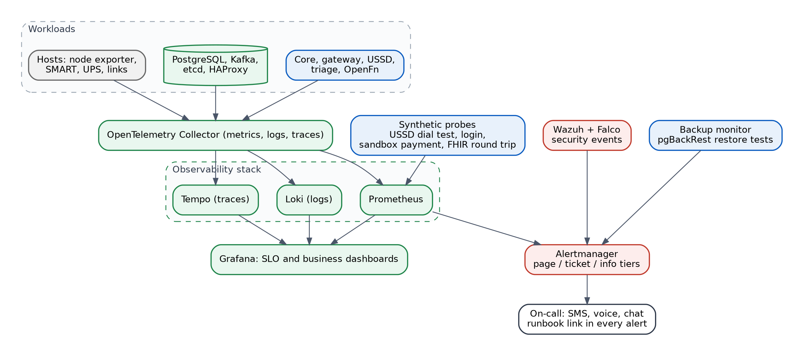
Figure 16. Observability and alerting architecture.

7.3 Deployment strategy
Stage | What happens | Gate
Commit | Unit and module-boundary tests, lint, secret scan | All pass
Build | Image build, SBOM, vulnerability scan, signing, push to the internal registry | No critical findings
Test environment | Contract tests against both OpenAPI documents, FHIR profile validation, PII test suite, saga tests with a payment stub | All pass
Staging | Production-like topology at small scale; load test; chaos subset; migration rehearsal with a copy of anonymised data | SLOs met under load
Production (blue/green) | Expand migration, deploy green, smoke test, weighted shift with SLO gates (Section 4.6.3) | Automatic rollback on breach
Post-release | Watch dashboards for 24 hours; contract migration later | No regression

- Environments. Development, test, staging, production, and a DR site. Staging mirrors production topology so failovers can be rehearsed.
- Infrastructure as code. Ansible roles for hosts, hardening, Patroni, Kafka, HAProxy and Keepalived. Configuration in version control with review.
- Low-bandwidth friendly. Images and packages come from an internal registry and mirror, so releases do not depend on internet speed at the data center.
- Cadence. Small, frequent releases (weekly), emergency patches within 24 hours for critical vulnerabilities, change freeze windows around national peaks.
- Models and rules. Model and clinical rule releases follow the same pipeline plus clinical sign-off, and ship in shadow mode first.

7.4 Resilience testing and game days
Exercise | Frequency | Pass criteria | Measured in the reference implementation
Kill the database leader under load | Quarterly | Failover under 60 s; zero lost committed writes; clients recover with retries | Writes resumed after 16.8 to 21.3 s; 0 acknowledged writes lost
Partition the cluster 2 | 1 | Quarterly | No divergent writes; minority stops; clean rejoin with pg_rewind | Isolated leader stopped writes after 4 to 7 s; new leader after 17 to 23 s; never two writable leaders; same rows on every node after healing
Lose one Kafka broker, then two | Quarterly | One: no impact. Two: producers fail safely and recover when restored | One broker: 50 of 50 messages with acks=all, no errors. Two brokers: not run
Fail one HAProxy host | Quarterly | Virtual IP moves in seconds; no dropped sessions beyond the in-flight requests | Not exercised (no Keepalived in Docker Compose)
EMR offline for 2 hours, then back | Quarterly | Events queue, replay without duplicates, lag returns under SLO | The district hospital's OpenMRS stopped 30 s (plus its 48 s restart): writes waited and arrived once each, in order
Duplicate and delayed payment webhooks | Every release (staging) | No double charge, no double refund; reconciliation clean | 2 duplicates acknowledged and ignored, 1 forged webhook rejected (401), one payment
Model failure and kill switch | Quarterly | Cases continue on rules; clinicians see the banner | New cases rules-only at once; banner shown to clinicians
PII canary leak test | Every release | No canary token reaches the model or its logs | 10 of 10 identifiers removed; 0 identifiers in AI-zone logs
USSD load test | Every release | 2,000 concurrent sessions with step latency inside budget | Single sessions only (slowest step 176 ms); load test not run
Full restore from backup | Monthly automated; quarterly manual | Restore within RTO; data verified | Not exercised
DR site failover | Twice a year | RTO under 4 hours; RPO under 5 minutes | Not exercised
Security tabletop and penetration test | Tabletop twice a year; test annually | Findings tracked to closure | Audit tamper check: the edited entry was found and attributed

Tools: Toxiproxy, tc netem and Pumba for network faults, k6 for load, and scripted failure injection in staging. Results feed the Patroni and Kafka tuning and the runbooks.

7.5 Capacity and scaling model
The model is parametric. The job description states that the earlier Babyl platform delivered 3.5 million consultations in about seven years, roughly 1,400 a day. The design target below is about 70 times that rate, to leave room for national rollout.
Parameter | Value | Derivation
Registered citizens | 10 million | Assumption A8
Consultation journeys per day | 100,000 | About 1% daily activity
Peak hour share | 15% | 15,000 journeys per hour, about 4 per second
Requests per journey | About 12 | Login, consent, intake, payment, queue, consult, sync
Average peak request rate | About 50 per second | 4.2 journeys x 12
Design capacity | 500 requests per second | 10 times headroom
Concurrent USSD sessions | About 400 at peak; design for 2,000 | 4.2 per second x 90 second sessions
Database write rate | About 30 per second at peak; design for 500 | Single leader is ample
Data growth | About 10 GB a day (clinical plus audit) | Planning 20 TB usable over three years with replication and attachments

Tier | Indicative sizing (per site) | Notes
Data nodes (3) | 16 cores, 128 GB RAM, NVMe storage, 25 GbE | PostgreSQL, etcd and Kafka share nodes at this scale; separate later
Application nodes (3) | 8 cores, 32 GB RAM | Core, USSD gateway, triage, OpenFn, gateway instances
Edge (2) | 4 cores, 16 GB RAM | HAProxy and Keepalived pair
AI zone (2) | 16 cores, 64 GB RAM | CPU inference is enough for the first models; GPU optional later
Operations (2) | 8 cores, 32 GB RAM | Observability stack, registry, bastion
Power and network | Dual power feeds, UPS, redundant switches and uplinks | Power cuts and link loss are expected, not exceptional

Scaling path. Scale vertically first, then add core and USSD instances, then add read replicas, then partition data by region if one writer is no longer enough. Each step is triggered by an SLO burn or a saturation alert, not by guesswork.

7.6 Security operations and compliance cadence
Activity | Cadence
Access recertification (who can see what) | Quarterly
Audit chain verification and sampled audit review | Monthly
Vulnerability scan and patch windows | Weekly scan; critical fixes within 7 days or sooner by severity
Secret and certificate rotation | Automated; reviewed monthly
Backup restore verification | Monthly
Clinical safety review of the AI hazard log | Quarterly
Penetration test and data protection review | Annually and before major releases

7.7 Phased roadmap
Phase | Timing | Scope | Exit criteria
0 Foundations | Weeks 0 to 6 | Environments, CI/CD, HA data tier, observability, security baseline, IremboAccount and IremboPay sandbox integrations, profile package, ADRs approved | Failover and restore game days pass; pipeline gates in place
1 Pilot | Weeks 6 to 16 | Web and USSD journeys, rules-based triage, pilot health centres synchronised with eBuzima (tenants of the central instance) and their district hospital's OpenMRS, audit pipeline, first DR test | SLOs met for four consecutive weeks; no SEV1 in the last two weeks
2 Regional rollout | Months 4 to 9 | More facilities, identity matching at scale and review queue, payment reconciliation and reimbursement, AI in shadow mode, load test at 25% of design | Match precision above 99.9%; reconciliation clean for a month
3 National | Months 9 to 15 | Full capacity, live DR site, AI limited pilot with human review, quarterly game days; stateless tier on Kubernetes (RKE2) once the ADR-013 readiness criteria are met | Clinical safety lead signs off AI gates; DR failover meets RTO and RPO
4 Optimise | After month 15 | Service extraction where evidence exists, R5 evaluation, advanced analytics on de-identified data | Evidence-based; each item has an ADR

7.8 Runbook index
- Database leader failure, split-brain suspicion, replica rebuild, point-in-time recovery
- Kafka broker loss, under-replicated partitions, consumer lag and replay
- Edge failover, blue/green release and rollback, certificate expiry
- Payment webhook storm, missing confirmations, refund failure, reconciliation breaks
- EMR offline, sync backlog, dead-letter replay, conflict resolution
- Identity: wrong link report, unlink procedure, review queue backlog
- AI: kill switch, drift alert, PII canary alert, rule set rollback
- Security: break-glass review, suspected breach, audit chain break, credential compromise
- Facility power or connectivity loss and degraded-mode operation

7.9 Key risks
Risk | Impact | Mitigation
IremboAccount or IremboPay interface differs from assumptions A1 and A2 | Schedule | Ports and adapters isolate the change; confirm early with the platform teams
Clinical triage rules arrive late | AI and triage scope | Launch rules-only advisory mode with the interim protocol; AI stays in shadow mode
Operations skills limited on-premise | Reliability | Boring technology, runbooks, training, managed support contract, game days
Heterogeneous EMR versions across facilities | Interoperability effort | Facility inventory, integration engine for older systems, pilot with newest first
AI gives false reassurance | Patient safety | Rules floor, escalate-only, human review, monitoring, kill switch
USSD aggregator limits or outages | Access for feature-phone users | Second aggregator behind one gateway contract; SMS fallback
Power and connectivity at facilities | Continuity | Queue and replay, offline-tolerant clients, UPS and redundant links
Legal interpretation of data protection duties | Compliance | Early legal review (A9); retention and consent as configuration

8 Evaluation criteria: evidence and residual gaps
This section lets a reviewer check each stated criterion against concrete content, and is honest about what is still open. Appendix D shows which parts of the design run in the reference implementation and what they measured.
Criterion | Evidence in this document | Residual gap and next step
Architectural depth  Edge cases such as network partitions and data inconsistency | • Partition behaviour designed and tabulated for PostgreSQL, etcd, Kafka and Valkey, including gray failure and two-site risk (4.6.2)  • Inconsistency handled by outbox, idempotency keys, saga compensations, reconciliation, sync ledger with hashes, version checks and a conflict queue (4.3, 4.5.2)  • Failure table for payments, sync and triage (4.3, 7.4)  • Game days with pass criteria (7.4) | Timing values need measurement on real hardware. The reference implementation and game-day results will provide evidence.
Domain expertise  HL7 FHIR and health-data security | • Resource mapping with identifiers, terminology (ICD-10, LOINC, ATC), profiles, validation, $match, conditional create, If-Match, transaction Bundles, Provenance, AuditEvent (4.5, 5.6)  • Consent, purpose of use, break-glass, pseudonymization, tamper-evident audit, segregation of duties (4.6.4, 4.7.2) | National profile set and national identifier system URIs are assumptions until confirmed (A6).
Pragmatism  On-premise in a developing-market context | • Modular monolith with quantified operating overhead and extraction rules (4.4)  • Boring technology, thin-team runbooks, phased rollout, capacity model grounded in the Babyl history (7.5, 7.7)  • USSD and low bandwidth, queue and replay for unreliable links, UPS and redundant links, internal mirrors (4.3, 7.3, 7.5) | Hardware sizing is indicative and should be validated with the facility and procurement.
Safety  Clinical safety and data privacy in AI triage | • Rules floor and escalate-only merge, state machine that blocks clinical action until review, kill switch, shadow-mode release path (4.7.1 to 4.7.4)  • Layered PII gateway, isolated zone with no egress, output checks and canary tests (4.7.2)  • Hazard log with controls (4.7.4) | Clinical content and thresholds belong to clinical leadership (A7). A formal clinical safety case needs their input.

Open questions for Irembo
1. Confirm the IremboAccount OIDC capabilities and the IremboPay payment, webhook and settlement interfaces (A1, A2).
2. Which national FHIR profiles and identifier systems should TeleClinic use (A6)?
3. Can TeleClinic get API access, a sandbox and a data-sharing agreement for eBuzima, and which OpenMRS sites are still in use (A3)?
4. Does the data center offer three fault domains or a witness site (A5)?
5. Which clinical triage protocol is approved, and who is the clinical safety owner (A7)?
6. What are the retention and consent requirements confirmed by legal counsel (A9)?
7. How does a new service onboard to IremboHub (client registration, credentials, shared notification services), and who owns that process (A10)?
8. Can TeleClinic join the national health information exchange as an OpenHIM client and use the client registry and the UPI (A11)?
9. How should TeleClinic bookings relate to appointments made in the eBuzima patient app, so a patient does not see two booking systems?

Appendix A OpenAPI: Interoperability and Sync API
Validated against the OpenAPI 3.1 schema. Also supplied as teleclinic-interop-api.yaml.
openapi: 3.1.0
info:
title: TeleClinic Interoperability and Sync API
version: 1.0.0
summary: FHIR R4 facade, patient matching and sync-gateway control endpoints
description: |
High-level contract for the interoperability layer of TeleClinic.
Clinical resources follow HL7 FHIR R4 (4.0.1) and the TeleClinic national profiles.
Every call is authenticated with an OIDC access token, authorised by scope and consent,
and written to the audit trail (who, what, which patient, purpose of use).
servers:
- url: https://api.teleclinic.example/interop/v1
description: Production (on-premise)
security:
- oidc: [system/Patient.read]
tags:
- name: FHIR
- name: Identity
- name: Sync
paths:
/fhir/metadata:
get:
tags: [FHIR]
summary: Capability statement (profiles, search parameters, operations)
security: []
responses:
'200':
description: FHIR CapabilityStatement
content:
application/fhir+json:
schema: {$ref: '#/components/schemas/FhirResource'}
/fhir/Patient/$match:
post:
tags: [FHIR, Identity]
summary: Find candidate patients (probabilistic match, scored)
description: |
Implements the FHIR Patient $match operation. Returns a searchset Bundle where each entry
carries a score and a match-grade (certain, probable, possible, certainly-not).
It never merges anything: linking is a separate, audited decision.
security: [{oidc: [system/Patient.read]}]
requestBody:
required: true
content:
application/fhir+json:
schema: {$ref: '#/components/schemas/FhirResource'}
responses:
'200':
description: Bundle of candidates with scores
content:
application/fhir+json:
schema: {$ref: '#/components/schemas/FhirResource'}
'403': {$ref: '#/components/responses/Forbidden'}
'422': {$ref: '#/components/responses/Unprocessable'}
/fhir/Patient/{id}:
get:
tags: [FHIR]
summary: Read a patient (profile-conformant)
parameters:
- {$ref: '#/components/parameters/ResourceId'}
- {$ref: '#/components/parameters/Purpose'}
security: [{oidc: [patient/Patient.read]}]
responses:
'200':
description: FHIR Patient with ETag version
headers:
ETag: {schema: {type: string}, description: 'W/"version" used for If-Match updates'}
content:
application/fhir+json:
schema: {$ref: '#/components/schemas/FhirResource'}
'404': {$ref: '#/components/responses/NotFound'}
'403': {$ref: '#/components/responses/Forbidden'}
/fhir/Patient:
get:
tags: [FHIR]
summary: Search patients by identifier or demographics
parameters:
- {name: identifier, in: query, schema: {type: string}, description: 'system|value, for example national ID or IremboAccount subject'}
- {name: family, in: query, schema: {type: string}}
- {name: birthdate, in: query, schema: {type: string}}
- {$ref: '#/components/parameters/Purpose'}
responses:
'200':
description: searchset Bundle
content:
application/fhir+json:
schema: {$ref: '#/components/schemas/FhirResource'}
/fhir/Encounter:
get:
tags: [FHIR]
summary: Search consultations (Encounter)
parameters:
- {name: patient, in: query, required: true, schema: {type: string}}
- {name: date, in: query, schema: {type: string}, description: 'for example ge2026-01-01'}
- {$ref: '#/components/parameters/Purpose'}
security: [{oidc: [patient/Encounter.read]}]
responses:
'200':
description: searchset Bundle
content:
application/fhir+json:
schema: {$ref: '#/components/schemas/FhirResource'}
/fhir/Observation:
get:
tags: [FHIR]
summary: Search observations such as vital signs and results
parameters:
- {name: patient, in: query, required: true, schema: {type: string}}
- {name: code, in: query, schema: {type: string}, description: 'system|code, for example http://loinc.org|8480-6'}
- {name: _sort, in: query, schema: {type: string}, example: '-date'}
- {$ref: '#/components/parameters/Purpose'}
security: [{oidc: [patient/Observation.read]}]
responses:
'200':
description: searchset Bundle
content:
application/fhir+json:
schema: {$ref: '#/components/schemas/FhirResource'}
/fhir:
post:
tags: [FHIR]
summary: Submit a transaction Bundle (atomic)
description: |
Creates Patient, Encounter, Observation, Condition and MedicationRequest in one atomic unit.
Use conditional create (If-None-Exist inside entries) to stay idempotent on retries.
security: [{oidc: [system/*.write]}]
parameters:
- {name: Idempotency-Key, in: header, required: true, schema: {type: string, format: uuid}}
requestBody:
required: true
content:
application/fhir+json:
schema: {$ref: '#/components/schemas/FhirResource'}
responses:
'200':
description: transaction-response Bundle
content:
application/fhir+json:
schema: {$ref: '#/components/schemas/FhirResource'}
'409':
description: Version conflict (If-Match failed); sent to the conflict queue
content:
application/fhir+json:
schema: {$ref: '#/components/schemas/OperationOutcome'}
'422': {$ref: '#/components/responses/Unprocessable'}
/fhir/AuditEvent:
get:
tags: [FHIR]
summary: Who accessed or changed this patient's data
parameters:
- {name: entity, in: query, required: true, schema: {type: string}, example: 'Patient/123'}
- {name: date, in: query, schema: {type: string}}
security: [{oidc: [system/AuditEvent.read]}]
responses:
'200':
description: searchset Bundle of AuditEvent
content:
application/fhir+json:
schema: {$ref: '#/components/schemas/FhirResource'}
/identity/links:
get:
tags: [Identity]
summary: Active links, automatic and decided by a clerk
security: [{oidc: [system/Identity.review]}]
responses:
'200':
description: Active links with the TeleClinic patient and the identifiers offered to the EMR record
content:
application/json:
schema: {type: array, items: {type: object}}
post:
tags: [Identity]
summary: Record a link decision between two patient records
description: Creates a reversible Patient.link. Requires human approval unless the score is above the auto-link threshold and two strong identifiers agree.
security: [{oidc: [system/Identity.write]}]
requestBody:
required: true
content:
application/json:
schema: {$ref: '#/components/schemas/LinkDecision'}
responses:
'201':
description: Link created
content:
application/json:
schema: {$ref: '#/components/schemas/LinkDecision'}
'409': {$ref: '#/components/responses/Conflict'}
/identity/links/{linkId}:
delete:
tags: [Identity]
summary: Unlink (correct a wrong link); source records are untouched
parameters:
- {name: linkId, in: path, required: true, schema: {type: string}}
security: [{oidc: [system/Identity.write]}]
responses:
'204': {description: Unlinked and audited}
/identity/review-queue:
get:
tags: [Identity]
summary: Medium-confidence candidate pairs awaiting a clerk
security: [{oidc: [system/Identity.review]}]
responses:
'200':
description: Page of candidate pairs with side-by-side evidence
content:
application/json:
schema: {type: array, items: {$ref: '#/components/schemas/ReviewItem'}}
/identity/review-queue/{candidateId}/dismiss:
post:
tags: [Identity]
summary: Not the same person. The pair leaves the queue; the decision is audited
parameters:
- {name: candidateId, in: path, required: true, schema: {type: string}}
security: [{oidc: [system/Identity.write]}]
requestBody:
content:
application/json:
schema:
type: object
properties:
reason: {type: string}
responses:
'204': {description: Dismissed and audited}
/identity/blocked:
get:
tags: [Identity]
summary: Pairs never offered for linking (both records carry a national ID and they differ)
security: [{oidc: [system/Identity.review]}]
responses:
'200':
description: Blocked pairs, with the same side-by-side shape as the review queue
content:
application/json:
schema: {type: array, items: {$ref: '#/components/schemas/ReviewItem'}}
/sync/ledger/{resourceType}/{id}:
get:
tags: [Sync]
summary: Sync ledger entry for one record (ids, versions, hash, origin)
parameters:
- {name: resourceType, in: path, required: true, schema: {type: string}}
- {$ref: '#/components/parameters/ResourceId'}
- name: externalSystem
in: query
required: false
description: One EMR's entry (a record can be known to eBuzima and to a hospital's OpenMRS); default, the most recently synced
schema: {type: string, example: ebuzima}
security: [{oidc: [system/Sync.read]}]
responses:
'200':
description: Ledger entry
content:
application/json:
schema: {$ref: '#/components/schemas/LedgerEntry'}
'404': {$ref: '#/components/responses/NotFound'}
/sync/inbound:
post:
tags: [Sync]
summary: Receive a change detected in an external EMR (called by the sync gateway)
description: Echoes (origin tag is ours, or content hash unchanged) are acknowledged and dropped. Others go through the conflict policy.
security: [{oidc: [system/Sync.write]}]
parameters:
- {name: Idempotency-Key, in: header, required: true, schema: {type: string, format: uuid}}
requestBody:
required: true
content:
application/json:
schema: {$ref: '#/components/schemas/InboundChange'}
responses:
'202': {description: Accepted for processing}
'200': {description: 'Echo detected, ignored'}
/sync/conflicts:
get:
tags: [Sync]
summary: Open conflicts needing a human decision
security: [{oidc: [system/Sync.review]}]
responses:
'200':
description: Open conflicts
content:
application/json:
schema: {type: array, items: {$ref: '#/components/schemas/Conflict'}}
/sync/conflicts/{conflictId}/resolve:
post:
tags: [Sync]
summary: Resolve a conflict (keep teleclinic, keep external, or manual merge)
parameters:
- {name: conflictId, in: path, required: true, schema: {type: string}}
security: [{oidc: [system/Sync.review]}]
requestBody:
required: true
content:
application/json:
schema:
type: object
required: [decision, reason]
properties:
decision: {type: string, enum: [KEEP_TELECLINIC, KEEP_EXTERNAL, MANUAL]}
reason: {type: string}
responses:
'200': {description: Resolved and audited}
components:
securitySchemes:
oidc:
type: openIdConnect
openIdConnectUrl: https://account.irembo.example/.well-known/openid-configuration
parameters:
ResourceId:
name: id
in: path
required: true
schema: {type: string}
Purpose:
name: X-Purpose-Of-Use
in: header
required: true
schema: {type: string, enum: [TREAT, PAYMENT, OPERATIONS, PATIENT_ACCESS, BREAK_GLASS]}
description: Recorded in the audit trail. BREAK_GLASS additionally requires X-Break-Glass-Reason and raises an alert.
responses:
Forbidden:
description: Missing scope, no consent, or policy denied
content: {application/fhir+json: {schema: {$ref: '#/components/schemas/OperationOutcome'}}}
NotFound:
description: Not found
content: {application/fhir+json: {schema: {$ref: '#/components/schemas/OperationOutcome'}}}
Unprocessable:
description: Resource fails profile validation
content: {application/fhir+json: {schema: {$ref: '#/components/schemas/OperationOutcome'}}}
Conflict:
description: Conflicting state
content: {application/json: {schema: {$ref: '#/components/schemas/OperationOutcome'}}}
schemas:
FhirResource:
type: object
required: [resourceType]
properties:
resourceType: {type: string}
additionalProperties: true
OperationOutcome:
type: object
required: [resourceType, issue]
properties:
resourceType: {type: string, const: OperationOutcome}
issue:
type: array
items:
type: object
properties:
severity: {type: string}
code: {type: string}
diagnostics: {type: string}
LinkDecision:
type: object
required: [sourcePatient, targetPatient, linkType, decidedBy, reason]
properties:
id: {type: string}
sourcePatient: {type: string, example: 'Patient/abc'}
targetPatient: {type: string, example: 'Patient/xyz'}
linkType: {type: string, enum: [seealso, refer, replaced-by, replaces]}
score: {type: number}
decidedBy: {type: string, description: 'user id, or "auto" when above threshold with two strong identifiers'}
reason: {type: string}
decidedAt: {type: string, format: date-time}
ReviewItem:
type: object
properties:
id: {type: string}
left: {$ref: '#/components/schemas/FhirResource'}
right: {$ref: '#/components/schemas/FhirResource'}
score: {type: number}
agreeingFields: {type: array, items: {type: string}}
conflictingFields: {type: array, items: {type: string}}
LedgerEntry:
type: object
properties:
resourceType: {type: string}
teleclinicId: {type: string}
externalSystem: {type: string, example: ebuzima}
externalId: {type: string}
lastSyncedVersion: {type: integer}
contentHash: {type: string}
origin: {type: string, enum: [teleclinic, external]}
lastSyncedAt: {type: string, format: date-time}
status: {type: string, enum: [IN_SYNC, PENDING, FAILED, CONFLICT]}
InboundChange:
type: object
required: [externalSystem, resource, origin, contentHash]
properties:
externalSystem:
type: string
description: The EMR the change comes from, as the facility registry names it (eBuzima for every health centre, or a hospital's OpenMRS)
example: ebuzima
resource: {$ref: '#/components/schemas/FhirResource'}
origin: {type: string}
contentHash: {type: string}
sourceVersion: {type: string}
Conflict:
type: object
properties:
id: {type: string}
resourceType: {type: string}
teleclinicVersion: {type: string}
externalVersion: {type: string}
fields: {type: array, items: {type: string}}
openedAt: {type: string, format: date-time}

Appendix B OpenAPI: AI Triage API
Validated against the OpenAPI 3.1 schema. Also supplied as teleclinic-triage-api.yaml.
openapi: 3.1.0
info:
title: TeleClinic AI Triage API
version: 1.0.0
summary: Deterministic safety rules (synchronous) plus model suggestions (asynchronous) with human review
description: |
Safety-first triage contract. The synchronous rules endpoint answers inside a USSD or web session.
The model produces an AI_PROPOSED suggestion asynchronously. A suggestion can only raise urgency,
and nothing clinical is finalised until a practitioner confirms or overrides it.
servers:
- url: https://api.teleclinic.example/triage/v1
security:
- oidc: [triage.read]
tags:
- name: Rules (synchronous)
- name: Model (asynchronous)
- name: Review
- name: Governance
paths:
/rules/evaluate:
post:
tags: [Rules (synchronous)]
summary: Evaluate red-flag rules inside the user session (target p95 under 100 ms)
security: [{oidc: [triage.evaluate]}]
requestBody:
required: true
content:
application/json:
schema: {$ref: '#/components/schemas/TriageIntake'}
responses:
'200':
description: Rule result. Emergency advice is shown to the patient immediately.
content:
application/json:
schema: {$ref: '#/components/schemas/RuleResult'}
'422': {description: Intake failed validation}
/cases/{caseId}/inference:
post:
tags: [Model (asynchronous)]
summary: Queue model inference (features are anonymised before leaving the core)
parameters:
- {name: caseId, in: path, required: true, schema: {type: string}}
- {name: Idempotency-Key, in: header, required: true, schema: {type: string, format: uuid}}
security: [{oidc: [triage.infer]}]
requestBody:
required: true
content:
application/json:
schema: {$ref: '#/components/schemas/InferenceRequest'}
responses:
'202':
description: Accepted. Poll the suggestion or wait for the webhook.
headers:
Location: {schema: {type: string}}
/cases/{caseId}/suggestion:
get:
tags: [Model (asynchronous)]
summary: Read the current suggestion
parameters:
- {name: caseId, in: path, required: true, schema: {type: string}}
responses:
'200':
description: Suggestion in its current state, from RULES_ONLY or AI_PROPOSED through to FINAL
content:
application/json:
schema: {$ref: '#/components/schemas/Suggestion'}
'404': {description: No suggestion yet (rules-only case)}
/cases/{caseId}/review:
post:
tags: [Review]
summary: Practitioner confirms or overrides the suggestion
description: Only a user with the clinician role can call this. Overrides require a reason. The decision is signed and audited.
parameters:
- {name: caseId, in: path, required: true, schema: {type: string}}
security: [{oidc: [triage.review]}]
requestBody:
required: true
content:
application/json:
schema: {$ref: '#/components/schemas/ReviewDecision'}
responses:
'200':
description: Case is FINAL; orders, referrals and prescriptions are unlocked
content:
application/json:
schema: {$ref: '#/components/schemas/Suggestion'}
'403': {description: Caller is not a clinician for this case}
'409': {description: Case already finalised}
/anonymize:
post:
tags: [Model (asynchronous)]
summary: Internal. Mask identifiers and return model-safe features
description: mTLS only. Applies the field allowlist, runs PII recognizers (national ID, phone, names), redacts free text and replaces identifiers with tokens held in the pseudonym vault.
security: [{mtls: []}]
requestBody:
required: true
content:
application/json:
schema: {$ref: '#/components/schemas/AnonymizeRequest'}
responses:
'200':
description: Masked payload and redaction report
content:
application/json:
schema: {$ref: '#/components/schemas/AnonymizeResponse'}
/models/active:
get:
tags: [Governance]
summary: Model version, training data window, validation metrics and model card link
responses:
'200':
description: Active model metadata
content:
application/json:
schema: {$ref: '#/components/schemas/ModelInfo'}
/models/kill-switch:
post:
tags: [Governance]
summary: Disable model suggestions immediately (system falls back to rules only)
security: [{oidc: [triage.admin]}]
requestBody:
required: true
content:
application/json:
schema:
type: object
required: [reason]
properties: {reason: {type: string}}
responses:
'200': {description: Model disabled and audited}
/models/activate:
post:
tags: [Governance]
summary: Turn model suggestions back on, in ACTIVE or SHADOW mode
security: [{oidc: [triage.admin]}]
requestBody:
required: true
content:
application/json:
schema:
type: object
required: [reason]
properties:
reason: {type: string}
mode: {type: string, enum: [ACTIVE, SHADOW]}
responses:
'200':
description: Model enabled and audited
content:
application/json:
schema: {$ref: '#/components/schemas/ModelInfo'}
webhooks:
suggestionReady:
post:
summary: Sent to the core when a suggestion is AI_PROPOSED
requestBody:
content:
application/json:
schema: {$ref: '#/components/schemas/Suggestion'}
responses:
'200': {description: Acknowledged}
components:
securitySchemes:
oidc:
type: openIdConnect
openIdConnectUrl: https://account.irembo.example/.well-known/openid-configuration
mtls:
type: mutualTLS
schemas:
Urgency:
type: string
enum: [ROUTINE, SEMI_URGENT, URGENT, EMERGENCY]
TriageIntake:
type: object
required: [caseId, channel, ageBand, sex, symptoms]
properties:
caseId: {type: string}
channel: {type: string, enum: [WEB, MOBILE, USSD, VOICE]}
ageBand: {type: string, example: '5-11'}
sex: {type: string, enum: [F, M, OTHER, UNKNOWN]}
pregnant: {type: boolean}
symptoms:
type: array
items: {type: string, description: 'coded symptom id from the national symptom list'}
durationDays: {type: integer}
vitals:
type: object
properties:
temperatureC: {type: number}
heartRate: {type: integer}
respiratoryRate: {type: integer}
spo2: {type: integer}
freeText: {type: string, description: 'Not accepted on USSD. Redacted before any model use.'}
RuleResult:
type: object
required: [urgency, redFlags, rulesetVersion]
properties:
urgency: {$ref: '#/components/schemas/Urgency'}
redFlags: {type: array, items: {type: string}}
patientAdvice: {type: string, maxLength: 160, description: 'Short text that fits a USSD screen'}
rulesetVersion: {type: string}
requiresClinicianReview: {type: boolean}
InferenceRequest:
type: object
required: [anonymisedFeatures, rulesUrgency]
properties:
anonymisedFeatures: {type: object, additionalProperties: true}
rulesUrgency: {$ref: '#/components/schemas/Urgency'}
callbackUrl: {type: string, format: uri}
Suggestion:
type: object
required: [caseId, status, urgency, modelVersion]
properties:
caseId: {type: string}
status: {type: string, enum: [RULES_ONLY, AI_PROPOSED, UNDER_REVIEW, CONFIRMED, OVERRIDDEN, UNREVIEWED_TIMEOUT, FINAL]}
urgency: {$ref: '#/components/schemas/Urgency'}
rulesFloor: {$ref: '#/components/schemas/Urgency'}
confidence: {type: number, minimum: 0, maximum: 1}
contributingFactors: {type: array, items: {type: string}}
modelVersion: {type: string}
createdAt: {type: string, format: date-time}
reviewedBy: {type: string}
reviewReason: {type: string}
ReviewDecision:
type: object
required: [decision, finalUrgency]
properties:
decision: {type: string, enum: [CONFIRM, OVERRIDE]}
finalUrgency: {$ref: '#/components/schemas/Urgency'}
reason: {type: string, description: 'Mandatory when decision is OVERRIDE'}
AnonymizeRequest:
type: object
required: [payload]
properties:
payload: {type: object, additionalProperties: true}
AnonymizeResponse:
type: object
properties:
maskedPayload: {type: object, additionalProperties: true}
redactions:
type: array
items:
type: object
properties:
field: {type: string}
entityType: {type: string, example: NATIONAL_ID}
action: {type: string, enum: [REMOVED, TOKENISED, GENERALISED]}
tokenMapId: {type: string, description: 'reference to the pseudonym vault entry, never returned to the model'}
ModelInfo:
type: object
properties:
modelVersion: {type: string}
trainedOn: {type: string}
validation: {type: object, additionalProperties: {type: number}}
modelCardUrl: {type: string, format: uri}
mode: {type: string, enum: [SHADOW, ACTIVE, DISABLED]}

Appendix C Glossary
Term | Meaning
ADR | Architecture decision record
BFF | Backend for frontend: the server holds the OIDC tokens and the browser holds only a session cookie
ACL | Anti-corruption layer: a translation boundary that keeps another system's model out of the domain
Blue/green | Two identical production pools; traffic moves from the live one to the new one gradually
CBHI | Community-based health insurance (Mutuelle de santé), administered by RSSB
CDC | Change data capture
CRVS | Civil registration and vital statistics: the registry of births, marriages and deaths
eBuzima | Rwanda's national EMR for public health facilities, run by the Ministry of Health on a customised ERPNext (Frappe) base
FHIR | Fast Healthcare Interoperability Resources, the HL7 standard for exchanging health data
HITL | Human in the loop
IPS | International Patient Summary
ISR | In-sync replicas (Kafka)
IVR, DTMF | Interactive voice response; the keypad tones used to answer voice menus
KRaft | Kafka's built-in Raft consensus mode, without ZooKeeper
LOINC, ICD-10, ATC, UCUM | Code systems for observations, diagnoses, medicines and units of measure
MLOps | Practices and tools to train, version, release, monitor and roll back machine-learning models
NIDA | National Identification Agency, which holds the national population registry and national IDs
OIDC, PKCE | OpenID Connect and Proof Key for Code Exchange
OpenHIM | Open-source interoperability layer used by the Rwanda health information exchange
Outbox | Table written in the same transaction as a state change, relayed to the broker afterwards
PII | Personally identifiable information
RKE2 | A security-focused Kubernetes distribution suited to on-premise clusters
RPO, RTO | Maximum tolerable data loss and recovery time
Saga | A sequence of local transactions with compensating actions for failure
SHR | Shared health record: the national store of patient summaries in the health information exchange
Split-brain | Two parts of a cluster both acting as leader after a partition
UPI | Unique patient identifier issued by the national client registry (format YYMMDD-FOSAID-RAND4)
USSD | Unstructured Supplementary Service Data: session-based menus on any mobile phone
WORM | Write once, read many storage

Appendix D Companion reference implementation
A Docker-based reference implementation accompanies this document. It runs the design on one 16 GB machine with Docker Compose, including the eBuzima software stack, a real OpenMRS O3 and OpenFn, so the hardest parts can be seen working rather than only described. Every scene below is a script that passes or fails, and each one prints what it measured. All data is synthetic. Repository: https://github.com/rubailly/teleclinic. Demo video: link added at submission.
Scene in the demo | How to run it | Measured
Booking on the web and over USSD, a guardian booking for a child, insurance co-payment, mobile money and SMS | make journey; make ussd | Slowest USSD step 176 ms of a 1.5 s budget; longest screen 130 of 182 characters
Payment webhook replayed twice and forged once | make scenario-webhooks | Duplicates ignored, forged one rejected (401), still one payment
Clinician gate, escalate-only merge, model kill switch, PII removed before the model | make clinician | Orders refused (403) until a clinician decides; 0 identifiers in AI-zone logs
PostgreSQL leader killed during writes | make scenario-kill-db-leader | Writes resumed after 16.8 to 21.3 s; 0 acknowledged writes lost
Leader isolated by a network partition | make scenario-partition | Old leader read-only after 4 to 7 s; new leader after 17 to 23 s; never two writable leaders
Kafka broker stopped | make scenario-kill-kafka-broker | 50 of 50 messages written with acks=all
Sync without loops: TeleClinic and eBuzima, in Kimironko Health Centre's tenant (OpenFn workflows) | make scenario-sync | Decision to eBuzima p95 3.8 s; one encounter in the right tenant; own write dropped as an echo; a nurse's phone edit pushed, applied once, not sent back
Identity, safely: review, link, unlink, hard block, automatic link (district hospital's OpenMRS) | make scenario-identity | Bands as designed; national ID written to OpenMRS on link and removed on unlink; both audited
The hospital record goes offline | make scenario-emr-offline | Writes waited while OpenMRS was down and arrived once each, in order; decision to OpenMRS p95 2.3 s
Release under load, then a bad build | make release; make release-bad | 1,181 requests, 0 failed; bad build rolled back at the 1% or 10% step in under 15 ms
Purpose of use, consent, "who accessed my record", audit tamper check | make audit; make scenario-tamper | DBA query in the trail after about 1 s; edited entry found and attributed; alert after about 10 s
SLO dashboard, alert with runbook, ops cockpit with a button per scenario | Grafana and the ops cockpit | "No writable leader" alert 13 s after a leader kill

Real and stand-in. Real: the core (Java 21, Spring Boot 3, Spring Modulith), OpenMRS O3 as a district hospital's EMR, OpenFn Lightning as the sync gateway, HAProxy, APISIX, PostgreSQL 16 with Patroni and three etcd members, Kafka KRaft with three brokers, Valkey, the USSD gateway, the anonymization gateway (Presidio), the triage model (ONNX Runtime), pgAudit shipped by Vector, Prometheus and Grafana. Stand-ins, labelled on every screen: Keycloak for IremboAccount, a mock for IremboPay and the insurance check, and a phone and aggregator simulator for USSD, mobile money and SMS. eBuzima is represented by its public software stack (ERPNext with the Frappe Healthcare app, one site, a tenant per health centre); its Ministry customisations and API policies are assumption A3.
Differences from the production design. One machine instead of three fault domains; PostgreSQL 16 instead of 17; one Valkey node instead of three with Sentinel; no Keepalived, so edge redundancy is documented only; metrics only (Prometheus and Grafana), without the log and trace stores; no write-once archive or signed daily checkpoint for the audit trail. Outbound EMR writes are pulled by the gateway from a queue in the core rather than read from Kafka (see the note in 4.5.2). Footprint: 39 containers use about 6.1 GB of memory (eBuzima, OpenMRS and OpenFn about 2.8 GB of it), and a clean reset to a known state takes about one minute.
Only what runs is claimed as built. Everything else in this document is a design intention, and the targets in Section 1 stay design targets; the measured column shows what one machine achieved.

Appendix E Sources on the Rwandan context
Public sources used for the Rwandan context in Sections 2.2, 4.1, 4.3 and 4.5. Deployment figures change quickly and should be confirmed with the Ministry of Health.
- Rwanda Biomedical Centre, presented at ICAP CQUIN, April 2026. Rwanda's Digital Health Transformation: The eBuzima EMR System. Centralised, web-based national EMR; records synchronised across public facilities; integrated patient app. https://cquin.icap.columbia.edu/wp-content/uploads/2026/04/Rwandas-eBuzima-EMR_KP-and-PrEP-Modules_Zephanie_Final.pdf
- Resolve to Save Lives, July 2026. How Rwanda is delivering better health outcomes with digital tools. eBuzima in about 70% of roughly 500 health centres; one centrally managed version; insurance coverage validation. https://resolvetosavelives.org/strategies-in-action/how-rwanda-is-delivering-better-health-outcomes-with-digital-tools/
- TechCabal, April 2025. Rwanda hopes to ditch paper health records with e-Ubuzima rollout. Locally built platform, patient app for appointments, infrastructure needs. https://techcabal.com/2025/04/24/rwanda-e-ubuzima-rollout/
- OpenHIE case study, Regenstrief Institute. Connecting the dots: Rwanda's digital healthcare revolution. OpenHIM interoperability layer, shared health record, NIDA, CRVS and the UPI format. https://ohie.org/wp-content/uploads/2024/08/RawandaHealthExchangeArchitecture.pdf
- RHIES client registry documentation. HAPI FHIR based client registry of the Rwanda health information exchange. https://github.com/savicsorg/rhies_ClientRegistry/wiki

