University of Wah
Department of Computer Science
BS Cyber Security
SECURE SOFTWARE DESIGN AND DEVELOPMENT
Project Report

Title: Online Secure Bank

Submitted to: Ma’am Muniba Khan
Group Members:
Awais Asif (UW-23-CY-BS-010)
Rubaiqa Pervez (UW-23-CY-BS-020)
Seemab Khan (UW-23-CY-BS-005)

Table of Contents
- Abstract ……………………………………………………….………………………........................ 03
- Introduction ………………………………………………….……………………………………………. 03
- Problem Statement ………………………………………….……………………………………………03
- Project Objective ………………………………………….……………………………………………… 03
- System Overview ………………………………………….……………………………………………….04
- Technology Stack ………………………………………….………………………………………………04
- System Architecture ……………………………………….……………………………………………. 04
- Database Design and Data Flow …………………………..………………………………………….05
- Core Modules Implementation ………………………..…..………………………………………….05

  - Authentication Module ……………….……………………………………….……………………05
  - Hashing & Security Utilities ……………..………..……………………….……………………..05
  - Transaction Handling Logic …………………………………………………….…………………05
  - Environment Configuration ………………………………….……………………………………06
- Unit Testing Strategy and Implementation ……………………………….……….……………….06
- Diagrams ………………….……………………………………………………….…………………………07
- STRIDE Threat Modelling …………………………………………………..……………………………10

  - Overview of STRIDE …………………………….………………………………………….10
  - STRIDE Mapping with Secure-Bank Code …………………………..………………11
- Security Analysis and Mitigations ……………...…………………………………………………….12
- Results and Evaluation …………………………………………………………….…………………….12
- Limitations ………………………………………………….……………………………………………….12
- Future Enhancements ………………………………………………………....….……………………12
- Conclusion ………………………………………………………………….…….………………………..13

1. Abstract
This report presents the design, implementation, testing, and security analysis of Online-Secure-Bank, a secure banking-oriented application developed in Python. The system emphasizes strong authentication, data integrity, secure storage, and threat-aware design. STRIDE threat modelling is applied to identify, mitigate, and validate security threats at the code and architecture level. Unit testing ensures correct and secure behaviour. This report reflects the actual modules implemented and can serve as both a submission and presentation reference.

2. Introduction
Modern banking systems are high-value targets for cyberattacks due to sensitive financial and personal data. The Online-Secure-Bank project demonstrates the practical application of secure coding, cryptography, testing, and threat modelling. Key focus areas include:
- Confidentiality
- Data Integrity
- Authentication
- Accountability

3. Problem Statement
Traditional online banking systems often suffer from critical vulnerabilities due to:
- Weak authentication mechanisms
- Poor input validation (e.g., SQL Injection)
- Lack of role-based access control
- Insecure storage of passwords and sensitive data
- Insufficient logging and monitoring
There is a need for a secure-by-design system that proactively mitigates such threats.

4. Project Objectives
The main objectives of Secure-Bank are:
- Design a secure banking application using Python
- Implement strong authentication mechanisms
- Protect sensitive data via cryptographic hashing
- Validate system behaviour through unit testing
- Apply STRIDE threat modelling for structured security analysis
- Ensure academic soundness and industry alignment

5. System Overview
Online-Secure-Bank is a backend-focused secure application designed to handle authentication and sensitive operations safely:
- Users are authenticated before accessing protected resources
- Credentials are never stored in plaintext
- Critical operations are validated and logged
- Security threats are analysed and mitigated at design and code levels

6. Technology Stack
- Programming Language: Python
- Environment Management .env configuration file
- Security: SHA-256 hashing
- Testing Framework: Python unit test
- Project Structure: Modular layout for maintainability

7. System Architecture
The system follows a modular layered architecture:
- Presentation / Entry Layer: Handles user requests and input
- Application Logic Layer: Implements authentication and business rules
- Security Layer: Provides hashing and validation utilities
- Testing Layer: Unit tests to verify authentication and security logic
This separation improves maintainability, testability, and security auditing.

8. Database Design and Data Flow
Although Online-Secure-Bank emphasizes backend logic, the logical database flow is:
- User provides credentials
- Password is hashed using SHA-256
- Hash is stored or compared with existing hash
- Authentication decision is returned
This ensures that passwords remain secure even if the database is compromised.

9. Core Modules Implementation

9.1 Authentication Module
Handles:
- User login validation
- Secure credential comparison
- Access control logic
Passwords are always stored and compared as hashes to reduce risk.

9.2 Hashing & Security Utilities
Implemented with SHA-256:
- Converts sensitive data to fixed-length hashes
- Provides one-way encryption
- Supports data integrity verification

9.3 Transaction / Logic Handling
Business logic ensures:
- Unauthorized users cannot access protected operations
- Invalid input is rejected
- Security checks are enforced before critical actions

9.4 Environment Configuration
Sensitive configuration values are stored in a .env file to avoid hardcoding secrets, following industry best practices.

10. Unit Testing Strategy and Implementation
Python unit test is used to verify:
- Authentication System
- Correct Login
- Incorrect Password
- Invalid Email
- Test Authentication System
- Test Email Validation
- Validate Email
Unit tests validate security logic and prevent regression errors.

11. Diagrams
(Include system architecture, data flow, and module interaction diagrams here.)
- Architecture Diagram:
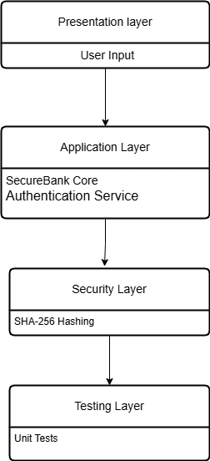

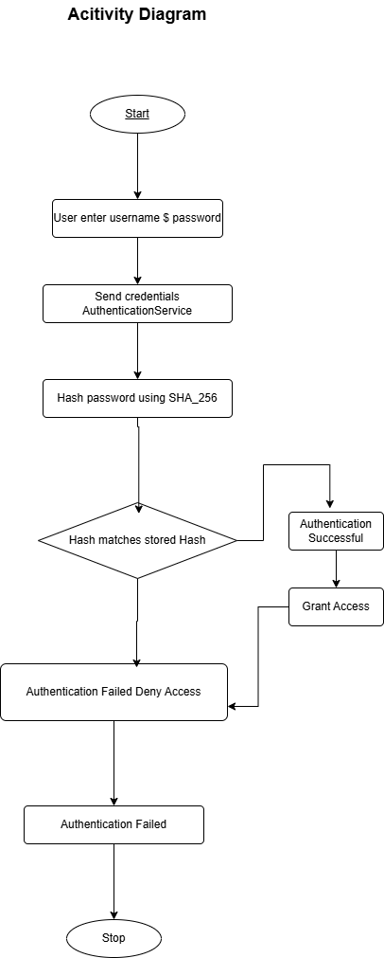
- Activity Diagram:

- Use Case Diagram:
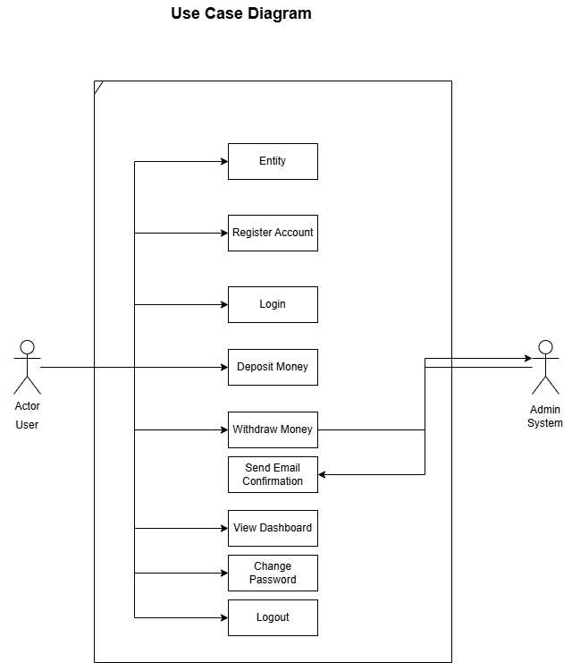

- Class Diagram:
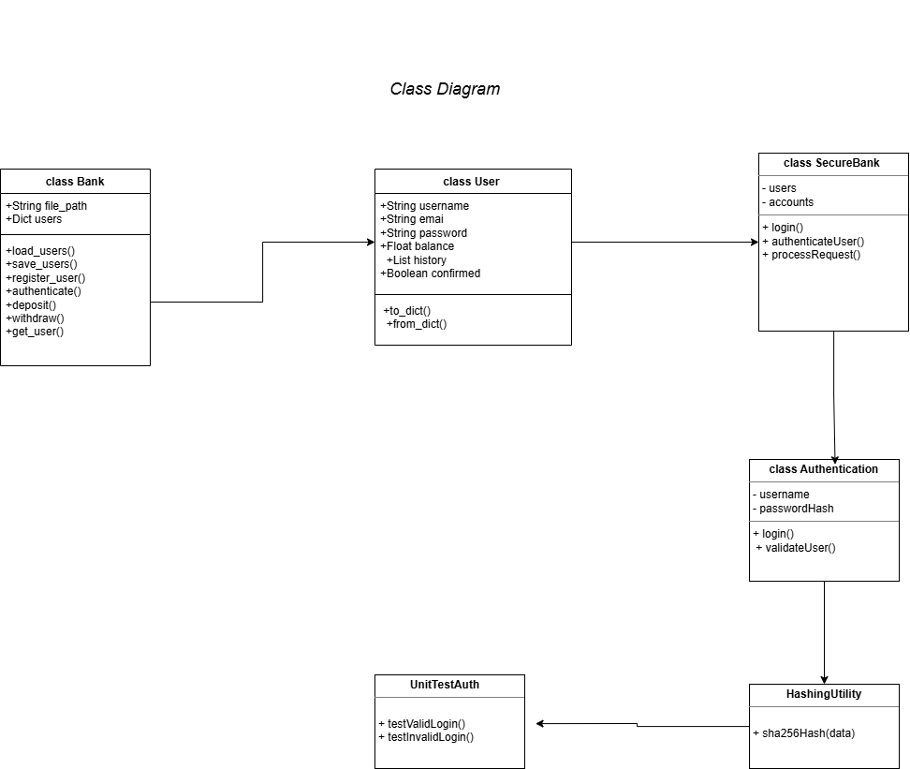

12. STRIDE Threat Modelling

12.1 Overview of STRIDE
STRIDE categorizes security threats into six types:
- S – Spoofing: Impersonation of a user
- T – Tampering: Unauthorized data modification
- R – Repudiation: Denial of performed actions
- I – Information Disclosure: Leakage of sensitive data
- D – Denial of Service: System unavailability
- E – Elevation of Privilege: Unauthorized access to higher privileges

12.2 STRIDE Applied to Secure-Bank
- Spoofing:
  - Threat: Attacker impersonates a legitimate user.
  - Mitigation: Secure authentication, hashed passwords, session validation.
- Tampering:
  - Threat: Unauthorized modification of transactions or data.
  - Mitigation: Input validation, secure database transactions, audit logs.
- Repudiation:
  - Threat: User denies performing an action.
  - Mitigation: Audit logging, timestamped transaction records.
- Information Disclosure:
  - Threat: Leakage of sensitive data.
  - Mitigation: Encryption, restricted role-based access, secure database access.
- Denial of Service (DoS):
  - Threat: System becomes unavailable due to excessive requests.
  - Mitigation: Input limits, controlled request handling.
- Elevation of Privilege:
  - Threat: User gains admin-level access without permission.
  - Mitigation: Role-Based Access Control (RBAC), role validation checks.

13. Security Analysis and Mitigations
Secure-Bank demonstrates:
- Défense-in-depth: layered security measures
- Secure credential handling using hashes
- Reduced attack surface via modular design
- STRIDE-aligned threat mitigation

14. Results and Evaluation
The project successfully:
- Authenticates users securely
- Protects sensitive information
- Passes unit tests
- Implements STRIDE in a practical scenario

15. Limitations
- No graphical user interface
- Limited logging
- No real-time monitoring
These are acceptable for an academic prototype.

16. Future Enhancements
- Integration with a real database
- Role-based access control
- Audit logging
- Web or mobile frontend
- Advanced cryptography (bcrypt, Argon2)

17. Conclusion
The Online-Secure-Bank project demonstrates a security-focused banking application built using sound software design principles and practical coding techniques. Security is embedded into the system through careful architecture, secure coding, and systematic testing.
The system enforces strong authentication, with credentials never stored or processed in plaintext. SHA-256 hashing protects sensitive data, while modular design separates authentication, hashing, and core logic, improving maintainability, scalability, and auditability.
Unit testing ensures reliability by validating authentication behaviour, handling edge cases, and reducing regression risks, supporting non-repudiation through verified system behaviour.
STRIDE threat modelling guides security design, addressing Spoofing, Tampering, Repudiation, Information Disclosure, Denial of Service, and Elevation of Privilege with appropriate mitigations like hashed credentials, controlled logic flow, restricted access, and test verification.
The layered architecture input handling, application logic, security services, and testing—minimizes the attack surface and aligns with secure SDLC practices. While the prototype lacks a GUI or real-time monitoring, it meets academic objectives and provides a solid foundation for future enhancements.

