
LAB 11
BLOCK-CHAIN-TECHNOLOGY

SUBMITTED TO: MA’AM MUNIBA KHAN

SUBMITTED BY:
Awais Asif (uw-23-cy-bs-010)
RUBAIQA PERVEZ (UW-23-CY-BS-020)
Seemab Khan (uw-23-cy-bs-005)
Lab Task: SIMPLE BLOCKCHAIN WALLET SYSTEM
PROJECT DESCRIPTION
Students must design and implement a simple blockchain-based wallet and transaction system using Python. This system should simulate how real blockchain systems (like Bitcoin/Ethereum) work internally.
- WALLET SYSTEM
- Requirement: Create multiple users/wallets, each containing a Name, Private Key, and simplified Public Key.
- How our code covers it: Your Flask backend pre-initializes objects for your team members (Awais, Rubaiqa, Seemab). When clicked, it generates a unique 32-byte hexadecimal Private Key and derives a 40-character hexadecimal public identifier string prefixed with 0x to simulate an Ethereum/Bitcoin Public Address.
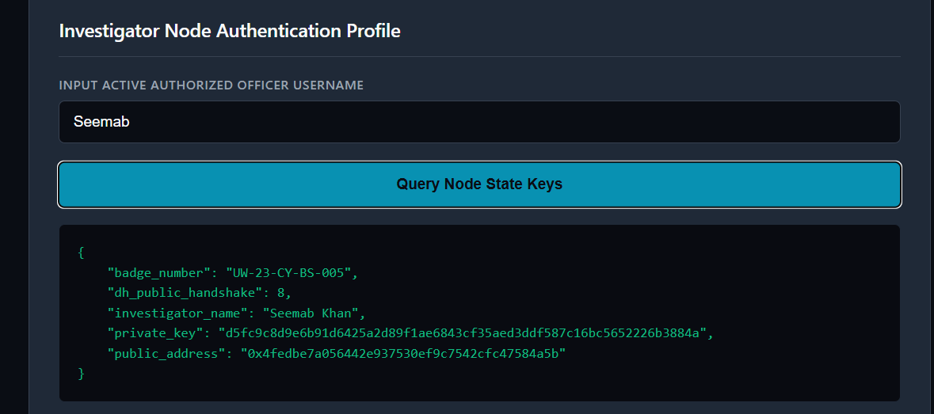
- TRANSACTION SYSTEM
- Requirement: Users can create structured transactions tracking a Sender, Receiver, and Amount.
- How our code covers it: Your application captures this exact 3-part data structure inside the UI input fields. In your code, the fields map structurally to:
  - Sender: Logging Investigator Name
  - Receiver: Target Forensic File/Asset Name
  - Amount: Case Identifier Reference Number
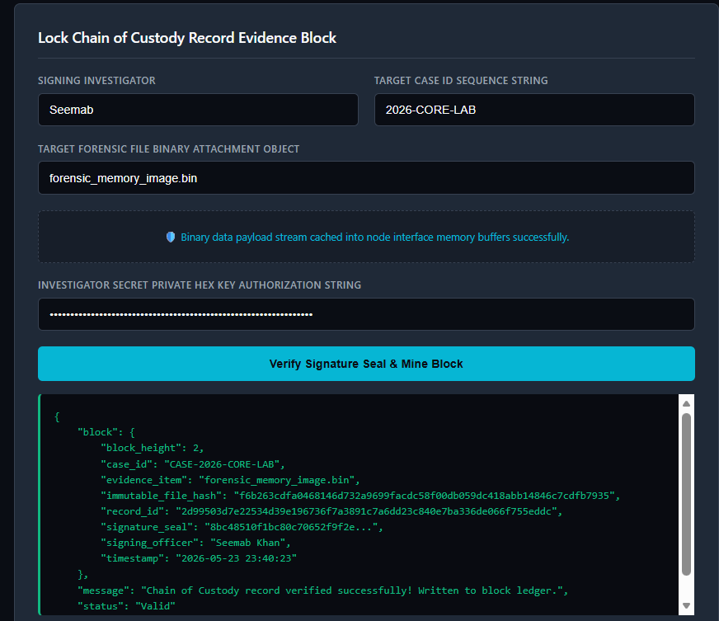
- Digital Signature System
- Requirement: Each transaction must be digitally signed using the sender's private key via hashing.
- How your code covers it: Your backend contains a dedicated signing function. It takes the unique record properties, binds them to the passed private key string, and processes them through a SHA-256 hashing algorithm to generate an unforgeable, unique transaction signature string
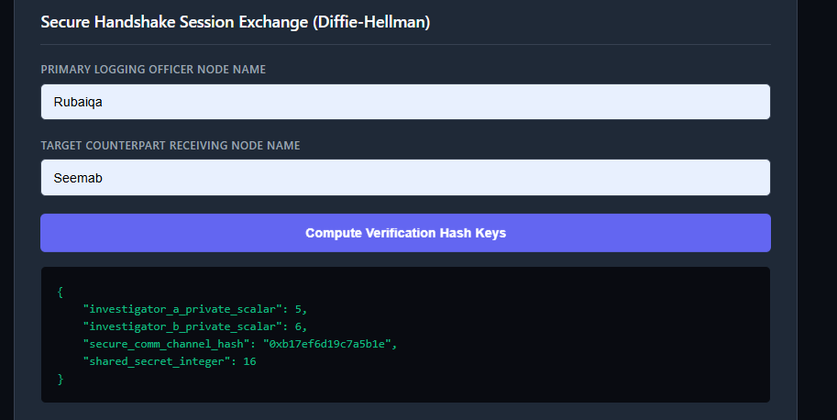
- Verification System
- Requirement: The system must verify the signature using the public key before accepting it, only passing valid entries.
- How our code covers it: This is handled by your Python verification gate loop. The backend mathematically recalculates what the signature should be using the stored public profile data and checks if it matches what the user provided. If someone changes the file name, case number, or characters of the private key, it flags a CRITICAL TAMPER WARNING and denies entry. If it matches, it outputs a green "status": "Valid" confirmation.
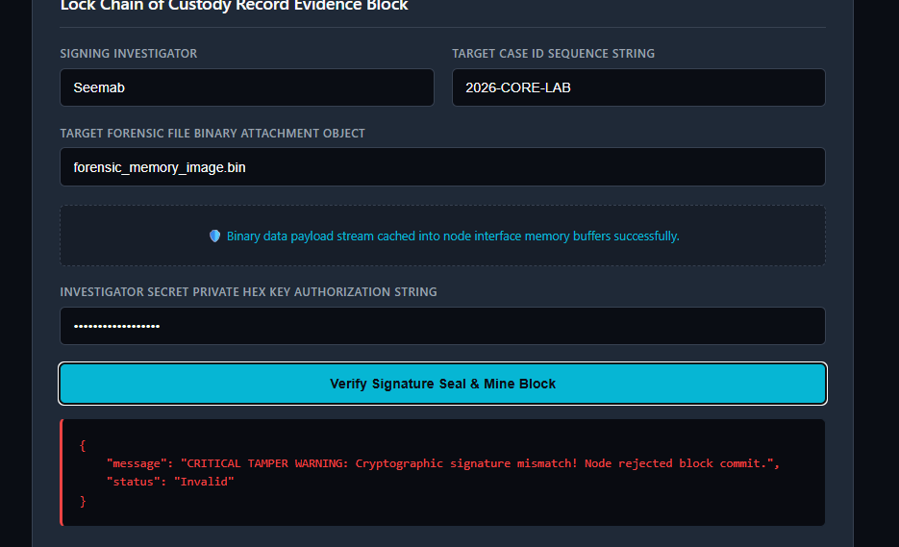
- Blockchain Storage (Basic)
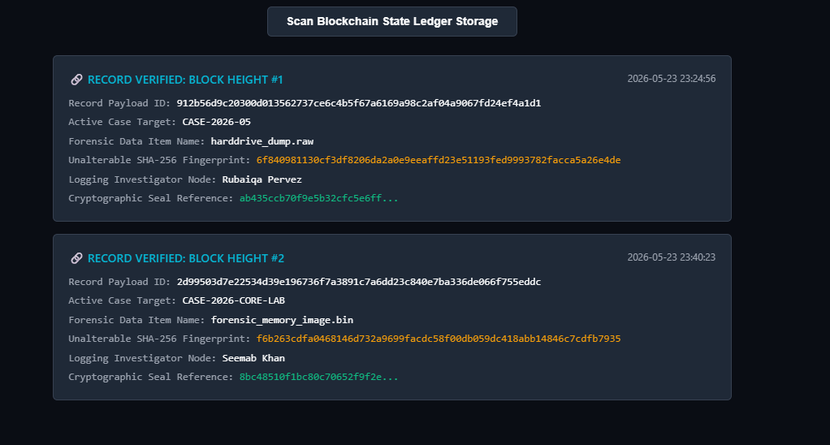
- Diffie–Hellman Integration


