University of Wah


Computer Science Department

Web Engineering Course (CYS-463L)

MID-SESSIONAL

SUBMITTED TO: SIR QADEER
SUBMITTED BY: RUBAIQA PERVEZ (UW-23-CY-BS-020)

Q1. Develop a Mini Student Web Portal consisting of multiple linked webpages. You are required to design and implement a multi-page website where all pages are connected through navigation.
- Introduction:
This is a Student Portal website I made for the University of Wah. It’s a place where students can sign up, log in, see their dashboard, and pick their classes for the new semester.
- How I built it (The Tools)

- HTML: Used to build the structure of the pages.
- CSS & Bootstrap: Used to make the website look professional and "cool" with a dark blue and orange theme.
- JavaScript: The "brain" of the project. It handles the login and remembers which courses you picked.
- Features
- Smart Login: You can register your account, and the website will remember your name and email when you log in.
- Course Picker: You can click on subjects like "Web Engineering" or "AI." The website shows a checkmark when you select them and counts how many you’ve picked.
- The Dashboard: Once you log in, it says "Hello" to you by your name and shows if you are enrolled in classes or not.
- Mobile Friendly: The website looks great on both a computer and a phone because it is "responsive".
- Feedback Form: Students can give a star rating (1 to 5 stars) and write comments about their experience.
- How the pages work together
- Home Page: The starting point that explains what the portal does.
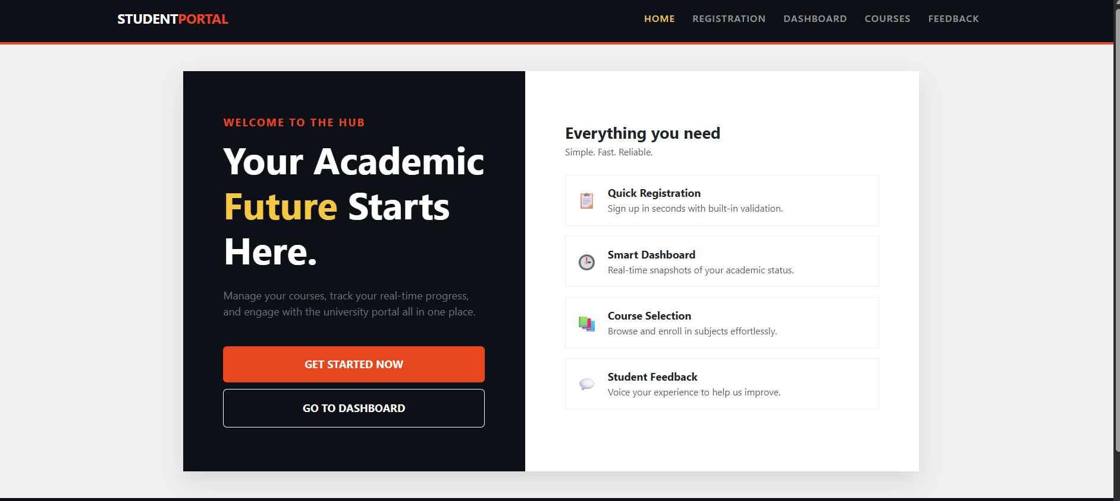
- Registration: Where you create your account.
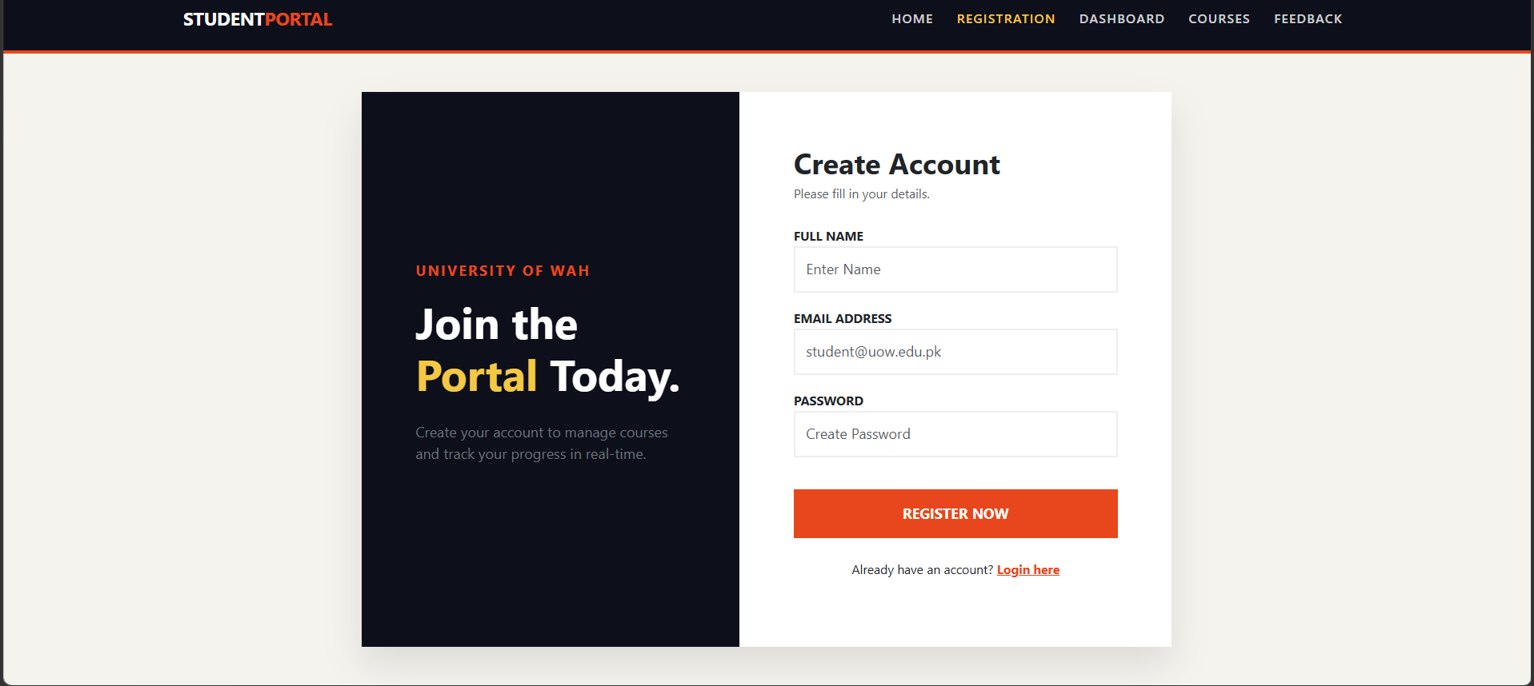
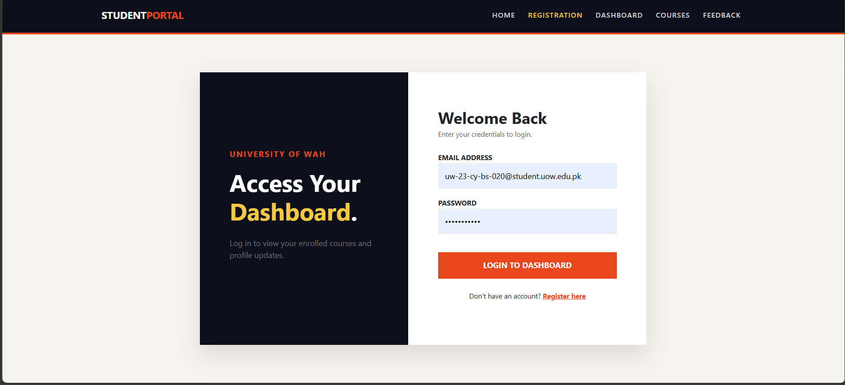

- Dashboard: Your personal area that shows your name, email, and how many courses you joined.
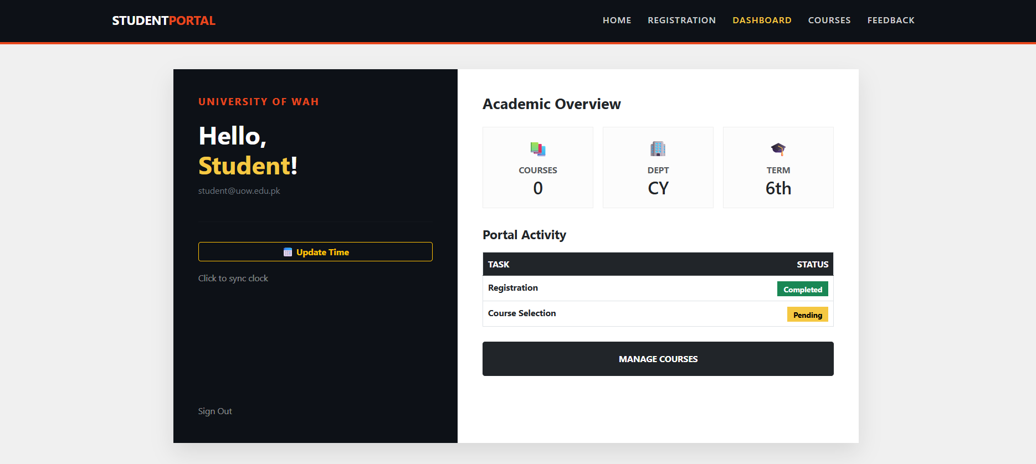
- Course Page: Where you actually pick your subjects for the semester.
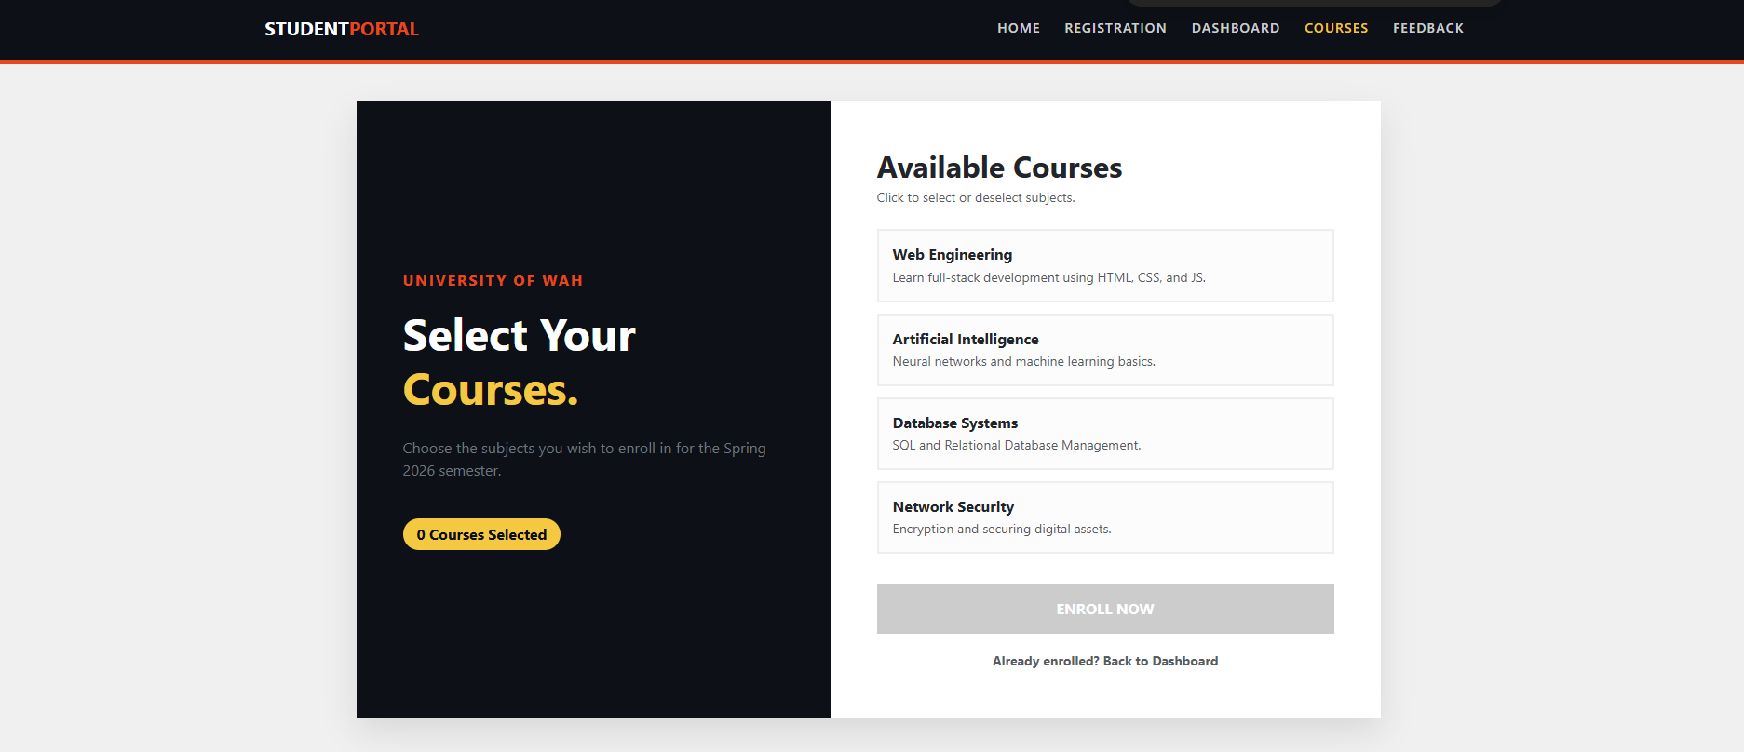
- Feedback: A final page to rate the portal with stars.
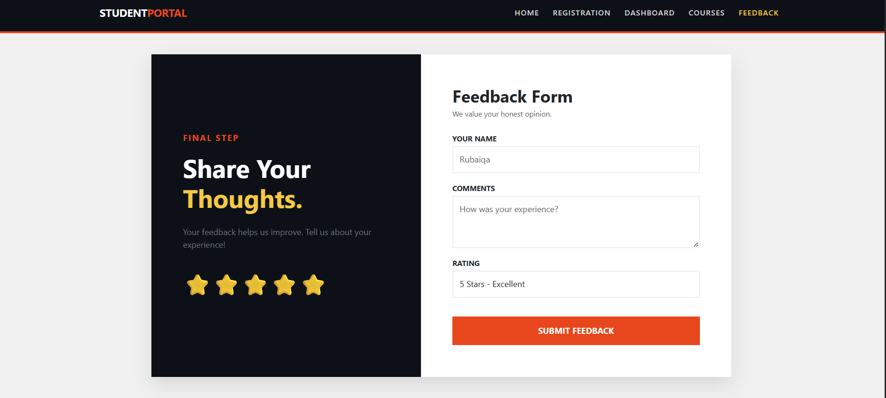
- Conclusion
This portal successfully demonstrates the practical application of Web Engineering principles. By combining aesthetic design with functional client-side logic, it provides a robust foundation for a professional university management system.
- Git-hub Link
https://github.com/rubaiqapervez26/Student-Portal

