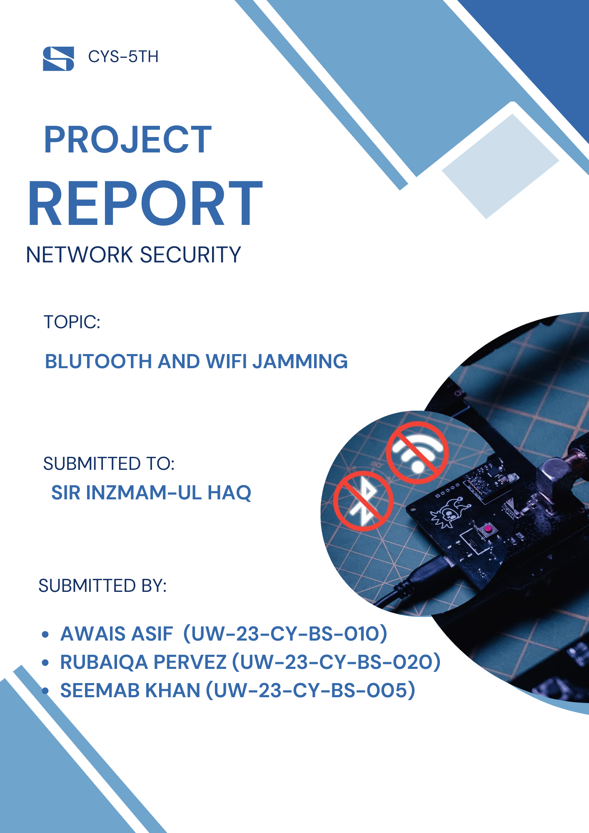

Table of Contents
- Abstract ….………………………………………………………………………… 03
- Introduction ………………………………………………………………………. 03
- Objectives …………………………………………………………………………. 03
- Scope and Ethical Considerations …………………………………………………. 03
- Hardware Components Used ……………………………………………………… 04
5.1 ESP32 WROOM 32U ………………………………………………………. 04
5.2 nRF24L01 PA/LNA Antenna Module ………………………………………. 04
5.3 Adapter / Protector Module …………………………………………………. 04
5.4 Push Button …………………………………………………………………. 04
5.5 Jumper Wires and Power Supply …………………………………………… 04
- Pin Configuration (nRF24L01 with ESP32 – VSPI) ……………………………… 04
- Software and Libraries Used ………………………………………………………. 04
- System Working and Implementation ……………………………………………… 05
8.1 Initialization Phase …………………………………………………………. 05
8.2 Bluetooth Interference Analysis ……………………………………………. 05
8.3 Wi-Fi Interference Analysis ………………………………………………… 05
- Channel Hopping and Noise Behaviour …………………………………………... 06
- Security Perspective ………………………………………………………………. 06
- Mitigation Strategies ……………………………………………………………… 06
- Results and Observations …………………………………………………………. 06
- Conclusion………………………………………………………………………… 07

Abstract
This project presents a practical and experimental study of wireless interference in Bluetooth and Wi-Fi communication systems using an ESP32 and nRF24L01 PA/LNA module. The project was initially proposed as a Bluetooth-only interference device but was later upgraded to include Wi-Fi interference analysis as well. The main objective is to understand how wireless availability can be affected by noise, channel congestion, and radio frequency (RF) activity in the 2.4 GHz band. This study is carried out for academic learning and network security analysis in a controlled environment.

Introduction
Bluetooth and Wi-Fi are the most widely used wireless technologies operating in the unlicensed 2.4 GHz ISM band. Due to shared spectrum usage, these technologies are vulnerable to interference, congestion, and availability-based attacks. From a network security perspective, interference impacts the availability pillar of the CIA triad.
The original project proposal focused on Bluetooth interference. During development, the project was upgraded to analyze both Bluetooth and Wi-Fi behavior under interference conditions using the same hardware platform and improved firmware logic.

Objectives
- To analyze Bluetooth and Wi-Fi behavior under RF interference.
- To study how weak wireless signals are affected by noise.
- To understand availability attacks in wireless network security.
- To perform controlled experimentation using ESP32 and nRF24L01.
- To propose mitigation and defensive strategies.

Scope and Ethical Considerations
This project is limited to:
- Academic and laboratory environments only.
- Controlled testing on personal devices.
- Educational learning and security research.
Note: Intentional disruption of public or operational networks is illegal and unethical. This project is documented strictly from a defensive and analytical security viewpoint.

Hardware Components Used
- ESP32-WROOM-32U
Acts as the main controller. Provides processing capability and internal Wi-Fi and Bluetooth radios.
- nRF24L01 PA/LNA Antenna Module
Used for high-power 2.4 GHz RF transmission and channel hopping experiments.
- Adapter / Protector Module
Ensures stable 3.3 V power to the nRF24L01 and protects it from voltage spikes.
- Push Button
Used to switch between different operating modes.
- Female Jumper Wires (Minimum 7)
Used for SPI and power connections.
- USB Cable and Power Bank
Provides portable power to the ESP32.

Pin Configuration (nRF24L01 with ESP32 – VSPI)
NRF24L01 Pin | ESP32 Pin | Function
VCC | 3.3V | Power (5 V must not be used)
GND | GND | Ground
CE | GPIO 22 | Chip Enable
CNSwr | GPIO 21 | Chip Select
SCK | GPIO 18 | SPI Clock
MISO | GPIO 19 | Master In Slave Out
MOSI | GPIO 23 | Master Out Slave In

Software and Libraries Used
- RF24 Library
- ezButton Library
- ESP32 Bluetooth and Wi-Fi system libraries
- Arduino IDE for development and serial monitoring

System Working and Implementation

Initialization Phase
During startup:
  - ESP32 Wi-Fi and Bluetooth controllers are disabled to avoid self-interference.
  - SPI communication is initialized using the VSPI interface.
  - The nRF24L01 module is configured with:
    - Auto acknowledgment disabled
    - Maximum power amplification
    - 2 Mbps data rate
    - CRC disabled
    - Constant carrier transmission enabled
This configuration allows continuous RF activity on selected channels.

Bluetooth Interference Analysis
Bluetooth uses Frequency Hopping Spread Spectrum (FHSS) across multiple channels in the 2.4 GHz band. When strong RF activity exists:
    - Weak Bluetooth signals experience packet loss.
    - Connection delays and instability increase.
    - Re-transmissions occur frequently.
The experiment observes Bluetooth performance degradation when the noise floor increases due to continuous RF transmission.

Wi-Fi Interference Analysis
Wi-Fi operates on wider channels and relies on clear channel assessment. Under interference:
    - Channel collisions increase.
    - Throughput decreases.
    - Latency rises significantly.
The project demonstrates how RF congestion impacts Wi-Fi availability, especially for weak or distant connections.

Channel Hopping and Noise Behavior
The firmware dynamically changes RF channels:
  - Mode One: Sweeps lower channels sequentially.
  - Mode Two: Uses two-step channel hopping across the spectrum.
This behavior increases channel congestion and raises the noise floor, making it difficult for weak signals to maintain stable communication.
Noise is not measured in absolute dBm values but analyzed through observed effects, such as:
  - Signal drop
  - Increased retransmissions
  - Connection instability

Security Perspective
This project demonstrates a practical example of an availability-based wireless attack scenario. Understanding such behavior helps security professionals:
  - Design resilient networks
  - Implement proper channel management
  - Deploy monitoring and detection mechanisms

Mitigation Strategies
- Use dual-band (2.4 GHz and 5 GHz) Wi-Fi networks
- Proper access point placement
- Adaptive channel selection
- Wireless intrusion detection systems

Results and Observations
- Bluetooth shows better short-range resilience due to frequency hopping.
- Wi-Fi performance degrades faster under interference.
- Weak signals are affected earlier than strong signals.

Conclusion
The project successfully evolved from a Bluetooth-only setup into a combined Bluetooth and Wi-Fi interference analysis platform. It provides valuable hands-on understanding of wireless availability issues and strengthens practical knowledge in network security.
This project provides a comprehensive experimental study of wireless interference effects on Bluetooth and Wi-Fi communication from a network security perspective. The work successfully evolved from an initially proposed Bluetooth-only concept into a more advanced dual-technology analysis platform, demonstrating the practical impact of RF interference on the availability of wireless networks.
Through the use of the ESP32-WROOM-32U and the nRF24L01 PA/LNA module, the system was able to generate continuous RF activity across multiple channels in the 2.4 GHz ISM band. By implementing channel hopping and constant carrier transmission, the project demonstrated how increased RF noise and channel congestion negatively affect wireless communication, particularly for weak or distant signals.
The experimental observations showed that Bluetooth, due to its frequency hopping spread spectrum (FHSS) mechanism, exhibits better short-range resilience under interference when compared to Wi-Fi. However, under heavy noise conditions, Bluetooth connections still suffer from packet loss, increased latency, and frequent retransmissions. Wi-Fi, which operates on wider channels and relies on clear channel assessment, was observed to experience significant throughput degradation, increased collisions, and connection instability as the noise floor increased.
From a network security standpoint, this project highlights the importance of availability as a core security principle. Interference-based disruption represents a realistic threat scenario in wireless environments, especially in dense or unlicensed spectrum usage. Understanding such behavior allows security professionals and network engineers to design more resilient systems by adopting better channel management, signal optimization, and monitoring strategies.
Overall, this project achieved its objectives by combining practical hardware implementation with security-focused analysis. It enhanced hands-on understanding of wireless vulnerabilities, RF behavior, and defensive awareness. The results emphasize that secure wireless network design must not only focus on encryption and authentication but also consider resilience against interference and availability-based threats.

