# **CRM APPLICATION FOR JEWEL MANAGEMENT**

**College Name:Government Arts college Udhagamandalam**

**College Code:Bru11**

**TEAM ID: NM2025TMID48755**

**TEAM MEMBERS: 4**

**Team LeaderName: Rishiga .M**

**Email:** [**rishigamanikandan0412@gmail.com**](mailto:rishigamanikandan0412@gmail.com)

**Team Member1: Ruba kumar .S**

**Email:** [**rubakumar6374@gamil.com**](mailto:rubakumar6374@gamil.com)

**Team Member: Pavithra .M**

**Email:** [**ppavi4482@gmail.com**](mailto:ppavi4482@gmail.com)

**Team Member: Prathosh .R S**

**Email:** [**prathosh4786@gmail.com**](mailto:prathosh4786@gmail.com)

**1. INTRODUCTION**

**1.1 Project Overview**

The Jewel Management CRM is a Salesforce-based application designed to streamline the processes of managing jewelry business operations. It handles customer management, item tracking, order processing, and billing with automation features such as flows, triggers, validation rules, reports, and dashboards. The system provides jewelers with an efficient way to store data, track sales, and generate insights while ensuring secure role-based access.

**1.2 Purpose**

The main objective of the project is to enable jewelry businesses to efficiently manage customers, inventory, and transactions within Salesforce. It reduces manual errors, improves accuracy, and provides automation for day-to-day processes. With dashboards and reports, the CRM also helps in making data-driven business decisions and ensures better customer satisfaction.

**2. Development Phase**

**2.1 Salesforce Setup**

Created Developer Account and activated it.

By using this URL -  <https://developer.salesforce.com/signup>

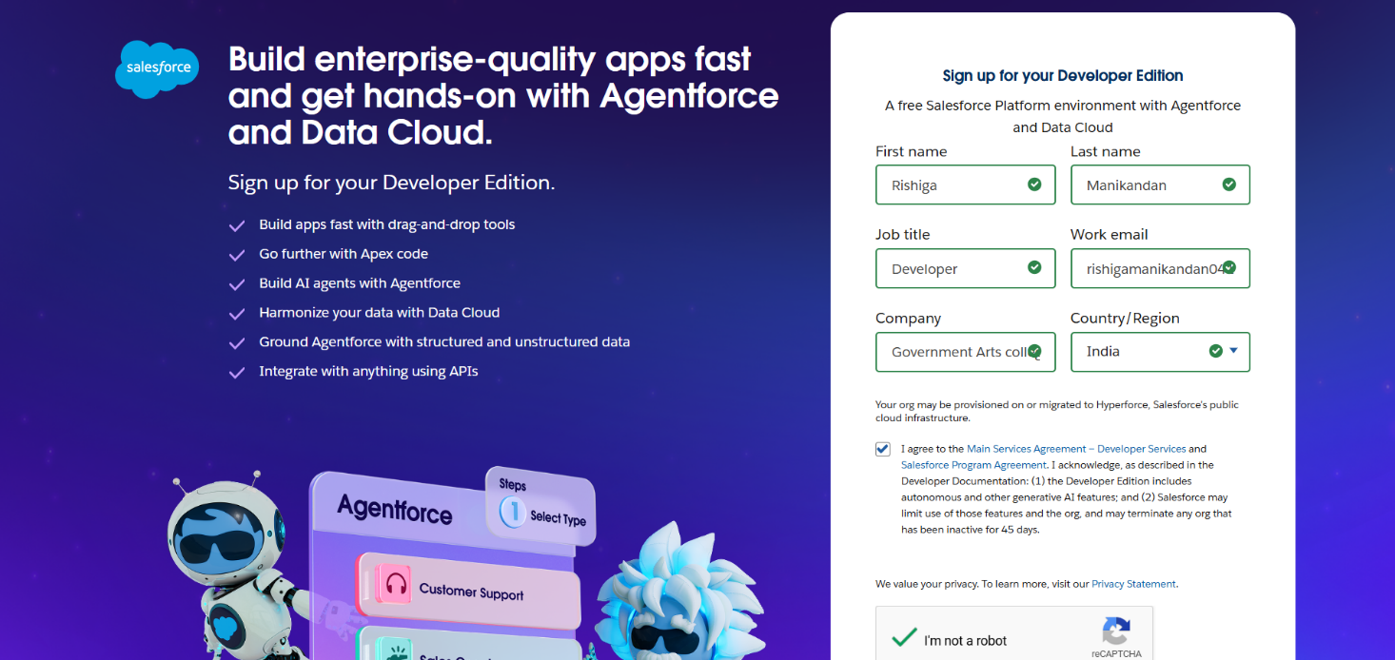

**2.2 Objects & Tabs**

Created custom objects (Jewel Customer, Item, Order, Billing).

Created custom tabs for each object.

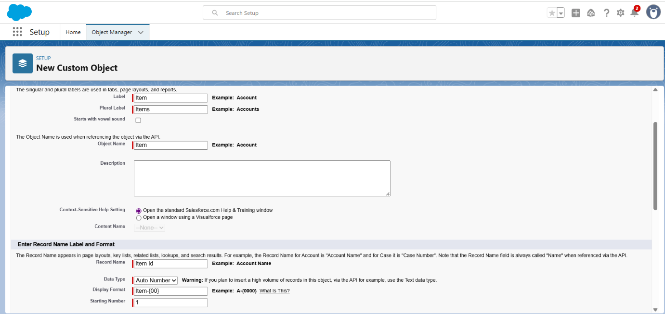

**2.3 Lightning App**

Created Jewel Management Lightning App with all required tabs.

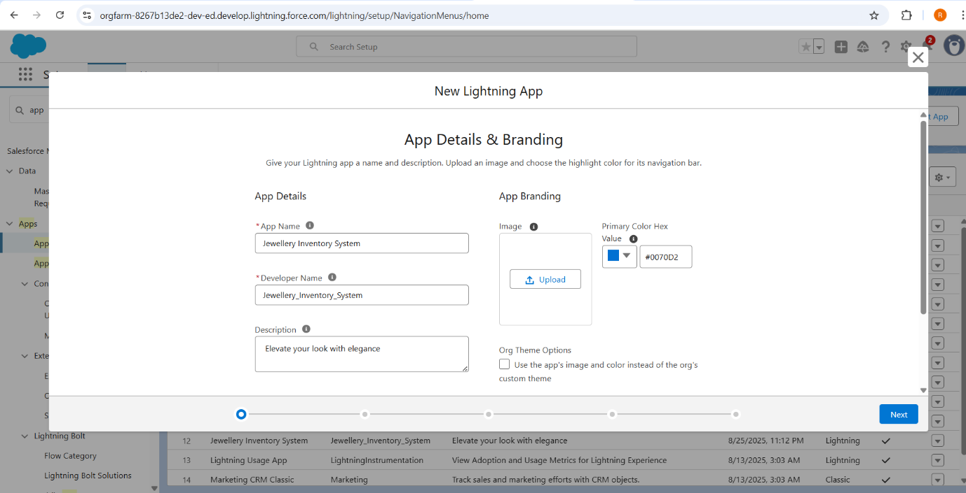

**2.4 Fields & Relationships**

Added fields (Phone, Email, Purity, Price, Picklist, Formula fields, etc.).

Created Lookup and Master-Detail relationships.

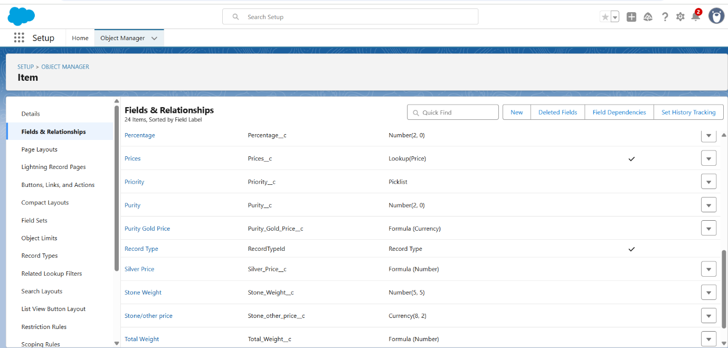

**2.5 Schema Builder**

Visualized object relationships and dependencies.

**2.6 Profiles & Roles**

Created Goldsmith and Worker profiles.

Defined role hierarchy (Worker reports to Goldsmith).

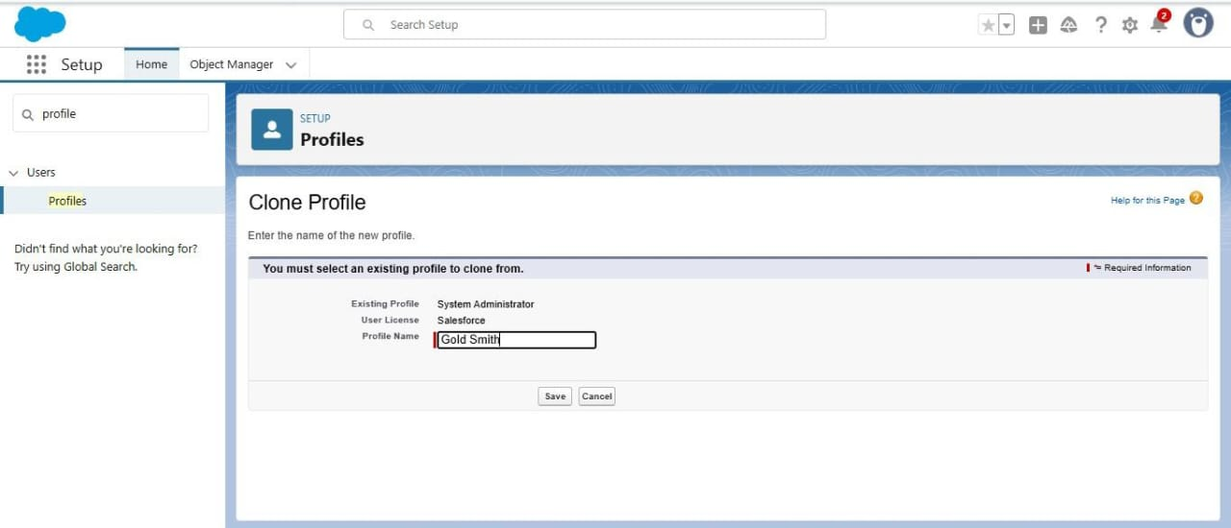

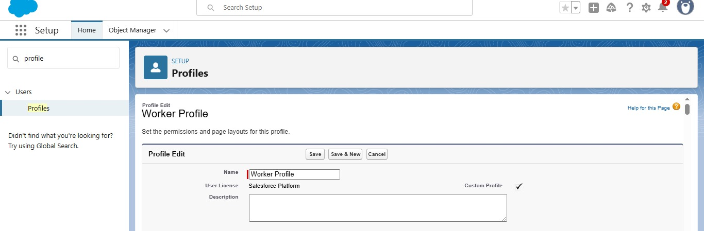

**2.7 Users**

Created users and assigned profiles/roles.

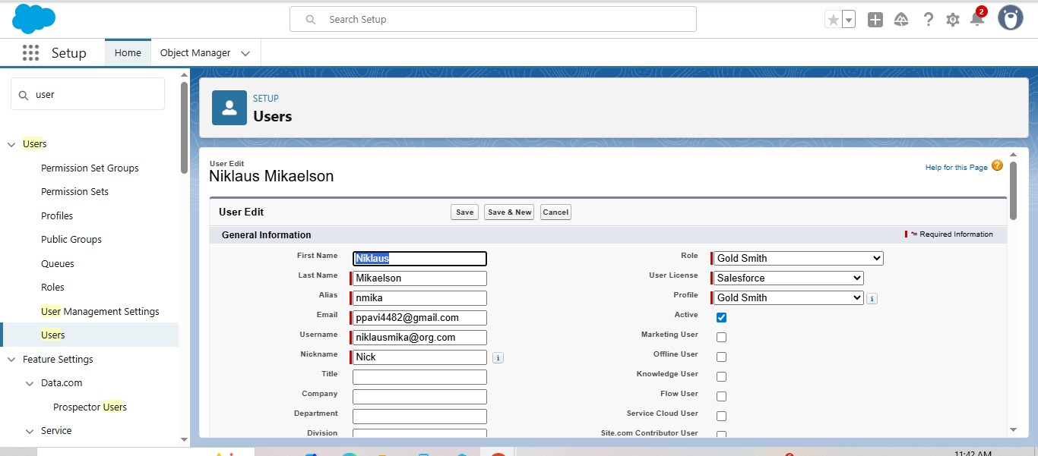

**2.8 Page Layouts & Record Types**

Designed Gold & Silver layouts.

Created record types (Gold, Silver).



**2.9 Permission Sets**

Created permission set for Billing Access.

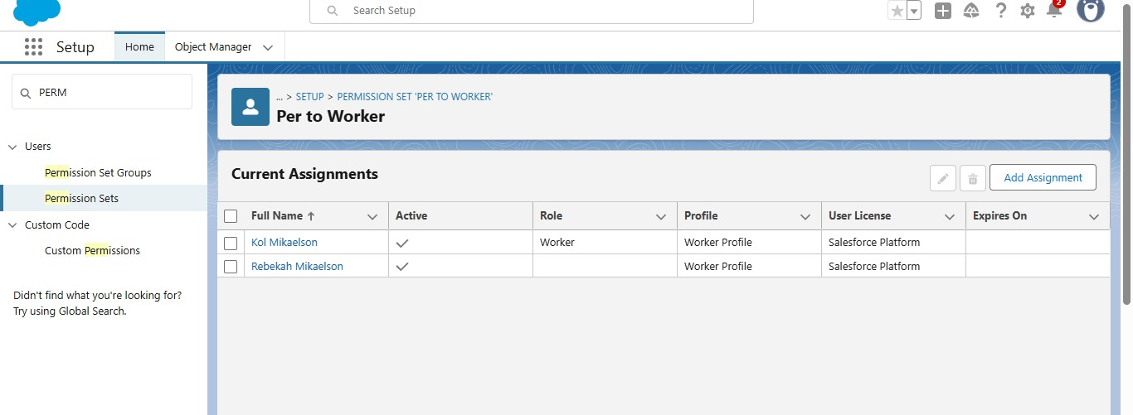

**2.10 Automation (Triggers & Flows)**

Apex Trigger to auto-generate Billing.

Flow for order confirmation and approval process.

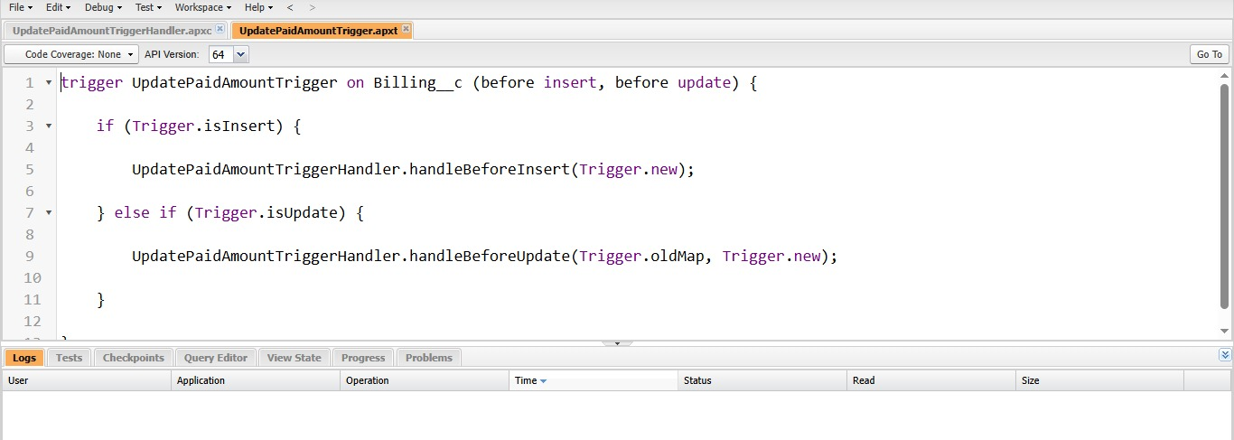

**2.11 Reports & Dashboards**

Reports for sales, customers, monthly sales trends.

Dashboard with KPIs.

**2.12 User Adoption**

Tested by creating, viewing, and deleting Jewel Customer records.

Monitored login history & usage metrics.

**4.Performance Testing**

The purpose of performance testing is to ensure that the CRM functions efficiently under different workloads and maintains smooth user experience.

**Tests Conducted**

**4.1 Record Load Test**

Created 100+ Jewel Customer records to validate system stability and responsiveness.

**4.2 Page Load Performance**

Measured Lightning record page load time for Item and Order objects.



**5. Testing Results**

**5.1 Functional Testing Results**

**Object Creation (Pass)**

Successfully created Jewel Customer and Item records with mandatory fields.

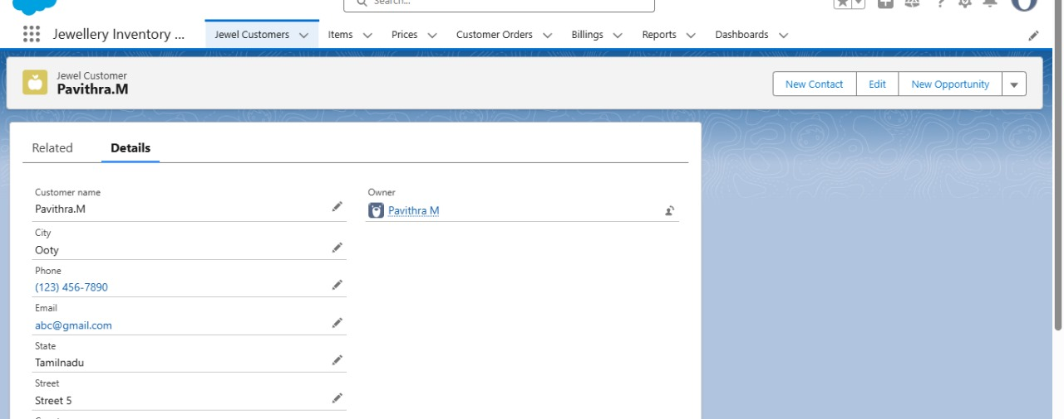

**Validation Rules (Pass)**

Invalid Phone number/Email triggered error messages correctly.

**Trigger Automation (Pass)**

Billing record was auto-created when Order status = Confirmed.

**Reports & Dashboards (Pass)**

Reports displayed accurate totals, dashboards generated charts successfully.

**5.2 Performance Testing Results**

Record Load Test (Pass)

Created and handled 100+ Jewel Customer records without errors.

**7. Conclusion**

The Jewel Management CRM Application in Salesforce successfully streamlines jewelry business operations by managing customers, items, orders, and billing in a single platform. With automation through triggers and flows, secure role-based access, and powerful reports and dashboards, the system improves efficiency and supports better decision-making.

The project also lays a strong foundation for future enhancements like AI recommendations, chatbot integration, and mobile app support, making it a scalable and reliable solution for jewel management.

**8. Appendix**

**8.1 Source Code: Apex Trigger & Handler**

**OrderTrigger.apxt**

trigger OrderTrigger on Order__c (after insert, after update) {

if (Trigger.isAfter && (Trigger.isInsert || Trigger.isUpdate)) {

OrderTriggerHandler.createBilling(Trigger.new);

}

}

**OrderTriggerHandler.apxc**

public class OrderTriggerHandler {

public static void createBilling(List<Order__c> newOrders) {

List<Billing_c> billingList = new List<Billing_c>();

for (Order__c ord : newOrders) {

if (ord.Status__c == 'Confirmed') {

Billing_c bill = new Billing_c();

bill.Order__c = ord.Id;

bill.Invoice_No__c = 'INV-' + String.valueOf(System.currentTimeMillis());

bill.Amount_Paid_c = ord.Total_Price_c;

bill.Payment_Status__c = 'Pending';

billingList.add(bill);

}

}

if (!billingList.isEmpty()) {

insert billingList;

}

}

}

**8.2 Scheduled Job Example**

MonthlyReportScheduler.ap

global class MonthlyReportScheduler implements Schedulable {

global void execute(SchedulableContext sc) {

sendMonthlySalesReport();

}

public static void sendMonthlySalesReport() {

List<Order_c> orders = [SELECT Id, Total_Pricec, Customer_r.Name

FROM Order__c

WHERE CreatedDate = THIS_MONTH];

// Example: Send email with monthly report (simplified)

String emailContent = 'This is the monthly sales report. Total Orders: ' + orders.size();

Messaging.SingleEmailMessage email = new Messaging.SingleEmailMessage();

email.setToAddresses(new String[]{'manager@jewelcrm.com'});

email.setSubject('Monthly Sales Report');

email.setPlainTextBody(emailContent);

Messaging.sendEmail(new Messaging.SingleEmailMessage[]{email});

}

}