Prediticker

PROJECT REPORT
SUBMITTED IN THE PARTIAL FULFILMENT FOR THE REQUIREMENT OF THE AWARD OF DIPLOMA IN COMPUTER ENGINEERING
SUBMITTED BY
Yash Wankhedkar (1813062) Vishal Rothe (1813050)
Rubal Singh (1813051) Harsh Singh (1813052)
Jay Dudhe (1913804)

GUIDE

Mrs.D.S.Nalinde

DEPARTMENT OF COMPUTER ENGINEERING
GOVERNMENT POLYTECHNIC, NAGPUR
(An Autonomous Institute of Government of Maharashtra)
(2020-2021)

GOVERNMENT POLYTECHNIC, NAGPUR
(An Autonomous Institute of Government of Maharashtra)
CERTIFICATE
This is certify that,
Yash Wankhedkar (1813062)
Harsh Singh (1813052)
Vishal Rothe (1813050)
Rubal Singh (1813051)
Jay dudhe (1913804)

Of term EVEN 2021 of Computer Engineering department students have submitted their Project report on Prediticker a fianancial dashboard During academic session 2020-2021 as a part of project work prescribed by Government Polytechnic, Nagpur for the partial fulfillment of the requirement of diploma in Computer Engineering, Sixth Semester . The project work is the record of students own work and is completely satisfactory.
Mrs. D.S.Nalinde Mr. S. P. Lambhade External
GUIDE HOD
The project work is the record of students own work and is completely satisfactory.
Dr. Manoj B. Daigavane
Principal
GOVERNMENT POLYTECHNIC, NAGPUR
GOVERNMENT POLYTECHNIC NAGPUR

CANDIDATES DECLARATION

We hereby certify that the work which is being presented in the project report entitled Prediticker by us in partial fulfillment of the requirement for the award of diploma in Computer Engineering, Govt. Polytechnic, Nagpur submitted to department of Computer Engineering is record of our own work carried out during Academic session 2020-21 (Even 2020) guided by Mrs. D.S.Nalinde.

Signature and Name of the students

Yash Wankhedkar (1813062) Vishal Rothe (1813050)

Harsh Singh (1813052) Rubal Singh (1813051)

Jay Dudhe (1913804)

ACKNOWLEDGEMENT

We would like to place on record my deep sense of gratitude to our guide, Mrs. D.S.Nalinde Dept.of Computer Engineering for his generous guidance, helpful and useful suggestions, continuous encouragement and supervision throughout the course of present work.

We express our sincere gratitude to Mr. S. P. Lambhade, Head of Department of Computer Engineering for his stimulating guidance. The success of any work depends on efforts of many individuals. We would like to take this opportunity to express our deep gratitude to all those who extended their support and have guided us to complete this project work.

We are extremely thankful to Dr. Manoj B. Daigavane, Principal, for providing us infrastructural facilities work in, without which this work would not have been possible.

Signature and Name of the students
Yash Wankhedkar Vishal Rothe

Harsh Singh Rubal Singh

Jay Dudhe

CONTENTS
Page No.
Chapter 1: INTRODUCTION 1
1.1 Motivation 1
1.2 Objectives 1
1.2 Brief Description of the System 2

Chapter 2: LITERATURE SURVEY 3
2.1 Importance of stock market 3
2.2 Adoption of financial dashboards 4
2.3 Forecasting technique 6

Chapter 3: SYSTEM ANALYSIS AND DESIGN 9
3.1 Analysis 9
3.1.1 Problem Definition 9
3.1.2 Objectives 9
3.1.3 Feasibility Study 10
3.1.4 Requirement Analysis 10
3.2 Design 12
3.2.1 Proposed Design 12
3.2.2 Design details 13

Chapter 4: SYSTEM IMPLEMENTATION & TESTING 17
4.1 Implementation Details 17
4.2 Testing Screenshots 20
4.3 Drawbacks 28
Chapter 5: CONCLUSION & FUTURE SCOPE 29
Chapter 6: REFERENCES 30

List of figures
Figure | Name | Page no.
Figure 2.2.1 | Framework of a successful dashboard | 5
Figure 3.2.1.1 | Block Digram Preditiker | 13
Figure 3.2.2.1 | Home Page data flow | 13
Figure 3.2.2.2 | Stock overview page data flow | 14
Figure 3.2.2.3 | Prediction page data flow | 15
Figure 3.2.2.4 | News Page data flow | 16
Figure 3.2.2.5 | Stock tweets page data flow | 16

List of tables
Table | Name | Page no.
Table 2.2.1 | comparison between prediction techniques | 7

List of Screenshots

No. | Name | Page no.
Figure 4.2.1 | Home page | 20
Figure 4.2.2 | Sidebar navigator | 21
Figure 4.2.3 | Stock overview page | 22
Figure 4.2.4 | Time series chart | 22
Figure 4.2.5 | Stock data | 23
Figure 4.2.6 | Prediction page | 24
Figure 4.2.7 | Brokerage calculator | 25
Figure 4.2.8 | brokerage analysis | 25
Figure 4.2.9 | Compare brokers | 26
Figure 4.2.10 | News page | 27
Figure 4.2.11 | Stock tweets | 28

ABSTRACT

More than ever before, financial professionals are under intense pressure to get fast insights, clear and reliable financial reports while driving their stocks performance higher. By using financial dashboards, an individual can swiftly comprehend and measure all the data accurately, and in real time. Prediticker is one such financial dashboard that aims to ease out the process of researching and doing fundamental analysis of a stock. Prediticker also has stock price forecasting capabilities that is a popular and an important topic in financial and academic studies. The main focus of the project is to make the stock market look less daunting to a novice individual by providing various different necessary analytical tools under one roof. Some of these analytical tools include a brokerage calculator, a prediction module, a fundamental analysis module etc. These all remove tedious traditional means of data analysis and reporting.
1. INTRODUCTION

1.1 Motivation

Fundamental analysis (FA) is a method of measuring a security's intrinsic value by examining related economic and financial factors of a stock. The end goal is to arrive at a number that an investor can compare with a stock’s current price in order to see whether the stock is undervalued or overvalued. Novice or green horn traders often find it difficult to perform fundamental analysis of a stock. This is due to the huge pool of resources that are available to them. The main motivation of the project is to eliminate the tedious process of researching for fundamental analysis values.
One of the major features of Prediticker is its brokerage calculator. The motivation behind this module stems from the hidden charges and taxes that major brokerage providers impose on the investors. Often times these taxes and charges being applied aren’t clearly justified and that just causes confusion among the investors. The brokerage calculator in prediticker aims to provide detailed information about the brokerage charges of various leading brokerage platforms like zerodha and groww.

1.2 Objective
Following are the objectives that Prediticker aims to achieve:
- Ease out the process of researching the stock market.
- Provide a platform for robust fundamental analysis.
- Provide a detailed analysis of brokerage taxes and charges.
- Be a one stop destination for novice traders regarding analysis.
- Provide a robust prediction chart for analysis.

1.3 Brief description of the system

Prediticker is written in python and uses streamlit for making the web application. Streamlit is an open-source Python library that makes it easy to create and share custom web apps for machine learning and data science.
It fetches all of the stock related data from Yahoo finance’s database. y_finance library is used to fetch this data. Real time data is scraped from yahoo finance’s website, yahoo_fin library is used to do this. All of this data is compiled into a pandas dataframe.All of this data is then used to do the prediction. The system feeds all of this data to fbprophet which is a procedure for forecasting time series data based on an additive model where non-linear trends are fit with yearly, weekly, and daily seasonality, plus holiday effects. Prophet is open source software released by Facebook's Core Data Science team.
The data outputted by fbprophet is then used to plot trend graphs and comparison charts. This is done by using plotly which is a python library that provides graphing, analytics, and statistics tools.
Prediticker uses newsapi to provide latest news related to a stock or trending news on the home page. It uses an api called newsapi to fetch news. Newsapi fetches news from over 50 different sources like BBC and ABC news. It returns the data in a json format which is then outputted by streamlit.
Following is a list of all the major modules used in Prediticker:
- fbprophet
- streamlit
- yahoo_fin
- yfinance
- plotly
- pandas

2. LITERATURE SURVEY

2.1 Importance of stock market

Indian stock market stood at third rank in the world. The Stock is essentially a share in a company’s ownership. Stocks are partial ownership of businesses instead of stock tickers piece of paper, which can be traded in the stock market [4]. If company ownership is divided into 100 parts, the investor purchase one part which is equal to one share then we can own 1 percent of that company. Stock exchange uses an automated matching system driven by order. Stock prices are deﬁned as any time how many buyers and sellers available for the same stock in the market. If the number of buyers is more than sellers then stock price becomes high and if the number of sellers higher than buyers then stock price becomes low. The best buy and sell order are looked into a counterparty angle. The best buy orderis which has the highest price and best sell order is which has the lowest price [5]. With this logic system can match the orders and executes the traders system. SEBI (Security and Exchange Board of India) regulates the stock market. In stock markets customers preferences and requirements are different. The estimated world stock market was at$36.6 trillion in early October 2008 [6]. The total world market for derivatives was estimated at approximately $791 trillion in face value or nominal value, 11 times the size of the world economy [7].

2.2 Adoption of financial dashboards

Recent years have seen the introduction of a “marketing dashboard” that brings the firm’s key marketing metrics into a single display. As defined by Clark, Abela, and Ambler (2006, p. 19); O’Sullivan and Abela (2007, p. 81); Wind (2005, p. 869); and Lehmann and Reibstein (2006, pp. 7-8), the key ele-ments of a dashboard include the summarization and integration of key performance metrics with underlying drivers to communicate performance throughout the organization.
We define a dashboard as a relatively small collection of interconnected key performance metrics and underlying performance drivers that reflects both short- and long-term interests to be viewed in common throughout the organization [1].
As defined by Clark, Abela, and Ambler (2006, p. 19); O’Sullivan and Abela (2007, p. 81); Wind (2005, p. 869); and Lehmann and Reibstein (2006, pp. 7-8), the key elements of a dashboard include the summarization and integration of key performance metrics with underlying drivers to communicate performance throughout the organization. We define a dashboard as a relatively small collection of interconnected key performance metrics and underlying performance drivers that reflects both short- and long-term interests to be viewed in common throughout the organization.
A dashboard enforces consistency in measures and measurement procedures across department and business units. a dashboard helps to monitor performance. Monitoring in turn may be both evaluative (who or what performed well?) and developmental (what have we learned?). A framework devised by Wierenga, Van Bruggen, and Staelin (1999) suggests the adoption and success of dasboards [1].

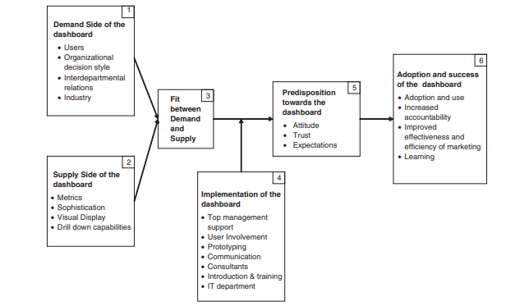 Figure 2.2.1: Framework of a successful dashboard

Dashboards respond to the increasing complexity and diversity of market data faced by senior management in the information age. Managers mention at least four factors driving the need for dashboards (LaPointe 2005):
1. poor organization of the many pieces of potentially decision-relevant data
2. managerial biases in information processing and decision making
3. the increasing demands for marketing accountability, given the dual objective of companies to grow
the top-line while keeping down costs for a healthy bottom-line
4. the need for cross-departmental integration in performance reporting practices and for resource allocation

Dashboards display the key metrics and facilitate the standardization of metrics across departments and business units. Additionally, they highlight inconsistencies across the organization and levels so that goals can be integrated.[1]
Prediticker adopts these key values and aims to provide a user friendly dashboard that takes into account the various different metrics related to the stock market. It assists user in three major ways: understanding the market, Research planning, and performance assessment.

2.2 Forecasting technique

Prediction of the Stock Market is a challenging task in predicting the stock prices in the future. Due to the ﬂuctuating nature of the stock, the stock market is too difﬁcult to predict. Stock prices are constantly changing every day. Estimating of the stock market has a high demand for stock customers. Applying all extracted rules at any time is a major challenge to estimate the future stock price with high accuracy. The latest prediction techniques adopted for the stock market such as Artiﬁcial Neural Network, Neuro Fuzzy System, Time Series Linear Models (TSLM), Recurrent Neural Network (RNN) and their advantages and disadvantages are studied and analyzed in this framework work.

There were two important indicators in the literature for stock price forecasting. They are fundamental and technical analysis. Both are used to analyse the stock market.
Major prediction techniques such as data mining, machine learning and deep learning techniques are used to estimate the future stock prices, based on these techniques some of the recent models derieved are:
- Holt-Winters
- Artiﬁcial Neural Network
- Hidden Markov Model
- ARIMA Model
- Time Series Linear Model
- Recurrent Neural Networks.[3]

Techniques | Advantages | Disadvantages | Parameter used
Artiﬁcial  neural  network | Better performance  compared to  regression. Lower  prediction error | Prediction gets  worse with increased  noise variation | Stock closing price
Support  vector  machine  for stock  prediction | Does not lose much  accuracy when  applied to a sample  from outside the  training sample | Exaggerate to minor  ﬂuctuations in the  training data which  decrease the  predictive ability | Consumer  investment, net  revenue, net income,  price per earnings  ratio of stock,  consumer spending,  diluted earnings per  share, unemployment  rate
Hidden  Markov  model | Used for  optimization  purpose | Evaluation,  decoding and  learning | Technical indicators
ARIMA | Robust and efﬁcient | It is suitable for short  term predictions  only | Open, high, low,  close prices and  moving average
Time series  linear  model | Integrate the actual  data to the ideal  linear model | Traditional and the  seasonal trends  present in the data | Data and number of  months
RNN | Previous time points  to input layer  contains inputs | It possible to feed  those words in  through a much  smaller set of input  nodes | Input hidden and  output layers

Table 2.2.1. comparison between prediction techniques

The prediction module that Prediticker uses i.e. fbprophet uses is additive model where non-linear trends are fit with yearly, weekly, and daily seasonality, plus holiday effects. It works best with time series that have strong seasonal effects and several seasons of historical data. Prophet is great at handling missing data and shifts in the trend, and typically handles outliers well.

Fbprophet uses a modular regression model that often works well with default parameters, and that allows analysts to select the components that are relevant to their forecasting problem and easily make adjustments as needed. The second component is a system for measuring and tracking forecast accuracy, and flagging forecasts that should be checked manually to help analysts make incremental improvements. This is a critical component which allows analysts to identify when adjustments need to be made to the model or when an entirely different model may be appropriate.[2]

3. SYSTEM ANALYSIS AND DESIGN
3.1 Analysis

3.1.1 Problem definition
A. Problem Statement:- A stock exchange market depicts savings and investments that are advantageous to increase the effectiveness of national economic. The future stock returns have some predictive relationships with the publicly available information of present and historical stock market indices. The investors decide the better time to sell/buy/hold a share in stock market based on the former relationship. Every investor faces difficulty in carrying out fundamental analysis of the stock market due to the huge pool of resources. This possesses a major challenge to design and develop an effective and efficient financial dashboard that assists the investors to take appropriate decisions.

B. Existing Systems :- Some of the major financial dashboards that exists are tickerfinology and qlik dashboards. They provide functionalities for fundamental analysis and for reporting. But these existing system are made for large financial organizations which are always a little overwhelming for novice traders. And some of them also fail to comply with latest fundamental analysis techniques like social media analysis which has a huge impact on the market in the modern ages.

3.1.2 Objectives
Following are the objectives that Prediticker aims to achieve:
- Ease out the process of researching the stock market.
- Provide a platform for robust fundamental analysis.
- Provide a detailed analysis of brokerage taxes and charges.
- Be a one stop destination for novice traders regarding analysis.
- Provide a robust prediction chart for analysis.

3.1.3 Feasibility Study
Simply put, stock market cannot be accurately predicted. The future, like any complex problem, has far too many variables to be predicted. The stock market is a place where buyers and sellers converge. When there are more buyers than sellers, the price increases. When there are more sellers than buyers, the price decreases. So, there is a factor which causes people to buy and sell. It has more to do with emotion than logic. Because emotion is unpredictable, stock market movements will be unpredictable.
There are some fundamental financial indicators by which a company’s stock value can be estimated. Some of the indicators and factors are: Price-to-Earning (P/E) Ratio, Price-to-Earning Growth (PEG) Ratio, Price-to-Sales (P/S) Ratio, Price/Cash Flow (P/CF) Ratio, Price-to-Book Value (P/BV) Ratio and Debt-to-Equity Ratio. Some of the parameters are available and accessible on the web but all of them aren’t. So we are confined to use the variables that are available to us.
The proposed system will not always produce accurate results since it does not account for the human behaviours. Factors like change in company’s leadership, internal matters, strikes, protests, natural disasters, change in the authority cannot be taken into account for relating it to the change in Stock market by the machine.

3.1.4 Requirement Analysis
After the extensive analysis of the problems in the system, we are familiarized with the requirement that the current system needs. The requirement that the system needs is categorized into the functional and non-functional requirements. These requirements are listed below:

Functional Requirements :
Functional requirement are the functions or features that must be included in any system to satisfy the business needs and be acceptable to the users. Based on this, the functional requirements that the system must require are as follows:
• The system should be able to generate an approximate share price.
• The system should collect accurate data from the yahoo finance, news sources and twitter in a consistent manner.
Software requirements of prediticker are as follows:
operating system: Windows, Mac or Linux
ram: more than 800mb of memory
space: the system accommodates space on the streamlit sharing cloud platform.
Additional software: a functional web browser with a stable internet connection.

Non-Functional Requirements:

Non-functional requirement is a description of features, characteristics and attribute of the system as well as any constraints that may limit the boundaries of the proposed system. The non-functional requirements are essentially based on the performance, information, economy, control and security efficiency and services. Based on these the non-functional requirements are as follows:
• The system should provide good accuracy.
• The system should have simple interface for users to use.
• To perform efficiently in short amount of time

3.2 DESIGN

3.2.1 Proposed design

Prediticker is written in python and uses streamlit for making the web application. Streamlit is an open-source Python library that makes it easy to create and share custom web apps for machine learning and data science.
It fetches all of the stock related data from Yahoo finance’s database. y_finance library is used to fetch this data. Real time data is scraped from yahoo finance’s website, yahoo_fin library is used to do this. All of this data is compiled into a pandas dataframe.
All of this data is then used to do the prediction. The system feeds all of this data to fbprophet which is a procedure for forecasting time series data based on an additive model where non-linear trends are fit with yearly, weekly, and daily seasonality, plus holiday effects. Prophet is open source software released by Facebook's Core Data Science team.
The data outputted by fbprophet is then used to plot trend graphs and comparison charts. This is done by using plotly which is a python library that provides graphing, analytics, and statistics tools.
Prediticker uses newsapi to provide latest news related to a stock or trending news on the home page.. Newsapi fetches news from over 50 different sources like BBC and ABC news. It returns the data in a json format which is then outputted by streamlit.
It uses stocktwit api to gather the trending tweets related to the stocks.

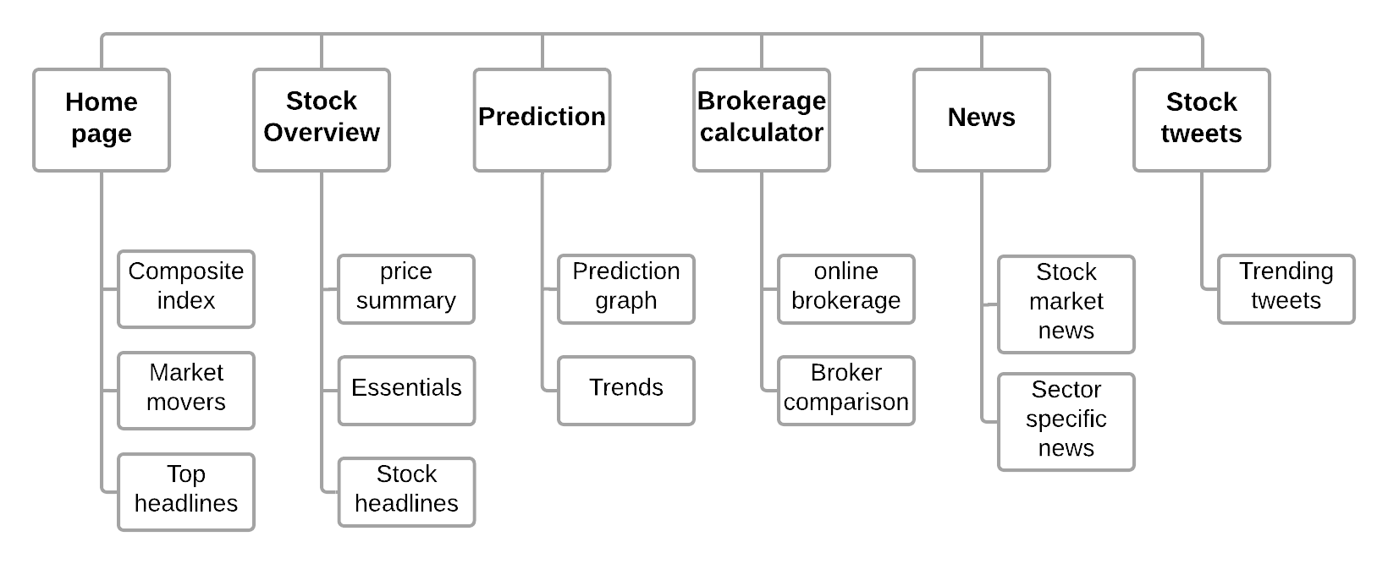 Figure 3.2.1.1: Block diagram of prediticker
3.2.2 Design details
Home page:
The home page displays the Top stock movers of the previous date and the various different composite indexes such as NASDAQ, NIFTY50. The colour of the indexes turns green or red depending upon the change in their price. The index data displays information such as the current index price, price change in currency and in percentage. All of this data is scraped from yahoo finance’s website by using yahoo_fin library. The home page also displays the latest trending news about the stock market. The news is scraped by the newsapi.
Yahoo finance
database
Scraped data
yahoo_fin
Prediticker home
page
Newsapi sources
streamlit
newsapi

Figure 3.2.2.1 : Home Page data flow

Stock overview page:

the stock overview page contains a text field for input. The user has to input the ticker of the stock that they want an overview of. Once the user specifies a ticker, yahoo_fin gathers all the data from the yahoo finance’s database and returns them in a json format which is then parsed by streamlit and displayed to the user. The stock overview page is mainly used to do the fundamental analysis of a stock. It displays data such as company essentials, stock essentials, current price of the stock, company name etc. Stock overview page also displays latest news related to the stock
Scraped data
Yahoo finance
database
yahoo_fin
Stock overview page
streamlit
Newsapi sources
newsapi

Figure 3.2.2.2 : Stock overview page data flow

Prediction page:
The prediction page includes a text input field where the user has to specify the ticker of the stock they wish to predict the price of. Once the ticker has been inputted, prediticker fetches 5 years worth of historical data from yahoo finance’s database by using yfinance library. Yfinance returns a pandas dataframe, this pandas dataframe is modified to be compatible with fbprophet’s standards. Then this modified dataframe is then fixed onto fbprophet which trains the dataset and predicts the prices. The predicted output is delivered in a pandas dataframe which is then visualized using plotly. It also displays the predicted weekly, monthly and yearly trends of the stock.

Download stock data from yahoo finance using yfinance

Modify the data frame

Fit the dataframe into fbprophet

Get the predicted dataframe

Visualize the data frame

Figure 3.2.2.3 : Prediction page data flow

Brokerage calculator:
The brokerage calculator page includes a selection field where the user can select the online broker that they will be using. Once the user has selected an online broker they are prompted to enter ticker of the stock that they will be buying. Once user enters the ticker prediticker gathers the stock related data from yahoo finance’s database using yahoo_fin. This data is then used to calculate various brokerage taxes and charges related to the broker selected. The user can also specify quantity and selling price to get a more detailed analysis.

News page:
By default the news page displays the latest headlines related to business and stock market. The user can filter the news by sector by selecting the sector in the drop down menu. When user selects a sector, a http request is generated using requests library to call the newsapi. The request gets modified depending upon the type of sector chosen. The api scrapes articles from over 50 sources and returns a json dictionary having data of all the article. Streamlit then displays the title of the article, article image, short excerpt from the article and the original article url on the page.

News api sources
News module
Json article dictionary
Request

Figure 3.2.2.4 : News Page data flow

Stock Tweets module:
The stockTwit module by default displays the most trending stock tweets on twitter. The user can also specify a specific stock by passing a ticker in the input field. When the user inputs a ticker a request is made to the Stocktwit api which returns the trending stock related tweets in a json format which is then displayed by streamlit on the page.
StockTwit database
StockTwit module
Json tweet dictionary
Request

Figure 3.2.2.5 : Stock tweets page data flow

4. SYSTEM IMPLEMENTATION AND TESTING

4.1 Implementation details:

Prediticker uses python for development. Python is an interpreted high-level general-purpose programming language. It uses various different python modules and libraries to bring the whole application together.
Detailed description of various libraries, api and modules used:

streamlit
Streamlit is an open-source app framework for Machine Learning and Data Science teams. Streamlit is used to make the actual web application. Streamlit’s sharing platform was used to deploy the application.

Plotly 4.14.3
The plotly Python library is an interactive, open-source plotting library that supports over 40 unique chart types covering a wide range of statistical, financial, geographic, scientific, and 3-dimensional use-cases. Plotly was used to visualize the data obtained from yahoo finance’s database and also to visualize the predicted output.

Pandas 1.2.4
pandas is a software library written for the Python programming language for data manipulation and analysis. In particular, it offers data structures and operations for manipulating numerical tables and time series. It is free software released under the three-clause BSD license. Fbprophet requires a pandas dataframe as an input. The data fetched from the yahoo finance database is packed into a pandas dataframe and provided to fbprophet as n input which in turn returns the predicted output in another pandas dataframe.

Numpy 1.20.2
NumPy is a library for the Python programming language, adding support for large, multi-dimensional arrays and matrices, along with a large collection of high-level mathematical functions to operate on these arrays.

Fbprophet 0.7.1
Prophet is a procedure for forecasting time series data based on an additive model where non-linear trends are fit with yearly, weekly, and daily seasonality, plus holiday effects. The data obtained from yahoo finance is packed into a pandas dataframe and is fitted into fbprophet which outputs a pandas dataframe with the predicted output.

Requests 2.25.1
Requests allows you to send HTTP/1.1 requests extremely easily. It is used to make api calls in the project.

Pillow 8.2.0
Python Imaging Library(pillow) is a free and open-source additional library for the Python programming language that adds support for opening, manipulating, and saving many different image file formats.

yahoo_fin
yahoo_fin library is used to scrape data from the yahoo finance website. This library is used to get the realtime data about the stock prices, indexes and also the fundamental data related to the stock.

Yfinance
yfinance library is used to access the yahoo finance database. This library is primarily used to retrieve the historical data of a particular stock which is then used for prediction.

Newsapi
newsapi is used in the project to fetch the stock related news. Requests library is used to send a request to the newsapi which returns the news articles in a json format. It scrapes data form over 50 news sources.

StockTwits
StockTwits api allows users to access the Stocktwits social graph, display curated data streams, integrate watch lists, and easily share messages, links and charts directly from your application. This api is used to get the trending tweets related to the stock.

4.2 Testing screenshots

Home page

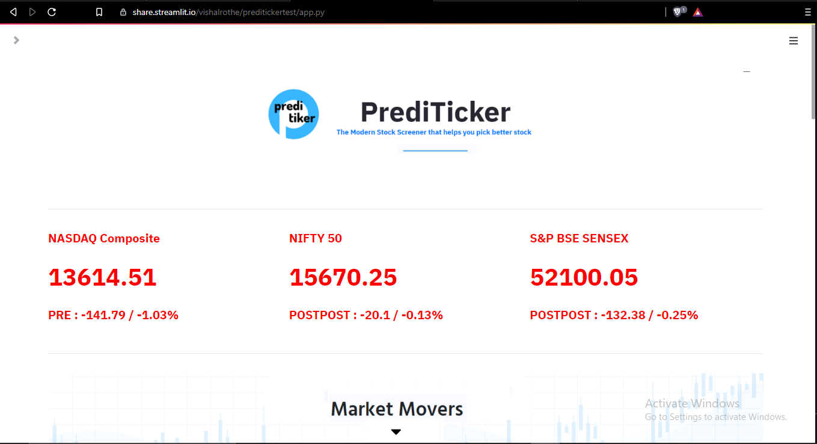 Figure 4.2.1: home page
The home page displays information about the Composite indexes like NASDAQ composite and NIFTY50. This information consists of the current price of the index, the status of the market(open, closed, pre or post), the change in price and in percentage. It also displays data about the top gainers, top losers and top active stocks. This data about the market movers is displayed in a table. It contains information such as the price of the stock, its volume, percent change, market cap, pe ratio etc. The bottom of the page displays the current headlines related to the market.

Sidebar navigator

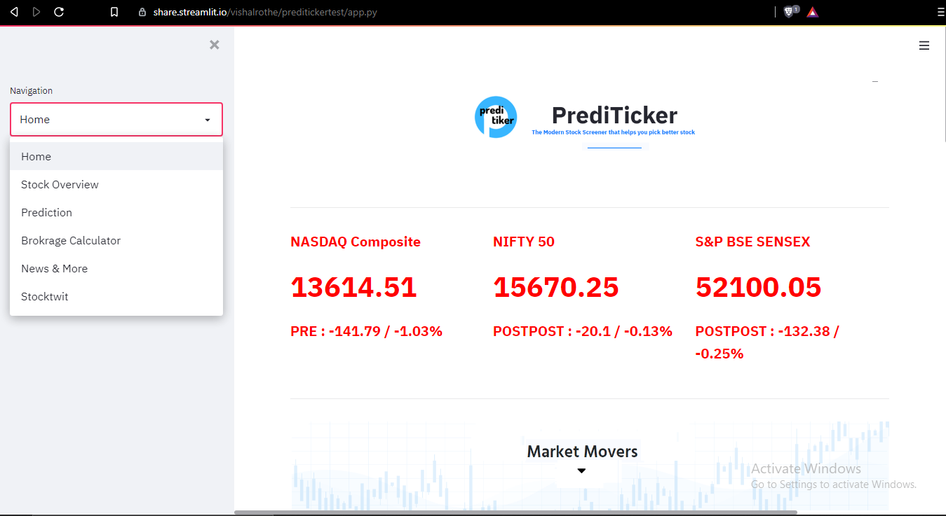 Figure 4.2.2: Sidebar navigator

You can navigate around the web application by using the navigator on the sidebar. Dropping down the bar lists all of the different pages that you can visit on the web application.

Stock overview page
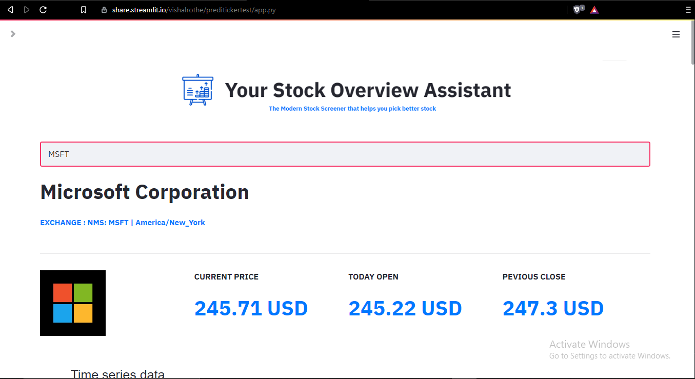 Figure 4.2.3: Stock overview page
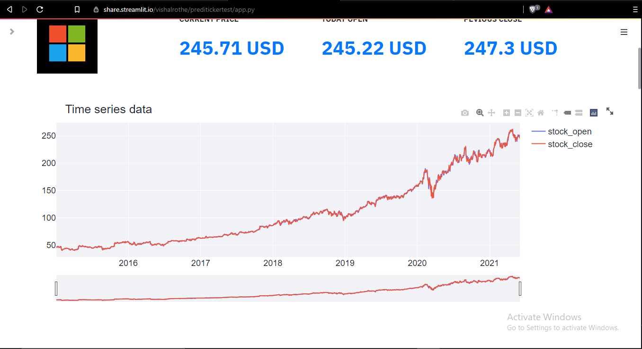 Figure 4.2.4: Time series chart

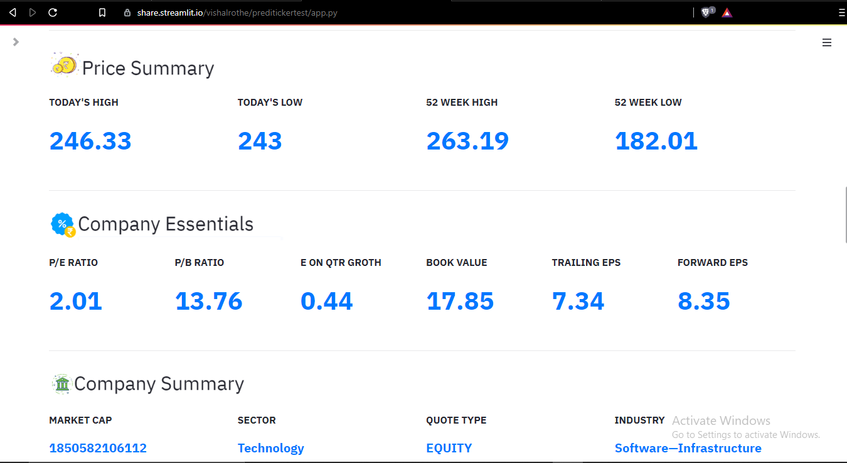 Figure 4.2.5: Stock data

The stock overview page is used for the fundamental analysis of a stock. It has a search bar where the user needs to input the ticker of the stock that they wish to get information about. Once the user inputs the ticker Prediticker fetches the data and displays it onto the page. This data consists of information such as the today’s high/low price, avg 52 week high/low, p/e ratio, p/b ratio, book value etc.
Along with the stock related data the page also displays the company related data with a brief business summary of the company.
An interactive time series chart and a candlestick chart is also displayed to get a better idea of the opening/closing, high/low price of the stock over the period of 5 years.
At the very bottom latest news related to the stock is displayed.

Prediction page
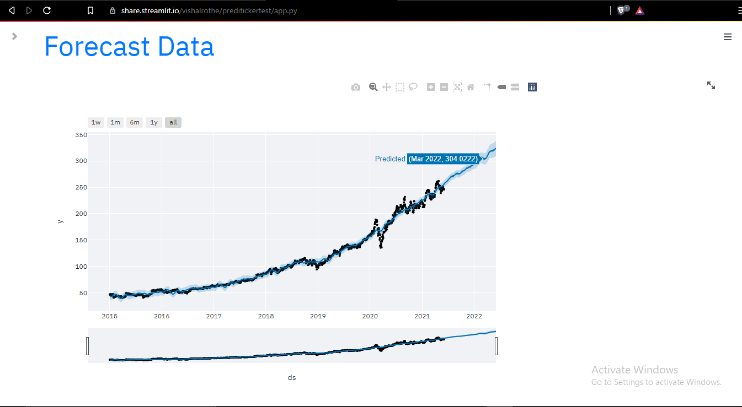 Figure 4.2.6: Prediction page
The prediction page has a search field that the user can use to input the ticker of the stock that they want to predict. Once the user inputs a ticker, the page fetches five years worth of stock price related data and displays an interactive time series chart with the predicted output. The page also displays the raw predicted data frame and also the predicted weekly, monthly and yearly trends.

Brokerage calculator
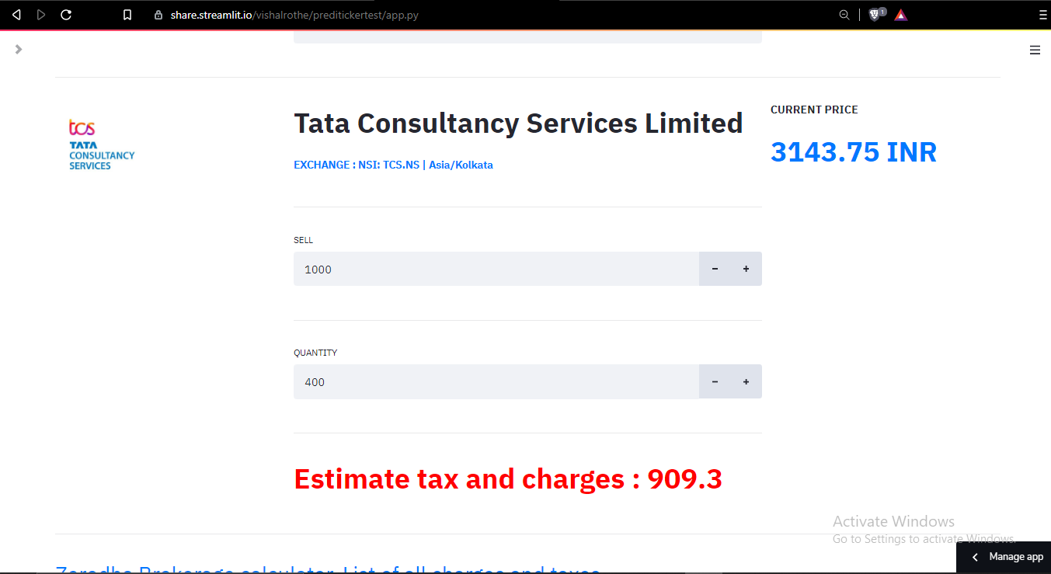 Figure 4.2.7: Brokerage calculator
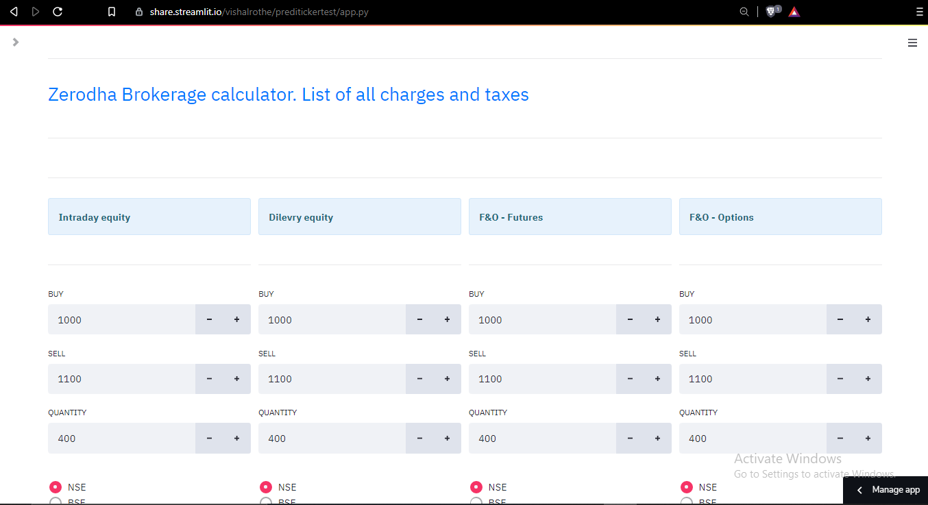 Figure 4.2.8: Brokerage analysis

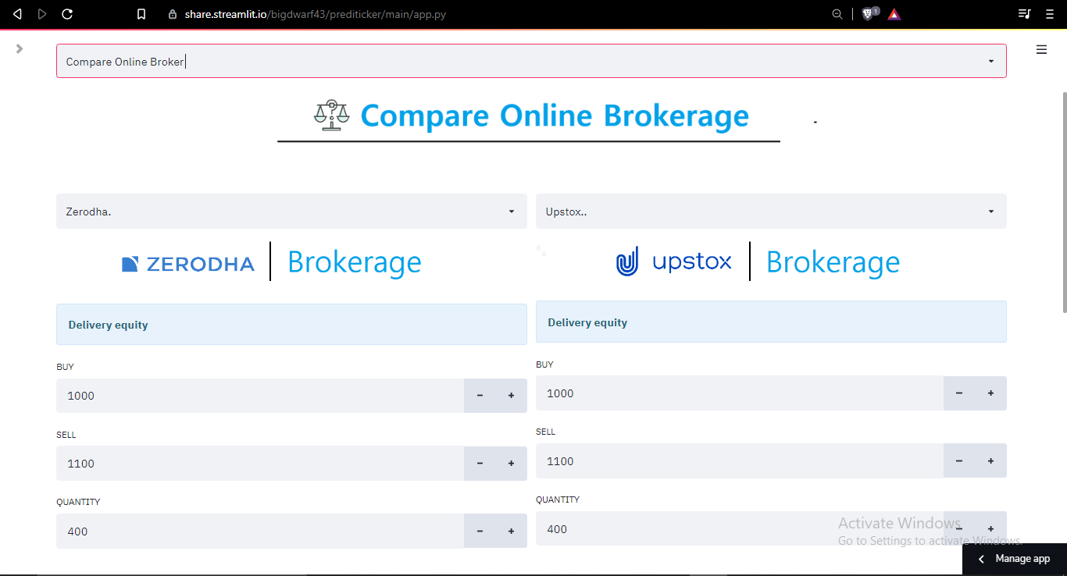 Figure 4.2.9: Compare online brokers
The brokerage calculator page allows the user to perform a detailed analysis of the taxes and charges of the major online trading platforms like zerodha and upstox. The page has a select box field where the user can choose to find out about the charges and taxes of a particular stock or they can compare the brokerage costs of the major trading platforms. If the user chooses the select online broker option they are prompted to input a ticker. The page displays the buying price and the estimated brokerage charges of the stock on the chosen trading platform. The user can opt for detailed analysis where they can tweak various values such as the quantity and the buying and selling price of the stock.
If the user selects the compare online broker option, they are prompted to input two of the brokers that they want to compare. The page then displays the charges and taxes of the platforms side by side making it easier to compare them. The user also has the option to input values such as buying/selling price and quantity to get a more precise idea.

News page

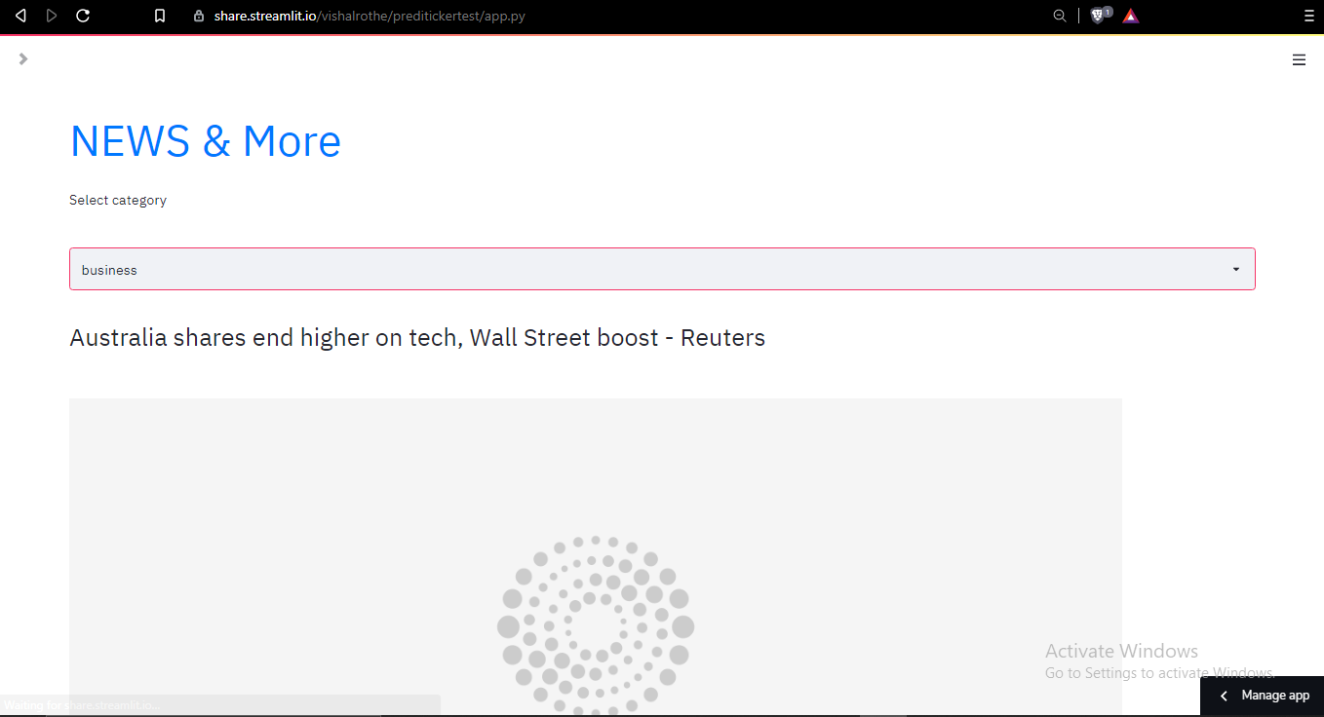 Figure 4.2.10: News page
The news page by default shows the news related to business and the stock market in general. But the user can click on the drop down menu on the page to bring a list of different sectors that the user can choose to filter the news related to that sector. Each of the news blocks has a title, an image, a little excerpt from the actual article and a link to the original article.

Stock tweet page

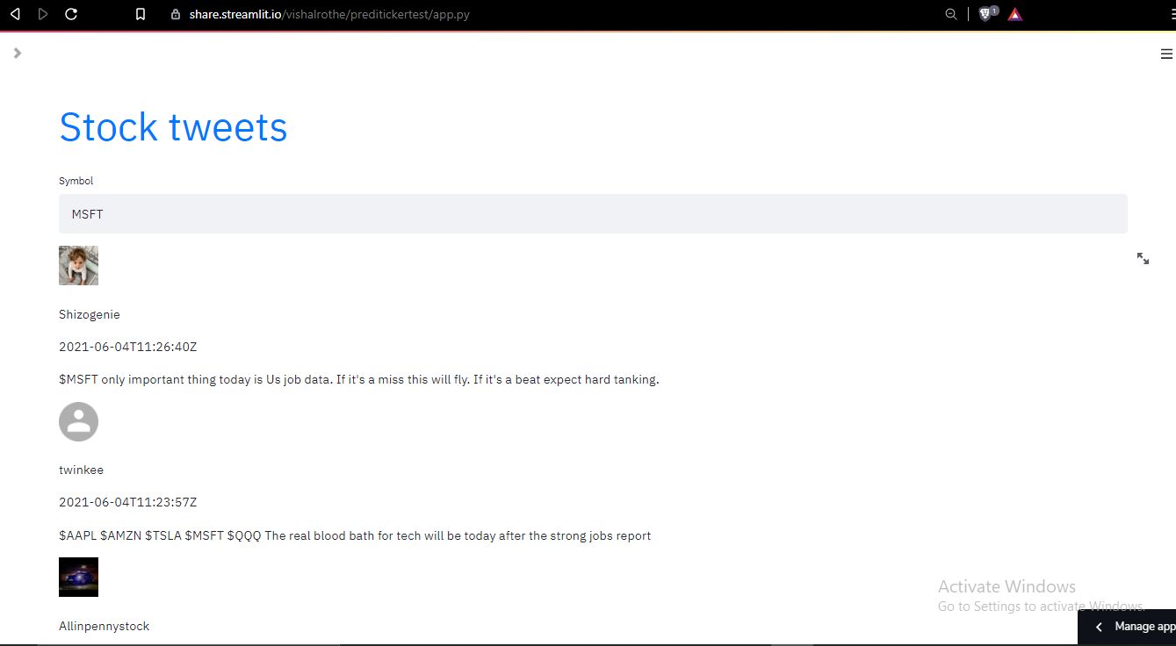 Figure 4.2.11: Stock tweets
The stock tweet page by default shows trending tweets related to the stock market. It features an input field that the user can use to filter out the tweets according to the ticker that they input. Every tweet block shows the original poster’s avatar, username, the tweet timestamp and the original tweet.

4.3 Drawbacks:
- historical data related to all of the NSE registered stocks is not available.
- Prediction is not accurate in case of the stocks that don’t have 5years+ historical data.

5. CONCLUSION AND FUTURE SCOPE
The objective of this project was to provide a one stop destination to novice investors for fundamental analysis of the stock market.. Even though it falls short in the prediction section because of the drawbacks related to the data collection, It does a great job for providing a robust platform for all the research needs. It eases out the process of researching which previously seemed to be a daunting task because of the huge pool of resources on the internet.
Future scope:
- NSE stocks related data can be accessed to make the system more complete.
- Prediction module can be made more accurate by analysing more historical data.
- Trading functionalities can be added to buy and sell stocks.
- Fbprophet can be made more robust by feeding it a data frame that takes into account human anamolies.

6. REFERENCES
[1] Pauwels, K.et al.(2009) ‘Dashboards as a Service: Why, What, How, and What Research Is Needed?’,Journal of Service Research, 12(2), pp. 175–189.
[2] Polamuri, Subba & Srinivas, K. & Mohan, A.. (2020). A Survey on Stock Market Prediction Using Machine Learning Techniques. 10.1007/978-981-15-1420-3_101.
[3] Taylor, Sean & Letham, Benjamin. (2017). Forecasting at scale. 10.7287/peerj.preprints.3190v2.
[4] Chavan PS (2013) Parameters for stock market prediction. Int J Comput Technol Appl
(IJCTA)

[5] Tsai C-F, Wang S-P (2009) Stock price forecasting by hybrid machine learning techniques.
In: International multiconference of engineers and computer scientists (IMECS)

[6] Preethi G, Santhi B (2012) Stock market forecasting techniques: a survey. J Theor Appl Inf
Technol (JTAIT)

[7] Patel MB, Yalamalle SR (2014) Stock price prediction using artiﬁcial neural network. Int J
Innov Res Sci Eng Technol (IJIRSET)

