6. Database backup:

Scheduled backup:

1. Pre-condition: SQL ServerAgent should be enabled.
2. Expand SQL Server Agent
3. Right click Jobs -> New job
4. Select name, description in general menu

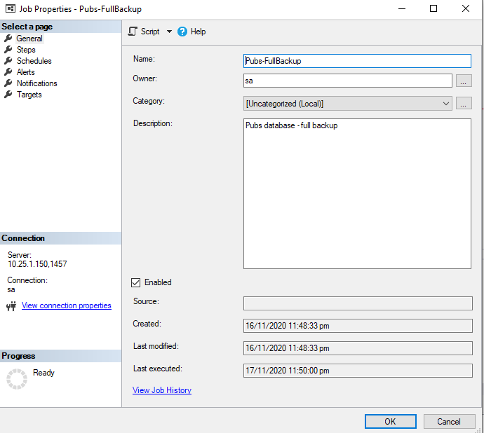

1. Add new step with name.

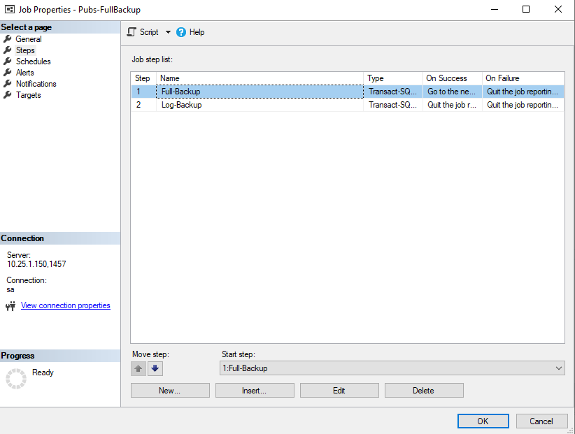

1. Enter script on the command dialog.

Eg:

BACKUP DATABASE Pubs TO DISK = '/var/opt/mssql/backups/pubs.bak'

GO

BACKUP LOG Pubs TO DISK = '/var/opt/mssql/backups/pubs.trn' WITH NORECOVERY

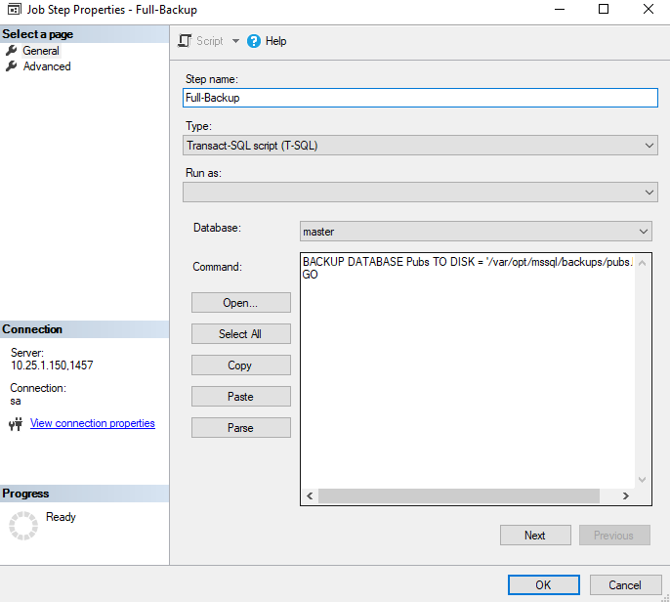

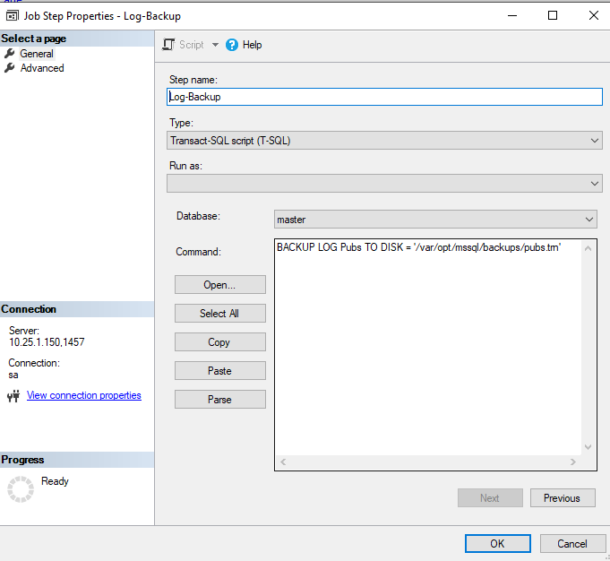

1. Select Schedule menu.

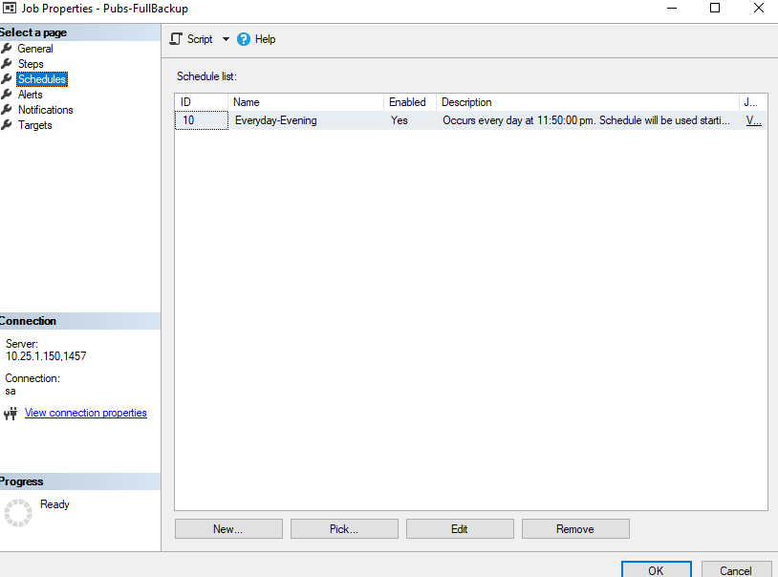

1. Add new schedule name, Frequency Daily, Occurs only at (Time) and start date.

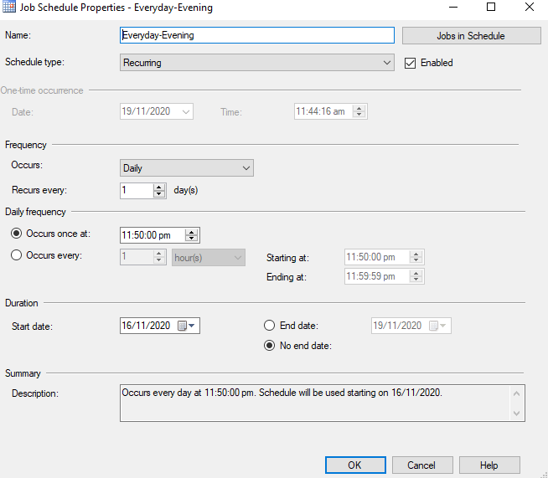

1. Give OK.

**Output:**

The SQL Server Agent will take backup according to the given scheduled time.

We can check the backup file at the given directory. I have created at docker container.

