# Week 13 Practical

# Duties of a DBA 10%

## Examine each of these carefully, screen captures and notes can be used as proof of completion. Perform any additional setup as required to complete these tasks.

* Check the previous night’s SQL Server database and transaction log backups and SQL Server Agent jobs for errors.

**SQL Server Agent – Auto backup:**

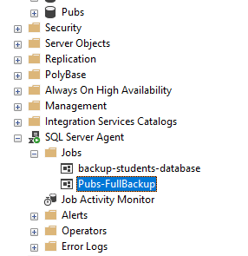

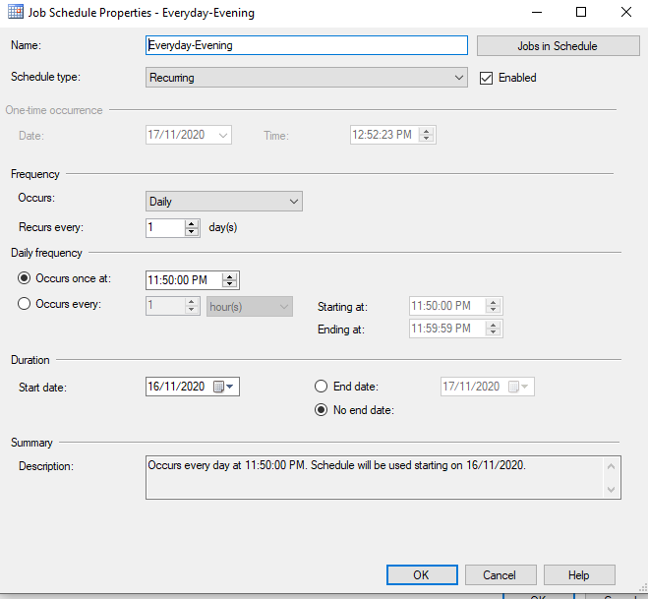

**Auto backup in docker container mssql server:**

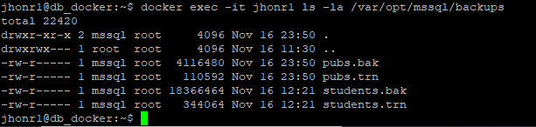

**SQL SERVER AGENT Error check:**

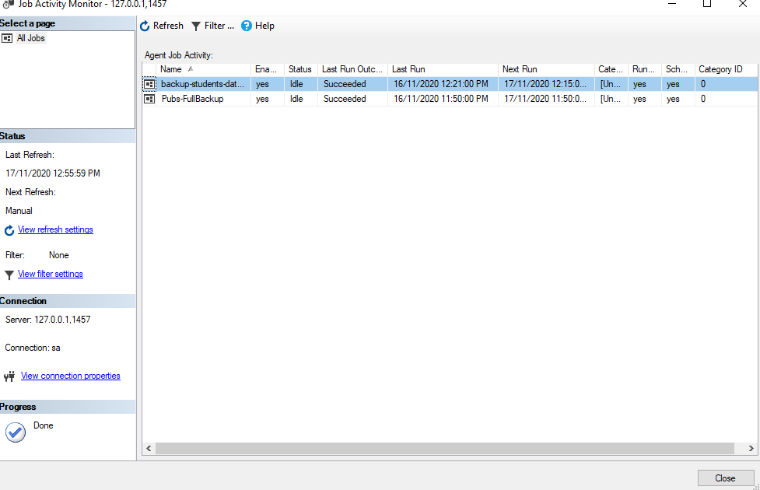

* Check all databases to make sure all are up and not marked as suspect. Check previous DBCC CHECKDB for errors.

**SCRIPT :**

**To get all databases one by one and run DBCC CHECKDB command.**

DECLARE @maximumRows int

DECLARE @currentRow int

DECLARE @_DBName nvarchar(100)

DECLARE @ExeTemp nvarchar(1000)

SET @maximumRows = (select Count(*) from sys.databases)

SET @currentRow = 1

WHILE @currentRow <= @maximumRows

BEGIN

WITH T1 AS

( SELECT

ROW_NUMBER() OVER(ORDER BY name) AS RowNumber, name

FROM sys.databases

)

SELECT @_DBName = name

FROM T1

WHERE RowNumber = @currentRow

SET @ExeTemp = 'USE ' + @_DBName + ' DBCC CHECKDB'

PRINT('Database: ' + @_DBName)

EXEC(@ExeTemp)

SET @currentRow += 1

END

**Output:**

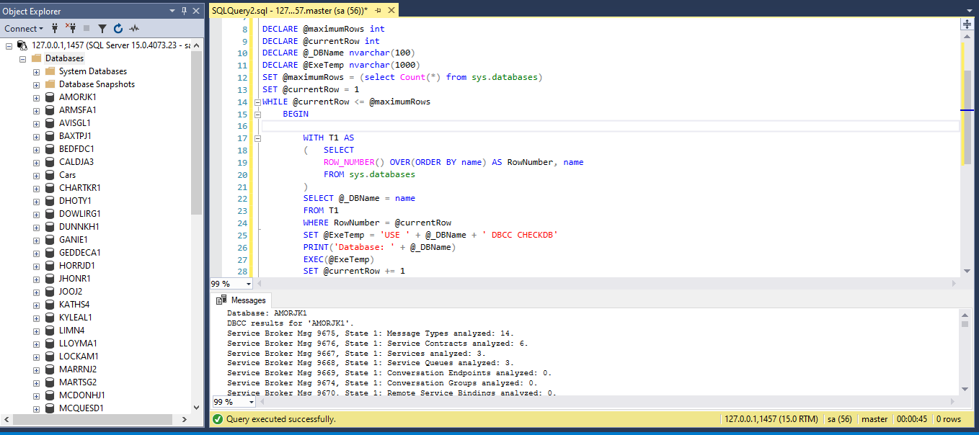

* Check SQL Server Log File entries for warnings and errors and determine if any entries warrant further investigation. Export and save the current log file.

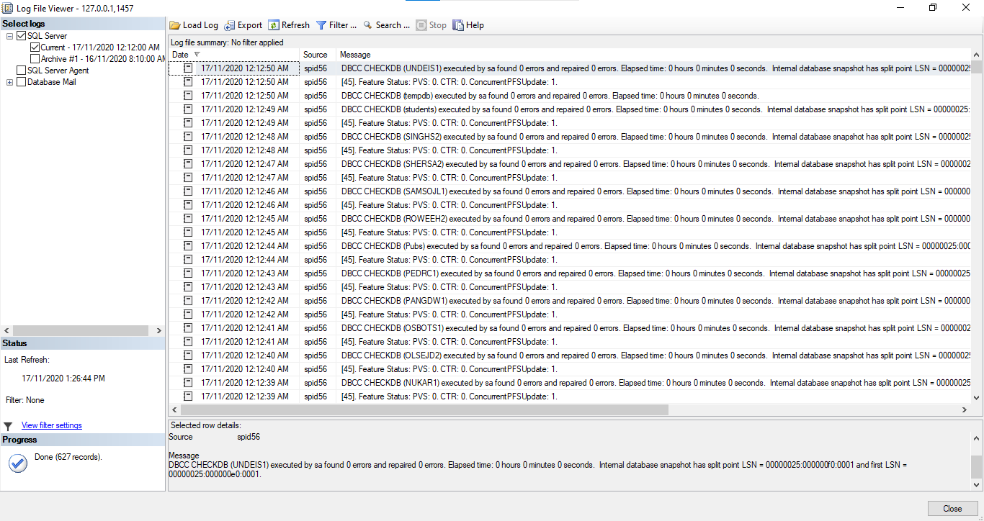

**Log file:**

LogFile-DBCC-CHECKDB.log

* Look for any security policy violations. Look for resources on the server, such as file sizes and disk space, and audit growth for long-term projections.
  1. Expand Security -> Audits -> New Audit
  2. Enter Audit name, Audit destination file path (/var/opt/mssql/data)
  3. Give OK.
  4. Right click the added Audit and select “Enable Audit”
  5. Success message will appear

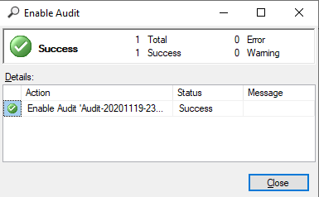

* 1. Check the Audit file in docker container.
  2. 
  3. Right click the Audit file in SSMS -> View Audit Logs

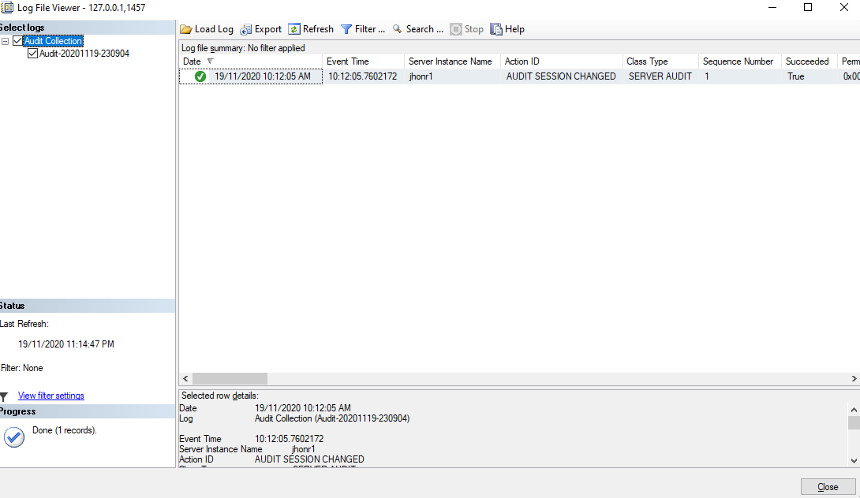

* Explore using long-running queries or tasks, Perfmon, etc. to generate data. Set up a sensible logging report to monitor disk and memory usage.

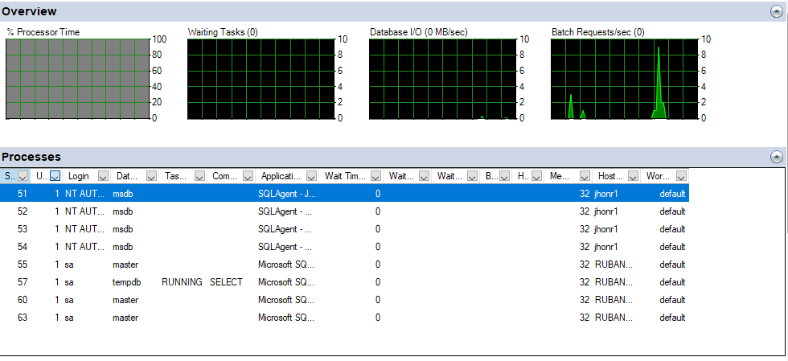

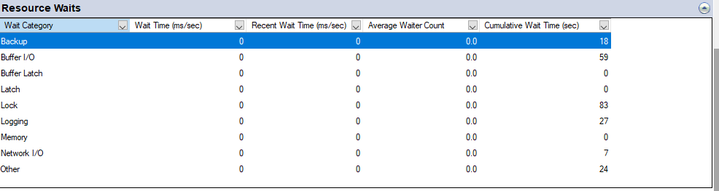

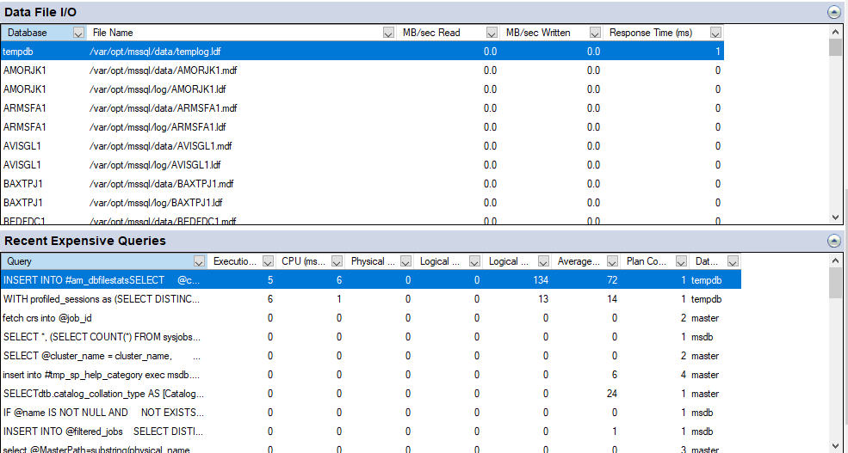

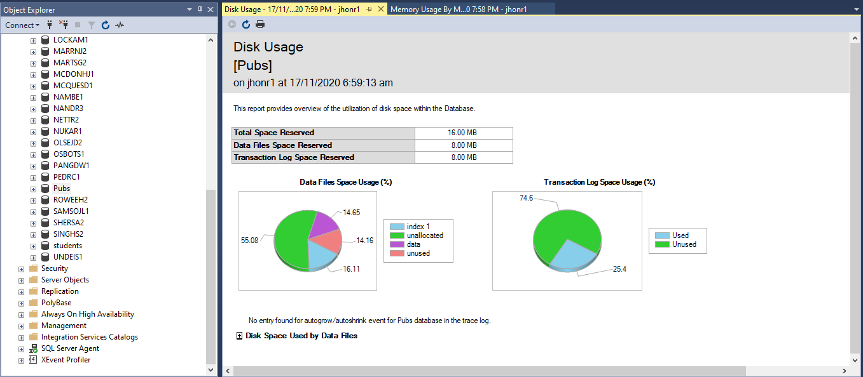

* What about your Container? What sort of usage data can you extract.

Run the command “docker stats jhonr1”



### Use your pubs database

DBA task

You want to recover a single table from a database backup – why?

It is the only table effected by a recent data loss.

Restoring an entire backup can take a significant amount of time, and you are under a lot of pressure to get it done fast

Perform the necessary data adjustments to check your solution is correct (delete rows etc). Provide an answer for each of the following scenarios:

1. The table still exists, but only some rows were deleted, restore the deleted data only.

Answer:

1. First I took backup of Pubs database.

BACKUP DATABASE Pubs TO DISK = '/var/opt/mssql/backups/pubs.bak'

1. Now I restored the Pubs database backup “pubs.bak” to a different name “Pubs_Restored”.

RESTORE DATABASE Pubs_Restored FROM DISK = '/var/opt/mssql/backups/pubs.bak'

WITH MOVE 'Pubs' TO '/var/opt/mssql/data/pubs_restored.mdf',

MOVE 'Pubs_log' TO '/var/opt/mssql/data/pubs_restored.ldf'

1. Now I had 2 databases Pubs, Pubs_Restored.
2. Now I needed to delete some rows in anyone of table which has primary key data type as “int”. So, I found that “jobs” table’s “job_id” has “int” data type.
3. In order to delete some rows in [Pubs].[dbo].[jobs], I needed to delete the foreign key in [Pubs].[dbo].[employee] table. So I deleted some rows in [Pubs].[dbo].[employee] (Eg: job_id = 4 and 5)

USE Pubs

GO

DELETE employee where job_id = 4

DELETE employee where job_id = 5

1. Now I can delete rows which has job_id = 4 and 5. So I deleted rows that matches job_id = 4, 5.

DELETE jobs where job_id = 4

DELETE jobs where job_id = 5

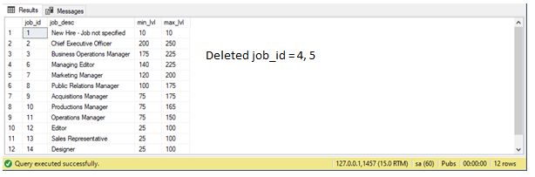

1. Then I executed the script, it checks the table [Pubs].[dbo].[jobs] with table [Pubs_Restored].[dbo].[jobs].
2. If jobs_id doesn’t match, it adds new row to [Pubs].[dbo].[jobs] table, else it updates [Pubs].[dbo].[jobs] table.

**SCRIPT:**

USE Pubs

GO

SET IDENTITY_INSERT jobs ON

MERGE jobs dest

USING (SELECT * FROM [Pubs_Restored].[dbo].[jobs] src) AS src

ON dest.job_id = src.job_id

WHEN MATCHED THEN UPDATE

SET dest.job_desc = src.job_desc, dest.min_lvl = src.min_lvl, dest.max_lvl = src.max_lvl

WHEN NOT MATCHED THEN INSERT

(job_id, job_desc, min_lvl, max_lvl) VALUES

(src.job_id, src.job_desc, src.min_lvl, src.max_lvl);

SET IDENTITY_INSERT jobs OFF

**RESULT AFTER RUNNING SCRIPT:**

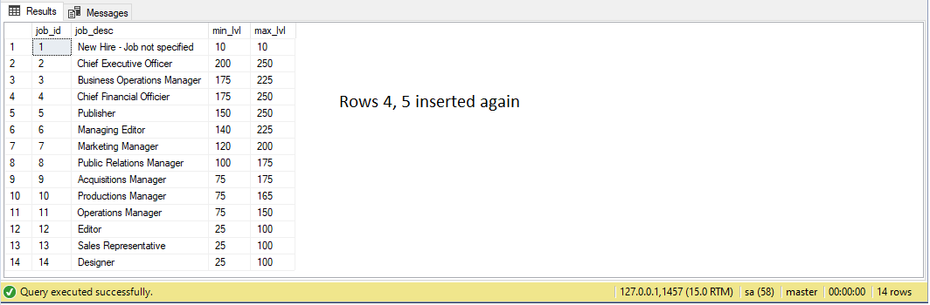

1. The table has been too badly damaged; restore the table structure and all the data.

Answer:

1. First I took backup of Pubs database.

BACKUP DATABASE Pubs TO DISK = '/var/opt/mssql/backups/pubs.bak'

1. Now I restored the Pubs database backup “pubs.bak” to a different name “Pubs_Restored”.

RESTORE DATABASE Pubs_Restored FROM DISK = '/var/opt/mssql/backups/pubs.bak'

WITH MOVE 'Pubs' TO '/var/opt/mssql/data/pubs_restored.mdf',

MOVE 'Pubs_log' TO '/var/opt/mssql/data/pubs_restored.ldf'

1. Now I had 2 databases Pubs, Pubs_Restored.
2. I updated some rows in [Pubs].[dbo].[employee] (Eg: job_id = 4 and 5)

USE Pubs

GO

UPDATE jobs set job_desc = 'Accounting Officer' where job_id = 4

UPDATE jobs set job_desc = 'Author' where job_id = 5

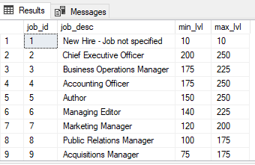

1. Then I executed the script, it checks the table [Pubs].[dbo].[jobs] with table [Pubs_Restored].[dbo].[jobs].
2. If jobs_id matches to [Pubs].[dbo].[jobs] table, it updates [Pubs].[dbo].[jobs] table.

**SCRIPT:**

USE Pubs

GO

SET IDENTITY_INSERT jobs ON

MERGE jobs dest

USING (SELECT * FROM [Pubs_Restored].[dbo].[jobs] src) AS src

ON dest.job_id = src.job_id

WHEN MATCHED THEN UPDATE

SET dest.job_desc = src.job_desc, dest.min_lvl = src.min_lvl, dest.max_lvl = src.max_lvl

WHEN NOT MATCHED THEN INSERT

(job_id, job_desc, min_lvl, max_lvl) VALUES

(src.job_id, src.job_desc, src.min_lvl, src.max_lvl);

SET IDENTITY_INSERT jobs OFF

**RESULT AFTER RUNNING SCRIPT:**

