🚀 Antigravity Sync Platform
Complete Developer Platform User Manual & Visual Guide

1. Platform Overview & Key Advantages
Antigravity Sync is an enterprise-grade monorepo developer workspace synchronization and automated machine onboarding platform. It replaces hours of manual developer environment setup—installing language runtimes, cloning repositories, installing package dependencies, setting up AI agent rules, and configuring IDE manifests—with a single click.
Advantage / Feature | Manual Machine Setup | Antigravity Sync Platform
Onboarding Duration | 4 to 8 Hours | 10 Seconds (1-Click)
System Prerequisites | Manual node, git, uv, agy CLI installs | Automated Pre-flight Background Runtime Installer
Framework Setup | Manual npm install, pod install, pip per repo | Automated React Native, Node, & Python Setup
Global & Team AI Rules | Manual configuration per project | Auto-injected ~/.gemini/config/AGENTS.md Header
User Memory & Workflow Sync | Fragmented / Lost across devices | Git-Style Line-by-Line Delta Sync (Excluding chats)
IDE Workspaces | Manual folder adding | Auto-registered ~/.gemini/config/projects/*.json
Background Sync Engine | Manual git pull across repos | Silent 15-Minute Background Engine & System Tray
Audit Log Diffs | None / Blind logs | Line-by-Line Colored Diff Inspector Modal (+ / -)

2. Step-by-Step User Flow Walkthrough

Step 1: Single-Click Download Portal
1. Open the company landing portal (sync.company.com or portal-website/index.html).
2. The website automatically detects your OS (Windows, macOS, or Linux).
3. Click 'Download for Windows (.exe Installer)' (or .dmg / .AppImage).

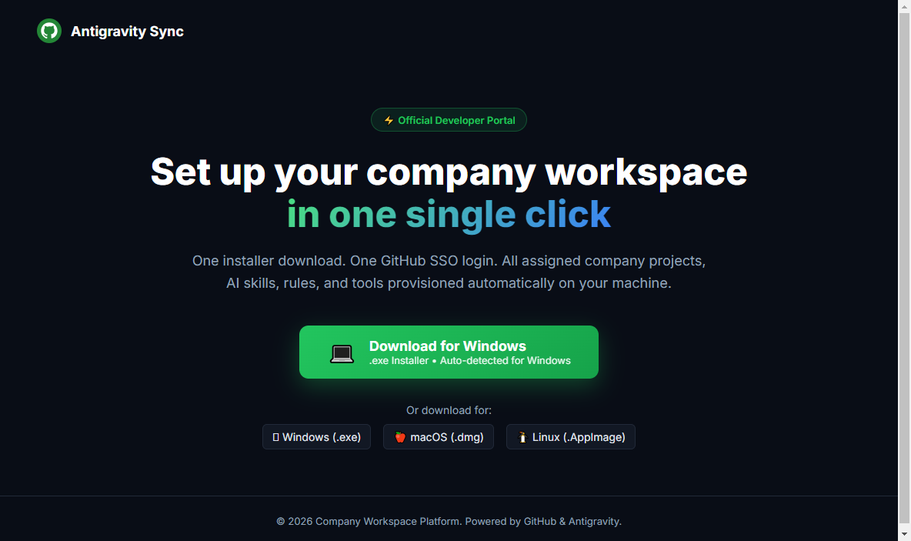
Figure 1: Actual Rendered Download Portal Web Page

Step 2: Desktop App Launch & 1-Click GitHub SSO Login
1. Install and launch the Antigravity Sync Desktop Application.
2. Click 'Sign in with GitHub'.
3. Complete browser OAuth authentication. Your token is encrypted in your OS Keychain (Windows Credential Vault / macOS Keychain).

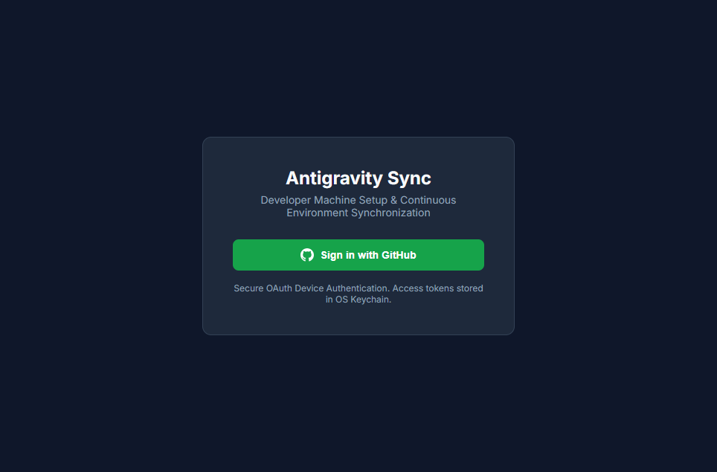
Figure 2: Actual Rendered Desktop Application UI

Step 3: Select Projects & Click 'Set Up My Machine'
1. In the 'My Projects' tab, toggle ON the projects you wish to set up on your machine.
2. Click the green 'Set Up My Machine' hero button.
3. Antigravity Sync automatically runs pre-flight runtime installation (Antigravity CLI, uv, Node.js, Git), clones repositories to ~/Projects/, provisions React Native/Node/Python environments, injects system memory rules, and registers workspace manifests in ~/.gemini/config/projects/.

Step 4: Inspect Synced File Diffs in Real Time
1. Open the 'Sync Status' tab.
2. Click 'Inspect Synced File Changes' on any log entry.
3. View exact line-by-line colored diffs (+ green additions / - red deletions) of provisioned rules, workflow skills, user memories, and project manifests!

3. Target Machine Directory Layout
~/Projects/ # (Windows: C:\Users\<User>\Projects\)
├── 📁 App Frontend/ # Cloned repository with installed dependencies
├── 📁 React Native Mobile App/ # Mobile repo with React Native rules & packages
└── 📁 Personal Side Project/ # Cloned personal repository
~/.gemini/
└── config/
├── AGENTS.md # Merged company guidelines & user memory header
├── mcp_config.json # Rendered MCP tool connections with secrets
├── hooks.json # Lifecycle automation hooks
├── memory/ # Personal user memories & learned preferences
├── skills/ # Team & personal workflow skills
└── projects/ # Registered project manifests for Antigravity IDE

