EWB CLOUD LABS – STUDENT PROJECT WORKBOOK
AWS VPC Peering Project
Connect two VPCs. Prove private connectivity.
Item | Detail
Name | Hindavi Sawardekar
Batch | 1
Project title | AWS VPC Peering Project
AWS Region | Asia Pacific (Sydney) – ap-southeast-2 (AZ ap-southeast-2a)
Completion date | 31st october 2026
Key pair / AMI / type | ewb-lab / Amazon Linux 2023 / t3.micro

1. Project Overview and Architecture
This project connects two non-overlapping AWS VPCs with a VPC peering connection so that two private EC2 instances can communicate over private IPv4 addresses. A single public bastion host in VPC A is the only internet-facing entry point and is used for administration. Both application servers have no public IP address.
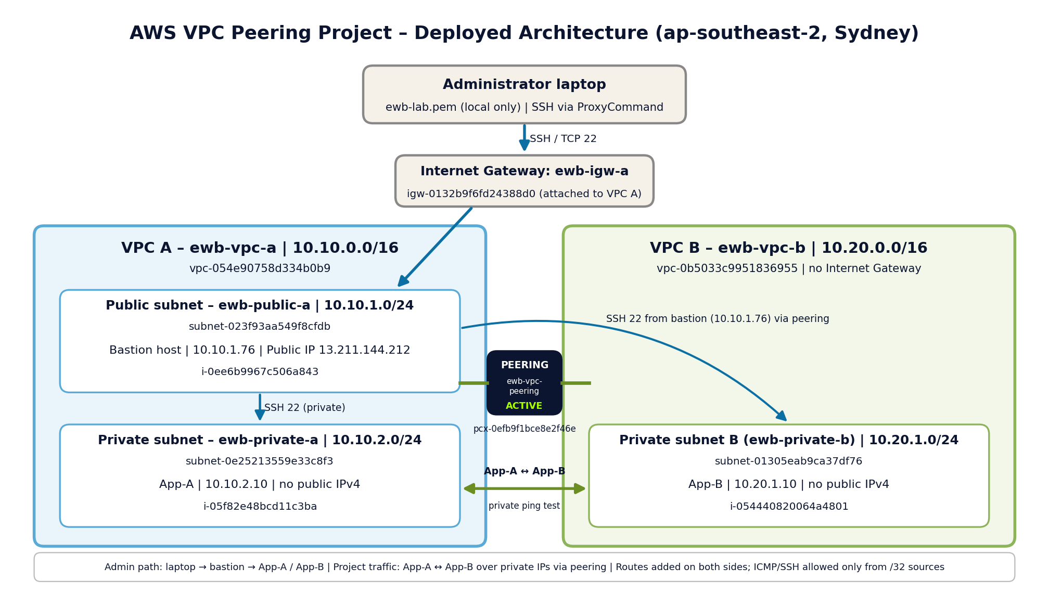
Figure 1: AWS VPC Peering Architecture

Traffic paths
- Administration: laptop → bastion (SSH 22) → App-A or App-B.
- Forward path: App-A (10.10.2.10) → peering connection → App-B (10.20.1.10).
- Return path: App-B → peering connection → App-A, using the matching route in the VPC B route table.

2. Resource Inventory and CIDR Configuration

VPCs and subnets
Resource | ID | CIDR | Notes
ewb-vpc-a | vpc-054e90758d334b0b9 | 10.10.0.0/16 | VPC A
ewb-public-a | subnet-023f93aa549f8cfdb | 10.10.1.0/24 | VPC A, public, bastion
ewb-private-a | subnet-0e25213559e33c8f3 | 10.10.2.0/24 | VPC A, private, App-A
ewb-vpc-b | vpc-0b5033c9951836955 | 10.20.0.0/16 | VPC B (no IGW)
Private Subnet B (ewb-private-b) | subnet-01305eab9ca37df76 | 10.20.1.0/24 | VPC B, private, App-B. No AWS Name tag was set; called ewb-private-b in this report

The VPC CIDR blocks 10.10.0.0/16 and 10.20.0.0/16 do not overlap, which is required to create the peering connection.

EC2 instances
Instance | Instance ID | Private IPv4 | Public IPv4 | Location / SG
Bastion | i-0ee6b9967c506a843 | 10.10.1.76 | 13.211.144.212 | ewb-public-a / ewb-bastion-sg
App-A | i-05f82e48bcd11c3ba | 10.10.2.10 | None | ewb-private-a / ewb-app-a-sg
App-B | i-054440820064a4801 | 10.20.1.10 | None | Private Subnet B / ewb-app-b-sg

Other resources
Resource | Name | ID
Internet Gateway | ewb-igw-a (attached to VPC A) | igw-0132b9f6fd24388d0
VPC Peering | ewb-vpc-peering | pcx-0efb9f1bce8e2f46e
Route table (VPC A public) | ewb-public-rt-a | rtb-0c6c95d099a575689
Route table (VPC A private) | ewb-private-rt-a | rtb-0d908d376768edac7
Route table (VPC B private) | ewb-private-rt-b | rtb-0e6e787405559f6b7
Security group | ewb-bastion-sg | sg-0e05b630e8ea01a93
Security group | ewb-app-a-sg | sg-0642480557ebfbad7
Security group | ewb-app-b-sg | sg-02e1d6f3c99f08277

3. Subnets and Route Tables
Each subnet has an explicit route table association. VPC peering does not add routes automatically, so a route to the peer CIDR was added in every relevant table.

3.1 Public route table – VPC A (ewb-public-rt-a)
Associated subnet: ewb-public-a (10.10.1.0/24). All routes Active.
Destination | Target | Purpose
10.10.0.0/16 | local | Bastion to App-A
0.0.0.0/0 | Internet Gateway (ewb-igw-a) | Bastion internet access
10.20.0.0/16 | Peering (pcx-0efb9f1bce8e2f46e) | Bastion reaches VPC B
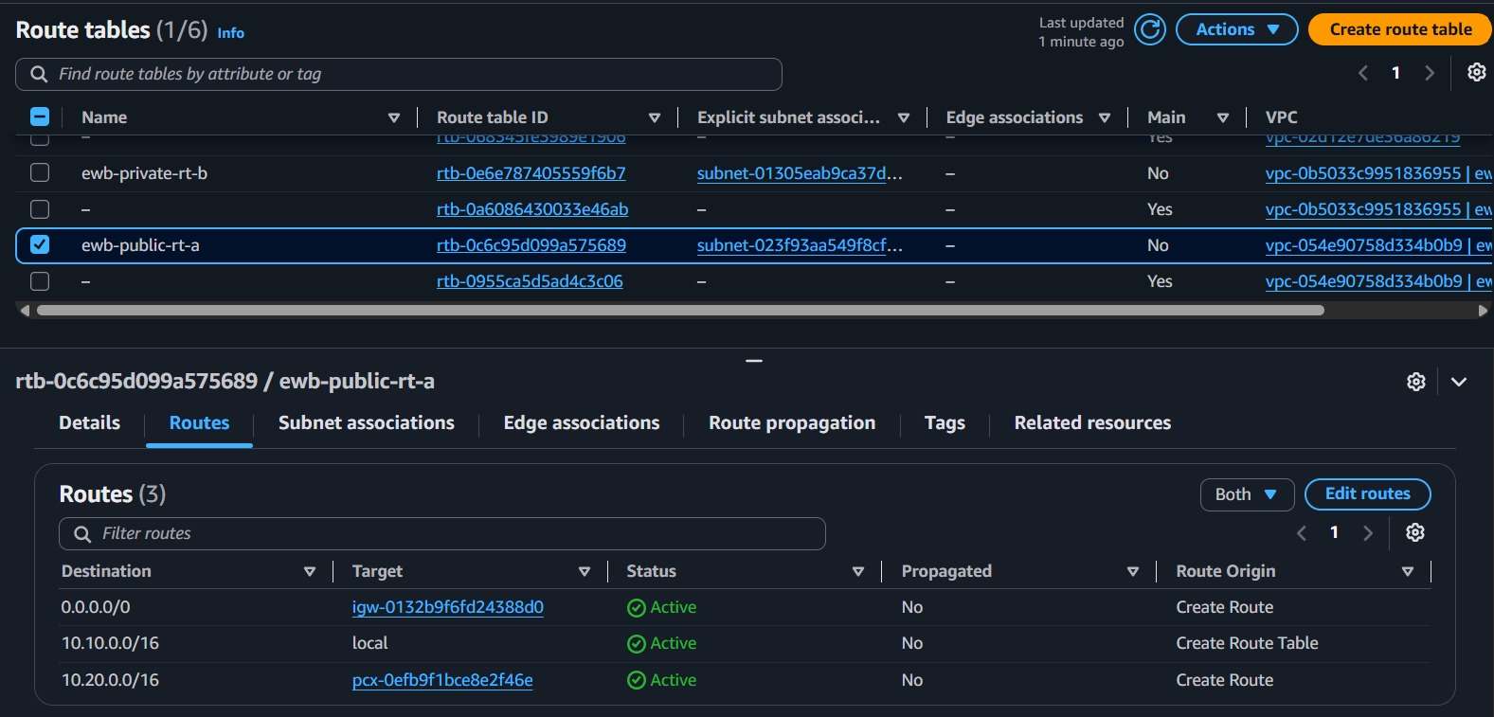
Figure 2: ewb-public-rt-a routes (VPC A public)

3.2 Private route table – VPC A (ewb-private-rt-a)
Associated subnet: ewb-private-a (10.10.2.0/24). All routes Active. No internet route.
Destination | Target | Purpose
10.10.0.0/16 | local | Existing VPC A route
10.20.0.0/16 | Peering (pcx-0efb9f1bce8e2f46e) | App-A to VPC B (forward path)
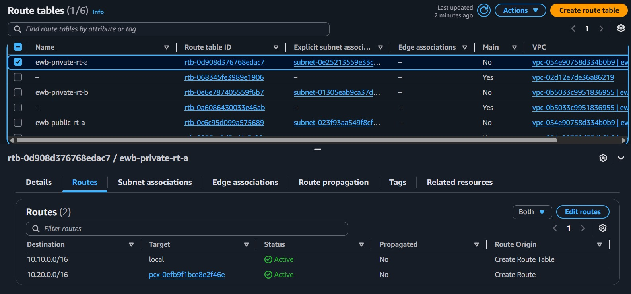
Figure 3: ewb-private-rt-a routes (VPC A private)

3.3 Private route table – VPC B (ewb-private-rt-b)
Associated subnet: Private Subnet B (10.20.1.0/24). All routes Active.
Destination | Target | Purpose
10.20.0.0/16 | local | Existing VPC B route
10.10.0.0/16 | Peering (pcx-0efb9f1bce8e2f46e) | Return path to VPC A
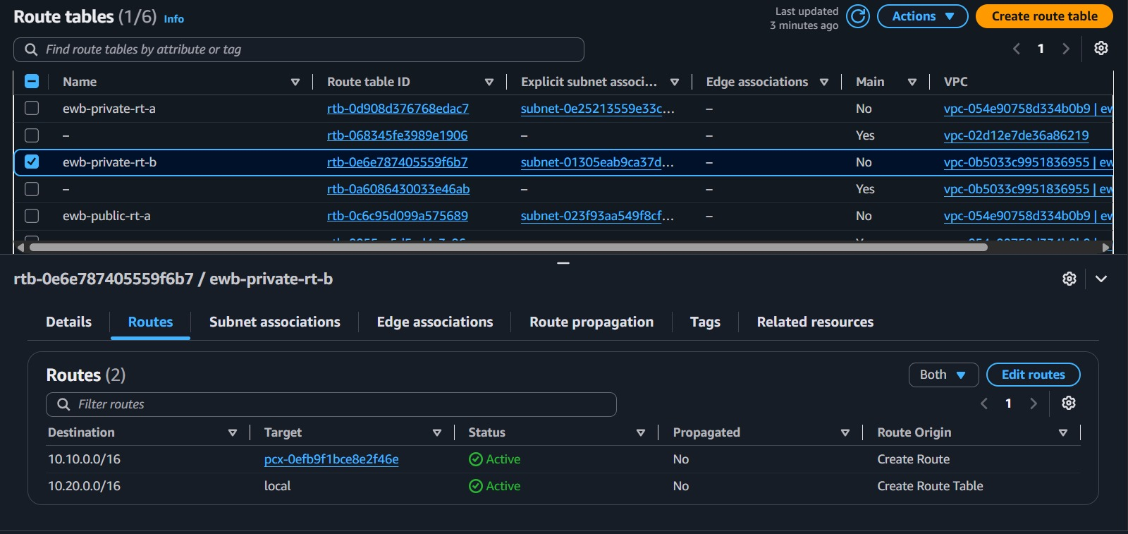
Figure 4: ewb-private-rt-b routes (VPC B private)

4. VPC Peering Connection
The peering connection ewb-vpc-peering (pcx-0efb9f1bce8e2f46e) connects requester VPC A (10.10.0.0/16) and accepter VPC B (10.20.0.0/16) in the same account and Region. The request was accepted and the status is Active. Active peering alone does not prove reachability; routes and security groups must also allow the traffic (see sections 6 and 7).
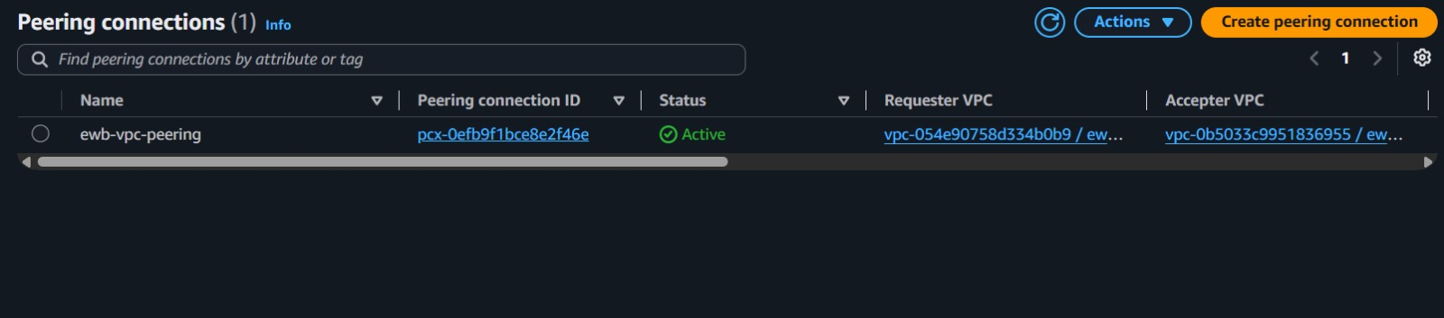
Figure 5: VPC peering connection showing Active status

5. Security Group Configuration
Inbound access is limited to individual hosts using /32 sources. SSH and ICMP are not open to 0.0.0.0/0. Default outbound allow-all rules were kept. Security groups are stateful, so replies to permitted traffic are allowed automatically.
Security group | Type / port | Source | Purpose
ewb-bastion-sg | SSH / TCP 22 | My public IPv4 /32 | Admin entry point
ewb-app-a-sg | SSH / TCP 22 | 10.10.1.76/32 (bastion) | SSH via bastion
ewb-app-a-sg | All ICMP – IPv4 | 10.20.1.10/32 (App-B) | Ping from App-B
ewb-app-b-sg | SSH / TCP 22 | 10.10.1.76/32 (bastion) | SSH via bastion
ewb-app-b-sg | All ICMP – IPv4 | 10.10.2.10/32 (App-A) | Ping from App-A

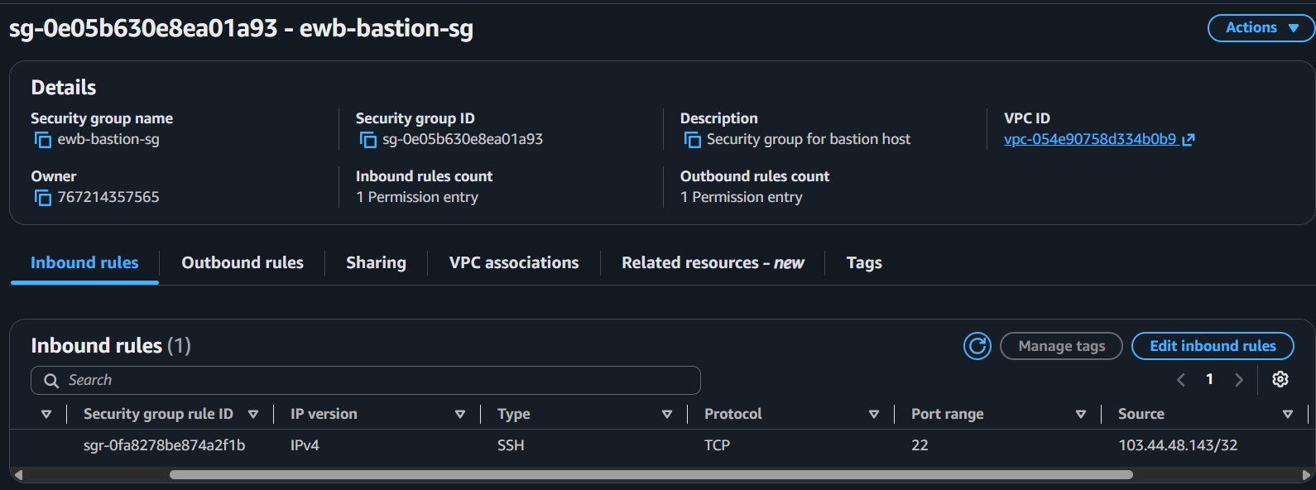
Figure 6: ewb-bastion-sg inbound rules
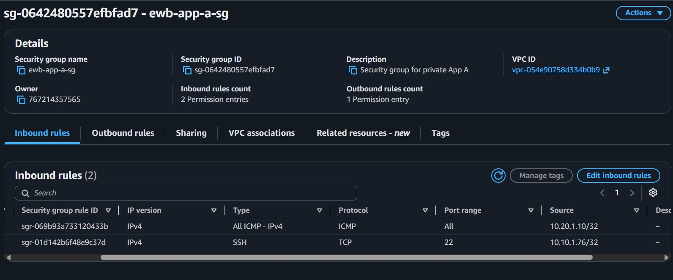
Figure 7: ewb-app-a-sg inbound rules
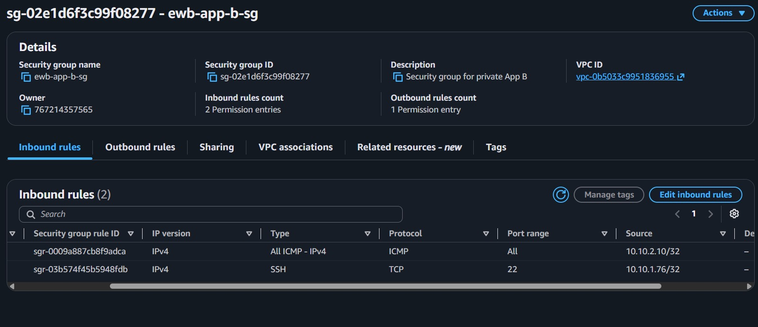
Figure 8: ewb-app-b-sg inbound rules

6. Connectivity Testing

6.1 SSH access through the bastion host
SSH access to the bastion host (13.211.144.212) and then to the private instances worked from the local Windows machine. The private key stayed on the local machine and was never copied to any instance. Evidence is in the terminal screenshots in sections 6.2 and 7, which show shells on App-A (ip-10-10-2-10) and App-B (ip-10-20-1-10), both reached through the bastion; the App-A login banner shows the last login came from the bastion private IP 10.10.1.76. A separate screenshot of the bastion login was not captured.
Initial ProxyJump/direct attempts to the private instances returned a permission denied error. Reaching the authentication stage showed routing and security groups were working, so the issue was with how the key was being presented. The working method was SSH ProxyCommand from PowerShell on the local machine:
ssh -i .\ewb-lab.pem -o "ProxyCommand=ssh -i .\ewb-lab.pem -W %h:%p ec2-user@13.211.144.212" ec2-user@10.10.2.10

6.2 Private ping tests
Both tests use private destination IPs and show four replies with 0% packet loss. The second screenshot is taken on App-B (prompt ip-10-20-1-10), which also shows shell access to App-B through the bastion; no separate SSH screenshot was captured for App-B.
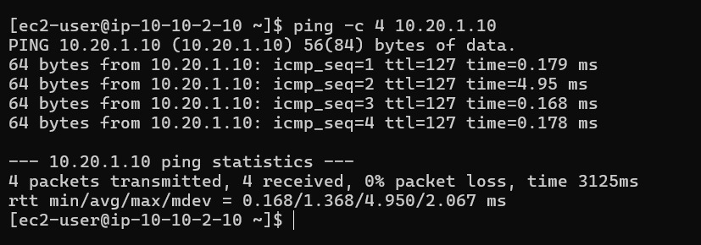
Figure 9: App-A → App-B: successful ping (forward path)
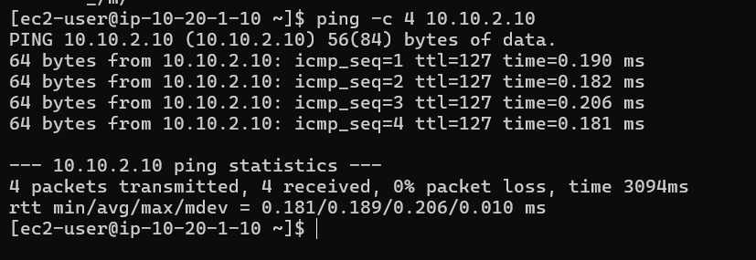
Figure 10: App-B → App-A: successful ping (return path)

6.3 Isolation check
App-A and App-B were launched with no public IPv4 address, as listed in the inventory in section 2; only the bastion has a public IP. A screenshot of the EC2 instance details for this check was not captured.

6.4 Evidence note: baseline test
The workbook asks for a baseline ping failure before peering exists. This baseline was not captured before the peering connection was created, so no baseline result is presented. Negative-test evidence is provided by the controlled security group failure in section 7.

7. Controlled Failure and Recovery

Failure
The inbound ICMP rule on ewb-app-b-sg (source 10.10.2.10/32) was temporarily removed. The SSH rule was kept. The screenshot's login banner (last login from 10.10.1.76) confirms the session reached App-A via the bastion. Pinging 10.20.1.10 from App-A (10.10.2.10) then produced 4 packets transmitted, 0 received, 100% packet loss. This shows that peering and correct routes are not enough on their own: the destination security group must also permit the traffic.
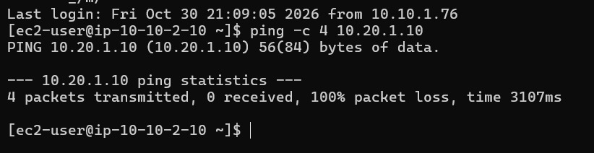
Figure 11: Controlled failure: App-A → App-B ping fails (ICMP rule removed)
A screenshot of the security group page at the moment the rule was removed was not captured; the failed ping is the evidence of the failure.

Recovery
The ICMP rule was restored on ewb-app-b-sg with source 10.10.2.10/32. The ping was repeated and connectivity returned.
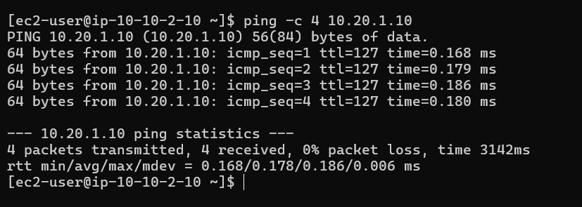
Figure 12: Recovery: App-A → App-B ping succeeds (ICMP rule restored)

8. Cleanup Evidence
All screenshots and this report were saved before any cleanup. Cleanup had not been completed at the time this report was submitted, because the AWS console was not responding, so no cleanup screenshots are included. The lab resources (three EC2 instances, the peering connection, security groups, subnets, route tables, the internet gateway and both VPCs) are to be deleted after submission to avoid charges.

9. Lessons Learned and Conclusion
- VPC CIDR blocks must not overlap for peering.
- VPC peering does not configure routes automatically.
- Routes are needed on both sides so requests and replies can both travel.
- Security groups can block traffic even when peering and routing are correct (shown by the controlled failure).
- A bastion host gives controlled administrative access to private instances without giving them public IPs.
- Controlled failure and recovery testing verifies that each security rule has a purpose.

Short answers to the workbook questions
Why is the return route needed? Replies from App-B must find their way back to 10.10.0.0/16, so VPC B needs a route to VPC A through the peering connection.
Why is the App-B SSH source the bastion private IP? The bastion opens the connection to App-B from inside VPC A, so App-B sees the bastion's private address (10.10.1.76) as the source.
Why does Active peering not guarantee a successful ping? Peering is only the link. Route tables and destination security group rules still decide whether packets are delivered.
Can VPC B use VPC A's internet gateway over peering? No. Peering does not provide transitive internet access, and VPC B has no internet gateway.

Conclusion
Two private VPCs were connected using VPC peering, three custom route tables and least-privilege security groups. Private communication was verified in both directions, administration was done only through a bastion host, and a controlled failure and recovery showed how security groups gate peered traffic.

