**A MONTE CARLO MODEL OF THE EXOSPHERE OF SATURN’s MOON, RHEA**

Lin Tu,1 Wing-Huen Ip1,2

*1Institute of Space Science, National Central University, Taiwan*

*2Institute of Astronomy, National Central University, Taiwan*

E-mail: 100623012@cc.ncu.edu.tw

**Abstract**

From the Cassini observations, it was found that carbon dioxide and oxygen exist in Rhea’s exosphere. Their origin might have to do with ion sputtering, meteorite impact vaporization, photodesorption, and surface thermal sublimation. We use a Monte Carlo method to construct a three dimensional model of the exosphere of Rhea which can, in turn, be used to study the corresponding magnetospheric interaction.

**Introduction**

Since Rhea's exosphere was found composed of oxygen and carbon-dioxide by Cassini [B.D. Teolis et al., 2010], the mechanics of loss and formation of Rhea’s exosphere have been paid more attention. According to Cassini’s data (Fig.1 and Fig.2), the density vs. altitude distri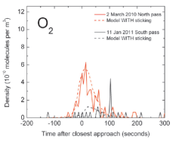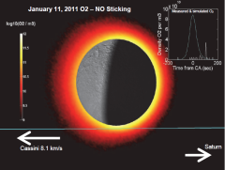bution of Rhea’s exosphere also changes between different seasons [B. D. Teolis et al., 2011] because of the different inclinations of incident solar radiation. In turn, solar radiation plays an important role in the formation of Rhea’s exosphere, the icy mantles may be determined in part by the photodesorption by ultraviolet radiation [M.S. Westley et al.,1995], sputtering the oxygen and carbon dioxide into the exosphere, in the exosphere the molecules do with a bounce motion. Considering of the chemical sputtering and electronic sputtering, the molecules would be ionized by solar radiation [Brown et al., 1984], and that is one of the loss mechanics of O2 in the exosphere.

|  |  |  |  |
| --- | --- | --- | --- |
| **Symbol** | **Physical meaning** | **Amount** | |
| S | solar radiation at the equator of Rhea | 16.7099 | |
| A | surface albedo | 0.05 | |
|  | Latitude | | |
|  | Longitude | | |
|  | Stefan-Boltzmann constant | | 5.6704*10-8 |
| k | thermal conductivity | | 6*10-4 |
| T | Temperature | |
|  | mass density | | 1.25*10-3] |
|  | specific heat | | 670 |

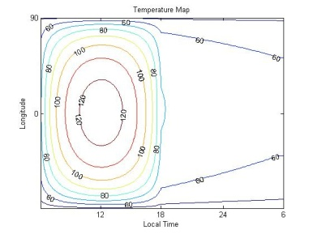

**Model**

1. Thermal Model

The temperature map Fig.3 is derived by the followed equations:

**Fig. 8**

.

The temperature is derived between z=0 and z= -1 meter and using the Crank-Nicolson finite difference routine.

The boundary condition is:

1. Source Mechanics and Loss mechanics

When the solar radiation interacts with the surface mental, oxygen would be sputtered into Rhea’s exosphere because of the photodesorption.

After the molecular oxygen has absorbed solar radiation during a time interval (lifetime), it would be ionized by solar X-rays. For the case of CO2, the sublimation occurs when the temperature is higher than 80K, and CO2 would condense again when temperature is lower than 60K.

|  |  |  |
| --- | --- | --- |
|  | CO2 | O2 |
| Sources | Polar cap  Dawn side | Day side |
| Formation mechanics | Sublimation | Photodesorption by UV |
| Loss mechanics  **Fig. 3** | Thermal escape  Photo-dissociation  Photo-ionization  Condensation | Thermal escape |

Tab.2 is the source and loss mechanics of the exospheric molecules, and the chemical process is as followed:

**Photodesorption :**

H2O + hH+OH

OH+OHH2O+O

O+OHO2+H

**Photo-ionization**

O2+ h O2++ e-

1. Monte Carlo method

The initial position of a particle is randomly chosen within the source region. Both the zenith angle and azimuth angle are also determined randomly.

And then we choose the velocity randomly from the maxwellian distribution of the local temperature, 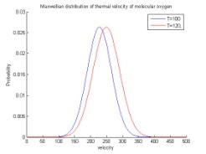Fig.4 is the thermal velocity of molecular oxygen when the temperature is 100 and 120K. We use the followed equations to find out the velocity of each molecular oxygen to do the bounce motion.

R is randomly chosen from 1 to k

**Result**

On Rhea, the scale height of its exosphere i100km-170km

Fig.6 Oxygen exosphere locates at the latitude ~ 0.4

The upper boundary is the horizon of Rhea, we can figure out the altitude is in the range of the scale height. Fig.7 describes the density of the different latitude at local time is 9:00, Fig.8 describes the condense CO2 density at the surface. Fig.9 describes altitude vs. latitude at local time = 12:00.

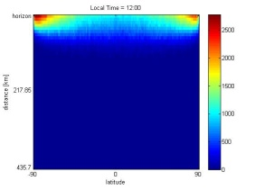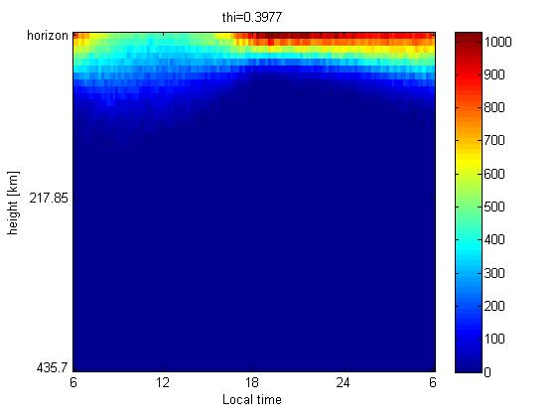

V

Fig.6

Fig.6

Fig.7

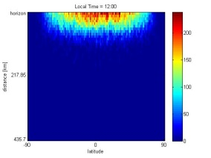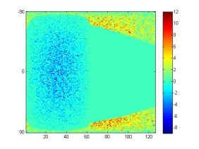

Fig.8 Fig.9

**Summary**

This model describes the bounce motion of molecular oxygen and carbon dioxide based on thermal velocity,

**Future Work**

The thermal model do not consider about the sublimation. If the local sublimation rate is derived, the density of the exosphere would be more accurate.

This model can be used in other planets, such as Dione, Triton, and Tethys.

**Reference**

Wang, Y.C., Ip, W.H. A surface thermal model and exospheric ballistic transport of planet Mercury, 2008.

M.S. Westley, R.A. Baragiola, R.E. Johnson & G. A. Baratta. Photodesorption from low-temperature water ice in interstellar and circumsolar grains, 1995

B. D. Teolis and J. H. Waite. Cassini discovers seasonal changes in Rhea’s exosphere, 2011.