**A MONTE CARLO MODEL OF THE EXOSPHERE OF SATURN’s MOON, RHEA**

Lin Tu (塗翎),1 Wing-Huen Ip1,2(葉永烜)

*1Institute of Space Science, National Central University, Taiwan*

*2Institute of Astronomy, National Central University, Taiwan*

E-mail: 100623012@cc.ncu.edu.tw

Abstract

From the Cassini observations, it was found that carbon dioxide and oxygen exist in Rhea’s exosphere. Their origin might have to do with ion sputtering, meteorite impact vaporization, photodesorption, and surface thermal sublimation. We use a Monte Carlo method to construct a three dimensional model of the exosphere of Rhea which can, in turn, be used to study the corresponding magnetospheric interaction.

Introduction

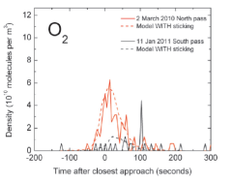  
Since the discovery of Rhea's O2 and CO2 exosphere by the Cassini observations (Teolis et al., 2010), much attention has been paid to the source and loss mechanisms of these atmospheric components. Recent work by Teolis et al. (2011) pointed out that Rhea's exospheric content also displays significant seasonal variation. This is because solar radiation plays an important role in the production of Rhea's exosphere via photosputtering and desorption of O2 and CO2 from the icy surface of this satellite. The goal of the present work is to construct a Monte Carlo model to simulate the bounce motion of the gas molecules across Rhea's surface once released until being lost to photodissociation or photoionization. From a statistical study of the orbital distribution of the test particles, the density distribution of O2 and CO2, respectively, could be computed.

**Figure.1**

The molecular oxygen density distribution is from 2010 and 2011 Cassini’s data. (From Teolis, 2011)

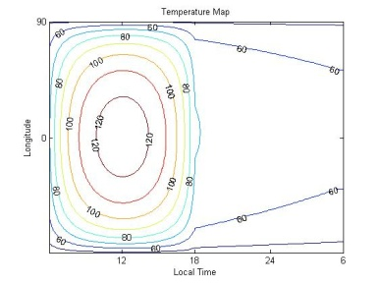Model

1. Thermal Model

The temperature map Fig.3 is derived by the followed equations:

**Figure. 2**

This contour describes the temperature map of Rhea.

|  |  |  |
| --- | --- | --- |
| **Symbol** | **Physical meaning** | **Amount** |
| S | solar radiation at the equator of Rhea | 16.7099 |
| A | surface albedo | 0.05 |
|  | Latitude | |
|  | Longitude | |
|  | Stefan-Boltzmann constant | 5.6704*10-8 |
| k | thermal conductivity | 6*10-4 |
| T | Temperature | |
|  | mass density | 1.25*10-3] |
|  | specific heat | 670 |

The temperature is derived between z=0 and z= -1 meter and using the Crank-Nicolson finite difference routine.

The boundary condition is:

**Table. 1**

The physical meaning of this thermal model

1. Source Mechanics and Loss mechanics

When the solar radiation interacts with the icy surface, oxygen would be sputtered into Rhea’s exosphere because of the photodesorption.

After the molecular oxygen has absorbed solar radiation during a certain time interval (lifetime), it would be ionized by solar UV and x-rays. For the case of CO2, the sublimation occurs when the temperature is higher than 80K, and CO2 would condense again when temperature is lower than 60K.

|  |  |  |
| --- | --- | --- |
|  | CO2 | O2 |
| Sources | Temperature>80K | Day side |
| Formation mechanics | Sublimation | Photodesorption by UV |
| Loss mechanics | Thermal escape  Photo-dissociation  Photo-ionization  Condensation | Thermal escape |

**Photodesorption :**

H2O + hH+OH

OH+OHH2O+O

O+OHO2+H

**Photo-ionization**

O2+ h O2++ e-

**Table. 2**

This is the source and loss mechanics of the exospheric molecules.

1. Monte Carlo method

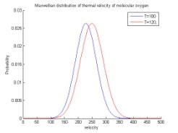The initial position of a particle is randomly chosen within the source region. Both the zenith angle and azimuth angle are also determined randomly.

And then we choose the velocity randomly from the maxwellian distribution of the local temperature, We use the following equations to find out the velocity of molecular oxygen to do the bounce motion.

**Figure.5**

Here is the maxwellian distribution of O2 and CO2’s thermal velocity when temperature is 100K and 120K.

, R is randomly chosen from 1 to j (we set j=12).

Result

On Rhea, the scale height of its exosphere i100km-170km

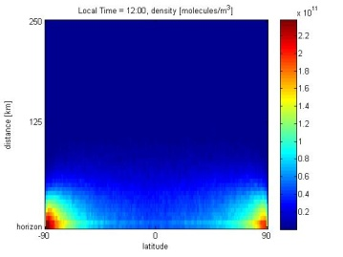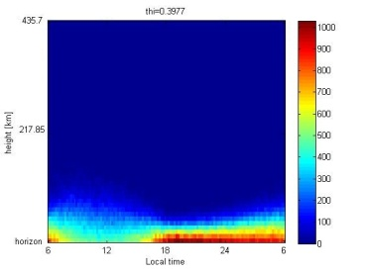

**Figure. 7**

This profile describes the density of the different latitude at local time is 9:00.

**Figure. 6**

Oxygen exosphere locates at the latitude ~ 22.9o, we can figure out the altitude is in the range of the scale height.

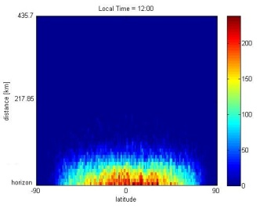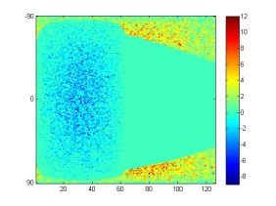

**Figure. 9**

This profile describes the CO2 density of altitude vs. latitude at local time = 12:00.

**Figure. 8**

This describes the condensing CO2 density at Rhea’s surface.

Summary & Future Work

This model describes the bounce motion of molecular oxygen and carbon dioxide based on thermal velocity, and

The thermal model do not consider about the sublimation of CO2. If the local sublimation rate is clear, the density of the exosphere would be more accurate.

This model can be used in other planets, such as Dione, Triton, and Tephis.

Reference

Y.C., Wang, W.H., Ip. A surface thermal model and exospheric ballistic transport of planet Mercury, 2008.

Baragiola, R.A., Baratta, G.A., Johnson, R.E., Westley M.S. Photodesorption from low-temperature water ice in interstellar and circumsolar grains, 1995.

Teolis, B. D. and Waite, J. H. Cassini discovers seasonal changes in Rhea’s exosphere, 2011.

Teolis,B.D., Jones, G.H., Miles, P.F., Tokar, R.L., Magee1,B.A., Waite1, J. H.,Roussos, E., Young, D.T., Crary, F.J., Coates, A. J., Johnson, R.E., W.-L., Tseng, Baragiola, R.A.