**Universidad Tecnológica de México**

**Verduzco López Rubén**

**Ing. Sistemas Computacionales**

**Ingeniería de Software**

**Miguel Ángel Rafael Arellano**

**Práctica 3**





UNIVERSIDAD TECNOLOGICA DE MÉXICO

|  |  |  |  |
| --- | --- | --- | --- |
| **Nombre de la Materia** | **Nombre del Profesor** | **No. Practica** | **Fecha** |
| Ingeniería de Software | Miguel Ángel Rafael Arellano | 3 | 09-Febrero-19 |

**Normas de seguridad del laboratorio de cómputo:**

No colocar sobre la mesa botellas de agua, No usar gorras, utilizar el celular solo en caso de emergencia, entregar el equipo de cómputo como lo recibimos, a esto se refiere conectar los cables que desconectamos (monitor, PC), colocar el mouse sobre el gabinete, acomodar las sillas, recoger la basura y depositarla en un recolector.

**Manejo de Modelos Orientado a Objetos**

**Practica**

**Introducción**

La **Programación Orientada a Objetos (POO u OOP**) es un paradigma de programación que define los programas en términos de “clases de objetos”, objetos que son entidades que combinan **estado** (propiedades o datos), **comportamiento** (procedimientos o *métodos*) e **identidad** (propiedad del objeto que lo diferencia del resto).

La programación orientada a objetos expresa un programa como un conjunto de estos objetos, que **colaboran** entre ellos para realizar tareas. Esto permite hacer los programas y módulos más fáciles de escribir, mantener y reutilizar.

Un **objeto** contiene toda la información que permite definirlo e identificarlo frente a otros objetos pertenecientes a otras clases (e incluso entre objetos de una misma clase, al poder tener valores bien diferenciados en sus atributos). A su vez, dispone de mecanismos de interacción (los llamados métodos) que favorecen la comunicación entre objetos (de una misma clase o de distintas), y en consecuencia, el cambio de estado en los propios objetos. Esta característica lleva a tratarlos como unidades indivisibles, en las que no se separan (ni deben separarse) información (datos) y procesamiento (métodos).

Las **clases** son declaraciones o abstracciones de objetos, lo que significa, que una clase es la definición de un objeto. Cuando se programa un objeto y se definen sus características y funcionalidades, realmente se programa una clase.

**Objetivos:**

* El alumno analiza los enunciados planteados para identificar los requerimientos de la base de datos.
* El alumno aplica sus conocimientos de programación estructurada, para realizar la base de datos.
* El alumno realiza la construcción de los modelos que representa el sistema.

**Competencias**

1.-El alumno fortalece su pensamiento analítico, conocimientos de base de datos y conocimientos de programación estructurada.

2.- El alumno utiliza y crea modelos para representar el sistema.

**Actividad 1**

Desarrolle una aplicación donde se utilice el concepto de clases para definir las características y estado de salud de una persona. Los atributos que se deben considerar son los siguientes:

Nombre, Ocupación, Lugar de Estudio, Profesión, Peso, Estatura, Edad.

Crear una clase para calcular el IMC (índice de masa corporal), además determinar si es profesionista y si cuenta con la mayoría de edad.

**Actividad 2**

Realice un programa en C++, de tal manera que se construya una solución para la jerarquía(herencia) de clases mostrada en la siguiente figura:

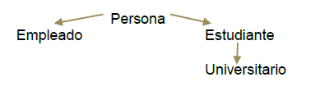

**Resultados.**

Para cada ejercicio se debe agregar el código de las clases, además de las pantallas de resultados que muestra la ejecución de cada programa.

**Actividad 1**

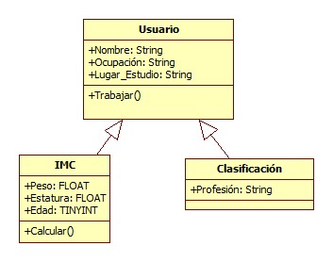

/*

* To change this license header, choose License Headers in Project Properties.

* To change this template file, choose Tools | Templates

* and open the template in the editor.

*/

package practica3A;

import java.awt.event.KeyEvent;

/**

*

* @author Rubén

*/

public class Calcular_Imc extends javax.swing.JFrame {

Persona p = new Persona();

/**

* Creates new form Calcular_Imc

*/

public Calcular_Imc() {

initComponents();

this.setTitle("Calcular Imc");

txt_titulo.setText("Calcular Imc");

jLabel1.setText("Nombre:");

jLabel2.setText("Ocupación:");

jLabel3.setText("Lugar de estudio:");

ch_profesion.setText("Profesión");

jLabel5.setText("Peso:");

jLabel6.setText("Estatura:");

jLabel7.setText("Edad");

txt_imc.setText("IMC:");

txt_profesion.setText("Profesión:");

txt_mayor.setText("Mayor de edad:");

b_guardar.setText("Guardar");

b_limpiar.setText("Limpiar");

ch_profesion.isSelected();

}

public void Guardar() {

try {

p.setNombre(txf_nombre.getText());

p.setOcupacion(txf_ocupacion.getText());

p.setLugar_de_estudio(txf_lugar_de_estudio.getText());

p.setPeso(Float.parseFloat(txf_peso.getText()));

p.setEstatura(Float.parseFloat(txf_estatura.getText()));

p.setEdad(Byte.parseByte(txf_edad.getText()));

if(ch_profesion.isSelected())

{

p.setProfesion(txf_profesion.getText());

txt_profesion.setText("Profesión: "+p.getProfesion());

}

else

txt_profesion.setText("Profesión: No tiene.");

txt_imc.setText("IMC: "+p.CalculoIMC());

txt_mayor.setText(p.Checar_Edad());

} catch (Exception ex) {

System.out.println("Error: "+ex);

}

}

public void Teclado(int teclado) {

if (teclado == KeyEvent.VK_ENTER) {

Guardar();

}

}

public void Limpiar() {

// Limpiar cálculo IMC

txt_imc.setText("IMC:");

// Limpiar jTextField

txf_nombre.setText("");

txf_ocupacion.setText("");

txf_lugar_de_estudio.setText("");

txf_peso.setText("");

txf_estatura.setText("");

txf_edad.setText("");

txf_profesion.setText("");

txt_profesion.setText("Profesión:");

}

/**

* This method is called from within the constructor to initialize the form.

* WARNING: Do NOT modify this code. The content of this method is always

* regenerated by the Form Editor.

*/

@SuppressWarnings("unchecked")

// <editor-fold defaultstate="collapsed" desc="Generated Code">

private void initComponents() {

jPanel1 = new javax.swing.JPanel();

jLabel1 = new javax.swing.JLabel();

jLabel2 = new javax.swing.JLabel();

jLabel3 = new javax.swing.JLabel();

txf_lugar_de_estudio = new javax.swing.JTextField();

txf_peso = new javax.swing.JTextField();

jLabel5 = new javax.swing.JLabel();

txf_estatura = new javax.swing.JTextField();

jLabel6 = new javax.swing.JLabel();

txf_edad = new javax.swing.JTextField();

jLabel7 = new javax.swing.JLabel();

txf_profesion = new javax.swing.JTextField();

b_guardar = new javax.swing.JButton();

txt_imc = new javax.swing.JLabel();

txf_nombre = new javax.swing.JTextField();

txf_ocupacion = new javax.swing.JTextField();

txt_titulo = new javax.swing.JLabel();

b_limpiar = new javax.swing.JButton();

ch_profesion = new javax.swing.JCheckBox();

txt_profesion = new javax.swing.JLabel();

txt_mayor = new javax.swing.JLabel();

setDefaultCloseOperation(javax.swing.WindowConstants.EXIT_ON_CLOSE);

jLabel1.setText("jLabel1");

jLabel2.setText("jLabel2");

jLabel3.setText("jLabel3");

jLabel5.setText("jLabel5");

jLabel6.setText("jLabel6");

jLabel7.setText("jLabel7");

txf_profesion.addKeyListener(new java.awt.event.KeyAdapter() {

public void keyPressed(java.awt.event.KeyEvent evt) {

txf_profesionKeyPressed(evt);

}

});

b_guardar.setText("jButton1");

b_guardar.setCursor(new java.awt.Cursor(java.awt.Cursor.HAND_CURSOR));

b_guardar.addActionListener(new java.awt.event.ActionListener() {

public void actionPerformed(java.awt.event.ActionEvent evt) {

b_guardarActionPerformed(evt);

}

});

txt_imc.setText("jLabel8");

txt_titulo.setText("jLabel8");

b_limpiar.setText("jButton1");

b_limpiar.setCursor(new java.awt.Cursor(java.awt.Cursor.HAND_CURSOR));

b_limpiar.addActionListener(new java.awt.event.ActionListener() {

public void actionPerformed(java.awt.event.ActionEvent evt) {

b_limpiarActionPerformed(evt);

}

});

ch_profesion.setText("jCheckBox1");

ch_profesion.addActionListener(new java.awt.event.ActionListener() {

public void actionPerformed(java.awt.event.ActionEvent evt) {

ch_profesionActionPerformed(evt);

}

});

txt_profesion.setText("jLabel4");

txt_mayor.setText("jLabel4");

javax.swing.GroupLayout jPanel1Layout = new javax.swing.GroupLayout(jPanel1);

jPanel1.setLayout(jPanel1Layout);

jPanel1Layout.setHorizontalGroup(

jPanel1Layout.createParallelGroup(javax.swing.GroupLayout.Alignment.LEADING)

.addGroup(jPanel1Layout.createSequentialGroup()

.addContainerGap()

.addGroup(jPanel1Layout.createParallelGroup(javax.swing.GroupLayout.Alignment.LEADING)

.addGroup(jPanel1Layout.createSequentialGroup()

.addGap(19, 19, 19)

.addComponent(txt_titulo)

.addGap(0, 0, Short.MAX_VALUE))

.addGroup(jPanel1Layout.createSequentialGroup()

.addGroup(jPanel1Layout.createParallelGroup(javax.swing.GroupLayout.Alignment.LEADING)

.addGroup(jPanel1Layout.createSequentialGroup()

.addGap(39, 39, 39)

.addComponent(b_guardar)

.addGap(61, 61, 61)

.addComponent(b_limpiar))

.addGroup(jPanel1Layout.createSequentialGroup()

.addGroup(jPanel1Layout.createParallelGroup(javax.swing.GroupLayout.Alignment.LEADING)

.addComponent(ch_profesion)

.addComponent(jLabel6)

.addComponent(jLabel7))

.addGap(45, 45, 45)

.addGroup(jPanel1Layout.createParallelGroup(javax.swing.GroupLayout.Alignment.LEADING)

.addComponent(txf_profesion, javax.swing.GroupLayout.PREFERRED_SIZE, 90, javax.swing.GroupLayout.PREFERRED_SIZE)

.addComponent(txf_lugar_de_estudio, javax.swing.GroupLayout.PREFERRED_SIZE, 90, javax.swing.GroupLayout.PREFERRED_SIZE)

.addComponent(txf_peso, javax.swing.GroupLayout.PREFERRED_SIZE, 90, javax.swing.GroupLayout.PREFERRED_SIZE)

.addComponent(txf_edad, javax.swing.GroupLayout.PREFERRED_SIZE, 90, javax.swing.GroupLayout.PREFERRED_SIZE)

.addGroup(jPanel1Layout.createSequentialGroup()

.addGroup(jPanel1Layout.createParallelGroup(javax.swing.GroupLayout.Alignment.LEADING)

.addComponent(txf_nombre, javax.swing.GroupLayout.PREFERRED_SIZE, 90, javax.swing.GroupLayout.PREFERRED_SIZE)

.addComponent(txf_ocupacion, javax.swing.GroupLayout.PREFERRED_SIZE, 90, javax.swing.GroupLayout.PREFERRED_SIZE)

.addComponent(txf_estatura, javax.swing.GroupLayout.PREFERRED_SIZE, 90, javax.swing.GroupLayout.PREFERRED_SIZE))

.addGap(58, 58, 58)

.addGroup(jPanel1Layout.createParallelGroup(javax.swing.GroupLayout.Alignment.LEADING)

.addComponent(txt_mayor)

.addComponent(txt_profesion)

.addComponent(txt_imc)))))

.addGroup(jPanel1Layout.createParallelGroup(javax.swing.GroupLayout.Alignment.TRAILING)

.addGroup(jPanel1Layout.createParallelGroup(javax.swing.GroupLayout.Alignment.LEADING)

.addComponent(jLabel2)

.addComponent(jLabel1)

.addComponent(jLabel3))

.addComponent(jLabel5, javax.swing.GroupLayout.Alignment.LEADING)))

.addGap(18, 148, Short.MAX_VALUE))))

);

jPanel1Layout.setVerticalGroup(

jPanel1Layout.createParallelGroup(javax.swing.GroupLayout.Alignment.LEADING)

.addGroup(jPanel1Layout.createSequentialGroup()

.addContainerGap()

.addComponent(txt_titulo)

.addGap(22, 22, 22)

.addGroup(jPanel1Layout.createParallelGroup(javax.swing.GroupLayout.Alignment.BASELINE)

.addComponent(jLabel1)

.addComponent(txf_nombre, javax.swing.GroupLayout.PREFERRED_SIZE, javax.swing.GroupLayout.DEFAULT_SIZE, javax.swing.GroupLayout.PREFERRED_SIZE)

.addComponent(txt_imc))

.addPreferredGap(javax.swing.LayoutStyle.ComponentPlacement.UNRELATED)

.addGroup(jPanel1Layout.createParallelGroup(javax.swing.GroupLayout.Alignment.BASELINE)

.addComponent(jLabel2)

.addComponent(txf_ocupacion, javax.swing.GroupLayout.PREFERRED_SIZE, javax.swing.GroupLayout.DEFAULT_SIZE, javax.swing.GroupLayout.PREFERRED_SIZE))

.addGap(11, 11, 11)

.addGroup(jPanel1Layout.createParallelGroup(javax.swing.GroupLayout.Alignment.BASELINE)

.addComponent(jLabel3)

.addComponent(txf_lugar_de_estudio, javax.swing.GroupLayout.PREFERRED_SIZE, javax.swing.GroupLayout.DEFAULT_SIZE, javax.swing.GroupLayout.PREFERRED_SIZE)

.addComponent(txt_profesion))

.addGap(14, 14, 14)

.addGroup(jPanel1Layout.createParallelGroup(javax.swing.GroupLayout.Alignment.BASELINE)

.addComponent(txf_peso, javax.swing.GroupLayout.PREFERRED_SIZE, javax.swing.GroupLayout.DEFAULT_SIZE, javax.swing.GroupLayout.PREFERRED_SIZE)

.addComponent(jLabel5))

.addPreferredGap(javax.swing.LayoutStyle.ComponentPlacement.UNRELATED)

.addGroup(jPanel1Layout.createParallelGroup(javax.swing.GroupLayout.Alignment.BASELINE)

.addComponent(jLabel6)

.addComponent(txf_estatura, javax.swing.GroupLayout.PREFERRED_SIZE, javax.swing.GroupLayout.DEFAULT_SIZE, javax.swing.GroupLayout.PREFERRED_SIZE)

.addComponent(txt_mayor))

.addGap(11, 11, 11)

.addGroup(jPanel1Layout.createParallelGroup(javax.swing.GroupLayout.Alignment.BASELINE)

.addComponent(jLabel7)

.addComponent(txf_edad, javax.swing.GroupLayout.PREFERRED_SIZE, javax.swing.GroupLayout.DEFAULT_SIZE, javax.swing.GroupLayout.PREFERRED_SIZE))

.addPreferredGap(javax.swing.LayoutStyle.ComponentPlacement.UNRELATED)

.addGroup(jPanel1Layout.createParallelGroup(javax.swing.GroupLayout.Alignment.LEADING)

.addComponent(txf_profesion, javax.swing.GroupLayout.PREFERRED_SIZE, javax.swing.GroupLayout.DEFAULT_SIZE, javax.swing.GroupLayout.PREFERRED_SIZE)

.addComponent(ch_profesion))

.addGap(21, 21, 21)

.addGroup(jPanel1Layout.createParallelGroup(javax.swing.GroupLayout.Alignment.BASELINE)

.addComponent(b_guardar)

.addComponent(b_limpiar))

.addContainerGap(27, Short.MAX_VALUE))

);

javax.swing.GroupLayout layout = new javax.swing.GroupLayout(getContentPane());

getContentPane().setLayout(layout);

layout.setHorizontalGroup(

layout.createParallelGroup(javax.swing.GroupLayout.Alignment.LEADING)

.addComponent(jPanel1, javax.swing.GroupLayout.DEFAULT_SIZE, javax.swing.GroupLayout.DEFAULT_SIZE, Short.MAX_VALUE)

);

layout.setVerticalGroup(

layout.createParallelGroup(javax.swing.GroupLayout.Alignment.LEADING)

.addComponent(jPanel1, javax.swing.GroupLayout.DEFAULT_SIZE, javax.swing.GroupLayout.DEFAULT_SIZE, Short.MAX_VALUE)

);

pack();

}// </editor-fold>

private void b_guardarActionPerformed(java.awt.event.ActionEvent evt) {

// Botón Guardar

Guardar();

}

private void txf_profesionKeyPressed(java.awt.event.KeyEvent evt) {

// Teclado Enter

Teclado(evt.getKeyCode());

}

private void b_limpiarActionPerformed(java.awt.event.ActionEvent evt) {

// Botón Limpiar

Limpiar();

}

private void ch_profesionActionPerformed(java.awt.event.ActionEvent evt) {

if (ch_profesion.isSelected()) {

txf_profesion.show();

} else {

txf_profesion.hide();

}

}

/**

* @param args the command line arguments

*/

public static void main(String args[]) {

/* Set the Nimbus look and feel */

//<editor-fold defaultstate="collapsed" desc=" Look and feel setting code (optional) ">

/* If Nimbus (introduced in Java SE 6) is not available, stay with the default look and feel.

* For details see http://download.oracle.com/javase/tutorial/uiswing/lookandfeel/plaf.html

*/

try {

for (javax.swing.UIManager.LookAndFeelInfo info : javax.swing.UIManager.getInstalledLookAndFeels()) {

if ("Nimbus".equals(info.getName())) {

javax.swing.UIManager.setLookAndFeel(info.getClassName());

break;

}

}

} catch (ClassNotFoundException ex) {

java.util.logging.Logger.getLogger(Calcular_Imc.class.getName()).log(java.util.logging.Level.SEVERE, null, ex);

} catch (InstantiationException ex) {

java.util.logging.Logger.getLogger(Calcular_Imc.class.getName()).log(java.util.logging.Level.SEVERE, null, ex);

} catch (IllegalAccessException ex) {

java.util.logging.Logger.getLogger(Calcular_Imc.class.getName()).log(java.util.logging.Level.SEVERE, null, ex);

} catch (javax.swing.UnsupportedLookAndFeelException ex) {

java.util.logging.Logger.getLogger(Calcular_Imc.class.getName()).log(java.util.logging.Level.SEVERE, null, ex);

}

//</editor-fold>

/* Create and display the form */

java.awt.EventQueue.invokeLater(new Runnable() {

public void run() {

new Calcular_Imc().setVisible(true);

}

});

}

// Variables declaration - do not modify

private javax.swing.JButton b_guardar;

private javax.swing.JButton b_limpiar;

private javax.swing.JCheckBox ch_profesion;

private javax.swing.JLabel jLabel1;

private javax.swing.JLabel jLabel2;

private javax.swing.JLabel jLabel3;

private javax.swing.JLabel jLabel5;

private javax.swing.JLabel jLabel6;

private javax.swing.JLabel jLabel7;

private javax.swing.JPanel jPanel1;

private javax.swing.JTextField txf_edad;

private javax.swing.JTextField txf_estatura;

private javax.swing.JTextField txf_lugar_de_estudio;

private javax.swing.JTextField txf_nombre;

private javax.swing.JTextField txf_ocupacion;

private javax.swing.JTextField txf_peso;

private javax.swing.JTextField txf_profesion;

private javax.swing.JLabel txt_imc;

private javax.swing.JLabel txt_mayor;

private javax.swing.JLabel txt_profesion;

private javax.swing.JLabel txt_titulo;

// End of variables declaration

}

/*

* To change this license header, choose License Headers in Project Properties.

* To change this template file, choose Tools | Templates

* and open the template in the editor.

*/

package practica3A;

/**

*

* @author Rubén

*/

public class Persona {

private String nombre;

private String ocupacion;

private String lugar_de_estudio;

private String profesion;

private float peso;

private float estatura;

private byte edad;

public Persona() {

}

public String getNombre() {

return nombre;

}

public void setNombre(String nombre) {

this.nombre = nombre;

}

public String getOcupacion() {

return ocupacion;

}

public void setOcupacion(String ocupacion) {

this.ocupacion = ocupacion;

}

public String getLugar_de_estudio() {

return lugar_de_estudio;

}

public void setLugar_de_estudio(String lugar_de_estudio) {

this.lugar_de_estudio = lugar_de_estudio;

}

public String getProfesion() {

return profesion;

}

public void setProfesion(String profesion) {

this.profesion = profesion;

}

public float getPeso() {

return peso;

}

public void setPeso(float peso) {

this.peso = peso;

}

public float getEstatura() {

return estatura;

}

public void setEstatura(float estatura) {

this.estatura = estatura;

}

public byte getEdad() {

return edad;

}

public void setEdad(byte edad) {

this.edad = edad;

}

public float CalculoIMC() {

// Aquí se puede calcular el IMC

return (float) (getPeso() / (getEstatura() * getEstatura()));

}

public String Checar_Edad() {

String retorno;

if (this.edad >= 18) {

retorno = "Es mayor de edad.";

} else {

retorno = "Es menor de edad.";

}

return retorno;

}

}

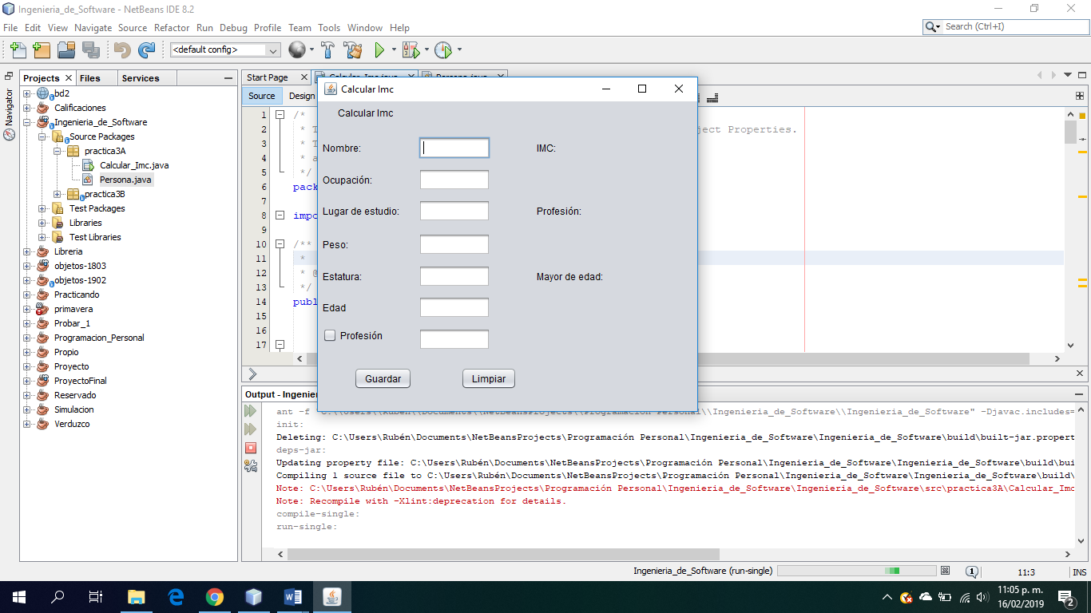

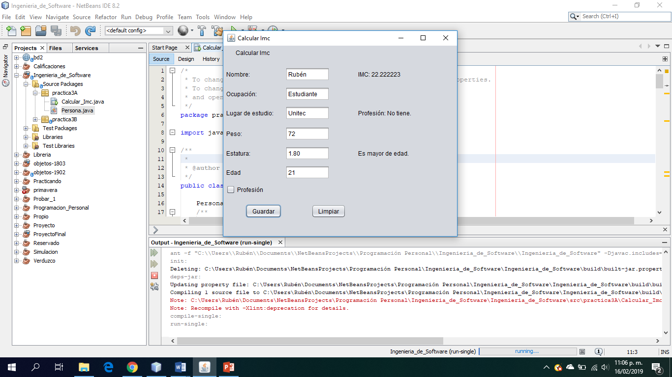

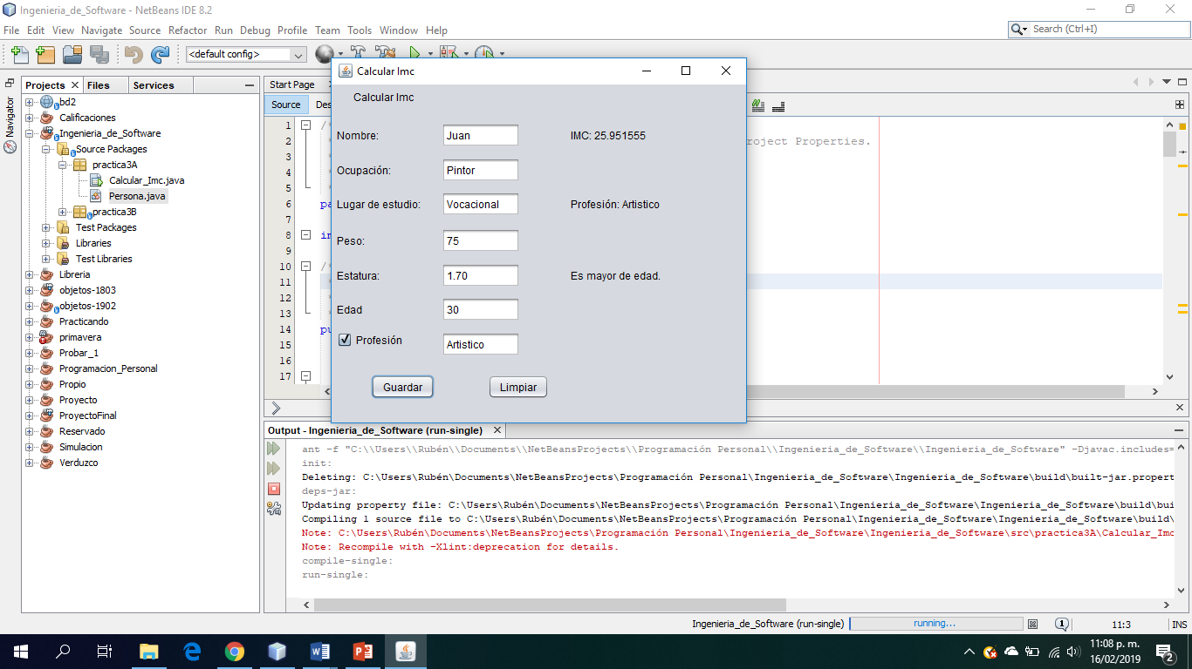

**Actividad 2**

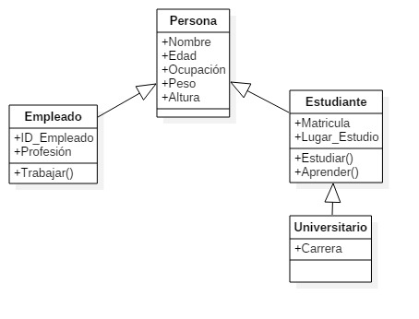

/*

* To change this license header, choose License Headers in Project Properties.

* To change this template file, choose Tools | Templates

* and open the template in the editor.

*/

package practica3B;

/**

*

* @author Rubén

*/

public class Empleado extends Persona{

private float salario;

@Override

public void ocupacion() {

}

public float getSalario() {

return salario;

}

public void setSalario(float salario) {

this.salario = salario;

}

}

/*

* To change this license header, choose License Headers in Project Properties.

* To change this template file, choose Tools | Templates

* and open the template in the editor.

*/

package practica3B;

/**

*

* @author Rubén

*/

public abstract class Estudiante extends Persona {

public abstract void nivel();

@Override

public void ocupacion() {

setTipo("Estudiante");

}

}

/*

* To change this license header, choose License Headers in Project Properties.

* To change this template file, choose Tools | Templates

* and open the template in the editor.

*/

package practica3B;

/**

*

* @author Rubén

*/

public abstract class Persona {

private String nombre;

private byte edad;

private String tipo;

public abstract void ocupacion();

public Persona() {

}

public String getNombre() {

return nombre;

}

public void setNombre(String nombre) {

this.nombre = nombre;

}

public byte getEdad() {

return edad;

}

public void setEdad(byte edad) {

this.edad = edad;

}

public String getTipo() {

return tipo;

}

public void setTipo(String tipo) {

this.tipo = tipo;

}

}

/*

* To change this license header, choose License Headers in Project Properties.

* To change this template file, choose Tools | Templates

* and open the template in the editor.

*/

package practica3B;

/**

*

* @author SE

*/

public class Personas extends javax.swing.JFrame {

/**

* Creates new form Personas

*/

Universitario u = new Universitario();

Empleado e = new Empleado();

public Personas() {

initComponents();

jLabel1.setText("Registro");

jLabel2.setText("Nombre:");

jLabel3.setText("Edad:");

jLabel4.setText("Profesión:");

jLabel5.setText("Salario:");

jCheckBox1.setText("Estudiante");

jCheckBox2.setText("Universitario");

jLabel6.setText("Nombre:");

jLabel7.setText("Edad:");

jLabel8.setText("Profesión:");

jLabel9.setText("Salario:");

jButton1.setText("Guardar");

}

/**

* This method is called from within the constructor to initialize the form.

* WARNING: Do NOT modify this code. The content of this method is always

* regenerated by the Form Editor.

*/

@SuppressWarnings("unchecked")

// <editor-fold defaultstate="collapsed" desc="Generated Code">

private void initComponents() {

jPanel1 = new javax.swing.JPanel();

jLabel1 = new javax.swing.JLabel();

jLabel2 = new javax.swing.JLabel();

txf_nombre = new javax.swing.JTextField();

jLabel3 = new javax.swing.JLabel();

txf_edad = new javax.swing.JTextField();

jLabel4 = new javax.swing.JLabel();

txf_profesion = new javax.swing.JTextField();

jLabel5 = new javax.swing.JLabel();

txf_nivel = new javax.swing.JTextField();

jButton1 = new javax.swing.JButton();

jLabel6 = new javax.swing.JLabel();

jLabel7 = new javax.swing.JLabel();

jLabel8 = new javax.swing.JLabel();

jLabel9 = new javax.swing.JLabel();

jCheckBox1 = new javax.swing.JCheckBox();

jCheckBox2 = new javax.swing.JCheckBox();

setDefaultCloseOperation(javax.swing.WindowConstants.EXIT_ON_CLOSE);

jLabel1.setText("jLabel1");

jLabel2.setText("jLabel2");

jLabel3.setText("jLabel3");

jLabel4.setText("jLabel4");

jLabel5.setText("jLabel5");

jButton1.setText("jButton1");

jButton1.addActionListener(new java.awt.event.ActionListener() {

public void actionPerformed(java.awt.event.ActionEvent evt) {

jButton1ActionPerformed(evt);

}

});

jLabel6.setText("jLabel6");

jLabel7.setText("jLabel7");

jLabel8.setText("jLabel8");

jLabel9.setText("jLabel9");

jCheckBox1.setText("jCheckBox1");

jCheckBox1.addActionListener(new java.awt.event.ActionListener() {

public void actionPerformed(java.awt.event.ActionEvent evt) {

jCheckBox1ActionPerformed(evt);

}

});

jCheckBox2.setText("jCheckBox2");

jCheckBox2.addActionListener(new java.awt.event.ActionListener() {

public void actionPerformed(java.awt.event.ActionEvent evt) {

jCheckBox2ActionPerformed(evt);

}

});

javax.swing.GroupLayout jPanel1Layout = new javax.swing.GroupLayout(jPanel1);

jPanel1.setLayout(jPanel1Layout);

jPanel1Layout.setHorizontalGroup(

jPanel1Layout.createParallelGroup(javax.swing.GroupLayout.Alignment.LEADING)

.addGroup(jPanel1Layout.createSequentialGroup()

.addContainerGap()

.addGroup(jPanel1Layout.createParallelGroup(javax.swing.GroupLayout.Alignment.LEADING)

.addComponent(jLabel1)

.addGroup(jPanel1Layout.createSequentialGroup()

.addGroup(jPanel1Layout.createParallelGroup(javax.swing.GroupLayout.Alignment.LEADING)

.addComponent(jLabel2)

.addComponent(jLabel3)

.addComponent(jLabel4)

.addComponent(jLabel5)

.addComponent(jButton1))

.addGap(38, 38, 38)

.addGroup(jPanel1Layout.createParallelGroup(javax.swing.GroupLayout.Alignment.LEADING)

.addComponent(jCheckBox1)

.addGroup(jPanel1Layout.createSequentialGroup()

.addGroup(jPanel1Layout.createParallelGroup(javax.swing.GroupLayout.Alignment.LEADING, false)

.addComponent(txf_nombre)

.addComponent(txf_edad)

.addComponent(txf_profesion)

.addComponent(txf_nivel, javax.swing.GroupLayout.DEFAULT_SIZE, 76, Short.MAX_VALUE))

.addGap(78, 78, 78)

.addGroup(jPanel1Layout.createParallelGroup(javax.swing.GroupLayout.Alignment.LEADING)

.addComponent(jLabel6)

.addComponent(jLabel7)

.addComponent(jLabel8)

.addComponent(jLabel9)))

.addComponent(jCheckBox2))))

.addContainerGap(121, Short.MAX_VALUE))

);

jPanel1Layout.setVerticalGroup(

jPanel1Layout.createParallelGroup(javax.swing.GroupLayout.Alignment.LEADING)

.addGroup(jPanel1Layout.createSequentialGroup()

.addContainerGap()

.addComponent(jLabel1)

.addGap(26, 26, 26)

.addGroup(jPanel1Layout.createParallelGroup(javax.swing.GroupLayout.Alignment.BASELINE)

.addComponent(jLabel2)

.addComponent(txf_nombre, javax.swing.GroupLayout.PREFERRED_SIZE, javax.swing.GroupLayout.DEFAULT_SIZE, javax.swing.GroupLayout.PREFERRED_SIZE)

.addComponent(jLabel6))

.addGap(18, 18, 18)

.addGroup(jPanel1Layout.createParallelGroup(javax.swing.GroupLayout.Alignment.BASELINE)

.addComponent(jLabel3)

.addComponent(txf_edad, javax.swing.GroupLayout.PREFERRED_SIZE, javax.swing.GroupLayout.DEFAULT_SIZE, javax.swing.GroupLayout.PREFERRED_SIZE)

.addComponent(jLabel7))

.addGap(18, 18, 18)

.addGroup(jPanel1Layout.createParallelGroup(javax.swing.GroupLayout.Alignment.BASELINE)

.addComponent(jLabel4)

.addComponent(txf_profesion, javax.swing.GroupLayout.PREFERRED_SIZE, javax.swing.GroupLayout.DEFAULT_SIZE, javax.swing.GroupLayout.PREFERRED_SIZE)

.addComponent(jLabel8))

.addGap(18, 18, 18)

.addGroup(jPanel1Layout.createParallelGroup(javax.swing.GroupLayout.Alignment.BASELINE)

.addComponent(jLabel5)

.addComponent(txf_nivel, javax.swing.GroupLayout.PREFERRED_SIZE, javax.swing.GroupLayout.DEFAULT_SIZE, javax.swing.GroupLayout.PREFERRED_SIZE)

.addComponent(jLabel9))

.addGap(28, 28, 28)

.addGroup(jPanel1Layout.createParallelGroup(javax.swing.GroupLayout.Alignment.BASELINE)

.addComponent(jButton1)

.addComponent(jCheckBox1))

.addPreferredGap(javax.swing.LayoutStyle.ComponentPlacement.UNRELATED)

.addComponent(jCheckBox2)

.addContainerGap(56, Short.MAX_VALUE))

);

javax.swing.GroupLayout layout = new javax.swing.GroupLayout(getContentPane());

getContentPane().setLayout(layout);

layout.setHorizontalGroup(

layout.createParallelGroup(javax.swing.GroupLayout.Alignment.LEADING)

.addComponent(jPanel1, javax.swing.GroupLayout.DEFAULT_SIZE, javax.swing.GroupLayout.DEFAULT_SIZE, Short.MAX_VALUE)

);

layout.setVerticalGroup(

layout.createParallelGroup(javax.swing.GroupLayout.Alignment.LEADING)

.addComponent(jPanel1, javax.swing.GroupLayout.DEFAULT_SIZE, javax.swing.GroupLayout.DEFAULT_SIZE, Short.MAX_VALUE)

);

pack();

}// </editor-fold>

private void jCheckBox1ActionPerformed(java.awt.event.ActionEvent evt) {

if (jCheckBox1.isSelected()) {

jLabel4.setText("Escuela:");

jLabel5.setText("-");

jLabel8.setText("Dedicación:");

jLabel9.setText("Nivel: No universitario");

} else {

jLabel4.setText("Profesión:");

jLabel5.setText("Salario:");

jLabel8.setText("Profesión:");

jLabel9.setText("Salario:");

}

}

private void jButton1ActionPerformed(java.awt.event.ActionEvent evt) {

// Guardar

try {

if (jCheckBox1.isSelected()) {

u.setNombre(txf_nombre.getText());

u.setEdad(Byte.parseByte(txf_edad.getText()));

u.setTipo("Estudiante");

u.setCurso(txf_nivel.getText());

jLabel6.setText("Nombre: " + u.getNombre());

jLabel7.setText("Edad: " + u.getEdad());

jLabel8.setText("Dedicación: " + u.getTipo());

if ((jCheckBox1.isSelected()) && (jCheckBox2.isSelected())) {

u.setCurso("Universitario");

jLabel9.setText("Nivel: " + u.getCurso());

} else {

jLabel9.setText("Nivel: No universitario");

}

} else {

e.setNombre(txf_nombre.getText());

e.setEdad(Byte.parseByte(txf_edad.getText()));

e.setTipo(txf_profesion.getText());

e.setSalario(Float.parseFloat(txf_nivel.getText()));

jLabel6.setText("Nombre: " + e.getNombre());

jLabel7.setText("Edad: " + e.getEdad());

jLabel8.setText("Profesión: " + e.getTipo());

jLabel9.setText("Salario: " + e.getSalario());

}

} catch (NumberFormatException ex) {

System.out.println("Error: "+ex);

}

}

private void jCheckBox2ActionPerformed(java.awt.event.ActionEvent evt) {

// TODO add your handling code here:

if ((jCheckBox1.isSelected()) && (jCheckBox2.isSelected())) {

u.setCurso("Universitario");

}

}

/**

* @param args the command line arguments

*/

public static void main(String args[]) {

/* Set the Nimbus look and feel */

//<editor-fold defaultstate="collapsed" desc=" Look and feel setting code (optional) ">

/* If Nimbus (introduced in Java SE 6) is not available, stay with the default look and feel.

* For details see http://download.oracle.com/javase/tutorial/uiswing/lookandfeel/plaf.html

*/

try {

for (javax.swing.UIManager.LookAndFeelInfo info : javax.swing.UIManager.getInstalledLookAndFeels()) {

if ("Nimbus".equals(info.getName())) {

javax.swing.UIManager.setLookAndFeel(info.getClassName());

break;

}

}

} catch (ClassNotFoundException ex) {

java.util.logging.Logger.getLogger(Personas.class.getName()).log(java.util.logging.Level.SEVERE, null, ex);

} catch (InstantiationException ex) {

java.util.logging.Logger.getLogger(Personas.class.getName()).log(java.util.logging.Level.SEVERE, null, ex);

} catch (IllegalAccessException ex) {

java.util.logging.Logger.getLogger(Personas.class.getName()).log(java.util.logging.Level.SEVERE, null, ex);

} catch (javax.swing.UnsupportedLookAndFeelException ex) {

java.util.logging.Logger.getLogger(Personas.class.getName()).log(java.util.logging.Level.SEVERE, null, ex);

}

//</editor-fold>

/* Create and display the form */

java.awt.EventQueue.invokeLater(new Runnable() {

public void run() {

new Personas().setVisible(true);

}

});

}

// Variables declaration - do not modify

private javax.swing.JButton jButton1;

private javax.swing.JCheckBox jCheckBox1;

private javax.swing.JCheckBox jCheckBox2;

private javax.swing.JLabel jLabel1;

private javax.swing.JLabel jLabel2;

private javax.swing.JLabel jLabel3;

private javax.swing.JLabel jLabel4;

private javax.swing.JLabel jLabel5;

private javax.swing.JLabel jLabel6;

private javax.swing.JLabel jLabel7;

private javax.swing.JLabel jLabel8;

private javax.swing.JLabel jLabel9;

private javax.swing.JPanel jPanel1;

private javax.swing.JTextField txf_edad;

private javax.swing.JTextField txf_nivel;

private javax.swing.JTextField txf_nombre;

private javax.swing.JTextField txf_profesion;

// End of variables declaration

}

/*

* To change this license header, choose License Headers in Project Properties.

* To change this template file, choose Tools | Templates

* and open the template in the editor.

*/

package practica3B;

/**

*

* @author Rubén

*/

public class Universitario extends Estudiante {

private String curso;

@Override

public void nivel() {

}

public String getCurso() {

return curso;

}

public void setCurso(String curso) {

this.curso = curso;

}

}

