1. APPIUM

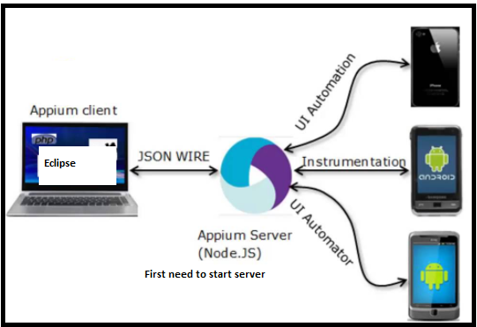

1. Download java and set java_Home in environment variables.
2. <https://developer.android.com/studio/index.html>

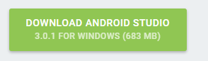

3A. Double click on .exe file after download and allow Administration Access🡪Next🡪Next🡪Next🡪It take about 5 to 10 minute to install 🡪Next🡪Finish🡪 android Studio will open.-->Next🡪Next🡪Next🡪Finish: it will install al the tools automatically will take a wile.

3B. Find SDK path: C:\Users\rubeldm\AppData\Local\Android\sdk

1. Check Android installation path in the machine
2. Set Android_Home Environmental variables path to SDK location and inclue bin folders path in path variable

i)Environment Variable: Android_Home: C:\Users\rubeldm\AppData\Local\Android\sdk

ii)Add path: C:\Users\rubeldm\AppData\Local\Android\sdk\tools

---------------C:\Users\rubeldm\AppData\Local\Android\sdk\tools\bin

--------------C:\Users\rubeldm\AppData\Local\Android\sdk\platform-tools

1. Open Android Studio and configure Emulator

* C:\Program Files\Android\Android Studio\bin -> click on studio64.exe

-->After open click on Start New Android Stodio project and just click next till finish

🡪click on Tools🡪Android🡪AVD Manager: click on Create Virtual device

->Select Phone🡪Nexus 5x🡪Next🡪Download Nougat –Android 🡪name AVD:Demo🡪Finish

7. Open Emulator and check if it working ,

-Open Emulator from cmd: cd C:\Users\rubeldm\AppData\Local\Android\sdk\platform-tools

- emulator –avd Demo

8. Download Node.js

--Appium come with Node.Js

9. <https://nodejs.org/en/download/>

ii)extract file

10.Set Node_Home Environment variables path

11.-Node_Home : C:\Program Files\nodejs

-path: C:\Program Files\nodejs\node_modules\npm\bin

Node: it is a software ,

npm: we can download any module like Appium through npm

12.Download Appium Server from Node

-Appium come with two parts , client and server

)client:you can write your code in multiple language like java c#, python

We need : Appium java client

)server:Appium server

Open cmd: npm install –g appium

--start server: appium

-uninstall npm from machine: npm uninstall –g appium

13. Download Appium Java client library

> <http://appium.io/downloads.html>

>select java

>

-