1. We need to modify class because we will use it for long time, so we can just copy to different class and then we can inherit it.

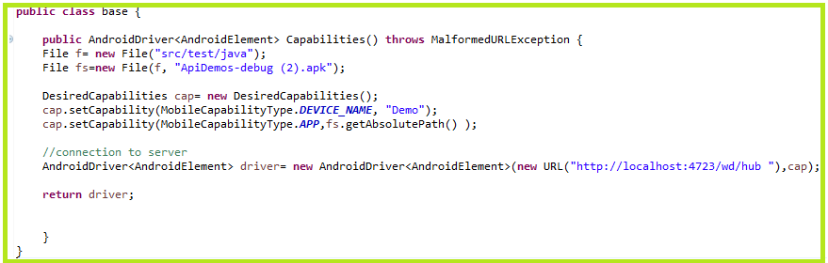

1. Create a class called basic and then inherited base class

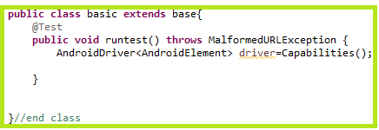

1. Open UI Automator viewer and then