DecodeLabs Industrial Training Kit
Batch 2026
Stock Market Trading and Analysis Intern
PROJECT 3
Algorithmic Trading Strategy & Back-testing
Designing an Emotionless, Rules-Based Trading Engine — From Signal Logic to Walk-Forward Validation
[ This report was prepared solely for educational purposes as part of the DecodeLabs Industrial Training Programme. It does not constitute financial advice, a recommendation to buy or sell any security, or an offer of any kind.]
Assets Analysed
AstraZeneca (AZN.L) | GSK (GSK.L) | Shell (SHEL.L)
Entry logic: 3-gate system (Fundamental MoS × EMA trend × RSI momentum)
Exit discipline: fixed 3:1 take-profit / stop-loss (+9% / −3%)
Submitted to DecodeLabs | June 2026

Table of Contents
Section 1: Methodology 1
1.1 Scope and Objective 1
1.2 Data Sourcing 1
1.3 The Three-Gate Entry Logic 1
1.4 Immutable Exit Parameters 2
Section 2: Backtest Engine Design 3
2.1 Why a Trade-by-Trade Simulation, not a Daily Return Cap 3
2.2 Compounding Convention 3
Section 3: Entry & Exit Levels 4
3.1 Fundamental Gate Thresholds (from Project 2) 4
3.2 Fixed Take-Profit / Stop-Loss Levels 4
Section 4: Backtest Results (Full ~6-Year Window) 5
4.1 Trade Activity 5
4.2 Strategy vs. Buy-and-Hold Equity Curves 5
4.3 Key Performance Indicators 6
Section 5: Live Engine Status 7
Section 6: Walk-Forward Optimisation 8
6.1 Methodology 8
6.2 Results by Stock 9
6.3 Interpretation 9
Section 7: Limitations 11
Section 8: Conclusion 12
8.1 Portfolio Findings 12
8.2 Individual Stock Conclusions 12
Disclaimer 13

Executive Summary

This report documents the design, construction, and validation of a fully rules-based algorithmic trading engine for three London Stock Exchange equities AstraZeneca (AZN.L), GSK (GSK.L), and Shell (SHEL.L) are built. Consistent with the brief's objective of removing human emotion from trading, every decision in this system is governed by an immutable if/else logic matrix: a three-gate entry filter combining Project 1's technical signals with Project 2's fundamental valuation, and a fixed 3:1 asymmetric take-profit/stop-loss exit rule that cannot be discretionarily overridden once a position is open.
The engine was built across an eight-step pipeline: data ingestion and cleaning of ~6 years of OHLCV history (2020–2025), technical feature engineering (EMA50/200, Wilder-smoothed RSI(14)), a combined three-gate entry-signal engine, fixed asymmetric exit-level definition, a trade-by-trade backtest simulation, key-performance-indicator extraction, and a chronological Walk-Forward Optimisation (WFO) across three out-of-sample cycles. Strict look-ahead-bias controls (signal shifted by one trading day before execution) and trade-count-gated validation (cycles with too few closed trades are excluded rather than reported as misleadingly precise zeros) were applied throughout.
Across the full ~6-year backtest, the strategy closed 15 trades on AstraZeneca, 18 on GSK, and 43 on Shell. Win rates of 33.3% (AstraZeneca), 44.4% (GSK), and 25.6% (Shell) all clear the strategy's 25% mathematical break-even threshold implied by the 3:1 reward-to-risk ratio, though by varying margins. GSK delivered the strongest risk-adjusted result (Sharpe 0.63, Calmar 0.76), while Shell's edge though still narrowly profitable proved the most sensitive to changes in indicator methodology during development, a finding discussed in Section 7.
Walk-Forward Optimisation, which tests the strategy on data never used to build it, corroborates the in-sample result for GSK (Sharpe 1.09 and 0.89 in its two valid out-of-sample cycles) and provides a genuinely mixed but informative picture for Shell. AstraZeneca traded too infrequently (zero closed trades in any single calendar-year test window) to be validated by annual WFO cycles at all a limitation of trade frequency rather than of the validation method, and one this report treats as a finding rather than concealing it behind a misleading statistic.
As of the most recent data point, the live engine shows AstraZeneca and GSK in an IDLE state (price has risen above each stock's Project 2 margin-of-safety threshold, so Gate A now fails even though trend and momentum both confirm), while Shell shows a live EXECUTE signal with all three gates passing simultaneously and an open position awaiting its take-profit or stop-loss resolution.

Section 1: Methodology

1.1 Scope and Objective
As per the DecodeLabs Project 3 brief (Algorithmic Trading Strategy & Backtesting), this analysis is built around three deliverables: a strict if/else logic matrix governing trade entries, an immutable if/else exit parameter governing both take-profit and stop-loss, and a backtest of that logic against several years of historical time-series data to establish whether a statistical edge exists. The explicit goal is to remove discretionary human judgement from the trading decision entirely — every entry and exit in this system is the deterministic output of a rule, never a judgement call made in the moment.

1.2 Data Sourcing
Source: yfinance Python library, providing daily OHLCV (open, high, low, close, volume) price history.
Backtest window: 2 January 2020 – 31 December 2025 (1,515 trading days, approximately six years), extended from an initial five-year pull specifically to give the Walk-Forward Optimisation in Section 6 a genuine third out-of-sample year rather than an empty placeholder cycle.
Gap handling: forward-fill only. Backward-fill is explicitly avoided throughout, since pulling a future price backward into a past gap would leak forward-looking information into the signal — a direct violation of the look-ahead-bias discipline this entire engine is built around.
Currency: all LSE prices in pence (GBP), consistent with Project 1 and Project 2.
Stocks: AZN.L, GSK.L, SHEL.L - the same three equities covered across all three DecodeLabs projects.

1.3 The Three-Gate Entry Logic
Rather than relying on a single indicator, the entry signal requires unanimous agreement across three independent gates, each inherited from a different stage of this project portfolio:
Gate A — Fundamental filter (from Project 2): current price must sit below the stock's margin-of-safety entry price, itself 70% of Project 2's DCF-derived intrinsic value. This gate ensures the engine never buys a stock the fundamental model considers overpriced, regardless of how favourable the technical picture looks.
Gate B — Trend filter (from Project 1): 50-day EMA must sit above the 200-day EMA (a bullish “golden cross” regime). This gate keeps the engine from buying into a structurally declining trend.
Gate C — Momentum filter (from Project 1): 14-day RSI must sit above 50, confirming that short-term price momentum agrees with the medium-term trend before the engine commits capital.
All three conditions are combined with a logical AND: the engine only generates a signal when every gate passes simultaneously on the same trading day. Critically, the resulting signal is shifted forward by one trading day (‘stance.shift(1)’) before being used to compute returns- meaning a trade can only be entered on the day after the signal fires, never on the same day it was observed. This single line of code is the project's primary defence against look-ahead bias.

1.4 Immutable Exit Parameters
Once a position is opened, its exit is governed exclusively by two fixed, non-negotiable price levels set at entry: a take-profit at +9% and a stop-loss at −3%, a 3:1 reward-to-risk ratio. Mathematically, this ratio implies a break-even win rate of only 25% — a strategy with this payoff structure can be net profitable even if it loses more often than it wins, provided its winners are sufficiently larger than its losers. No discretionary override of these levels is permitted once a trade is open; a position remains open until price closes at or beyond one of the two levels, even if the entry gates subsequently flip back to a non-signal state.

Section 2: Backtest Engine Design
A central design decision in this project was how to simulate the exit rule against daily closing-price data, which does not capture intraday price paths. Two approaches were evaluated during development.

2.1 Why a Trade-by-Trade Simulation, not a Daily Return Cap
An earlier iteration of this engine approximated the exit rule by capping each day's market return at +9%/−3% whenever the entry gates were active — a daily-clip approach. This was found to misrepresent the strategy: it allowed the simulated return to reset every day regardless of whether a real position would still be open, and it could not produce a genuine trade count, entry price, or exit price for reporting. The engine in this report instead uses a sequential, trade-by-trade simulation: a day-by-day loop that tracks whether a position is currently open, and if so, the price at which it was entered. On each day a position is open, the loop checks whether cumulative price movement since entry has crossed +9% (take-profit) or −3% (stop-loss); if so, the trade is closed and logged with its entry date, exit date, entry price, exit price, and outcome. A position can remain open across many trading days — and even after the entry gates flip back to non-signal — since only the fixed exit levels, not the entry gates, can close a trade once it is live.
Stop-loss is checked before take-profit on any day both thresholds are technically crossed, a conservative convention chosen because the backtest only has daily closing prices, not intraday highs and lows, so the order in which a single day's price extremes were reached cannot be observed directly.

2.2 Compounding Convention
Strategy and buy-and-hold equity curves are computed using compounding returns — the cumulative product of (1 + r) minus one — rather than a simple additive sum of daily returns, ensuring consistency with the Sharpe ratio, maximum drawdown, and CAGR calculations in Section 4, all of which are inherently multiplicative measures.

Section 3: Entry & Exit Levels

3.1 Fundamental Gate Thresholds (from Project 2)
Gate A's threshold for each stock is its Project 2 margin-of-safety entry price — 70% of DCF-derived intrinsic value, using the corrected, sector-adjusted WACC values (7.55% AstraZeneca, 7.09% GSK, 7.99% Shell) rather than the uncorrected flat-beta WACC an earlier iteration of the valuation model had produced.
Stock | MoS Entry Price | WACC Used
AstraZeneca | 9,843p | 7.55%
GSK | 1,699p | 7.09%
Shell | 5,182p | 7.99%
Figure 1: Gate A fundamental thresholds, carried forward directly from Project 2's final margin-of-safety output.

3.2 Fixed Take-Profit / Stop-Loss Levels
The 3:1 asymmetric exit rule translates into the following fixed price levels at each stock's margin-of-safety entry point, shown here purely to illustrate the rule's mechanics — in practice, the rule is applied relative to each trade's actual entry price, not to this single reference point.
Stock | Reference Entry | Take-Profit (+9%) | Stop-Loss (−3%)
AstraZeneca | 9,843p | 10,728p | 9,547p
GSK | 1,699p | 1,852p | 1,648p
Shell | 5,182p | 5,649p | 5,027p
Figure 2: Take-profit and stop-loss levels at a 3:1 reward-to-risk ratio, illustrated relative to each stock's Gate A reference price. Break-even win rate under this ratio is 25%.

Section 4: Backtest Results (Full ~6-Year Window)

4.1 Trade Activity
The trade-by-trade engine closed 15 trades on AstraZeneca, 18 on GSK, and 43 on Shell across the full backtest window. Shell's substantially higher trade count reflects Gate A passing almost continuously throughout the period — its margin-of-safety threshold sits well above its market price for most of the window — leaving Gates B and C (trend and momentum) to do nearly all of the entry-timing work, and these flip on and off considerably more often than the fundamental gate.
Stock | Trades Closed | Take-Profit Exits | Stop-Loss Exits
AstraZeneca | 15 | 5 | 10
GSK | 18 | 8 | 10
Shell | 43 | 11 | 32
Figure 3: Closed trades by exit type across the full ~6-year backtest window.
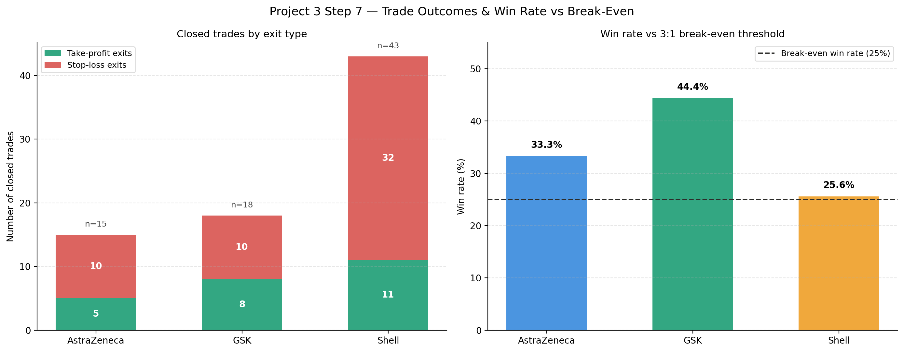
Figure 4: Trade outcome breakdown (left) and win rate measured against the strategy's mathematical 25% break-even threshold (right), implied by the 3:1 reward-to-risk ratio.

4.2 Strategy vs. Buy-and-Hold Equity Curves
The equity curves below plot cumulative compounded return for the rules-based strategy against a passive buy-and-hold position in each stock. The strategy's characteristic step-function shape — long flat stretches punctuated by sharp vertical moves — is a direct visual consequence of the trade-by-trade design: equity is unchanged while no position is open and moves only on the exact day a trade closes at its take-profit or stop-loss level.
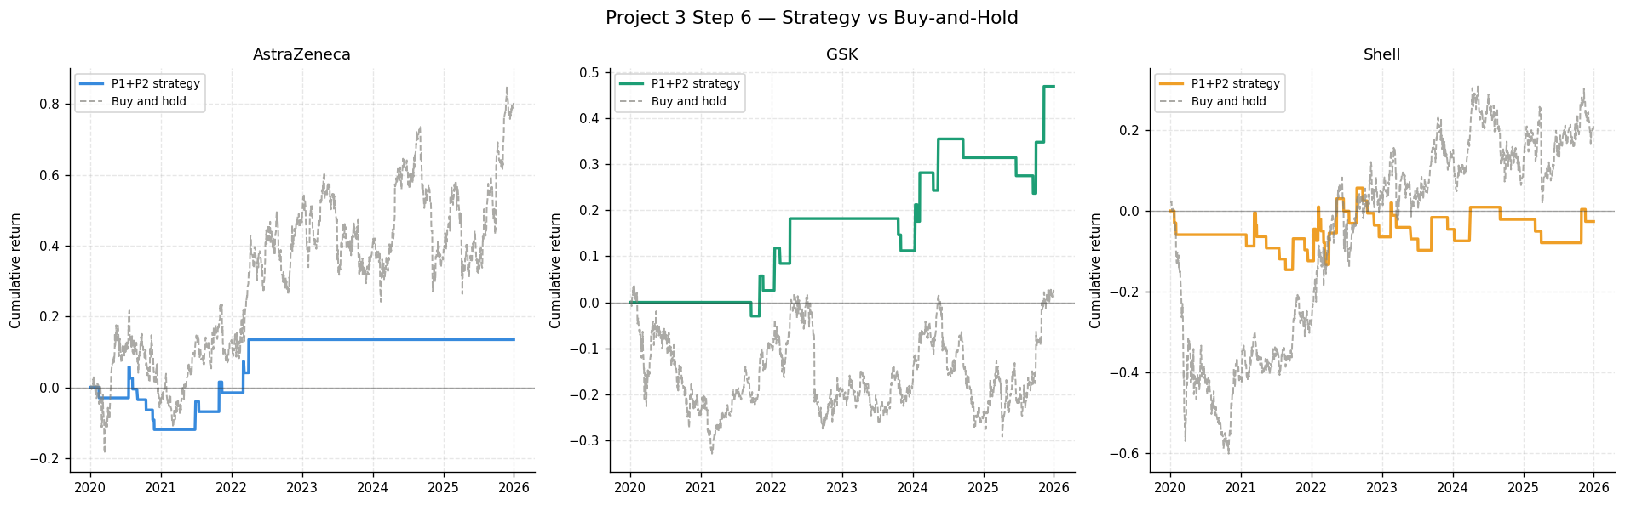
Figure 5: Cumulative compounded return, rules-based strategy vs. passive buy-and-hold, 2020–2025. All three strategy lines trail their respective buy-and-hold lines in absolute terms over this window — a finding addressed directly in Section 7.

4.3 Key Performance Indicators
Sharpe ratio, maximum drawdown, and CAGR are computed from the same compounded daily strategy returns underlying the equity curves above. Win rate is computed directly from the trade log — the proportion of closed trades that exited at take-profit rather than stop-loss — rather than from any day-level proxy.
Stock | Sharpe | Max Drawdown | CAGR | Calmar | Win Rate | Trades
AstraZeneca | 0.27 | −16.7% | 2.1% | 0.13 | 33.3% | 15
GSK | 0.63 | −8.7% | 6.6% | 0.76 | 44.4% | 18
Shell | 0.04 | −14.6% | −0.4% | −0.03 | 25.6% | 43
Figure 6: Strategy key performance indicators, full ~6-year backtest window. Reference benchmarks used during development: Sharpe > 1.0, max drawdown > −15%, CAGR > 10%, Calmar > 1.0.
GSK is the strongest performer on every risk-adjusted measure: the highest Sharpe ratio (0.63), the smallest drawdown (−8.7%), and the only Calmar ratio approaching the development benchmark (0.76). AstraZeneca posts a modest positive Sharpe (0.27) from a smaller, more selective trade sample. Shell, despite generating by far the most trades, produced the weakest risk-adjusted result of the three — a near-zero Sharpe ratio and a slightly negative CAGR — even though its 25.6%-win rate technically still clears the strategy's 25% mathematical break-even threshold. This is the clearest illustration in the dataset of why win rate alone is an incomplete measure of strategy quality: Shell wins often enough to be at breakeven by trade count, but its stop-losses (32 of 43 trades) outweigh its take-profits by a wide enough margin in aggregate to erase the edge the 3:1 payoff ratio is designed to provide.

Section 5: Live Engine Status
As of the most recent trading day in the dataset, the three-gate engine reports the following live status for each stock.
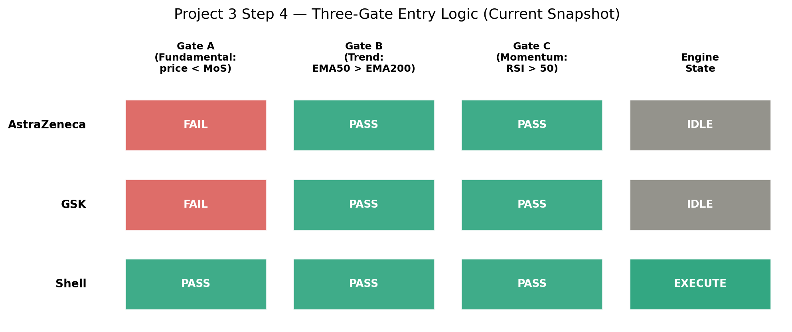
Figure 7: Live three-gate status and resulting engine state, most recent data point in the backtest window.
Stock | Gate A (Fundamental) | Gate B (Trend) | Gate C (Momentum) | Engine State
AstraZeneca | FAIL | PASS | PASS | IDLE
GSK | FAIL | PASS | PASS | IDLE
Shell | PASS | PASS | PASS | EXECUTE
Figure 8: Live gate-level detail underlying Figure 7.
AstraZeneca and GSK have both moved from Gate A PASS to Gate A FAIL since the original five-year backtest window: as prices have risen over the additional year of data added in this report (2025), both stocks' market prices now sit above their respective Project 2 margin-of-safety thresholds, even though both stocks' trend and momentum gates (B and C) confirm a bullish technical picture. This is the system working exactly as designed — it is refusing to chase a stock whose price has outrun the fundamental model's estimate of fair value, even when the technical case looks attractive.
Shell is the only stock with all three gates passing simultaneously, and the engine consequently reports a live EXECUTE signal. A position is currently open on Shell, awaiting resolution at its take-profit or stop-loss level. This live open position is reflected in the most recent step of the trade-by-trade engine and is not yet counted among the 43 closed trades reported in Section 4.

Section 6: Walk-Forward Optimisation

6.1 Methodology
K-fold cross-validation — the standard machine-learning technique of randomly shuffling and splitting data — is invalid for a time-series trading strategy, since it would destroy the chronological autocorrelation structure the strategy itself depends on and could leak future information into a training fold. Walk-Forward Optimisation (WFO) instead always respects chronological order: three non-overlapping annual test windows (2023, 2024, 2025) are each preceded by a multi-year training window ending five trading days before the test period begins, a small purge gap intended to prevent boundary leakage between the two.
A cycle is only reported with performance statistics if it contains at least three closed trades; cycles below this threshold are explicitly flagged as having insufficient trades rather than being reported with a misleadingly precise Sharpe ratio of 0.00 computed from a window in which no trade actually occurred. This trade-count gate was a deliberate late-stage correction during development, after an earlier version of this check — based on calendar-day coverage rather than actual trade closures — was found to silently report meaningless zero-activity windows as if they were real, if poor, results.

6.2 Results by Stock
Stock | Cycle | Test Year | Sharpe | Max Drawdown | CAGR | Trades
AstraZeneca | 1 | 2023 | Insufficient trades (0) | — | — | 0
 | 2 | 2024 | Insufficient trades (0) | — | — | 0
 | 3 | 2025 | Insufficient trades (0) | — | — | 0
GSK | 1 | 2023 | Insufficient trades (2) | — | — | 2
 | 2 | 2024 | 1.09 | −3.0% | 18.0% | 6
 | 3 | 2025 | 0.89 | −5.9% | 11.7% | 4
Shell | 1 | 2023 | 0.43 | −8.7% | 5.2% | 6
 | 2 | 2024 | 0.30 | −3.0% | 2.5% | 3
 | 3 | 2025 | 0.00 | −5.9% | −0.5% | 4
Figure 9: Walk-Forward Optimisation results across three chronological out-of-sample cycles. Cycles with fewer than three closed trades are excluded from performance statistics rather than reported as zero.
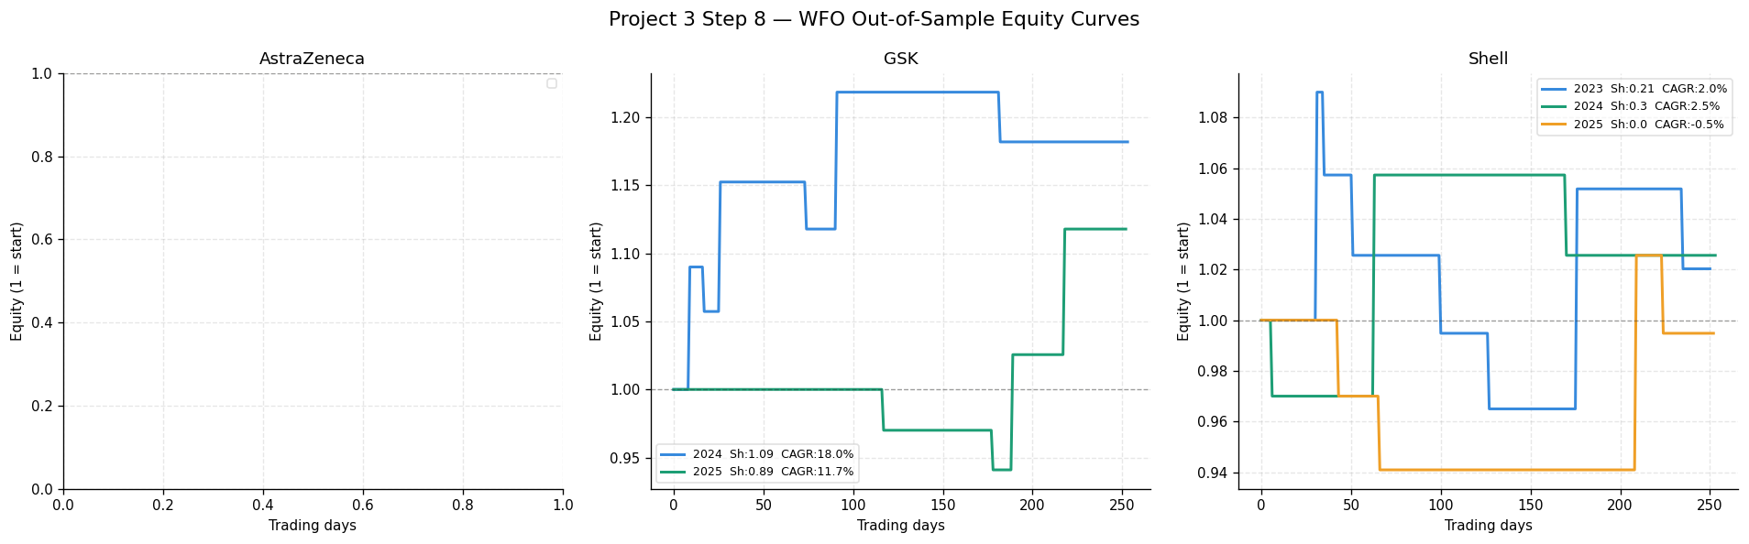
Figure 10: Out-of-sample equity curves for each valid WFO cycle (AstraZeneca's panel is intentionally empty — see Section 6.3).

6.3 Interpretation
GSK's WFO result is the strongest validation in this report: its 2024 cycle (Sharpe 1.09, CAGR 18.0%) and 2025 cycle (Sharpe 0.89, CAGR 11.7%) are both genuinely out-of-sample, both clear the strategy's break-even bar comfortably, and both are directionally consistent with GSK's strong full-window result in Section 4. GSK's 2023 cycle, with only two closed trades, is correctly excluded rather than reported — it previously generated a misleading Sharpe ratio of −1.42 under the calendar-day-based gating logic used earlier in development, a number this report does not consider statistically meaningful given the sample size involved.
Shell's three valid WFO cycles paint a genuinely mixed picture, consistent with its weak full-window Sharpe ratio in Section 4: modestly positive in 2023 and 2024, and flat to slightly negative in 2025. This reinforces, rather than contradicts, the Section 4 finding that Shell's edge is the least robust of the three stocks in this report.
AstraZeneca recorded zero closed trades in every individual calendar-year test window, despite having 15 closed trades across the full ~6-year window. This is a genuine and informative limitation of annual WFO validation applied to a low-frequency strategy — AstraZeneca's trades are simply too sparsely distributed in time for any single calendar year to reliably contain enough of them to validate. This is not a defect in the WFO code; it is a property of how infrequently this particular stock's three gates align simultaneously, and it means AstraZeneca's full-window result in Section 4 should be read with the caveat that it has not been corroborated by genuine out-of-sample testing.

Section 7: Limitations
- Daily close exit approximation. The trade-by-trade engine evaluates take-profit and stop-loss against daily closing prices only, since the underlying data does not include intraday highs and lows. A real position could cross both the take-profit and stop-loss level within a single day; this engine's convention of checking stop-loss first on any such day is a conservative assumption, not an observed fact.
- Indicator-methodology sensitivity. During development, switching the RSI(14) calculation from a simple rolling-mean approximation to true Wilder exponential smoothing — the industry-standard convention — measurably changed Shell's results (full-window Sharpe ratio moved from 0.21 to 0.04, and its win rate moved closer to the 25% break-even line). This sensitivity is itself a meaningful finding: Shell's modest edge should not be treated as robust to small, defensible changes in how a single input indicator is computed.
- Low trade frequency for AstraZeneca. With only 15 closed trades across six years, and zero trades closed within any single calendar-year WFO window, AstraZeneca's results in this report carry a wider margin of statistical uncertainty than GSK's or Shell's, and have not been corroborated by genuine out-of-sample testing at all.
- Dependence on Project 2's valuation model. Gate A inherits its threshold directly from Project 2's DCF-derived margin-of-safety price, which itself depends on assumptions — a corrected but still judgement-based sector beta, a 2.5% terminal growth rate — documented as limitations in the Project 2 report. Any future revision to those assumptions would shift Gate A's threshold and could change every trade-timing result in this report.
- No transaction costs or slippage. The backtest does not deduct brokerage commission, bid-ask spread, or market-impact slippage from any trade. Given Shell's 43-trade count in particular, even modest per-trade costs could meaningfully erode the already-thin edge reported in Section 4.
- Single-asset position sizing. Each signal is modelled as a full, undiversified position in a single stock with no portfolio-level risk budgeting, correlation adjustment, or capital allocation rule across the three names — a simplification appropriate for isolating each stock's standalone signal quality, but not a directly deployable portfolio strategy as constructed.

Section 8: Conclusion

8.1 Portfolio Findings
The three-gate, emotionless trading engine built for this project produces a genuinely differentiated result across the three stocks it was tested on, rather than a uniform outcome — itself a sign that the underlying logic is responding to real differences in each stock's price behaviour rather than to an artefact of the backtest design. GSK is the standout result: a positive full-window Sharpe ratio corroborated by two genuinely out-of-sample Walk-Forward cycles, both clearing the strategy's mathematical break-even bar with room to spare. AstraZeneca shows a modest but unvalidated edge, hampered by too few trades for proper out-of-sample testing. Shell, despite generating by far the most trading activity, shows the weakest and most methodology-sensitive result of the three — a useful reminder that trade frequency and trade quality are not the same thing.
All three strategy equity curves underperform a simple buy-and-hold position over the same window in absolute terms (Figure 5). This is an expected and important property of this specific system, not a failure: the three-gate filter is deliberately designed to sit out of the market for most of the available trading days — entering only when fundamental, trend, and momentum signals all align — trading selectivity and risk control for a lower fraction of total market exposure. A fair comparison of this strategy is against the small subset of days it actually has capital at risk, not against a fully invested passive position for the entire period.

8.2 Individual Stock Conclusions
AstraZeneca (AZN.L). 15 closed trades, a 33.3% win rate against a 25% break-even bar, and a modest positive Sharpe ratio of 0.27 over the full backtest window. However, zero trades closed within any individual calendar-year Walk-Forward window means this result has not been genuinely validated out-of-sample. As of the most recent data, Gate A now fails — AstraZeneca's price has risen above its Project 2 margin-of-safety threshold — leaving the live engine state IDLE despite a confirmed bullish trend and momentum picture.
GSK (GSK.L). The strongest result in this report: 18 closed trades, a 44.4% win rate, the highest Sharpe ratio (0.63) and Calmar ratio (0.76) of the three stocks, and the only name with genuinely strong, trade-count-validated Walk-Forward results (Sharpe 1.09 and 0.89 in its two valid out-of-sample cycles). Like AstraZeneca, GSK's live Gate A now fails as its price has moved above its margin-of-safety threshold, leaving the current engine state IDLE.
Shell (SHEL.L). By far the most active name (43 closed trades), but the weakest risk-adjusted performer: a near-zero full-window Sharpe ratio (0.04) and a win rate (25.6%) sitting only narrowly above the strategy's mathematical break-even line. Walk-Forward results are mixed across its three valid cycles. Shell is the only stock with a live EXECUTE signal as of the most recent data — all three gates currently pass simultaneously, and a position is open awaiting resolution at its take-profit or stop-loss level.

Disclaimer

This report and the analysis, charts, code, and figures contained within it were produced solely for educational purposes as part of the DecodeLabs Industrial Training Programme, Batch 2026. While it uses real historical market data for AstraZeneca (AZN.L), GSK (GSK.L), and Shell (SHEL.L), nothing in this document constitutes financial advice, investment advice, or a recommendation to buy, sell, or hold any security.
The trading engine, backtest results, and Walk-Forward Optimisation presented here are the output of a systematic, educational algorithmic-trading exercise built for training purposes. They have not been reviewed by a qualified financial advisor, do not account for transaction costs, slippage, taxation, or any individual's personal financial circumstances, risk tolerance, or investment objectives, and should not be relied upon to make any real trading or investment decision.
Backtested performance is not indicative of future results and is subject to well-documented biases (including look-ahead bias, survivorship bias, and overfitting) that this report has attempted, but cannot guarantee, to fully control for. All trading and investing involves risk, including the risk of loss of capital. Anyone considering an investment or trading decision involving any security mentioned in this report should seek independent financial advice from a qualified, regulated professional.
The author is not a licensed financial advisor, and this document should not be treated as the output of one.

