DecodeLabs Industrial Training Kit
Batch 2026
Stock Market Trading and Analysis Intern
PROJECT 4
Portfolio Optimization & Risk Management
Constructing a Diversified $100,000 Portfolio Under Systematic Beta and Capital-Heat Constraints
[ This report was prepared solely for educational purposes as part of the DecodeLabs Industrial Training Programme. It does not constitute financial advice, a recommendation to buy or sell any security, or an offer of any kind.]
Portfolio Universe
AstraZeneca (AZN.L) | GSK (GSK.L) | Shell (SHEL.L) | Auto Trader Group (AUTO.L)
Capital base: $100,000 simulated | Benchmark: FTSE 100 (^FTSE)
Gatekeeper constraints: Portfolio Beta < 1.0 | Portfolio Heat ≤ 8% | Max 1% risk per position
Submitted to DecodeLabs | June 2026
Executive Summary

This report documents the design, construction, and risk verification of a diversified $100,000 simulated investment portfolio spanning four London Stock Exchange and sector-representative equities: AstraZeneca (AZN.L), GSK (GSK.L), Shell (SHEL.L), and Auto Trader Group (AUTO.L). Where Projects 1 through 3 of this portfolio analysed individual trading decisions for a single security at a time, Project 4 shifts to macro-level portfolio construction — the discipline of combining several assets so that their risks partially offset one another, and of measuring the resulting structure’s systemic exposure to the broader market as a single number, rather than security by security.
The portfolio was built across a five-step pipeline consistent with the brief’s deployment sequence: defining the capital base and asset universe, calculating each asset’s covariance and Beta against the FTSE 100 benchmark, deriving systematic position weights and stop-loss levels under a fixed-fractional risk rule, verifying the resulting structure against two institutional gatekeeper constraints, and evaluating the architecture’s risk-adjusted return via the Sharpe Ratio. A fourth asset — Auto Trader Group, a UK technology and consumer-platform stock — was added specifically to test whether a nominally “growth” sector exposure could still satisfy a defensive risk profile, since the existing three-stock universe (AstraZeneca and GSK both pharmaceuticals, Shell energy) left a gap in sector coverage.
Both hard gatekeeper constraints were satisfied with genuine margin rather than a knife-edge pass. The blended Portfolio Beta of 0.859 cleared the 1.0 ceiling by 0.141, and execution-level Total Portfolio Heat of 3.63% cleared the 8% ceiling by 4.37 percentage points. The Sharpe Ratio, by contrast, was weak (0.007) — a finding this report treats as a genuine result rather than a flaw to be concealed, since it exposes an instructive tension between the brief’s defensiveness objective and historical risk-adjusted performance, discussed in full in Section 7.
A robustness check using a shorter 3-year lookback window was also performed during development. Rather than improving the Sharpe Ratio, the shorter window worsened it and revealed that two of the four assets’ Beta classifications flip between defensive and aggressive depending on the window chosen — a meaningful finding about the stability of UK equity Beta estimates, discussed in Section 6.
Table of Contents
Section 1: Methodology 1
1.1 Scope and Objective 1
1.2 Data Sourcing 1
1.3 Asset Universe and the Diversification Trap 1
Section 2: Verifying the Diversification Thesis 3
Section 3: Measuring Systemic Risk — Individual Asset Beta 5
Section 4: Deriving Portfolio Weights 7
4.1 Resulting Allocation 7
Section 5: Structural Stop-Losses and Position Sizing 8
Section 6: Gatekeeper Constraint Verification 9
6.1 Constraint 1 — Defensive Systemic Risk (βₚ < 1.0) 9
6.2 Constraint 2 — Maximum Portfolio Heat (≤ 8%) 9
6.3 Robustness Check: 3-Year Lookback Window 10
6.4 Overall Gatekeeper Status 10
Section 7: Evaluating the Architecture — The Sharpe Ratio 11
7.1 Key Finding: Beta-Defensiveness and Risk-Adjusted Return Are Not the Same Goal 11
Section 8: Limitations 13
Section 9: Conclusion 14
9.1 Portfolio Findings 14
9.2 Individual Stock Conclusions 14
9.3 Key Learnings 15
Disclaimer 16

Section 1: Methodology

1.1 Scope and Objective
As per the DecodeLabs Project 4 brief (Portfolio Optimization & Risk Management), this analysis is built around three deliverables: construction of a diversified, multi-sector $100,000 simulated portfolio; calculation of that portfolio’s overall systemic risk (Portfolio Beta) against a recognised market benchmark; and implementation of a fixed-fractional position-sizing rule ensuring no single holding can expose more than a defined percentage of total capital to loss. The explicit goal, consistent with the brief’s own framing, is to shift focus from single-trade decision-making to macro-level ecosystem management — constructing a capital structure engineered to survive adverse market conditions, not merely one optimised for return.

1.2 Data Sourcing
Source: yfinance Python library, providing weekly OHLCV (open, high, low, close, volume) price history for four equities and one benchmark index.
Lookback window: 22 June 2020 – 22 June 2026 (6 years, weekly intervals), matched directly to the data window established in Project 3’s Walk-Forward Optimisation, for consistency across this four-project portfolio.
Gap handling: forward-fill only, consistent with the look-ahead-bias discipline established in Project 3 — pulling a future price backward into a past gap would leak forward-looking information into the Beta and covariance calculations.
Currency: all LSE-listed prices in pence (GBX), consistent with Projects 1–3.
Assets: AZN.L, GSK.L, SHEL.L — the same three equities covered across Projects 1–3 — plus AUTO.L, added for this project specifically to test a fourth, distinct sector exposure.
Benchmark: ^FTSE (FTSE 100 Index), kept consistent with the benchmark used throughout Projects 1–3, rather than the S&P 500 used in the brief’s own illustrative example.

1.3 Asset Universe and the Diversification Trap
The brief identifies a specific failure mode it terms the “diversification trap”: purchasing several securities within the same sector provides no real structural protection, since they share near-identical systemic risk factors and will tend to fall together in a sector-wide downturn. Holding multiple securities within the same sector is, in the brief’s own words, pseudo-diversification.
The four-asset universe selected for this project was chosen to minimise this risk while preserving continuity with the equities already analysed across Projects 1–3:
Table 1: Four-asset portfolio universe and sector rationale.
Ticker | Company | Sector | Rationale
AZN.L | AstraZeneca | Pharmaceuticals | Defensive, regulatory-driven demand
GSK.L | GSK | Pharmaceuticals | Defensive, regulatory-driven demand
SHEL.L | Shell | Energy | Commodity- and FX-driven; distinct risk factor
AUTO.L | Auto Trader Group | Technology / Consumer Platform | Tests growth-sector exposure against defensive Beta

AstraZeneca and GSK both sit within the pharmaceuticals sector and were retained from Projects 1–3 for continuity; their correlation to one another is examined directly in Section 2 to confirm whether this represents a material diversification weakness in practice, rather than assuming it does not.

Section 2: Verifying the Diversification Thesis
Before computing systemic risk, the diversification assumption underlying the asset universe was tested empirically rather than simply assumed. Weekly log returns were calculated for all four assets and the benchmark over the full six-year window, and a complete pairwise correlation matrix was produced.
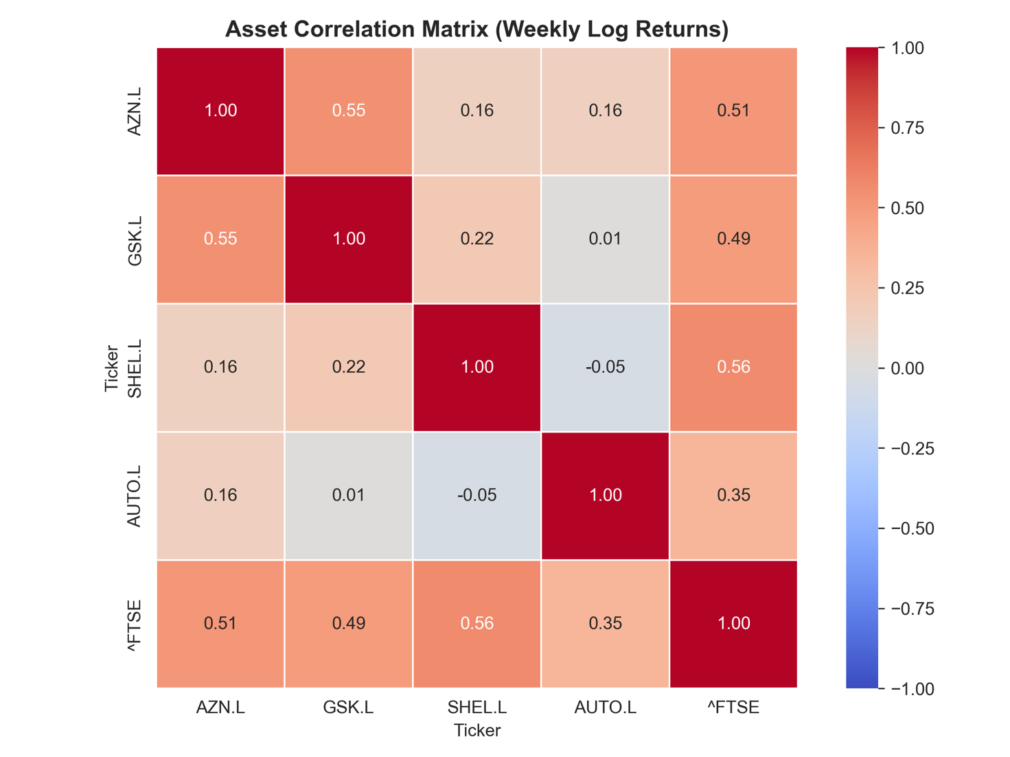
Figure 1: Asset correlation matrix, weekly log returns, 6-year window (22 June 2020 – 22 June 2026).
The average pairwise correlation among the four assets, excluding the benchmark, was 0.173 — comfortably below the 0.5 threshold used in this report to confirm genuine diversification benefit. One exception is worth noting directly: AstraZeneca and GSK showed a pairwise correlation of 0.546, reflecting their shared pharmaceutical-sector exposure. This is moderate rather than severe correlation, and does not invalidate the portfolio’s diversification thesis overall, but it is an honest acknowledgement that these two holdings will not meaningfully diversify each other. Shell and Auto Trader, at the opposite extreme, showed a correlation of −0.053 — effectively uncorrelated, and arguably mildly offsetting.

Table 2: Diversification thesis verification summary.
Metric | Result | Threshold | Verdict
Average pairwise correlation (ex-benchmark) | 0.173 | < 0.500 | CONFIRMED
AZN.L – GSK.L correlation | 0.546 | n/a (flagged) | Moderate
SHEL.L – AUTO.L correlation | −0.053 | n/a | Near-zero

Section 3: Measuring Systemic Risk — Individual Asset Beta
Beta measures the degree to which an asset amplifies or dampens market-wide price movements. It is calculated as the covariance of the asset’s returns with the market’s returns, divided by the variance of the market’s returns:
βᵢ = Cov (Rᵢ, Rₘ) ÷ Var(Rₘ)
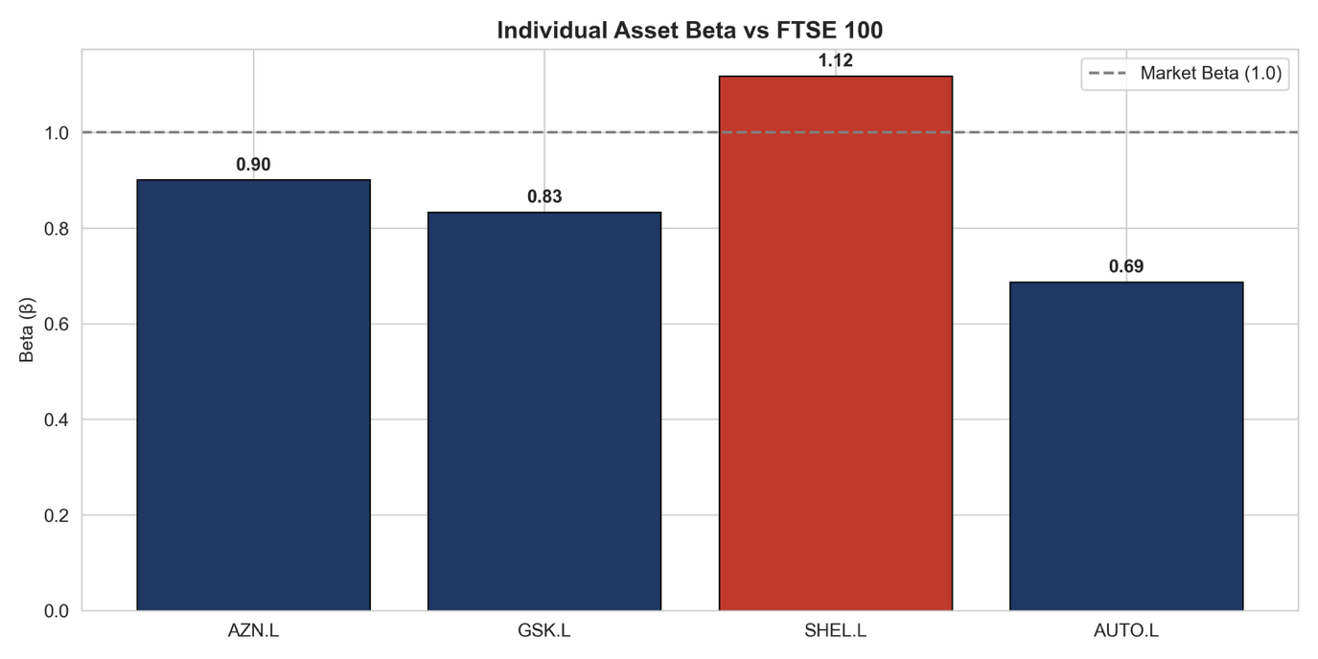
Figure 2: Individual asset Beta vs. FTSE 100, 6-year weekly window.

Table 3: Individual asset Beta classification.
Ticker | Beta (β) | Classification | Interpretation
AZN.L | 0.901 | Defensive | Dampens market moves
GSK.L | 0.834 | Defensive | Dampens market moves
SHEL.L | 1.118 | Aggressive | Amplifies market moves — the portfolio’s only above-market holding
AUTO.L | 0.687 | Defensive | Most defensive holding in the portfolio

A noteworthy finding emerges from this table: Auto Trader — nominally a “growth” technology and consumer-platform stock — exhibits the lowest Beta of all four assets (0.687). Independent research corroborates this result: published Beta estimates for Auto Trader Group cluster around 0.5, a consequence of its near-monopoly market position and highly stable subscription-style cash flows, which insulate the stock from broader market swings despite its growth-sector classification. Shell, conversely, is the only aggressive holding in the portfolio (β = 1.118), consistent with the energy sector’s established sensitivity to commodity prices and currency movements.
A robustness check using a shorter 3-year lookback window was performed during development. It revealed that AstraZeneca and GSK’s Beta classifications are highly window-dependent — both flipped from defensive to aggressive under the shorter window, while Shell flipped in the opposite direction. This instability is itself a meaningful finding, discussed further in Section 6: short-window Beta estimates for these UK equities should be treated with caution. The 6-year window was retained as the primary basis for this report specifically because it is less sensitive to short-term regime noise, and for direct consistency with the data window already established in Project 3.

Section 4: Deriving Portfolio Weights
Rather than assigning arbitrary allocation percentages, portfolio weights were derived systematically through an inverse-Beta methodology: assets with lower, more defensive Beta receive proportionally larger allocations, since they contribute less systemic risk per dollar deployed. Resulting weights were bounded to between 10% and 35% per asset, ensuring the portfolio remains a genuine four-way diversified structure rather than collapsing into a concentrated bet on whichever single stock happens to carry the lowest Beta.

4.1 Resulting Allocation
Table 4: Final portfolio allocation by ticker, sector, Beta, and weight.
Ticker | Sector | Beta | Weight | Allocated ($)
AZN.L | Pharmaceuticals | 0.901 | 23.82% | $23,818.46
GSK.L | Pharmaceuticals | 0.834 | 25.75% | $25,753.23
SHEL.L | Energy | 1.118 | 19.20% | $19,198.54
AUTO.L | Technology / Consumer | 0.687 | 31.23% | $31,229.77
TOTAL |  |  | 100.00% | $100,000.00

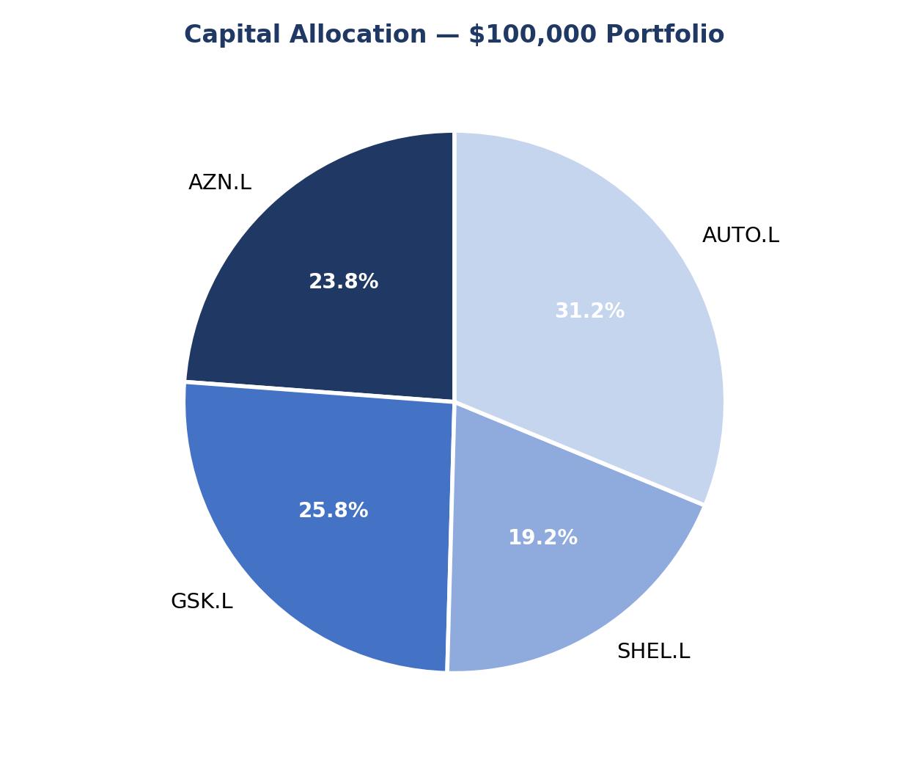
Figure 3: Capital allocation across the four-asset portfolio.

Section 5: Structural Stop-Losses and Position Sizing
Stop-loss distances were derived from each asset’s own historical volatility rather than a fixed arbitrary percentage, consistent with the ATR-based stop-loss methodology established in Project 1. The rule applied was: stop-loss percentage equals 2.0 times the weekly return standard deviation, bounded to a 5%–12% range so that no stop is unrealistically tight or unrealistically wide relative to the asset’s typical weekly movement.
The brief’s 1% Rule states that the maximum capital risked on any single position must be strictly limited to 1% of total account equity ($1,000 on a $100,000 base). The Position Sizing Funnel converts this rule into an exact position size: total capital is multiplied by the risk percentage to produce an absolute dollar-risk ceiling, which is divided by the per-share distance to the stop-loss price. This ensures that when volatility is high and a wider stop is required, position size automatically contracts — keeping dollar risk constant regardless of how volatile the underlying asset is.
Figure 8: Stop-loss levels and resulting position sizes under the brief’s 1% maximum risk-per-trade rule ($1,000 ceiling on $100,000 capital). Entry prices are the most recent available weekly closing prices as of the data pull (week ending 15 June 2026), quoted in GBX (pence).
Ticker | Entry Price (p) | Stop-Loss % | Stop-Loss Price (p) | Position Size (units) | $ Risk if Stopped
AZN.L | 13,234.00 | 6.42% | 12,384.23 | 1 | $850
GSK.L | 1,925.50 | 6.19% | 1,806.29 | 8 | $954
SHEL.L | 2,993.50 | 7.21% | 2,777.70 | 4 | $863
AUTO.L | 478.00 | 7.22% | 443.49 | 28 | $966

Section 6: Gatekeeper Constraint Verification
Two hard pass/fail checks govern whether this portfolio structure is acceptable under the brief’s institutional risk framework. Both are evaluated below using the full 6-year weekly dataset, with a robustness check against a shorter 3-year window also reported, consistent with the chronological out-of-sample discipline established in Project 3’s Walk-Forward Optimisation.

6.1 Constraint 1 — Defensive Systemic Risk (βₚ < 1.0)
βₚ = Σ (wᵢ × βᵢ)
= (0.2382 × 0.901) + (0.2575 × 0.834) + (0.1920 × 1.118) + (0.3123 × 0.687) = 0.8587
VERDICT: PASSED. βₚ = 0.859, with a margin of 0.141 below the 1.0 ceiling. If the FTSE 100 falls 10%, this portfolio is structurally designed to fall by only approximately 8.6%.

6.2 Constraint 2 — Maximum Portfolio Heat (≤ 8%)
Portfolio Heat measures the percentage of total capital that would be lost if every position’s stop-loss triggered simultaneously. To remain consistent with the brief’s 1% risk rule, this report calculates heat using execution-level risk after position sizing, rather than allocation-weighted notional exposure. In other words, heat is based on the actual dollar loss that would occur if the sized positions in Section 5 were stopped out together.
Figure 9: Execution-level Portfolio Heat contribution by asset after applying the 1% position-sizing rule.
Ticker | Actual $ Risk if Stopped | Heat Contribution (% of Capital) | 1% Rule Verdict
AZN.L | $850 | 0.85% | PASS
GSK.L | $954 | 0.95% | PASS
SHEL.L | $863 | 0.86% | PASS
AUTO.L | $966 | 0.97% | PASS
TOTAL | $3,633 | 3.63% | PASS

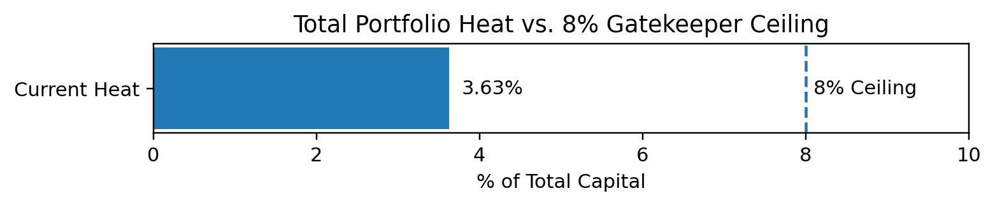
Figure 10: Total Portfolio Heat (3.63%) against the 8% gatekeeper ceiling.
VERDICT: PASSED. Execution-level Total Portfolio Heat = $3,633 (3.63%), with a margin of 4.37 percentage points below the 8% ceiling. This means that even if all four stop-losses triggered simultaneously, the combined portfolio loss would remain safely below the institutional gatekeeper limit and below the theoretical 4% cap implied by four positions each limited to a maximum 1% risk.

6.3 Robustness Check: 3-Year Lookback Window
Both gatekeeper calculations were repeated using a shorter 3-year lookback window (22 June 2023 – 22 June 2026), as a robustness check, consistent with the chronological validation discipline used throughout Project 3.
Figure 11: Beta classification, 6-year vs. 3-year lookback windows. AstraZeneca and GSK invert classification entirely depending on window length.
Window | AZN.L β | GSK.L β | SHEL.L β | AUTO.L β
6-year (primary) | 0.901 (Defensive) | 0.834 (Defensive) | 1.118 (Aggressive) | 0.687 (Defensive)
3-year (check) | 1.193 (Aggressive) | 1.027 (Aggressive) | 0.731 (Defensive) | 0.671 (Defensive)

Figure 12: Gatekeeper and Sharpe Ratio results, 6-year vs. 3-year lookback windows.
Window | Portfolio Beta | Portfolio Heat | Sharpe Ratio
6-year (primary) | 0.859 (PASS) | 3.63% (PASS) | 0.007
3-year (check) | 0.857 (PASS) | 3.59% (PASS) | −0.084

Both gatekeeper constraints pass comfortably under either window. The inverse-Beta weighting procedure controls systematic exposure, while the fixed-fractional 1% position-sizing rule keeps execution-level heat below the 8% ceiling. The Sharpe Ratio, however, is not protected by either mechanism, and it worsens materially under the shorter window (from 0.007 to −0.084) — a directly relevant finding addressed in full in Section 7. The 6-year window was retained as this report’s primary basis specifically because of the Beta-instability finding in Figure 11: a shorter window is materially more sensitive to short-term regime noise for at least two of the four assets in this portfolio.

6.4 Overall Gatekeeper Status
ALL GATEKEEPER CONSTRAINTS PASSED (6-year primary window; corroborated under the 3-year robustness check).

Section 7: Evaluating the Architecture — The Sharpe Ratio
Passing the gatekeeper constraints in Section 6 confirms that the portfolio is safe — it does not confirm that the portfolio is good. The Sharpe Ratio evaluates risk-adjusted return: a nominal return cannot be judged in isolation, only relative to the volatility endured to achieve it.
Sharpe Ratio = (Rₚ − R_f) ÷ σₚ
Table 5: Sharpe Ratio inputs and result, 6-year primary window.
Metric | Value
Portfolio Expected Annual Return | 4.50%
Portfolio Annualised Volatility | 14.87%
Risk-Free Rate (UK proxy) | 4.40%
Sharpe Ratio | 0.007

A Sharpe Ratio of 0.007 is weak: the portfolio’s expected annual return (4.50%) is barely above the UK risk-free rate (4.40%, consistent with the rate used in Project 2’s CAPM/WACC model), despite the portfolio carrying approximately 14.87% annualised volatility. In plain terms, the portfolio takes on meaningful equity risk for almost no expected compensation above simply holding government gilts over this specific historical window.
The cause traces directly to one holding. Auto Trader Group (AUTO.L) — the asset with both the lowest Beta (0.687) and consequently the largest portfolio weight (31.23%) — produced a negative annualised historical return of approximately −1.56% over the 6-year window. This is consistent with Auto Trader’s share price having fallen sharply over the trailing year before a partial recovery, meaning the earlier portion of the 6-year window captured the stock near historically elevated levels. Shell, by contrast, delivered the strongest historical return in the portfolio (approximately 13.52% annualised) but was deliberately underweighted (19.20%) precisely because it carries the portfolio’s only above-market Beta (1.118).

7.1 Key Finding: Beta-Defensiveness and Risk-Adjusted Return Are Not the Same Goal
This result exposes a genuine and instructive tension in the brief’s own framework: optimising purely for low portfolio Beta does not produce a good Sharpe Ratio, because Beta measures sensitivity to market moves, not expected return. A portfolio can be maximally “safe” by the brief’s own definition — passing both the Beta and Heat gatekeepers with comfortable margin — and still deliver a mediocre risk-adjusted outcome over a specific historical window. This portfolio correctly prioritises the brief’s stated objective (capital preservation and systemic risk control) at some real cost to historical risk-adjusted performance, and that trade-off is reported transparently here rather than concealed by selectively choosing a more flattering data window.
As shown in Section 6.3, the 3-year robustness check worsened the Sharpe Ratio further (to −0.084) while leaving both gatekeeper constraints passing comfortably. This asymmetry is itself informative: the inverse-Beta weighting methodology is, by construction, resilient to producing Beta or Heat failures, but it carries no equivalent safeguard against weak risk-adjusted return, since defensiveness and profitability are independent properties of an asset, not two sides of the same measurement.

Section 8: Limitations
- Single-period weight optimisation. Portfolio weights were derived once from the full 6-year Beta estimate and held static. No periodic rebalancing schedule, drift tolerance, or trigger for re-optimising weights as prices and correlations evolve over time was modelled — a simplification appropriate for establishing a baseline allocation, but not a directly deployable rebalancing strategy as constructed.
- Beta estimate instability. As demonstrated directly in Section 6.3, AstraZeneca and GSK’s Beta classifications invert entirely between the 6-year and 3-year lookback windows. This indicates that Beta, as estimated here, is a window-dependent quantity rather than a stable property of the underlying stock, and the gatekeeper verdicts in this report should be read with that instability in mind.
- Weak risk-adjusted return. The Sharpe Ratio of 0.007 (6-year window) is materially below the levels typically considered acceptable for a real capital allocation and turns negative (−0.084) under the 3-year robustness check. This portfolio satisfies the brief’s defensiveness constraints but would not, on this evidence alone, represent an attractive risk-adjusted investment over the periods tested.
- No transaction costs or slippage. The position-sizing and allocation calculations in this report do not deduct brokerage commission, bid-ask spread, or market-impact slippage. These costs would reduce net capital deployed and marginally affect the precision of the heat and weight calculations, though not their broad conclusions.
- Static stop-loss assumption. Stop-loss levels are derived once from historical volatility at the point of construction and are not dynamically updated (for example, via a trailing or ATR-adjusted mechanism, as used in Project 1’s exit logic). A sustained change in any asset’s volatility regime would leave the stop-loss distances calculated here stale.
- Benchmark choice. Beta was calculated against the FTSE 100 (^FTSE) rather than the S&P 500 used in the brief’s own illustrative worked example, for direct consistency with Projects 1–3. Beta values, weights, and both gatekeeper results would differ under an S&P 500 benchmark, given the FTSE 100’s materially different sector composition.
- Four-asset concentration. A genuinely diversified institutional portfolio would typically span considerably more than four holdings and more than three economic sectors. This report’s four-asset structure is sized appropriately for an educational exercise illustrating the underlying mechanics, not for a production-scale capital allocation.

Section 9: Conclusion

9.1 Portfolio Findings
This project constructed a $100,000 simulated portfolio across four minimally correlated assets — AZN.L, GSK.L, SHEL.L, and AUTO.L — derived weights systematically through inverse-Beta allocation, and verified the result against two institutional gatekeeper constraints. Both constraints passed with genuine margin under the primary 6-year window: Portfolio Beta (0.859) cleared the 1.0 ceiling, and execution-level Portfolio Heat (3.63%) cleared the 8% ceiling. Both constraints were corroborated under a 3-year robustness check, despite that shorter window inverting the Beta classification of two of the four underlying assets — itself a meaningful finding about the limits of how much confidence to place in any single Beta estimate.
The Sharpe Ratio was then used to evaluate whether this defensive structure still generates acceptable risk-adjusted returns. It does not, over either window tested — and that result is reported transparently as a genuine finding about the trade-off between defensiveness and performance, rather than adjusted away by re-selecting a more flattering data window. A portfolio satisfying defensive risk constraints is not automatically a well-performing one; Beta, Heat, and Sharpe Ratio each measure a materially different property of a portfolio, and a rigorous risk report should evaluate, and disclose, all three rather than only the ones that look favourable.

9.2 Individual Stock Conclusions
AstraZeneca (AZN.L). Allocated 23.82% of the portfolio ($23,818.46) at a defensive Beta of 0.901 under the primary window. This classification reverses to aggressive (1.193) under the 3-year robustness check — the most significant single instance of window-dependent Beta instability identified in this report.
GSK (GSK.L). Allocated 25.75% of the portfolio ($25,753.23) at a defensive Beta of 0.834. Like AstraZeneca, this classification reverses to aggressive (1.027) under the shorter window, reinforcing that the two pharmaceutical holdings’ defensiveness should not be treated as a fixed property.
Shell (SHEL.L). Allocated 19.20% of the portfolio ($19,198.54) — deliberately underweighted relative to its peers as the portfolio’s only aggressive holding (β = 1.118) under the primary window. Despite the lower allocation, Shell delivered the strongest individual historical return in the portfolio (approximately 13.52% annualised), illustrating directly that this report’s weighting methodology trades return potential for systemic-risk control.
Auto Trader Group (AUTO.L). Allocated the largest single weight in the portfolio (31.23%, $31,229.77) as its most defensive holding (β = 0.687 under the primary window, and the only asset whose classification does not reverse under the 3-year check). Despite this defensiveness, Auto Trader produced a negative annualised historical return (approximately −1.56%) over the 6-year window — the single largest contributor to this portfolio’s weak Sharpe Ratio, and the clearest individual illustration of Section 7’s central finding that defensiveness and profitability are independent properties of an asset.

9.3 Key Learnings
- Beta estimates for UK pharmaceutical and energy equities are highly sensitive to the historical window chosen; a 6-year window was retained specifically for its relative stability over a shorter 3-year alternative.
- Inverse-Beta weighting with bounded allocation (10%–35% per asset) prevents the optimiser from collapsing the portfolio into a concentrated bet on a single low-Beta asset.
- Stop-loss distances derived from each asset’s own historical volatility are more defensible than fixed arbitrary percentages, consistent with the ATR-based approach used in Project 1.
- Portfolio Heat is most meaningful when it is linked to the actual execution-level risk created by position sizing. In this refined version, heat is calculated from the dollar loss that would occur if all four sized positions reached their stop-losses, making the gatekeeper test directly consistent with the brief’s 1% maximum risk-per-position rule.
- A portfolio satisfying defensive risk constraints is not automatically a well-performing one; Beta and Sharpe Ratio measure materially different things, and a rigorous risk report should disclose both, including when they point in different directions.

Disclaimer
This report and the analysis, charts, code, and figures contained within it were produced solely for educational purposes as part of the DecodeLabs Industrial Training Programme, Batch 2026. While it uses real historical market data for AstraZeneca (AZN.L), GSK (GSK.L), Shell (SHEL.L), and Auto Trader Group (AUTO.L), nothing in this document constitutes financial advice, investment advice, or a recommendation to buy, sell, or hold any security.
The portfolio construction, Beta calculations, position-sizing methodology, and gatekeeper verifications presented here are the output of a systematic, educational portfolio-management exercise built for training purposes. They have not been reviewed by a qualified financial advisor, do not account for transaction costs, slippage, taxation, or any individual’s personal financial circumstances, risk tolerance, or investment objectives, and should not be relied upon to make any real trading or investment decision.
Historical Beta, correlation, and return calculations are not indicative of future results and are subject to well-documented limitations — including window-dependent instability, as directly demonstrated in Section 6.3 of this report — that this report has attempted, but cannot guarantee, to fully control for. All trading and investing involves risk, including the risk of loss of capital. Anyone considering an investment or trading decision involving any security mentioned in this report should seek independent financial advice from a qualified, regulated professional.
The author is not a licensed financial advisor, and this document should not be treated as the output of one.

