DecodeLabs Industrial Training Kit
Batch 2026
Stock Market Trading and Analysis Intern
PROJECT 2
Fundamental Valuation & Financial Modelling
Building the Analyst’s Blueprint — From Financial Statements to Intrinsic Value

[ This report was prepared solely for educational purposes as part of the DecodeLabs Industrial Training Programme. It does not constitute financial advice, a recommendation to buy or sell any security, or an offer of any kind.]
Assets Analysed
AstraZeneca (AZN.L) | GSK (GSK.L) | Shell (SHEL.L)
Valuation method: Discounted Cash Flow (DCF) + Relative Multiples
Margin of safety discipline: 30% discount to intrinsic value
Submitted to DecodeLabs | June 2026

Table of Contents
Section 1: Methodology 1
1.1 Scope and Objective 1
1.2 Data Sourcing 1
1.3 DCF Model Structure 1
1.4 Margin of Safety 2
Section 2: Financial Statement Analysis 3
2.1 Income Statement Summary (latest annual, £ billions) 3
2.2 Balance Sheet Summary 4
Section 3: Relative Valuation — Peer Multiples 5
3.1 Valuation Multiples 5
3.2 Risk-Return Positioning 6
Section 4: Discount Rate — Cost of Capital (WACC) 7
4.1 Market Assumptions 7
4.2 Beta and a Data-Quality Correction 7
4.3 WACC Results 8
Section 5: Discounted Cash Flow Valuation 9
5.1 Base-Case Results 9
5.2 Per-Share Valuation vs. Market Price 9
5.3 A Necessary Caveat — Terminal Value Sensitivity 10
Section 6: Discounted Cash Flow Scenario Analysis 11
6.1 Intrinsic Value by Scenario 11
6.2 Sensitivity to WACC and Terminal Growth 11
6.3 Scenario Comparison 12
6.4 Intrinsic Value Range 12
6.5 Scenario Tornado — Impact vs. Base Case 13
Section 7: Combined Verdict — Fundamentals & Technical Signal 14
7.1 Fundamental Scorecard 14
7.2 Project 1 Technical Signal (as of 22 May 2026) 15
7.3 Final Recommendation 15
Section 8: Limitations 16
Section 9: Conclusion & Watchlist 17
9.1 Portfolio Findings 17
9.2 Individual Stock Conclusions 17
Disclaimer 18

Executive Summary

This report values three London Stock Exchange equities AstraZeneca (AZN.L), GSK (GSK.L), and Shell (SHEL.L) using a Discounted Cash Flow (DCF) framework, peer relative-valuation multiples, and a 30% margin-of-safety discipline. Conducted for DecodeLabs Project 2, the analysis separates each company's underlying business value from its market price through mathematical logic rather than sentiment.
The model progressed through seven steps: financial data extraction, statement cleaning and ratio derivation, peer relative valuation, WACC calculation via CAPM, a five-year DCF with Gordon Growth terminal value, scenario stress-testing, and a final verdict combining fundamentals with Project 1's live technical signal. All data was sourced directly from company-reported figures via yfinance, with no reliance on analyst targets or media commentary.
As of 22 May 2026, AstraZeneca trades at 13,234p against an intrinsic value of 14,061p (+6.2%) essentially fair value, with its 26.7x P/E already reflecting much of its growth. GSK trades at 1,926p against 2,428p (+26.1%), the strongest ROE of the three but still short of the margin-of-safety entry point. Shell trades at 2,994p against 7,403p (+147.3%), the only stock clearing the threshold, driven by the lowest multiples and highest free cash flow yield of the three.
AstraZeneca (HOLD): At 26.7x P/E - a premium to the ~20x pharma peer average - the market has priced in much of its 9.8% revenue CAGR. Even under the Conservative scenario, intrinsic value (9,807p) sits below the current price.
GSK (HOLD): Moderate undervaluation with the strongest return profile (40.9% ROE, 13.6x P/E). Falls short of the margin-of-safety entry by a modest margin; the highest-priority watch candidate.
Shell (STRONG BUY): Significantly undervalued, with the lowest multiples (12.5x P/E, 4.6x EV/EBITDA) and highest FCF yield (14.4%); the only stock clearing the 30% bar.
Caveat: Terminal value represents 77–81% of enterprise value across all three, especially Shell's lean heavily on long-run growth assumptions.
Technical signal: All three sit in a bullish EMA regime, but the IPO Decision Engine returns IDLE, as RSI has not recovered above 50.

Section 1: Methodology

1.1 Scope and Objective
As per the DecodeLabs Project 2 brief (Fundamental Valuation & Financial Modelling), this analysis is built around three deliverables: extraction of company-reported financial data in place of media-driven inputs, a Discounted Cash Flow model projecting five years of free cash flow to derive an intrinsic share value, and a relative valuation cross-check using P/E, P/B, and EV/EBITDA multiples against sector peers. A 30% margin-of-safety discipline is then applied before any BUY-side verdict is issued, consistent with the value-investing principle that a model’s output should only be acted on once it embeds a buffer for forecasting error.

1.2 Data Sourcing
Source: yfinance Python library, aggregating company-reported financial statements (income statement, balance sheet, cash flow statement).
Primary disclosures: For UK-listed equities such as AZN.L, GSK.L, and SHEL.L, the underlying primary disclosures are annual reports and RNS filings made to the London Stock Exchange and Companies House; the UK equivalent of the US SEC’s 10-K/10-Q filing regime, though the two are not the same filing system.
Reference date: 22 May 2026 closing prices and pre-computed market ratios (trailing P/E, P/B, EV/EBITDA, beta, market capitalisation).
Currency: All LSE prices are quoted in pence (GBP) and tracked consistently throughout the model, since per-share intrinsic values are compared directly against pence-denominated quoted prices.
Stocks: AZN.L, GSK.L, SHEL.L.

1.3 DCF Model Structure
- Base free cash flow (FCF) is taken from the latest annual cash flow statement (Operating Cash Flow + Capital Expenditure, the latter already negative).
- FCF is projected forward five years using each stock’s trailing revenue CAGR as a growth proxy, clamped to a 3% - 20% range to prevent extreme single-year anomalies from dominating the forecast.
- Each year’s projected FCF is discounted back to present value using a stock-specific WACC (see Section 5).
- A terminal value is calculated using the Gordon Growth model beyond Year 5, assuming a 2.5% perpetual growth rate — in line with long-run UK nominal GDP growth expectations — and is itself discounted back to present value.
- Enterprise value (sum of discounted FCFs and discounted terminal value) is adjusted for net cash/debt to arrive at equity value, which is then divided by diluted shares outstanding to produce an intrinsic value per share.

1.4 Margin of Safety
Following Benjamin Graham’s margin-of-safety principle, a maximum purchase price is set at 70% of modelled intrinsic value (i.e. a 30% discount). A stock is rated BUY or STRONG BUY only if its current price sits below this threshold; otherwise, it is rated HOLD, HOLD/WATCH, or SELL depending on where the price falls relative to the base-case and conservative-case intrinsic values.

Section 2: Financial Statement Analysis
The three businesses differ substantially in scale and margin profile. Shell’s revenue (£266.9B) dwarfs AstraZeneca (£58.7B) and GSK (£32.7B), but its operating margin (10.3%) is far thinner than either pharmaceutical company’s (22.7% and 25.5% respectively); a structural difference that the DCF and ratio analysis both need to capture rather than treat the three as directly comparable businesses.

2.1 Income Statement Summary (latest annual, £ billions)
Metric | AstraZeneca | GSK | Shell
Revenue | £58.74B | £32.67B | £266.89B
Gross profit | £48.11B | £23.65B | £42.49B
Operating income | £13.33B | £8.34B | £27.58B
Net income | £10.22B | £5.72B | £17.84B
EBITDA | £19.51B | £10.40B | £56.66B
Gross margin | 81.9% | 72.4% | 15.9%
Operating margin | 22.7% | 25.5% | 10.3%
Net profit margin | 17.2% | 17.8% | 7.0%
Revenue growth YoY | +8.6% | +4.1% | –6.1%
Revenue CAGR (4yr) | +9.8% | +3.7% | –11.2%
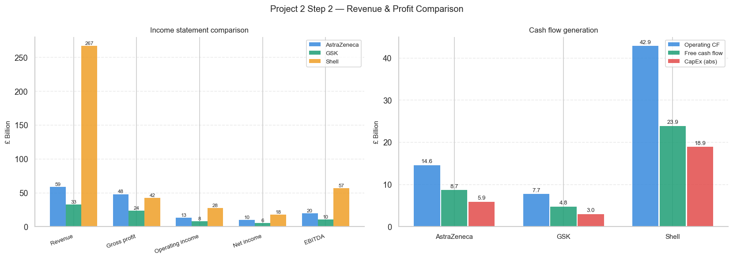
Figure 1: Income statement and cash flow generation comparison across the three stocks.
Shell’s 4-year revenue CAGR is negative (–11.2%), reflecting the post-2022 normalisation of energy prices from their war-driven peak. This decline is a key reason the DCF growth-rate input for Shell is clamped to the model’s 3% floor rather than extrapolating the historical trend.

2.2 Balance Sheet Summary
Metric | AstraZeneca | GSK | Shell
Total assets | £114.07B | £61.12B | £370.35B
Total debt | £29.15B | £17.72B | £75.64B
Total equity | £48.67B | £16.38B | £174.39B
Cash & equivalents | £5.71B | £3.15B | £29.63B
Net cash / (net debt) | –£23.44B | –£14.57B | –£46.01B
D/E ratio | 59.9% | 108.2% | 43.4%
ROE | 23.5% | 40.9% | 10.7%
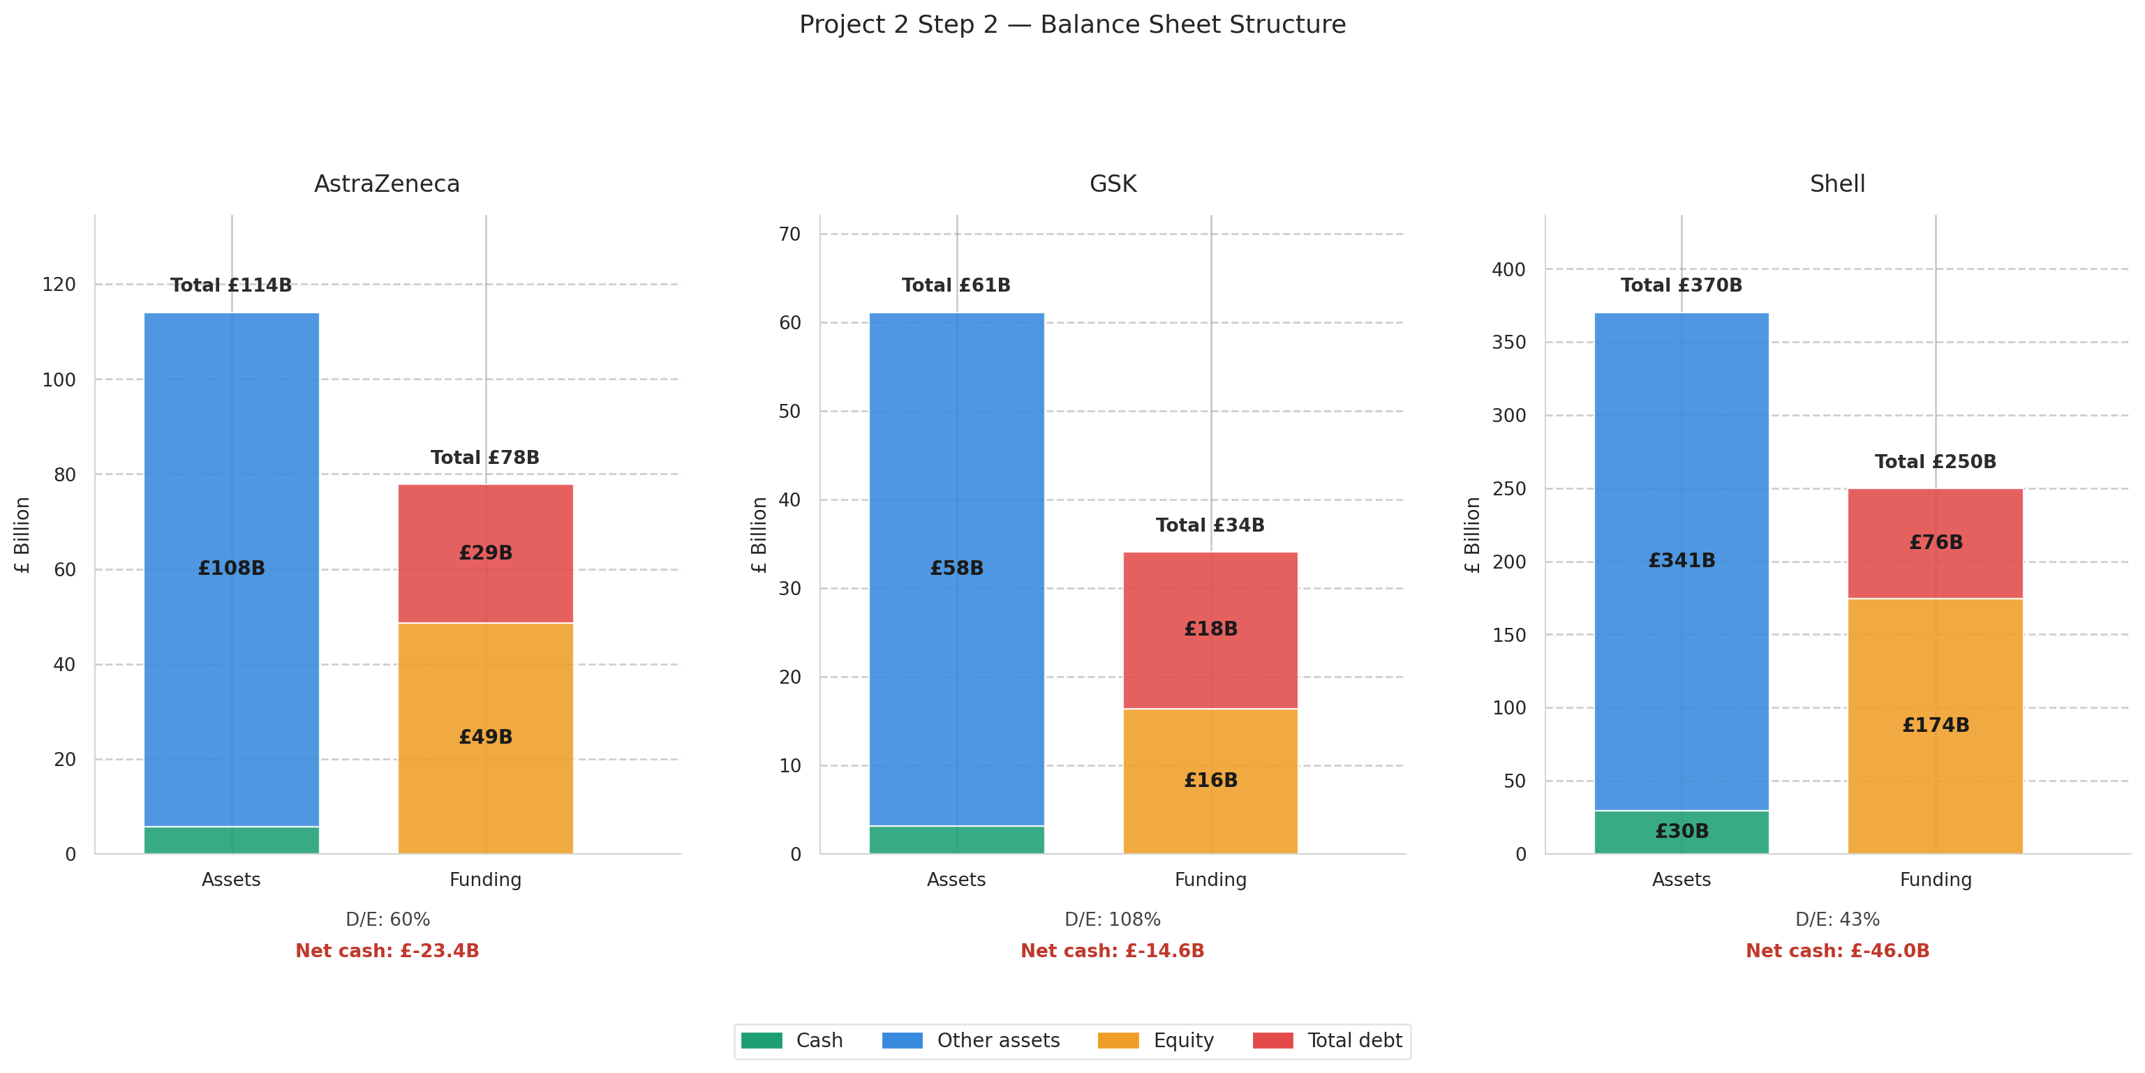
Figure 2: Balance sheet structure — cash and other assets (left bar) versus equity and debt funding (right bar), with current D/E ratio and net cash position annotated below each panel.
All three companies carry net debt rather than net cash, with Shell’s £46.0B net debt position the largest in absolute terms, though proportionally modest against its £370B asset base. GSK’s 108.2% D/E ratio is the highest of the three — a function of its comparatively small equity base rather than excessive borrowing in absolute terms (£17.7B debt, similar in scale to AstraZeneca’s £29.2B).

Section 3: Relative Valuation — Peer Multiples
Relative valuation cross-checks the DCF’s conclusions against how the market is currently pricing each stock relative to its earnings, book value, and cash-adjusted earnings (EV/EBITDA). AstraZeneca and GSK are compared against a pharmaceutical-sector average; Shell is compared against an energy-sector average, since blending the two would obscure each stock’s sector-relative positioning.

3.1 Valuation Multiples
Metric | AstraZeneca | GSK | Shell
P/E ratio | 26.7x | 13.6x | 12.5x
P/B ratio | 5.8x | 4.3x | 1.3x
EV/EBITDA | 11.6x | 8.1x | 4.6x
Dividend yield | 1.8% | 3.5% | 3.8%
FCF yield | 4.2% | 6.2% | 14.4%
Sector average P/E | ~20x (Pharma) | ~20x (Pharma) | ~11x (Energy)
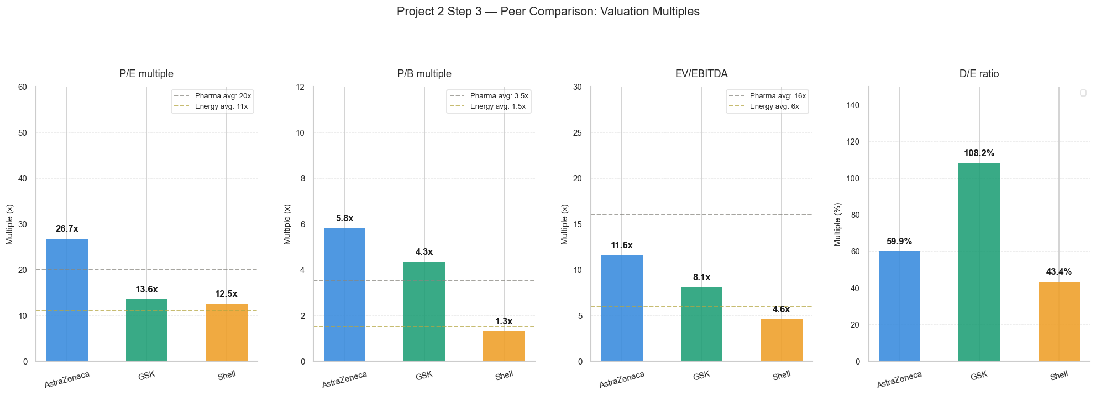
Figure 3: P/E, P/B, EV/EBITDA, and D/E ratio against pharma- and energy-sector averages (dashed lines).
AstraZeneca trades at a premium to the pharmaceutical sector average across every multiple shown — 26.7x P/E versus a ~20x sector average — consistent with the DCF’s conclusion that the stock is close to fair value rather than cheap. GSK and Shell both trade at a discount to their respective sector averages on every multiple, reinforcing the DCF’s base-case upside for both, though the magnitude of Shell’s discount (P/B of just 1.3x against energy-sector book values) is the most pronounced single data point in the entire comparison.

3.2 Risk-Return Positioning
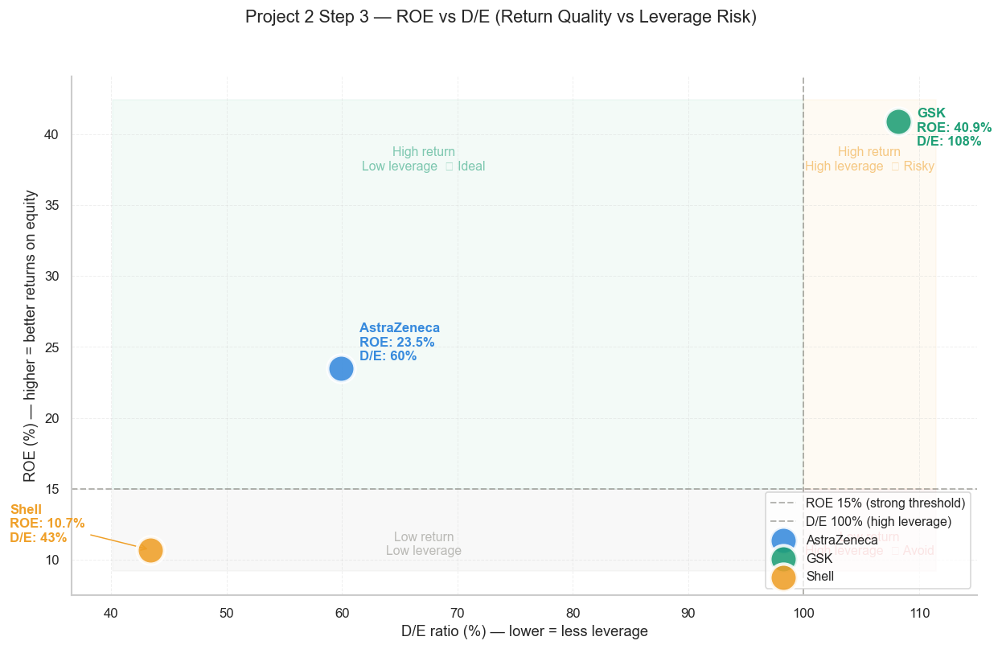
Figure 4: Return on equity plotted against leverage (D/E ratio) — GSK combines the highest ROE with the highest leverage; Shell combines moderate ROE with the lowest leverage of the three.
GSK’s 40.9% ROE is materially higher than AstraZeneca’s 23.5% or Shell’s 10.7%, but this partly reflects its smaller, more leveraged equity base (108.2% D/E) rather than purely superior capital efficiency. Shell’s lower ROE is paired with the lowest leverage of the three names, a more conservative balance sheet structure for a cyclical, capital-intensive energy business.

Section 4: Discount Rate — Cost of Capital (WACC)
A single discount rate cannot fairly represent three businesses with materially different risk profiles. This model derives a stock-specific Weighted Average Cost of Capital (WACC) using CAPM for the cost of equity and an interest-coverage-based approach for the after-tax cost of debt, weighted by each company’s actual capital structure (market value of equity and book value of debt).

4.1 Market Assumptions
Risk-free rate (Rf): 4.40% — 10-year UK gilt yield.
Market return (Rm): 9.90% — UK long-run equity market return.
Equity risk premium (ERP): 5.50% (Rm − Rf).
UK corporate tax rate: 21% (default, overridden per stock where a reliable effective rate is available).

4.2 Beta and a Data-Quality Correction
The raw beta values returned by the data provider for all three stocks were not usable without adjustment: AstraZeneca 0.21, GSK 0.29, and Shell −0.25. A negative beta for an integrated oil major, or a beta below 0.3 for a large pharmaceutical company, is not a credible estimate of systematic risk; it reflects a short or noisy estimation window in the underlying data rather than each company’s true sensitivity to the broader market.
Rather than using these raw figures directly, or applying a single arbitrary floor across all three stocks, this model substitutes sector-typical beta estimates wherever the raw beta falls outside a credible 0.4–2.0 range: 0.65 for the two pharmaceutical companies (AstraZeneca, GSK), and 1.00 for Shell, reflecting typical systematic risk for UK large-cap names in each sector. This correction is the single most consequential adjustment in the entire model; it is the difference between every business modelling as a 5–6% WACC “STRONG BUY” (an artefact of unreliable data) and the differentiated 7.1–8.0% WACC range, and corresponding differentiated verdicts, presented in this report.

4.3 WACC Results
Stock | Beta (used) | Cost of Equity | Cost of Debt (AT) | WACC
AstraZeneca | 0.65 | 7.98% | 4.57% | 7.55%
GSK | 0.65 | 7.98% | 3.25% | 7.09%
Shell | 1.00 | 9.90% | 3.79% | 7.99%
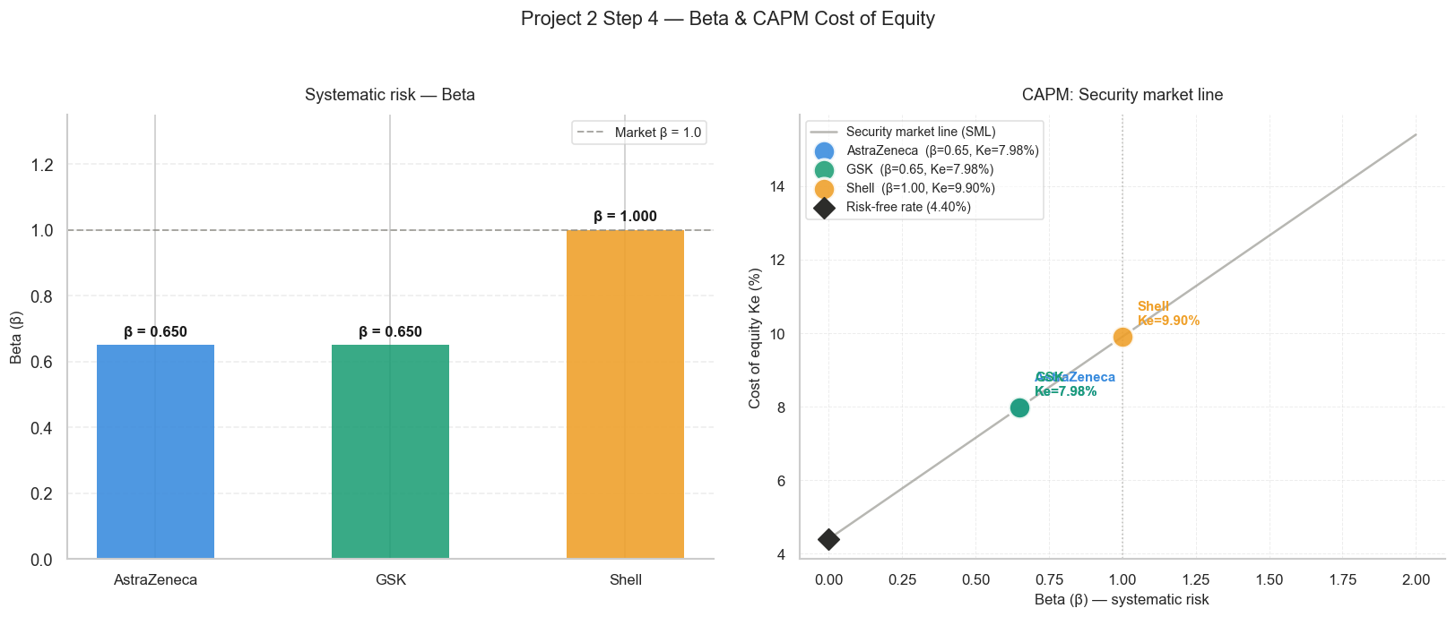
Figure 5: Corrected beta values (left) and the resulting CAPM cost-of-equity positions on the security market line (right).
Shell’s WACC (7.99%) is the highest of the three, driven by its higher assumed beta and larger debt weighting (31.3% of capital, against 12–19% for the pharmaceutical pair). GSK’s WACC (7.09%) is the lowest, reflecting its lower cost of debt despite carrying the highest D/E ratio of the three — a consequence of its debt being weighted at market value of equity rather than book equity in the capital-structure calculation.

Section 5: Discounted Cash Flow Valuation

5.1 Base-Case Results
Stock | Base FCF | FCF Growth | Terminal Value % EV | Equity Value
AstraZeneca | £8.67B | 9.82% | 80.9% | £218.06B
GSK | £4.76B | 3.66% | 80.7% | £97.29B
Shell | £23.92B | 3.00% | 77.2% | £410.44B
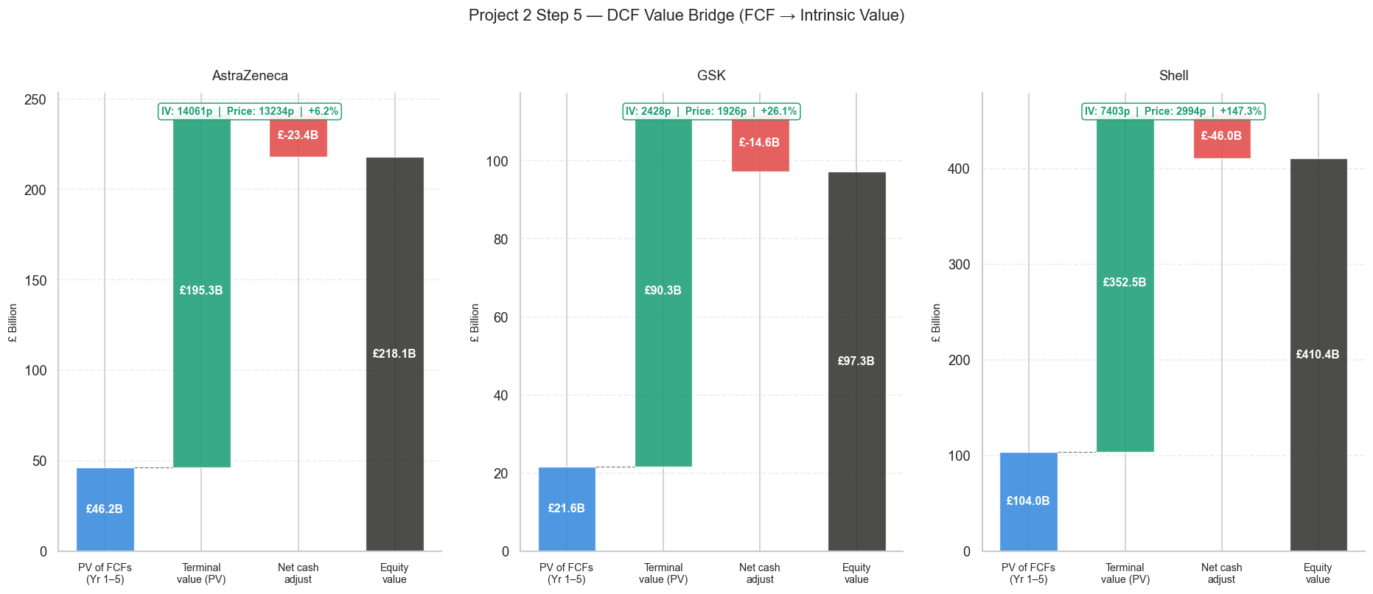
Figure 6: DCF value bridge from discounted Year 1–5 free cash flow, through terminal value, to total equity value per stock.

5.2 Per-Share Valuation vs. Market Price
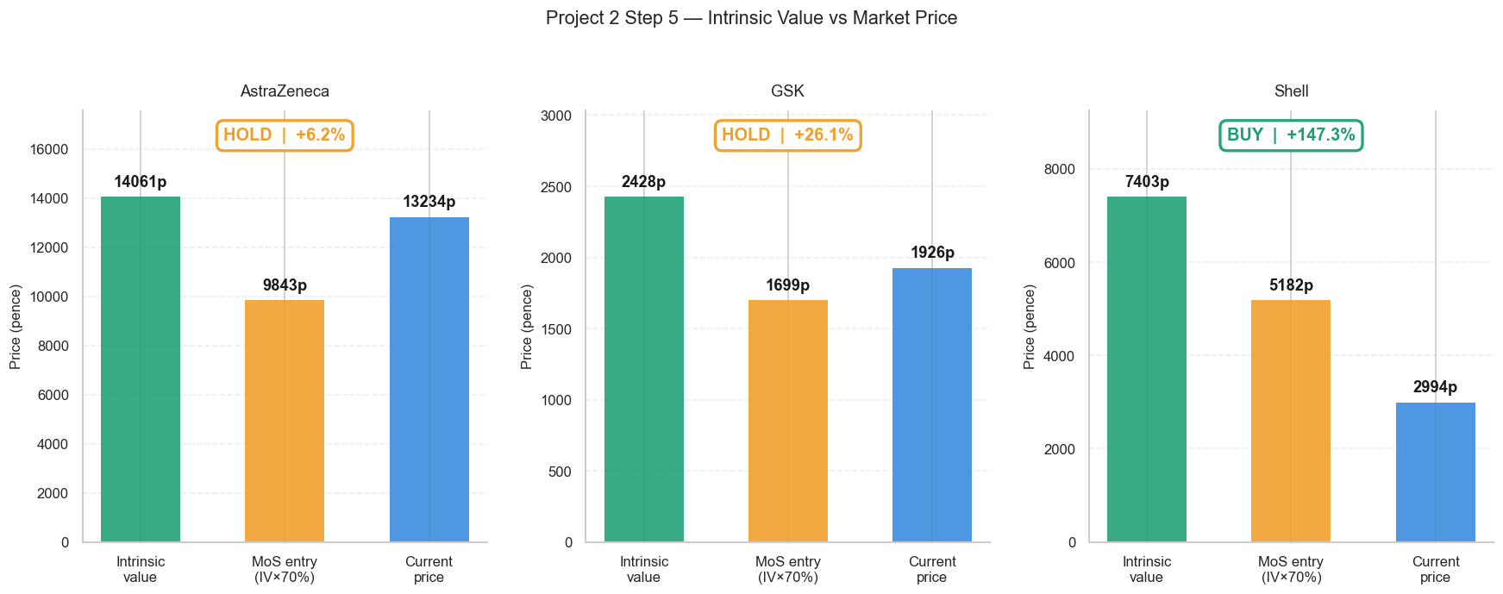
Figure 7: Intrinsic value, 30%-margin-of-safety entry price, and current market price, per stock (pence).
Stock | Intrinsic Value | Current Price | MoS Entry (70%) | Upside
AstraZeneca | 14,061p | 13,234p | 9,843p | +6.2%
GSK | 2,428p | 1,926p | 1,699p | +26.1%
Shell | 7,403p | 2,994p | 5,182p | +147.3%

5.3 A Necessary Caveat — Terminal Value Sensitivity
Model warning (auto-flagged): Across all three stocks, the terminal value represents 77–81% of total enterprise value. This means each valuation leans heavily on a single long-run assumption (2.5% perpetual growth against a 7.1–8.0% WACC) rather than on the five years of explicit cash flow forecasts. The model automatically flags this in its output whenever the WACC-minus-growth spread falls below 5 percentage points or terminal value exceeds 75% of enterprise value — as it does here for all three names.
This is not a flaw unique to this model - long-dated DCFs are structurally sensitive to terminal assumptions - but it does mean the magnitude of Shell’s +147.3% headline upside should be read as “the market is pricing in a more pessimistic long-run outlook for Shell than this model assumes,” rather than as a precise, low-uncertainty number. The qualitative direction of the conclusion (Shell screens cheap; AstraZeneca screens fair-to-rich) is corroborated independently by the peer multiple analysis, which does not depend on any terminal-value assumption at all — a useful cross-check given this sensitivity.

Section 6: Discounted Cash Flow Scenario Analysis
To stress-test the base-case Discounted Cash Flow (DCF) results, the model also runs a Conservative scenario (reduced growth and margin assumptions) and a Bull scenario (elevated growth and margin assumptions) for each stock. These define a realistic range around the base-case intrinsic value, rather than treating the base case as a single precise answer. This section presents the full scenario analysis for AstraZeneca (AZN.L), GSK (GSK.L), and Shell (SHEL.L).

6.1 Intrinsic Value by Scenario
Stock | Conservative IV | Base IV | Bull IV
AstraZeneca | 9,807p | 14,061p | 18,253p
GSK | 1,743p | 2,428p | 3,036p
Shell | 5,614p | 7,403p | 8,939p

Across all three stocks, the Bull scenario raises intrinsic value materially above the Base case, and the Conservative scenario lowers it — but the proportional width of this range differs by stock, as the charts below illustrate.

6.2 Sensitivity to WACC and Terminal Growth
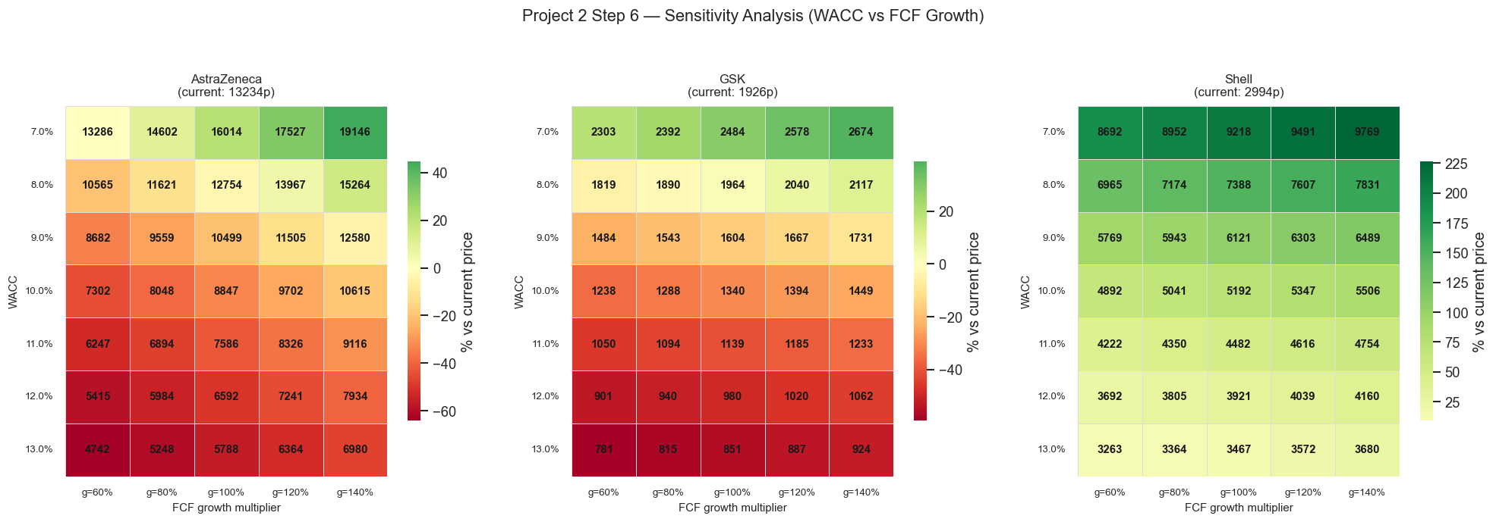
Figure 8: Sensitivity of intrinsic value to combined WACC and terminal growth rate assumptions, per stock.
Each heatmap shows how intrinsic value moves as WACC (rows) and terminal growth (columns) are varied independently around the model's base-case assumptions. The gradient from red (lower value) to green (higher value) makes clear that intrinsic value is more sensitive to WACC than to terminal growth for all three stocks, since the colour bands run more steeply across rows than across columns.

6.3 Scenario Comparison
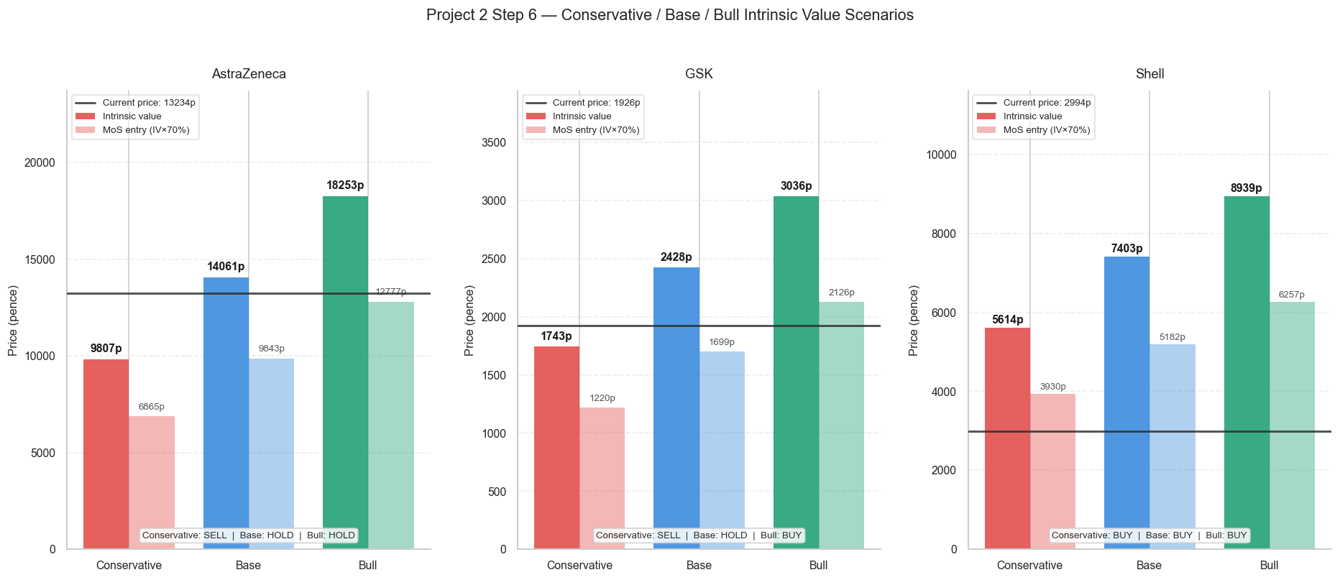
Figure 9: Conservative / Base / Bull intrinsic value by stock, with the current price and margin-of-safety entry price overlaid, and the resulting verdict under each scenario.
This comparison shows that GSK's verdict is the most scenario-sensitive of the three: it would be rated SELL under the Conservative case but BUY under the Bull case, with the Base case landing on HOLD between the two. AstraZeneca remains HOLD or worse across all three scenarios — even its Bull-case intrinsic value sits only moderately above the current price. Shell remains BUY-rated even under its most cautious assumptions, the most scenario-robust conclusion among the three stocks.

6.4 Intrinsic Value Range
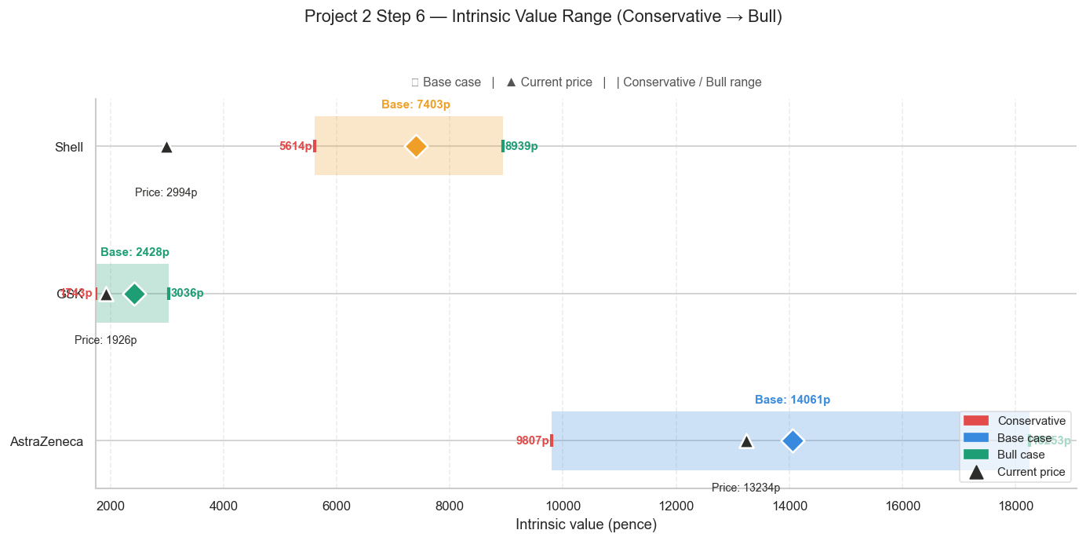
Figure 10: Intrinsic value range (Conservative → Bull) for all three stocks on a common pence axis, with current price marked.
Plotting all three stocks on a single pence axis highlights the difference in absolute scale between the three names: AstraZeneca's range (9,807p–18,253p) spans many thousands of pence given its already-high share price, while GSK's range (1,743p–3,036p) is comparatively narrow in absolute terms despite being similar in proportional width. Shell's current price (2,994p) sits to the left of its entire Conservative-to-Bull range, visually reinforcing the margin-of-safety conclusion reached elsewhere in this analysis.

6.5 Scenario Tornado — Impact vs. Base Case
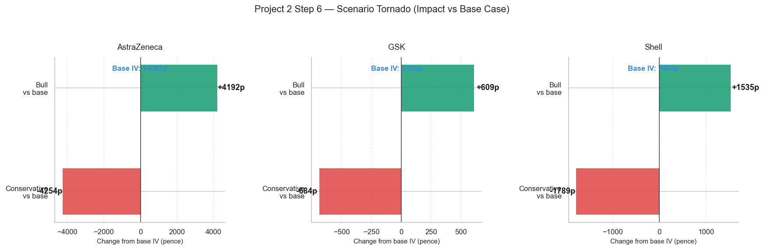
Figure 11: Scenario tornado — pence impact of the Bull and Conservative scenarios relative to each stock’s base-case intrinsic value.
The tornado chart isolates the absolute pence swing each scenario produces relative to the Base case. AstraZeneca shows by far the largest swing in absolute terms (+4,192p under Bull, −4,254p under Conservative), compared with GSK (+609p / −684p) and Shell (+1,535p / −1,789p). This reflects AstraZeneca's higher base free cash flow and greater growth-rate sensitivity in the model, rather than indicating that AstraZeneca carries greater proportional risk than the other two stocks.

Section 7: Combined Verdict — Fundamentals & Technical Signal
The final verdict for each stock combines the fundamental score derived in this report with the live technical signal from Project 1’s IPO Decision Engine, which tracks price action against support/resistance zones, 50/200-day EMA regime, and RSI momentum. This section reconciles the two rather than treating them as independent analyses.

7.1 Fundamental Scorecard
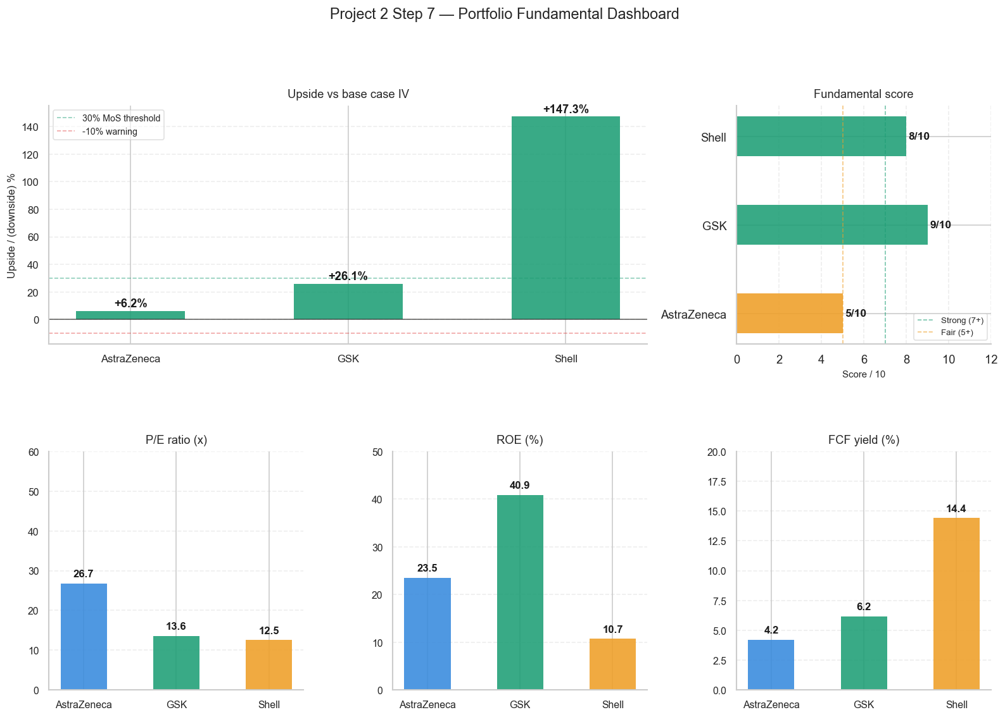
Figure 12: Portfolio fundamental dashboard — upside vs. base-case intrinsic value, fundamental score out of 10, and key valuation/quality metrics, side by side across all three stocks.
GSK scores highest on fundamentals (9/10), combining meaningful undervaluation with the strongest return on equity and a reasonable valuation multiple. Shell scores 8/10, reflecting its deep discount to intrinsic value and high free cash flow yield, offset slightly by its lower ROE. AstraZeneca scores lowest (5/10) — not because the underlying business is weak, but because its current price already reflects most of the value the model can identify, leaving little margin of safety.

7.2 Project 1 Technical Signal (as of 22 May 2026)
Stock | EMA Regime | RSI | Engine State
AstraZeneca | Bullish (50 > 200 EMA) | 46.0 | IDLE
GSK | Bullish (50 > 200 EMA) | 39.5 | IDLE
Shell | Bullish (50 > 200 EMA) | 39.5 | IDLE

All three stocks currently sit in a bullish medium-term EMA regime, but none has RSI momentum above the 50 threshold the engine requires to confirm an entry signal — leaving all three IDLE in Project 1’s gating logic. This is not a contradiction of the fundamental verdicts above: it means the medium-term trend agrees with a constructive view on GSK and Shell, but short-term price momentum has not yet turned to confirm a tactical entry point for any of the three. A fundamentals-led investor acting on this report’s STRONG BUY / HOLD calls would be doing so ahead of, rather than alongside, a technical confirmation signal.

7.3 Final Recommendation
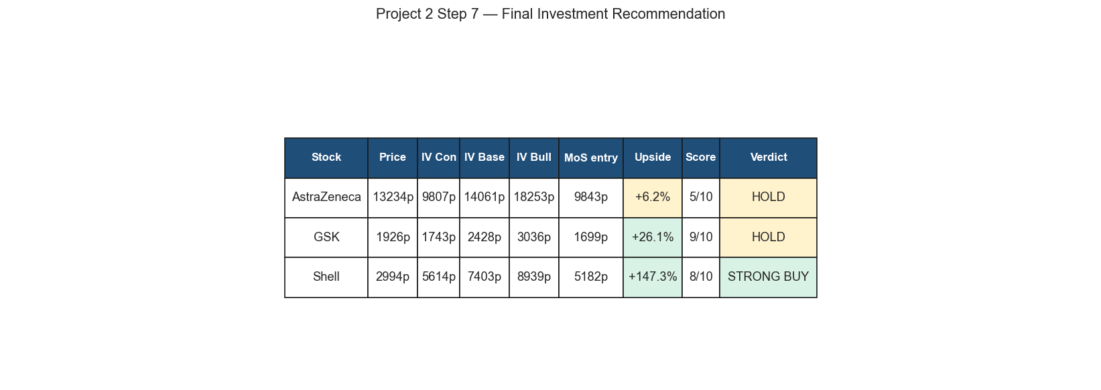
Figure 13: Final investment recommendation summary table, combining valuation levels, upside, fundamental score, and verdict per stock.

Section 8: Limitations
- Terminal value sensitivity. As noted in Section 5, 77–81% of each stock’s enterprise value derives from the terminal value rather than the explicit five-year forecast. A small change in the long-run growth or discount-rate assumption would move every conclusion in this report materially.
- Beta substitution. Section 5.2’s sector-typical beta values (0.65 pharma, 1.00 energy) are a reasoned substitution for unreliable raw data, not a directly observed market parameter. A different reasonable choice within the 0.4–2.0 range would shift each WACC, and therefore each intrinsic value, by a measurable amount.
- Single-point growth proxy. FCF growth is proxied by historical revenue CAGR, clamped to a 3%–20% range. This does not capture forward-looking factors such as pipeline readouts (pharma) or commodity price cycles (energy) that a sell-side analyst would typically layer in separately.
- Static capital structure. The WACC calculation uses a single snapshot of each company’s capital structure rather than a target or normalised structure, which can shift meaningfully for a business like Shell that runs active buyback programmes.
- Sector benchmark precision. The pharma (~20x P/E) and energy (~11x P/E) sector averages used in Section 4 are indicative reference points rather than a constructed basket of exact peer companies.

Section 9: Conclusion & Watchlist

9.1 Portfolio Findings
The fundamental valuation of AstraZeneca, GSK, and Shell as of 22 May 2026 confirms that the market is pricing the two pharmaceutical names efficiently-to-richly, while leaving a substantial valuation gap open on the energy name. AstraZeneca’s premium multiple (26.7x P/E) already reflects its superior growth profile (9.8% revenue CAGR); GSK offers a modest discount with the strongest capital efficiency of the three; Shell offers the largest discount, corroborated independently by both the DCF and the sector-relative multiples.
Project 1’s IPO Decision Engine returns IDLE for all three stocks as of the same date. This is not a bearish assessment — it is a precision filter. Gate B confirms the bullish regime for all three; Gate C (RSI above 50) is the gate currently failing for every stock, requiring a modest momentum recovery before a technical entry would be confirmed alongside this report’s fundamental verdicts.

9.2 Individual Stock Conclusions
AstraZeneca (AZN.L)
AstraZeneca closed the analysis period at 13,234p, against a modelled intrinsic value of 14,061p — essentially fair value (+6.2% upside). At a 26.7x P/E, a premium to the ~20x pharma sector average, the market has already priced in much of the stock’s double-digit revenue growth. Even under the model’s Conservative scenario, intrinsic value (9,807p) sits below the current price, the only stock for which this holds. Verdict: HOLD. The stock does not offer the 30% margin of safety required for a BUY rating; a better entry point would require either a price pullback toward the 9,800–10,000p region or a re-rating of the underlying growth assumptions.
GSK (GSK.L)
GSK closed at 1,926p against a modelled intrinsic value of 2,428p (+26.1% upside), the strongest return-on-equity profile of the three (40.9% ROE) at a comparatively modest 13.6x P/E. It falls short of the 30% margin-of-safety entry price (1,699p) by a meaningful but not extreme margin. Verdict: HOLD, with GSK as the highest-priority watch candidate of the two HOLD-rated names — a moderate pullback toward the high 1,600s to low 1,700s would bring the stock within the model’s buy discipline.
Shell (SHEL.L)
Shell closed at 2,994p against a modelled intrinsic value of 7,403p (+147.3% upside), the only stock in the portfolio that clears the 30% margin-of-safety threshold (5,182p). This is driven by the lowest valuation multiples of the three (12.5x P/E, 4.6x EV/EBITDA, 1.3x P/B) and the highest free cash flow yield (14.4%). Verdict: STRONG BUY — subject to the terminal-value sensitivity caveat in Section 5, which should temper confidence in the precise magnitude, though not the direction, of this conclusion. The qualitative result is corroborated independently by Shell’s deep discount on every relative multiple in Section 4.

Disclaimer
This report and the analysis, charts, and figures contained within it were produced solely for educational purposes as part of the DecodeLabs Industrial Training Programme, Batch 2026. While it uses real historical and current market data for AstraZeneca (AZN.L), GSK (GSK.L), and Shell (SHEL.L), nothing in this document constitutes financial advice, investment advice, or a recommendation to buy, sell, or hold any security.
The DCF model, WACC derivation, and margin-of-safety verdicts presented here are the output of a systematic fundamental analysis exercise built for training purposes. They have not been reviewed by a qualified financial advisor, do not account for an individual’s personal financial circumstances, risk tolerance, or investment objectives, and should not be relied upon to make any real trading or investment decision.
Modelled intrinsic values and upside/downside figures shown in this report are not indicative of future results. All investing involves risk, including the risk of loss of capital. Anyone considering an investment decision involving any security mentioned in this report should seek independent financial advice from a qualified, regulated professional.
The author is not a licensed financial advisor, and this document should not be treated as the output of one.

