**NTUST Derivatives LabTM Module 2**

|  |  |
| --- | --- |
| **Installation Guide and User’s Manual** | Last updated: 2019-04-17 |

1. Download the *TaiwanTech Derivatives Lab* code (Module 2) from the following Github depository:  
     
   <https://github.com/ruben-tsui/OptionsPricingStrategies>  
     
   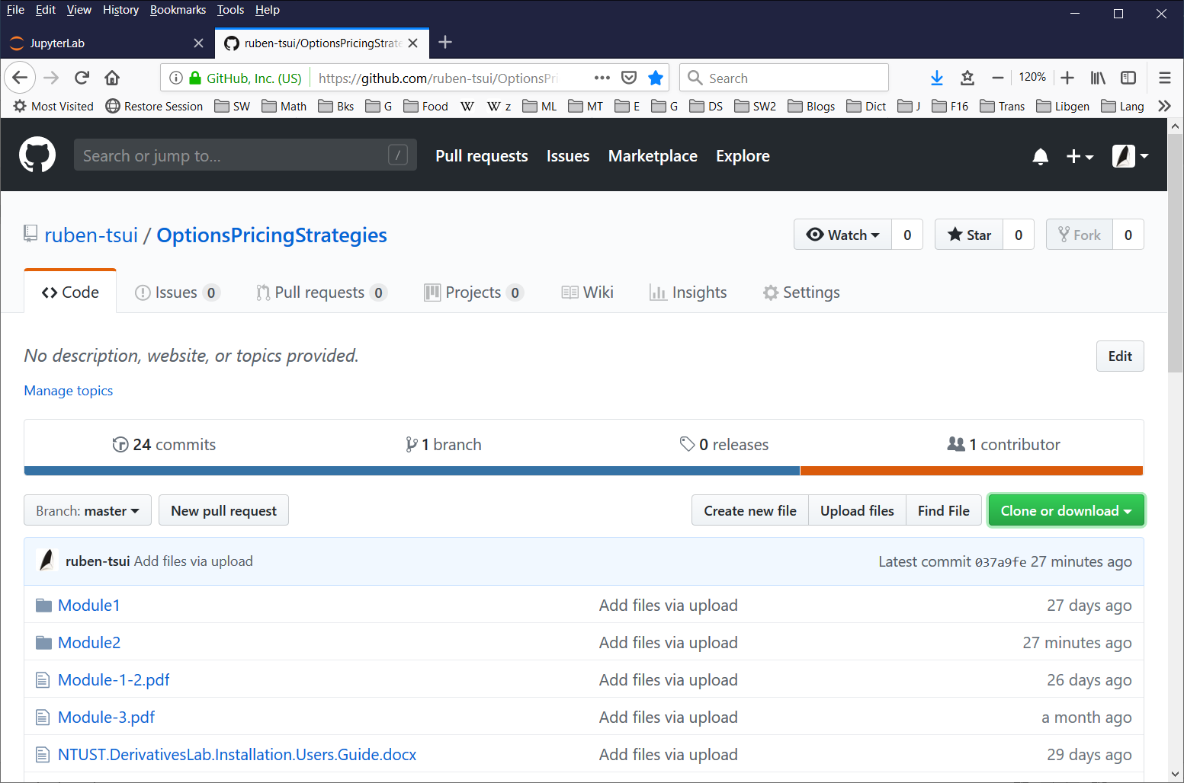   
     
   Click on the Clone or download button to get all files in a ZIP archive. Unzip the archive into a folder of your choice, e.g.,   
     
   C:\Options\OptionsPricingStrategies-master  
     
   Please note that the ZIP archive contains the entire repository, including all preivously seen modules (e.g. Module 1). Now select the Module2 folder (refer to the screenshot below).

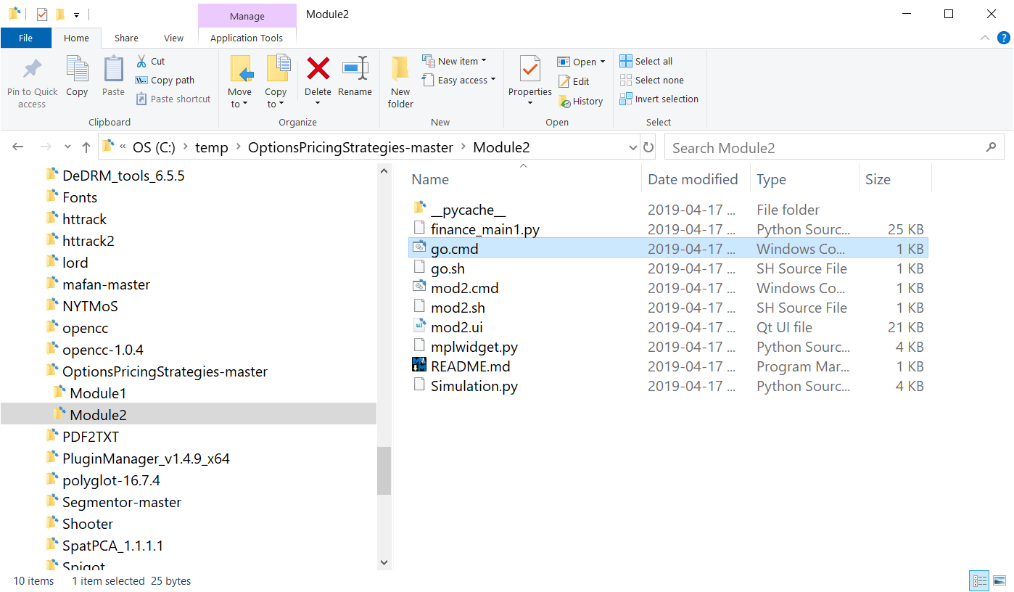

1. Run the mod2.cmd or go.cmd (or just mod2 / go if your file extension is hidden). An application with a blank results screen will appear.  
     
   For macOS users, open a terminal and cd (change directory) to the Module2 folder. Then issue the command: bash go.sh or bash mod2.sh

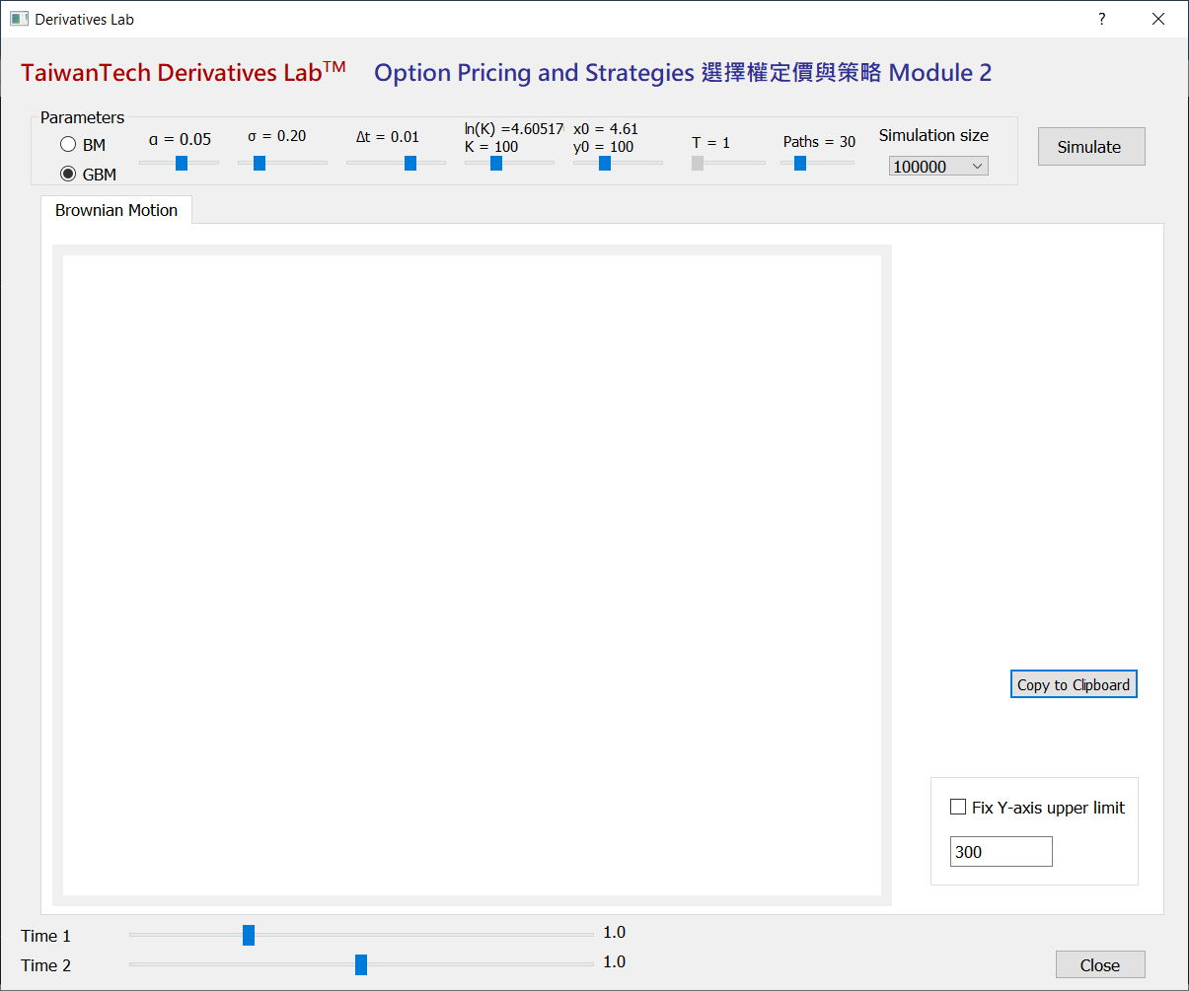

1. At the top of the app make adjustments to the input parameters (with default values as shown):   
     
   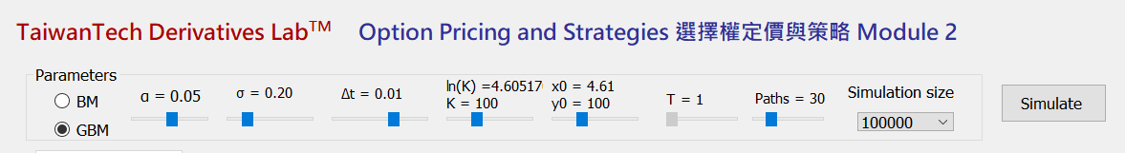

|  |  |  |  |  |  |  |  |  |  |
| --- | --- | --- | --- | --- | --- | --- | --- | --- | --- |
| **Model** | ***α*** | ***σ*** | **Δt** | ***K*** | ***x0, y0*** | ***T*** | **Paths** | ***N*** | **Button** |
| Brownian Motion (BM), or Geometric Brownian Motion (GBM) | alpha – drift parameter | sigma – volatility parameter | Infinitesimal time step (discretized) | strike price | initial values  x0 = ln(y0)  y0 = exp(x0) | Maturity | No. of simulated paths to show | Simulation size  Options:  105, 2×105 | Begin simulation |

When the parameters are satisfactory, press the Simulation button to begin simulation.

1. The simulated results and graphs are as follows:  
     
   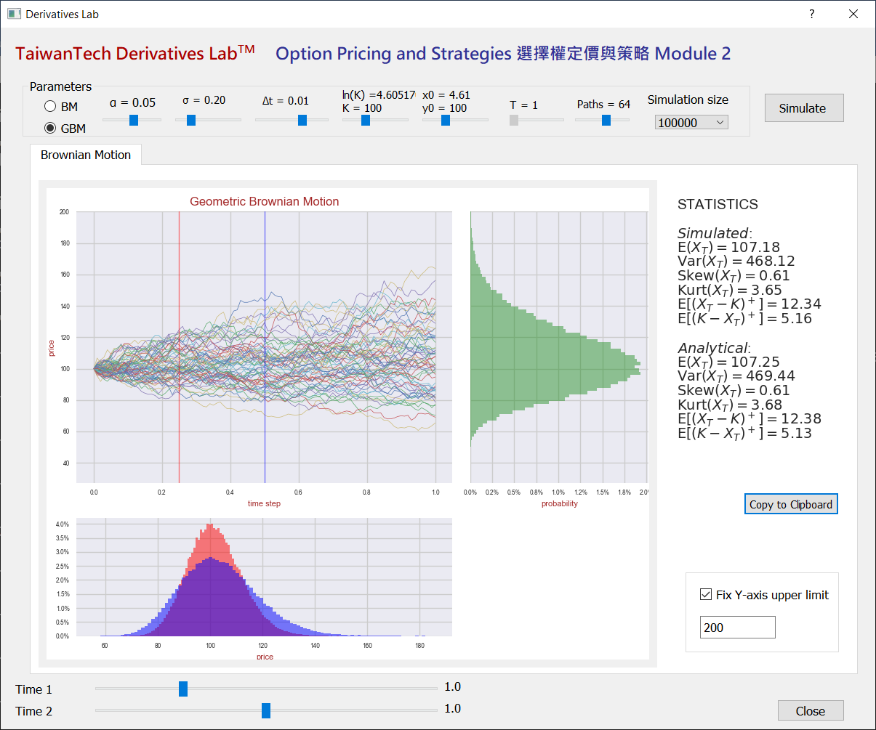
2. You can adjust the *Time 1* and *Time 2* sliders at the bottom to see the distributions at different time steps.
3. Check “Fix Y-axis upper limit” and enter an upper limit for the Y-axis to get a more readable main plot (the line plot).
4. You can also press the the Copy to Clipboard button to copy the descriptive statistics of the simulated results to the clipboard (which you can then paste to another application, such as Excel.)  
     
     
   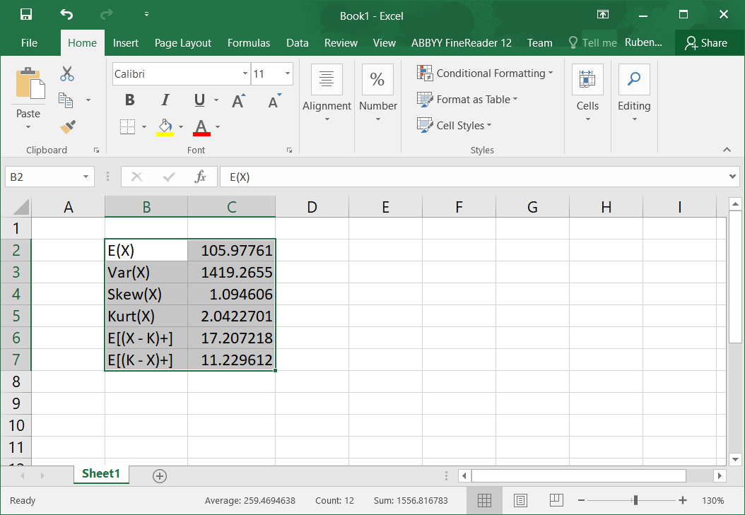
5. To quit the app, press the Close button.