**NTUST Derivatives LabTM Module 1**

|  |  |
| --- | --- |
| **Installation Guide and User’s Manual** | Last updated: 2019-03-20 |

**Part I. Installation Instructions**

1. Download and install the Anaconda distribution for Python 3 from:  
     
   <https://www.anaconda.com/distribution/>

Supported platforms: Windows, macOS, Linux  
Latest version: 2018.12; Python 3.7 (as of March 2019)  
Disk space requirements (Windows 64-bit): approx. 614 MB download; 4 to 5 GB installed  
  
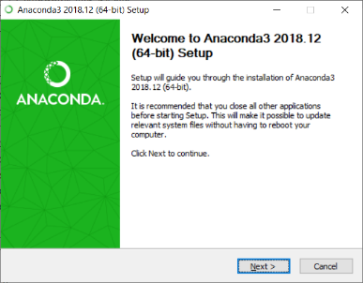 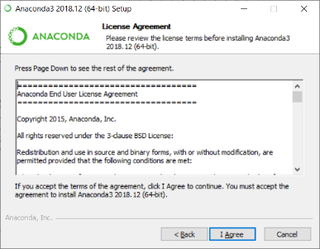 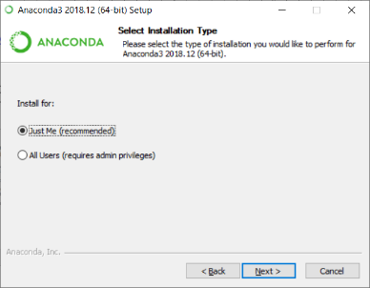

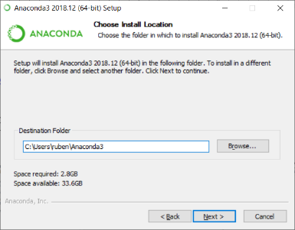 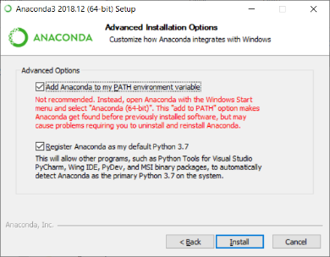 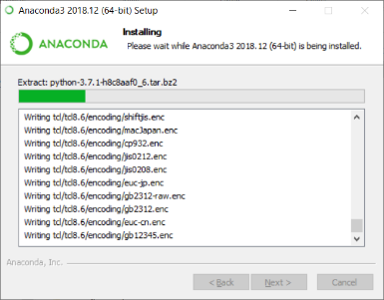  
  
(It takes about 10 minutes to install the entire system and all packages)  
  
Note: This is the software platform on which the NTUST Derivatives Lab runs.

1. Download the *NTUST Derivatives Lab* code (Module 1) from the following Github depository:  
     
   <https://github.com/ruben-tsui/OptionsPricingStrategies>  
     
   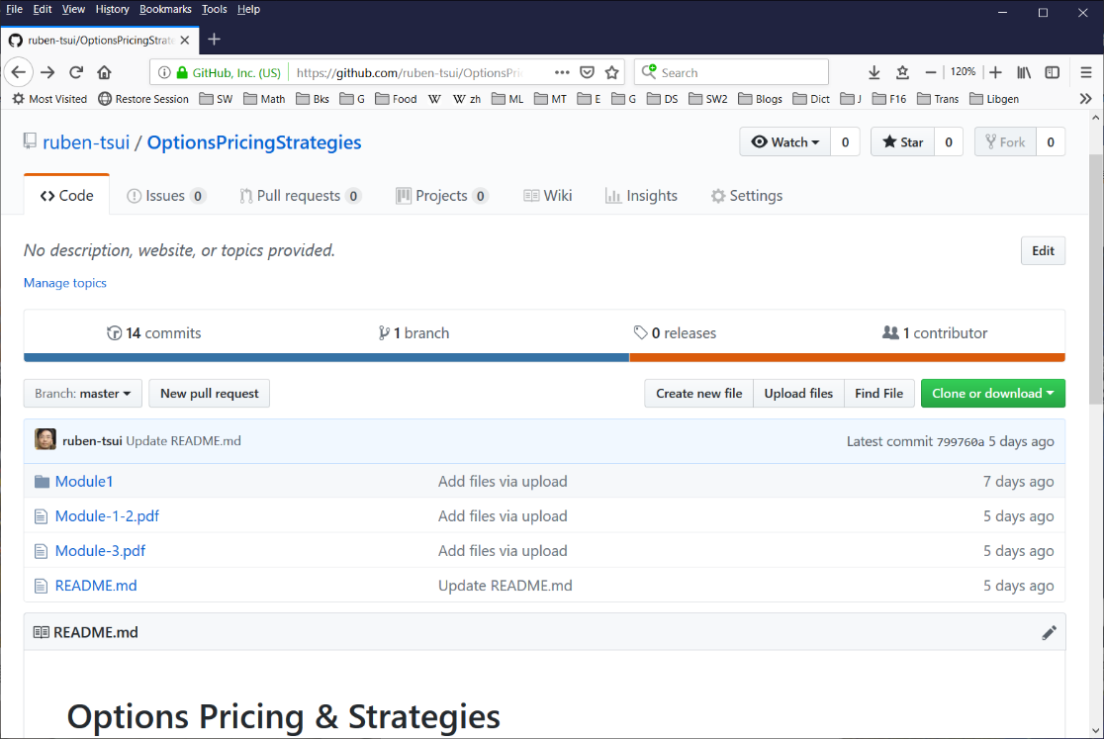   
     
   Click on the Clone or download button to get all files in a ZIP archive. Unzip the archive into a folder of your choice, e.g.,   
     
   C:\Options\OptionsPricingStrategies-master  
     
   Then select the Module1 folder (refer to the screenshot below).  
     
   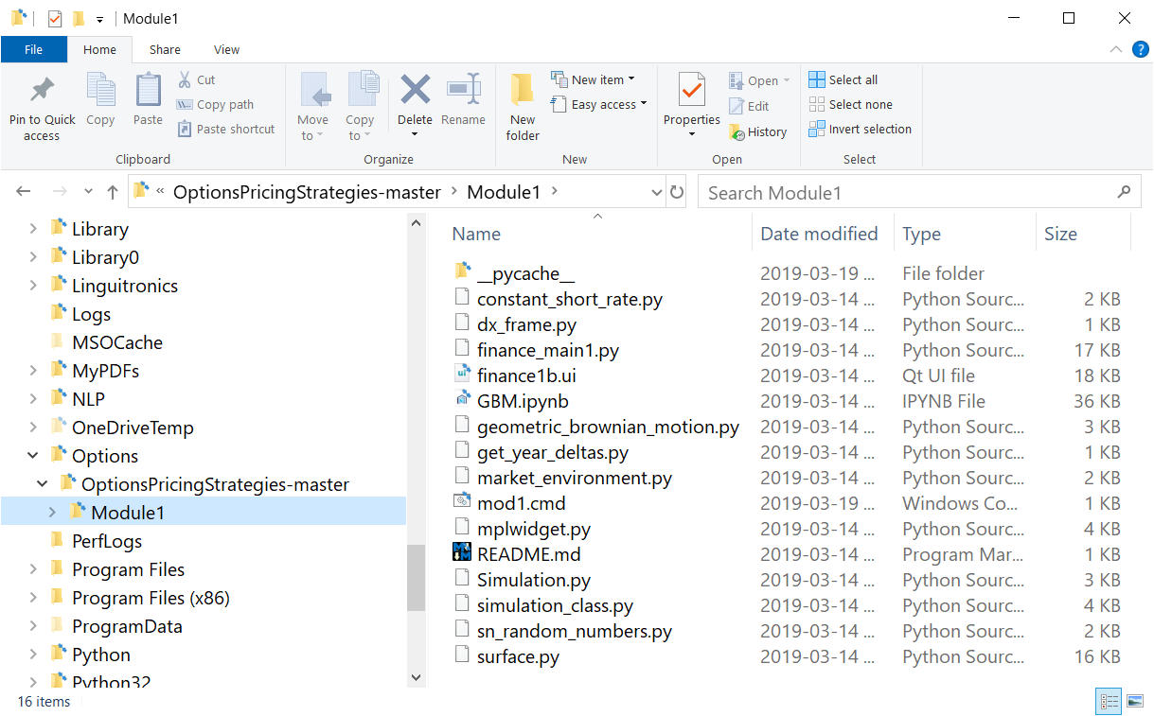
2. Run the mod1.cmd (or just mod1 if your file extension is hidden). An application with a blank results screen will appear.  
     
   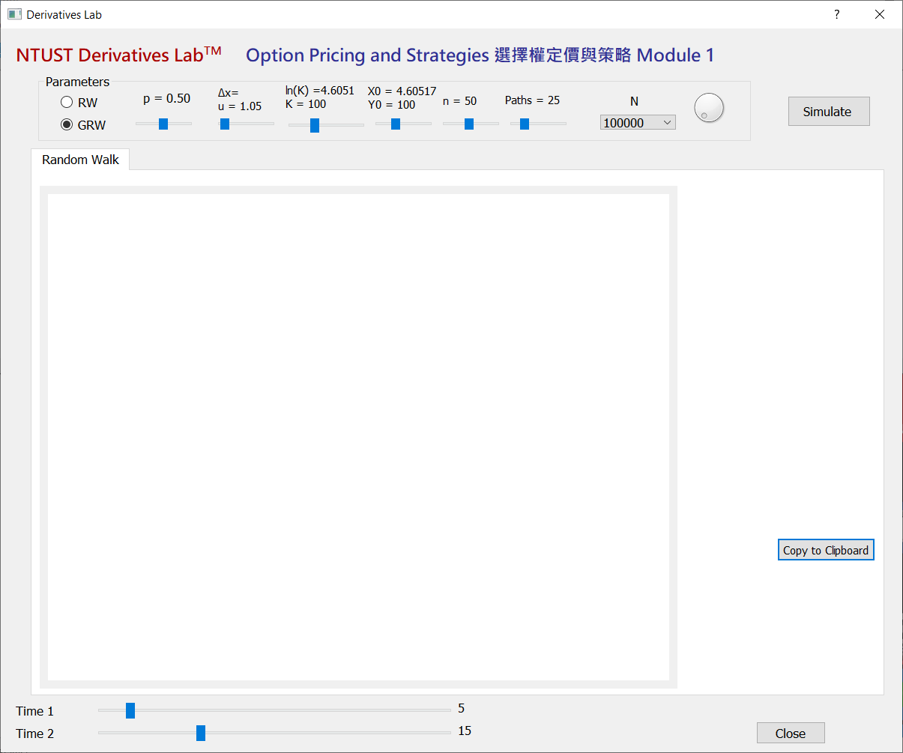
3. At the top of the app make adjustments to the input parameters (with default values as shown):   
     
   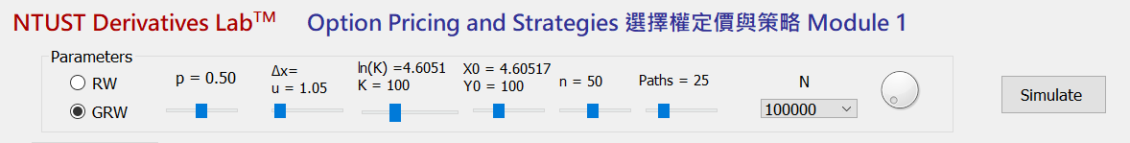

|  |  |  |  |  |  |  |  |  |
| --- | --- | --- | --- | --- | --- | --- | --- | --- |
| **Model** | ***p*** | ***u* , Δ*x*** | ***K*** | ***x0, y0*** | ***n*** | **Paths** | ***N*** | **Button** |
| Random Walk (RW), or Geometric RW | “up” probability | “up” factor (GRW); “up” increment (RW) | strike price | initial values | No. of time steps to simulate | No. of simulated paths to show | Simulation size  Options:  105, 2×105, 5×105, 106 | Begin simulation |

When the parameters are satisfactory, press the Simulation button to begin simulation.

1. The simulated results and graphs are as follows:  
     
   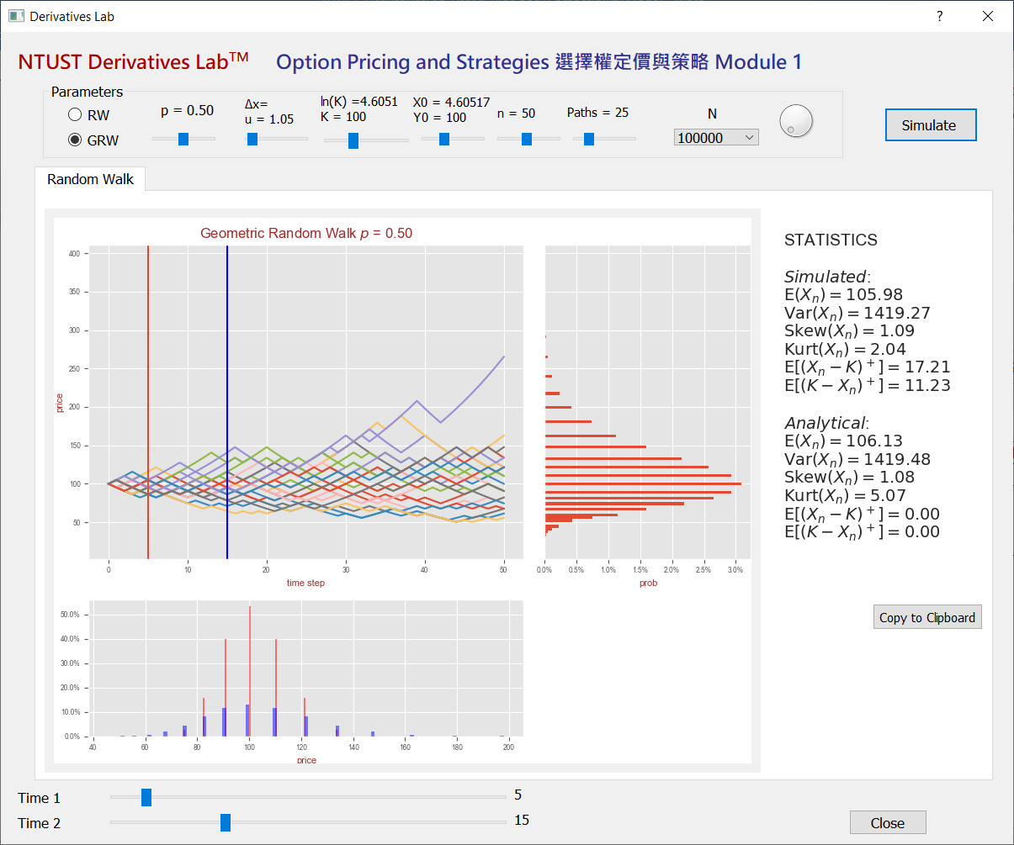
2. You can adjust the *Time 1* and *Time 2* sliders at the bottom to see the distributions at different time steps.
3. You can also press the the Copy to Clipboard button to copy the descriptive statistics of the simulated results to the clipboard (which you can then paste to another application, such as Excel.)  
     
     
   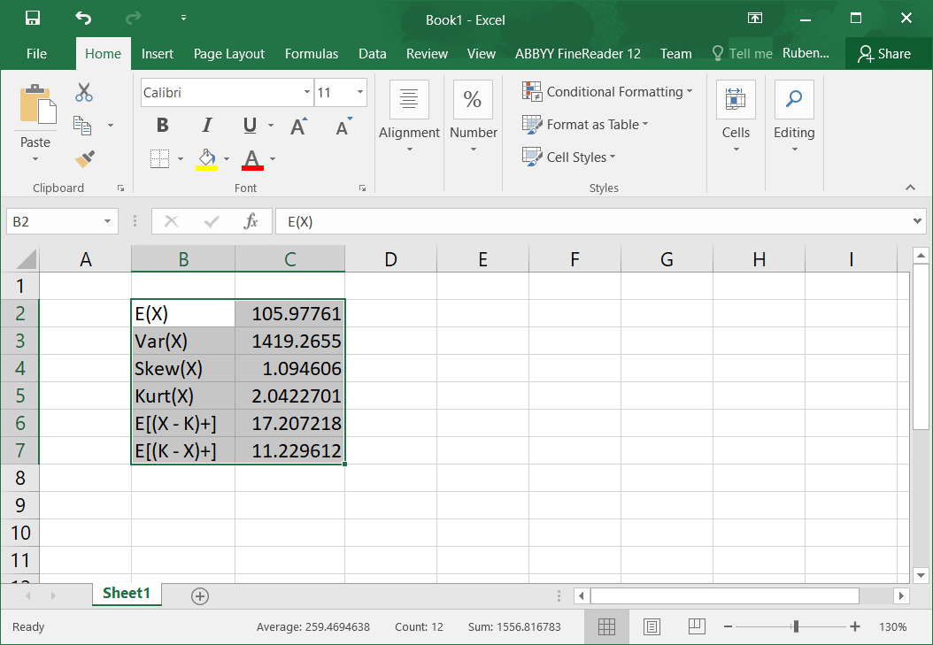
4. To quit the app, press the Close button.