 |  |  | 

Project Acronym | Fed4FIRE
Project Title | Federation for FIRE
Instrument | Large scale integrating project (IP)
Call identifier | FP7-ICT-2011-8
Project number | 318389
Project website | www.fed4fire.eu
Experiment | GEO-Cloud

Orchestrator and Archive&Catalogue Software Document

Work package | WP10
Task | T10.1.2 GEO-Cloud Experiment
Due date | 31/01/2014
Submission date | 31/01/2014
Report Lead | Félix Pedrera (DEIMOS)
Version | 1.0
Authors | Félix Pedrera (DEIMOS), Manuel José LaTorre (DEIMOS) , Rubén Pérez Pascual (DEIMOS)
Reviewers | Jonathan Becedas (DEIMOS)

Document ID | GEO-Cloud-DMS-TEC-TNO03-E
Abstract | This document provides the detail design of Orchestrator component.
Keywords | Deliverable

Nature of the document | R | Report | X
Nature of the document | P | Prototype
Nature of the document | D | Demonstrator
Nature of the document | O | Other
Dissemination level | PU | Public
Dissemination level | PP | Restricted to other programme participants (including the Commission)
Dissemination level | RE | Restricted to a group specified by the consortium (including the Commission)
Dissemination level | CO | Confidential, only for members of the consortium (including the Commission) | X

Disclaimer

The information, documentation and figures available in this deliverable, is written by the Fed4FIRE (Federation for FIRE) – project consortium under EC co-financing contract FP7-ICT-318389 and does not necessarily reflect the views of the European Commission. The European Commission is not liable for any use that may be made of the information contained herein.
Executive Summary

In this document, the procedures to design Orchestrator are presented.
In the first section it is despited the Orchestrator proposals .
Then, it shows the Orchestrator architecture and how it works.
Finally, the interfaces and modules from Orchestrator are shown.
Acronyms and Abbreviations

F4F | Fed4FIRE
XML | eXtensible Markup Language
GS | Ground Station
Table of Contents

1Introduction 7
i)The L0 processor 9
ii)The L1A processor 10
iii)The L1B processor 10
iv)The L1C processor 10
v)Archive 11
2Detail Design 12
2.1Use Cases 12
2.2Architecture 13
2.3Flow Diagrams 14
2.3.1Pooling GS 14
2.3.2Get Raw Data 15
2.3.3Generate Job Order 16
2.3.4Create Processing Chain 17
2.3.5Image Processing 18
2.3.6Delete Processing Chain 19
3Bibliography 20

Introduction

The Orchestrator is a critical component to process raw data from GS.
Its main function is to manage the automatic distribution of the raw data to the processors and get support to Archive.

The Orchestrator has the following functions:

- It identifies which outputs shall be generated by the processors.
- Generating the Job Orders: they contain all the necessary information that the processors need. They include the interfaces and addresses of the folders in which the input information for the processors is located and the folders in which the outputs of the processors have to be sent. They also include the format in which the processors generate their output. They are XML files.
- It must be looking for raw data in GS for start to processing.
- It is able to move the raw data from GS to a shared storage for processors using.
- When all processor have finished, the Orchestrator sends processed data to Archive.

Next Figure shows all components with Orchestrator interactions.

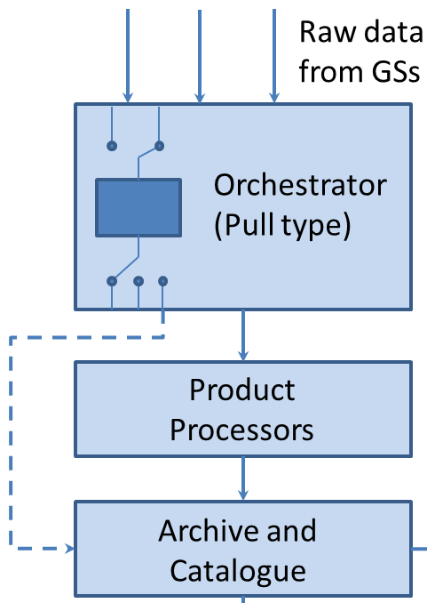

Figure . Orchestrator interactions.

Functionality of this module are described as follows:

- It is driven by the event of new data has been download in a GS.
- When the event occurs, the Orchestrator moves raw data to a shared storage and creates a new chain of processing.
- The Orchestrator has total control of input the each processor and theirs outputs. It manages that output that one is input of other processor.
- In each time processing chain, the Orchestrator makes different Job Orders for processors. Job Order contains all useful information for processors to proceed.
- When Orchestrator detects that one time of processing has successfully done, it deploy the next processor of processing chain.
- When this chain finalize, this module take the final produced image and puts into archive.

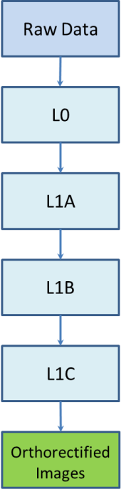

Figure . Flow data in processing chain.

Now it has a look to each processor individually. They are:

The L0 processor

The acquired data is organized into image sectors of predefined size and structure and converted in scenes. Scenes, as defined here, are used throughout the subsequent L1 levels. The size and configuration of the scene is not changed again in the processing chain, for this reason the scene definition is constant for all the L1 levels.

The inputs are the following
- The Raw Data.
- The configuration files.
- The JobOrder.

The outputs are the following:
- The L0 products.

The L1A processor

This section describes the functionality of the processors included in the Level 1A of the Automatic Processing Chain. The goal of Level 1A is to calibrate the scenes. The resulting images are given in units of radiances.

The L1A component works on the scenes that compound the L0 product, performing different transformations over pixel values to generate radiances.

The inputs to the L1A level are:
- One L0 scene.
- The configuration file.
- The JobOrder.

The output is:
- The L1A product.

The L1B processor

Level 1B implements the geolocation, re-sampling and packing.

The inputs to the L1B level are the following:
- The L1A product.
- The configuration file.
- The JobOrder.

The outputs are the following:
- The L1B products.

The L1C processor

The L1C processor performs the ortho-rectification of the L1B product using ground control points.

The inputs to the L1C level are the following:
- The L1B product.
- The configuration file.
- The JobOrder.

The output is the following:
- The L1C products.

Archive

The component that in the Orchestrator acts as Storage is the Archive.
This component is based in Geo-Server software.
Geo-Server is explained in GEO-CLOUD-DMS-TEC-TEC09-10.

The orchestrator communicate with Geo-Server by Gsconfig0.6.7 API.
In this way, when the Orchestrator gets an processed image, it puts into Geo-Server' storage. Also, Geo-Server is notified and creating a new layer, it uploads the meta-data of the image in order to proportionate CSW support. If somebody apply for the data, it sends a petition for CSW to Geo-Server.
The interface between both is based in Orchestrator orders to Geo-Server to create a new layer with the processed image and push into its database. When Geo-Server create the layer, automatically it uploads the image and image's meta-data to supply CSW services.
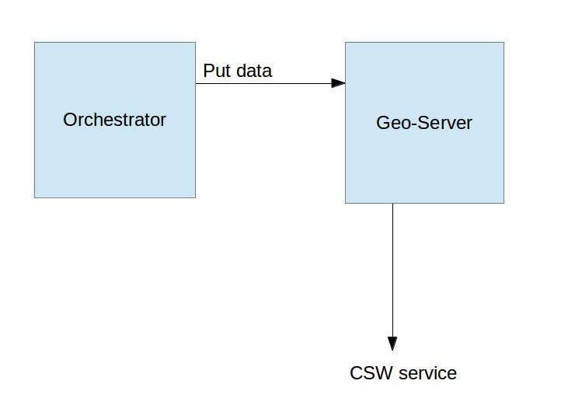

Detail Design

Use Cases

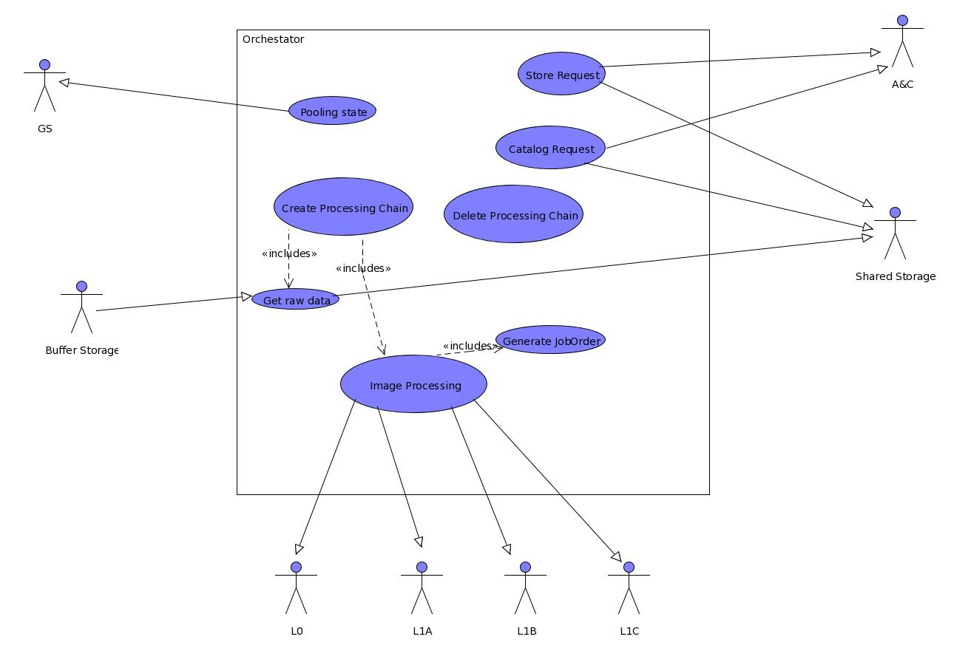

Architecture

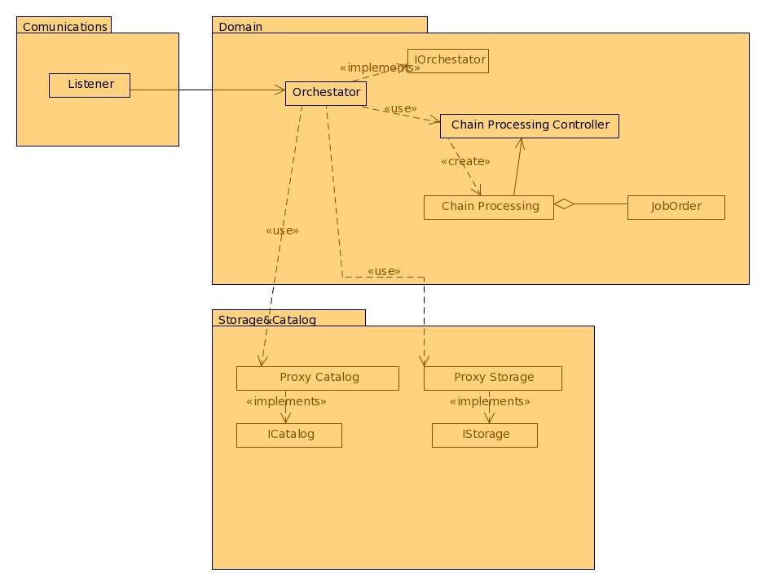
Orchestrator has been divided in three individual packets.

- Communications Packet contains a component that are pooling the GSs.
- Storage Catalog Packet contains the elements that play with other systems as Archive or Catalog.
- In Domain Packet are all components by orchestrator is able to create processing chains and processing raw data.

Flow Diagrams

Pooling GS

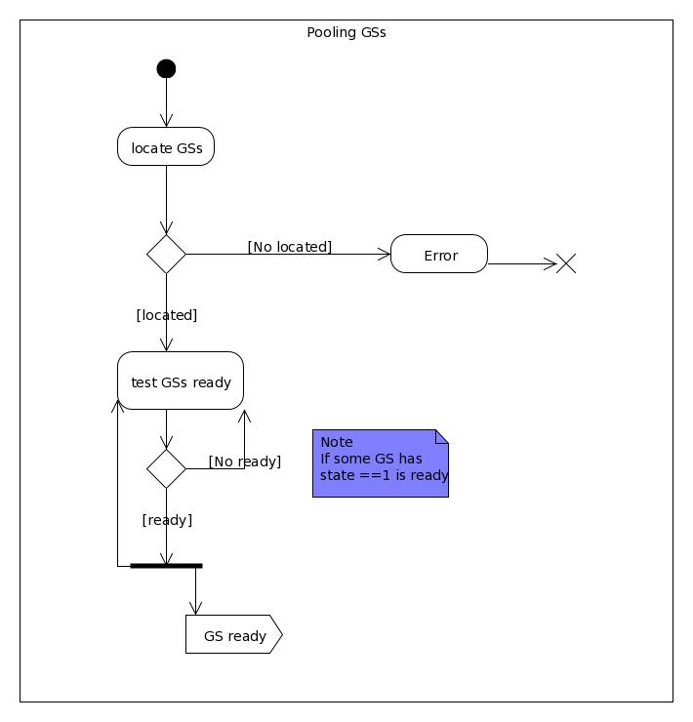

Get Raw Data

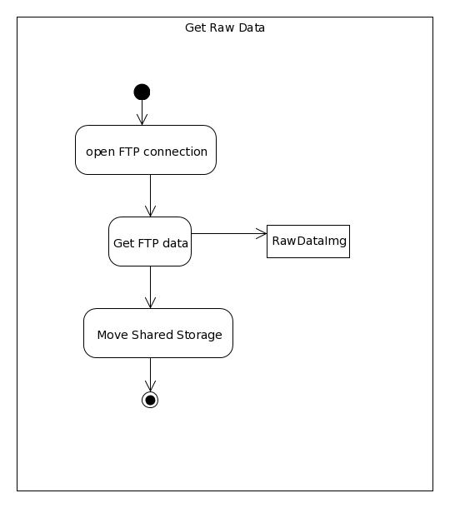

Generate Job Order

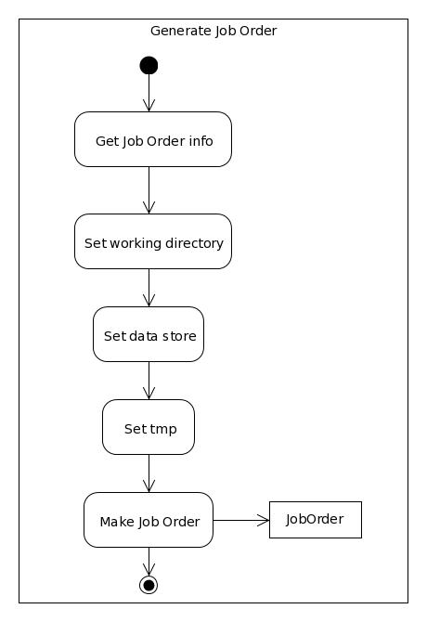

Create Processing Chain
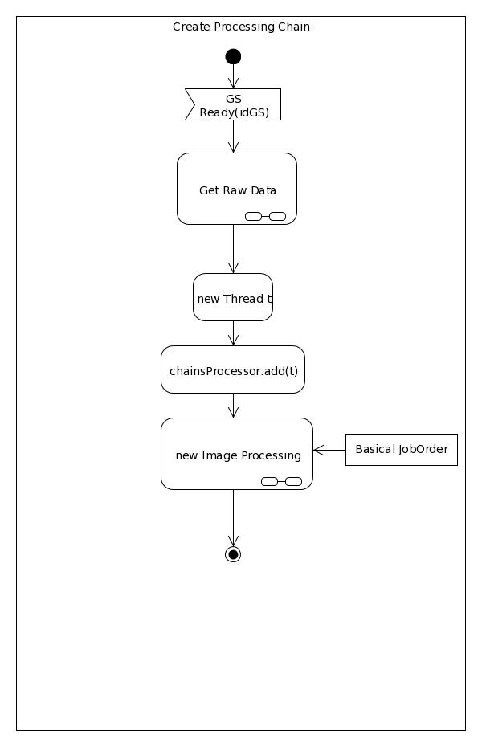

Image Processing
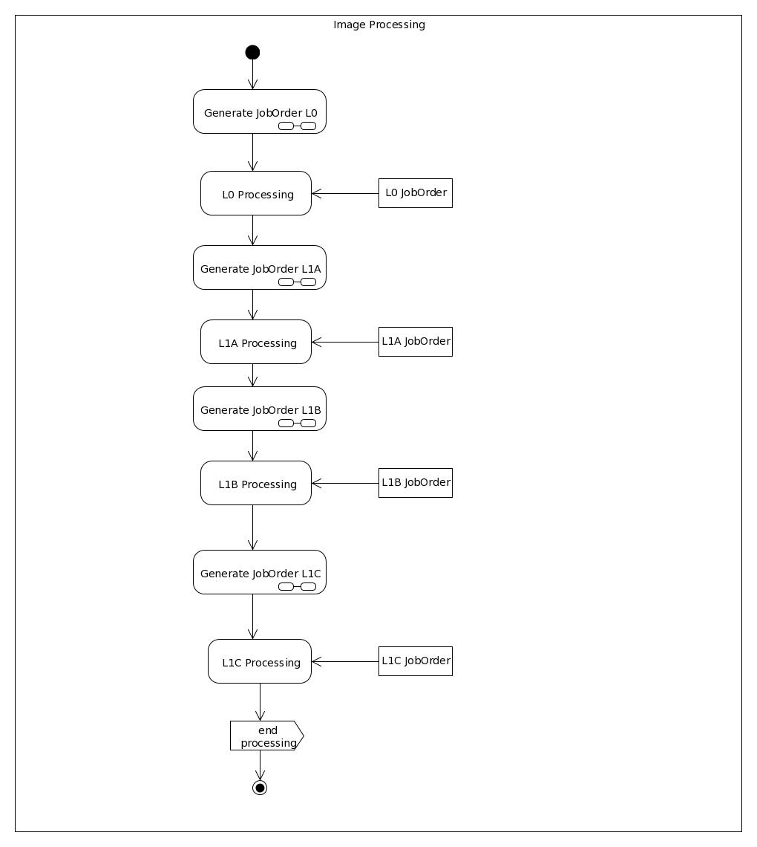

Delete Processing Chain

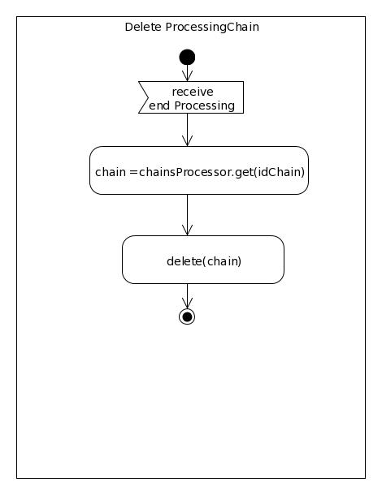

Bibliography
1. fed4FIRE. [Online] http://www.fed4fire.eu/tools.html.
2. Winslow D. and Genthall S. GsConfig0.6.7. [Online], last visited 2014 https://pypi.python.org/pypi/gsconfig/0.6.7, las visited 2014
3. OpenGeo, Geo-Server [Onlline] http://geoserver.org/display/GEOS/Welcome, last visited 2014.
4. Pedrera F., LaTorre M. Sprint 28F_DMS , 2014

