 |  |  | 

Project Acronym | Fed4FIRE
Project Title | Federation for FIRE
Instrument | Large scale integrating project (IP)
Call identifier | FP7-ICT-2011-8
Project number | 318389
Project website | www.fed4fire.eu
Experiment | GEO-Cloud

GEO-Cloud Experiment Implementation in Virtual Wall and BonFIRE

Work package | WP10
Task | T10.1.2 GEO-Cloud Experiment
Due date | 30/05/2014
Submission date | 09/06/2014
Report Lead | Félix Pedrera (DEIMOS)
Version | 1.0
Authors | Manuel José Latorre, Félix Pedrera, Rubén Pérez (DEIMOS)
Reviewers | Jonathan Becedas (DEIMOS)

Document ID | GEO-Cloud-DMS-TEC-TEC15-10-E
Abstract | This document provides technical information about the GEO-Cloud experiment implementation and integration in Virtual Wall and BonFIRE.
Keywords | Report

Nature of the document | R | Report | X
Nature of the document | P | Prototype
Nature of the document | D | Demonstrator
Nature of the document | O | Other
Dissemination level | PU | Public
Dissemination level | PP | Restricted to other programme participants (including the Commission)
Dissemination level | RE | Restricted to a group specified by the consortium (including the Commission)
Dissemination level | CO | Confidential, only for members of the consortium (including the Commission) | X

Disclaimer

The information, documentation and figures available in this deliverable, is written by the Fed4FIRE (Federation for FIRE) – project consortium under EC co-financing contract FP7-ICT-318389 and does not necessarily reflect the views of the European Commission. The European Commission is not liable for any use that may be made of the information contained herein.
Executive Summary

In this document the detailed implementation of GEO-Cloud is presented. The document is divided into the following sections:

In section 1, the implementation is introduced indicating the testbeds involved in it and the required steps for the implementation.

Section 2 is dedicated to the implementation of the Space System Simulator in Virtual Wall. Firstly, the new modified topology (different to the designed one) is depicted because of the handicaps of the hardware during the implementation. Then, nodes reservation is explained and detailed. Finally, the scripts included in each type of node are described before the presentation of the execution.

Section 3 is dedicated to the implementation of the software developed in the BonFIRE testbed. Nodes reservation is firstly depicted. Architecture and setup are also explained. And again, the scripts for each node are included before the description of the execution.

After the explanation of the implementation, the integration in the testbeds is described in sections 4 and 5, relative to the integration of Virtual Wall – BonFIRE and BonFIRE – IDV respectively.

Section 6 is devoted to describe the demonstration of the GEO-Cloud experiment prepared for the European Commission in June 2014.

Finally, section 7 provides the main conclusions.

Acronyms and Abbreviations

BF | BonFIRE
CPU | Central Processing Unit
CSW | Catalogue Services for the Web
EaaS | Elasticity as a Service
FTP | File Transfer Protocol
GS | Ground Station
HTTP | Hypertext Transfer Protocol
Sat | Satellite
SQL | Structured Query Language
VM | Virtual Machine
VW | Virtual Wall
WMS | Web Map Service
WMS-C | Web Map Tile Caching
WMTS | Web Map Tile Service
WPS | Web Processing Service
WS | Web Service
XML | eXtensible Markup Language
Table of Contents

1 Introduction 8
2 Implementation in Virtual Wall 9
2.1 Nodes reservation and setup 10
2.1.1 SS nodes setup 10
2.1.2 GS nodes setup 11
2.2 Execution 13
3 Implementation in BonFIRE 14
3.1 Nodes reservation 14
3.1.1 Distributed Database 14
3.1.2 Orchestrator 14
3.1.3 Processing Chain 14
3.1.4 Archive and Catalogue 14
3.1.5 Image Distribution and Visualization 14
3.2 Nodes setup 14
3.2.1 Database node setup 14
3.2.2 Orchestrator node setup 15
3.2.3 Processing Chain node setup 16
3.2.4 Archive and Catalogue node setup 16
3.2.5 Image Distribution and Visualization node setup 17
3.3 Architecture 17
4 DEMO Explanation 19
5 Conclusions 21

Introduction

The GEO-Cloud experiment implementation is the following step in the project, after the design of the system. This step consists of the procedures to be followed in order to have the testbeds available and ready to execute the experiment and start obtaining results. In the document, the whole implementation process is covered and also the integration between testbeds is explained.

Besides, a demonstration of the project was required by the European Commission to know first-hand how it works. It is presented the execution of one scenario together with a video that provides visual information of the satellite system in the process, and also including an interactive exercise allowing the access to the images acquired during the demonstration through a web service.

Implementation in Virtual Wall

In Virtual Wall the Space System Simulator was implemented. It is constituted of the following modules:
- The Satellite System Simulator
- The Ground Station System Simulator

The topology network designed is depicted in Figure 1.

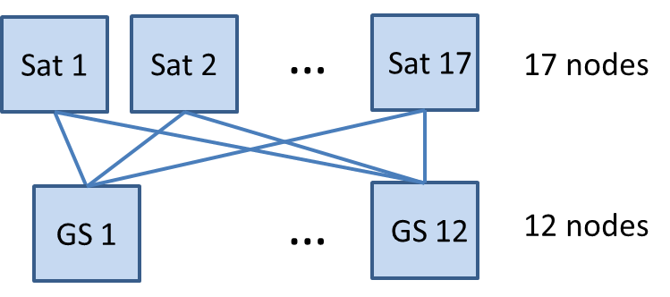
Figure 1 Topology Network in Virtual Wall

The previous topology network involves Sat nodes to have 12 connections with the GS nodes; and GS nodes 17 connections with Sat nodes plus one connection with the BonFIRE cloud.

The nodes in Virtual Wall have a limitation of 5 physical connections. To deploy the previous topology we adapted the Space System Simulator software to establish those connections by software. This was done by making the Satellite System Simulator flexible to connect with any ground station from GS1 to GS12. Then the Satellite System Simulator can be multiplied and only connect to it the number of GS nodes desired.

The solution was to multiply the Satellite System Simulator by three and connect 4 ground stations to each Satellite System Simulator. This ensures the same performance and dynamics of the previous topology network described in Figure 1, and the only thing it changes is the software.

The Space System Simulator implemented in Virtual Wall is depicted in Figure 2.
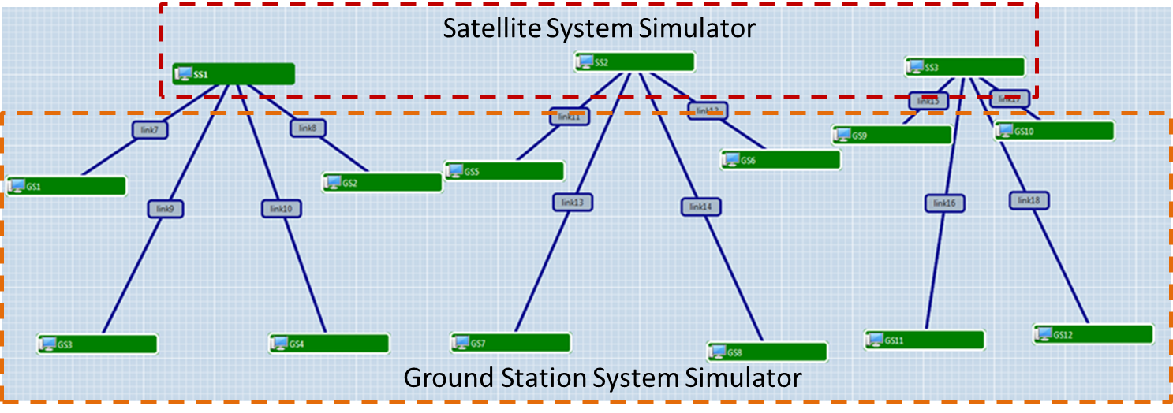
Figure 2 Space System Simulator implemented in Virtual Wall

Nodes reservation and setup
The Space System Simulator is then constituted by 15 “Generic nodes” in Virtual Wall 1. The configuration of the experiment makes the provisioning of “any available node”, which is more flexible in case a node is being used in other experiment (see Figure 3). The links between SS (Satellite Simulators) and GS (Ground Stations Simulators) nodes are TCP. The definition of the dependencies and the commands that will be installed at setup is defined in JFed using a RSPEC specification. This specification includes some bash commands or instructions that will execute after reservation automatically.

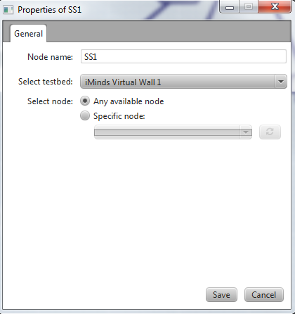
Figure 3 Configuration of Virtual Wall nodes

SS nodes setup

The configuration of the nodes is done by using JFed Experiment. The Satellite Simulators software is developed under Python. To install the libraries the nodes need connectivity with the Internet. For that purpose a gateway has to be configured:

<execute shell="sh" command="sudo route del default gw 10.2.15.254"/>
<execute shell="sh" command="sudo route add default gw 10.2.15.253"/>

And the update of the system has to be carried out to update the repositories and dependencies:

<execute shell="sh" command="sudo apt-get update"/>

Once the update is finished Python can be installed. The Satellite Simulators require the connection with a database that provides the scenario number and the initial conditions for their execution. The MySQL library is also required:

<execute shell="sh" command="sudo apt-get install python python-mysqldb -y"/>

The database is located in BonFIRE. It has an IP that can change. In order to obtain that IP and include it in the Satellite Simulator, a script to acquire the IP of the database was developed “push_dbIP.sh”. It contains the following code:

#!/bin/bash

ip=$1

touch /users/jbecedas/ipdb
echo $ip > /users/jbecedas/ipdb

This file is located in Google Drive. The following sentence acquires the file from Google Drive:

<execute shell="sh" command="sudo wget --no-check-certificate google_drive_host_address -O /users/jbecedas/push_dbIP.sh"/>

Where google_drive_host_address is the address of the Google Drive host in which the scripts are located.

The execution of the push_dbIP.sh script acquires the IP of the database and includes it in the file ipdb, created by “push_dbIP.sh”:
<execute shell="sh" command="sudo bash /users/jbecedas/push_dbIP.sh 129.215.175.147"/>

Now, the node is perfectly configured to proceed with the installation of the Satellite Simulator. The software of the simulator has been archived too in Google Drive. With the following command the software is acquired:

<execute shell="sh" command="sudo wget --no-check-certificate google_drive_host_address -O /users/jbecedas/satellite.py"/>

It can now be executed in the node.

GS nodes setup

The Ground Station Simulators software is developed under Python. To install the libraries the nodes need connectivity with the Internet. For that purpose a gateway has to be configured:

<execute shell="sh" command="sudo route del default gw 10.2.15.254"/>
<execute shell="sh" command="sudo route add default gw 10.2.15.253"/>
As occurred with the SS nodes, the update and the installation of Python and MySQL are required:

<execute shell="sh" command="sudo apt-get update"/>
<execute shell="sh" command="sudo apt-get install python python-mysqldb -y"/>

The IP of the database has to be included in the node:

<execute shell="sh" command="sudo wget --no-check-certificate google_drive_host_address -O /users/jbecedas/push_dbIP.sh"/>
<execute shell="sh" command="sudo bash /users/jbecedas/push_dbIP.sh 129.215.175.147"/>

The software of the Ground Stations Simulator developed in Python is also located in Google Drive:

<execute shell="sh" command="sudo wget --no-check-certificate google_drive_host_address -O /users/jbecedas/groundstation.py"/>

The GS nodes are required to open an FTP to be accessed from the Orchestrator in BonFIRE. The FTP is configured by executing the “install_ftp.sh” file. This file has the following code:

#!/bin/bash

sudo apt-get update
sudo apt-get install mysql-client ftp ftplib3 vsftpd -y
sudo sed -i "s/listen=YES/listen=NO/" /etc/vsftpd.conf
sudo sed -i "s/#listen_ipv6=NO/listen_ipv6=YES/" /etc/vsftpd.conf
sudo sed -i "s/#listen_ipv6=YES/listen_ipv6=YES/" /etc/vsftpd.conf
sudo sed -i "s/anonymous_enable=YES/anonymous_enable=NO/" /etc/vsftpd.conf
sudo sed -i "s/#local_enable=NO/local_enable=YES/" /etc/vsftpd.conf
sudo sed -i "s/#local_enable=YES/local_enable=YES/" /etc/vsftpd.conf
sudo sed -i "s/#write_enable=NO/write_enable=YES/" /etc/vsftpd.conf
sudo sed -i "s/#write_enable=YES/write_enable=YES/" /etc/vsftpd.conf
sudo sed -i "s/#local_umask/local_umask/" /etc/vsftpd.conf
sudo sed -i "s/#chroot_list_file/chroot_list_file/" /etc/vsftpd.conf
sudo mkdir -p /home/ftp/deimos
sudo mkdir /home/deimos
sudo useradd -d /home/deimos -g ftp deimos
sudo chmod 777 -R /home
sudo touch /etc/vsftpd.chroot_list
sudo su
echo "deimos:deimos"|chpasswd
echo "deimos" >> /etc/vsftpd.chroot_list
sudo service vsftpd restart

It is executed as follows:

<execute shell="sh" command="sudo bash /users/jbecedas/install_ftp.sh"/>

Through the FTP connection the raw data will be transferred from the GS nodes to the BonFIRE cloud. The raw data is located in Google Drive too.

<execute shell="sh" command="sudo wget --no-check-certificate google_drive_host_address -O /tmp/original.bin "/>

Execution

The execution of the Satellite Simulators and the Ground Station Simulators is described in GEO-Cloud-DMS-TEC-TEC11-10-E-2014-05-07.docx.

A summary is here included:

The execution of the Satellite Simulator software:
> python satellite.py <IDSAT> <SCENARIO> <DBHOST> [LOGLEVEL]
where:
- IDSAT is the satellite identity. This value must be an integer.
- SCENARIO is the scenario number to simulate. Must be an integer.
- DBHOST is the host where the data base is located. Must be a hostname or an IP direction.
- LOGLEVEL is the level of log that the software will show. The values can be: INFO, DEBUG. This parameter is optative. By default its value is INFO.
The execution of the Ground Station Simulator software:
> python groundstation.py <IDSAT> <SCENARIO> <DBHOST> [LOGLEVEL]
where:
- IDSAT is the ground station identity. This value must be an integer.
- SCENARIO is the scenario to simulate. Must be an integer.
- DBHOST is the host where the data base is located. Must be a hostname or an IP direction.
- LOGLEVEL is the level of log that the software will show. The values can be: INFO, DEBUG. This parameter is optative. By default its value is INFO.

Implementation in BonFIRE

In BonFIRE the following modules are computed:
- The distributed database with the information of the scenario and the initial conditions for the experiment.
- Orchestrator
- Image Processing Chain.
- Archive and Catalogue.
- Image Distribution and Visualization.

Nodes reservation

Distributed Database
It is a Virtual Machine instance type medium, with 2 CPUs, 2048 MiB in the INRIA testbed. It was configured to have an IPV4.

Orchestrator
It is an x-large instance with 4 CPUs, 8192 MiB, in the EPCC testbed.

Processing Chain
It is an x-large instance with 4 CPUs, 8192 MiB, in the EPCC testbed.

It has a Datablock linked with 100GB of memory.

Archive and Catalogue
It is a Virtual Machine instance type medium, with 2CPUs, 2048 MiB in the INRIA testbed. It was configured to have an IPV4.

It has a Datablock linked with 100GB of memory.

Image Distribution and Visualization
It is constituted by:
- Raster and Vector Datastore: It is a Virtual Machine Custom in INRIA. It is linked an R&V Datastore, which is a shared storage instance with 100GB located in be-ibbt.
- EO server: It is a Virtual Machine Custom in INRIA. It was configured to have an IPV4
- Tiles Cache: It is a Virtual Machine Custom in INRIA. It was configured to have an IPV4. It is linked an R&V Datastore, which is a shared storage instance with 100GB located in be-ibbt.

Nodes setup

Database node setup
The software of the database creation and filling the database is developed in Python. The file “setup.sh” in the database folder contains the setup of the node.

The node is firstly updated and upgraded:

apt-get update
apt-get upgrade -y

Then, the libraries of Python, MySQL server, MySQL client, and essentials tools are installed:

apt-get install mysql-server -y
apt-get install build-essential python-dev libmysqlclient-dev -y
apt-get install python-mysqldb

The service MySQL is restarted, just in case it was started before:

service mysql restart

The database “modelDataBase” is incorporated to MySQL:

mysql -u root -p < modelDataBase

The database “modelDataBase” is computed in the file “modelDataBase”. It is constituted of three tables: GroundStations, Scenarios and Satellites. The database is described in GEO-Cloud-DMS-TEC-TEC11-10-E-2014-05-07.docx.

Then, a bind is done in the public interface:

sed "s/bind-address/bind-address $(hostname -I | cut -f 1 -d ' ') #/g" /etc/mysql/my.cnf

And, finally, the service Mysql is restarted to update the previous configuration:

service mysql restart

Orchestrator node setup
The software of the Orchestrator is developed in Python. The file “setup.sh” in the orchestrator folder contains the setup of the node.

The node is firstly updated and upgraded:

apt-get update
apt-get upgrade -y

Then, the libraries of Python, MySQL Python client, Python ftp to connect with the ground stations, and other ftp libraries:
apt-get install python-mysqldb python-ftputil ftplib-dev ftplib3

After that, a pair of rsa-keys has to be generated. These are created by doing the following:

ssh-keygen –t rsa

This generates two files into the directory ~/.ssh, which are named id_rsa.pub and id_rsa. The first one is the public key which has to be copied into the remote machine to allow remote access; the second one is the private key, but this file does not need any further modifications.

Then the code of the orchestrator is uploaded to the node and the main.py is executed:

python main.py

More information about the orchestrator code can be found in GEO-Cloud-DMS-TEC-TEC10-10-E-2014-03-10.

Processing Chain node setup
The node of the processing chain was setup to install the image processing software previously developed by Elecnor Deimos. Both the setup and the installation of the image processing software are background of Elecnor Deimos. They are described in the internal report D2-DMS-PP-TEC-SIM05-2C.pdf

Once the setup is ready, the public key of the Orchestrator node has to be copied into the file ~/.ssh/known_hosts to allow the Orchestrator to establish a remote connection using ssh and scp. In this node a pair of rsa-keys has to be generated too. To generate them, the following command is executed.

ssh-keygen –t rsa

Archive and Catalogue node setup
The archive and catalogue software is based on the open geo-software Geoserver. It requires Java and Apache-Tomcat.

The node is configured with the Geoserver version 2.5 and ApacheTomcat 7.0.53. The configuration of the node and the installation of the software required are computed in the file install.sh.

The node is updated and upgraded:

apt-get update && apt-get upgrade -y

Unzip, Wget and Java dependencies are installed:

apt-get install unzip wget openjdk-6-jdk openjdk-6-jre -y

Then, Apache-Tomcat, Geoserver and the Geoserver plugin are installed and configured.

cd /tmp
rm -rf /tmp/geo* /tmp/apache* /usr/share/tomcat* /tmp/*.jar
wget --tries=10 downloads.sourceforge.net/project/geoserver/GeoServer/${VERSIONGS}/$WAR&& unzip ${WAR} && rm ${WAR}
wget --tries=10 apache.rediris.es/tomcat/tomcat-7/v${VERSIONT}/bin/${APACHE}.tar.gz && tar xvzf ${APACHE}.tar.gz
wget --tries=10 http://sourceforge.net/projects/geoserver/files/"GeoServer Extensions"/${VERSIONGS}/${PLUGIN} && unzip ${PLUGIN} && rm ${PLUGIN}
#http://downloads.sourceforge.net/project/geoserver/GeoServer%20Extensions/${VERSIONGS}/${PLUGIN}?r=http%3A%2F%2Fsourceforge.net%2Fprojects%2Fgeoserver%2Ffiles%2FGeoServer%2520Extensions%2F2.5%2F&ts=1399541643&use_mirror=kent
export CATALINA_HOME=/usr/share/tomcat7/${APACHE}/
export JAVA_OPTS="-Xms1024m -Xmx10246m -XX:NewSize=256m -XX:MaxNewSize=356m -XX:PermSize=256m -XX:MaxPermSize=356m"

JAVA_HOME=/usr/lib/jvm/java-1.6.0-openjdk
JRE_HOME=/usr/lib/jvm/java-1.6.0-openjdk/jre
#export JAVA_HOME
#export JRE_HOME
PATH=$PATH:$JAVA_HOME/bin:$JRE_HOME/bin
export PATH

mkdir /usr/share/tomcat7
mv /tmp/${APACHE} /usr/share/tomcat7

sed -i 's/"8080"/"80"/g' /usr/share/tomcat7/${APACHE}/conf/server.xml

mv /tmp/geoserver.war /usr/share/tomcat7/${APACHE}/webapps
sleep 2s

/usr/share/tomcat7/${APACHE}/bin/startup.sh
#/usr/share/tomcat7/${APACHE}/bin/startup.sh

sleep 2s

mv /tmp/*.jar /usr/share/tomcat7/apache-tomcat-7.0.53/webapps/geoserver/WEB-INF/lib/

#/usr/share/tomcat7/${APACHE}/bin/stop.sh
/usr/share/tomcat7/${APACHE}/bin/startup.sh

Finally, the RSA public key from the Processing chain node has to be copied into the ~/.ssh/known_hosts file to allow the Processing chain node to establish a remote connection using ssh and scp.

Image Distribution and Visualization nodes setup

Architecture

The architecture of the system computed in cloud is depicted in Figure 4. The communications between modules and other testbeds are also depicted.

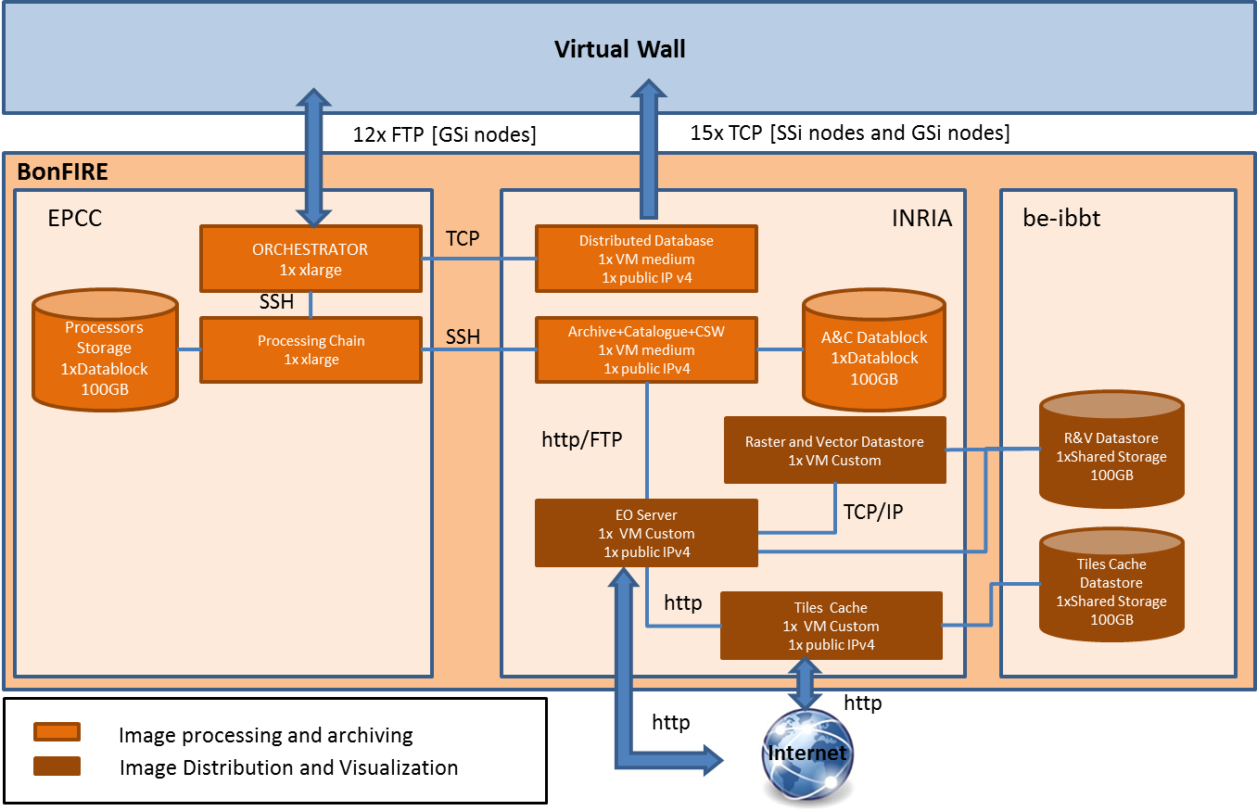

Figure 4 Architecture of the system computed in cloud

The previous architecture makes the Orchestrator and the Processing Chain work slightly different to the functioning designed in GEO-Cloud-DMS-TEC-TEC10-10-E-2014-03-10.docx. Note that here; the orchestrator does not communicated with a shared storage, in which the processors send the products and from which the A&C module gets the final product. On the contrary, there is a Storage instance associated to the Processing Chain. This is a temporal solution while the Fed4FIRE partners are developing the Elasticity as a Service characteristic for BonFIRE.

We will start obtaining preliminary results with this solution and when the Elasticity as a Service is ready we will change the architecture for the originally designed one, in order to use the elasticity feature.

GEO-Cloud demo

A demo of the GEO-Cloud experiment was prepared to be presented to the European Commission during the first Fed4FIRE review. The demo consists of executing the GEO-Cloud experiment to measure the time it takes an image from its download in a ground station until a user accesses to it through the Internet. Figure 5 depicts the architecture of the GEO-Cloud system and its functionality.

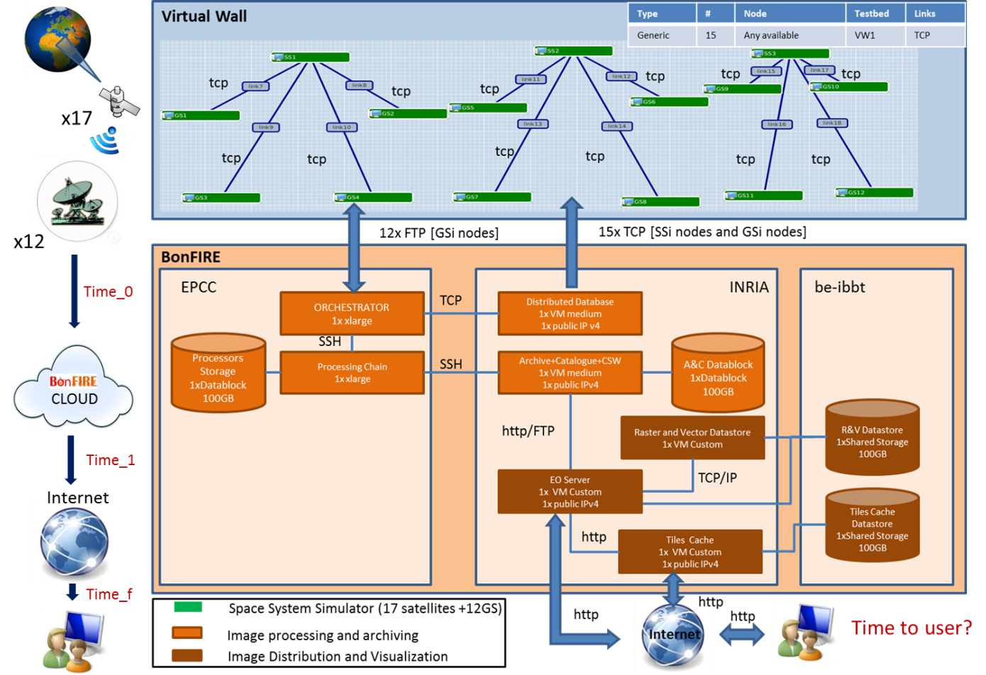
Figure 5 GEO-Cloud demo

Table 1 summarizes the actions that will be carried out in the GEO-Cloud demo.
Table 1 Actions of the GEO-Cloud demo
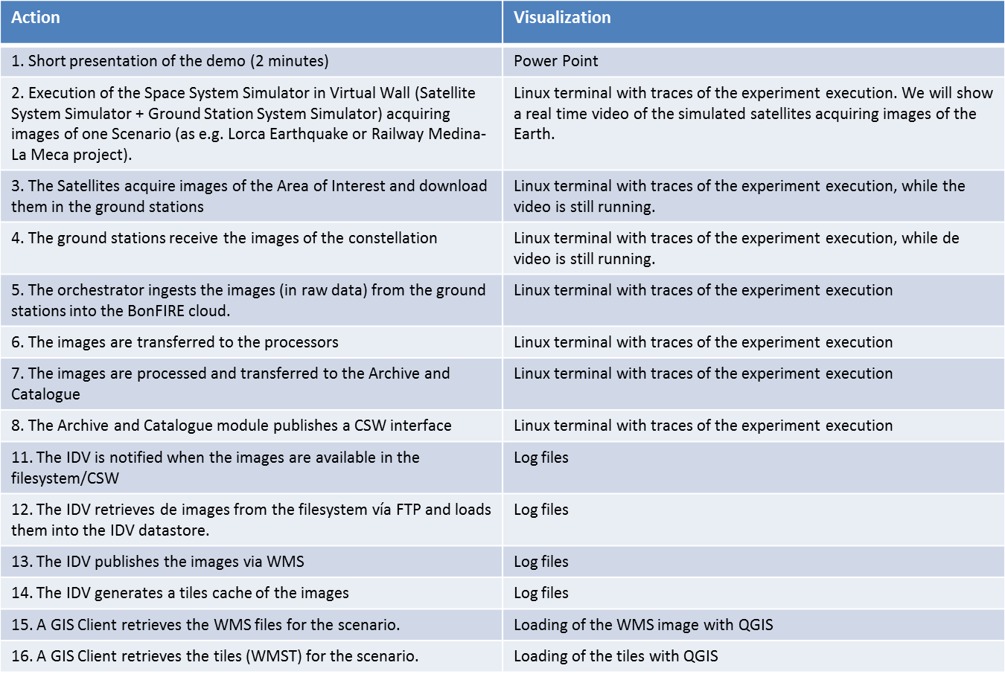

Conclusions

This document presents the implementation and integration of all the modules that constitute the GEO-Cloud system. We can say that the first release of the GEO-Cloud experiment is ready. However some future works will be carried out during the experiment execution stage:

- Implementation of the original architecture when the Elasticity as a Service will be ready in BonFIRE.
- Setup of the impairments in the Virtual Wall networks.

